FCLE Item Bank #1
Comp 1
- What do a republic and a direct democracy have in common?
- rule by a single political party
- rule by the people
- rule by a small group of leaders
- rule by the single leader

- What system of government was in place after the United States adopted the U.S. Constitution?
- Confederal
- Federal
- Oligarchy
- Parliamentary

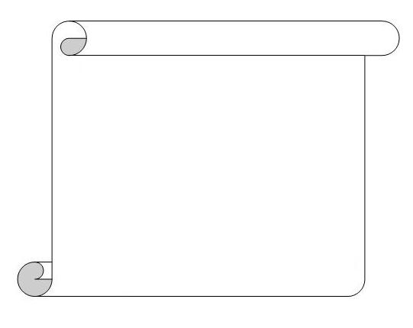
- The quote below is from a historical document.

A Prince whose character is thus marked by every act which may define a Tyrant, is unfit to be the ruler of a free people.

How does this quote reflect the influence of Enlightenment ideas on the Founding Fathers?
- They had reservations about self-government.
- They were concerned with property rights.
- They supported individual liberties.
- They created a limited monarchy.
- How are the Enlightenment ideas that influenced the Founding Fathers reflected in modern institutions?
- Colonies have been re-established to preserve popular sovereignty
- Oligarchies have increased to safeguard natural rights.
- The United Nations promotes universal human rights.
- The European Union encourages economic stability.

- The conversation below concerns lawmaking.
---------------------------
Doug: I believe in making laws only when everyone can participate in public decision making.

Shena: I disagree with you; it is best for laws to be made by the people who have been elected for that purpose.
---------------------------

Which political principle from the colonial era is being discussed?
- Limited monarchy
- Self-government
- Social contract
- Natural rights

- The statement below was expressed by colonists in the 1750s and 1760s.

No taxation without representation!

Source: Public Domain/U.S. National Archives and Records Administration

How does the modern political system in the United States uphold the principle expressed in the statement?
- by requiring federal tax bills to be voted on by all citizens
- by making local governments responsible for enforcing federal tax laws
- by requiring federal tax bills to be introduced in one house of Congress
- by requiring federal tax bills to be proposed by the Secretary of the Treasury

- Below is a diagram.

Which statement completes the diagram?
- It is the role of government to determine natural rights.
- It is the role of government to protect natural rights.
- People establish natural rights.
- People possess natural rights.

- The statement below was written by John Adams in April 1776.

A representation of the people in one assembly being obtained, a question arises, whether all the powers of government, legislative, executive, and judicial, shall be left in this body? I think a people cannot be long free, nor ever happy, whose government is in one assembly.

Source: Thoughts on Government, Letter of John Adams

Which basic principle of American government is John Adams describing in this statement?
- Separation of powers
- Individual rights
- Natural laws
- Civic Virtue

- Which principle does the U.S. Supreme Court apply when it declares an act of Congress unconstitutional?
- Separation of powers
- Checks and balances
- Advice and consent
- Executive privilege

- Which principle supports President Eisenhower’s action to uphold the U.S. Supreme Court’s decision that public schools should be integrated?
- Judicial review
- Checks and balances
- Separation of powers
- Constitutional government

Comp 2

- The following passage is from McCulloch v. Maryland (1819).

If … such be the mandate of the Constitution, we have only to obey; but that instrument does not profess to enumerate the means by which the powers it confers may be executed…

Which constitutional provision does this decision support?
- Commerce clause
- Judicial review
- Habeus corpus
- Elastic clause

- The quote below was made by a member of Congress.

“President Reagan is still our President. But he should not be able to …impose his …vision of the Constitution on the Supreme Court and on the next generation of Americans. No justice would be better than this injustice.” - Edward Kennedy, 1987
Source: Public Domain

How have similar statements influenced the actions of government?
- Congressional confirmation of presidential nominations
- Senate confirmation of presidential appointments
- Congressional confirmation of presidential pardons
- Senate confirmation of presidential vetoes

- Which is an example of a Tenth Amendment issue?
- State governments oversee public schools
- State governments coin money
- National governments make treaties
- National governments declare war

- The map below illustrates a constitutional power.
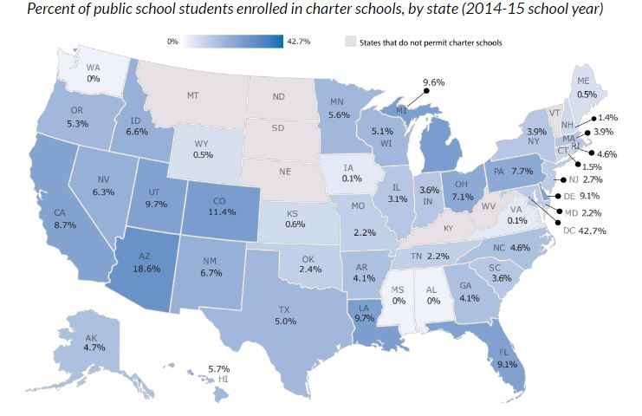Source: Center for Education Statistics

What constitutional relationship does the map illustrate?
- Reserved powers
- Expressed powers
- Delegated powers
- Concurrent powers

- The newspaper headline below describes an event in U.S. history.

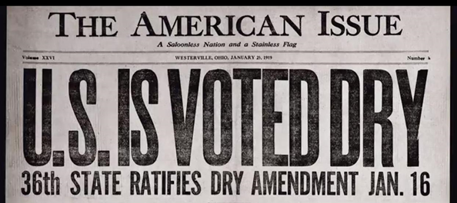

Source: Anti-Saloon League Museum

Based on the headline, what happened before the event presented in the image?
- Two-thirds of each house of Congress voted to support the amendment.
- The president rejected the amendment after Congress voted to support it.
- Three-fourths of each house of Congress voted to support the amendment.
- The president forwarded the amendment to the states after Congress voted to support it.
- Between 1870 and 1913, one amendment was added to the U.S. Constitution. Based on this information, what can be inferred about the constitutional amendment process?
- Amending the U.S. Constitution is a relatively time consuming and difficult process that does not allow changes to happen easily.
- Amending the U.S. Constitution is a relatively quick and simple process that allows change to happen easily.
- Amending the Constitution has rarely been tried.
- Amending the Constitution requires unanimous consent.

- Which action formally accuses a government official of “wrongdoing”?
- Filibuster
- Impeach
- Override
- Pardon

- The statement below was made during a speech by President Barack Obama on September 9, 2009.

I am not the first President to take up this cause, but I am determined to be the last. It has now been nearly a century since Theodore Roosevelt first called for healthcare reform. And ever since, nearly every president and Congress, whether Democrat or Republican, has attempted to meet this challenge in some way.

Source: The White House Office of the Press Secretary

Which federal power is most likely to expand under the reform effort described in the passage?
- Coin and print money
- Naturalization laws
- Lay and collect taxes
- Education standards

- The political cartoon below illustrates a foreign policy issue.
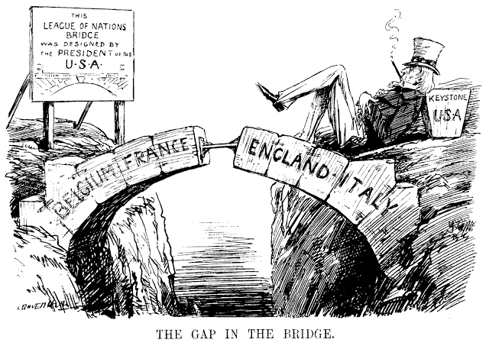
Source: Public Domain

Based on the political cartoon, which statement best explains how the Senate's refusal to ratify a treaty affects the ability of the president to conduct foreign policy?
- It limits the ability of the president to act as commander-in-chief.
- It limits the ability of the president to conduct trade negotiations.
- It limits the ability of the president to offer support to other nations.
- It limits the ability of the president to act as chief executive.

- The image below illustrates a civic obligation.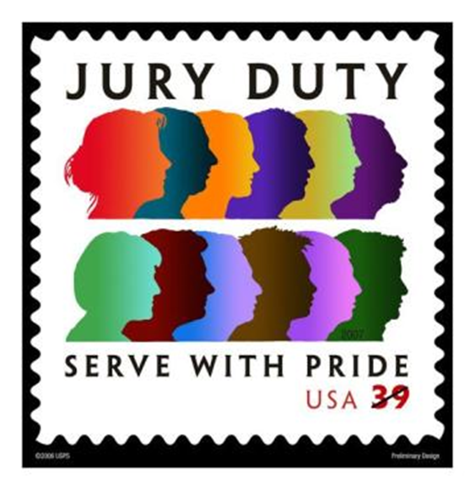
Source: United States Postal Service

Which constitutional right is most affected by the civic obligation illustrated in the image?
- Speedy trial
- Trial by peers
- Legal representation
- Peaceable assembly

Comp 3
- Below is a statement from the Constitution of Massachusetts (1780).
The body politic is formed by a voluntary association of individuals; …. which the whole people covenants with each citizen and each citizen with the whole people that all shall be governed by certain laws for the common good.

Source: Public Domain/U.S. National Archives and Records

Source: Public Domain/U.S. National Archives and Records Administration

Which principle expressed in the statement influenced the Founding Fathers when they wrote the Constitution?
- Separation of powers
- Social contract
- Rule of law
- Natural law

- Which idea is from the Magna Carta?
- The people should have the right to replace the government.
- The people should support a strong central government.
- The government should give people a fair and speedy trial.
- The government should have a separation of powers.

- Which statement reflects an idea contained within Common Sense?
- Self-government is a right of the colonies.
- Limited monarchy was an appropriate solution to the problems between England and the colonies.
- Power should be shared between the colonies and the central government in England.
- Checks and balances were necessary to limit the power of government.

- The statements below are from the English Bill of Rights (1689).

That the pretended power of suspending laws … without consent of Parliament is illegal;

That excessive bail ought not to be required, nor excessive fines imposed, nor cruel and unusual punishment inflicted;

And that for redress of all grievances, and for the amending, strengthening and preserving of the laws, Parliaments ought to be held frequently.

Source: U.S. National Archives and Records Administration

Which purpose of government from the Preamble to the U.S. Constitution can best be traced to these statements?
- Provide for the common defense
- Promote the general welfare
- Ensure domestic tranquility
- Establish justice

- The passage below was written by Thomas Paine in his 1776 pamphlet, Common Sense.

And as he hath shown himself such an … enemy to liberty, and discovered such a thirst for ... power, is he, or is he not, a proper man to say to these colonies, "You shall make no laws but what I please"?

Source: U.S. National Archives and Records Administration

Based on this passage, how is the author’s view reflected in the U.S. political system?
- The monarchy creates limited government.
- The monarchy supports self-government.
- Representatives are appointed.
- Representatives are elected.

- The image is a political cartoon that ran in the Boston Gazette in 1765.

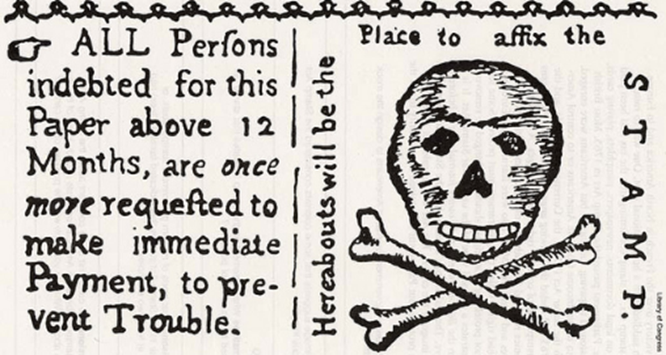

Source: Library of Congress

Which statement describes the significance of the image?
- It demonstrated that Parliament ignored the colonists’ petitions
- It demonstrated that Parliament controlled the colonists’ publications.
- It represented the colonists’ opposition to English tax policies.
- It represented the colonists’ fulfillment of English tax policies.

- The political cartoon below was created by Benjamin Franklin in1754. The small letters beside sections of the snake are the initials of British colonies.

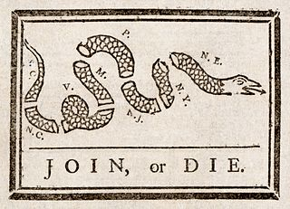

Source: Library of Congress

By the 1770’s, which action did colonists use this cartoon to support?
- Declaring independence from the British monarchy.
- Declaring loyalty to the British monarchy.
- Dissolving colonial legislatures.
- Dissolving colonial charters.

- The quotes below are from historical documents.
Declaration of Independence
“For imposing Taxes on us without our Consent”

Article I Section 7 U.S. Constitution
“All bills for raising Revenue shall originate in the House of Representatives…”

Which statement describes the relationship between the ideas expressed in the two excerpts?
- Both declare to the world why the colonists wanted freedom from England.
- Both respond to Parliament’s claim of virtual representation.
- Both respond to English policies imposed upon the colonists.
- Both show how England dealt with actions of the colonists.

- Below is a statement from a historical document.

A Prince whose character is thus marked by every act which may define a Tyrant, is unfit to be the ruler of a free people.

Source: Public Domain/U.S. National Archives and Records Administration

In which document is this statement found?
- Magna Carta
- Mayflower Compact
- Articles of Confederation
- Declaration of Independence

- The passage below is from a historical document.

We hold these truths to be self-evident, that all men are created equal, that they are endowed by their Creator with certain unalienable Rights....

Source: U.S. National Archives and Records Administration

What is the main idea of this passage?
- Only citizens can enjoy the rights guaranteed by a government.
- People have rights that cannot be denied by any government.
- Government must equally distribute power among people.
- Government is necessary to promote equality.

Comp 4
- The passage below is from a speech by President George W. Bush, March 19, 2003.

On my orders, coalition forces have begun striking selected targets of military importance to undermine Saddam Hussein's ability to wage war. These are opening stages of what will be a broad and concerted campaign.

Source: Office of the White House Press Secretary Archives

What constitutional role justifies the actions described in the passage?
- commander-in-chief
- negotiator-in-chief
- chief legislator
- chief regulator

- The table below describes presidential vetoes.
President  (Years) | Presidential  Vetoes | Legislative  Overrides
Barack H. Obama (2009-present) | 2 | 0
George W. Bush (2001-2009) | 12 | 4
William J. Clinton (1993-2001) | 37 | 2
George H. W. Bush (1989-1993) | 44 | 1
Ronald Reagan (1981-1989) | 78 | 9
Jimmy Carter (1977-1981) | 31 | 2
Gerald R. Ford (1974-1977) | 66 | 12
Richard M. Nixon (1969-1974) | 43 | 7
Source: U.S. House of Representatives

Based on the table, how has the legislative process been impacted by presidential vetoes?
- The presidents’ views are often ignored in lawmaking.
- The presidents’ views are often reflected in public policy.
- Congress is often unified in rejecting the views of the president on public policy.
- Congress is often influenced by the desires of citizens on lawmaking.
- The statement below is from Executive Order 10924, President John F. Kennedy, March 1, 1961.

The Peace Corps shall be responsible for the training and service abroad of men and women of the United States in new programs of assistance to nations and areas of the world, and in conjunction with…other international organizations.

Source: U.S. National Archives and Records Administration

What opportunities does the executive order create for citizens and the government?
- to provide for the common defense
- to establish domestic tranquility
- to advance the common good
- to administer justice

- Which presidential action was based on Article I of the U.S. Constitution?
- John F. Kennedy’s statements about missiles in Cuba
- Franklin Roosevelt asking Congress to declare war on Japan
- Dwight Eisenhower’s statements about communism in Africa
- George H. Bush asking Congress to commit troops for Gulf War I

- The newspaper headline below describes an event in U.S. history.

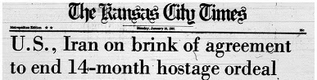

Which presidential action is represented by the headline?
- Treaty ratification
- Veto override
- Diplomacy
- Terrorism

6. Which of the following legislative actions was intended to facilitate military recruitment?
- Selective Service Act of 1940
- USA PATRIOT Act of 2001
- Homestead Act of 1862
- Sedition Act of 1918

7. How did the Gentleman’s Agreement of 1907 impact immigration to the United States?
- It reduced immigration from Japan.
- It encouraged immigration from China.
- It expanded immigration from allied countries.
- It limited immigration from communist countries.

8. Which option best explains why President Lincoln issued the Emancipation Proclamation in 1863?
- to challenge his political rival Stephen Douglas
- to free enslaved persons in the United States
- to undermine the Confederate war effort
- to fulfill the original goal of the Civil War

9. Which of President Johnson’s policies established by executive order was eventually severely limited by the Supreme Court decision in Students for Fair Admissions, Inc. v. President and Fellows of Harvard College?
- creation of affirmative action
- naming of the Kennedy Space Center
- establishment of the Warren Commission
- adjusting military pay for active duty troops

10. The provided passage is from a presidential veto message.
“...deeply impressed with the belief that some of the powers and privileges possessed by the existing bank are unauthorized by the Constitution, subversive of the rights of the States, and dangerous to the liberties of the people, I felt it my duty…to call the attention of Congress to the practicability of organizing an institution combining all its advantages and obviating these objections….I can perceive none of those modifications of the bank charter which are necessary, in my opinion, to make it compatible with justice, with sound policy, or with the Constitution of our country. . .”
Source: National Archives

Which president issued the provided veto message to Congress?

- Theodore Roosevelt
- Andrew Jackson
- William McKinley
- Ronald Reagan

