1. Which government action was a result of the vagueness of Article III in the United States Constitution?
- passage of the Judiciary Act of 1789
- issuance of the Monroe Doctrine in 1823
- passage of Alien and Sedition Acts of 1798
- issuance of McCulloch v. Maryland in 1819

2. Which legislative action by the United States Congress allowed the federal government to do what state governments were banned from doing in Worcester v. Georgia (1832)?

- Indian Removal Act
- Chinese Exclusion Act
- Tonkin Gulf Resolution
- Missouri Compromise

3. Which of the following laws resulted in ‘detribalizing’ thousands of Native Americans in the United States?
- Kansas-Nebraska Act
- Homestead Act
- Neutrality Act
- Dawes Act

4. Which purpose of government as found in the Preamble to the United States Constitution do the Patient Protection and Affordable Care Act, the Clean Air Act, and the Occupational Safety and Health Act have in common?
- provide for the common defense
- promote the general welfare
- secure domestic tranquility
- establish justice

5. What do the Adams-Onis Treaty (1819), the Treaty of Guadalupe-Hidalgo (1848) and the Treaty of Paris (1898) have most in common?
- They expanded the territory of the United States.
- They impacted the same region of the United States.
- They ended military conflicts in favor of the United States.
- They established deeper trade relations with allies of the United States.

6. Which executive action was done to enforce Brown v. Board of Education (1954)?
- Eisenhower’s Executive Order 10730
- Roosevelt’s Executive Order 9066
- Johnson’s Executive Order 11246
- Truman’s Executive Order 9981

7. Which of the following legislative actions was intended to facilitate military recruitment?

- Selective Service Act of 1940
- USA PATRIOT Act of 2001
- Homestead Act of 1862
- Sedition Act of 1918

8. How did the Gentleman’s Agreement of 1907 impact immigration to the United States?
- It reduced immigration from Japan.
- It encouraged immigration from China.
- It expanded immigration from allied countries.
- It limited immigration from communist countries.

9. Which option best explains why President Lincoln issued the Emancipation Proclamation in 1863?
- to challenge his political rival Stephen Douglas
- to free enslaved persons in the United States
- to undermine the Confederate war effort
- to fulfill the original goal of the Civil War

10. Which of President Johnson’s policies established by executive order was eventually severely limited by the Supreme Court decision in Students for Fair Admissions, Inc. v. President and Fellows of Harvard College?
- creation of affirmative action
- naming of the Kennedy Space Center
- establishment of the Warren Commission
- adjusting military pay for active duty troops

11. The provided passage is from a presidential veto message.
“...deeply impressed with the belief that some of the powers and privileges possessed by the existing bank are unauthorized by the Constitution, subversive of the rights of the States, and dangerous to the liberties of the people, I felt it my duty…to call the attention of Congress to the practicability of organizing an institution combining all its advantages and obviating these objections….I can perceive none of those modifications of the bank charter which are necessary, in my opinion, to make it compatible with justice, with sound policy, or with the Constitution of our country. . .”
Source: National Archives

Which president issued the provided veto message to Congress?

- Theodore Roosevelt
- Andrew Jackson
- William McKinley
- Ronald Reagan

12. How did the Pendleton Act of 1883 impact the federal government of the United States?
- It professionalized the civil service.
- It limited punishment through demotion.
- It reduced the growth of the bureaucracy.
- It expanded the number of opportunities for minorities.

13. Which legislative action limited First Amendment rights?
- Sedition Act of 1798
- Missouri Compromise of 1820
- Chinese Exclusion Act of 1882
- Tonkin Gulf Resolution of 1964

14. The cartoon illustrates an executive action.
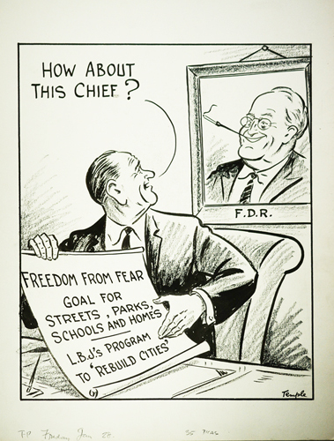
Source: University of Miami

Which government action is suggested by the cartoon?
- creation of the Department of Housing and Urban Development (1965)
- creation of the Department of Homeland Security (2002)
- passage of the Voting Rights Act (1965)
- approval of the Paris Accords (1973)

15. Which of the following legislative actions was passed in response to events such as the Cuyahoga River in Ohio catching fire?
- Resource Recovery and Conservation Act of 1976
- Occupational Safety and Health Act of 1970
- Clean Water Act of 1972
- Clean Air Act of 1970

16. Which of the following government actions directly offered an apology for the internment of people of Japanese descent during World War Two?
- Civil Liberties Act of 1988, signed by President Reagan
- Executive Order 9981 of 1948, issued by President Truman
- Trump v. Hawaii decision of 2018, written by Chief Justice Roberts
- Korematsu v. United States decision of 1944, written by Associate Justice Hugo Black

