What was the Compromise of 1850?
Competency #4: Understanding of landmark Supreme Court cases, landmark legislation, and landmark executive actions and their impact on law and society
Activity Vocabulary and Significant Figures:
VOCABULARY​
- Sovereignty – the authority of a state to govern itself or another state​
- Acquisition - an asset or object bought or obtained​
- Nullification – the act of making something null, void, or invalid​
- Compromise - an agreement or a settlement of a dispute that is reached by each side making concessions.​
- Territories - an area of land under the jurisdiction of a ruler or state​
KEY FIGURES​
- Senator Henry Clay (Kentucky)– The Great Compromiser​
- Senator Stephen A. Douglas (Illinois) – Champion of Popular Sovereignty
- Senator Daniel Webster (Massachusetts) – Key orator in successfully arguing for compromise from Massachusetts.​
Teacher Note:
There are hyperlinks in the PowerPoint for further explanation and discussion of events
Lesson Steps:
The lesson features a PowerPoint presentation that explores the key events leading up to the Compromise of 1850, with a focus on territorial expansion and slavery. It will highlight significant figures, essential vocabulary, and visuals, including a map of U.S. territories and a timeline of relevant events leading up to the compromise. Additionally, the presentation will incorporate video overviews of the Compromise of 1850 and its impact in the years following. The PowerPoint concludes with sample questions for students to test their knowledge of the legislation.
- The instructor should review the PowerPoint with their students, expanding upon the key points of the Compromise of 1850 and the relevance of each of the provisions outlined in the Compromise. The video will provide students with a brief and concise overview of events from the Mexican American War onward.
- Following completion of the video and PowerPoint, the instructor will review the key vocabulary of the lesson along with significant figures and encourage students to discuss their meaning and/or importance in the Compromise.
- Following the discussion of vocabulary and figures, students will review the sample questions in groups and discuss answers.
Teacher Background Information:
Instructor should have knowledge of the Compromise of 1850, key figures, provisions, and the events that led to the Compromise and their effects on the legislation, including but not limited to the Northwest Ordinance, the U.S. Constitution, the Louisiana Purchase, the Missouri Compromise, the Election of 1844 (Manifest Destiny Election), the Mexican American War, the Treaty of Guadalupe Hidalgo and how the events connect to one another.
Documents and Resources:
Video Link “Compromise of 1850: Civil Rights to Civil War”
Compromise of 1850: From Civil Rights to Civil War - YouTube
Northwest Ordinance
Northwest Ordinance (1787) | National Archives
The US Constitution
The Constitution of the United States | National Archives
The Louisiana Purchase
Louisiana Purchase Treaty (1803) | National Archives
The Missouri Compromise
Missouri Compromise (1820) | National Archives
The Election of 1844 (Manifest Destiny Election)
Introduction - Presidential Election of 1844: A Resource Guide - Research Guides at Library of Congress
Mexican American War
Milestones in the History of U.S. Foreign Relations - Office of the Historian
Treaty of Guadalupe Hidalgo
Treaty of Guadalupe Hidalgo | DocsTeach
The Compromise of 1850
The Compromise of 1850 | DocsTeach
The U.S. Annexes Texas
The U.S. Annexes Texas
U.S. Territorial Acquisitions
U.S. Territorial Acquisitions

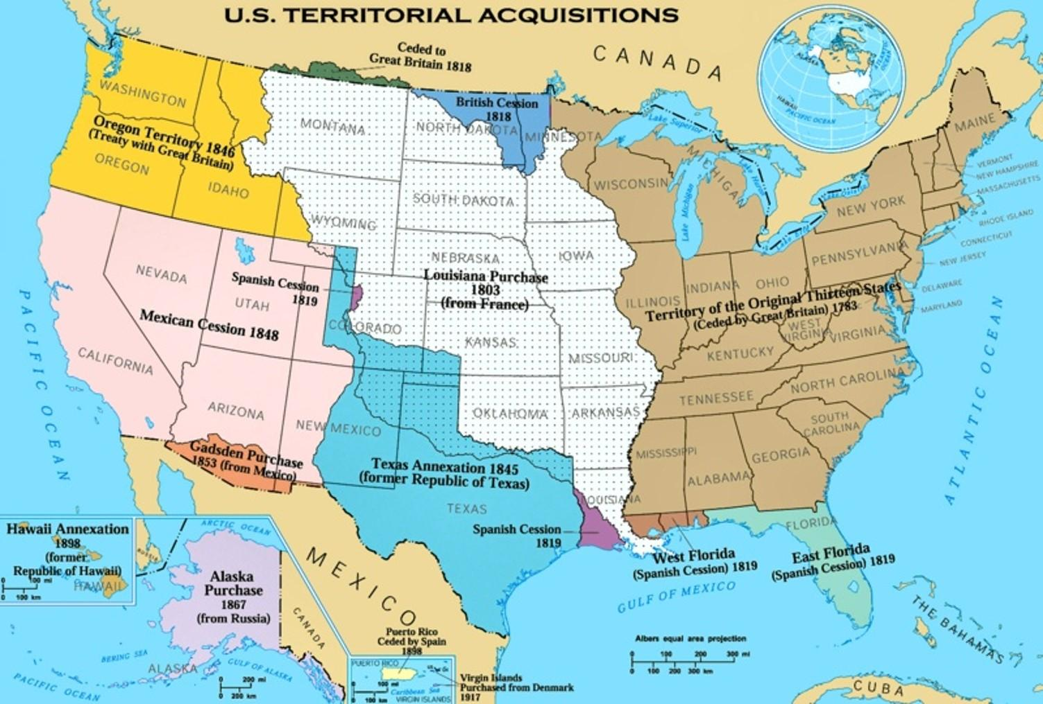
File:U.S. Territorial Acquisitions.png - Wikipedia

Sample Questions
1. Popular sovereignty was an important element of the Compromise of 1850 because it
A. stopped the spread of slavery in the United States
B. reflected the democratic tradition of self-determination.
C. provided a national solution to the issue of slavery
D. upheld the principles of the white supremacy

2. The most alarming aspect of the Compromise of 1850 for anti-slavery advocates was:
A. abolition of the slave trade in Washington, DC
B. popular sovereignty in the Utah and New Mexico territories
C. the new Fugitive Slave Law
D. settlement of the Texas and New Mexico boundary dispute

3. Which of the following statements regarding the Compromise of 1850 is accurate?
A. It temporarily solved the slavery issue in the Western territories.
B. It ended the sectional crisis in the United States
C. The Fugitive Slave Law conflicted with constitutional ideals
D. It was created to respond to the nullification crisis.
ANSWER KEY
- B
- C
- A

