**Competency Four**

**Florida Civic Literacy Examination (FCLE)**

## What is Competency Four?

Competency Four will assess your understanding of landmark Supreme Court cases, landmark legislation, and landmark executive actions, and their impact on law and society.

**What is a landmark Supreme Court case?**

A landmark Supreme Court case establishes an important precedent and shapes the future decision-making of courts in a particular area of law.

**What is a landmark executive action?**

An executive order is a directive given by the President of the United States that manages operations of the federal government.

**What is landmark legislation?**

Landmark legislation is a law that has a significant impact on society and results in major changes. This lesson will teach us about the Voting Rights Act (1965).

The Voting Rights Act of 1965 was enacted to enforce the [Fifteenth Amendment](https://www.archives.gov/milestone-documents/15th-amendment) to the U.S. Constitution. The Fifteenth Amendment, ratified in 1870, guaranteed Black men the right to vote. Black men did vote and even held public office throughout the late 1800’s. However, racial oppression and the steadfast efforts of Jim Crow segregation laws made it not only difficult but virtually impossible and even dangerous for African Americans in the South to exercise their right to vote.

The [Voting Rights Act](https://www.archives.gov/milestone-documents/voting-rights-act)**,** signed into law on August 6, 1965, by President Lyndon B. Johnson, specifically addressed the disenfranchisement of hundreds of thousands of African Americans. This law would initiate more than 200,000 new voter registrations among African Americans, with fifty percent of the African American population registered to vote by the end of 1966.

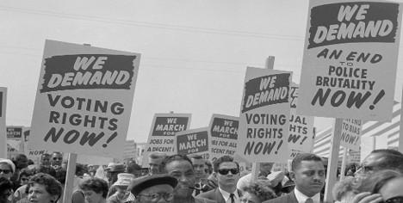

[Voting Rights Protest](https://socialwelfare.library.vcu.edu/federal/voting-rights-act-of-1965/)

Three elements were used to reinforce voter disenfranchisement: literacy tests, Grandfather Clauses, and the poll tax.

**Literacy Tests**

Literacy Tests were enforced in some states and even introduced into the state constitution, as a requirement before citizens could be granted the right to vote. In Alabama, for example, African American voters were required to take and pass the Alabama literacy test. Most African Americans failed, even those college-educated. The tests were yet another tool used in the ongoing efforts to maintain discriminatory practices in voting.

[Sample Literacy Test](https://jimcrowmuseum.ferris.edu/pdfs-docs/origins/al_literacy.pdf)

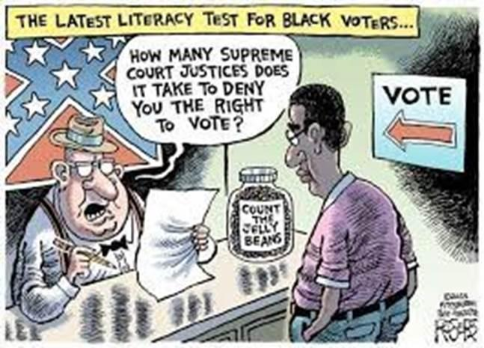

[Informed Voter Test Political Cartoon](https://www.nealumphred.com/informed-voter-test/)

**Grandfather Clauses**

Grandfather Clauses stated that people who had voted or were descendants of voters were not required to take the literacy tests. This largely affected white, illiterate citizens. Grandfather Clauses essentially assured their right to vote without meeting any literacy requirement.

[Black Americans and the Vote National Archives](https://www.archives.gov/research/african-americans/vote#:~:text=The%20infamous%20%E2%80%9Cgrandfather%20clause%2C%E2%80%9D,denied%20them%20their%20voting%20rights.)

[Origins of the Grandfather Clause YouTube video (one minute)](https://www.youtube.com/watch?v=__-bO7_lz9c)

**Poll Taxes**

Poll taxes were a voting fee. Citizens who were eligible to vote were required to pay the poll tax before they could cast their vote. However, the **Grandfather Clause**, excused some poor white citizens from paying the poll tax. There were no exceptions, however, for African Americans. In Alabama, for example, the poll tax was $1.50. Today, that would be the equivalent of approximately $55.00.

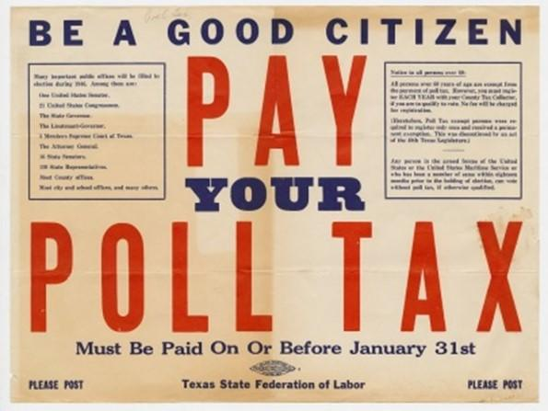 [Poll Tax Notice](https://hornbakelibrary.wordpress.com/2018/02/22/labors-role-in-abolishing-the-poll-tax/)

## Let’s discuss the Voting Rights Act of 1965

| Describe the legislation in your own words. |  |
| --- | --- |
| What significant event led to the initiation of this legislation? |  |
| Which **constitutional amendment** is the focus of the case? |  |
| Discuss the primary ***concern*** in the case and how it relates to the constitutional amendment you selected. |  |
| What is the primary question being raised in the Voting Rights Act? |  |
| What was the ***final decision*** made by President Johnson and Congress? |  |
| What was the **reason** for this decision? |  |

# 

# RESPONSIBILITY OF THE U.S. CONSTITUTION TO UPHOLD

# THE VOTING RIGHTS ACT OF 1965

The **Voting Rights Act of 1965 (VRA)** was enacted to enforce the 15th Amendment and eliminate race discrimination in voting. Its key responsibilities include:

1. **Banning Discriminatory Voting Practices** – The law outlawed literacy tests and other tactics historically used to disenfranchise Black voters.
2. **Federal Oversight in Certain Areas** – States and counties with histories of voter suppression were required to secure federal approval before changing voting laws.
3. **Protection Against Intimidation** – The law made it illegal to intimidate, threaten, or coerce anyone trying to vote.
4. **Language Assistance** – Required jurisdictions with large non-English-speaking populations to provide bilingual voting materials.
5. **Ongoing Amendments and Protections** – The law has been amended multiple times to address voter suppression tactics as they emerge.

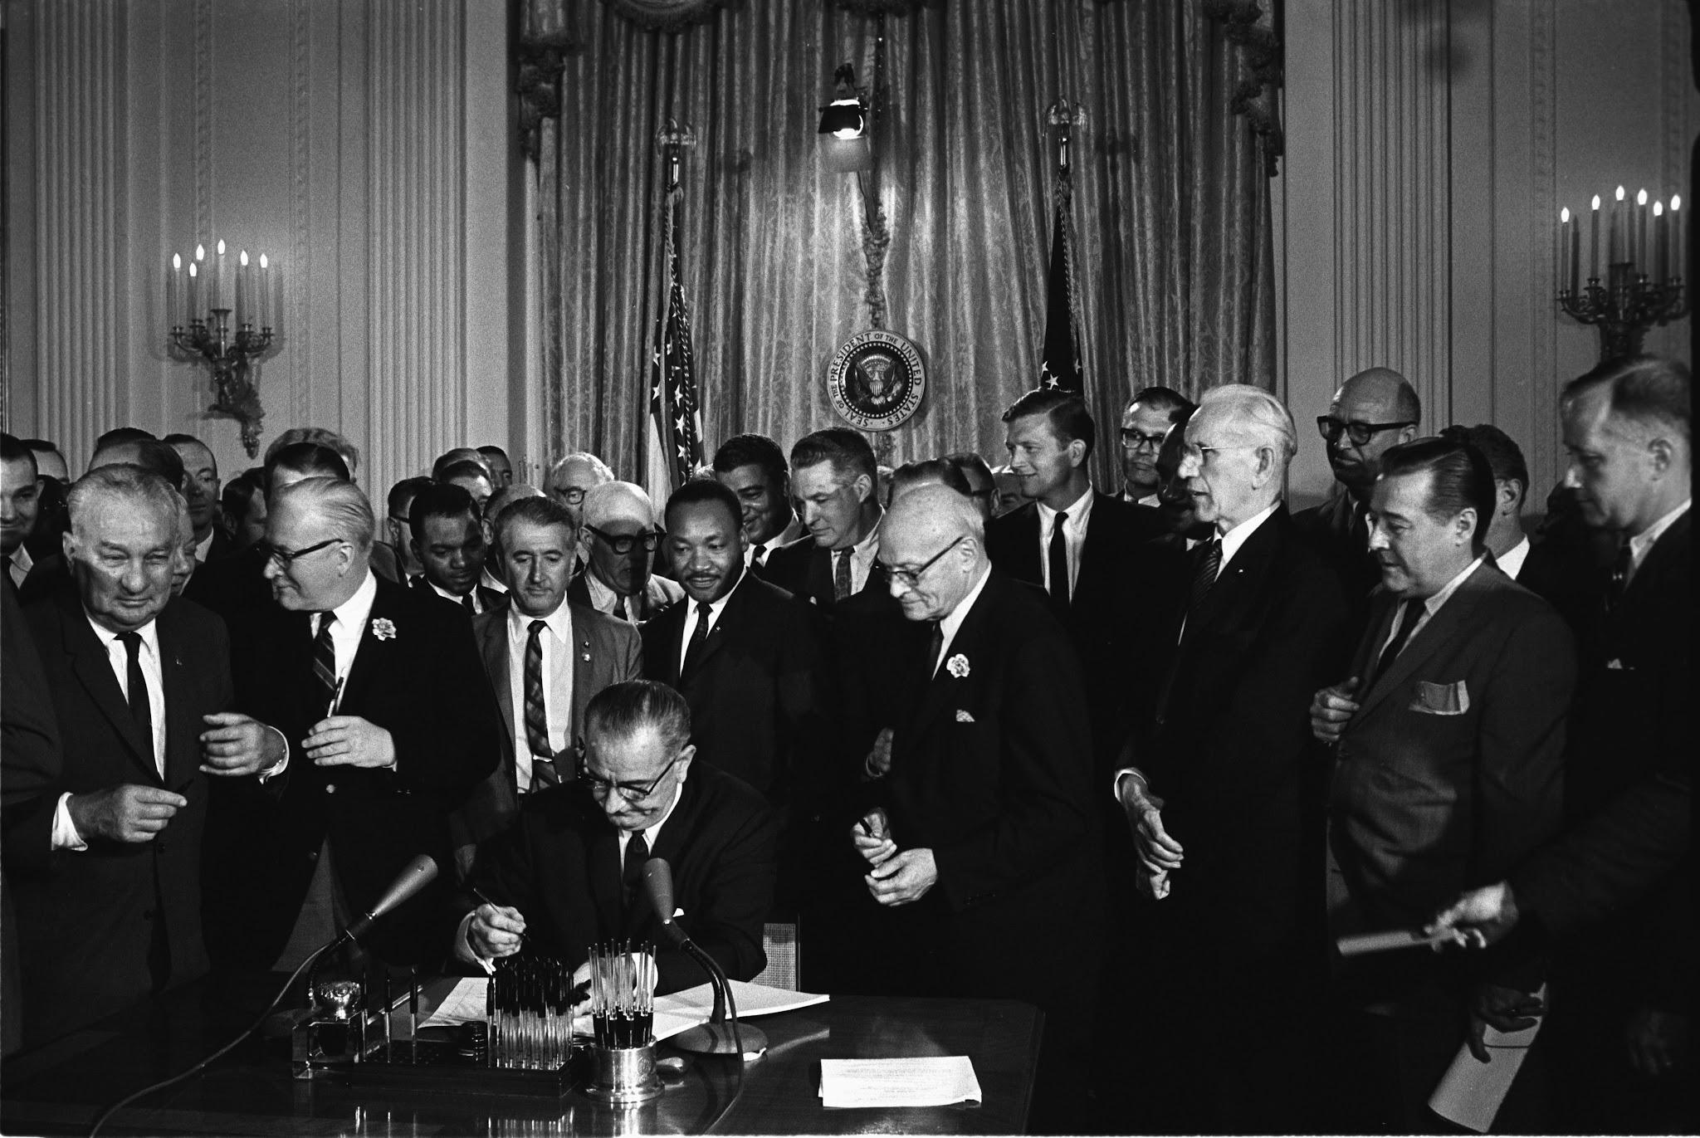

[President Johnson signs the Voting Rights Act](https://dp.la/primary-source-sets/voting-rights-act-of-1965/sources/1389)

**Discussion questions:**

1. Why was the Voting Rights Act of 1965 necessary despite the 15th Amendment having been ratified almost 100 years earlier?
2. How did the Civil Rights Movement contribute to the passage of this law?
3. What impact did the Act have on voter participation in the U.S?
4. What are some challenges to voting rights today?
5. What is a voting literacy test?
6. What is a poll tax?
7. Analyze the Civil Rights Movement in your own words.
8. Discuss the impact of the Selma to Montgomery March.