Florida Civic Literacy Support Lesson
Title: The New Deal, the Court, and Federalism
How did the New Deal expand the role of the federal government?
An Activity for High School Civic Literacy Competency #4

Competency #4: Understanding of landmark Supreme Court cases, landmark legislation, and landmark executive actions and their impact on law and society

Benchmark and Benchmark Clarification Correlations

Benchmark: SS.912.CG.3.12 Analyze the concept of federalism in the United States and its role in establishing the relationship between the state and national governments .
*Students will analyze how states have challenged the national government regarding states’ rights (e.g., New Deal)
Benchmark: SS.912.A.5.11: Examine causes, course, and consequences of the Great Depression and the New Deal.
*Students will identify and/or evaluate the impact of business practices, consumer patterns, and government policies of the 1920s and 1930s as they relate to the Great Depression and subsequent New Deal.

Activity Vocabulary
Agricultural Adjustment Act
federalism
Great Depression
New Deal
Social Security Act

Teacher Note: There are multiple handouts for each center.

Lesson Steps:

There are 3 “centers” in this activity. Divide students into small groups and place each group at a center. Students will then move from one center to another until they have rotated to all three centers. Students should take approximately 15 minutes at each center. Depending on the size of your class you may need to make multiple versions of each center or larger groups or otherwise adjust to accommodate your class. Students will complete one center question sheet per group.
Afterward, you may have different groups present results or review as a whole class.

Teacher Background Information

Teachers should have basic knowledge of the Great Depression and attempts by Roosevelt and Congress to address issues posed by the Great Depression through New Deal legislation. Teachers should also understand how the Supreme Court viewed New Deal legislation and how that view shifted over time.
Center 1
Document A
“To relieve the existing national economic emergency by increasing agricultural purchasing power, to raise revenue for extraordinary expenses incurred by reason of such emergency. to provide emergency relief with respect to agricultural indebtedness, to provide for the orderly liquidation of joint-stock land banks, and for other purposes.”
Agricultural Adjustment Act of 1933 Pub. L. No. 73-10, 48 Stat. 31

Document B
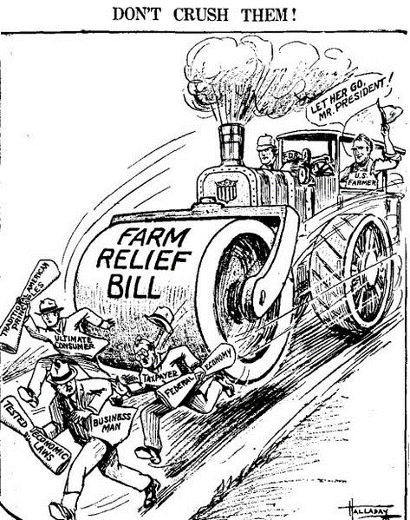

Document C:
Congress has no power to enforce its commands on the farmer to the ends sought by the Agricultural Adjustment Act. It must follow that it may not indirectly accomplish those ends by taxing and spending to purchase compliance… A possible result of sustaining the claimed federal power would be that every business group which thought itself underprivileged might demand that a tax be laid on its vendors or vendees, the proceeds to be appropriated to the redress of its deficiency of income.
United States v. Butler, 297 U.S. 1 (1936)

Center 2
Document D:
Franklin Delano Roosevelt and the Court Packing Controversy: Background Essay
Supreme Court Historical Society
Introduction
In February 1937, President Franklin D. Roosevelt submitted a plan to Congress for increasing the number of Supreme Court Justices from nine to as many as fifteen. His proposal ignited a political powder keg that would burn into the heat of summer.
Section 1: Background
When President Franklin Delano Roosevelt took office on March 4th, 1933, he inherited a nation in distress. Industrial production was down almost 50%. Prices and wages had fallen to disastrous levels. And nearly one third of the labor force was out of work. It was the Great Depression.
Section 2: The New Deal
Hoping to bring America out of its economic tailspin, FDR began proposing new governmental regulations on local and interstate commerce. He championed measures to limit work hours and set minimum wages for labor. His Agricultural Adjustment Act was designed to raise produce prices by subsidizing farmers not to grow as many crops. Congress swiftly enacted Roosevelt’s recovery initiatives, collectively called ‘The New Deal,’ and sent relief to many in need.
Section 3: Judicial Opposition
The Supreme Court of the United States soon invalidated many of the president’s New Deal measures as unconstitutional. No Supreme Court had ever struck down so many laws so quickly. An adamantly conservative bloc of Justices known as the ‘Four Horsemen’ consistently held that governmental regulation of commerce and labor infringed on personal liberties. They held that Roosevelt’s reforms restricted an individual’s right to form contracts–in violation of the Fifth and Fourteenth Amendments. On a nine-man court, the Four Horsemen only needed one more vote for a majority. Justice Owen Roberts almost always voted with them. Often, so did Chief Justice Charles Evans Hughes. As measure after measure was revoked, including a popular minimum wage law from New York state protecting women and children workers, FDR realized that his New Deal was no match for an old court.
Section 4: The Proposal
Franklin D. Roosevelt won a landslide reelection in 1936. To him, this confirmed that Depression-weary Americans wanted his initiatives declared constitutional. But the Judiciary Branch stood in the way. So, on February 5th, 1937, FDR boldly asked Congress for the authority to reform the Supreme Court. He proposed a plan to appoint an additional Justice for everyone not retired by age 70. This would allow him to promptly handpick as many as six new judges for the bench. The president argued that the aging court needed more Justices to help with its caseload, because he said its members were “slow and infirm” and behind in their work.
But no one doubted his true agenda. Enlarging the Court from 9 to as many as 15 would effectively outnumber the conservatives on the bench and dilute their power. Yet FDR carefully pointed out that this was not the first time a president had sought to change the number of Supreme Court Justices. Indeed, the Constitution says nothing about the size of the Court, leaving that decision for Congress to determine.
Congress originally fixed the number of Supreme Court Justices at 6. Then, it gradually added new seats to the Supreme Court as the country expanded westward. There needed to be enough Supreme Court Justices to preside over the new judicial circuits because Congress did not provide salaries for circuit judges until 1869 and the Justices did double duty. In 1807 a seventh Supreme Court seat was added to represent Kentucky, Ohio and Tennessee. In 1837, Congress added two new justices and 2 new judicial circuits. A 10th seat was added in 1863 to cover the west coast. But in 1866 Congress sought to gradually reduce the Court’s size to 7 by forbidding replacement appointments when Justices departed. The intent was to give judges much-needed salary raises and to deny President Andrew Johnson the chance to appoint southern sympathizers to the Court. Finally, in 1869 Congress fixed the size of the Court at 9.
Section 5: Court Reactions
The Supreme Court, which was not at all behind on its docket, was insulted by the Roosevelt administration’s proposal. Chief Justice Hughes fought back. He wrote a letter to the Senate Judiciary Committee assuring them that the Court was “fully abreast of its work” and that there was “no congestion of cases” on its calendar. Hughes complained that the enlargement plan would be inefficient: with “more judges to hear, more judges to confer, more judges to discuss, more judges to be convinced and to decide.” Even the liberal bloc of Justices opposed the Court-enlargement plan. To stem criticism, Roosevelt told the public in a radio “Fireside Chat” that he was not trying to pack the Court with partisan Justices.
Meanwhile, impressed by FDR’s landslide victory and concerned that Congress with its large Democratic majority would enact his Court proposal, two Justices unexpectedly voted to uphold New Deal initiatives.
Thus, on March 29 the Court dramatically reversed itself in upholding the legality of a Washington State minimum wage law for women. Justice Roberts switched his vote from a very similar case from New York decided less than a year before. Writing the opinion in the case, Chief Justice Hughes said that the due process clauses of the Fifth and Fourteenth Amendments require “the protection of the law against the evils which menace the health, safety, morals and welfare of the people.” Two weeks later, Hughes and Roberts cast their votes in a landmark case ruling that federal regulation of labor relations was constitutional.
Section 6: Franklin Delano Roosevelt Perseveres
Other rulings in the spring of 1937 showed the Supreme Court turning around its stance on New Deal initiatives, including upholding the Social Security Act. It was joked how “a switch in time saved nine.” But if this ‘switch’ was a tactic to get the president to drop his petition for judicial reform, then it failed. FDR still wanted his six new Justices.
In May, Justice Van Devanter, one of the conservatives, announced his retirement. Congress had quietly passed a law allowing Supreme Court Justices to retire and continue to receive their full salary, just as lower court judges did. The old conservative bloc had irretrievably lost its leverage. Still, Roosevelt did not stop pushing Congress to enact a plan for enlarging the court, and his obstinacy made him a target for criticism.
Section 7: The Senate Judiciary Committee Reacts
A scathing Senate Judiciary Committee report released in June said that FDR’s court bill: “…should be so emphatically rejected that its parallel will never again be presented to the free representatives of the free people of America.”
Of the ten Senators who signed the report, seven were Democrats. Detractors made much of this dissension within the president’s own party. To heal the rift, Roosevelt invited all 407 Democratic Congressmen, including the signers of the report, to a weekend of fun and games on Jefferson Island in the Chesapeake Bay. It was a brilliant move. After three days of relaxed camaraderie, many were willing to reconsider the president’s proposal.
To capitalize on this momentum, the Roosevelt administration revised the bill to authorize the president to gradually appoint one Justice per calendar year for each member of the Court who had reached the age of 75. This would allow him 4 appointees–plus a 5th to fill Van Devanter’s open seat.
Section 8: A Heated Debate
The “Great Debate” on the Court enlargement bill finally opened on the Senate floor in July 1937. Senate majority leader Joe Robinson of Arkansas led the fight for enacting it. He had helped power many of the New Deal laws through the Senate and was known as “Scrappy Joe” for his talent for strong-arming his colleagues. Senator Wheeler, the liberal Democrat from Montana, led the fight for defeating it. But both sides faced a common foe. Washington sweltered in the grip of a killer heat wave, and the Congressmen were condemned to argue in an un-air-conditioned chamber.
Section 9: The End of the Right
Senator Robinson opened the proceedings with a two-hour long speech. He had enough promised votes to pass the court bill, but he wanted a clear two-thirds majority to avoid a filibuster. He knew his best tactic would be to make the debate into an endurance contest. One third of the senators were over 60, and in no condition to stew in a hot room. Robinson went long rounds with his opposition, bellowing and stamping his feet like an enraged bull. But strain clearly showed on his reddened face and in the stoop of his shoulders as he fended off assaults to the bill. His trademark vigor flagged, and when he returned to his apartment that night he dropped dead from the heat and stress.
Section 10: Burial
The Great Debate was not yet over, but without Senator Robinson’s aggressive advocacy, Franklin Delano Roosevelt’s judiciary bill was doomed. Senators who had been only tenuously committed to the plan switched their loyalties, giving the opposition forces an absolute majority for the first time.
At Senator Wheeler’s insistence the measure was put to a vote right away. No concessions were made to spare embarrassment to the administration or its supporters. And so, on July 22nd, 1937 —after 168 days— President Roosevelt’s plan for enlarging the Supreme Court was defeated. Senator Hiram Johnson, a Republican from California, summed it up for many when he cried out in Congress, “Glory be to God.”
Franklin Delano Roosevelt would go on to appoint 8 Supreme Court Justices as vacancies opened during his 12 years in office. They would transform the judiciary into a critical partner in implementing the New Deal. But his failed Court-packing campaign marked the last time a president asked Congress to change the number of seats on the Supreme Court.
Document E:
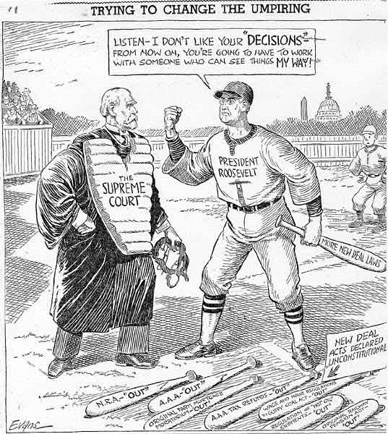

Center 3

Document F:
“AN ACT to provide for the general welfare by establishing a system of Federal old-age benefits, and by enabling the several States to make more adequate provision for aged persons, blind persons, dependent and crippled children, maternal and child welfare, public health, and the administration of their unemployment compensation laws; to establish a Social Security Board; to raise revenue; and for other purposes.”
-Social Security Act 1935, National Archives

Document G:
In a 5-to-4 decision, the Court held that the tax under the Social Security Act was a constitutional exercise of congressional power. Writing for the majority, Justice Benjamin N. Cardozo found that the tax did not coerce the states in contravention of the Tenth Amendment. The Court underscored the high rate of unemployment and poorly performing economy in concluding that the tax would benefit the general welfare. According to the majority, the Act would benefit both the states and the federal government. The majority rejected the argument that the Act provision was void as involving an unconstitutional attempt to coerce the States to adopt unemployment compensation legislation approved by the Federal Government.
In dissenting opinions, Justices McReynolds, Sutherland, Van Devanter, and Butler viewed the Social Security Act as a Congressional overreach. These dissenters came to be known collectively as the Four Horsemen, the conservative members of the Court who opposed President Franklin D. Roosevelt’s New Deal agenda.
Source: Steward Machine Company v. Collector of Internal Revenue (1937)
Document H:
Long before the economic blight of the depression descended on the Nation, millions of our people were living in wastelands of want and fear. Men and women too old and infirm to work either depended on those who had but little to share, or spent their remaining years within the walls of a poorhouse . . .The Social Security Act offers to all our citizens a workable and working method of meeting urgent present needs and of forestalling future need . . . One word of warning, however. In our efforts to provide security for all of the American people, let us not allow ourselves to be misled by those who advocate shortcuts to Utopia or fantastic financial schemes. We have come a long way. But we still have a long way to go. There is still today a frontier that remains unconquered--an America unclaimed. This is the great, the nationwide frontier of insecurity, of human want and fear. This is the frontier--the America--we have set ourselves to reclaim."
-- President Franklin Roosevelt
Radio address on the Third Anniversary of the Social Security Act
August 14, 1938

Name: ___________________________________________________________________ Date: ______________________

Legislative and Executive Action: Federalism and the New Deal Centers Questions

Center 1: Agricultural Adjustment Act, Don’t Crush Them Political Cartoon, and United States v. Butler

Questions:
- What were the goals of the Agricultural Adjustment Act?
- What is the emergency that the Agricultural Adjustment Act refers to?
- Based on the cartoon, who might oppose the Agricultural Adjustment Act?
- How did the Supreme Court rule on the Agricultural Adjustment Act?
- What was the Supreme Court’s reasoning for their ruling?

Center 2: Court Packing Plan Background Essay and Umpire Cartoon

Questions:
- What were some of the goals of Roosevelt’s New Deal legislation?
- What were some of the reasons the Supreme Court gave for knocking down New Deal legislation?
- How did FDR propose to alter the court and how would that benefit him and his New Deal?
- What were the most common reactions to Roosevelt’s proposals?
- Based on the cartoon, what are some of Roosevelt’s New Deal policies that the court struck down?

Center 3: Social Security Act, Steward Machine Company v. Collector of IRS, and Roosevelt speech

Questions:
- Using Document F, explain the purpose of the Social Security Act. What founding document does it reference?
- How did the court rule in the Steward Machine Company case?
- What did critics and the dissenting justices argue regarding the Social Security Act?
- What does Roosevelt argue are the successes of Social Security?
- What does Roosevelt warn about in his speech?

Summary:
- How did the New Deal challenge previously held beliefs about federalism and the relationship between states and the federal government?
- Based on these readings, was the New Deal successful in solving some of the issues of the Great Depression?

Answer Key
(Answers may vary, but the main idea should be similar)
- The goal of the AAA was to raise crop prices by lowering production, thus helping to bring an end to the farm crisis of the Great Depression.
- The Great Depression. People were starving in cities, and it often cost farmers more to get their crops to cities than they would earn in return. Farmers had increased production during WWI and never sufficiently pulled back in the 1920’s. This led to plummeting prices in the late 1920’s and 1930’s.
- Businessmen, taxpayers and consumers. Consumers would be paying more for fruits and vegetables. Businesses and taxpayers would be paying more in taxes.
- They ruled that it was unconstitutional because it attempted to regulate and control agriculture production which is reserved for the states.
- Under the 10th A, the power in question is reserved for the states.
- The goals were to bring the US out of the Great Depression through regulation of commerce, establishment of minimum wage, and raising produce prices.
- The court argued that these laws infringed upon liberties. They held that Roosevelt’s reforms restricted an individual’s right to form contracts–in violation of the Fifth and Fourteenth Amendments.
- He proposed to expand the court to 15 justices. This would allow him to appoint 6 justices, effectively, making those who decided against the New Deal outnumbered and allowing New Deal legislation to stand.
- The proposal was overwhelmingly criticized by both members of the court and the Senate, including members of Roosevelt’s own party.
- AAA, NRA and more.
- The purpose of Social Security was to provide old age insurance and well as to help support the disabled and their families. It references the Preamble of the Constitution, “general welfare.”
- It upheld the Social Security Act.
- They argued it was an overreach of federal power.
- It offers a workable method of meeting present needs and preparing for future needs.
- We still have a way to go. Be wary of those who promise shortcuts.
- The New Deal blurred the lines between state and federal power. The federal government was granted unprecedented amounts of power in this time of crisis and sometimes the court tried to stop it, but over time it began to uphold more federal government intervention.
- Social Security was successful in that it was allowed and still exists today.

Sources

Agricultural Adjustment Act. Agricultural Adjustment Act of 1933
United States v. Butler. United States v. Butler
Social Security Act. Social Security Act
Steward Machine Company v. Collector of Internal Revenue. Steward Machine Company v. Collector of Internal Revenue
Court Packing Plan Background: FDR and the Court Packing Controversy
Radio Address on the Third Anniversary of the Social Security Act. White House, Washington, D.C., August 15, 1938. FDR Radio Address on the Third Anniversary of the Social Security Act
Political Cartoons: Anti-New Deal Political Cartoons

