FJCC Critical Benchmark Notes Assessment

1. This image is a historical document.

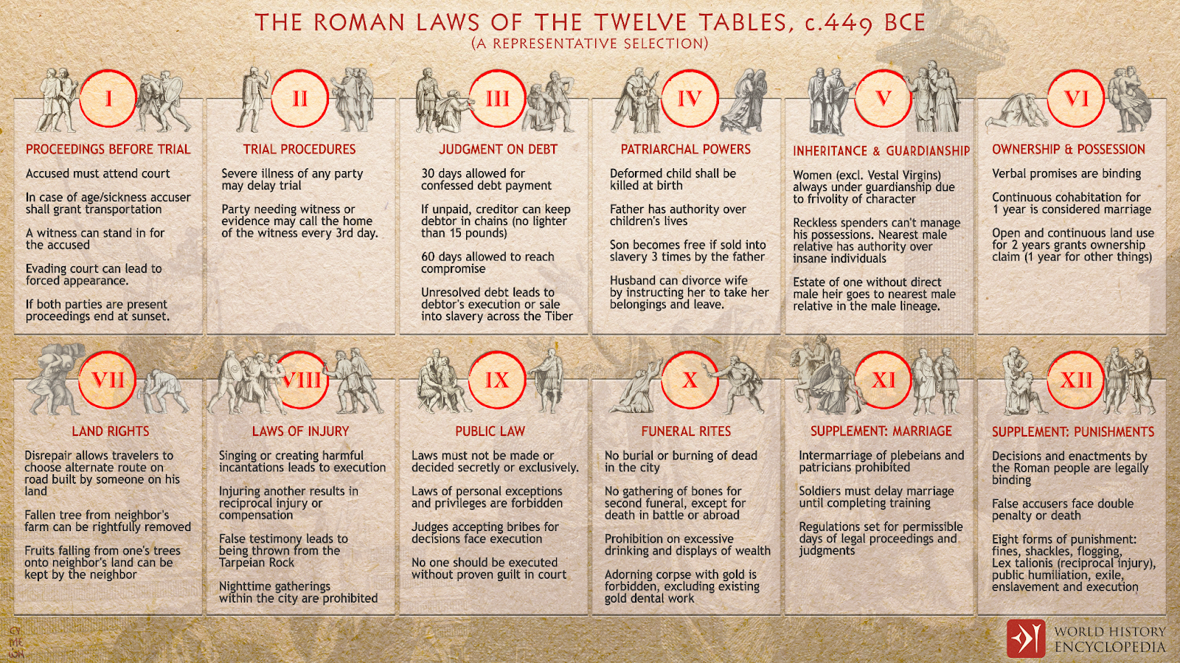

How does the constitutional republic of the United States reflect the ideas expressed in this document?
- by establishing a tradition of civic participation
- by allowing states to challenge federal laws in court
- by maintaining rule of law and holding all citizens accountable
- by creating a separation of powers between branches of government

2. This passage comes from the Preamble to the U.S. Constitution.

We the People of the United States … do ordain and establish this Constitution for the United States of America.

Based on this passage, which foundational principle is being described?
- rule of law
- due process of law
- limited government
- equality of mankind

3. This diagram shows that the colonists formed some of their political views from some historical documents.

English Bill of Rights

speedy and fair jury trial

Common Sense

?

Which phrase completes this diagram?
- natural rights
- habeas corpus
- due process of law
- representative self-government

4. Which foundational principle is reflected in the creation of three branches of government?
- natural rights
- social contract
- separation of powers
- consent of the governed

5. This diagram describes a cause that led to the writing of the Declaration of Independence.

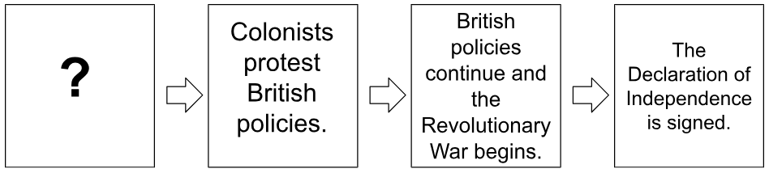

Which action completes this diagram?
- Colonial agricultural trade increases.
- Colonial religious rights are restricted.
- The British enact a series of taxes in the colonies.
- The British grant the colonists representation in Parliament.

6. This passage comes from the Declaration of Independence.

We hold these truths to be self-evident, that all men are created equal, that they are endowed by their Creator with certain unalienable Rights, that among these are Life, Liberty and the pursuit of Happiness. That to secure these rights, Governments are instituted among Men, deriving their just powers from the consent of the governed.

Based on this passage, where should governments get their power?
- from God
- from the public
- from the legislative branch
- from the executive branch

7. Which weakness of the Articles of Confederation was highlighted by the events of Shays’s Rebellion?
- no national armed forces
- no power to enter treaties
- lack of a legislative branch
- lack of a national court system

8. In the Preamble to the U.S. Constitution, what is the meaning of the phrase “We the People”?
- Citizens express their will through political parties.
- Citizens express their will by directly creating laws.
- Government receives taxes from citizens and exists to support them.
- Government receives its power from citizens and exists to serve them.

9. This newspaper headline details an important step in filling a vacancy on the U.S. Supreme Court.

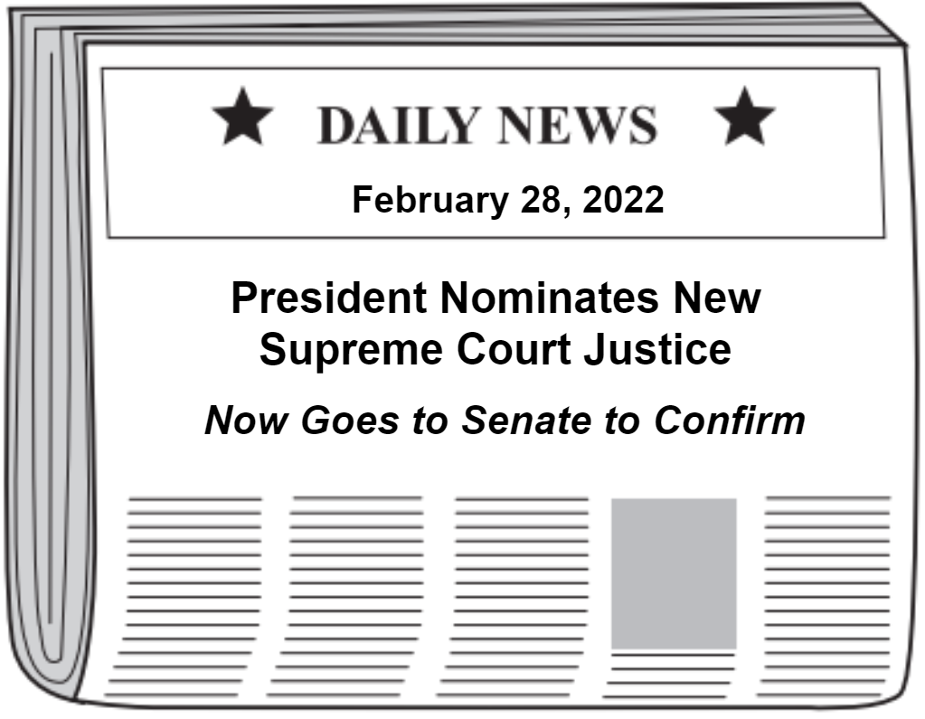

Which constitutional principle does this headline illustrate?
- rule of law
- judicial review
- checks and balances
- separation of powers

10. This passage is from Anti-Federalist Paper #84, written by Brutus.

The Constitution proposed to your acceptance is designed, not for yourselves alone, but for generations yet unborn. The principles, therefore, upon which the social compact is founded, ought to have been clearly and precisely stated, and the most express and full declaration of rights to have been made. But on this subject there is almost an entire silence.

Based on this passage, with which statement regarding ratification of the U.S. Constitution would the author agree?
- The Constitution should limit local government.
- The Constitution should protect individual rights.
- The Constitution should create a strong national government.
- The Constitution should protect the rights of the individual states.

11. Which option best describes the importance of the rule of law?
- It allows police to keep evidence a secret during a criminal trial.
- It exempts government leaders from having to follow procedures.
- It protects citizens from arbitrary and abusive uses of government power.
- It ensures different laws can be applied to people of different social classes.

12. This photograph shows individuals becoming U.S. citizens through the naturalization process.

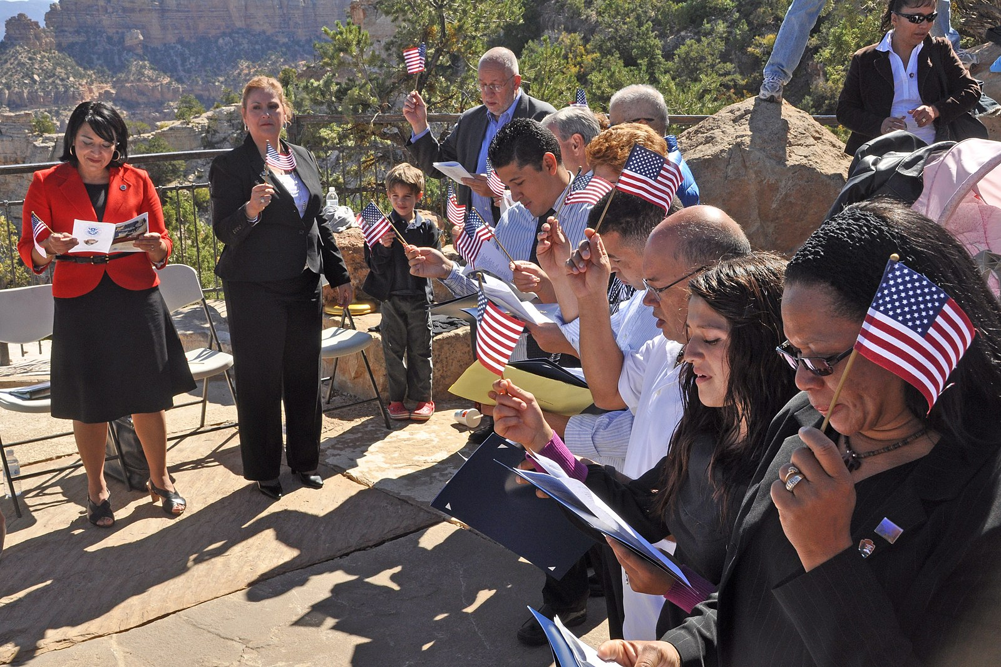

Which of the following describes the eligibility requirements they had to meet?
- reside in the U.S. for five years, be of good moral character, and be able to speak and read basic English
- be of good moral character, achieve permanent residency, and pledge to serve in the armed forces
- reside in the U.S. for five years, pass a reading and math test, and be at least 25 years old
- be of good moral character, pass a U.S. history and government test, and pay $15,000

13. This image shows a legal document.
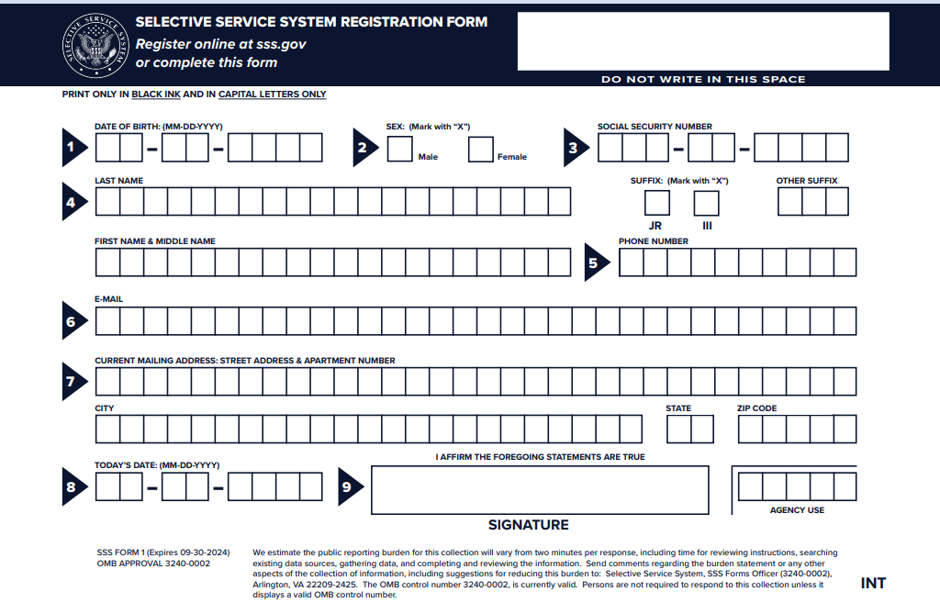
Why are certain citizens obligated to respond to this document?
- to defend the safety and security of the nation
- to ensure they stay informed about political issues
- to guarantee their right to vote in national elections
- to protect the constitutional right to be tried by one’s peers

14. This diagram shows freedoms protected in the Bill of Rights.

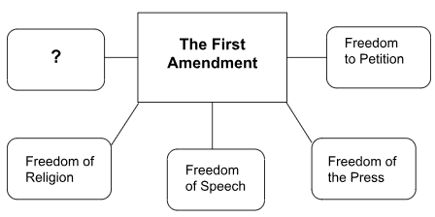

Which statement best completes this diagram?
- Freedom to Vote
- Freedom of Assembly
- Freedom to a Trial by Jury
- Freedom from Habeas Corpus

15. This passage about government is from Federalist No. 78.

A constitution is, in fact, and must be regarded by the judges, as a fundamental law. It therefore belongs to them to ascertain its meaning, as well as the meaning of any particular act proceeding from the legislative body.

Which conclusion may be drawn from the author’s views in this passage?
- The U.S. Constitution requires a bill of rights.
- The U.S. Supreme Court ensures individual rights are protected.
- The U.S. Constitution requires state laws to align with national laws.
- The U.S. Congress has the sole responsibility of passing legislation.

16. This diagram shows the steps in selecting a juror.

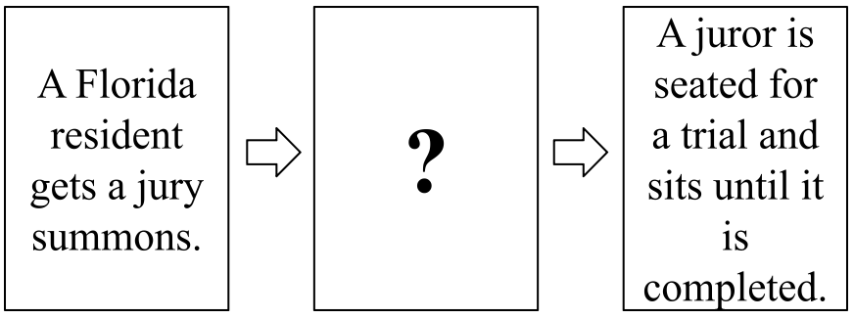

Which statement completes this diagram?
- The jury pool listens to arguments and delivers a verdict.
- Attorneys narrow the jury pool through the voir dire process.
- Attorneys identify a foreperson to speak on behalf of the jury pool.
- The jury pool meets with court clerks to determine any biases that would affect the trial.

17. This diagram shows steps in the election process at the national level.

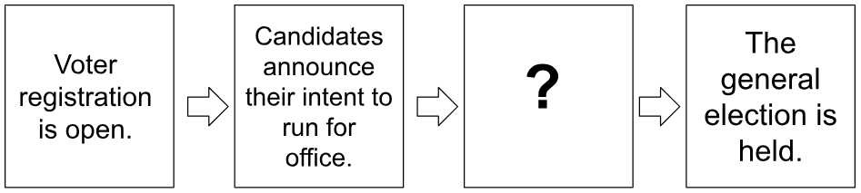

Which statement best completes this diagram?
- Political parties hold midterm elections.
- The winner of the political debates takes the oath of office.
- Primary elections are held to narrow down the candidates.
- State legislatures cast votes to determine who will appear on the ballot.

18. This table shows the biographies of two candidates running for governor of Florida.

Candidate A | Candidate B
-Was born in Alabama  -Lived in Florida during 4 years of college  -44 years old  -Has a degree in Political Science from UCF  -Has lived in Gainesville, FL for the last 2 years | -Was born in Tampa, FL  -Raised in Florida  -59 years old  -Has a law degree from Georgia Tech  -Lived abroad in France for 6 years  -Has lived in Orlando, FL for the last 10 years

According to this biographical information, for which reason is Candidate A NOT qualified to run for governor of Florida?
- Candidate A is not old enough.
- Candidate A was not born in Florida.
- Candidate A does not have a law degree.
- Candidate A has not lived in Florida long enough.

19. Which option is an example of how an individual may influence the government?
- signing a petition
- walking by a protest
- writing a lifestyle blog
- watching a presidential debate

20. This image is a propaganda poster created by the U.S. government in 1944.

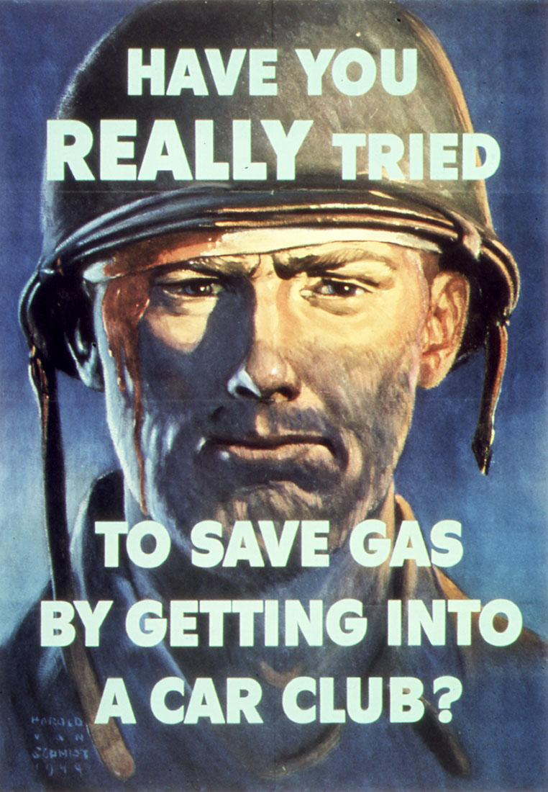
What was the desired impact of propaganda like this poster?
- boost the economy during wartime
- enlist more men into the armed forces
- reduce the cost of goods to support the armed forces
- encourage the public to support the war effort at home

21. Luis and Isabelle are frustrated there isn’t a crosswalk near their neighborhood for all the students who walk home from school.

Which of the following is an example of an appropriate course of action these students could take to address their concerns?
- send an email to their U.S. senator
- propose a plan at a city council meeting
- hold a fundraiser and use the money to make their own crosswalk
- ask a local police officer to ban vehicles from this road during school hours

22. This table describes a form of government.

🔹 Limited personal freedoms
🔹 Rulers are chosen by a higher power
🔹 Laws and decisions are based on religious beliefs
🔹 Religious authorities rule in the name of a god or deity

What form of government is being described in this table?
- theocracy
- republic
- oligarchy
- monarchy

23. This diagram shows a comparison of two different systems of government.

Federal System | Confederal System
-Power is shared among levels.  -Central governments and state governments have specific responsibilities.  -The U.S. Constitution currently uses this system. | -A loose joining of independent states.  -Individual states maintain the most power.  -The U.S. tried this system under the Articles of Confederation.

Which would be considered an advantage of a federal system of government?
- There are fewer laws that governments have to follow.
- It is easier for states to enter treaties with foreign nations.
- There is a stronger national government to protect the nation.
- It is able to make quicker decisions with power concentrated in one individual.

24. This newspaper headline describes an event in U.S. history.
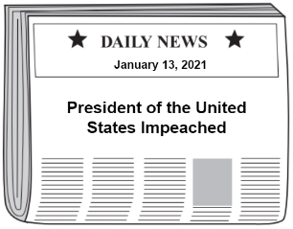
Which part of the national government initiated the process described in this newspaper headline?
- Senate
- Vice President
- Supreme Court
- House of Representatives

25. What is an example of an enumerated power?
- the power to hold elections
- the power to establish local governments
- the power to regulate interstate commerce
- the power to set requirements for teaching licenses

26. This diagram shows the two ways that an amendment to the U.S. Constitution is ratified.

? | Three-fourths of state conventions vote to ratify the amendment.

Which statement completes this diagram?
- Three-fourths of state legislatures vote to ratify the amendment.
- The president issues an executive order and ratifies the amendment.
- Two-thirds of both houses of Congress vote to ratify the amendment.
- The Supreme Court rules the amendment is constitutional and ratifies the amendment.

27. This newspaper headline details an amendment to the U.S. Constitution.
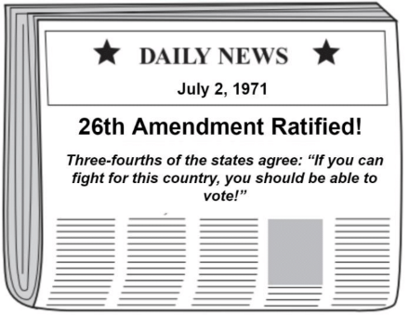
How did this amendment affect participation in the American political process?
- The amendment allowed all college students to vote.
- The amendment allowed more citizens to register to vote.
- The amendment increased the political power of the elderly.
- The amendment increased the political power of returning veterans.

28. This diagram shows some of the steps involved with a bill becoming a law at the national level of government.

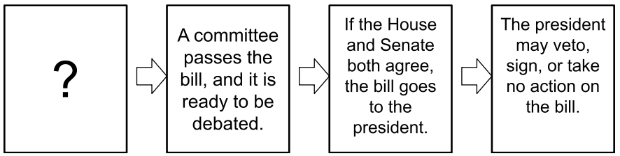

What is the first step in this lawmaking process?
- A governor introduces a bill.
- A member of Congress introduces a bill.
- The judicial branch rules if a bill is constitutional.
- The executive branch rules if a bill is constitutional.

29. This diagram provides details about processes carried out by the executive branch at the national level of government.
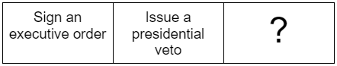
Which option best completes this diagram?
- Fund the armed sources
- Draft bills to become laws
- Make Cabinet appointments
- Advise Supreme Court justices

30. This diagram provides details about the Florida court system.

Florida County Court

Florida Circuit Court

Florida District Court of Appeal

?

Which court completes this diagram?
- Florida Supreme Court
- Florida Military Court
- Florida Traffic Court
- Florida Trial Court

31. Which option refers to laws created by judicial decisions and precedents?
- civil law
- natural law
- common law
- constitutional law

32. Which statement identifies the impact of United States v. Nixon (1974)?
- Rule of law applies to the president.
- Executive privilege protects the president from judicial review.
- The U.S. Supreme Court does not have the power to intervene in presidential matters.
- The president is able to record secret conversations with foreign governments and cabinet members.

33. Which statement identifies a similarity between the U.S. and Florida constitutions?
- both guarantee individual freedoms
- both have the same amendment process
- both outline the process for obtaining citizenship
- both outline the framework for state and local governments

34. This diagram identifies powers of the different levels of government.

National | State | Local
Declare war | ? | Operate public utilities

Which power completes this diagram?
- Coin money
- Sign treaties
- Establish post offices
- Establish school districts and school boards

35. How does the 12th Amendment impact the process of presidential elections in the United States?
- It ensures presidents and vice presidents are elected as a team.
- It creates a system that allows voters to more directly elect the president.
- It ensures that candidates running for the office of president are more qualified.
- It creates an opportunity for the Supreme Court to overturn presidential election results.

36. This table describes economic systems.

Capitalism | Socialism | Communism
Consumers and producers control and influence the economy. | The government controls most major industries. | ?

Which statement completes this table?
- Individuals and companies control major industries.
- The economy is free of government regulation and control.
- Supply and demand are left to the free market, but the government controls wages.
- The government heavily regulates the economy and controls all aspects of daily life.

37. Which action is an example of a foreign policy decision?
- Congress enacts new tax laws.
- The Supreme Court takes a case involving a foreign-born citizen.
- Soldiers are sent to another country to promote peacekeeping efforts.
- The National Guard helps citizens in Florida during a natural disaster.

38. Which action illustrates citizen participation in an international organization?
- Steve teaches others about the World Trade Organization.
- Chris writes a report on the history of the United Nations.
- Liz reads the latest decisions made by the International Court of Justice.
- Kimberly volunteers to raise funds for the United Nations International Children’s Emergency Fund.

39. This statement was made by President George W. Bush on September 20, 2001, explaining why the United States was engaging in military action in the Middle East.

Great harm has been done to us. We have suffered great loss. And in our grief and anger we have found our mission and our moment. Freedom and fear are at war. The advance of human freedom – the great achievement of our time, and the great hope of every time – now depends on us. Our nation – this generation – will lift a dark threat of violence from our people and our future. We will rally the world to this cause by our efforts, by our courage. We will not tire, we will not falter, and we will not fail.

Based on this statement, what was the reason for the United States’ involvement in this international conflict?
- A partnering country committed acts of espionage.
- The United States was facing a humanitarian crisis.
- The United States was the target of a terrorist attack.
- A partnering country broke promises outlined in a treaty.

Answer Key

- C (SS.7.CG.1.1)
- C (SS.7.CG.1.2)
- D (SS.7.CG.1.3)
- C (SS.7.CG.1.4)
- C (SS.7.CG.1.5)
- B (SS.7.CG.1.6)
- A (SS.7.CG.1.7)
- D (SS.7.CG.1.8)
- C (SS.7.CG.1.9)
- B (SS.7.CG.1.10)
- C (SS.7.CG.1.11)
- A (SS.7.CG.2.1)
- A (SS.7.CG.2.2)
- B (SS.7.CG.2.3)
- B (SS.7.CG.2.4)
- B (SS.7.CG.2.5)
- C (SS.7.CG.2.6)
- D (SS.7.CG.2.7)
- A (SS.7.CG.2.8)
- D (SS.7.CG.2.9)
- B (SS.7.CG.2.10)
- A (SS.7.CG.3.1)
- C (SS.7.CG.3.2)
- D (SS.7.CG.3.3)
- C (SS.7.CG.3.4)
- A (SS.7.CG.3.5)
- B (SS.7.CG.3.6)
- B (SS.7.CG.3.7)
- C (SS.7.CG.3.8)
- A (SS.7.CG.3.9)
- C (SS.7.CG.3.10)
- A (SS.7.CG.3.11)
- A (SS.7.CG.3.12)
- D (SS.7.CG.3.13)
- A (SS.7.CG.3.14)
- D (SS.7.CG.3.15)
- C (SS.7.CG.4.1)
- D (SS.7.CG.4.2)
- C (SS.7.CG.4.3)

