Civics Career Academy Support Lesson
What are the different types of experiential learning?
A Lesson for Civics Career Academy Course ‘Public Service Experiential Learning

Course
Public Service Experiential Learning

Benchmark
SS.912.CG.2: Evaluate the roles, rights and responsibilities of U.S. citizens and determine methods of active participation in society, government and the political system.

Course Unit
UNIT 2
Lesson Foci
Lessons focusing on experiential learning requirements, including timekeeping, reflection and assessment, behavior expectations, professional communication, and presentation, will help students understand what is required when they engage in experiential learning.

Activity Documents, Materials, and Handouts

KWL Chart (graphic organizer)

Activity Vocabulary
Community service - unpaid work performed by a person or group of people for the benefit and betterment of their community without any form of compensation; community service can be distinct from volunteering, since it is not always performed on a voluntary basis and may be compulsory
Experiential learning - the process of learning through experience, and is more narrowly defined as "learning through reflection on doing"; hands-on learning can be a form of experiential learning, but does not necessarily involve students reflecting on their product
Internship - a professional learning experience that offers meaningful, practical work related to a student's field of study or career interest; n internship gives a student the opportunity for career exploration and development, and to learn new skills
Job shadowing - a type of on-the-job training that allows an interested employee to follow and closely observe another employee performing the role.;this type of learning is usually used to onboard new employees into an organization or into a new role. Job shadowing may also be used as a learning opportunity for interns or students to gain an understanding of the role requirements and the job tasks
Service learning - a teaching and learning methodology which fosters civic responsibility and applies classroom learning through meaningful service to the community

Teacher Note
INSERT ANY NOTES THAT WOULD HELP THE TEACHER WITH THIS LESSON.

Authorship
Isaiah Blue, Polk
Laura Brimer, Polk
Lynnette Drayton, Broward

Lesson Steps
- Guided Lesson:
  - Provide students with the definitions of each of the unit vocabulary words which consists of experiential learning and the foue types of experiential learning:
  - job shadowing
  - service learning
  - community service
  - internships
- Small group assignment:
  - Group students into foue small groups (corresponding to the four types of experiential learning)
  - Hand out copies of the KWL chart
  - Each student will complete the K column of the KWL Chart by indicating what they know about their assigned experiential learning topic
  - Each group have will read their assigned experiential learning topic articles and view the corresponding videos
  - After reviewing the articles and videos, each group will identify three points learned about their experiential learning topic and list under the L column of the KWL chart
  - Students will share their findings with the whole group by creating a scenario to better demonstrate the meaning of their assigned experiential learning topic
- Exit ticket:
  - Each student will list at least two points learned about another experiential learning topic

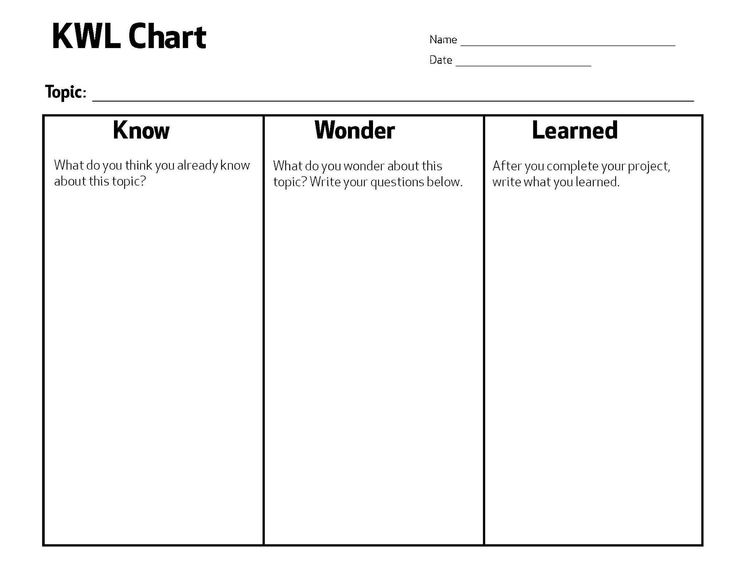

Sources

Job Shadowing:
Articles
https://blog.prepscholar.com/job-shadowing-for-high-school-students
https://www.collegeraptor.com/explore-careers/articles/careers-internships/what-is-job-shadowing/
Videos
https://www.youtube.com/watch?v=NReyQDWgY18
https://explore-work.com/video-job-shadowing/

Service Learning:
Articles
https://www.edutopia.org/article/benefits-service-learning-high-school-students/
https://cft.vanderbilt.edu/guides-sub-pages/teaching-through-community-engagement/
Videos
https://www.youtube.com/watch?v=FIg-pXSxut0
https://www.youtube.com/watch?v=kFd-yiAfrmE

Community Service:
Articles
https://thebridgeteencenter.org/news/the-importance-of-community-service-in-a-teens-life
https://www.edutopia.org/article/how-community-service-supports-students-tough-times/
Videos
https://www.youtube.com/watch?v=L_MWpvMm5tk
https://www.youtube.com/watch?v=2szQhR4oZtA

Internship:
Articles
https://www.usnews.com/education/k12/articles/the-rise-of-high-school-internships
https://www.weareteachers.com/internships-for-high-school-students/
Videos
https://www.youtube.com/watch?v=TEDR6Jg2Pls
https://www.youtube.com/watch?v=9iVSDhNrmNo

