Civics Career Academy Support Lesson
Public Service Research
Essential Question: How to identify a Public Service Research Topic?
A Lesson for Civics Career Academy Course ‘Public Service Research’

Course
Public Service Research

Benchmark

03.01- Demonstrate higher order critical thinking and reasoning skills appropriate for public service and nonprofit leadership.

05.01
Demonstrate the value of civic dispositions when engaged in public service and non-profit research.

Course Unit
Unit 1: Identifying a Public Service Research Focus
Lesson Foci
Identify potential public service research projects

Activity Documents, Materials, and Handouts
INSERT MATERIALS AND RESOURCES

- Lesson Presentation: Choosing a Topic & Developing a Research Question- https://safeshare.tv/x/ss661e8ce8db8a8
- Lesson Presentation: How to write a Strong research question for research papers- https://safeshare.tv/x/IF2FQeP5wpI
- Depths of Complexity Brainstorming
- 3-2-1 Formative Assessment

Activity Vocabulary
INSERT VOCABULARY AND DEFINITION HERE
Research- systematic inquiry to describe, explain, predict, and control the observed phenomenon..
Research question- A clear statement in the form of a question of the specific issue that a researcher wishes to analyze
Academic research- A thorough investigation into what is known about a given topic. In most cases, you will be required to examine and analyze scholarly sources
Applied research- A type of research focused on a specific local problem and resulting in an action
plan to address the problem.

Authorship
CREDIT WHERE CREDIT IS DUE!
Name/District
Latoya Patterson / Nassau County
Dr. Kenneth Davis / FSCJ
Marlene Bodine-Landis / Broward County

Lesson Steps

- Warm up- Vocabulary Review
- Lesson Presentation: Choosing a Topic & Developing a Research Question- https://safeshare.tv/x/ss661e8ce8db8a8
- Lesson Presentation: How to write a Strong research question for research papers- https://safeshare.tv/x/IF2FQeP5wpI
- Depths of Complexity Brainstorming
- Wrap-up – 3-2-1 Reflection

Enrichment Suggestion #1 – Experiential Learning in Public Service
Enrichment Suggestion #2 – Unit Vocabulary

Teacher Background Information

This lesson is designed to be completed in a 90-minute block but can be split into two 50-minute blocks.

What content does the teacher need to know to teach this lesson effectively?

Depths of Complexity Brainstorming
Depths of Complexity: to examine an issue or question critically and thoroughly, it must be done from many different perspectives. The following are 19 possible perspectives.
- Ethical concerns
- Medical
- Mankind’s responsibility
- Societal, Global benefits/concerns for a better future
- Implications
- Humane/Inhumane
- Scientific concerns
- Individual concerns: Race relations
- Safety psychological and physical
- Legal
- Emotional
- Environmental concerns
- Political implications
- Family concerns
- Pretext (false reasons) (media politics)
- Economics
- Cultural impact
- Military concerns
- Religious
Peel the Onion:
1. Choose a “depth of complexity” item that is affected by your topic
2. Create a chain reaction graphic organizer for each depth of complexity you chose
a. Think of as many starting points for each depth of complexity as possible
b. Go as far as possible from each starting point.
3. Repeat for each new depth of complexity.

So What?
In the social sciences, the research problem establishes the means by which you must answer the "So What?" question. This declarative question refers to a research problem surviving the relevancy test [the quality of a measurement procedure that provides repeatability and accuracy]. Note that answering the "So What?" question requires a commitment on your part to not only show that you have reviewed the literature, but that you have thoroughly considered the significance of the research problem and its implications applied to creating new knowledge and understanding or informing practice.
To survive the "So What" question, problem statements should possess the following attributes:
- Clarity and precision [a well-written statement does not make sweeping generalizations and irresponsible pronouncements; it also does include unspecific determinates like "very" or "giant"],
- Demonstrate a researchable topic or issue [i.e., feasibility of conducting the study is based upon access to information that can be effectively acquired, gathered, interpreted, synthesized, and understood],
- Identification of what would be studied, while avoiding the use of value-laden words and terms,
- Identification of an overarching question or small set of questions accompanied by key factors or variables,
- Identification of key concepts and terms,
- Articulation of the study's conceptual boundaries or parameters or limitations,
- Some generalizability in regards to applicability and bringing results into general use,
- Conveyance of the study's importance, benefits, and justification [i.e., regardless of the type of research, it is important to demonstrate that the research is not trivial],
- Does not have unnecessary jargon or overly complex sentence constructions; and,
- Conveyance of more than the mere gathering of descriptive data providing only a snapshot of the issue or phenomenon under investigation.

Bryman, Alan. “The Research Question in Social Research: What is its Role?” International Journal of Social Research Methodology 10 (2007): 5-20; Brown, Perry J., Allen Dyer, and Ross S. Whaley. "Recreation Research—So What?" Journal of Leisure Research 5 (1973): 16-24; Castellanos, Susie. Critical Writing and Thinking. The Writing Center. Dean of the College. Brown University; Ellis, Timothy J. and Yair Levy Nova. "Framework of Problem-Based Research: A Guide for Novice Researchers on the Development of a Research-Worthy Problem." Informing Science: the International Journal of an Emerging Transdiscipline 11 (2008); Thesis and Purpose Statements. The Writer’s Handbook. Writing Center. University of Wisconsin, Madison; Thesis Statements. The Writing Center. University of North Carolina; Tips and Examples for Writing Thesis Statements. The Writing Lab and The OWL. Purdue University; Selwyn, Neil. "‘So What?’…A Question that Every Journal Article Needs to Answer." Learning, Media, and Technology 39 (2014): 1-5.

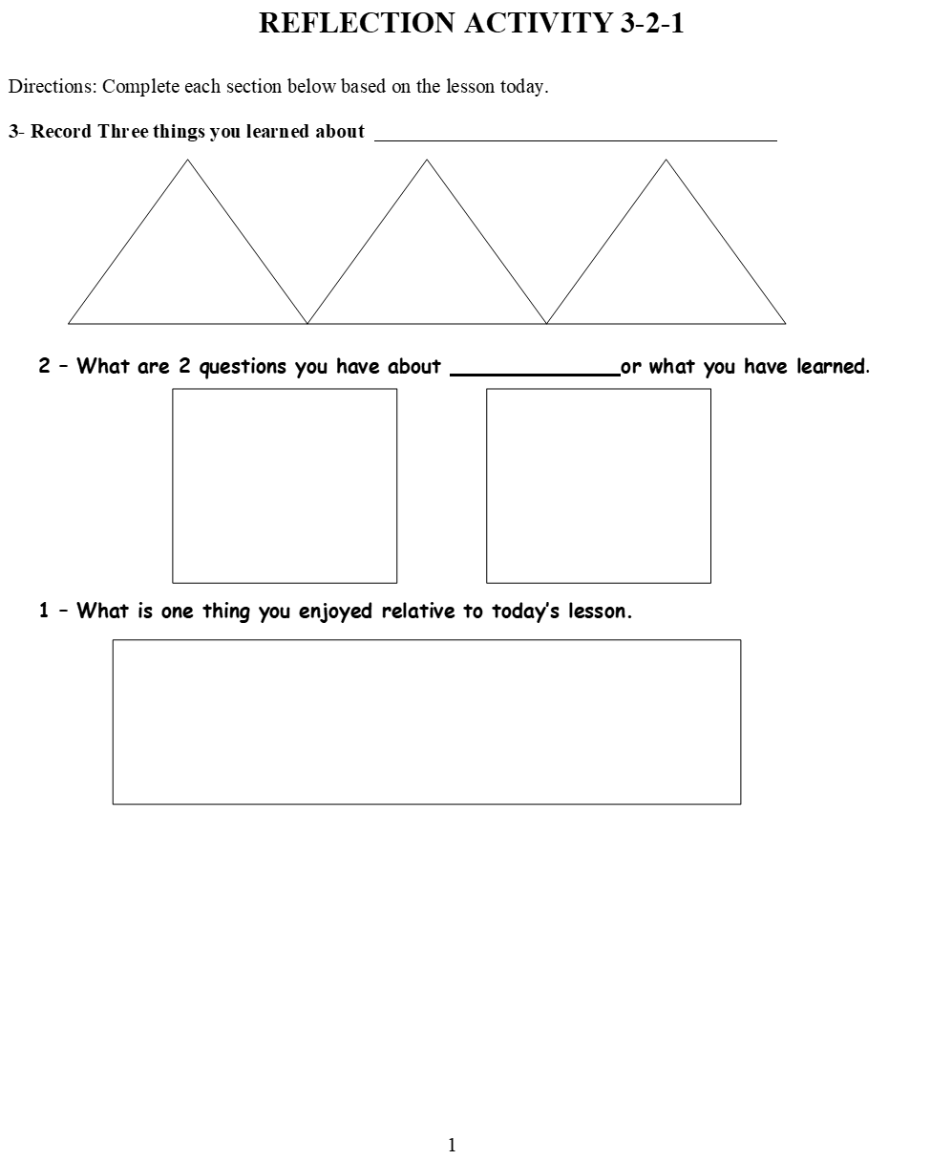

Sources

Babbie, E. (2010) The practice of social research. 12th Edition, Wadsworth, Belmont.

The Research Problem/Question - Organizing Academic Research Papers - Research Guides at Sacred Heart University

https://files.eric.ed.gov/fulltext/ED611000.pdf

https://sheridancollege.libguides.com/academic-research

