Civics Career Academy Support Lesson
JFK vs. Nixon - An Analysis

Essential Questions:
What is public service communication?
What is civic health, and how does public service communication support civic health in a constitutional republic?
Why are negotiation and collaboration skills necessary to enhance civic health?

An Activity for Civics Career Academy Course - Public Service Communication

Course
Public Service Communication

Benchmark
11.01 from Civics Standards | “Explain how public opinion shapes personal opinion and how civic participation can influence election outcomes.”

Course Unit
Unit #1
Lesson Foci
Explain how interpersonal communication skills, information processing and information transfer impact government service and non-profit civic environments.

Activity Documents, Materials, and Handouts
Materials
• JFK in History: Campaign of 1960 - Link: Campaign of 1960 | JFK Library
• Excerpts from the Kennedy/Nixon September 26, 1960 debate
• Clark M. Clifford memo, dated September 27, 1960 - page 1, page 2 (Link: Television debates: Correspondence | JFK Library)
• Debate Score Sheet
Retro Report Video: Lesson Plan: Political Debates and the Kennedy-Nixon Debate | Retro Report (11 mins)

Activity Vocabulary
Argument: a reason or the reasoning given for or against a matter under discussion  Civic Engagement:working to make a difference in the civic life of our communities and developing the combination of knowledge, skills, values and motivation to make that difference  Civic Health: the manner in which communities organize to define and address public problems  Collaboration:to work jointly with others or together especially in an intellectual endeavor  Cultural Communication:the use of language and other communicative means to carry out the activities and commitments of their particular communities in and through the use of symbolic resources  Debate:a formal discussion on a particular topic in a public meeting or legislative assembly, in which opposing arguments are put forward | Evidence: that which tends to prove or disprove something; ground for belief; proof  Government Service: Municipal, Provincial or Federal services provided directly to the public  Interest Groups: a group of people drawn or acting together in support of a common interest or to voice a common concern  Interpersonal Communication: communication between two or more people  Media: the main means of mass communication  Political Parties: a group of persons organized to acquire and exercise political power | Public Speaking:speaking in person to a live audience  Reasoning: the process of thinking about something in a logical way in order to form a conclusion or judgment

Authorship
CREDIT WHERE CREDIT IS DUE!
Name/District
Robert Ball - Polk
Kyle Ryan - Polk
Andrew Goldberg - Duval

Lesson Steps

Materials
• JFK in History: Campaign of 1960 - Link: Campaign of 1960 | JFK Library
• Excerpts from the Kennedy/Nixon September 26, 1960 debate
• Clark M. Clifford memo, dated September 27, 1960 - page 1, page 2 (Link: Television debates: Correspondence | JFK Library)
• Debate Score Sheet
Retro Report Video: Lesson Plan: Political Debates and the Kennedy-Nixon Debate | Retro Report (11 mins)

Procedure
1. Have students read JFK in History: Campaign of 1960 to provide historical background on the debates.

2. Have students read excerpts from the September 26, 1960 debate as a class (link: Political Debates Lesson Plan 2020.pdf (jfklibrary.org))

3. Pass out the debate score sheet for the debate and have students complete the worksheet based on the excerpts they read and video clips below:
-JFK vs. Nixon 1960 debate. Link: Kennedy vs. Nixon - 1st 1960 Debate - Bing video (8 mins).
-JFK vs. Nixon 1960 Body Language Compilation Link: Nixon vs. Kennedy debate - body language compilation - YouTube (3 minutes)

4. Discuss the results of the debate score sheet as a class, allowing students to share out who they believed the winner and loser is based on their score sheets. Also discuss the importance of appearance and body language as a nonverbal communication strategy.

5. Provide students with a Clark M. Clifford (an American lawyer who served as an important political adviser to Democratic presidents) memo to Kennedy dated September 27, 1960 (also from the lesson plan).

6. Discuss the following:
a. What points did Clifford make in writing that Kennedy was “the winner”? (Kennedy
was concise, convincing, and kept Nixon on the defensive)
b. Brainstorm how a candidate can be convincing, and how he/she may keep the other
candidate on the defensive.
c. What were Clifford’s main concerns? (Kennedy should make sure voters know that
his political goals are different from Nixon’s; he needs to differentiate himself; and
he needs to show more personal warmth.)

7. Why would it be important for the challenger to differentiate his goals from the
incumbent administration?

8. What were Clifford’s suggestions for dealing with these concerns? (Kennedy should
be specific in bringing up the differences in their goals; he should bring up his
discussions with ordinary people and his contacts with Navy servicemen to show he
understands the concerns of average Americans.)

9. Use Clifford’s concerns and suggestions as you discuss with your students the important
attributes that make a candidate a “winner” of a debate.

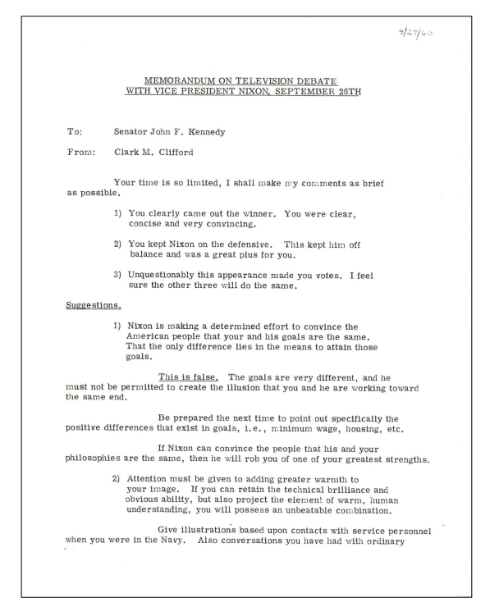
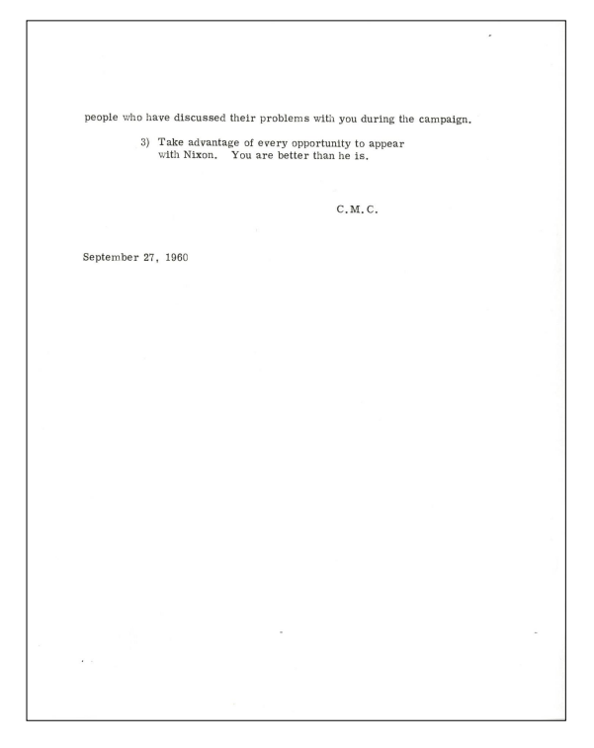
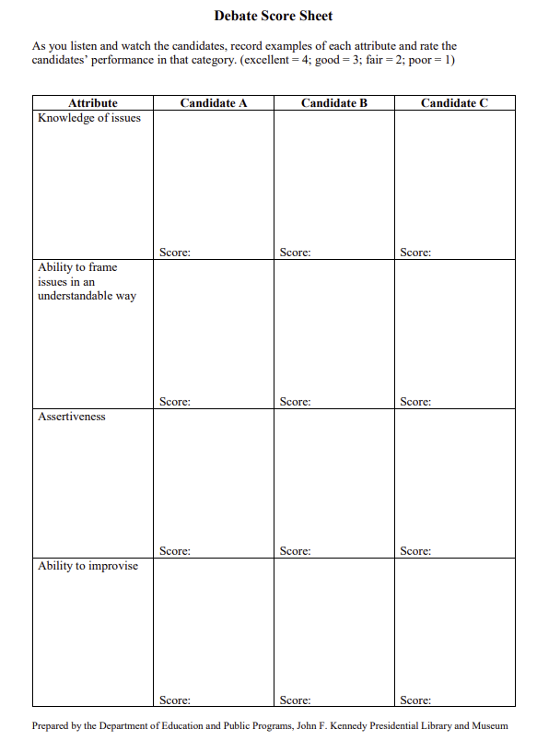
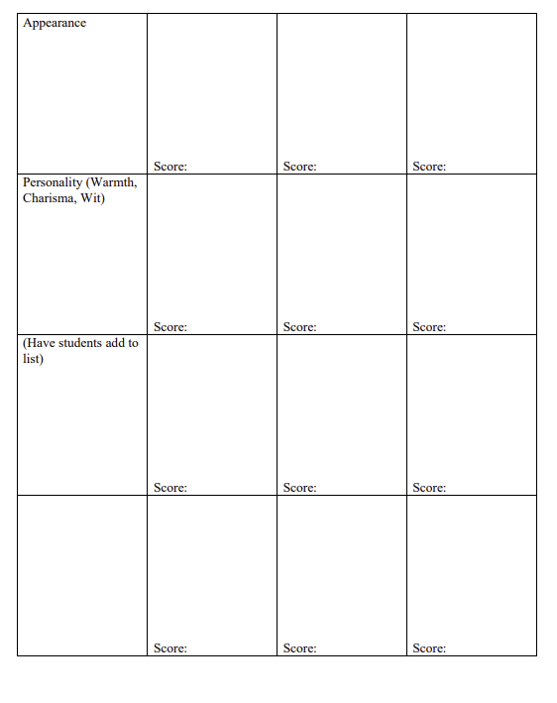

Enrichment Suggestion #1 –
For enrichment, have students watch a political debate, filling in the score sheet handout to help them evaluate the debate. (We have suggested a few attributes in the handout, but you should add your own based on your previous brainstorming with students.) Have them use their score sheet to write a memo to their chosen candidate in the style of Clark Clifford noting:
• who they think “won” the debate.
• what worked or didn’t work for their candidate.
• how their candidate can help to improve his/her image.
• what their candidate can do to better persuade voters that he/she is the right choice for them. Encourage students to use their memo as a way to give specific help to their candidate, not as an opportunity to denigrate the other candidate.

Enrichment Suggestion #2 –
Analyze the communication styles of each type of president mentioned in the article. Write a short 1-2 page paper about which communication strategy was most effective for the public and why. Prepare to share.
Link: How US Presidents Have Communicated with the Public—From the Telegraph to Twitter | HISTORY

Enrichment Suggestion #3 –
Brainstorm the issues in an upcoming election in your area. Take notes of students' responses and share the notes with them. Have students discuss where they stand on the
issues. Have students research where the candidates stand on these issues, and have them write a
one-page paper describing which candidate’s views are most compatible with their own and
why.

Teacher Background Information

What content does the teacher need to know to teach this lesson effectively?
- Basic knowledge of JFK and Nixon and Clark M. Clifford
- Historical content knowledge of the 1960s and the Cold War
- Foundational knowledge of debating/how to conduct a debate/regulations and expectations of a debate
- Preview the 1960 debates

Name: ___________________________________________________________________ Date: ______________________

Sources
mportant_in_public_administratio

Lesson Plan: Political Debates Lesson Plan 2020.pdf (jfklibrary.org)
Why Interpersonal communication is important in Public Administration
https://www.researchgate.net/publication/319476845_Why_interpersonal_communication_is_important_in_public_administration
Why Study interpersonal Communication
https://open.lib.umn.edu/communication/chapter/6-1-principles-of-interpersonal-
communication
Five Things to Practice for Effective Communications Skills
https://www.usgs.gov/human-capital/interpersonal-communication
Commision on PresidentialCo Debates
https://www.debates.org/about-cpd/
Northern Illinois University Center for Innovative Teaching and Learning
https://www.niu.edu/citl/resources/guides/instructional-guide/classroom-debates.shtm
High School Unified Manual of the National Speech
and Debate Association
https://www.speechanddebate.org/wp-content/uploads/High-School-Unified-Manual-2022-
American Center For Political Leadership (Polk County) Political Discourse
High School Essay/Scholarship
https://theacpl.org/essay-contest/

