STUDENTS INVESTIGATING PRIMARY SOURCES
Presenting Political Parties
What is the impact of political parties?
A Short Activity for Middle School Civics
Benchmark Correlations
SS.7.CG.2.6 – Examine the election and voting process at the local, state and national levels.
Benchmark Clarification: Students will explain the origins of the Republican and Democratic political parties and evaluate their roles in shaping public policy.
ELA.7.R.2.1 – Explain how individual text sections and/or features convey a purpose in texts.
ELA.7.R.2.2 –Compare two or more central ideas and their development throughout a text.

Activity Documents and Handouts
- Fishin’ Season political cartoon
- Cartoon Analysis Worksheet
- Presenting Political Parties Worksheet
- Rocking the Boat political cartoon

Full Document Citations
The Fishin' Season; 7/7/1919; Berryman Political Cartoon Collection, 1896 - 1949; Records of the U.S. Senate, Record Group 46; National Archives Building, Washington, DC. National Archives Identifier: 1693475.
[https://catalog.archives.gov/id/1693475]
[https://www.docsteach.org/documents/document/the-fishin-season]

Rocking the Boat; 6/5/1922; (G-099); Berryman Political Cartoon Collection, 1896 - 1949; Records of the U.S. Senate, 1789 - 2015, Record Group 46; National Archives Building, Washington, DC. National Archives Identifier: 6011735.
[https://catalog.archives.gov/id/6011735]
[https://www.docsteach.org/documents/document/rocking-the-boat]

Activity Vocabulary
Democratic Party – a political party that believes that the federal government should take a more active role in people's lives, particularly those who are in economic need
political party – an organization that tries to get political power by electing members to public office so that their political ideas can become laws or policies
Republican Party – a political party that believes that the federal government should play a less active role in people's lives and that individuals can take care of themselves without government economic help
third party – a political party that is not one of the two major parties in the country; a minor party
two-party system – a political system consisting primarily of two major parties, more or less equal in strength

- Write the term “political parties” on the board and instruct students to take out a piece of notebook paper. Have students work independently to write down words or phrases they associate with political parties.
- Instruct students to turn to a shoulder partner and compare their notes. Have students circle any words or phrases that they have in common with their partner.
- Have students share out as a whole class.
- Project and pass out “The Fishin’ Season” political cartoon.
- Direct students to visually scan the political cartoon and identify three items that stand out to them in the document. (Examples could include: donkey, elephant, fishing poles, tree branch, water, sign)
- Engage students in a class discussion about the political cartoon using the following questions:
  - What actions are the characters in this cartoon doing? (Fishing; looking for issues for their campaigns)
  - What emotions do the characters convey? What details in the cartoon make you think that way? (They look shocked, surprised, maybe worried. Their facial expressions, eyes and mouth convey these emotions.)
- Pass out the Cartoon Analysis Worksheet and share with students that they are going to learn more about this cartoon by conducting an analysis of the image. Teacher Note: If needed, share the following information with students to provide additional background information on political parties. It is important to share with students that the definitions for the Democratic and Republican parties reflect their current approach to government. Both political parties have changed their ideas on government throughout United States history.
  - The donkey is a symbol for the Democratic Party. The Democratic Party is a political party that believes that the federal government should take a more active role in people's lives, particularly those who are in economic need.
  - The elephant is a symbol for the Republic Party. The Republican Party is a political party that believes that the federal government should play a less active role in people's lives and that individuals can take care of themselves without government economic help.
  - Currently, in the United States, we have a two-party system. This means that we have a government system where members of two major parties dominate the government, more or less equal in strength. There are other political parties. These parties are called third parties.
- Work through the Cartoon Analysis Worksheet as a whole class. Teacher Note: Use the Answer Key to guide completion of the worksheet.
- Keep “The Fishin’ Season” cartoon projected on the board and pass out the Presenting Political Parties worksheet. Work through the questions as a whole class. Teacher Note: Use the Answer Key to guide the discussion.
- Project and pass out the “Rocking the Boat” political cartoon.
- Direct students to visually scan the political cartoon and identify three items that stand out to them in the image. (Examples could include: donkey, elephant, boat, sweat, facial expressions, water)
- Engage students in a class discussion about the political cartoon using the following questions:
  - What actions are the characters in this cartoon doing? (They are in a boat, the elephant is seated and the donkey is standing on the sides of the boat, “rocking it”.)
  - What emotions do the characters convey? What details in the cartoon make you think that way? (The elephant looks nervous and the donkey looks excited and happy. Their facial expressions and the text: “Gee! Ain’t This Fun!” convey these emotions.)
- Place students into pairs and instruct students to work with their partner to answer the questions on the Presenting Political Parties worksheet. Rotate through the classroom to monitor comprehension.
- Engage students in a discussion about the cartoon by having students share their answers.
- Direct student attention to the question at the bottom of the worksheet. Ask students, “What does the term impact mean?” Share with students that impact means to have an influence or effect.
- Lead students through a think aloud to make connections between the actions in the cartoons and how those actions relate to the political parties having an impact with voters, with specific issues and in the government.
- Have students work independently to answer the final question on their worksheet.

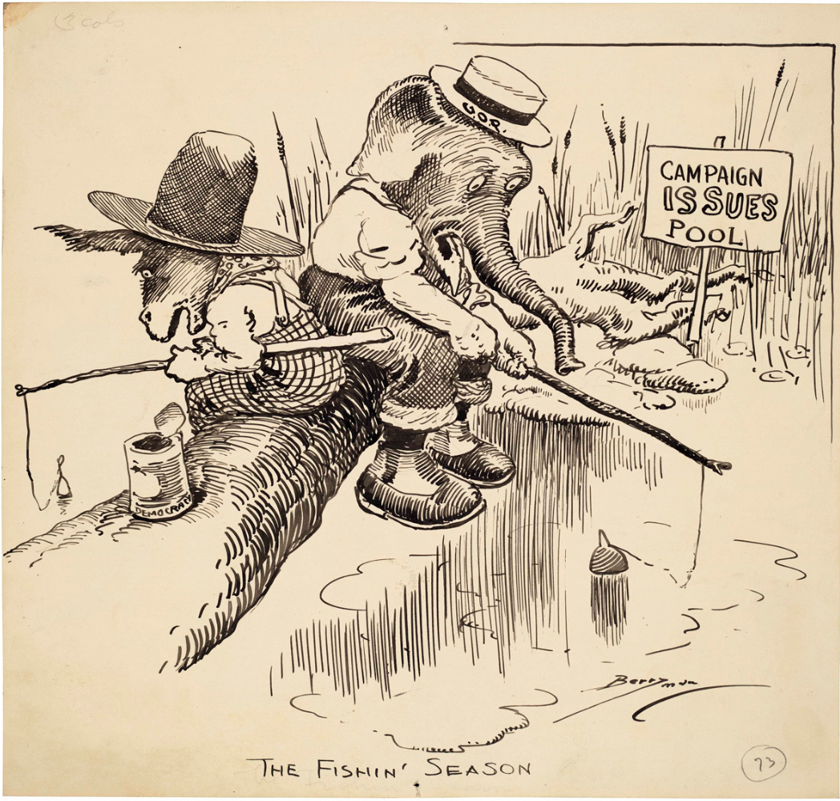

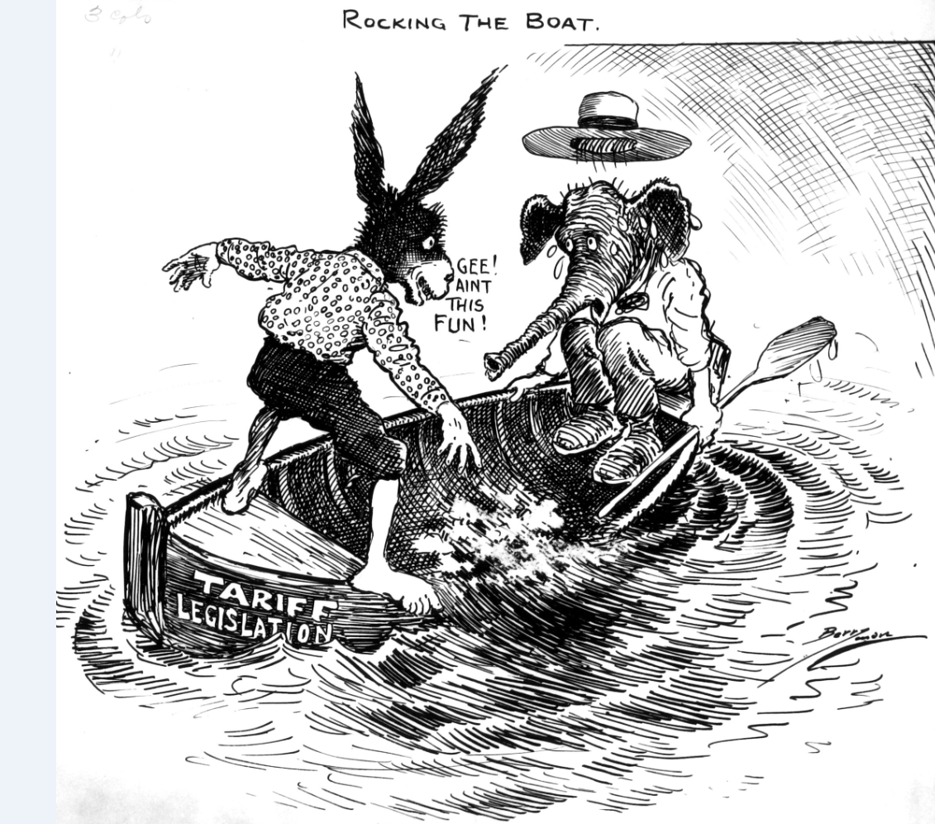

Presenting Political Parties
Questions | The Fishin’ Season | Rocking the Boat
Which political parties do the two characters in the cartoon represent? | _________________________________________  _________________________________________  _________________________________________  _________________________________________ | _________________________________________  _________________________________________  _________________________________________  _________________________________________
What does the action in the cartoon suggest about the purpose of political parties? | _________________________________________  _________________________________________  _________________________________________  _________________________________________ | _________________________________________  _________________________________________  _________________________________________  _________________________________________
Can you tell anything about each political party from the cartoon? | _________________________________________  _________________________________________  _________________________________________  _________________________________________ | _________________________________________  _________________________________________  _________________________________________  _________________________________________
What does this cartoon suggest about how parties organize and unite voters? | _________________________________________  _________________________________________  _________________________________________  _________________________________________ | _________________________________________  _________________________________________  _________________________________________  _________________________________________

Based on these cartoons, what impact do political parties have on government and society?

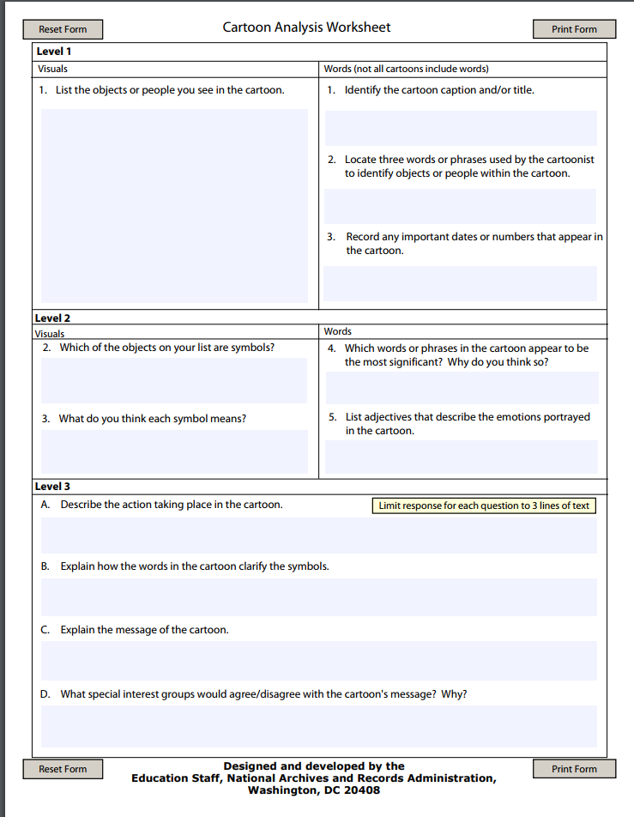
Presenting Political Parties – Sample Answers
Questions | The Fishin’ Season | Rocking the Boat
Which political parties do the two characters in the cartoon represent? | Democratic and Republican Parties | Democratic and Republican Parties
What does the action in the cartoon suggest about the purpose of political parties? | Political parties are concerned with issues. Sometimes, they look for issues from the people they represent. Sometimes, they choose issues that are important to them or may benefit them. | Sometimes, political parties challenge each other. In this cartoon, the Democratic Party (donkey) is making sure that the Republican Party (elephant) cannot do whatever they want without considering the Democratic Party’s thoughts and ideas.
Can you tell anything about each political party from the cartoon? | They both look for issues. In this cartoon, each party is looking for issues on different sides of the “campaign pool”. | In this example, the Democratic Party is rocking the boat. They are making sure the Republican Party doesn’t have an easy journey to their destination.
What does this cartoon suggest about how parties organize and unite voters? | Political parties unite voters that care about the issues in “their side” of the campaign pool. This may also mean that they don’t work to unite voters who care about issues on the other side of the campaign pool. | Political parties work on behalf of the people they represent. Sometimes this involves preventing (or rocking the boat) the other party from accomplishing their goal.

Based on these cartoons, what impact do political parties have on government and society? | Political parties determine the issues that get attention in government. Sometimes, these issues are determined from the “campaign issues pool”. The issues that get attention from political parties can impact what laws are passed and people’s lives are impacted by laws passed (or not passed) in Congress. Political parties have impact on the actions of the other political parties. They can choose to work with the other party or try to prevent that party from reaching their goals.

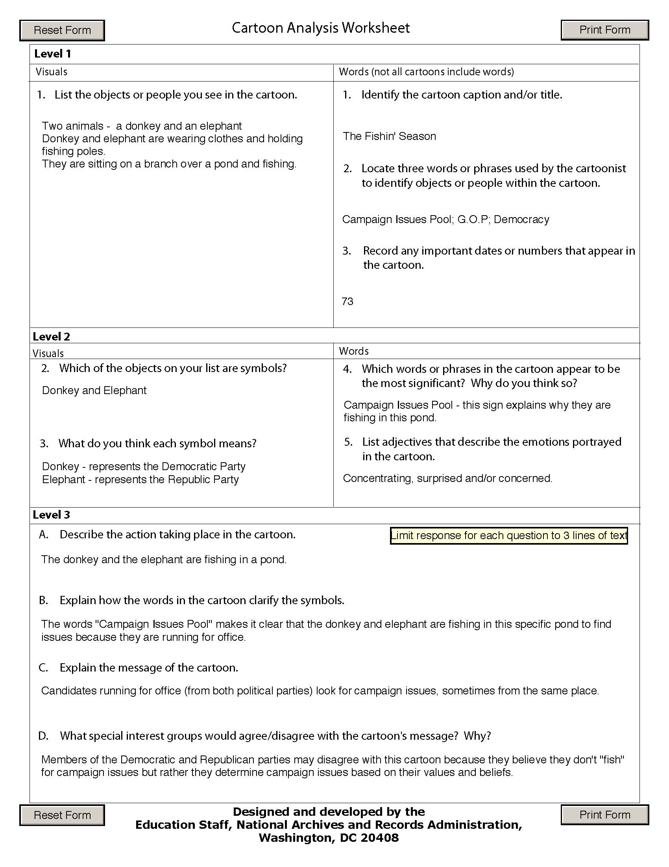
Cartoon Analysis Worksheet – Sample Answers

