STUDENTS INVESTIGATING PRIMARY SOURCES
Thinking Through Timelines: Creating the Constitution
Why do we celebrate Constitution Day?
A Short Activity for Third Grade
Benchmark Correlations
Constitution Day Information
SS.3.A.1.1 – Analyze primary and secondary sources.
Benchmark Clarification: Students will analyze information about what they read or observe in primary and secondary sources.
SS.3.CG.1.1 – Explain how the U.S. Constitution establishes the purpose and fulfills the need for government.
Benchmark Clarification: Students will explain the purpose of and need for government in terms of protection of rights, organization, security and services.
SS.3.CG.2.3 – Explain the history and meaning behind patriotic holidays and observances.
Benchmark Clarification: Students will identify patriotic holidays and observances to include, but not limited to, American Founders Month, Celebrate Freedom Week, Constitution Day, Independence Day, Martin Luther King Jr. Day, Medal of Honor Day, Memorial Day, Patriot Day, Veterans Day.
ELA.3.R.2.3 – Explain the development of an author’s purpose in an informational text.

Activity Documents and Handouts
- Creating the Constitution PowerPoint Presentation
- Copies of Primary Sources: the Dunlap Broadside of the Declaration of Independence, Surrender of Cornwallis at Yorktown, the Articles of Confederation, and exterior view of Independence Hall
- Creating the Constitution Graphic Organizer

Full Document Citations
Articles of Confederation, 3/1/1781; Records of the Continental and Confederation Congresses and the Constitutional Convention, Record Group 360. National Archives at Washington, DC. National Archives Identifier: 301687.
[https://catalog.archives.gov/id/301687]
[https://www.docsteach.org/documents/document/articles-of-confederation]

Constitution of the United States, 9/17/1787; General Records of the United States Government, Record Group 11; National Archives at Washington, DC. National Archives Identifier: 1667751.
[https://catalog.archives.gov/id/1667751]
[https://www.docsteach.org/documents/document/constitution]

Dunlap Broadside [Declaration of Independence], July 4, 1776; Rough Journals, 9/5/1774 - 3/2/1789; Records of the Continental and Confederation Congresses and the Constitutional Convention, 1765 - 1821, Record Group 360; National Archives Building, Washington DC. National Archives Identifier: 301682.
[https://catalog.archives.gov/id/301682]
[https://www.docsteach.org/documents/document/dunlap-broadside]

Exterior view of Independence Hall, ca. 1776; General Photographic File of the Commission of Fine Arts, ca. 1910 - 1950; Records of the Commission of Fine Arts, Record Group 66. National Archives at College Park. National Archives Identifier: 518208.
[https://catalog.archives.gov/id/518208]
[https://www.docsteach.org/documents/document/exterior-view-of-independence-hall]

Map of the Original 13 Colonies in 1776 taken from http://mrnussbaum.com/images/13map13a.gif, accessed on July 22, 2016.

Map of the British Empire in 1763 taken from http://www.conservapedia.com/File:B-Emp-1763.jpg , accessed on July 22, 2016.

Signing of the Constitution by Howard Chandler Christy, 1940. Oil on Canvas. House wing, east stairway U.S. Capitol Building, Washington, DC. Accessed 31 July 2016. [http://www.aoc.gov/art/other-paintings-and-murals/signing-constitution]

Surrender of Cornwallis at Yorktown, Virginia, October 19, 1781, by which over 7,000 British and Hessians became prisoners. Copy of lithograph by James Baillie, circa 1845; George Washington Bicentennial Commission, 1931 - 1932; Records of Commissions of the Legislative Branch, Record Group 148. National Archives at College Park. National Archives Identifier: 532883.
[https://catalog.archives.gov/id/532883]
[https://www.docsteach.org/documents/document/surrender-of-cornwallis-at-yorktown-virginia-october-19-1781-lithograph-by-james-baillie]

Activity Vocabulary
Articles of Confederation – March 1, 1781 – the first constitution of the United States
Declaration of Independence – July 4, 1776 – the document that stated the American colonists’ independence from Great Britain
George Washington – June 15, 1775 – he becomes the leader, or general, of the Continental (American Colonist) Army during the American Revolution; he eventually becomes the first president of the United States
Independence Hall – building in Philadelphia, PA where the Declaration of Independence and the U.S. Constitution were signed
United States Constitution – September 17, 1787 – this document organizes and outlines the structure and powers of the government for the United States

Teacher Note: The PowerPoint Presentation file follows along with the activity sequence. Before starting this activity, be sure to download and open the PowerPoint file.
- Project the image of the first page of the United States Constitution from the PowerPoint file.
- Direct students to visually scan the document and identify one item that stands out to them in the image. (Examples could include: a document, We the People, Article I)
- Ask students if they can identify the document. (United States Constitution).
- Share with students that every year Constitution Day is celebrated on September 17th. A group of representatives, or delegates, from 12 of the 13 states met in Philadelphia to create the U.S. Constitution. On September 17th, 1787 the delegates to the Constitutional Convention met for the last time to sign the U.S. Constitution. The Constitution organizes the United States government and outlines the structure and power of the government.
- Project the map from the PowerPoint file. Explain to students that before the United States was an independent country, it was part of Great Britain. All of the land that was part of Great Britain was called the British Empire. Explain to students that there were important events that occurred between the time the colonists declared their independence from Great Britain to the signing of the U.S. Constitution and that they will explore some of those events.
- Move students into pairs or small groups and pass out copies of the following primary source images: the Dunlap Broadside of the Declaration of Independence, Surrender of Cornwallis at Yorktown, the Articles of Confederation, exterior view of Independence Hall and the signing of the Constitution.
- Instruct students to work with their partner or group members to think about how each of these images relate to the writing of the U.S. Constitution and to try and put the images in order by when they occurred. Provide students only a minute to do this and then have students share out some of their ideas.
- Pass out the Creating the Constitution graphic organizer and project the image of the Dunlap Broadside of the Declaration of Independence from the PowerPoint file. Direct students to visually scan the document and work with their partner or small group to identify an item that stands out to them in the image. (Examples could include: document, large and small text, John Hancock )
- Share with students that the Declaration told the world why the colonists wanted independence from Great Britain. This document led to the colonies becoming independent and eventually becoming a new independent country, the United States. Direct students to write the date of the event and 1-2 notes on their graphic organizer.
- Project the next image of the Surrender of Cornwallis at Yorktown. Direct students to visually scan the image and identify three items that stand out to them in the image. (Examples could include: two groups of men, flag, ships in the distance, uniforms)
- Explain to students that the colonists went to war with Great Britain. General George Washington was the leader of the colonial army, and General Cornwallis was one of the leaders of Great Britain’s army. The colonists defeated Great Britain, and General Cornwallis surrendered, or admitted that Great Britain had lost the war in the colonies. This happened at the town of Yorktown, Virginia. Direct students to write down 1-2 notes on their graphic organizers about the Surrender of Cornwallis at Yorktown. Teacher Note: It is important to remember that the war continued overseas and that the Treaty of Paris, which recognized the United States as an independent nation, was signed September 3, 1783.
- Project the image of the Articles of Confederation. Direct students to visually scan the document and identify one item that stands out to them in the document. (Examples could include: a document, text, script)
- Explain to students that they are looking at the Articles of Confederation. This document was the first constitution of the United States written during the American Revolution. The Articles of Confederation had some weaknesses and delegates, or representatives, from the states decided to create a new constitution to replace the Articles of Confederation. Direct students to write the date of the document and 1-2 notes on their graphic organizers about the Articles of Confederation.
- Project the image of Independence Hall in Philadelphia. Direct students to visually scan the image and identify three items that stand out to them. (Examples could include: a large building, people walking, horses)
- Explain to students that the Articles of Confederation had some problems in it that created weaknesses in the new government of the United States. The leaders of the United States decided that there needed to be a new plan to make the government stronger. This plan, called the Constitution, was signed at Independence Hall in Philadelphia, Pennsylvania. Independence Hall was the same building where the Declaration of Independence had been signed in 1776. Direct students to write the date of the event and 1-2 notes on their graphic organizer about Independence Hall.
- Project the image of the signing of the Constitution. Direct students to visually scan the image and identify three items that stand out to them. (Examples could include; men with raised hands, George Washington standing at a desk, flags)
- Explain to students that the signing of the Constitution took place on September 17, 1787 and it is the reason why we celebrate Constitution Day on September 17th. Direct students to write the date of the event and 1-2 notes on their graphic organizer.
- Project the image of the U.S. Constitution. Direct students to visually scan the image and identify one item that stands out to them. (Examples could include: a document, We the People, text, Article I.)
- Share with students that eleven years after the signing of the Declaration of Independence the U.S. Constitution was written. The U.S. Constitution establishes the structure and powers of the United States government. Our government today still follows the U.S. Constitution. Direct students to write the date of the event and 1-2 notes on their graphic organizer.
- Pose the following question for closure: Why do we celebrate Constitution Day?
Extension Suggestion – Instruct students to create a front-page newspaper headline and corresponding image to illustrate their understanding of the reason we celebrate Constitution Day.

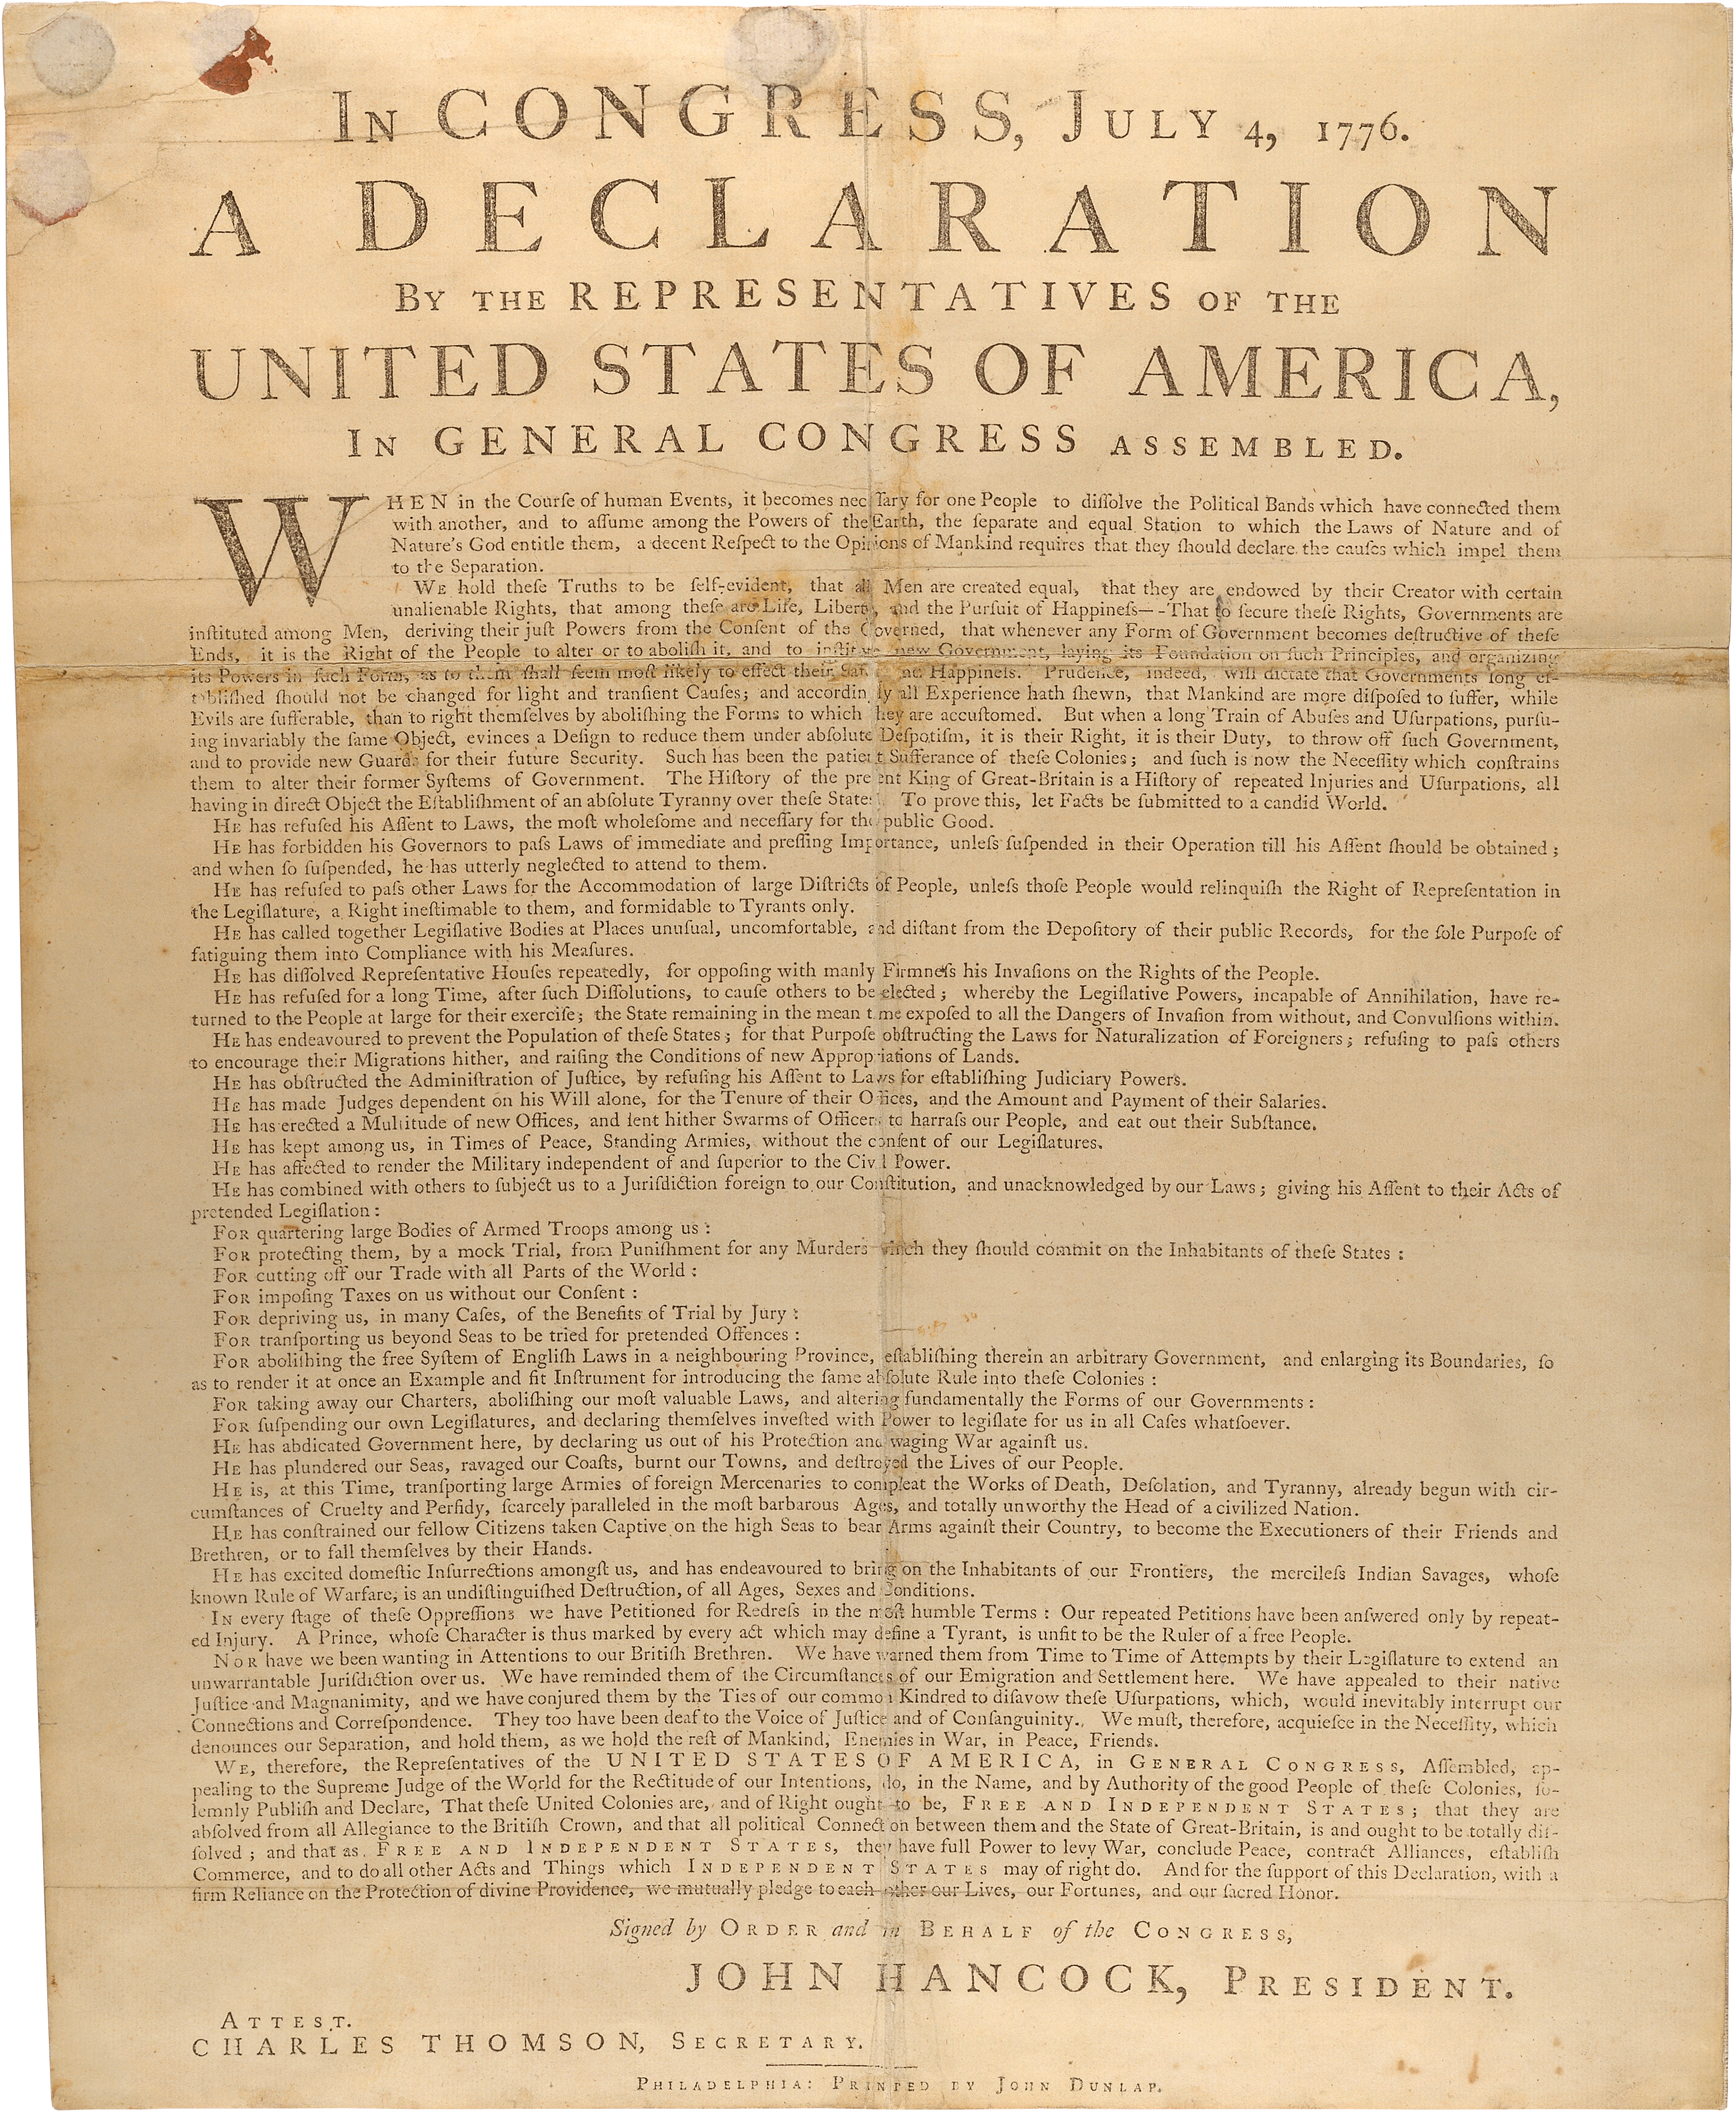

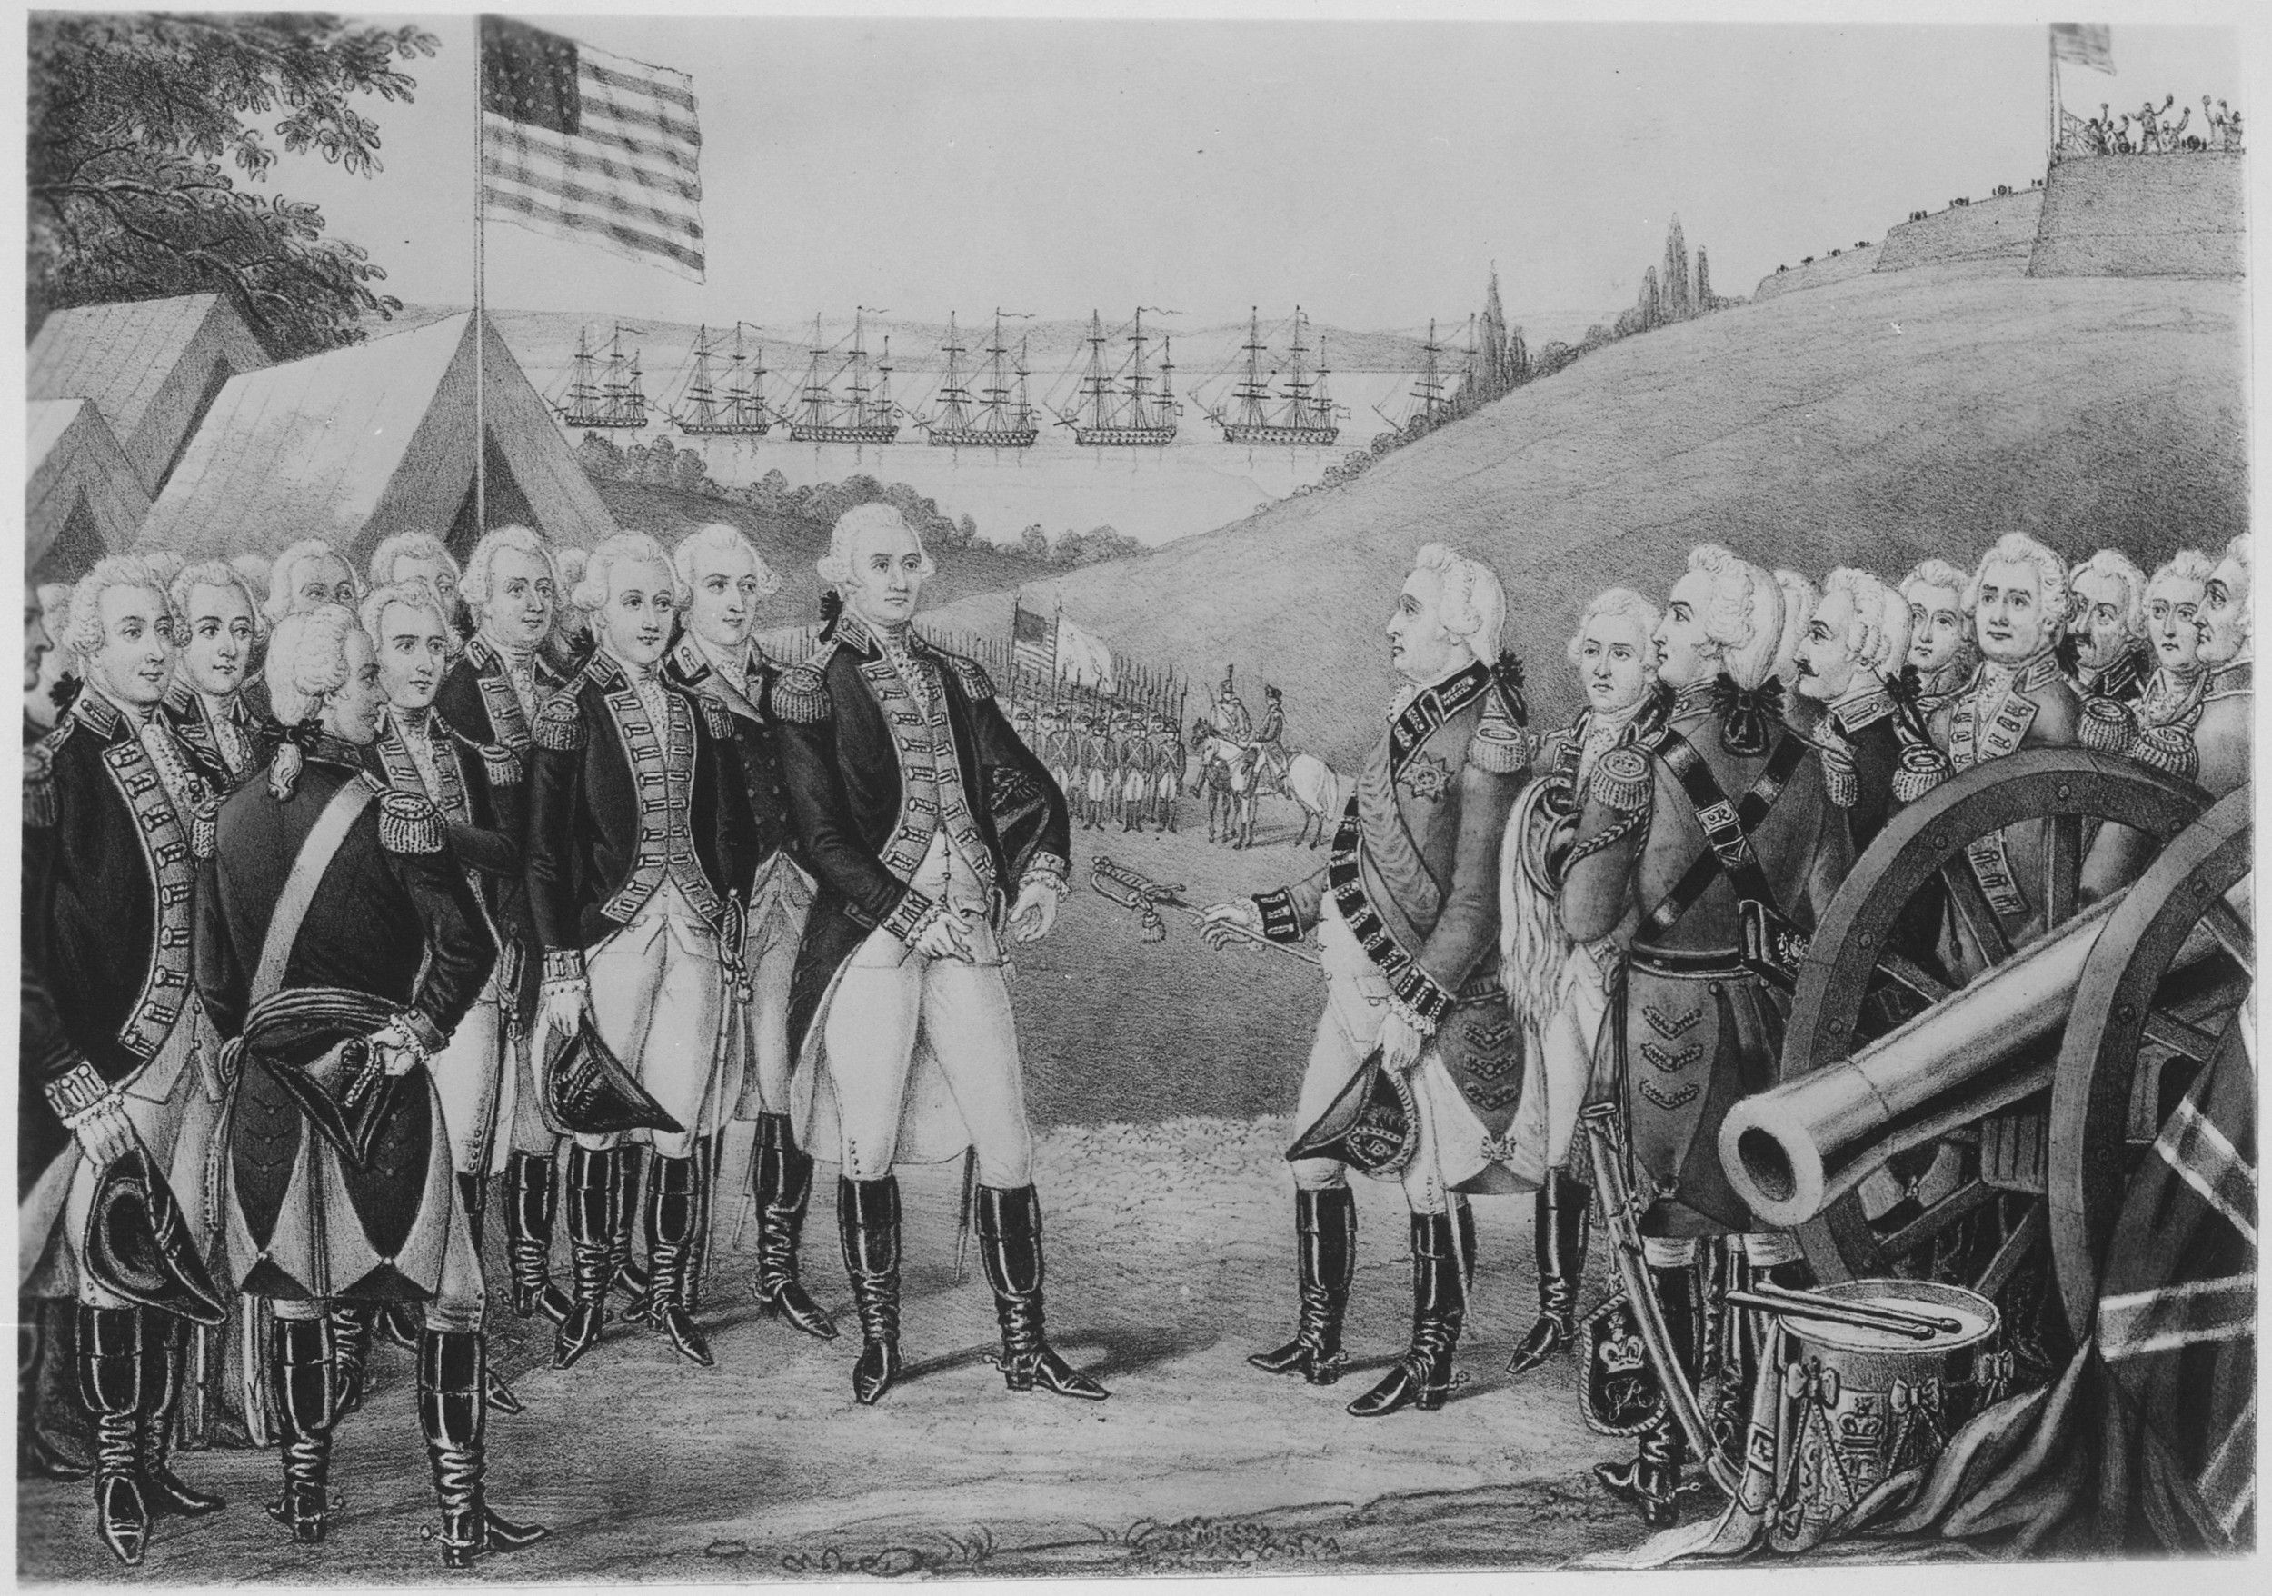

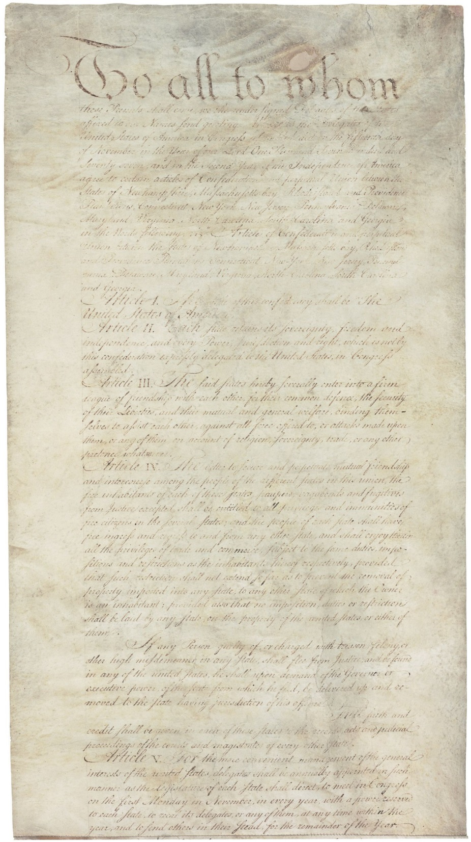
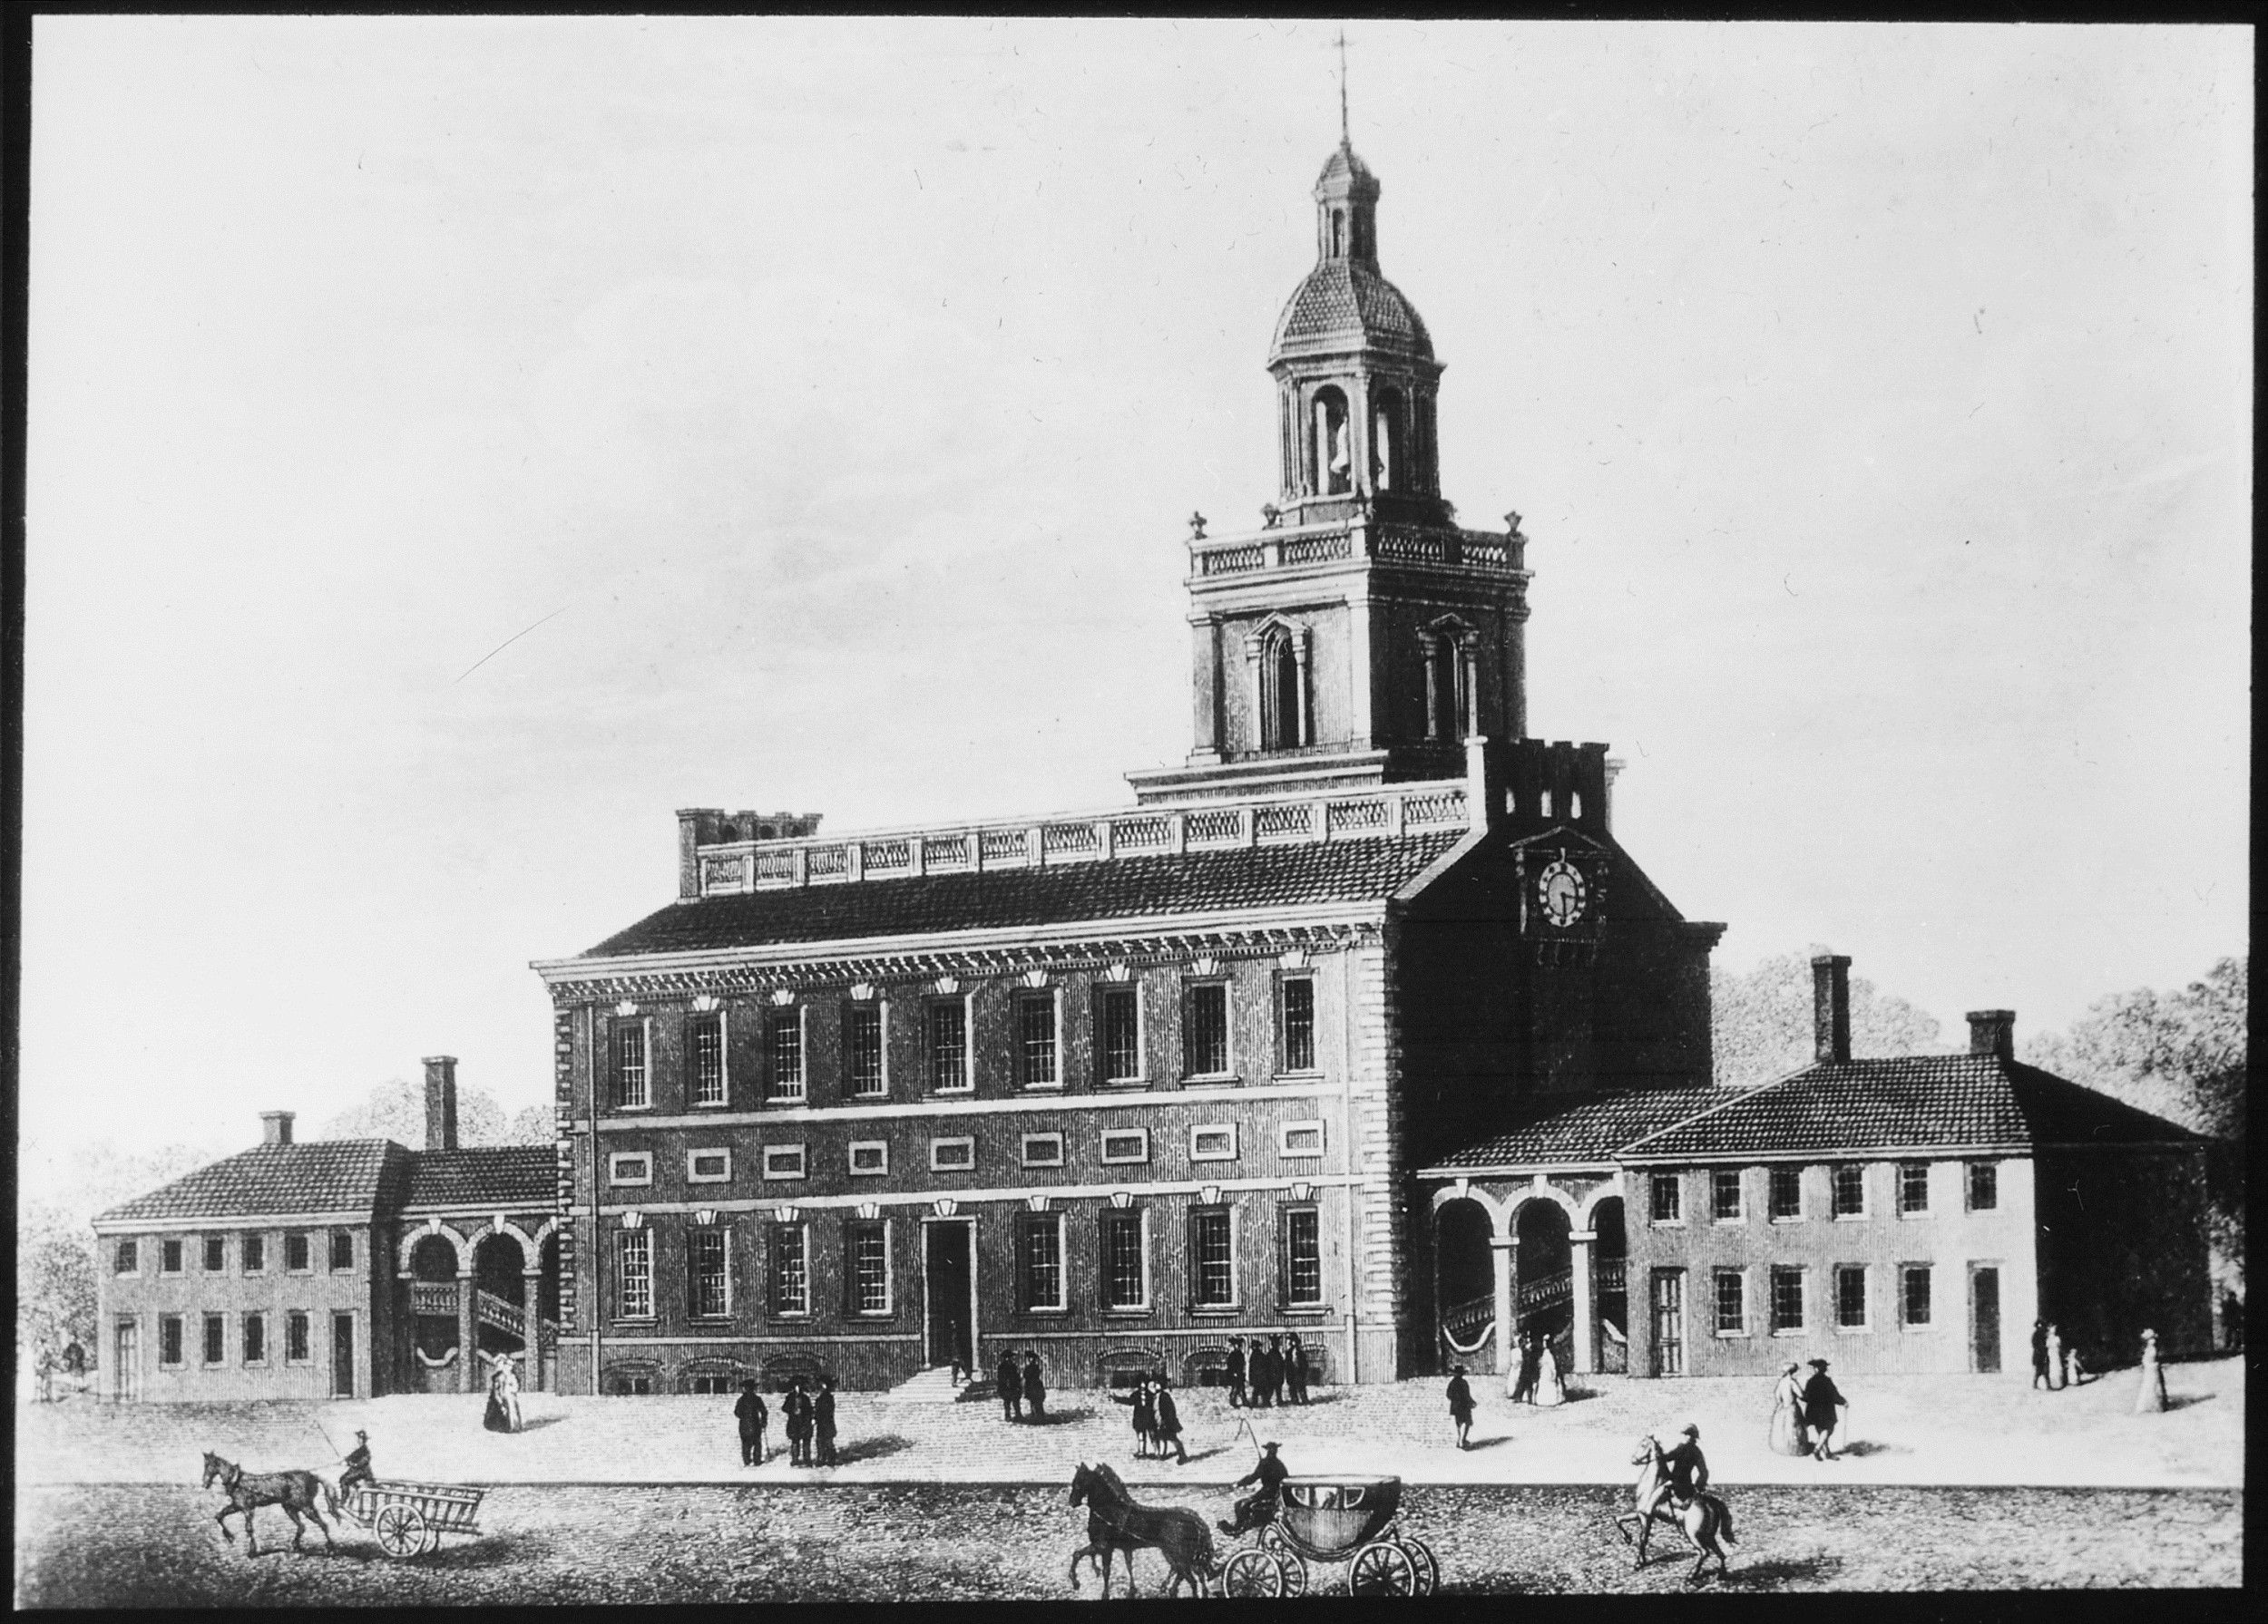
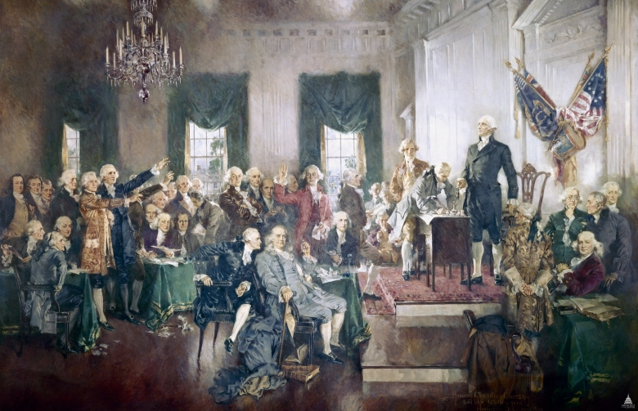
Name: __________________________________________________ Date: ______________
Creating the Constitution
Date: __________________________________________
Notes: _________________________________________
________________________________________________
________________________________________________

Date: __________________________________________
Notes: _________________________________________
________________________________________________
________________________________________________

Date: __________________________________________
Notes: _________________________________________
________________________________________________
________________________________________________

Date: __________________________________________
Notes: _________________________________________
________________________________________________
________________________________________________

Date: __________________________________________
Notes: _________________________________________
________________________________________________
________________________________________________

Date: __________________________________________
Notes: _________________________________________
________________________________________________
________________________________________________

The Constitution of the United States
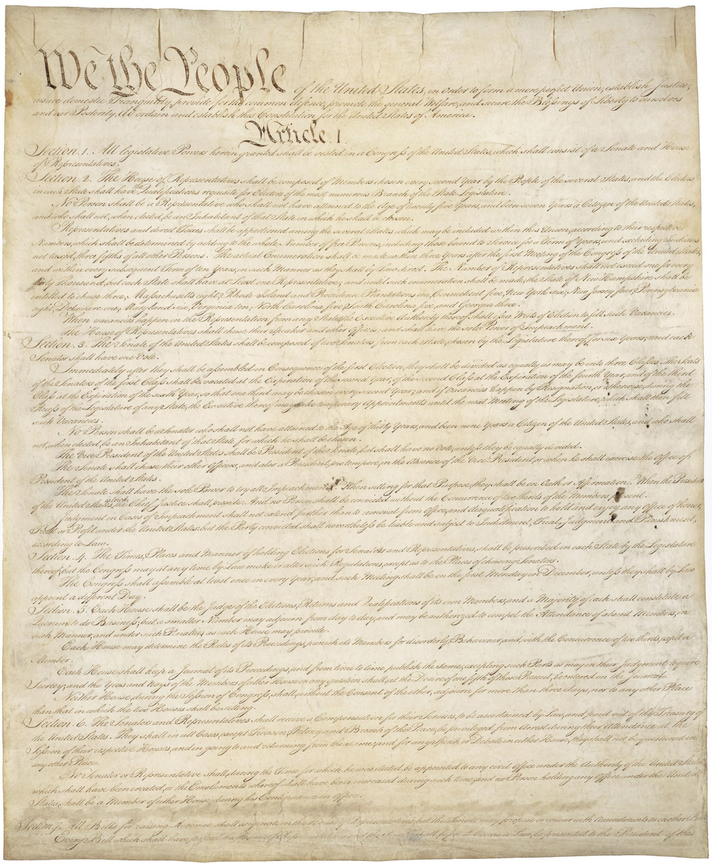

The Signing of the Constitution

Independence Hall
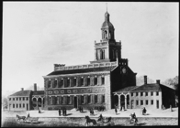

Articles of Confederation
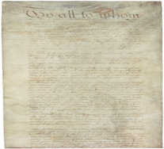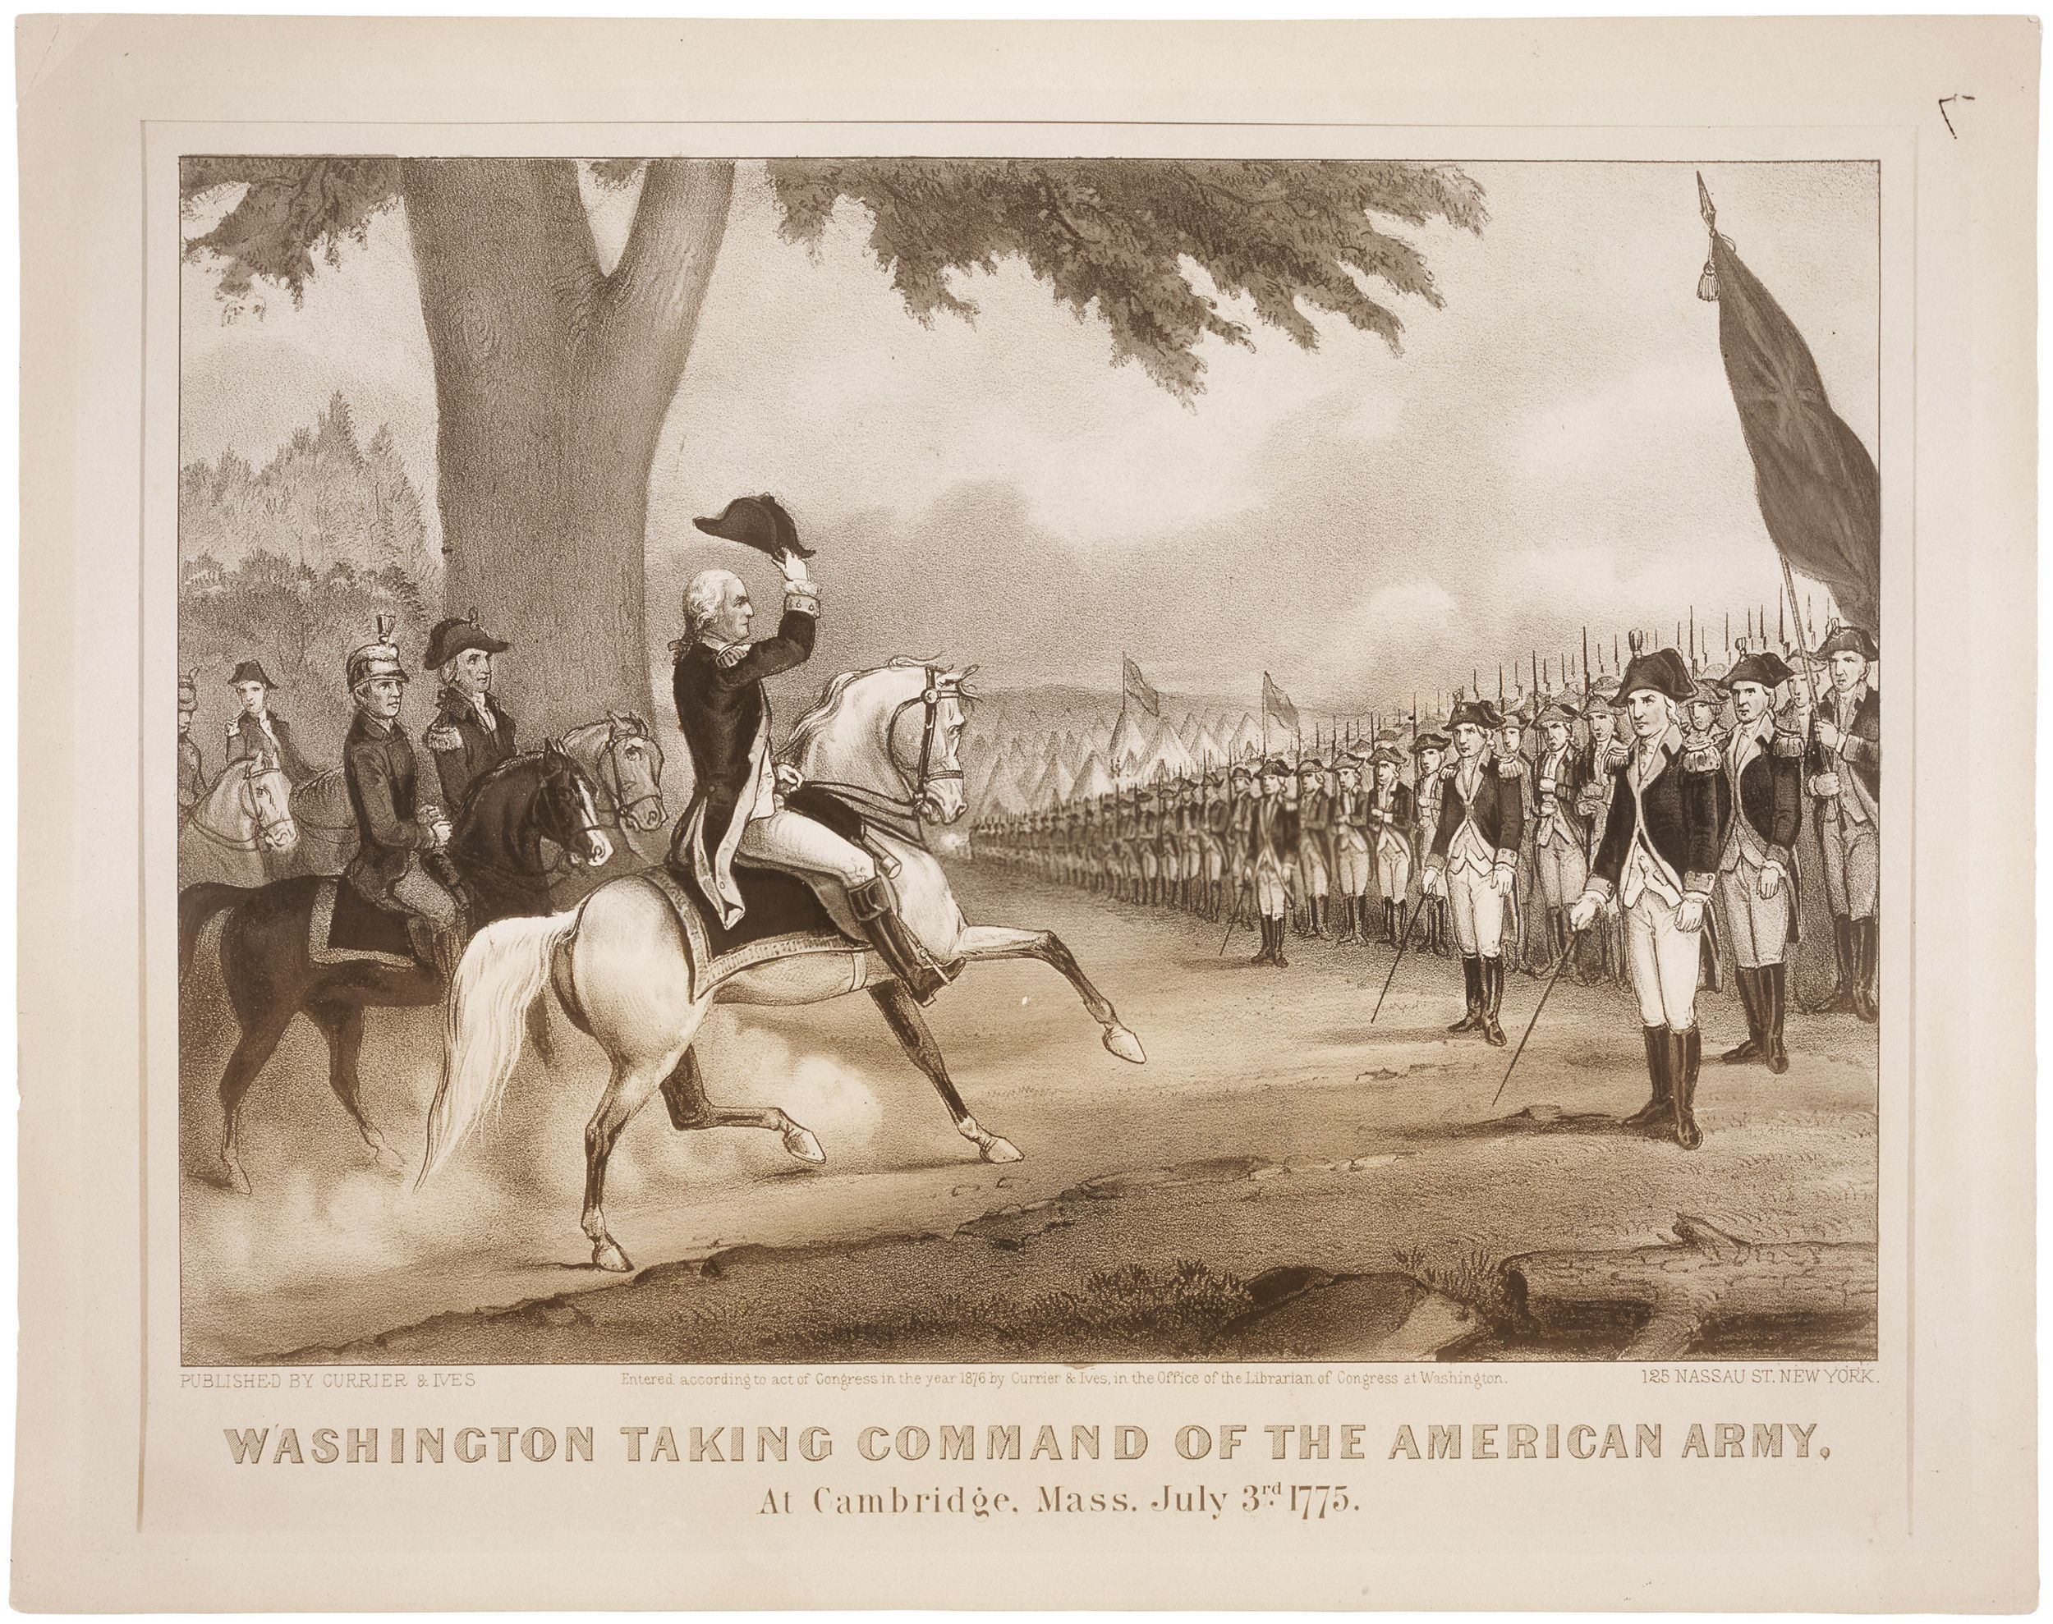

Surrender of Cornwallis
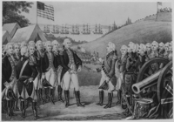
The Declaration of Independence

