STUDENTS INVESTIGATING PRIMARY SOURCES
Arguing Arkansas: Analyzing the Impact of Eisenhower’s Little Rock Speech
How did civil rights conflicts affect American society during the Eisenhower era?
A Short Activity for High School U.S. History and U.S. Government Courses
Benchmark Correlations
SS.912.A.7.8 – Analyze significant Supreme Court decisions relating to integration, busing, affirmative action, the rights of the accused, and reproductive rights.
Benchmark Clarification: Students will evaluate how significant Supreme Court decisions relating to integration, busing, affirmative action, the rights of the accused, and reproductive rights both united and divided groups of people in the United States.
SS.912.CG.2.6 – Explain how the principles contained in foundational documents contributed to the expansion of civil rights and liberties over time.
Benchmark Clarification: Students will explain how different groups of people had their civil rights expanded through legislative action, executive action, and the courts.
ELA.R.2 – Reading Informational Text
ELA.R.3 – Reading Across Genres

Activity Documents and Handouts
- Arguing Arkansas Graphic Organizer
- Letter to President Dwight D. Eisenhower from Mr. and Mrs. J.H. Armstrong against School Integration
- Opinion in Brown et al v. Board of Education of Topeka et al., Page 3 Only
- Press Release Containing Speech on Radio and Television Given by President Dwight D. Eisenhower, Modified Version
*This document has been modified for this specific activity. It has been abridged to assist with reading comprehension and the time limits of the activity. The original document is greater in length.

Full Document Citations
Letter to President Dwight D. Eisenhower from Mr. and Mrs. J.H. Armstrong against School Integration, 9/24/1957; Bulk Mail Files, 1953-1961; White House Central Files (Eisenhower Administration), 1953-1961; Dwight D. Eisenhower Presidential Library. National Archives Identifier: 6092866.
[https://catalog.archives.gov/id/6092866]
[https://www.docsteach.org/documents/document/letter-to-president-dwight-d-eisenhower-from-mr-and-mrs-j-h-armstrong-against-school-integration]
Opinion in Brown et al. v. Board of Education of Topeka et al., 1954; Case File for Brown et al. v. Board of Education of Topeka et al., 1950-1955; Appellate Jurisdiction Case files, 1792-2010; Records of the Supreme Court of the United States, Record Group 267; National Archives at Washington, DC. National Archives Identifier: 1656510.
[https://catalog.archives.gov/id/1656510]
[https://www.docsteach.org/documents/document/opinion-brown-v-board]
Press Release Containing Speech on Radio and Television Given by President Dwight D. Eisenhower, 9/24/1957; Press Releases for Press and Radio Conferences, 1952-1961; Kevin McCann Speech Files, 1946-1960; Dwight D. Eisenhower Presidential Library. National Archives Identifier: 17366765.
[https://www.eisenhower.archives.gov/research/online_documents/civil_rights_little_rock/1957_09_24_Press_Release.pdf]

Activity Vocabulary
applicability – relevance
compulsory – required
decree – a formal order, having the force of law
demagogue - a person, especially a political leader, who gains power and popularity by arousing the emotions, passions, and prejudices of the people
disposition – state of mind regarding something
inherent – innate, existing in one from birth
plaintiff – the person who brings legal action against another person in a civil trial
propound – to put forth for consideration
subordinate – of less importance, secondary

- Project and distribute the “Letter to President Dwight D. Eisenhower from Mr. and Mrs. J.H. Armstrong” on the board and distribute the graphic organizer to students as they enter the room.
- Direct students to visually scan the document and identify three items that stand out to them in the document. (Examples could include: letter format, original signature, language, return address.)
- Have a few students share out. Teacher Note: Clarify that the use of the term “Negro” reflected common language of the era (reference the Universal Negro Improvement Association as an example).
- Explain to students that this letter serves as a “petition” to President Eisenhower in response to his speech on Little Rock, Arkansas in a nationally televised address on September 24, 1957, and was written by people living in a traditional Southern state.
- Direct students to read the letter independently to identify the authors, issue and the authors’ position on that issue and to complete the “Document 1” space on their graphic organizer. Teacher Note: If needed, model how to complete the graphic organizer for the students. Also, if needed, project the Activity Vocabulary table to assist students with any unfamiliar terms.
- Direct students to compare responses with their immediate shoulder partner to check for understanding.
- Rotate through the student pairs to monitor understanding.
- Divide the class into six groups and assign three groups the “Opinion in Brown et al v. Board of Education of Topeka et al., Page 3” and the other three groups the modified version of the “Press Release Containing Speech on Radio and Television Given by President Eisenhower”. Teacher Note: If needed, continue to project the Activity Vocabulary table to assist students with any unfamiliar terms.
- Direct students to work with their group members to read the document they have been assigned and complete a document bubble on the graphic organizer to identify the author(s), issue and the authors’ position on the issue.
- Direct each group to select a representative to share their portion of the graphic organizer with the whole class. Instruct students to complete the remaining document bubble on the graphic organizer for the document not assigned to their group.
- Direct student attention to the overarching question on the graphic organizer: Based on these documents, what conclusion(s) can you draw?
- Discuss the question as a whole group and instruct students to respond to the question on the graphic organizer. Encourage students to isolate a reference from the texts to support their responses.
- Extend the discussion by having students address the guiding question: How did civil rights conflicts affect American society during the Eisenhower era?
Enrichment Suggestion #1 – Use the following discussion questions to extend the conversation: How did President Eisenhower’s Little Rock decision influence the expansion of civil rights? How did each document contribute to uniting or dividing people in the United States?
Enrichment Suggestion #2 – Use alternative documents that address integration a few years after the Brown decision and engage students in the same activity. Examples of documents are listed below:
- Situation Report 233 by the Office of the Deputy Chief of Staff for Military Operations, 3/10/1958; Little Rock, Volume I – Reports (8), 3/1960-5/1960; Alphabetical Subject Files, 1953-1961; White House Office, Office of the Staff Secretary: Records of Paul T. Carroll, Andrew J. Goodpaster, L. Arthur Minnich, and Christopher H. Russell, 1952-1961; Dwight D. Eisenhower Presidential Library. National Archives Identifier: 17367521. [https://www.eisenhower.archives.gov/research/online_documents/civil_rights_little_rock/Situation_Report_no233.pdf]
- Letter, Jackie Robinson to President Dwight D. Eisenhower, 5/13/1958; Official Files, 1953-1961; White House Central Files (Eisenhower Administration), 1953-1961; Dwight D. Eisenhower Presidential Library. National Archives Identifier: 17368592. [https://www.eisenhower.archives.gov/research/online_documents/civil_rights_little_rock/1958_05_13_Robinson_to_DDE.pdf]

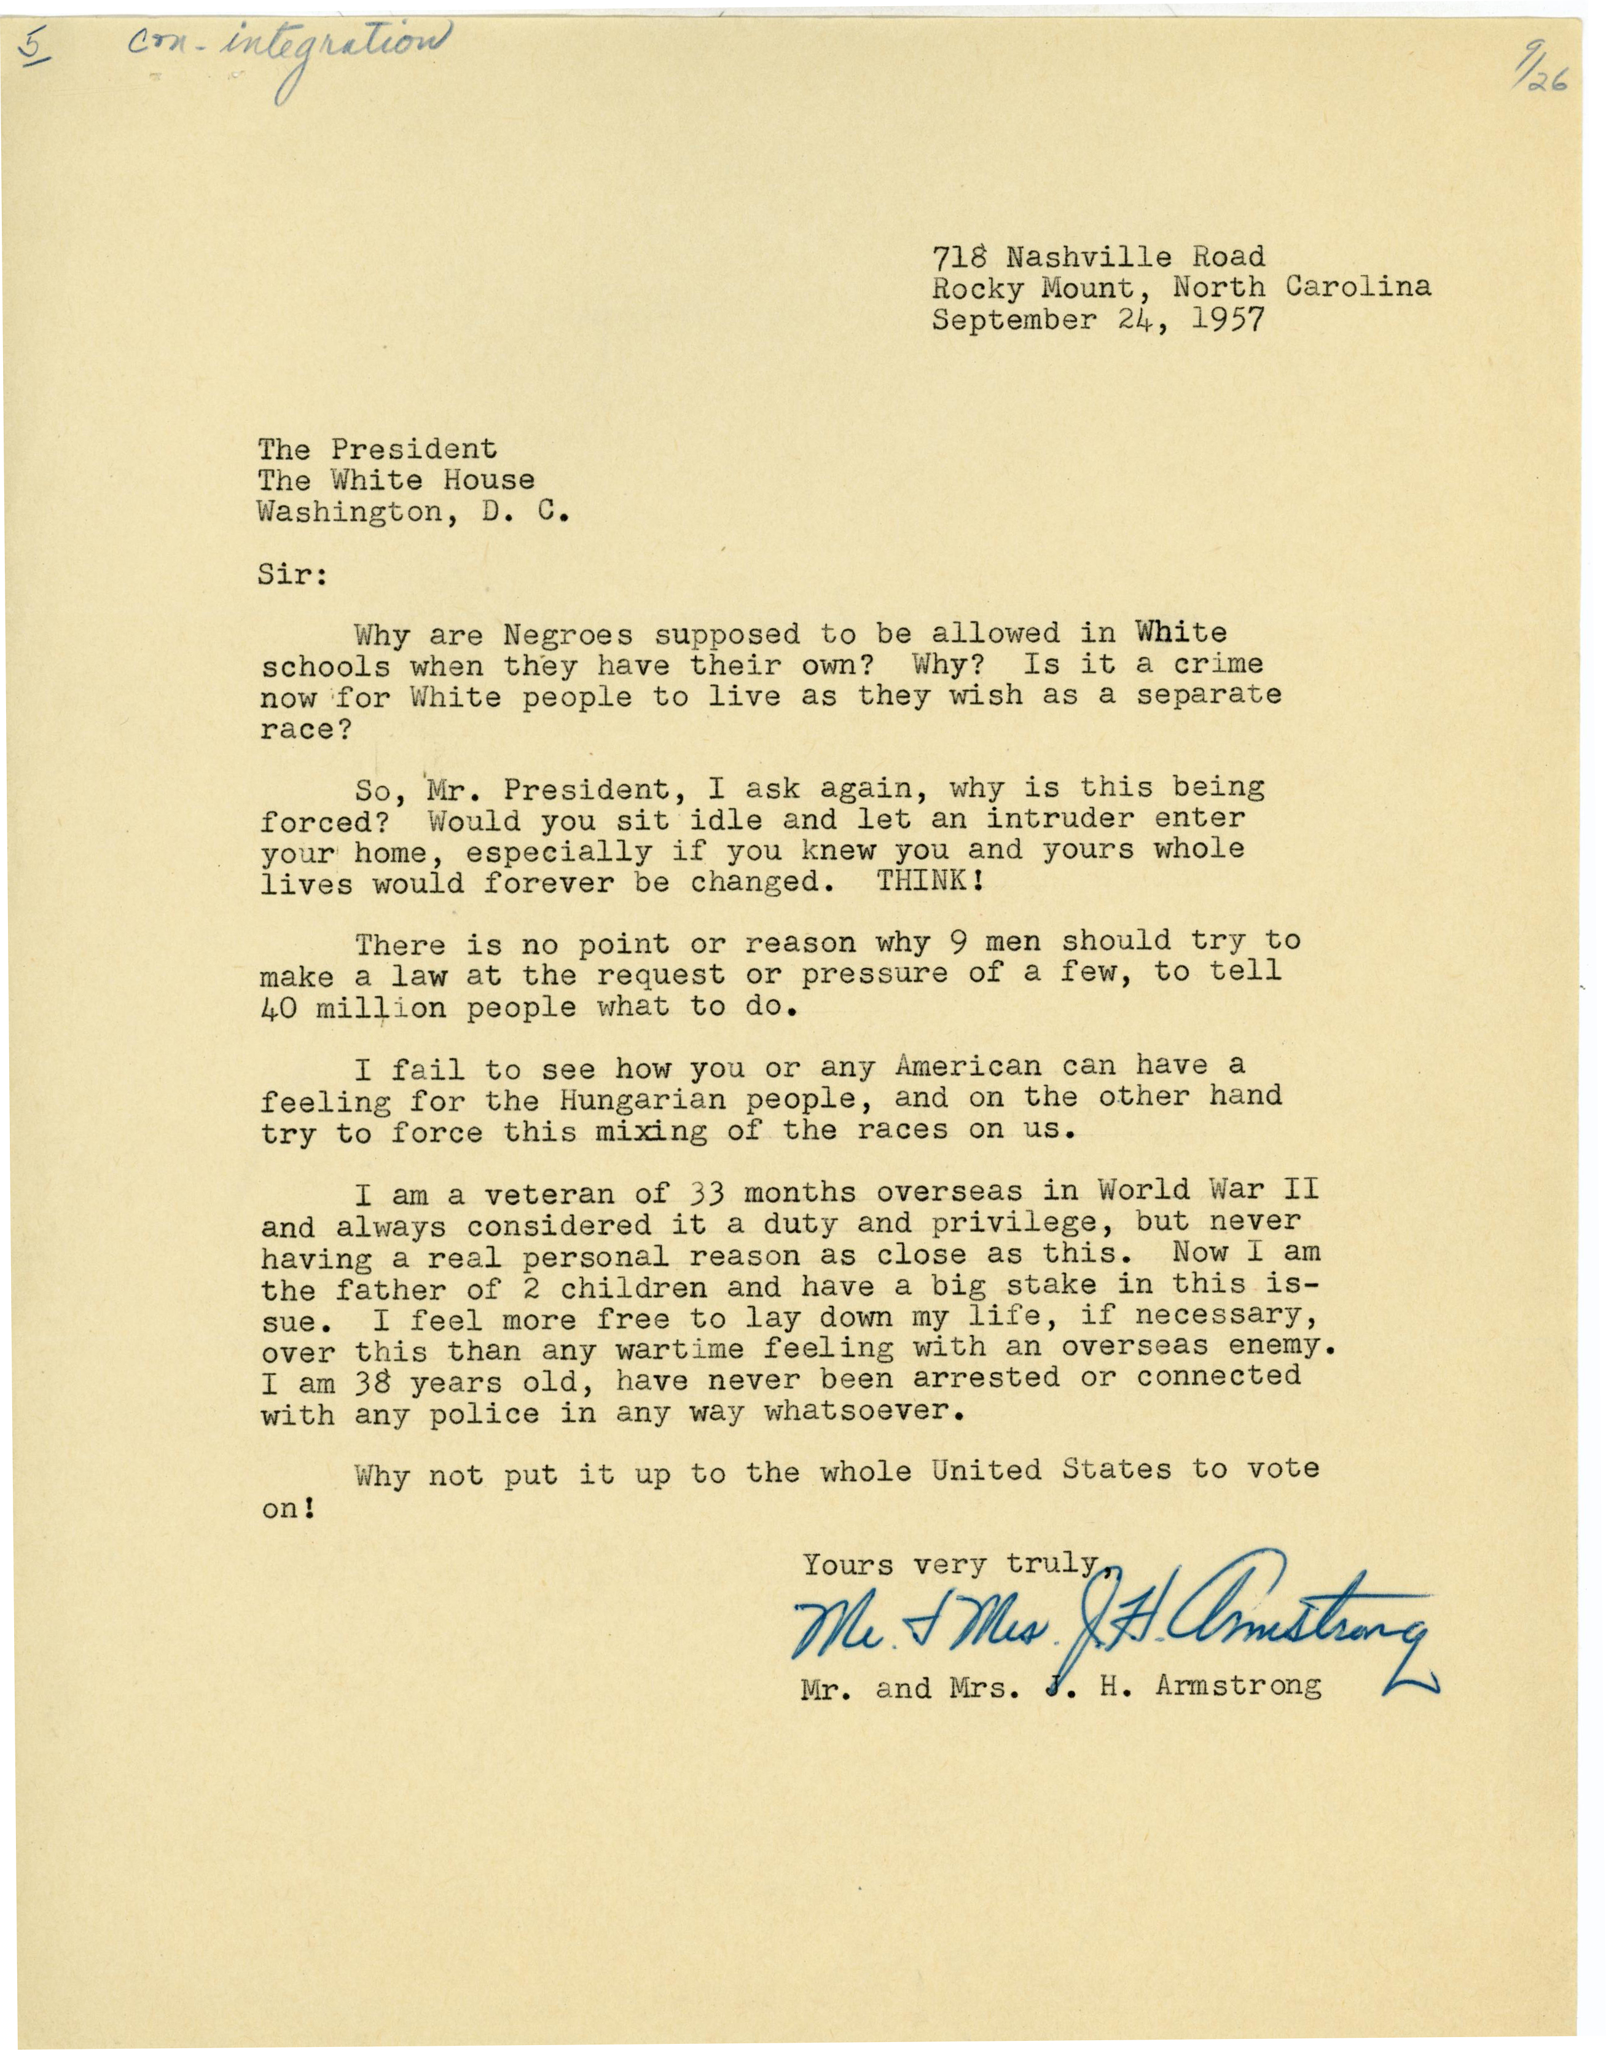
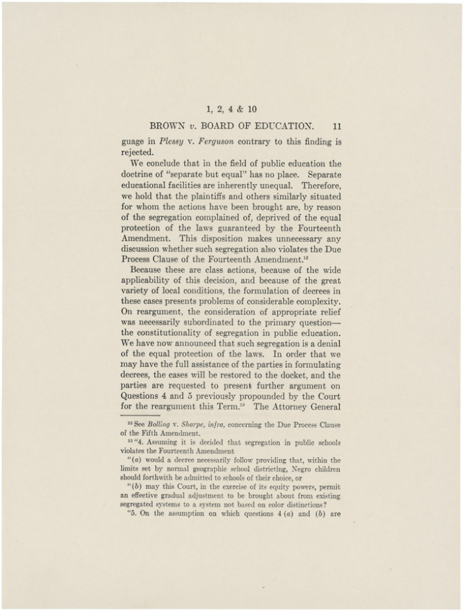
Press Release Containing Speech on Radio and Television Given by President Eisenhower
MODIFIED VERSION*
*This document has been modified for this specific activity. It has been abridged to assist with reading comprehension and the time limits of the activity. The original document is greater in length.
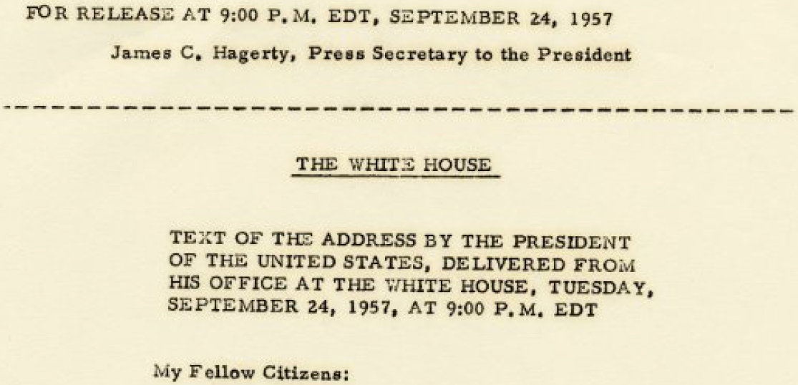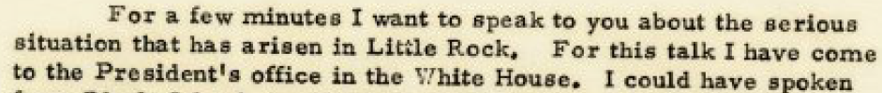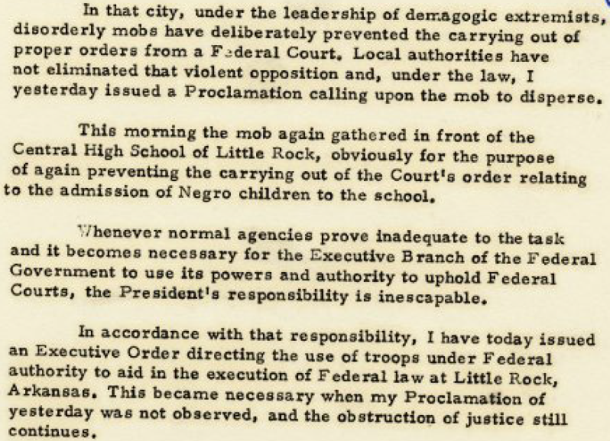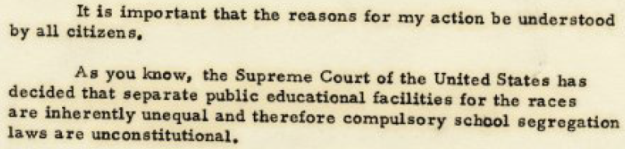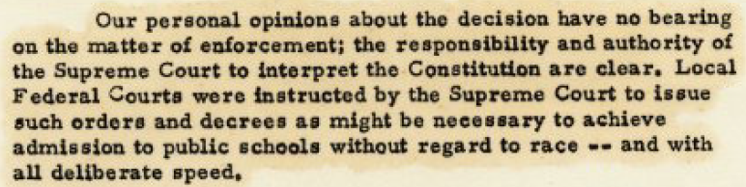

Name: ___________________________________________________ Date: ________________________
Document 2
Author(s): _____________________________
___________________________________________
Issue: ___________________________________
__________________________________________
__________________________________________
Author’s Position: ___________________
__________________________________________
__________________________________________
_________________________________________
____________________________________
____________________________________
____________________________________
____________________________________
____________________________________
__________________________________
_______________________________
______________________________

Document 3
Author(s): _______________________________________________
_____________________________________________________________
Issue: _____________________________________________________
____________________________________________________________
Author’s Position: _____________________________________
___________________________________________________________
__________________________________________
Document 1
Author(s): _____________________________
___________________________________________
Issue: ___________________________________
__________________________________________
__________________________________________
Author’s Position: ___________________
__________________________________________
__________________________________________
_________________________________________

Arguing Arkansas
Based on these documents, what conclusion can you draw?

Document 2
Author(s): U.S. Supreme Court
Issue: Brown v. Board of Education
Author’s Position: The court determined that “separate but equal” has no place in public education, was fundamentally unequal and that segregation is a denial of the equal protection of the laws.
After the Brown v. Board of Education decision there were differing views on integration.

Document 3
Author(s): President Eisenhower
Issue: the integration of public schools
Author’s Position: President Eisenhower is using the power of the executive branch to enforce the judicial branches decision on Brown v. Board of Education.
Document 1
Author(s): Mr. and Mrs. J.H. Armstrong
Issue: integrated/desegregated schools; Brown Decision/judicial overreach; national referendum on integration/desegregation (students could identify any of these as the issues)
Author’s Position: Integration/desegregation of schools is wholly unacceptable; Brown decision is an example of judicial overreach; instead of nine, unelected judges determining the will of the people, why not allow the people to make their own determinations regarding the integration/desegregation of the public school system through an election.

Arguing Arkansas – ANSWER KEY
Based on these documents, what conclusion can you draw?

