STUDENTS INVESTIGATING PRIMARY SOURCES
Anyone Home?
How does this political cartoon illustrate the lawmaking process?
A Short Activity for High School and Middle School
Benchmark Correlations
SS.912.CG.3.3 – Analyze the structures, functions, and processes of the legislative branch as described in Article I of the U.S. Constitution.
Benchmark Clarification: Students will analyze the role of the legislative branch in terms of its relationship with the judicial and executive branch of the government.
ELA.R.2 – Reading Informational Text
ELA.R.3 – Reading Across Genres

SS.7.CG.3.7 – Explain the structure, functions, and processes of the legislative branch of government.
Benchmark Clarification: Students will examine the processes of the legislative branch (e.g., how a bill becomes a law, appointment confirmation, committee selection).
Benchmark Clarification: Students will compare and contrast the lawmaking process at the local, state and national levels.
ELA.8.R.2.2 - Analyze two or more central ideas and their development throughout a text.
ELA.8.R.3.2 - Paraphrase content from grade-level texts.
ELA.7.R.2.2 - Compare two or more central ideas and their development throughout a text.
ELA.7.R.3.2 - Paraphrase content from grade-level texts.

Activity Documents and Handouts
- Anyone Home? Political Cartoon
- Identifying Symbols Handout
- Article 1, Section 7 Excerpt from the U.S. Constitution

Full Document Citation
Anyone Home?, cartoon by Clifford Berryman, February 24, 1920; U.S. Senate Collection, Record Group 46; National Archives Building, Washington DC. National Archives Identifier: 6011590.
[https://catalog.archives.gov/id/6011590]
[https://www.docsteach.org/documents/document/anyone-home]

Activity Vocabulary
anthropomorphic – having human characteristics
symbol – an image or object used to represent ideas or qualities

Teacher Note
Before starting this activity, view the Teacher Background Information on the political cartoon.

- Project the full page “Anyone Home?” political cartoon on the board as students enter the room.
- Direct students to visually scan the document and identify three items that stand out to them in the document. (Examples could include: an anthropomorphic rolled up piece of paper “a bill”, door and door bell, Capitol dome)
- Have a few students share out and write the items on the board. Point out the text in the cartoon to the students, including: “Railroad Bill”, “O.K. House”, “O.K. Senate” and “White House”. Teacher Note: Explain the definition of the term “anthropomorphic”.
- Share with students that everything they see in this image was a choice made by the artist, Clifford Berryman, to convey his message.
- Pass out the Identifying Symbols graphic organizer and review the definition of “symbol” as a whole class.
- Instruct students to turn to their shoulder partner and work together to answer the following questions and record the answers on the graphic organizer: Which of the items we identified are symbols? What do you think each symbol means or represents? Teacher Note: If needed, use the following questions to guide student completion of the graphic organizer: What does the removal of a hat signify? Think about why people remove their hats during sporting events during the national anthem (it’s a sign of respect). What does the fact that bill needs to ring the doorbell tell us? Would the bill need to ring the doorbell if it was his house? (He is a visitor, the doorbell announces visitors)
- Have pairs of students merge with another pair and compare their answers. Instruct students to add any additional information they discuss as a group of four in the “Updates” column.
- Have a few of the groups share out.
- Pose the following question for discussion: “Based on the symbols you’ve identified and the other images you see, what action has the artist depicted?” Teacher Note: Lead students to the understanding that the artist has depicted a bill being sent to the White House after it has been approved by the House of Representatives and the Senate.
- Project and pass out the transcript of Article 1, Section 7 of the U.S. Constitution.
- Instruct students to identify the text in Article 1 that matches the action in the cartoon. Teacher Note: Provide time for students to identify the appropriate text. Lead students to the following answer: Every Bill which shall have passed the House of Representatives and the Senate, shall, before it become a Law, be presented to the President of the United States
- Pose the following question for discussion: Why do you think the artist drew the bill this way? Teacher Note: Lead students to the understanding that the bill’s fate is about to be decided by the president, perhaps the bill’s fate is uncertain, the president’s decision is unclear at this moment in time.
Enrichment Suggestion #1 – Instruct students to create a thought bubble for the bill in the cartoon.
Enrichment Suggestion #2 – Using Article I, Section 7 have students create a companion cartoon based on the two different possible outcomes for how this bill might feel upon leaving the White House.
Enrichment Suggestion #3 – Provide students with context for this cartoon by using the features available from the Evening Star. Explain to students that to further understand why Berryman drew this cartoon, they need to know what was happening around the time it was created. Share with students that they can view the newspaper in which it was published. Go to Evening star [(Washington, D.C.), 24 Feb. 1920. Chronicling America: Historic American Newspapers. Lib. of Congress] and point out features of the front page.
http://chroniclingamerica.loc.gov/lccn/sn83045462/1920-02-24/ed-1/seq-1/

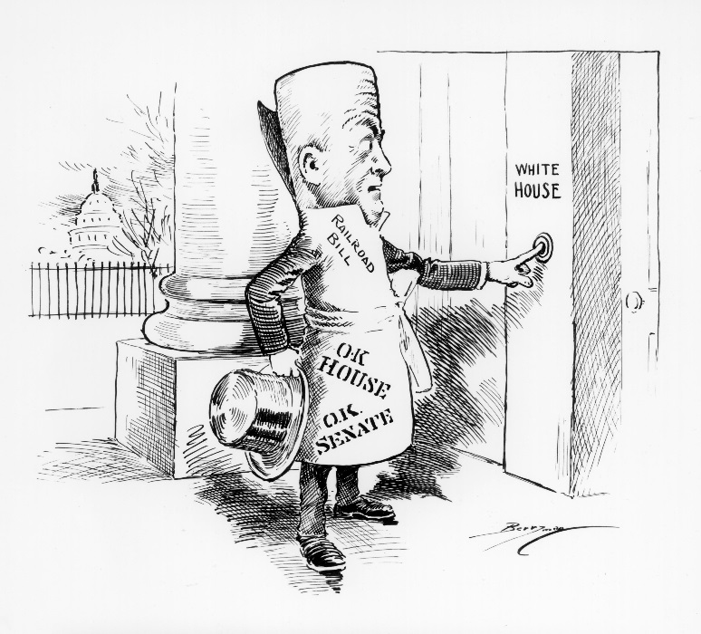

Anyone Home?
Teacher Background Information

“Anyone Home?”
February 24, 1920
6011590

Background from NARA Catalog:
During World War I, the government had seized control of the nation's railroads as part of the effort to shift the economy to wartime production causing railroad workers to be chafed under provisions of the seizure that restricted wage increases. After long debates both houses of Congress approved a railroad bill which would denationalize ownership, and that bill was sent to President Woodrow Wilson for his approval. Representatives of the railway workers unions were debating whether to urge Wilson to veto the bill because of its labor provisions. Berryman shows that the decision is now up to the President. The railroad bill caricature, with top hat in hand and O.K. stamps from both the House and the Senate on his frock coat, rings the doorbell at the White House.

Representing Congress: Clifford K. Berryman’s Political Cartoons eBook: pages 29, 59

Name: ___________________________________________________________________ Date: ______________________
Anyone Home?
Identifying Symbols

Directions: List four symbols from the political cartoon. Explain the meaning of each symbol.
Symbol | Meaning | Updates
_____________________________________ | ______________________________________  ______________________________________  ______________________________________  ______________________________________ | ______________________________________  ______________________________________  ______________________________________  ______________________________________
_____________________________________ | ______________________________________  ______________________________________  ______________________________________  ______________________________________ | ______________________________________  ______________________________________  ______________________________________  ______________________________________
_____________________________________ | ______________________________________  ______________________________________  ______________________________________  ______________________________________ | ______________________________________  ______________________________________  ______________________________________  ______________________________________
_____________________________________ | ______________________________________  ______________________________________  ______________________________________  ______________________________________ | ______________________________________  ______________________________________  ______________________________________  ______________________________________

Article I, Section 7
All Bills for raising Revenue shall originate in the House of Representatives; but the Senate may propose or concur with Amendments as on other Bills.

Every Bill which shall have passed the House of Representatives and the Senate, shall, before it become a Law, be presented to the President of the United States If he approve; he shall sign it, but if not he shall return it, with his Objections to that House in which it shall have originated, who shall enter the Objections at large on their Journal, and proceed to reconsider it. If after such Reconsideration two thirds of that House shall agree to pass the Bill, it shall be sent, together with the Objections, to the other House, by which it shall likewise be reconsidered, and if approved by two thirds of that House, it shall become a Law.

But in all such Cases the Votes of both Houses shall be determined by yeas and Nays, and the Names of the Persons voting for and against the Bill shall be entered on the Journal of each House respectively.

If any Bill shall not be returned by the President within ten Days (Sundays excepted) after it shall have been presented to him, the Same shall be a Law, in like Manner as if he had signed it, unless the Congress by their Adjournment prevent its Return, in which Case it shall not be a Law.

Every Order, Resolution, or Vote to which the Concurrence of the Senate and House of Representatives may be necessary (except on a question of Adjournment) shall be presented to the President of the United States; and before the Same shall take Effect, shall be approved by him, or being disapproved by him, shall be repassed by two thirds of the Senate and House of Representatives, according to the Rules and Limitations prescribed in the Case of a Bill.

Anyone Home? Sample Answers

Symbol | Meaning
Top Hat | The bill’s dress symbolizes that this is a formal occasion; the removal of a hat before entering a house is a gesture of respect.
Doorbell | The bill pressing the doorbell indicates that the bill’s arrival needs to be announced, and the bill needs to bet let into the White House. This action symbolizes the formality of the occasion
Capitol dome | A symbol of the legislative branch of government, a symbol for Washington, D.C., shows where the bill has come from
Bill/Person | represents a piece of legislation approved by both the House of Representatives and the Senate, the fact that the bill is depicted as a grown man and not an infant or child could symbolize where this bill is in its journey to become a law. The fact that this bill is also depicted as a man could represent the fact that government at this time is still very much dominated by men

