Student Voting Election Simulation User Guide
Teacher Information for use with the SS.7.C.2.9 & SS.7.C.2.7 FJCC Lesson Plan
- How do I get started?
Go to electionsimulation.floridacitizen.org
Click on REGISTER
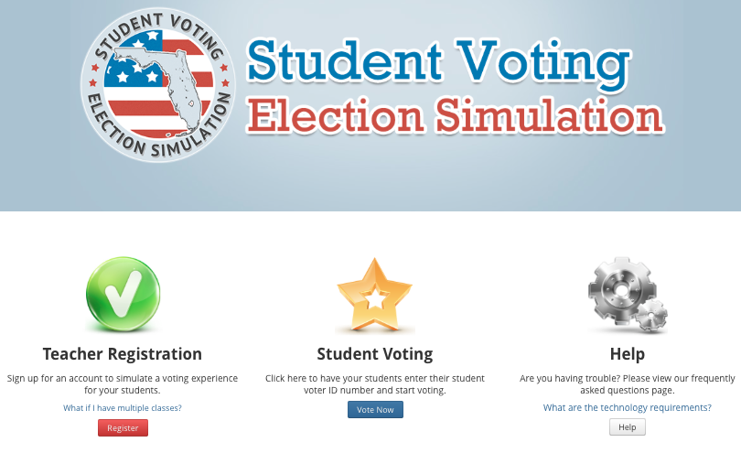
Click Here
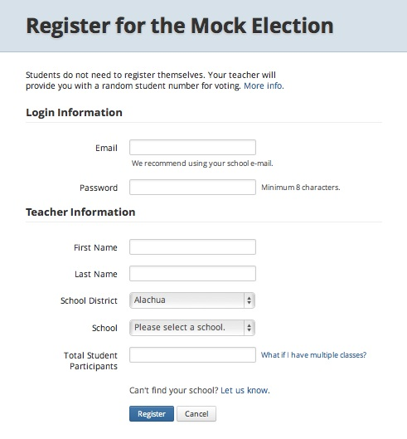
- What information do I need to provide to register?
- An email address
- Create a password (minimum of 8 characters)
- First and Last Name
- School District
- School Name
- Total Student Participants – (This is the total number of students you teach.)

- How do I view the ballot?
Once you have registered, login and you will see the Teacher Home Page. Click on VIEW BALLOT.
This ballot is aligned to the SS.7.C.2.9/SS.7.C.2.7 “Candidates & Elections” Lesson Plan.
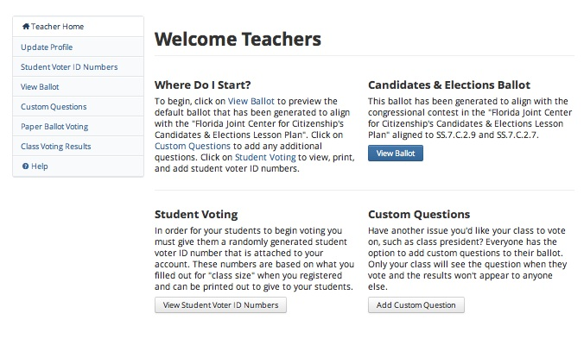
Click Here

Your ballot will automatically include the default question aligned to the lesson.
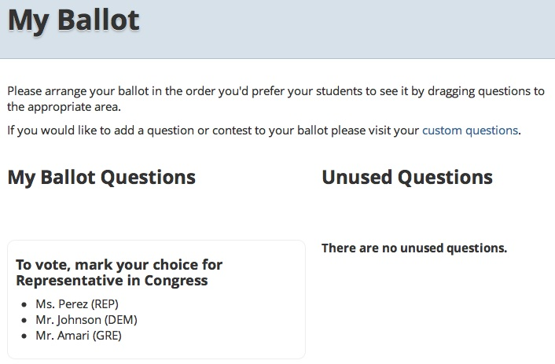
- How can I add questions to the ballot? If you want to add questions to your ballot, in addition to the default question, click on ADD CUSTOM QUESTIONS.
Click Here

- How do I register my students to vote?
From the Teacher Home page, click on VIEW STUDENT VOTER ID NUMBERS.
Students will need a unique student voter id number to vote. Students voter id numbers will be automatically generated based on the number of students you entered when you created an account for the website. You can add numbers if you have more students and you can print the numbers to hand out to students. All students will need a voter id number to participate.
Click Here

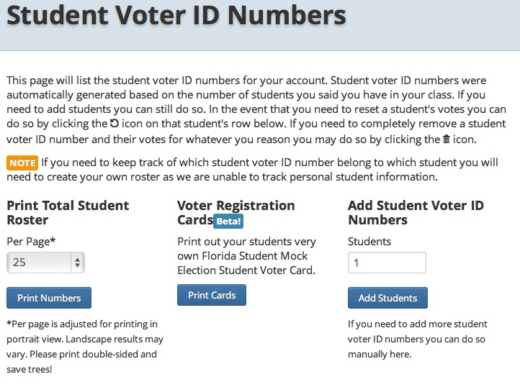
On the Student Voter ID Numbers Page,
- you can print the student voter id numbers in a roster format and assign each student a number manually,
- you can generate the numbers into a Voter Registration Card for each student,
- you can add student voter id numbers,
- you can view if a student voter id number has been used to vote,
- you can reset a student voter id number, and
- you can delete a student voter id number.

- How do my students vote?
Go to the homepage and click on VOTE NOW.
Students will be prompted to enter their unique student voter id number.
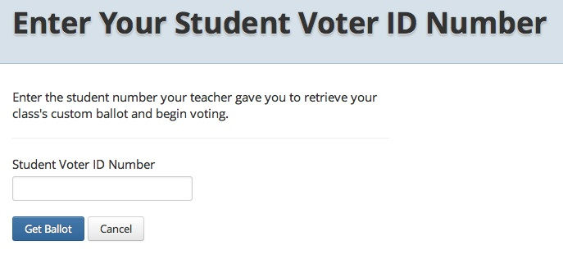
Click Here

- How can I analyze the results?
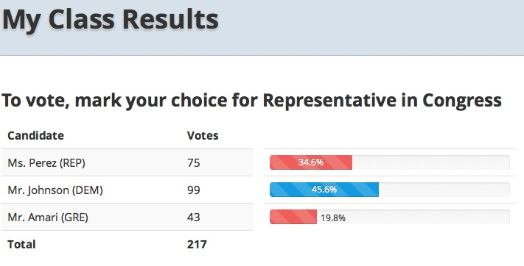
When your students have finished voting, return to the Teacher Home Page and click on CLASS VOTING RESULTS to view the outcome. On this page you can view the total votes and percentages for each candidate. At this time, results cannot be divided by individual classes.

