THE UNITED STATES AND INTERNATIONAL CONFLICT
SS.7.C.4.3 Describe examples of how the United States has dealt with international conflicts.

TABLE OF CONTENTS

Lesson Summary 2
Suggested Student Activity Sequence 4
Student Activity Sheets & Reading Materials 8
Sources 28
Answer Keys 29
Civics Content Vocabulary 39
Essential Teacher Content Background Information 40

Lesson Summary
Essential Questions
What international conflicts has the U.S. been involved in? Why did the U.S. become involved? What kinds of actions did the U.S. take in these conflicts?

NGSSS Benchmark
SS.C.7.4.3 Describe examples of how the United States has dealt with international conflicts.

Florida Standards
LAFS.68.RH.1.1 LAFS.68.RH.1.2 LAFS.68.RH.2.6 LAFS.68.RH.3.7
LAFS.68.WHST.1.1 LAFS.68.WHST.1.2 LAFS.68.WHST.4.10 LAFS.7.SL.1.1
LAFS.7.SL.1.2 LAFS.7.SL.1.3 LAFS.7.SL.2.4 MAFS.K12.MP.6.1

Overview
In this lesson, students will examine conflict and cooperation using past and current international events, and they will analyze the conditions, actions, and motivations of past and current international events.

Learning Goals/Benchmark Clarifications
- Students will identify specific examples of international conflicts in which the United States has been involved.
- Students will identify the reasons for the United States becoming involved in past international conflicts.
- Students will analyze primary source documents pertaining to international incidents to determine the course of action taken by the United States.
- Students will identify the different methods used by the United States to deal with international conflicts.

Benchmark Content Limits
- Items will not require students to evaluate the efficacy of any decision made by the United States.
- Items will not require students to evaluate the consequences of U.S. involvement in any international conflict.
- Items are not limited to identified war, but also include humanitarian efforts, peacekeeping operations, conflict resolution, etc.

Civics EOC Reporting Category
Reporting Category 3 – Government Policies and Political Processes

Suggested Time Frame
- Five 45-50 minute class periods

Civics Content Vocabulary
- Bay of Pigs, conflict, conflict resolution, cooperation, Cuban Missile Crisis, diplomacy, Gulf War I, Gulf War II, humanitarian action, international conflict, Iran Hostage Crisis, Korean War, military action, North Atlantic Treaty Organization, peacekeeping, terrorism, United Nations, U.S. State Department, Vietnam War, World War I, World War II

Instructional Strategies
Reading of complex text Use of primary sources Cooperative learning

Materials
Computer with internet access to project lesson activity sheets
Student activity sheets, reading materials and other materials:
- Analysis Activity Complex Text Graphic Organizer
- Conflict and Cooperation, Pages 1 and 2 reading from iCivics: http://www.icivics.org/teachers/lesson-plans/conflict-and-cooperation
- Conflict and Cooperation, Activity Pages 1 and 2 – optional
- Presentation Notes
- Scenario: World War I
- International Scenarios: World War II (1939-1945), Korean War (1950-1953), Bay of Pigs Invasion (1961), The Cuban Missile Crisis (1962), Iran Hostage Crisis (1979-1981), Gulf War I (1991), and Gulf War II (2002-2009)
- Five Years article
- President Franklin Roosevelt’s “Day of Infamy” audio recording from the National Archives, https://catalog.archives.gov/id/1436350
  - The file needs to be downloaded in order to play.
- Questions About Zlata’s Diary
- Excerpts from Zlata’s Diary

Lesson Activities and Daily Schedule
Please use the chart below to track activity completion.

Day | Task # | Steps in Lesson | Description | Completed?  Yes/No
Day One | Task 1 | 1-3 | Hook Activity
 | Task 2 | 4-11 | Conflict and Cooperation Reading and Activities
 | Task 3 | 12-15 | World War I Scenario Activity
Day Two | Task 4 | 16-27 | International Conflict Scenarios in Cooperative Groups and Presentations
Day Three | Task 4 | 16-27 | International Conflict Scenarios in Cooperative Groups and Presentations  (continued)
 | Task 5 | 28-35 | Gulf War II through Primary Sources
Day Four | Task 6 | 36 | Checking for Understanding A
 | Task 7 | 37-41 | Kosovo Case Study
Day Five | Task 8 | 42-47 | Zlata’s Diary Activities
 | Task 9 | 48 | Checking for Understanding B

Suggested Student Activity Sequence

- To begin the lesson, list the definitions of “conflict” and “cooperation” on the board.
- Instruct students to think of an example of conflict and cooperation in their lives. Allow students to share out.
- Project the definition of “international conflict” on the board and explain to students that they will learn about a variety of international conflicts that the U.S. has dealt with.
- Pass out the “Analysis Activity Complex Text Graphic Organizer” student activity sheet and the “Conflict and Cooperation, Pages 1 and 2” reading from iCivics: http://www.icivics.org/teachers/lesson-plans/conflict-and-cooperation.
- Read the “Conflict and Cooperation, Pages 1 and 2” reading as a whole class and complete the activity sheet.
- Instruct students to share out their summaries for the Page 2 paragraphs on Conditions, Motivations, and Actions. Teacher note: If additional support is needed, instruct students to complete the “Conflict and Cooperation, Activity Pages 1 and 2” from iCivics.
- Share with students that the U.S. has used various methods when dealing with international conflicts and that most of the conflict resolution methods for international conflicts can be categorized as “Military Action,” “Diplomacy,” “Humanitarian Efforts,” or “Peacekeeping Operations.”
- Provide students with the following key points about “Military Action,” “Diplomacy,” “Humanitarian Action” and “Peacekeeping Operations” and instruct them to take notes on the back of their activity sheet.
- Military action involves members of the U.S. military (Army, Marine Corps, Navy, Air Force and Coast Guard) having a presence in another country. Military action typically involves the use of force to stop a conflict.
- Diplomacy involves keeping up relations between the governments of different countries. The primary diplomat for the U.S. is the Secretary of State. The Secretary of State is in charge of the U.S. State Department.
- Humanitarian action is work focused on improving the health and happiness of other people. Humanitarian action can include providing food and medical care, supplies and other necessities to a country or group of people in need.
- Peacekeeping operations involve enforcing a truce between countries or groups by utilizing an international military force.
- Project the U.S. State Department’s website: http://www.state.gov/ and point out the “Diplomacy in Action” tagline at the top of the page. Hover over the “Policy Issues” tab and share some of the diplomatic issues that the State Department is currently focused on.
- Explain to students that, as a member of the United Nations and the North Atlantic Treaty Organization (NATO), the U.S. supports the UN and NATO and their efforts in peacekeeping operations and humanitarian action.
- Project the “United Nations Peacekeeping” issues page: https://peacekeeping.un.org/en and briefly tour the site for students to gain a sense of the different peacekeeping operations that the UN is currently focused on. Complete the same process for humanitarian action, by briefly touring the UN Deliver Humanitarian Aid page: http://www.un.org/en/sections/what-we-do/deliver-humanitarian-aid/index.html.
- Move students into small cooperative groups and pass out another “Analysis Activity Complex Text Graphic Organizer” activity sheet and the “Scenario: World War I” reading. Teacher note: You will need at least seven cooperative groups for activities in the lesson. You can have more than seven, but will need a minimum of seven.
- Explain to students that they will look at another international conflict that the U.S. has been involved in.
- Instruct students to work in their cooperative groups to read and complete the graphic organizer.
- Have students share out their answers. Instruct students to explain how they arrived at their answer and what in the text helped them answer each question.
- Explain to students that their cooperative groups will become “experts” on one international conflict by reading and completing a graphic organizer. They will then present their international conflict to the class and teach their peers.
- Pass out a scenario for one of the following international conflicts to each group: World War II (1939-1945), Korean War (1950-1953), Bay of Pigs Invasion (1961), The Cuban Missile Crisis (1962), Iran Hostage Crisis (1979-1981), Gulf War I (1991), and Gulf War II (2002-2009) and another “Analysis Activity Complex Text Graphic Organizer” activity sheet.
- Provide time for the groups to read, complete their graphic organizer and prepare to present the information to the class.
- Pass out the “Presentation Notes” student activity sheet and explain to students that during the presentations, their task is to take notes on the conflicts they did not learn about in their cooperative group.
- Have the group for World War II (1939-1945) report out by sharing their answers to the questions on the “Analysis Activity Complex Text Graphic Organizer” activity sheet.
- Explain to students that they will listen to an audio recording of President Roosevelt’s “Day of Infamy” Speech that was delivered to a joint session of Congress on December 8, 1941, the day after the attack on Pearl Harbor. Access the audio file from the National Archives Catalog, https://catalog.archives.gov/id/1436350. Teacher note: You will need to download the file in order to play it.
- Instruct students to take notes on the back of their “Presentation Notes” activity sheet on the following questions:
- How does President Roosevelt describe the relationship between the U.S. and Japan before the attack? (the U.S. was at peace with Japan and the U.S. was in conversations with Japanese government to maintain peace in the Pacific)
- How does President Roosevelt describe Japan’s actions after the attack on Pearl Harbor? (Japanese ambassador sent a reply that it was useless to continue diplomatic talks, the Japanese has deliberately sought to deceive the U.S., Japanese attacked on Hong Kong, Guam, Philippine islands, Midway Island, and other islands, the Japanese have taken an offensive position in the Pacific)
- What is President Roosevelt’s response to the attack on Pearl Harbor? (He directed that all measures be taken for the defense of the U.S.)
- Play the audio of President Roosevelt’s speech starting at 1:45 and ending at 6:15.
- Review the answers as a whole class.
- Pose the following question for discussion: “How does the audio of President Roosevelt’s speech add to your understanding of why the U.S. entered World War II?”
- Have the rest of the groups present their conflict by sharing their answers to the questions on their “Graphic Organizer” and describing the conflict to which they were assigned. Teacher note: Have the group assigned to Gulf War II be the last group to present.
- Emphasize the use of the term “terrorism” in the presentation of Gulf War II and instruct students to add the term to their notes.
- Explain to students that they have learned about Gulf War II from an informational text and they will now look at some different sources to gain further understanding of this war. Explain to students that photographs are powerful primary sources that can often provide different perspectives on an issue or event.
- Select one or two of the New York Times Multimedia photographs on the Iraq war: http://www.nytimes.com/slideshow/2007/11/15/arts/1118-GILB_2.html
- Pose the following questions for discussion: “What is happening in this photograph? What are some of the details that stand out to you? What is the issue that this photograph is focusing on? Does the photograph tell some kind of a story? If so, what do you think the story is?” Teacher note: If additional support is needed to analyze the photograph, use the National Archives Photo Analysis Worksheet: http://www.archives.gov/education/lessons/worksheets/photo_analysis_worksheet.pdf.
- Instruct students to answer the following questions, in complete sentences, in their notes: How do the photographs provide an additional perspective or understanding of the war? How do the photographs relate to what you already know?
- Pass out the article “Five Years” reading by, John Burns, a war reporter for the New York Times.
- Explain to students that they will look at another type of source to learn about Gulf War II. Explain to students that this text focuses on the point of view of the author and their task as readers is to understand the author’s point of view of the war and then compare that view with the other information they have learned so far.
- Read the article and answer the guiding questions as a whole class.
- Pose the following questions for discussion: “What is the author’s point of view? What can you identify in the text that reveals his point of view? Did he share some facts about the war and appear to leave out others? Why do you think this is?”
- Checking for Understanding A (Formative Assessment):
Instruct students to write a well-crafted response using one of the following prompts:
Prompt 1
Using what you have learned from the reading and presentations on international conflicts, identify the reasons for the U.S. becoming involved in past international conflicts. Cite specific evidence to support your explanation.
Prompt 2
Using what you have learned about Gulf War II (the Iraq War), compare the presentation about the international conflict with the photographs and article you read. Using all three sources, explain the reasons for the U.S. getting involved in the conflict and the outcome.
- Remind students that the U.S. has been in involved in conflicts in other countries in order to provide diplomatic, humanitarian or peacekeeping actions. Return student attention to their graphic organizer from the beginning of the lesson and have a student remind the class of the definition of these terms.
- Use a classroom or online resource and project a map of Kosovo. If using an online mapping program, scroll out so that students can see where Kosovo is in terms of Asia and the rest of the world.
- Provide students with the following key points about Kosovo:
- Kosovo was an independent province of Serbia, but in 1989, Serbian President Slobodan Milosevic took away Kosovo’s ability to govern itself.
- About 90 percent of Kosovo's two million people were ethnic Albanians.
- After this action by President Milosevic, Serbians began killing the ethnic Albanians in Kosovo.
- President Bill Clinton sent U.S. troops to nearby Yugoslavia (now known as Serbia and Montenegro) as part of a group of peacekeeping forces through the North Atlantic Treaty Organization (NATO) to stop the killing of ethnic Albanians.
- President Clinton said force by the NATO troops was also necessary to prevent the conflict from spilling over into neighboring countries. He also hoped that the pressure of troops would weaken the Serbian government’s power and strengthen the democratic opposition in Serbia.
- The NATO forces were successful and remained in the region for a while longer to serve as a peacekeeping force.
- Pose the following question for students to discuss in small groups: “Under what circumstances do you think should the U.S. get involved in another country for humanitarian and/or peacekeeping reasons?” Have the groups try to come up with a set of criteria that should be met for this kind of involvement.”
- Have students report out their group discussion responses. Try to get the class to reach a consensus on what criteria should be considered for humanitarian and/or peacekeeping efforts.
- Tell the students that they will look at another primary source related to international conflict – this one, from the war in the Balkans.
- Pass out the “Excerpts from Zlata’s Diary: A Child’s Life in Sarajevo” reading and “Questions About Zlata’s Diary” student activity sheet.
- Provide the following key points about the war in the Balkans:
- The former nation of Yugoslavia was made up of different republics, which included a variety of different groups including: Serbs, Croats, Bosnian Muslims, Albanians, Slovenes and others.
- In 1991, two groups declared independence: the Croats and the Slovenes.
- The Yugoslav army, a majority being Serbs, fought against this independence and began fighting with the Slovenes and Croats.
- Thousands were killed during this fighting.
- In 1992, due to a ceasefire led by the United Nations, the fighting paused.
- Bosnia, one of the republics had a mix of Serbs, Muslims and Croats, was next to try for independence.
- Bosnia's Serbs, backed by Serbs elsewhere in Yugoslavia, resisted. Under leader Radovan Karadzic, they threatened bloodshed if Bosnia's Muslims and Croats - who outnumbered Serbs - broke away.
- Over a million Bosnian Muslims and Croats were driven from their homes in ethnic cleansing. Serbs suffered as well. UN peacekeepers, brought in to stop the fighting, were seen as ineffective.
- Read excerpts from "Zlata's Diary," and explain that the book is a journal written by a young teen girl from Sarajevo between 1991 and 1993. Many people have compared her diary to Anne Frank’s Diary of a Young Girl.
- Instruct students to individually answer the questions on the activity sheet.
- Have students discuss their answers/responses to the diary entries in a whole class discussion
- Check for Understanding B (Formative Assessment):
Have students write a well-crafted response to one of the following prompts:
Prompt 1
Identify the different methods used by the U.S. to deal with international conflicts. Cite evidence from the lesson activities to explain each method.
Prompt 2
Some people believe that war will always occur in the world. Write an argument for or against this statement. As part of the argument, explain the alternatives to war and why or why not these alternatives can replace war.
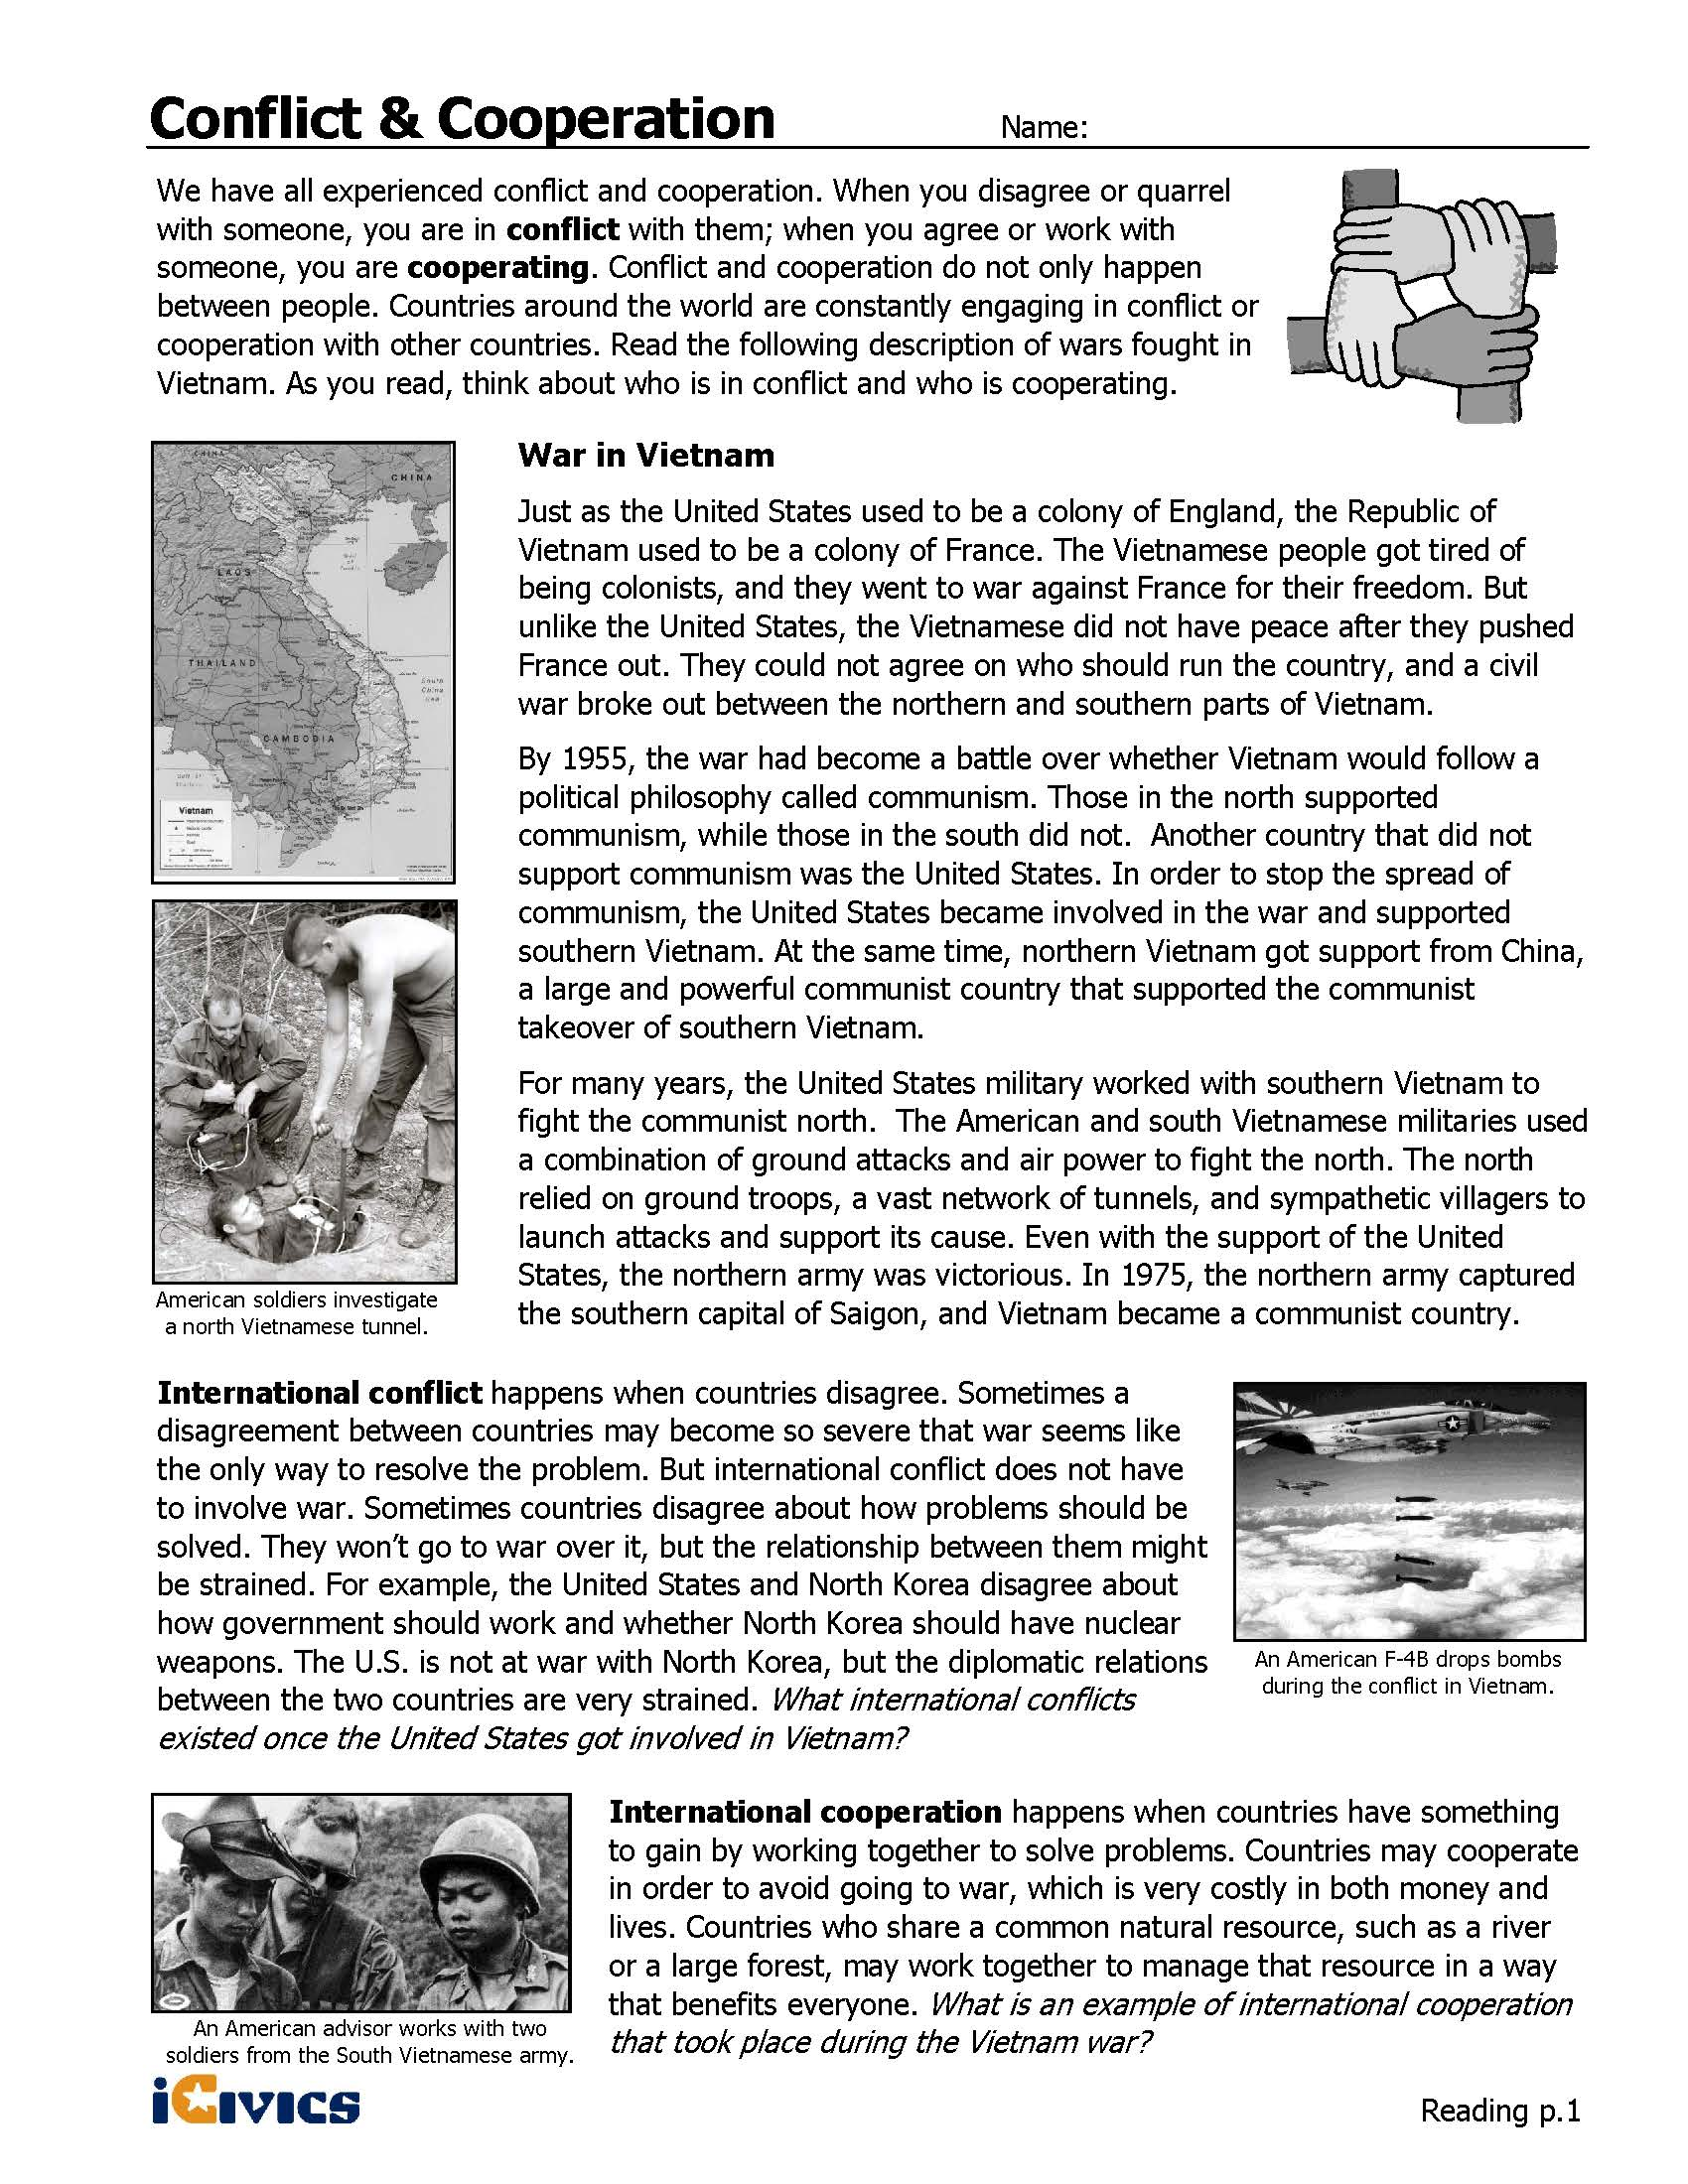
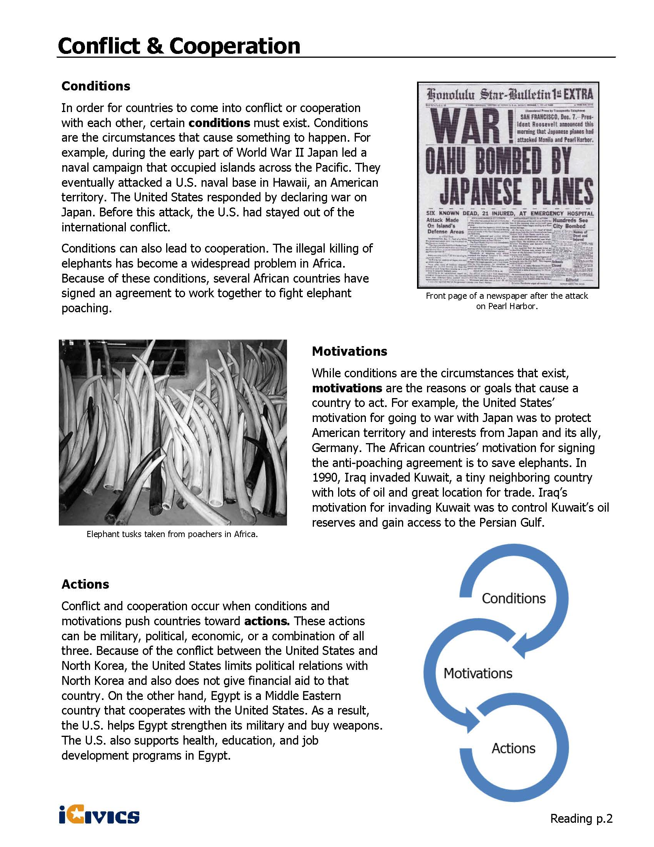
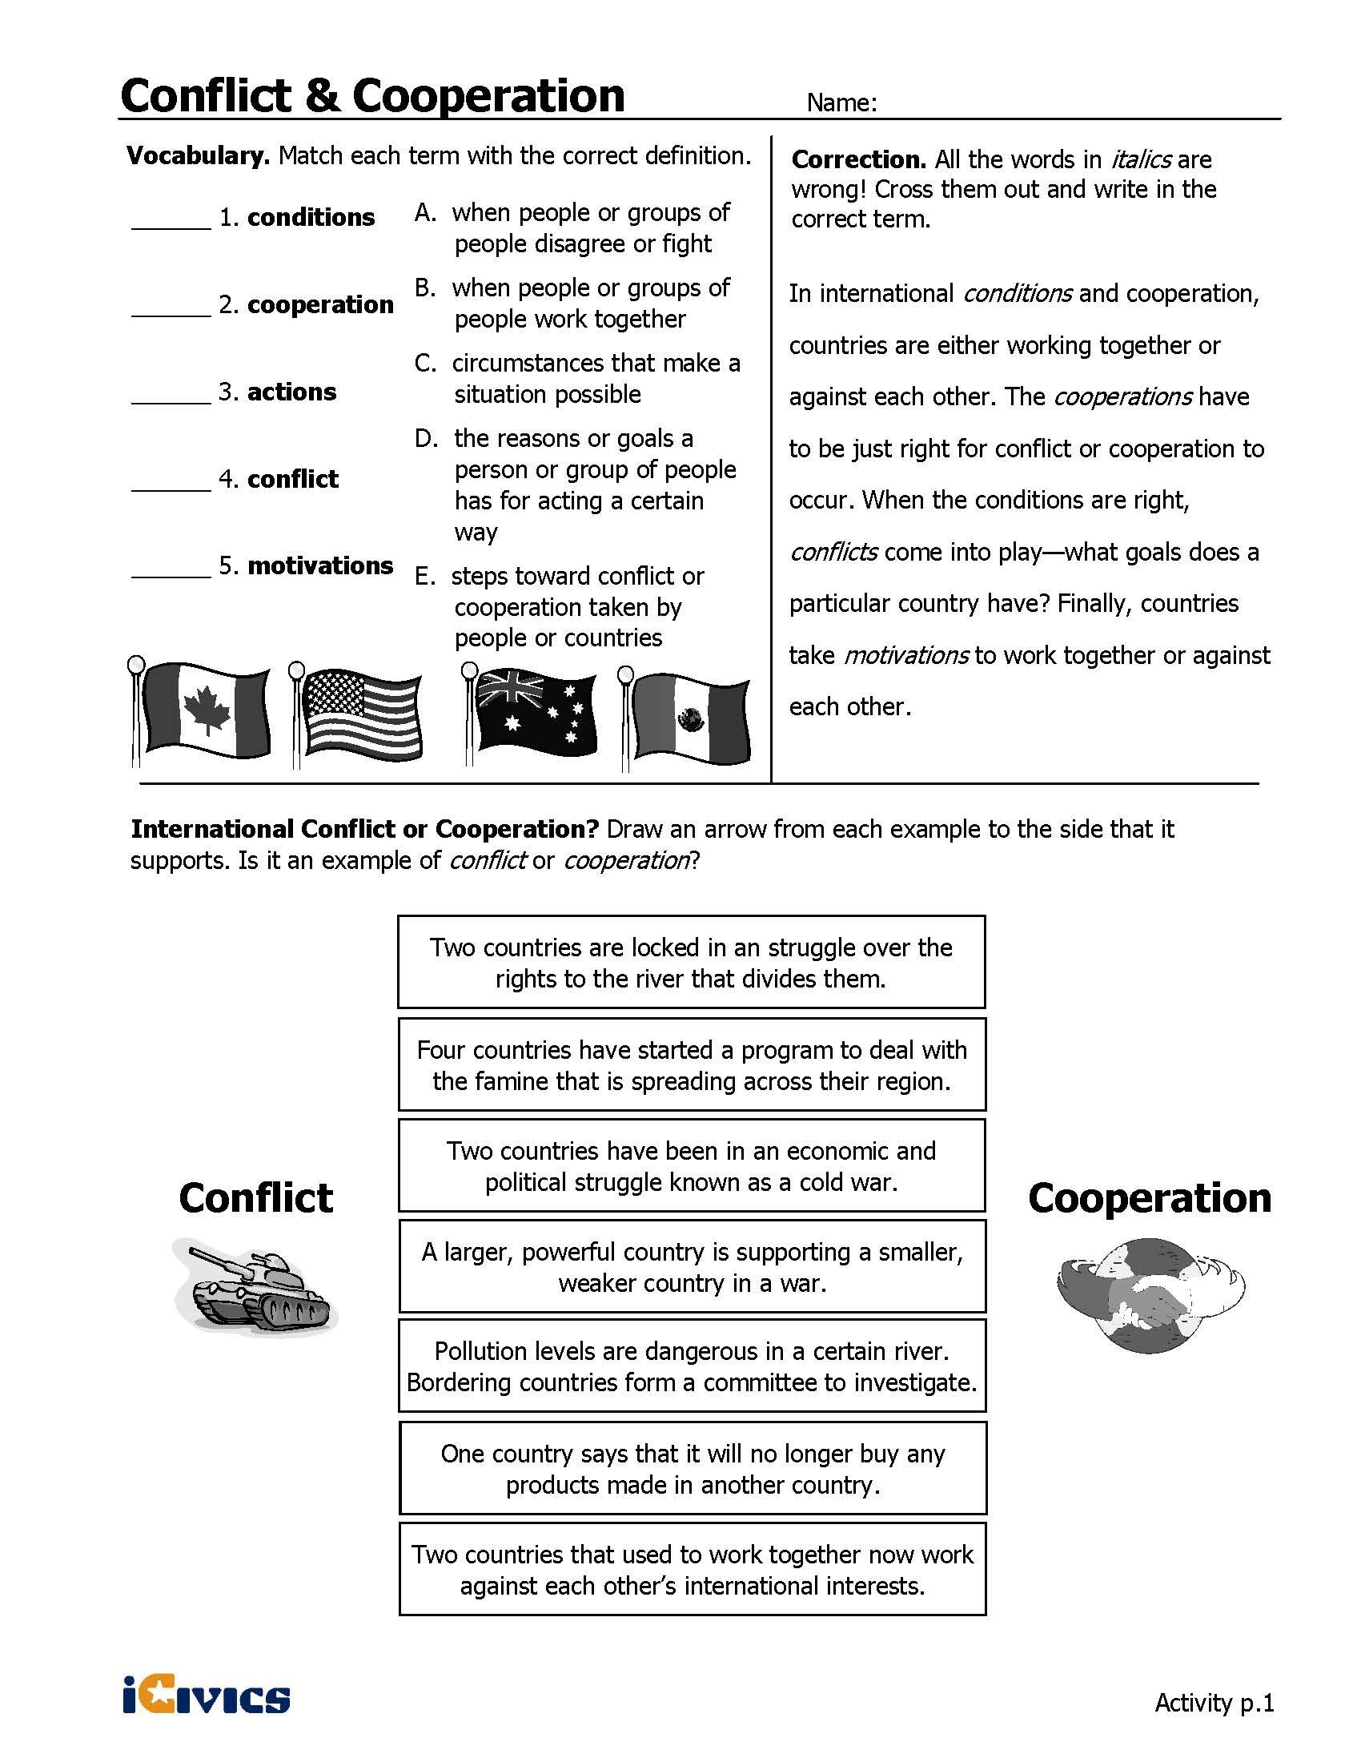
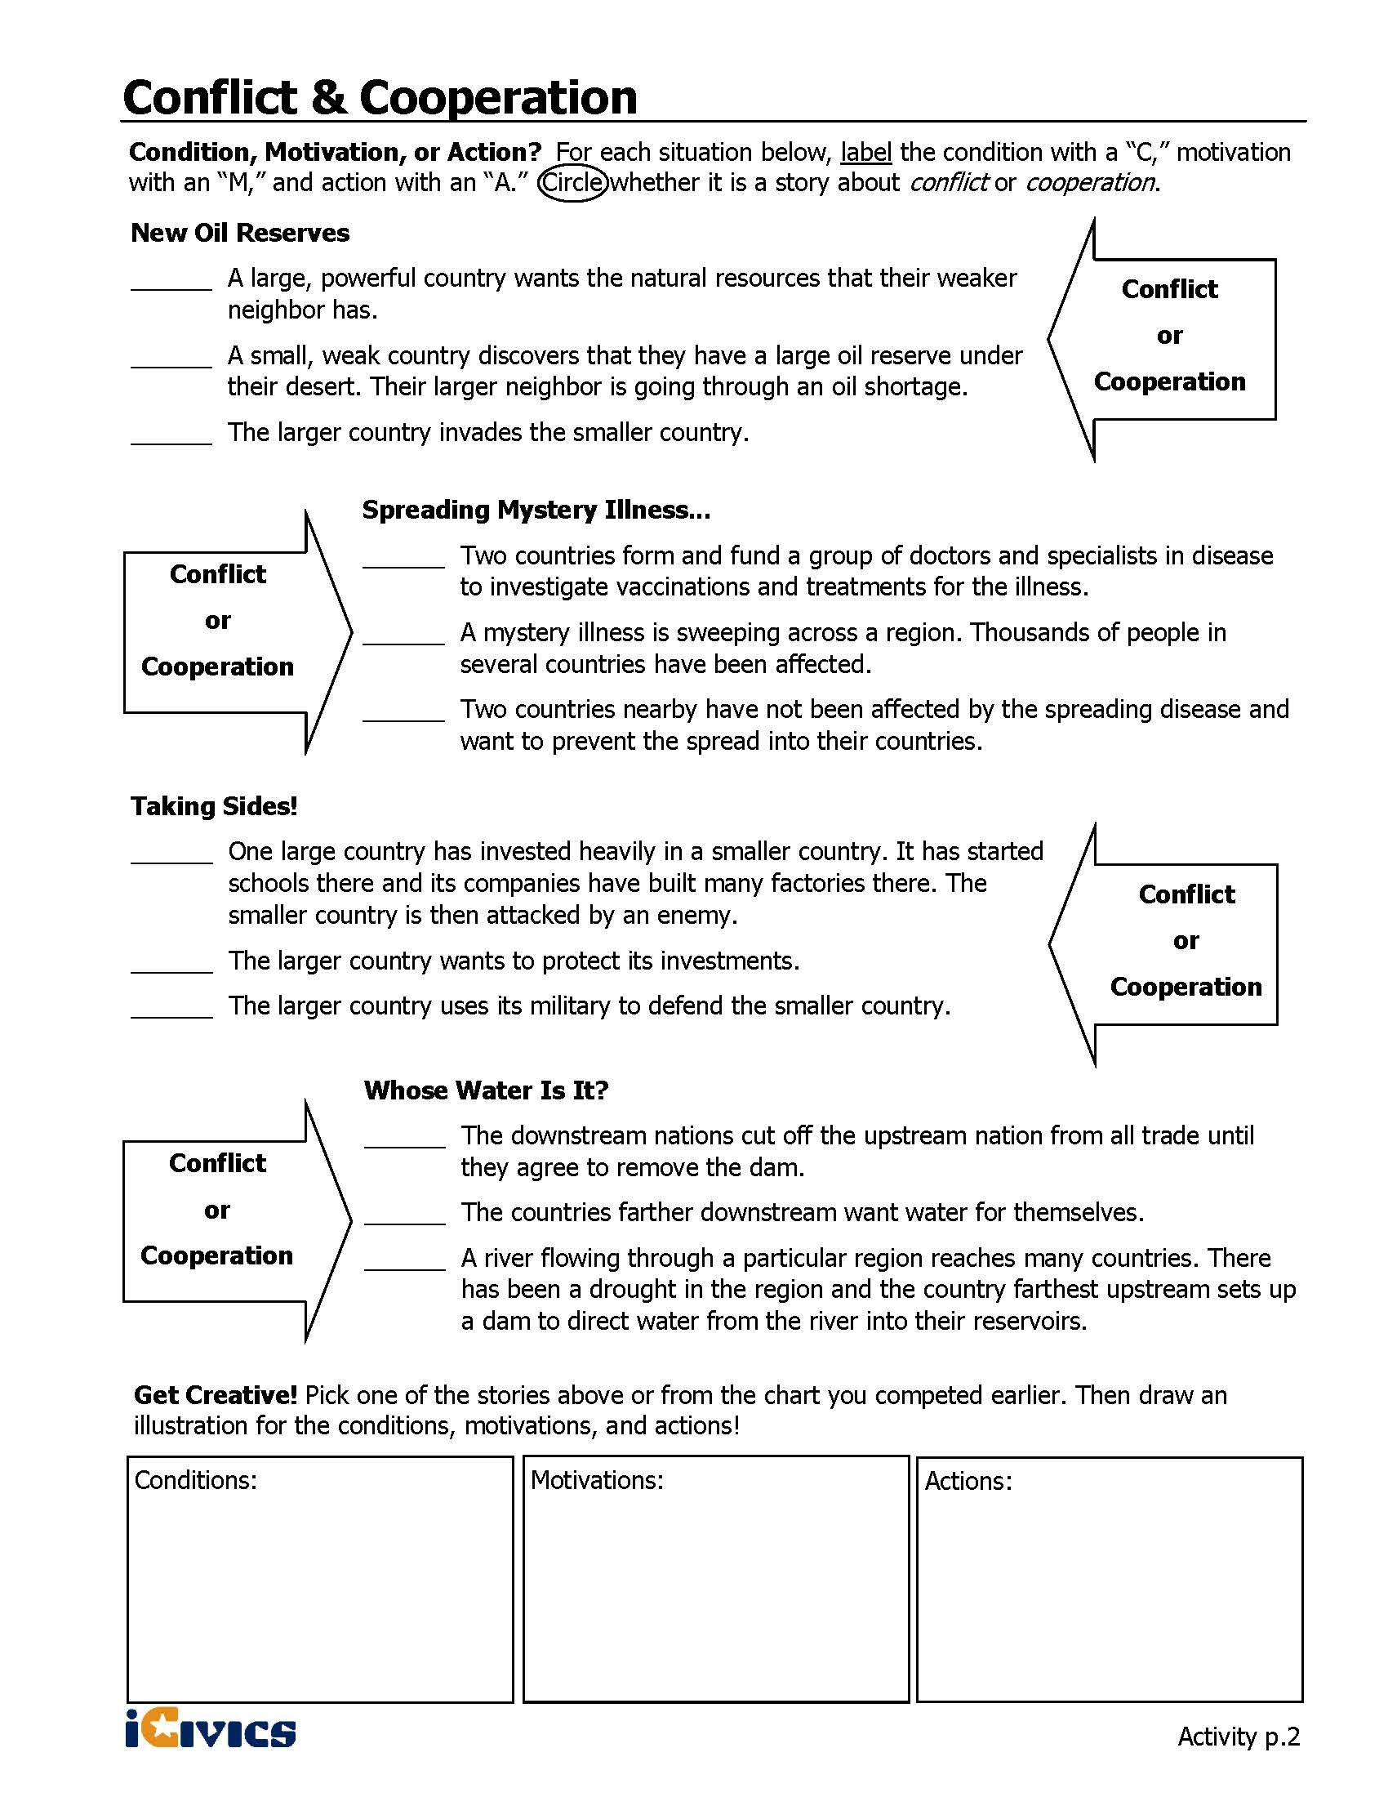
ANALYSIS ACTIVITY COMPLEX TEXT GRAPHIC ORGANIZER
For Conflict and Cooperation Reading Pages 1 and 2
Directions: After reading, cite specific evidence from the text that helps you answer each question in the first box. In the second box, summarize the evidence in your own words.

Summarize specific information from the text based on your assigned scenario.
Name of Conflict
Why did the U.S. become involved?
Evidence from Text
Summary of Text
With whom was the U.S. involved in conflict?
Evidence from Text
Summary of Text
What methods did the U.S. use to deal with the conflict (e.g., diplomacy, military action, humanitarian, or peacekeeping)?
Evidence from Text
Summary of Text
What was the outcome of the conflict?
Evidence from Text
Summary of Text
Your Opinion: Why do you think the U.S. should/should not have been involved in the conflict? What, if anything, could the U.S. have done differently?

ANALYSIS ACTIVITY COMPLEX TEXT GRAPHIC ORGANIZER
For Conflict and Cooperation Reading Pages 1 and 2

Based on what you have read in the text, define the following terms:
International Conflict

International Cooperation

Three Factors for Conflict or Cooperation
Title
Evidence from Text
Summary
of Text

Notes from Class Discussion:

SCENARIO ANALYSIS COMPLEX TEXT GRAPHIC ORGANIZER
After reading your scenario, cite specific information from the text that summarizes the answers to the questions below. Once you have completed the reading and listed your evidence, write a statement in the “Your Opinion” box that explains why you think the U.S. should/should not have been involved in the conflict and what the U.S. could have done differently (if anything).

Summarize specific information from the text based on your assigned scenario.
Name of Conflict
Why did the U.S. become involved?
Evidence from Text
Summary of Text
With whom was the U.S. involved in conflict?
Evidence from Text
Summary of Text
What methods did the U.S. use to deal with the conflict (e.g., diplomacy, military action, humanitarian, or peacekeeping)?
Evidence from Text
Summary of Text
What was the outcome of the conflict?
Evidence from Text
Summary of Text
Your Opinion: Why do you think the U.S. should/should not have been involved in the conflict? What, if anything, could the U.S. have done differently?

Presentation Notes

World War II | _____________________________________________________  _____________________________________________________  _____________________________________________________  _____________________________________________________
Korean War | _____________________________________________________  _____________________________________________________  _____________________________________________________  _____________________________________________________
Bay of Pigs | _____________________________________________________  _____________________________________________________  _____________________________________________________  _____________________________________________________
Cuban Missile Crisis | _____________________________________________________  _____________________________________________________  _____________________________________________________  _____________________________________________________
Iran Hostage Crisis | _____________________________________________________  _____________________________________________________  _____________________________________________________  _____________________________________________________
Gulf War I | _____________________________________________________  _____________________________________________________  _____________________________________________________  _____________________________________________________
Gulf War II | _____________________________________________________  _____________________________________________________  _____________________________________________________  _____________________________________________________

SCENARIO: WORLD WAR I (1914-1918)

A local European war soon became a global war that lasted from 1914-1918. World War I was the first war that involved nations (28) from around the world, and is commonly called The Great War or The War to End All Wars.

World War I - Outbreak of War

On June 28, 1914, a Serbian named Gavrilo Princip assassinated Franz Ferdinand, the Archduke of Austria, in Sarajevo. Exactly one month later, Austria-Hungary declared war on Serbia. The war divided Europe into two armed camps - on one side was the Triple Alliance made up of Germany, Austria-Hungary and Italy, and their enemy was the Triple Entente of France, Russia and Great Britain. As other countries began to join sides, the Triple Alliance became known as the Central Powers and the Triple Entente became the Allied Forces.

The Role of the United States

Most Americans favored staying out of the conflict and President Wilson publicly and formally stated that the U.S. would follow a policy of neutrality, not choosing a side. In three years, however, the U.S. would become involved in the war.

As the war in Europe raged on American sympathies were clearly on the side of the Allied Forces. When the war began, England implemented a block of German ships in the hopes of cutting off their supplies. Germany responded by using submarines, known as U Boats, to sneak up on their enemy and sink their ships. Germans did not limit their attacks to military ships. Any ship sailing in the war zone was considered an enemy. This became known as unrestricted submarine warfare. On May 7, 1915 the British cruise ship Lusitania was sunk off the coast of England. Over 1,198 passengers including 128 Americans were killed. Americas were furious and demanded a stop to this type of attack.

After this attack, President Woodrow Wilson began to actively campaign for Americans to support the Allied Forces. Besides being culturally similar, England and France were U.S. trade partners. From 1914 to 1916, trade with the Allies grew from $825 million to $3.2 billion. If the Allies were to lose the war, U.S. trade would be threatened. Americans increasingly saw Germany as the enemy. Germany was a dictatorship fighting against the more established democracies of the world. As a democratic nation, the U.S. felt obligated to support them and began fighting with the Allied Forces.

World War I - Fighting on the Front

WWI was different from previous wars because soldiers used efficient weapons like machine guns, artillery, tanks and air force. Military operations began in three major areas in Europe - the western front (France/Belgium), the eastern front (Russia) and the southern front (Serbia). Many of the deadliest battles occurred during WWI, including Ypres, Vimy Ridge, Somme and Gallipoli. Although thousands of soldiers died during these battles, they were all turning points for the Allied Forces in helping them win World War I. On October 3, 1918, Germany requested a cease-fire. The war ended on the 11th hour of the 11th day of the 11th month, when the warring parties signed the Armistice and agreed to stop fighting.

Adapted from http://www.kidzworld.com/article/5701-overview-of-world-war-i and http://www.socialstudieshelp.com/Lesson_75_Notes.htm

SCENARIO: WORLD WAR II (1939-1945)

For Americans, World War II had a clear-cut purpose. People knew why they were fighting: to defeat tyranny. Most of Europe had been conquered by Nazi Germany, which was under the control of dictator Adolf Hitler. The war in Europe began with Germany's invasion of Poland in 1939. Wherever the Nazis went, they conducted a campaign of terror, mainly against Jews, but also against other minorities. In Asia and the Pacific, Japanese armies invaded country after country, island after island. On December 7, 1941, Japanese planes bombed the U.S. Navy base at Pearl Harbor in Hawaii, a U.S. territory at the time. The next day, the U.S. Congress declared war, taking the U.S. into World War II.

What Caused World War II?
Most historians believe that the causes of World War II can be traced to World War I (1914-1918). Americans had fought in that earlier war to "make the world safe for democracy." Those were the words and goals of U.S. President Woodrow Wilson. But the peace treaties that ended World War I did not make the world safe for democracy. Instead, they caused bitterness and anger that led to World War II. Germany and its allies had been the losers in World War I. Germany was stripped of one sixth of its territory and forced to pay huge reparations (payments by a defeated country for the destruction it caused in a war). After World War I, Germany suffered from high unemployment and runaway inflation. German money became almost worthless. Many Germans were angry about the peace treaty that ended World War I. In the early 1930s, the world was hit by an economic depression. Workers lost their jobs, trade fell off, and times were hard. People looked for leaders who could bring about change.

Rise of Dictatorships
Germany, Italy, and Japan all came under the rule of dictators or military leaders. Mussolini, a dictator, took power in Italy in 1922. Military leaders took control of Japan in the early 1930s. In Germany, Adolf Hitler, leader of the Nazi Party, gained power in 1933. These leaders promised to restore their countries to greatness. But they set up totalitarian governments (A totalitarian government is controlled by a single political party that allows no opposition and tightly controls people's lives.). Hitler began to arm Germany for war. Japan invaded China. Mussolini sent Italian troops to conquer Ethiopia, in Africa.

A World at War
Hitler had a plan to conquer Europe. He began by taking Austria, then Czechoslovakia. As Winston Churchill, who became Britain's wartime leader, said, "Britain and France had to choose between war and dishonor. They chose dishonor. They will have war." Churchill's words came true. In 1939, German troops invaded Poland. World War II in Europe had begun. The U.S. did not enter the war until December 1941, but once it did, it took a leadership role. U.S. troops fought in North Africa, Europe, and the Pacific. At home, Americans rolled up their sleeves to out produce the Axis powers (Germany, Italy, and Japan) in the weapons of warplanes, battleships, and guns.

A Changed World
Germany surrendered on May 7, 1945, ending the war in Europe. The war in the Pacific did not end until after the U.S. dropped two atomic bombs on Japan — the only time such bombs were ever used in war. Japan surrendered on August 14, 1945.

Adapted from: http://www.scholastic.com/teachers/article/world-war-ii-overview

SCENARIO: THE KOREAN WAR (1950-1953)

The Korean War was fought between South Korea and communist North Korea. The war ended with little resolution and the countries are still divided today.
Before the War
Before the war, the northern half of Korea was under the control of the Soviet Union and the southern half was under the control of the U.S. The two sides were divided at the 38th parallel. Eventually two separate states formed with North Korea forming a communist government and South Korea forming a capitalist government. The two sides did not get along and there were constant clashes and battles along the border at the 38th parallel.
North Korea Attacks
On June 25, 1950 North Korea invaded South Korea. The South Korean Army fled and forces from the United Nations came to help out. Supporting North Korea were the Soviet Union and the People's Republic of China. Supporting South Korea were the United States, Great Britain, and the United Nations. The U.S. Army and United Nations forces were led by General Douglas MacArthur.

Soon the South Korean government only occupied a small part of Korea on the southern tip.

At first the United Nations and the U.S. were only trying to defend South Korea. However, after the first summer of fighting, President Truman decided to not only defend South Korea but also to try and rid North Korea of communism. General MacArthur led the UN forces on an attack and they were able to defeat much of the North Korean army. He took control of South Korea up to the 38th parallel. MacArthur continued to be aggressive and pushed the North Koreans all the way to the northern border. In response, the Chinese sent their army to enter the war. With the two sides of Korea divided at the 38th parallel, the two sides would battle at this line for the rest of the war.
End of the War

When Dwight D. Eisenhower became president of the U.S., he was willing to compromise to end the war. On July 17, 1953, a treaty ended the war. Few things had changed. Both countries would remain independent, and the border would remain at the 38th parallel. However, between the two countries a 2-mile zone was placed as a buffer in hopes to prevent future wars.

Adapted from: http://www.ducksters.com/history/cold_war/korean_war.php

SCENARIO: BAY OF PIGS INVASION (1961)

In 1961 the U.S. sent trained Cuban exiles to Cuba to try and overthrow Fidel Castro’s government because they were trying to prevent the spread of communism to the Americas. The effort failed.
Before the Invasion
Fidel Castro helped to lead the Cuban Revolution in overthrowing the existing government of Cuba in 1959. He was a strong communist and was allied with the Soviet Union. This deeply concerned the U.S. due to the fact that this gave communism and the Soviet Union a place in the Americas. The CIA, or Central Intelligence Agency, was tasked with overthrowing Fidel Castro's government in Cuba. There were many people from Cuba who fled the country when Fidel Castro became leader. The people who fled were considered exiles. The CIA began to train these exiles. The idea was that they would sneak back into Cuba and begin a war against Castro. They would gather others and eventually overthrow Castro. The plan changed, however. The new plan was to help the exiles to invade the island, get the locals to join forces, and quickly take over.
Planning the Invasion
The invasion was originally planned to occur at the city of Trinidad, but President Kennedy thought that they needed a more isolated place. The Bay of Pigs was chosen instead. The idea was that planes would fly in first and destroy the Cuban air force. Then 1500 soldiers would land and they would try to convince people to join them in rebelling against Castro. The CIA tried to plan the invasion in secret, however, too many people knew and word got out. The Cubans knew the invasion was coming.
The Invasion
The invasion occurred on April 17, 1961. It did not go well. Although the Cuban air force was damaged by early air strikes, there were still Cuban planes left to attack the invaders. Once the invasion started, it took too long for the troops and ammunition to get off the ships. Before the ammunition could be unloaded, Cuban planes sunk the invader's ships. Some of the troops who were supposed to slow down Castro's forces on the ground landed at the wrong place or in the swamps. Soon the invaders were surrounded by a much larger force and were running out of bullets. They tried to retreat, but most were eventually captured and imprisoned.
Results
The result for the U.S. was that the U.S. government, especially the CIA, looked weak. It also seemed to strengthen Castro's government within Cuba and caused him to look to the Soviet Union as a military ally.

Adapted from: http://www.ducksters.com/history/cold_war/bay_of_pigs.php

SCENARIO: THE CUBAN MISSILE CRISIS (1962)

The Cuban Missile Crisis occurred in 1962 when the Soviet Union began to place nuclear missiles in Cuba. The U.S. government refused to allow this and, after 13 tense days and many secret negotiations, the Soviet Union agreed to remove the missiles.
Leading up to the Crisis
The U.S. put several nuclear missile sites in Turkey and Italy that were within range to strike Moscow, the capital of the Soviet Union. As a result, the Soviet Union government believed they needed missile sites that could strike at the U.S. At the same time the Cuban government wanted protection from the United States. They decided to work together and have the Soviet Union put nuclear missiles in Cuba that could strike the U.S.
How the Crisis Began
On October 14, 1962 an American spy plane flying over Cuba captured pictures of long-range Soviet missiles in Cuba. The missiles could reach any place in the U.S. and cause mass destruction. President Kennedy called a meeting with his main security advisors. President Kennedy and his advisers considered a number of options from diplomacy to a full attack and invasion of Cuba. The Joint Chiefs of Staff recommended an invasion to the president. They believed it was the only practical option. However, Kennedy was concerned that this would start World War III between the U.S. and the Soviet Union. Instead, he decided to set up a naval blockade.
Blockade
Kennedy announced his plan on October 22, 1962. He showed the world the missile bases in Cuba and said that the U.S. would block Cuba from receiving any additional weapons. He also said that any attack on the U.S. from Cuba would be considered an act of war from the Soviet Union. Over the next several days the crisis became more intense. The Soviet Union said they would not back down. By October 24th, Kennedy believed the U.S. would have to invade Cuba.
Negotiations
Although the Soviet Union publicly said they would not back down, they secretly negotiated with the U.S. Eventually the two sides reached an agreement. The Soviet Union would remove the missiles from Cuba as long as the United States agreed to never invade Cuba again. In secret, the U.S. also had to agree to remove their nuclear missiles from Turkey and Italy. The crisis was over, and it was seen as President Kennedy's greatest moment of world leadership.

Adapted from: http://www.ducksters.com/history/cold_war/cuban_missile_crisis.php

SCENARIO: THE IRAN HOSTAGE CRISIS (1979-1981)

The Iran hostage crisis occurred after the capture of the American embassy in Tehran, Iran by Iranian students on Nov. 4, 1979.

What Happened?

For several decades the United States had been the primary supporter of Muhammad Reza Shah Pahlevi, referred to as the Shah. The Shah was the primary leader of the autocracy in Iran. Eight U.S. presidents provided the Shah with military and economic aid in exchange for oil. Some people in Iran were opposed to the Shah because he did not grant the people freedoms he promised in the 1960s. These people were also opposed to Americans because the U.S. was supporting the Shah. On January 16, 1979 the Shah and his family were forced to flee Iran due to extreme protests against his leadership. Following the Shah's departure, conservative Muslims led by the Ayatollah Ruhollah Khomeini staged a revolt, abolishing the Shah’s government and establishing an Islamic Republic.

On November 1, 1979 Khomeini urged his people to demonstrate against the U.S. On November 4 thousands gathered around the U.S. embassy in protest and the embassy was taken by force by members of the crowd. Out of 90 occupants in the U.S. Embassy in Tehran, 66 were originally taken captive. The hostages were often shown blindfolded to local crowds and television cameras.

What Was The U.S. Response?

President Carter decided to use economic pressure in this situation by stopping oil imports from Iran and freezing Iranian bank accounts in the United States. At the same time, he began several diplomatic initiatives to free the hostages, all of which failed. On Apr. 24, 1980, the U.S. attempted a rescue mission that also failed.

Resolution

In the United States, the failure to resolve the crisis contributed to Ronald Reagan's defeat of Jimmy Carter in the 1980 presidential election. After the election, successful negotiations began. On January 20, 1981, the day of President Reagan's inauguration, the United States unfroze around $1 billion in Iranian assets, and the hostages were freed after 444 days.

Adapted from: http://www.infoplease.com/encyclopedia/history/iran-hostage-crisis.html, http://encyclopedia.kids.net.au/page/mo/Mohammad_Reza_Pahlavi_of_Iran and
http://academickids.com/encyclopedia/index.php/Iran_Hostage_Crisis

SCENARIO: GULF WAR I (1991)

The First Gulf War, also known as the Persian Gulf War, took place during January and February 1991. This conflict was between Iraq and a coalition of 32 nations including the United States, Britain, Egypt, France, and Saudi Arabia.

How Did It Start?

Iraq’s president Saddam Hussein invaded the country of Kuwait and declared that the invasion was a response to overproduction of oil in Kuwait. This overproduction cost Iraq an estimated $14 billion a year because oil prices fell. Hussein also accused Kuwait of illegally pumping oil from an Iraqi oil field. Both of these reasons resulted in Iraq's invasion of Kuwait on Aug. 2, 1990.

What Did Other Countries Do?

The United Nations Security Council called for Iraq to withdraw from Kuwait and the U.S. stopped most trade with Iraq. On August 7, U.S. troops moved into Saudi Arabia to protect Saudi oil fields because Saudi Arabia borders Iraq and Kuwait. On November 29, 1990 the United Nations set January 15, 1991, as the deadline for a peaceful withdrawal of Iraqi troops from Kuwait. When Saddam Hussein refused, Operation Desert Storm was launched on Jan. 18, 1991.

The U.S.-led coalition of nations began a massive air war to destroy Iraq's military and their public works system. The coalition forces invaded Kuwait and southern Iraq on Feb. 24 and, over the next four days, defeated the Iraqis and freed Kuwait. When U.S. President George H. W. Bush declared a cease-fire on Feb. 28, most of the Iraqi forces in Kuwait had either surrendered or fled.

What Was The Result?

Although the war was a military victory for the coalition, Kuwait and Iraq suffered enormous property damage, and Saddam Hussein was not removed from power. Iraq agreed to peace terms but every effort was made by the Iraqis to disobey the terms, particularly the required weapons inspections by the United Nations.

Adapted from: http://education.yahoo.com/reference/encyclopedia/entry/PersGWar, Accessed April 2013

SCENARIO: GULF WAR II (IRAQ WAR) (2002-2009)

After the first Gulf War, the United Nations Security Council adopted Resolution 687. This resolution stated that all Iraq long-range missiles, nuclear, biological and chemical weapons must be destroyed.
On September 11, 2001 the United States was subjected to multiple terror attacks on the World Trade Center in New York City and the Pentagon, just outside Washington, DC. After these attacks, President George W. Bush accused Iraq of developing weapons that violated UN Security Council Resolution 687; the president wanted to make sure that UN weapons inspectors were allowed full access to Iraq. Through late 2002 and into 2003, Iraq reluctantly allowed weapons inspectors back in the country and seemed to be making progress, but President Bush was not satisfied.
The Iraq War Starts
On March 20th, 2003, the Iraq War began when the United States led a coalition of about 40 countries into battle with Iraq. Most of the forces were U.S. and British forces. The coalition invasion combined land, air and water assaults and moved through Iraq until the coalition forces controlled most of the large cities. On April 15th, 2003, the invasion was declared complete. Over the rest of 2003 the coalition forces began to hunt down and capture all government figures from former Iraqi President Saddam Hussein’s leadership. This included the capture of Saddam Hussein in December 2003.
The War Changes
There were small-scale attacks on the U.S.-led forces after the invasion. Over time, these attacks became constant and increasingly deadly. Through 2004, both U.S.-led forces and Iraqi civilians were being attacked. The first election of an Iraqi government under the new constitution took place in 2005. That year also saw the heaviest attacks on the coalition forces and civilians. The new Iraqi government also took office in 2006, and former President Saddam Hussein was executed for his crimes against Iraq in December.
In 2007 there was a massive increase in U.S. forces in Iraq, and the attacks on them decreased. This was also the year when the Iraqi government voted in favor of coalition forces leaving the nation. In 2008, Iraq was finally able to start defending itself as the new Iraqi army was formed and its troops started basic training.
Conclusion
Since 2009, President Obama has reduced the number of troops in Iraq as the Iraqi armed forces started controlling the security of their own nation. While the situation in Iraq is not completely stable, the U.S. has greatly decreased its role there and is no longer at war with Iraq.
Adapted from: http://www.thefinertimes.com/War-in-The-Middle-East/iraq-war-summary.html

March 19, 2008
Five Years
By JOHN F. BURNS
Copyright 2008 The New York Times Company

Five years on, it seems like a dream. On the evening of March 19, 2003, a small group of Western journalists had grandstand seats for the big event in Baghdad, the start of the full-scale American bombing of strategic targets in the Iraqi capital. We had forced a way through a bolted door at the top of an emergency staircase leading to the 21st-story roof of the Palestine Hotel, with a wide view of Saddam Hussein’s command complex across the Tigris River.

The bombing had been jump-started 16 hours earlier, when President Bush ordered two B-1 bombers to attack the Dora Farms complex in south-central Baghdad in a dawn raid intended to kill Mr. Hussein and end the war before it began. That caught everyone by surprise, including Saddam, who somehow survived. But by nightfall, the city was braced. The BBC reported B-52 bombers were taking off from a base in England in early afternoon, and we knew that zero hour for Baghdad would be about 9 p.m. At precisely that moment — not a few seconds early or late — the first cruise missile struck the vast, bunker-like presidential command complex in what would become, under the American occupation, the Green Zone. For 40 minutes, followed by a break, and then another 40 minutes, many missiles and bombs struck palaces, military complexes, intelligence buildings, the heart of Saddam Hussein’s years of murderous tyranny. In Washington, they called it “shock and awe.” In Baghdad, Iraqis yearning for their liberation from Saddam called it, simply, “the air show.”

As they must have to many Americans watching the live television coverage, those missiles and bombs seemed, in the headiness of that moment, to be the right punishment for a terrible dictator, and the horror he had visited on Iraq’s people. The strikes were very accurate in the beginning, with only isolated instances, during the 19 days before American troops reached Baghdad, of stray missiles killing innocent civilians. Early one morning, I went to the smoking wreckage of the city’s central telephone exchange, only to find patients from Iraq’s main heart hospital, 150 feet away, across a narrow lane, uninjured, out in the garden in their pajamas watching the commotion.

It was not long, of course, before events in Iraq began giving everybody cause to reconsider. On April 9, the day the Marines entered Baghdad and used one of their tanks to help the crowd haul down Saddam’s statue, American troops stood by while mobs began looting palaces, museums and hospitals. Late in the day, at the oil ministry, I discovered it was the only building marines had orders to protect. Turning to Jon Lee Anderson, a correspondent for The New Yorker who had been my companion that day, I saw shock mirrored in his face. “Say it ain’t so,” I said. But it was.

Looking back, it has been fashionable to say the Americans began losing the war right then. At the least, it was the first misstep in what quickly became a long chronicle: the failure to find weapons of mass destruction, the primary cause the Bush Administration had given for the war; the absence of a plan, at least any the Pentagon intended to use, for the period after Baghdad fell; the breaking apart of the Iraqi Army, and thus casting aside the help it might have given in dealing with armed opponents of the U.S., who started fighting within 10 days of American troops entering Baghdad; the lack of an effective American strategy, at least until the troop increase last year finally began bringing the war’s toll down.

At the fifth anniversary, the conflict’s heavy burden challenges those who hoped Mr. Hussein’s removal might be accomplished at an acceptable cost. Back in 2003, only a few could have guessed that the current “surge” would raise the American troop commitment above 160,000, the highest level since the invasion, in the war’s fifth year, or that the toll would include tens of thousands of Iraqi civilians killed, as well over 4,000 American troops; or that America’s costs would rise above $650 billion by 2008, on their way to perhaps $2 trillion if the commitment continues for another five years. Beyond that, there are a million or more Iraqis living as refugees in neighboring Arab countries, and the pitiful toll of fear and poverty on Iraqi streets.

They know, too, about the deep divisions of ethnicity, religion, and tribe that were kept hidden for 25 years by Mr. Hussein’s totalitarian rule. As much as America’s policy failures, these factors have contributed to the mess in Iraq. If fully considered, they might have given people second thoughts about the wisdom of the invasion. What seems certain is that those entrusted with the task of fulfilling the American mission were confronted, from the beginning, with the odds stacked against them. Iraq, in 2003, could not have been more unprepared to embrace democracy, since democracy depends on popular consent and trust.

Discuss the following questions:
      - According to the article, how did Mr. Burns’ perspective of the war change during his time in Iraq?
      - What events and images had the most impact on him during his five-year assignment?
      - Why were Mr. Burns and New Yorker correspondent Jon Lee Anderson shocked in April of 2003?
      - What do you think Mr. Burns means when he writes, “Back in 2003, only a few could have guessed” what would happen during the war?
      - Generally, what conclusions can you draw about this reporter’s experiences covering the war based on this article?
      - What conclusions, if any, can you draw about the war itself based on this article?
      - What perspectives do you think might be missing from this account? Why?

Excerpts from Zlata’s Diary: A Child’s Life in Sarajevo
(Zlata Filipovic. New York: Penguin Books, 1994)
Sunday, April 12, 1992: “I keep thinking about the march I joined today. It’s bigger and stronger than war. That’s why it will win. The people must be the ones to win, not the war, because war has nothing to do with humanity. War is something inhuman.”

Monday, June 29, 1992: “That’s my life! The life of an innocent eleven-year-old schoolgirl!! A schoolgirl without school, without the fun and excitement of school. A child without games, without friends, without the sun, without birds, without nature, without fruit, without chocolate or sweets, with just a little powdered milk. In short, a child without a childhood. A wartime child. I now realize that I am really living through a war, I am witnessing an ugly, disgusting war. I and thousands of other children in this town that is being destroyed, that is crying, weeping, seeking help, but getting none. God, will this ever stop, will I ever be a schoolgirl again, will I ever enjoy my childhood again? I once heard that childhood is the most wonderful time of your life. And it is. I loved it, and now an ugly war is taking it all away from me.”

Monday, March 15, 1993: “There are no trees to blossom and no birds, because the war has destroyed them as well. There is no sound of birds twittering in springtime. There aren’t even any pigeons—the symbol of Sarajevo. No noisy children, no games. Even the children no longer seem like children. They’ve had their childhood taken from them, and without that they can’t be children. It’s as if Sarajevo is slowly dying, disappearing. Life is disappearing. So how can I feel spring, when spring is something that awakens life, and here there is no life, here everything seems to have died.”

Thursday, November 19, 1992: “I keep wanting to explain these stupid politics to myself, because it seems to me that politics caused this war, making it our everyday reality. War has crossed out the day and replaced it with horror, and now horrors are unfolding instead of days. It looks to me as though these politics mean Serbs, Croats and Muslims. But they are all people. They are all the same. They look like people, there’s no difference…but now there’s ‘something’ that wants to make them different.”

Saturday, July 17, 1993: “Suddenly, unexpectedly, someone is using the ugly powers of war, which horrify me, to try to pull and drag me away from the shores of peace, from the happiness of wonderful friendships, playing and love. I feel like a swimmer who was made to enter the cold water, against her will. I feel shocked, sad, unhappy and frightened and I wonder where they are forcing me to go, I wonder why they have taken away my peaceful and lovely shores of my childhood. I used to rejoice at each new day, because each was beautiful in its own way. I used to rejoice at the sun, at playing, at songs. In short, I enjoyed my childhood. I had no need of a better one. I have less and less strength to keep swimming in these cold waters. So take me back to the shores of my childhood, where I was warm, happy and content, like all the children whose childhood and the right to enjoy it are now being destroyed.”

Monday, December 28, 1992: “...I look over at Mommy and Daddy. ... Somehow they look even sadder to me in the light of the oil lamp. ... God, what is this war doing to my parents? They don’t look like my old Mommy and Daddy anymore. Will this ever stop? Will our suffering stop so that my parents can be what they used to be—cheerful, smiling, nice-looking?”

Saturday, July 10, 1993: I’m reading through my letters. Letters are all I’ve got left of my friends. I read them and they take me back to my friends.”

Monday, August 2, 1993: “Some people compare me with Anne Frank. That frightens me, Mommy. I don’t want to suffer her fate.”

Questions about Zlata’s Diary

- Zlata calls war “inhuman.” What does she mean by this statement?

- Why are the writer's details important?

- How do they help you as the reader?

- What do they tell us about the Zlata?

- What questions do you have about Zlata and her life?

- What do you and Zlata have in common?

- What effects do wars have on families?

Sources
U.S. State Department’s website: http://www.state.gov/
United Nations websites: https://peacekeeping.un.org/en and http://www.un.org/en/sections/what-we-do/deliver-humanitarian-aid/
Conflict and Cooperation, iCivics Lesson Plan http://www.icivics.org/teachers/lesson-plans/conflict-and-cooperation
New York Times Slide Show on Iraq: http://www.nytimes.com/slideshow/2007/11/15/arts/1118-GILB_2.html
World War I Reading: Adapted from http://www.kidzworld.com/article/5701-overview-of-world-war-i and http://www.socialstudieshelp.com/Lesson_75_Notes.htm
World War II Reading: Adapted from http://www.scholastic.com/teachers/article/world-war-ii-overview
“Day of Infamy” Speech Audio File: https://catalog.archives.gov/id/1436350
Korean War Reading: Adapted from http://www.ducksters.com/history/cold_war/korean_war.php
Bay of Pigs Reading: Adapted from
http://www.ducksters.com/history/cold_war/bay_of_pigs.php
Cuban Missile Crisis Reading: Adapted from
http://www.ducksters.com/history/cold_war/cuban_missile_crisis.php
Iran Hostage Crisis: Adapted from: http://www.infoplease.com/encyclopedia/history/iran-hostage-crisis.html, http://encyclopedia.kids.net.au/page/mo/Mohammad_Reza_Pahlavi_of_Iran and
http://academickids.com/encyclopedia/index.php/Iran_Hostage_Crisis
Gulf War I Reading Adapted from: http://education.yahoo.com/reference/encyclopedia/entry/PersGWar, Accessed April 2013
Gulf War II Reading Adapted from: http://www.thefinertimes.com/War-in-The-Middle-East/iraq-war-summary.html
“Five Years” Essay: http://www.nytimes.com/2008/03/16/weekinreview/16jburns.html?pagewanted=all&_r=0
Balkan War and Zlata’s Diary Sources:
http://www.teachervision.fen.com/writing/lesson-plan/3514.html
http://school.discoveryeducation.com/lessonplans/activities/childrenofwar/questions.html, Accessed April 2013
http://www.bbc.co.uk/news/world-europe-17632399

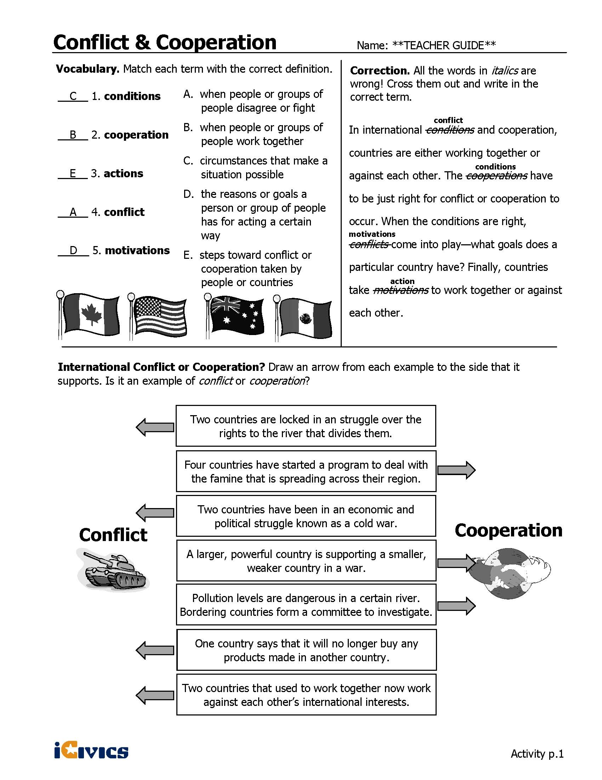
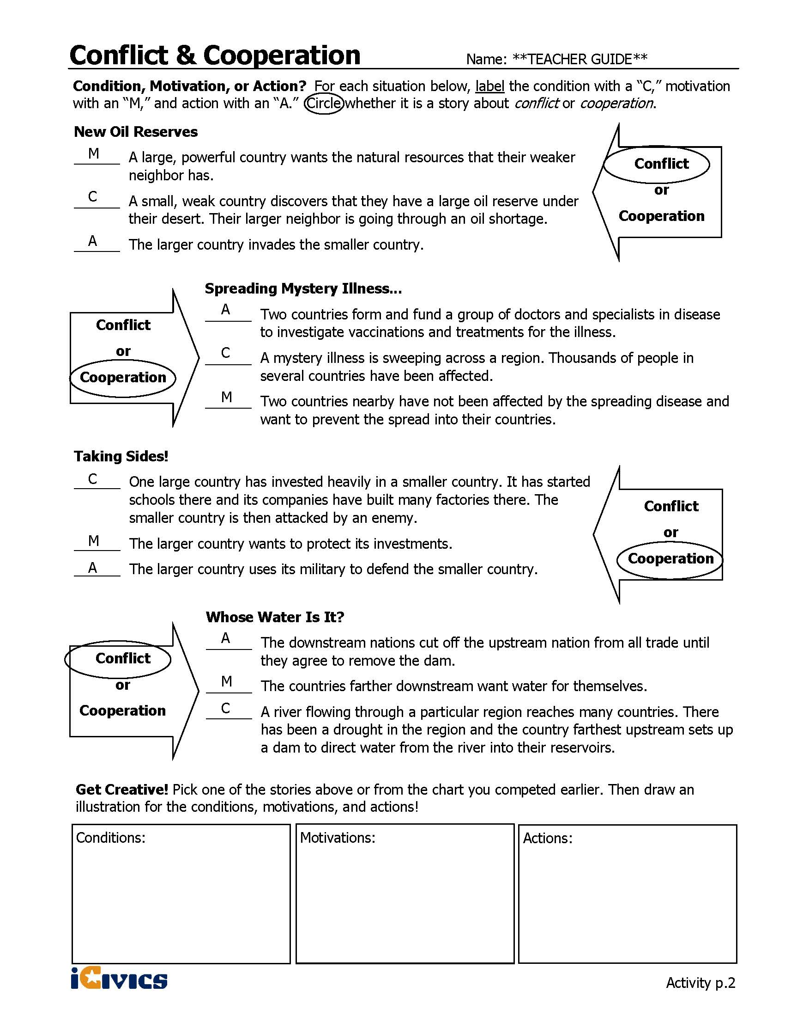
ANALYSIS ACTIVITY COMPLEX TEXT GRAPHIC ORGANIZER – Sample Answers
For Conflict and Cooperation Reading Pages 1 and 2
Directions: After reading, cite specific evidence from the text that helps you answer each question in the first box. In the second box, summarize the evidence in your own words.

Summarize specific information from the text based on your assigned scenario.
Name of Conflict |  | Vietnam War
Why did the U.S. become involved?
Evidence from Text | In order to stop the spread of communism, the United States became involved in the war and supported southern Vietnam.
Summary of Text | A civil war was being fought between North and South Vietnam because communists wanted to take over South Vietnam. The U.S. got involved to stop the spread of communism and the growing power of the Chinese, who supported North Vietnam.
With whom was the U.S. involved in conflict?
Evidence from Text | At the same time, northern Vietnam got support from China, a large and powerful communist country that supported the communist takeover of southern Vietnam.
Summary of Text | The North Vietnamese and the Chinese.
What methods did the U.S. use to deal with the conflict (e.g., diplomacy, military action, humanitarian, or peacekeeping)?
Evidence from Text | For many years, the military worked with southern Vietnam to fight the communist north. The American and southern Vietnamese militaries used a combination of ground attacks and air power to fight the north.
Summary of Text | Military action by supporting the South Vietnamese;  Additional note: diplomacy when the U.S. had to admit defeat by the North Vietnamese.
What was the outcome of the conflict?
Evidence from Text | …the northern army was victorious. In 1975, they captured the South Vietnamese capital city, and the entire country of Vietnam became communist.
Summary of Text | North Vietnamese troops were victorious.
Based on what you have read in the text, define the following terms:
International Conflict
International conflict happens when countries disagree.
International Cooperation
International cooperation happens when countries have something to gain by working together to solve problems. Countries may cooperate in order to avoid going to war or to manage a resource.

Three Factors for Conflict or Cooperation
Title | Conditions | Motivations | Actions
Evidence from Text | Conditions are the circumstances that cause something to happen. | Motivations are the reasons or goals that cause a country to act. | Conditions and motivations push countries toward actions. These actions can be military, political, economic, or a combination of all three.

SCENARIO ANALYSIS COMPLEX TEXT GRAPHIC ORGANIZER – Sample Answers
Summarize specific information from the text based on your assigned scenario.
Name of Conflict |  | World War I
Why did the U.S. become involved?
Evidence from Text | On May 7, 1915 the British cruise ship Lusitania was sunk off the coast of England. Over 1,198 passengers including 128 Americans were killed. Americas were furious and demanded a stop to this type of attack. As a democratic nation, the U.S. felt obligated to support them and began fighting with the Allies.
Summary of Text | After the sinking of the Lusitania, the U.S. entered the war and fought with the Allied Forces.
With whom was the U.S. involved in conflict?
Evidence from Text | The war divided Europe into two armed camps - on one side was the Triple Alliance made up of Germany, Austria-Hungary and Italy
Summary of Text | Germany, Austria-Hungary, and Italy
What methods did the U.S. use to deal with the conflict (e.g., diplomacy, military action, humanitarian, or peacekeeping)?
Evidence from Text | As a democratic nation, the U.S. felt obligated to support them and began fighting with the Allied Forces.
Summary of Text | military action
What was the outcome of the conflict?
Evidence from Text | …they were all turning points for the Allied Forces in helping them win World War I. On October 3, 1918, Germany requested a cease-fire. The war ended on the 11th hour of the 11th day of the 11th month, when the warring parties signed the Armistice and agreed to stop fighting.
Summary of Text | The Allied Forces won the war.

Summarize specific information from the text based on your assigned scenario.
Name of Conflict |  | World War II
Why did the U.S. become involved?
Evidence from Text | On December 7, 1941, Japanese planes bombed the U.S. Navy base at Pearl Harbor in Hawaii, a U.S. territory at the time. The next day, the U.S. Congress declared war, taking the U.S. into World War II.
Summary of Text | After the bombing at Pearl Harbor, the U.S. entered World War II.
With whom was the U.S. involved in conflict?
Evidence from Text | the Axis powers (Germany, Italy, and Japan)
Summary of Text | Germany, Italy, and Japan
What methods did the U.S. use to deal with the conflict (e.g., diplomacy, military action, humanitarian, or peacekeeping)?
Evidence from Text | The U.S. did not enter the war until December 1941, but once it did, it took a leadership role. U.S. troops fought in North Africa, Europe, and the Pacific.
Summary of Text | military action
What was the outcome of the conflict?
Evidence from Text | Germany surrendered on May 7, 1945, ending the war in Europe. The war in the Pacific did not end until after the U.S. dropped two atomic bombs on Japan — the only time such bombs were ever used in war. Japan surrendered on August 14, 1945.
Summary of Text | Germany and Japan surrendered.

Summarize specific information from the text based on your assigned scenario.
Name of Conflict |  | Korean War
Why did the U.S. become involved?
Evidence from Text | On June 25, 1950 North Korea invaded South Korea. The South Korean Army fled and forces from the United Nations came to help out. The U.S. provided most of the United Nations forces.
Summary of Text | The U.S. became involved after North Korea invaded South Korea.
With whom was the U.S. involved in conflict?
Evidence from Text | Supporting North Korea were the Soviet Union and the People's Republic of China. Supporting South Korea were the United States, Great Britain, and the United Nations.
Summary of Text | North Korea, Soviet Union, and the People’s Republic of China
What methods did the U.S. use to deal with the conflict (e.g., diplomacy, military action, humanitarian, or peacekeeping)?
Evidence from Text | At first the United Nations and the U.S. were only trying to defend South Korea. However, after the first summer of fighting, President Truman decided to not only defend South Korea but also to try and rid North Korea of communism.
Summary of Text | military action
What was the outcome of the conflict?
Evidence from Text | On July 17, 1953, a treaty ended the war. Both countries would remain independent, and the border would remain at the 38th parallel. However, between the two countries a 2-mile zone was placed as a buffer in hopes to prevent future wars.
Summary of Text | A treaty ended the war.

Summarize specific information from the text based on your assigned scenario.
Name of Conflict |  | Bay of Pigs Invasion
Why did the U.S. become involved?
Evidence from Text | In 1961 the U.S. sent trained Cuban exiles to Cuba to try and overthrow Fidel Castro’s government because they were trying to prevent the spread of communism to the Americas.
Summary of Text | The U.S. wanted to prevent the spread of communism to the Americas.
With whom was the U.S. involved in conflict?
Evidence from Text | Fidel Castro helped to lead the Cuban Revolution in overthrowing the existing government of Cuba in 1959. He was a strong communist and was allied with the Soviet Union. This deeply concerned the U.S. due to the fact that this gave communism and the Soviet Union a place in the Americas.
Summary of Text | The Soviet Union and Fidel Castro of Cuba.
What methods did the U.S. use to deal with the conflict (e.g., diplomacy, military action, humanitarian, or peacekeeping)?
Evidence from Text | The CIA began to train these exiles. The idea was that they would sneak back into Cuba and begin a war against Castro. They would gather others and eventually overthrow Castro. The plan changed, however. The new plan was to help the exiles to invade the island, get the locals to join forces, and quickly take over.
Summary of Text | military action
What was the outcome of the conflict?
Evidence from Text | The result for the U.S. was that the U.S. government, especially the CIA, looked weak. It also seemed to strengthen Castro's government within Cuba and caused him to look to the Soviet Union as a military ally.
Summary of Text | The invasion was not a success and it made the situation between the U.S. and the Soviet Union worse than before the invasion.

Summarize specific information from the text based on your assigned scenario.
Name of Conflict |  | The Cuban Missile Crisis
Why did the U.S. become involved?
Evidence from Text | The Cuban Missile Crisis occurred in 1962 when the Soviet Union began to place nuclear missiles in Cuba. The U.S. government refused to allow this and, after 13 tense days and many secret negotiations, the Soviet Union agreed to remove the missiles.
Summary of Text | The U.S. wanted to prevent the Soviet Union from placing nuclear missiles in Cuba.
With whom was the U.S. involved in conflict?
Evidence from Text | On October 14, 1962 an American spy plane flying over Cuba captured pictures of long-range Soviet missiles in Cuba. The missiles could reach any place in the U.S. and cause mass destruction. President Kennedy called a meeting with his main security advisors. President Kennedy and his advisers considered a number of options from diplomacy to a full attack and invasion of Cuba.
Summary of Text | The Soviet Union and Cuba.
What methods did the U.S. use to deal with the conflict (e.g., diplomacy, military action, humanitarian, or peacekeeping)?
Evidence from Text | Although the Soviet Union publicly said they would not back down, they secretly negotiated with the U.S. Eventually the two sides reached an agreement. The Soviet Union would remove the missiles from Cuba as long as the United States agreed to never invade Cuba again.
Summary of Text | diplomacy
What was the outcome of the conflict?
Evidence from Text | The Soviet Union would remove the missiles from Cuba as long as the United States agreed to never invade Cuba again. In secret, the U.S. also had to agree to remove their nuclear missiles from Turkey and Italy. The crisis was over, and it was seen as President Kennedy's greatest moment of world leadership.
Summary of Text | The crisis ended with the Soviet Union and the U.S. both removing missiles.

Summarize specific information from the text based on your assigned scenario.
Name of Conflict |  | The Iran Hostage Crisis
Why did the U.S. become involved?
Evidence from Text | On November 1, 1979 Khomeini urged his people to demonstrate against the U.S. On November 4 thousands gathered around the U.S. embassy in protest and the embassy was taken by force by members of the crowd. Out of 90 occupants in the U.S. Embassy in Tehran, 66 were originally taken captive. The hostages were often shown blindfolded to local crowds and television cameras.
Summary of Text | The U.S. embassy in Iran was taken captive.
With whom was the U.S. involved in conflict?
Evidence from Text | Following the Shah's departure, conservative Muslims led by the Ayatollah Ruhollah Khomeini staged a revolt, abolishing the Shah’s government and establishing an Islamic Republic.
Summary of Text | Ayatollah Ruhollah Khomeini and the Islamic Republic
What methods did the U.S. use to deal with the conflict (e.g., diplomacy, military action, humanitarian, or peacekeeping)?
Evidence from Text | President Carter decided to use economic pressure in this situation by stopping oil imports from Iran and freezing Iranian bank accounts in the United States. At the same time, he began several diplomatic initiatives to free the hostages, all of which failed. On Apr. 24, 1980, the U.S. attempted a rescue mission that also failed.
Summary of Text | diplomacy and economic pressure
What was the outcome of the conflict?
Evidence from Text | On January 20, 1981, the day of President Reagan's inauguration, the United States unfroze around $1 billion in Iranian assets, and the hostages were freed after 444 days.
Summary of Text | The hostages were freed.

Summarize specific information from the text based on your assigned scenario.
Name of Conflict |  | Gulf War I
Why did the U.S. become involved?
Evidence from Text | Iraq’s president Saddam Hussein invaded the country of Kuwait and declared that the invasion was a response to overproduction of oil in Kuwait. Hussein also accused Kuwait of illegally pumping oil from an Iraqi oil field. The United Nations Security Council called for Iraq to withdraw from Kuwait and the U.S. stopped most trade with Iraq. On August 7, U.S. troops moved into Saudi Arabia to protect Saudi oil fields because Saudi Arabia borders Iraq and Kuwait.
Summary of Text | The U.S. became involved due to trade concerns and oil resources in Kuwait and Saudi Arabia.
With whom was the U.S. involved in conflict?
Evidence from Text | On November 29, 1990 the United Nations set January 15, 1991, as the deadline for a peaceful withdrawal of Iraqi troops from Kuwait. When Saddam Hussein refused, Operation Desert Storm was launched on Jan. 18, 1991.
Summary of Text | The U.S. was in conflict with Saddam Hussein and Iraqi troops.
What methods did the U.S. use to deal with the conflict (e.g., diplomacy, military action, humanitarian, or peacekeeping)?
Evidence from Text | The U.S.-led coalition of nations began a massive air war to destroy Iraq's military and their public works system.
Summary of Text | military action
What was the outcome of the conflict?
Evidence from Text | The coalition forces invaded Kuwait and southern Iraq on Feb. 24 and, over the next four days, defeated the Iraqis and freed Kuwait. When U.S. President George H. W. Bush declared a cease-fire on Feb. 28, most of the Iraqi forces in Kuwait had either surrendered or fled. Although the war was a military victory for the coalition, Kuwait and Iraq suffered enormous property damage, and Saddam Hussein was not removed from power. Iraq agreed to peace terms but every effort was made by the Iraqis to disobey the terms, particularly the required weapons inspections by the United Nations.
Summary of Text | Iraq was defeated but Saddam Hussein was not removed from power.

Summarize specific information from the text based on your assigned scenario.
Name of Conflict |  | Gulf War II
Why did the U.S. become involved?
Evidence from Text | After these attacks, President George W. Bush accused Iraq of developing weapons that violated UN Security Council Resolution 687; the president wanted to make sure that UN weapons inspectors were allowed full access to Iraq. Through late 2002 and into 2003, Iraq reluctantly allowed weapons inspectors back in the country and seemed to be making progress, but President Bush was not satisfied. On March 20th, 2003, the Iraq War began when the United States led a coalition of about 40 countries into battle with Iraq.
Summary of Text | After September 11, 2001, President George W. Bush accused Iraq of violating Resolution 687. President Bush was not satisfied with the access Iraq was providing the UN so the U.S. went into battle with Iraq.
With whom was the U.S. involved in conflict?
Evidence from Text | Through late 2002 and into 2003, Iraq reluctantly allowed weapons inspectors back in the country and seemed to be making progress, but President Bush was not satisfied.
Summary of Text | Iraq
What methods did the U.S. use to deal with the conflict (e.g., diplomacy, military action, humanitarian, or peacekeeping)?
Evidence from Text | The coalition invasion combined land, air and water assaults and moved through Iraq until the coalition forces controlled most of the large cities.
Summary of Text | military action
What was the outcome of the conflict?
Evidence from Text | Since 2009, President Obama has reduced the number of troops in Iraq as the Iraqi armed forces started controlling the security of their own nation. While the situation in Iraq is not completely stable, the U.S. has greatly decreased its role there and is no longer at war with Iraq.
Summary of Text | The U.S. is no longer at war with Iraq, but there is still a military presence in the country.

Five Years – Sample Answers
March 19, 2008
Five Years
By JOHN F. BURNS
Copyright 2008 The New York Times Company

Discuss the following questions:
- According to the article, how did Mr. Burns’ perspective of the war change during his time in Iraq? Looking back, it has been fashionable to say the Americans began losing the war right then. At the least, it was the first misstep in what quickly became a long chronicle: the failure to find weapons of mass destruction, the primary cause the Bush Administration had given for the war; the absence of a plan, at least any the Pentagon intended to use, for the period after Baghdad fell; the breaking apart of the Iraqi Army, and thus casting aside the help it might have given in dealing with armed opponents of the U.S., who started fighting within 10 days of American troops entering Baghdad; the lack of an effective American strategy, at least until the troop increase last year finally began bringing the war’s toll down.
- What events and images had the most impact on him during his five-year assignment? On April 9, the day the Marines entered Baghdad and used one of their tanks to help the crowd haul down Saddam’s statue, American troops stood by while mobs began looting palaces, museums and hospitals. Late in the day, at the oil ministry, I discovered it was the only building marines had orders to protect. Turning to Jon Lee Anderson, a correspondent for The New Yorker who had been my companion that day, I saw shock mirrored in his face. “Say it ain’t so,” I said. But it was.
- Why were Mr. Burns and New Yorker correspondent Jon Lee Anderson shocked in April of 2003? Late in the day, at the oil ministry, I discovered it was the only building marines had orders to protect. Turning to Jon Lee Anderson, a correspondent for The New Yorker who had been my companion that day, I saw shock mirrored in his face. “Say it ain’t so,” I said. But it was.
- What do you think Mr. Burns means when he writes, “Back in 2003, only a few could have guessed” what would happen during the war? What seems certain is that those entrusted with the task of fulfilling the American mission were confronted, from the beginning, with the odds stacked against them. Iraq, in 2003, could not have been more unprepared to embrace democracy, since democracy depends on popular consent and trust.
- Generally, what conclusions can you draw about this reporter’s experiences covering the war based on this article? The reporter is surprised about the length and depth of the war: “At the fifth anniversary, the conflict’s heavy burden challenges those who hoped Mr. Hussein’s removal might be accomplished at an acceptable cost. Back in 2003, only a few could have guessed that the current “surge” would raise the American troop commitment above 160,000, the highest level since the invasion, in the war’s fifth year, or that the toll would include tens of thousands of Iraqi civilians killed, as well over 4,000 American troops; or that America’s costs would rise above $650 billion by 2008, on their way to perhaps $2 trillion if the commitment continues for another five years. Beyond that, there are a million or more Iraqis living as refugees in neighboring Arab countries, and the pitiful toll of fear and poverty on Iraqi streets.”
- What conclusions, if any, can you draw about the war itself based on this article? The war was a more difficult and long process than what people initially thought it might be. The reasons for going to war went beyond the search for weapons.
- What perspectives do you think might be missing from this account? Why? The U.S. government and Iraqi perspectives. This is due to the fact that the author is writing a personal account based on his experience as a journalist.

Questions about Zlata’s Diary – Sample Answers

- Zlata calls war “inhuman.” What does she mean by this statement? The people must be the ones to win, not the war, because war has nothing to do with humanity.
- Why are the writer's details important? She is able to provide a personal perspective regarding her experience during the war.
- How do they help you as the reader? Her details paint a picture of what wartime life was like for a young girl.
- What do they tell us about the Zlata? She is very aware of what is happening and her surroundings. She is said for her prewar life and wants the war to end.
- What questions do you have about Zlata and her life? What was her life like after the war?
- What do you and Zlata have in common? Friends, family, concerns about life, emotions
- What effects do wars have on families? : “...I look over at Mommy and Daddy. ... Somehow they look even sadder to me in the light of the oil lamp. ... God, what is this war doing to my parents? They don’t look like my old Mommy and Daddy anymore. Will this ever stop? Will our suffering stop so that my parents can be what they used to be—cheerful, smiling, nice-looking?”

Civics Content Vocabulary
Word/Term | Part of Speech | Definition
Bay of Pigs | event | a bay of the Caribbean Sea in Cuba: it was the site of an attempted invasion of Cuba by anti-Fidel Castro forces in April 1961.
conflict | noun | a sharp disagreement (between ideas, interests, or purposes)
conflict resolution | noun | the process of ending a conflict or disagreement
cooperation | noun | the act of working together
Cuban Missile Crisis | event | in October 1962, leaders of the U.S. and the Soviet Union engaged in a tense, 13-day political and military standoff over the placement of nuclear-armed Soviet missiles in Cuba
diplomacy | noun | the work of keeping up relations between the governments of different countries
Gulf War I | event | a military conflict in 1991 between Iraq and a group of 34 nations; the war was approved by the United Nations and led by the U.S; also known as the Persian Gulf War
Gulf War II | event | the 2003 military conflict in Iraq, also called the Iraq War or "Operation Iraqi Freedom", which began March 20, 2003; started by the U.S., Great Britain, and other nations
humanitarian efforts | noun | work focused on improving the health and happiness of other people
international conflict | noun | a conflict between two different nations or groups
Iran Hostage Crisis | event | a 444-day period during which the new government of Iran after the Iranian Revolution held hostage 66 diplomats and U.S. citizens, beginning on November 4, 1979 and ending on January 20, 1981
Korean War | event | a war between North and South Korea; South Korea was aided by the U.S. and other countries; it was fought from 1950-1953
military action | noun | members of the U.S. military (Army, Marine Corps, Navy, Air Force and Coast Guard) are sent to another country to use force to stop a conflict
North Atlantic Treaty Organization (NATO) | proper noun | a group of 28 countries that has agreed to protect each other in case of attack; founded in 1949
peacekeeping operations | noun | enforcing a truce between countries or groups by an international military force
terrorism | noun | the use of extreme fear and violence as a way to achieve a political goal
United Nations | proper noun | an organization founded in 1943 to keep the peace, develop friendly relationships among countries, and improve the quality of life for the world’s poor people; consists of 193 member countries
U.S. State Department | proper noun | the federal department of the U. S. government that makes foreign policies; part of the executive branch of the federal government
Vietnam War | event | a military conflict (1954-1975) between the Communist forces of North Vietnam (supported by China and the Soviet Union) and the non-Communist forces of South Vietnam (supported by the U.S.)
World War I | event | a war between the Allied Powers (including Russia, France, British Empire, Italy, the U.S., Japan, Romania, Serbia, Belgium, Greece, Portugal, Montenegro), and the Central Powers (including Germany, Austria-Hungary, Turkey, Bulgaria); that lasted from 1914 to 1918
World War II | event | a war that began in 1937 in Asia, in 1939 in Europe, and in 1941 in the U.S.; it lasted until 1945 and involved most of the world’s countries

Essential Teacher Content Background Information

This section addresses the following issues:

- War powers and the president
- The President as Commander-in-Chief
- War Powers Timeline

1. War powers and the president

The United States Constitution divides war powers between Congress and the President. Article I, Section 8 of the U.S. Constitution grants Congress the power to declare war, control war funding, raise and support the armed forces, and affirms the “Power…to make all Laws which shall be necessary and proper for carrying into Execution…all other Powers vested by this Constitution in the Government of the United States, or in any Department or Officer thereof.” Article II, Section 2 of the U.S. Constitution states that, “The President shall be commander in chief of the Army and Navy of the United States, and of the militia of the several states, when called into the actual service of the United States…”

Congress has officially declared war five times: the War of 1812 (1812-1815), The Mexican-American War (1846-1848), the Spanish-American War (1898), World War I (1914-1918; the U.S. entered World War I in 1917) and World War II (1939-1945; the U.S. entered World War II in 1941). Presidents have often interpreted their role as Commander-in-Chief as allowing them to use the U.S. military to “…preserve, protect, and defend the Constitution of the United States,” as stated in their Oath of Office. As a result, presidents have used the U.S. military frequently without formal declarations of war from Congress. Some of the best known examples of the president acting as Commander-in-Chief without a formal declaration of war from Congress include the Civil War (1861-1865), the Korean War (1950-1953), the Vietnam War (1964-1975), the Gulf War I (1990-1991), and Gulf War II (2003-present).

2. The President as Commander-in-Chief

The president serves as Commander-in-Chief during wartime (whether declared or not) and during other international conflicts that may not involve armed conflict such as threats or attacks on citizens. Modern presidents have taken action when secret operations are involved and when diplomatic efforts have failed. Recent examples of this presidential practice include John F. Kennedy’s (D, 1961-1963) involvement in the Bay of Pigs Invasion (1961) and the Cuban Missile Crisis (1962). President Jimmy Carter’s (D, 1977-1981) attempt to rescue embassy hostages in Iran (1980), and Ronald Reagan’s (R, 1981-1989) incursions in Lebanon (1982), Grenada (1983), and the Persian Gulf (1987-1988). This trend continued with President George H.W. Bush’s (R, 1989-1993) removal of Panamanian President Manuel Noriega (1989), and President Bill Clinton’s (D, 1993-2001) military interventions involving the civil wars of Bosnia, Kosovo, and Macedonia (1993-2000). President George W. Bush (R, 2001-2009) secured authorization from Congress for military action to overthrow the Taliban in Afghanistan (2002), and for the invasion of Iraq (2002) in response to the terrorist acts that took place on September 11, 2001.

3. War Powers Timeline

Date | Event
1914 | The Triple Entente of Great Britain, France and Russia goes to war against the Triple Alliance: Germany, Austria-Hungary and Italy. The United States stays neutral until it can no longer ignore German submarine attacks on passenger and merchant ships.
February 26, 1917 | President Woodrow Wilson asks Congress for authority to arm American merchant ships with U.S. naval personnel and equipment; a filibuster thwarts his request. Wilson then arms ships by executive order, citing authority from an old anti-piracy law. On April 6, 1917, Congress hands him a declaration of war on Germany. (War is declared on Austria-Hungary in December.) U.S. involvement tips the balance against Germany, which signs a cease-fire pact Nov. 11, 1918.
December 7, 1941 | Attack on Pearl Harbor, which leads to U.S. engagement in World War II. During the war, President Franklin Roosevelt wields great, unchecked power. The slogan "politics stops at the water's edge" represented new bipartisanship in foreign policy.
June 24, 1950 | North Korea invades South Korea; the next day, the U.N. Security Council calls for a withdrawal, and on June 26, President Harry Truman announces that the United States will "vigorously support the effort of the Council to terminate this serious breach of the peace." Congress and the public are told on June 27 that Truman has dispatched warships and planes to aid South Korea. The president describes U.S. involvement as a police action carried out on behalf of the United Nations. "We are not at war," he says. On June 30, he authorizes the use of ground troops and bombing missions.
August 7, 1964 | Congress passes Gulf of Tonkin Resolution in response to reports that North Vietnamese torpedo boats attacked U.S. vessels. The resolution allows for the defense of U.S. forces and allies, and is used by Presidents Lyndon B. Johnson and later Richard M. Nixon to permit military action in Southeast Asia, despite a divided Congress. The resolution is repealed in 1970.
November 7, 1973 | Creation of the War Powers Act. Despite a veto by President Nixon, the Resolution passes Congress and is made law. Under the resolution, the president must notify Congress when he sends troops into areas where "imminent" hostilities are likely, and withdraw the troops within 60 days unless Congress declares war, authorizes the operation or extends the deadline.
August 10, 1990 | Iraq invades Kuwait in August 1990, seizing it as a new province. After several months of U.N. resolutions, Iraq ignores a deadline to withdraw. Congress grants authority to President George H.W. Bush to use military force to oust Iraqi forces. The allied attack begins on Jan. 17, 1991.
September 11, 2001 | Terrorist members of al Qaeda attack the World Trade Center and Pentagon, compelling President George W. Bush to send troops to fight the Taliban in Afghanistan.
November, 2001 | The Bush administration announces vast cuts in the U.S. nuclear arsenal, propose reorganizing the Immigration and Naturalization and sign an order allowing terrorists to be tried in military tribunals, all without Congressional approval. The Bush administration maintains that presidential powers naturally swell in times of crisis - inflating Bush's "dominance over American government exceeding that of other post-Watergate presidents and rivaling even Franklin D. Roosevelt's command," according to a Nov. 20, 2001, Washington Post article by Dana Milbank.
October 11, 2002 | President George W. Bush pushes for an invasion of Iraq, arguing that the country has terrorist links and possesses weapons of mass destruction. On Oct. 11, Congress grants him authority to commit U.S. forces. The House adopts the resolution 296-133; the Senate, 77-23. Bush is unable to gain U.N. support, however. The United States attacks on March 19, 2003, but no weapons of mass destruction are found. Iraqi leader Saddam Hussein is captured in December. The Iraqis execute him in December 2006 in connection with a 1982 massacre. Although a U.S. troop drawdown begins in 2010, thousands of troops remain in Iraq.
Sources: “War Powers Act Timeline”, OnPolitics Political News, The Washington Post,
available at: http://www.washingtonpost.com/wp-srv/onpolitics/articles/timeline_politics1.html
“Timelines-War Powers”, Annenberg Classroom, available at: http://www.annenbergclassroom.org/timeline/war-powers

