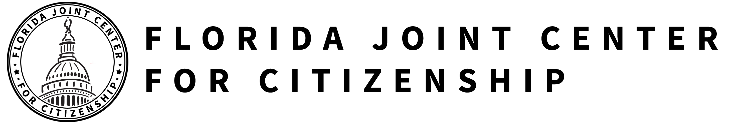

GOVERNMENT AND CITIZEN PARTICIPATION
IN INTERNATIONAL ORGANIZATIONS
SS.7.C.4.2 Recognize government and citizen participation in international organizations.

TABLE OF CONTENTS

Lesson Summary 2
Suggested Student Activity Sequence 4
Student Activity Sheets & Reading Materials 7
Sources 20
Answer Keys 21
Civics Content Vocabulary 24
Essential Teacher Content Background Information 25

Lesson Summary
Essential Questions
What are international organizations? How can government and individual citizens support and play a role in them?

NGSSS Benchmark
SS.7.C.4.2 Recognize government and citizen participation in international organizations.

Florida Standards
LAFS.68.RH.1.2 LAFS.68.RH.3.7 LAFS.68.RH.3.9 LAFS.68.WHST.1.2
LAFS.68.WHST.2.4 LAFS.68.WHST.2.5 LAFS.68.WHST.2.6 LAFS.68.WHST.3.7
LAFS.68.WHST.3.8 LAFS.68.WHST.3.9 LAFS.68.WHST.4.10 LAFS.7.SL.1.1
LAFS.7.SL.1.2 LAFS.7.SL.2.4 MAFS.K12.MP.5.1 MAFS.K12.MP.6.1

Overview
In this lesson, students will understand major international organizations, their work and how countries or citizens can participate or support them. Students will conduct a research project on the international organization of their choice.

Learning Goals/Benchmark Clarifications
- Students will identify major international organizations in which government plays a role.
- Students will recognize that international organizations may be located in the United States.
- Students will describe ways that individual citizens and government can seek participation in international organizations.
- Students will examine the ways that government and individuals may support international organizations.

Benchmark Content Limits
- Items will not require students to recall any specific policies related to domestic or international organizations.
- Items will not require students to evaluate the efficacy of any specific domestic or international organization.

Civics EOC Reporting Category
Reporting Category 3 – Government Policies and Political Processes

Suggested Time Frame
- Seven 45-50 minute class periods

Civics Content Vocabulary
- European Union, intergovernmental organization, international organization, International Red Cross/Red Crescent, non-governmental organization/international non-governmental organization (NGO/INGO), North American Free Trade Agreement (NAFTA), North Atlantic Treaty Organization (NATO), treaty, United Nations (UN), United Nations International Children’s Emergency Fund (UNICEF), World Bank, World Court, World Health Organization (WHO), World Trade Organization (WTO)

Instructional Strategies
Reading of complex text Research skills Cooperative learning Case Study

Materials
Computer with internet access to project lesson activity sheets
Student activity sheets:
- International Organizations
- International Organization Research Project Guidelines
Student reading materials:
- International Organizations Reading from iCivics: http://www.icivics.org/teachers/lesson-plans/international-organizations
- World Court reading
- Martha’s Story reading and questions

Lesson Activities and Daily Schedule
Please use the chart below to track activity completion.

Day | Task # | Steps in Lesson | Description | Completed?  Yes/No
Day One | Task 1 | 1-3 | Hook Activity
 | Task 2 | 4-11 | International Organizations Background Reading
 | Task 3 | 12-23 | International Organizations Cooperative Group Work and Presentations
Day Two | Task 3 | 12-23 | International Organizations Cooperative Group Work and Presentations  (continued)
Day Three | Task 4 | 24-26 | World Court Reading
 | Task 5 | 27-30 | Website Research Activities
Day Four | Task 5 | 27-30 | Website Research Activities  (continued)
 | Task 6 | 31 | Checking for Understanding A
Day Five | Task 7 | 32-38 | UNICEF and Martha’s Story
 | Task 8 | 39 | Checking for Understanding B: Research Assessment
Day Six | Task 8 | 39 | Checking for Understanding B: Research Assessment  (Research Time in the Media Center)
Day Seven | Task 8 | 39 | Checking for Understanding B: Research Assessment  (Additional Class Time for Research or Writing)

Suggested Student Activity Sequence

- To begin this lesson, project the following prompt on the board: Make a list of the issues or problems that you know of that are happening around the world.
- Provide time for students to brainstorm and share out.
- Pose the following questions for discussion: “Do you think that countries work together to solve these problems and issues? Can citizens play a role in solving the problems and issues?”
- Pass out the “International Organizations” student activity sheet and the “International Organizations” reading from iCivics: http://www.icivics.org/teachers/lesson-plans/international-organizations.
- Read the first paragraph aloud as a whole class.
- Instruct students to define the term “international organization” on their student activity sheet.
- Have students share out.
- Place students into pairs and instruct them to read the remaining paragraphs and mark the text that will help them define the terms: intergovernmental organizations and nongovernmental organizations (NGOs).
- Provide students with the following key points on nongovernmental organizations (NGOs) and instruct them to take notes on their activity sheet:
- Some nongovernmental organizations are concerned with international issues, these organizations are known as international nongovernmental organizations or INGOs.
- NGO/INGOs perform a variety of services and humanitarian functions, communicate citizen concerns to governments, advocate for certain issues such as human rights or the environment, and encourage political participation.
- Provide students with a non-example of a NGO. Explain that a NGO is not a treaty (which is a formal agreement among the governments of several nations). As a non-example, cite the North American Free Trade Agreement (NAFTA), which is a formal agreement among the governments of the U.S., Canada, and Mexico to form a large free trade zone in North America and eliminate taxes on the buying and selling of each other’s products.
- Instruct students to add this information to their activity sheet.
- Explain to students that they are going to learn about a variety of international organizations and they will begin by looking at one organization as a whole class.
- Project the website for the World Trade Organization: http://www.wto.org/.
- Instruct students to find the “World Trade Organization” row on their activity sheet.
- Pose the following questions for discussion: “According to the activity sheet, what do we need to know about the World Trade Organization? Based on what you see on the World Trade Organization’s homepage, where should we look to gather this information?” (year established, headquarters, intergovernmental organization, or NGO, who is involved, main purpose, how can countries/citizens support and participate)
- Guide students through the World Trade Organization’s website to gather the information for the activity sheet. (year established - 1995; headquarters – Geneva, Switzerland; intergovernmental organization; 159 countries; main purpose – The World Trade Organization works with nations around the world to support international trade. They work to lower trade barriers, educate governments, businesses and individuals on trade rules around the world and settle trade conflicts by serving as a neutral party. Countries can become a member by signing an agreement.)
- Organize students into small cooperative working groups and assign each group an international organization to read, summarize and present to the class. Teacher note: You will need at least six groups.
- Pass out an international organization reading, one per group, for the following organizations: United Nations, North Atlantic Treating Organization, The European Union, The World Health Organization, The Red Cross/Red Crescent Societies, and The World Bank from iCivics: http://www.icivics.org/teachers/lesson-plans/international-organizations.
- Explain to students that each group will read about a different organization and will report about their assigned organization to the rest of the class. Explain to students that each reading has guiding questions that are intended to help students understand the main ideas of the reading. As a group, their task is to read, answer the guiding questions and fill in the row for their assigned organization on the “International Organizations” student activity sheet. Teacher note: Some of the columns on the activity sheet will remain unanswered after the reading is completed.
- Provide students with time to read, complete the guiding questions that accompany their reading and prepare for their presentation.
- Bring the class back together and return student attention to the “International Organizations” student activity sheet.
- Explain to students that they will take turns presenting their organization to the whole class. Instruct students to take notes on their activity sheet during the presentations. Teacher note: Have the United Nations and World Health Organization be the last two groups to present. After the United Nations presentation, ask students what information they can fill in on their activity sheet for the UNICEF row.
- Clarify any information during the group presentations to ensure that students are accurately taking notes.
- Explain to students that within the United Nations, there are two international organizations they will learn about: United Nations Children’s Fund (UNICEF) and the World Court.
- Pass out the “World Court” reading and instruct students to read independently and fill in the “World Court” row on their activity sheet.
- Engage students in a whole class discussion to review their answers.
- Pose the following questions for discussion: “Based on the readings and presentations, do we have all of the information that is requested on the activity sheet? What is missing? (headquarters and information related to how governments or individuals can join or support) What does this tell you about the reading? Where should we look for more information?” Teacher note: Lead students to the understanding that the reading is one source of information on the international organizations and they will need to look at a second source in order to gain a more complete picture of the organizations.
- Project the website for the European Union: http://europa.eu/index_en.htm and pose the following question for discussion: “Based on what you see on the EU’s homepage, where do you think we can find the information we need to answer the rest of our questions?”
- Lead students to the following pages: information related to locations: https://ec.europa.eu/info/about-european-commission/organisational-structure/locations_en#headquarters and information related to membership - https://europa.eu/european-union/about-eu/easy-to-read_en.
- Complete this process for the remaining organizations that need additional information. Teacher note: As an alternative, instruct students to complete this for homework.
- Checking for Understanding A (Formative Assessment):
Instruct students to write a well-crafted response to the following prompt:
Prompt
Using what you have learned from the reading, presentations, and internet research on international organizations, choose three organizations and explain the function of the organization and how a country or individual citizens can participate and/or support the organization.
- Remind students that UNICEF is the United Nations International Children’s Emergency Fund. Explain to students that their work is focused on children’s issues throughout the world. Project the website: http://www.unicef.org/whatwedo/index.html# and scroll down on the homepage so that students can see some of the issues in which UNICEF is involved (child protection and inclusion, child survival, education, emergency management, etc.).
- Explain that war or armed conflict has a large impact on the lives of children around the world. Provide the following key points about the issue:
  - The most direct physical impact of armed conflict is death—according to UNICEF, more than 2 million children have died in armed conflicts in the past decade.
  - At least 6 million children have been seriously injured or disabled.
  - Disruption of the local water and electricity supplies in times of armed conflict increases the spread of disease in war-affected areas. This creates stressed and/or damaged health care systems, which are often ill equipped to deal with the casualties.
  - War also causes emotional and psychological damage in children, especially when they are orphaned or separated from their families. It also prevents them from getting an education.
  - UNICEF tries to protect children in these situations with medical help, shelter, finding their families, and getting back to school.
- Show students the two-minute video, “Martha’s Story” from UNICEF: https://www.teachertube.com/video/marthas-story-armed-conflict-and-children-171621.
- Pass out the “Martha’s Story” reading and instruct students to independently read and answer the questions.
- Pose the following questions for discussion: “How is Martha’s life similar to yours? How is it different? What are the things about Martha’s life that seem to make her happy? How are they similar or different from the things that make you happy? What do you think Martha needs most to secure a successful and happy future? What do you think about UNICEF working with children like Martha?”
- Project UNICEF’s homepage: http://www.unicef.org/ and remind students that UNICEF is part of the United Nations and countries can support UNICEF through their involvement with the United Nations. Pose the following questions to the students: “Do you think that individual citizens can support or participate in UNICEF? Is there anything you see on the website that shows people where to go if they want to support UNICEF?” (Support UNICEF button on the top right of the page.)
- Review the variety of ways UNICEF suggests that individual citizens can support their work: donate money, support through social media, sign up for the newsletter, and purchase a UNICEF gift. Explain to students that another way that individual citizens can participate and support UNICEF is by working or interning for the organization.
- Checking for Understanding B (Research Assessment):
Explain to students that they will research an international organization of their choice to learn about what they do, their impact on the issues they focus on and the ways for countries and individual citizens can participate and support the organization.
Pass out the “International Organization Research Project Guidelines” overview and review the project expectations and grading criteria as a whole class.
Explain to students that they will use their research and writing skills to write a well-crafted informational essay on the international organization of their choice. Teacher note: If time permits, spend one class period in the media center for students to begin the research process while having the support of the media specialist. If your students require additional assistance in conducting their research, see the “Scaffolding Methods for Research Paper Writing” lesson plan from ReadWriteThink: http://www.readwritethink.org/classroom-resources/lesson-plans/scaffolding-methods-research-paper-1155.html?tab=4#tabs.

International Organizations

Intergovernmental Organization - | Nongovernmental Organization (NGO) -

Non-Example | Who is involved? | What is their main purpose?
North American Free Trade Agreement (NAFTA)

Name of Organization & Year | Where are the headquarters? | Intergovernmental or NGO? | Who is involved? | What is their main purpose? | How can governments or individuals join or support this organization?
European Union

_________
North Atlantic Treaty Organization
___________
Red Cross/Red Crescent
_________
United Nations
_________
United Nations Children’s Fund (UNICEF)
_________
World Bank
_________
World Court
_________
World Health Organization
_________
World Trade Organization
_________

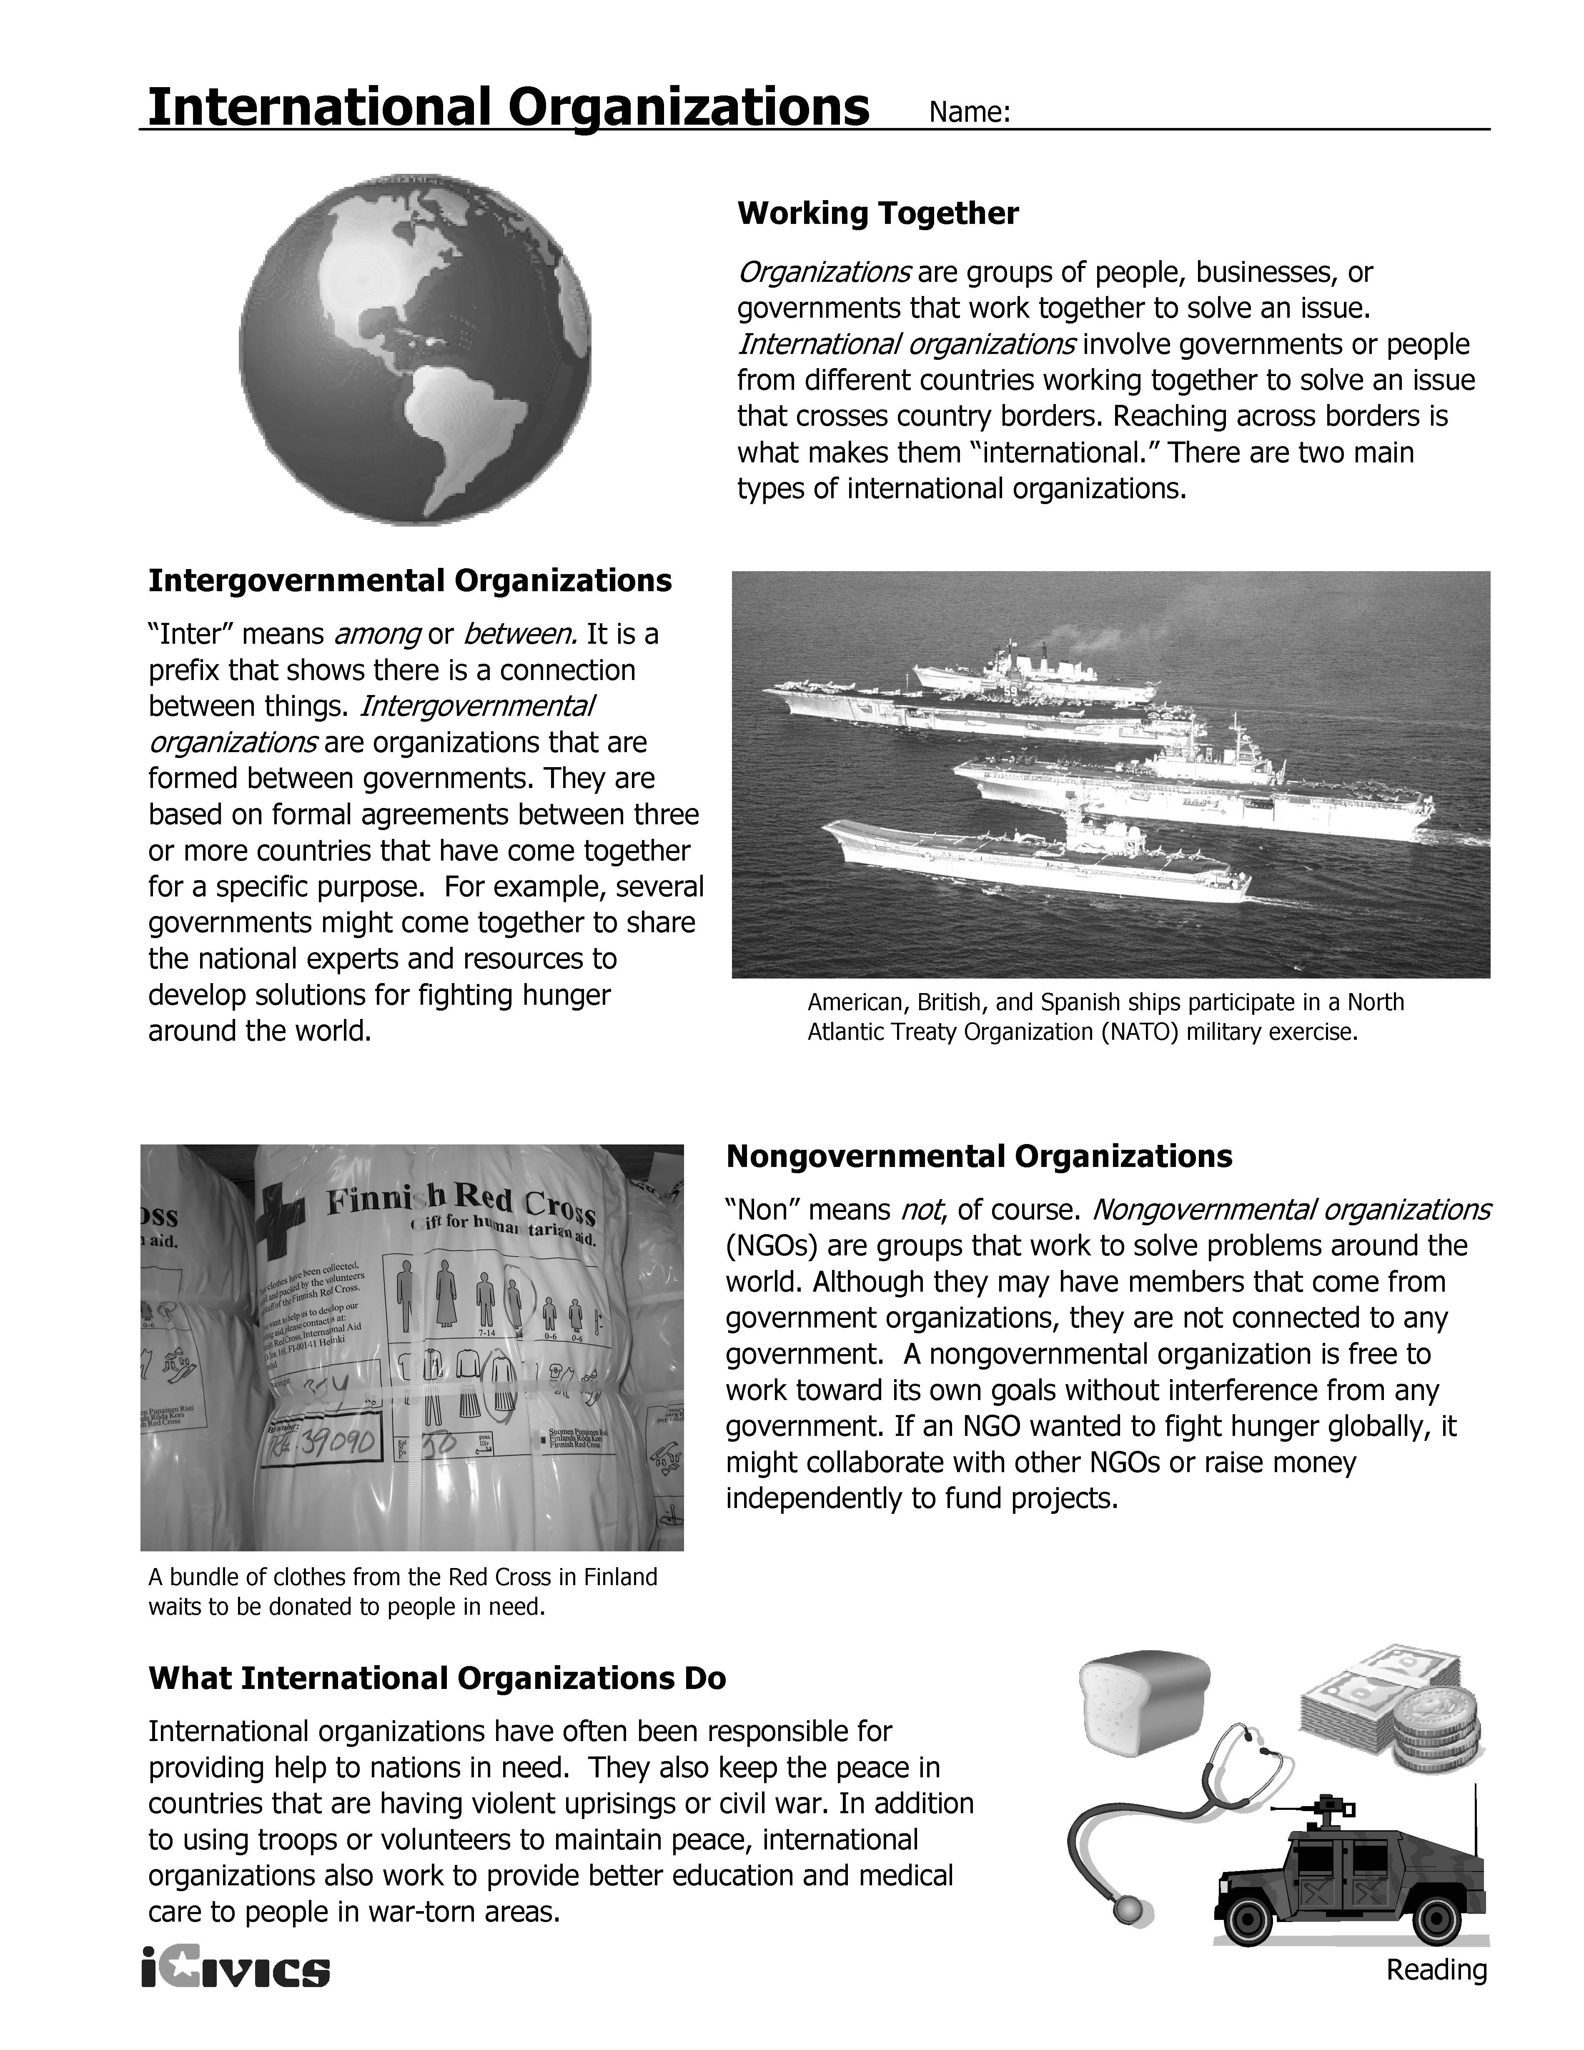
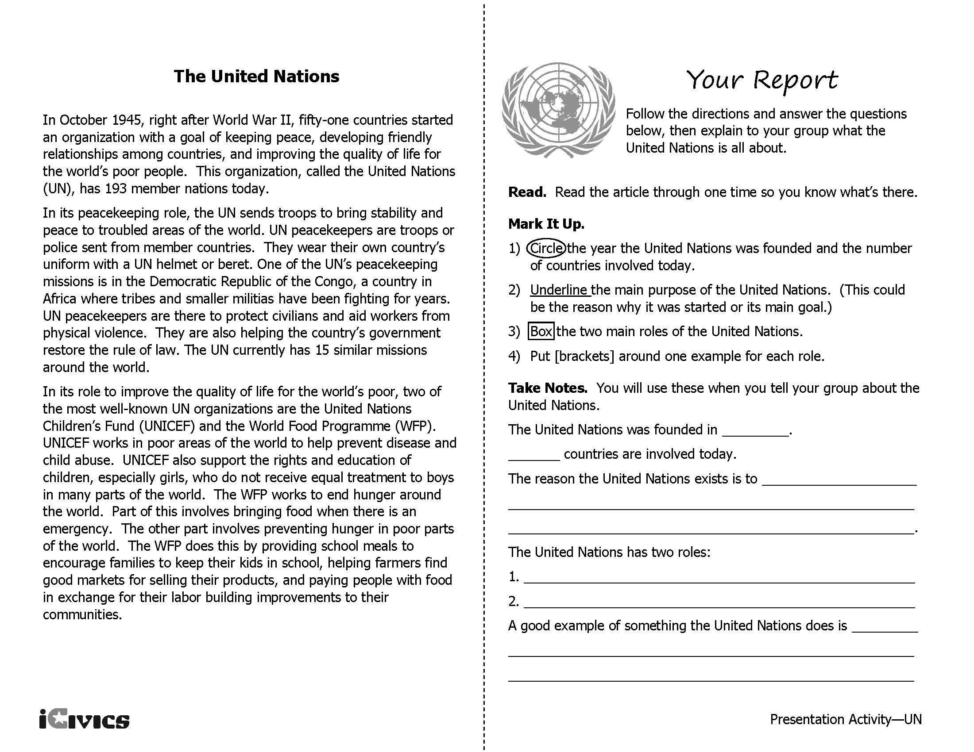
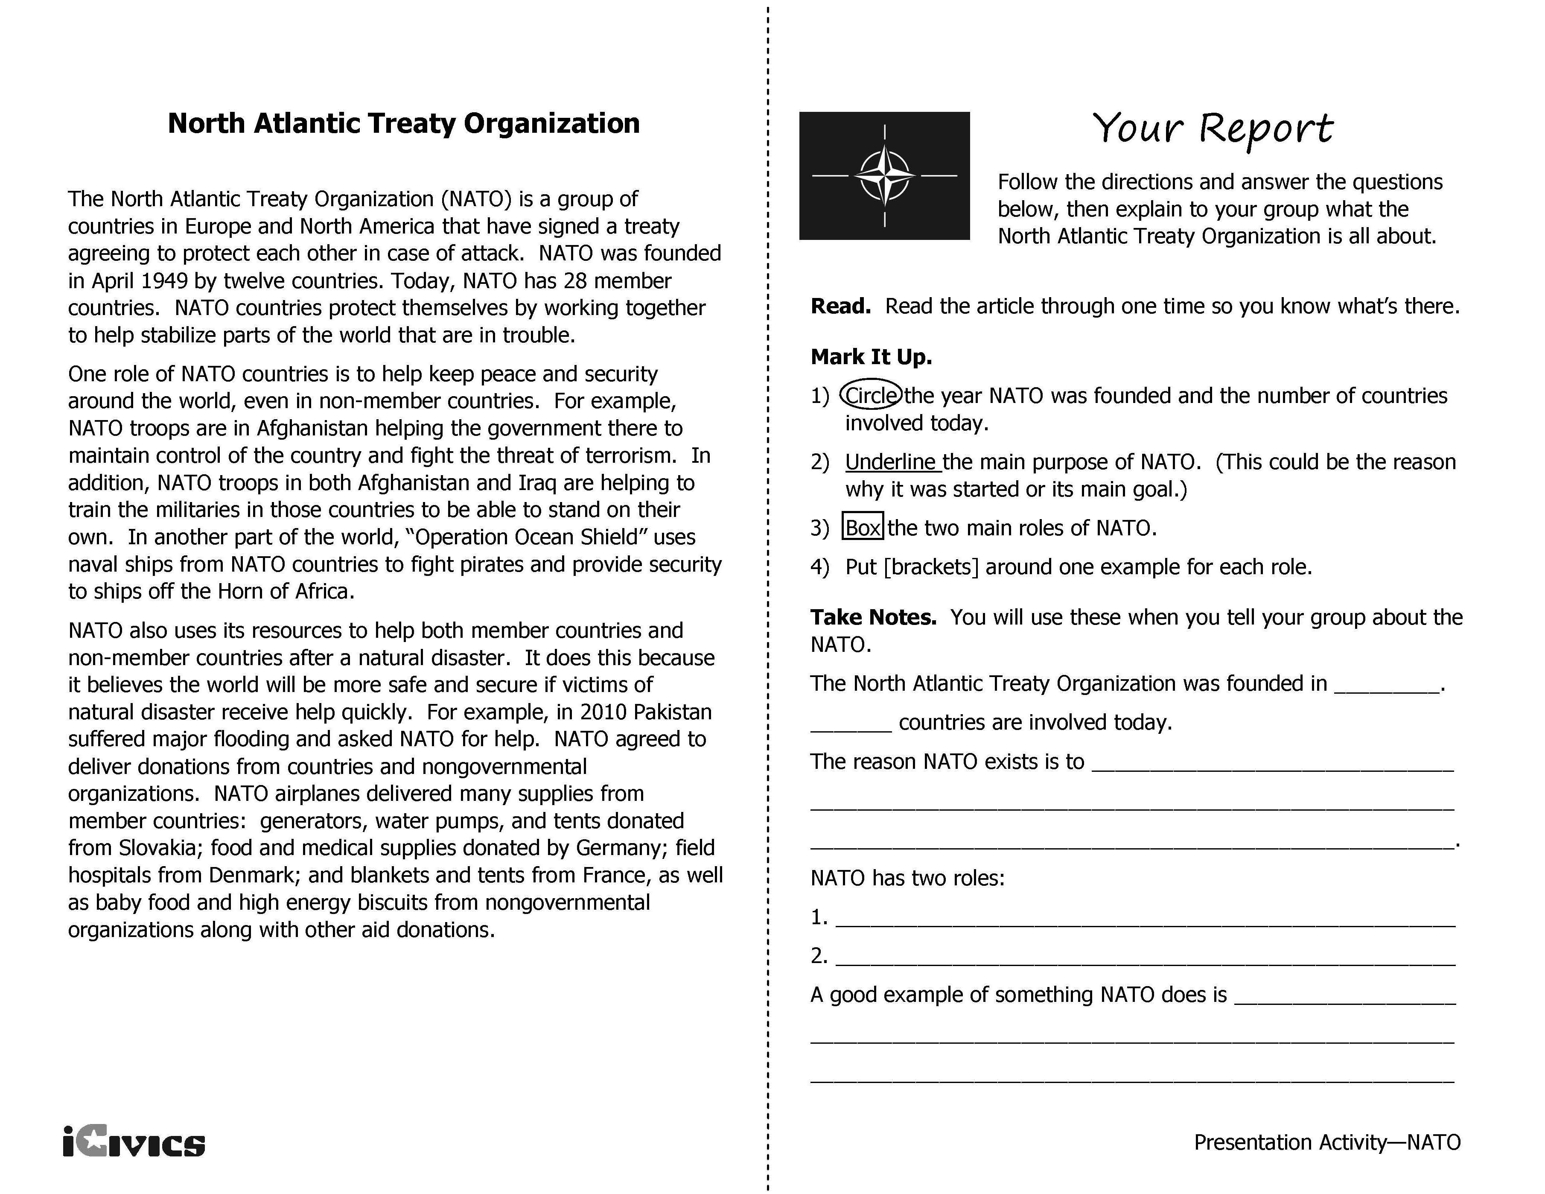
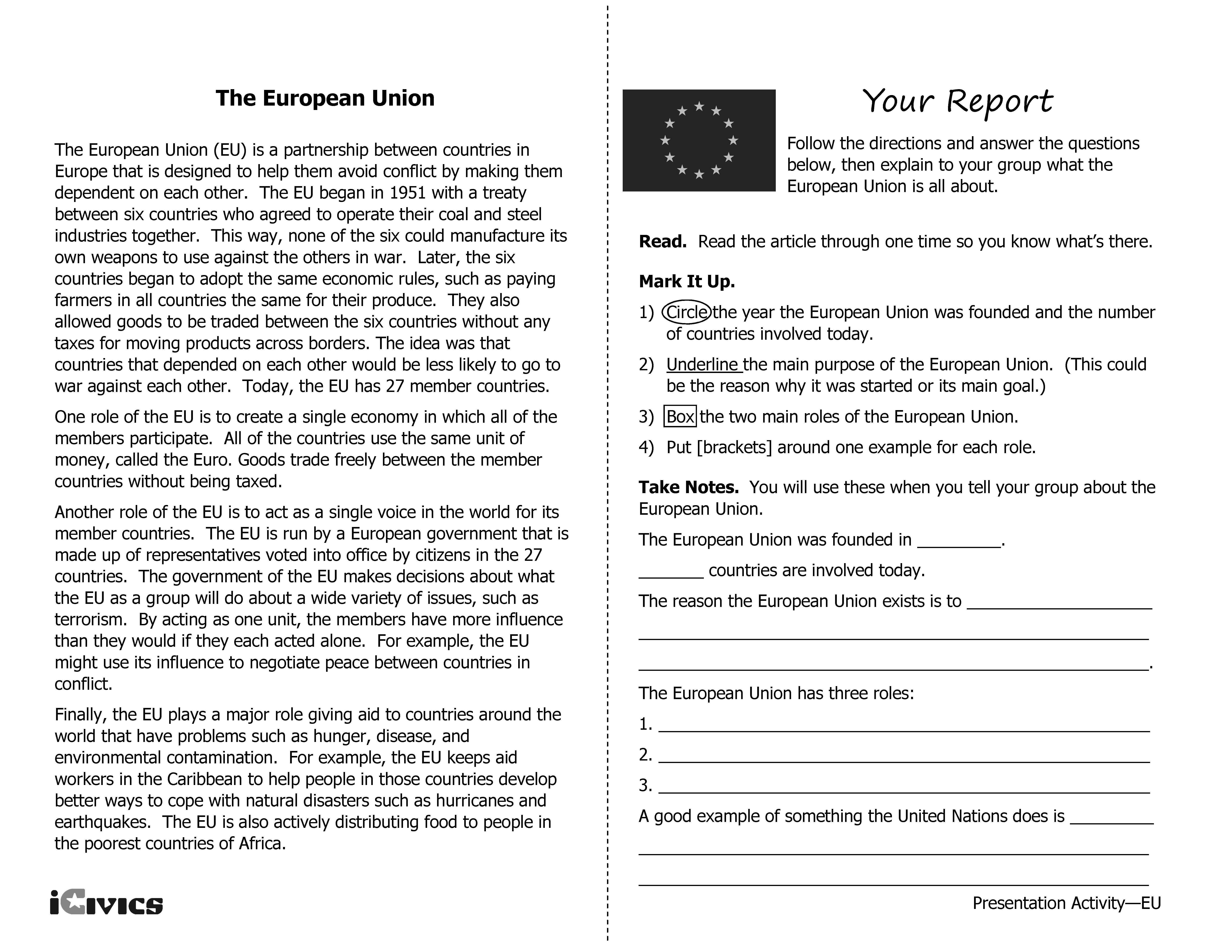
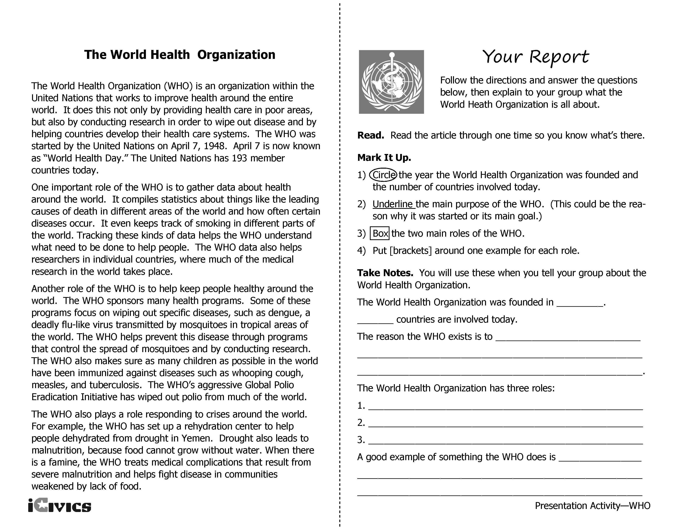
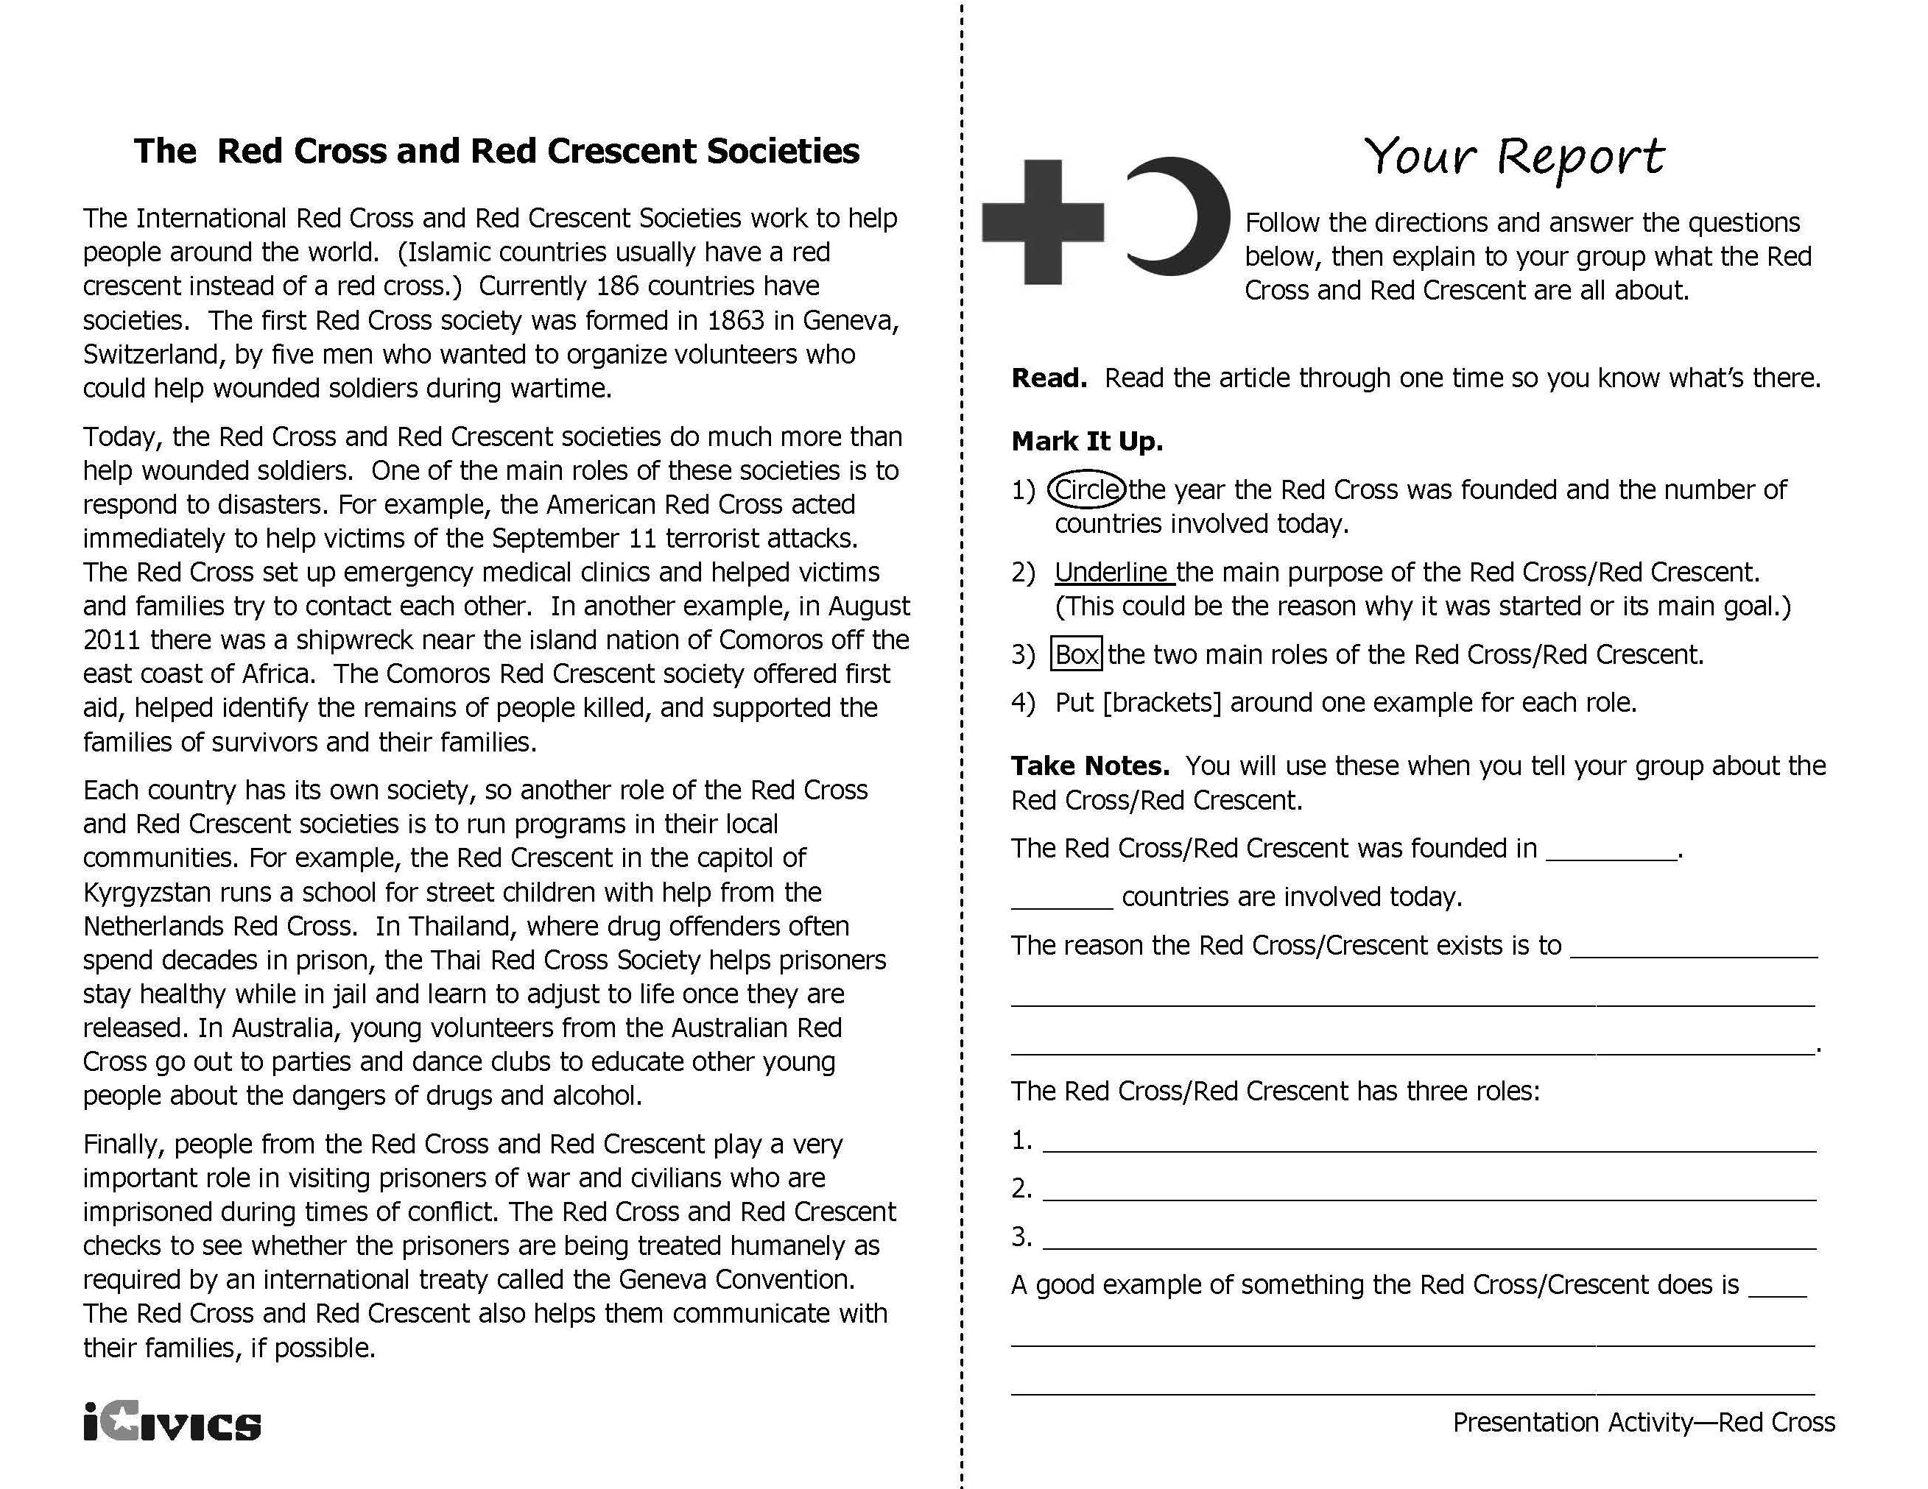
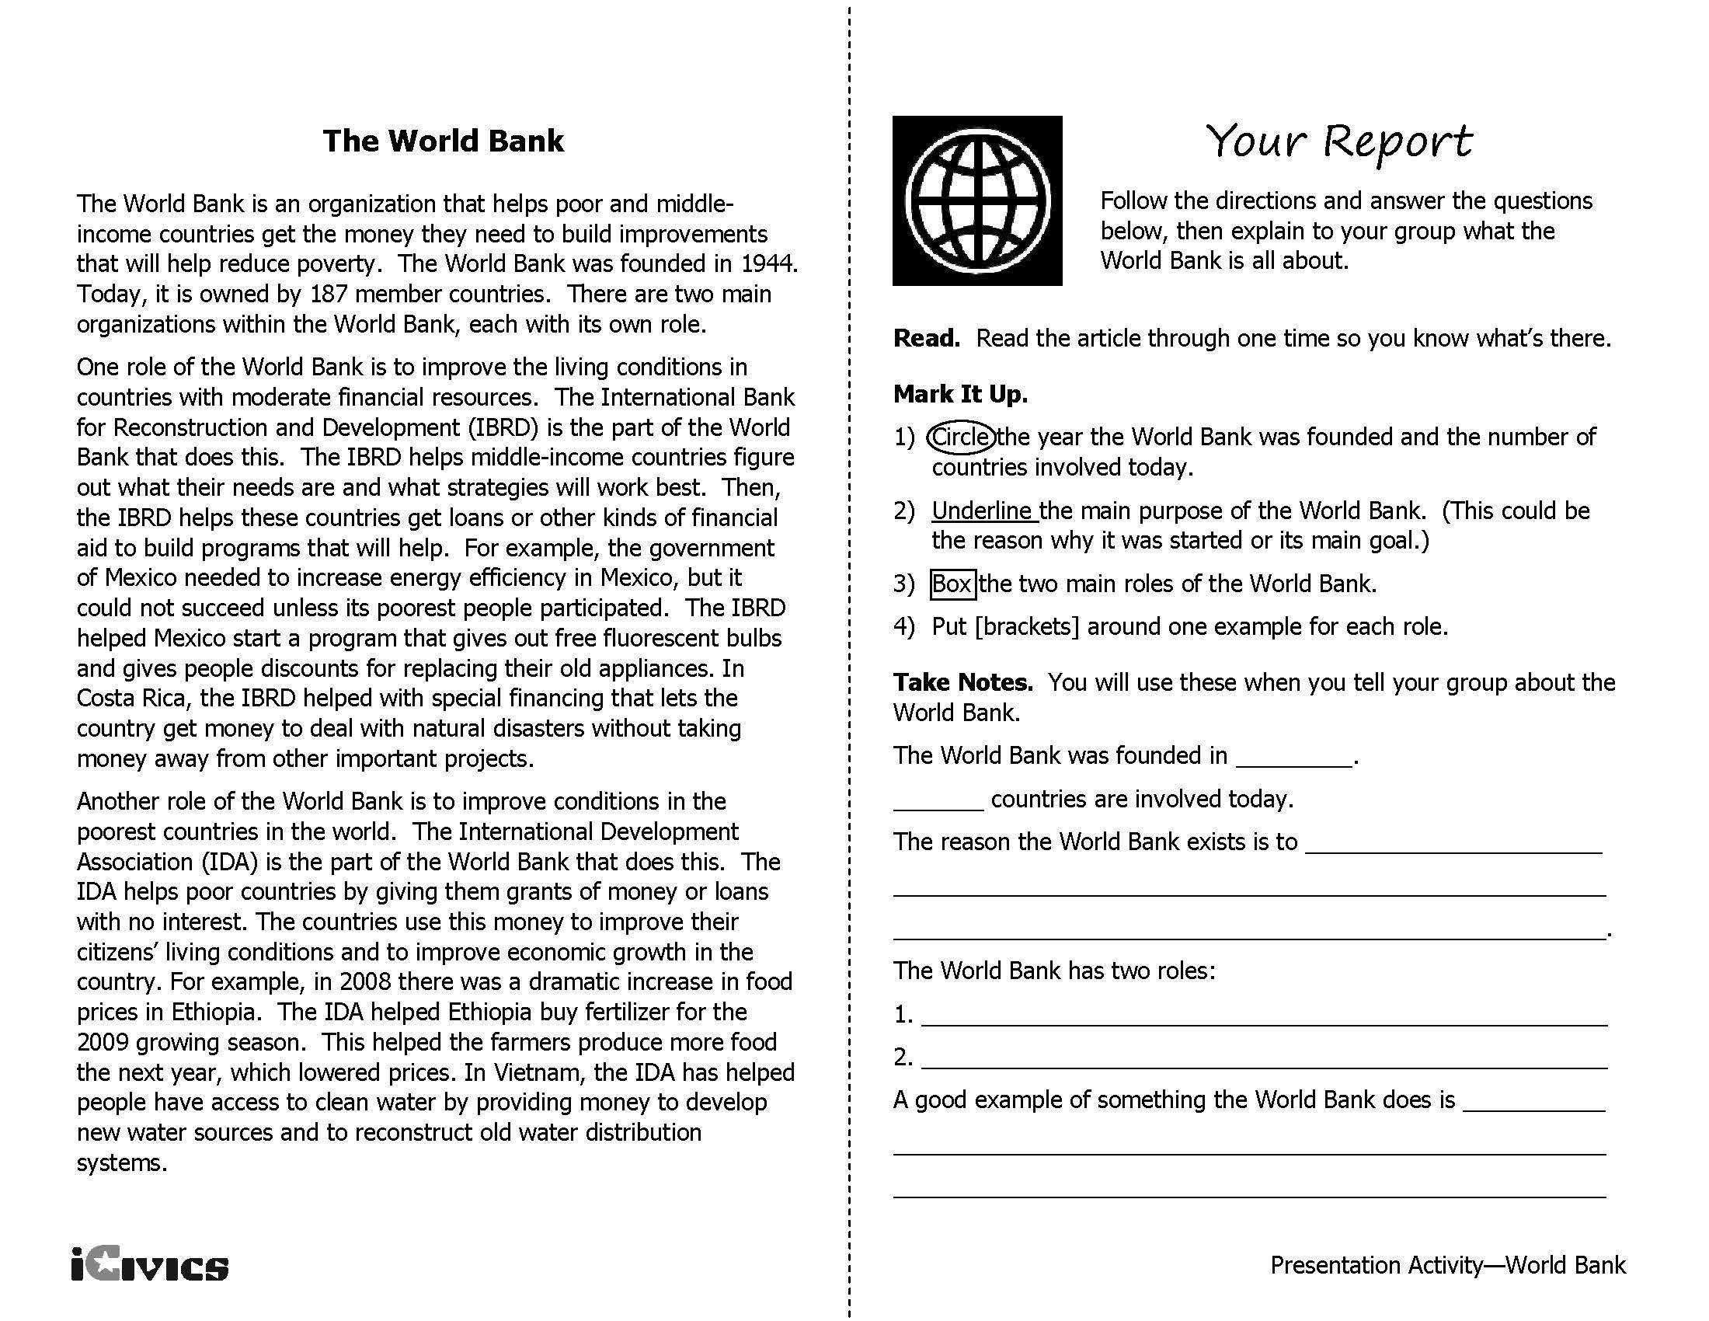
THE WORLD COURT
International Court of Justice
The International Court of Justice, also known as the World Court, was established in 1945 by the United Nations and began work in 1946. The Statute of the International Court of Justice is the main constitutional document that guides the Court.
The International Court of Justice acts as a world court and handles cases where two nations are in conflict. Typically, the nations must be members of the United Nations. If the nation is not a member of the United Nations, they have to agree to have the case heard at the International Court of Justice.
The Court also provides advice to the United Nations and other organizations on legal questions. The United Nations Charter gives the UN the power to enforce World Court rulings. However, the five permanent members of the UN Security Council have veto power to overrule, or reverse, a ruling.
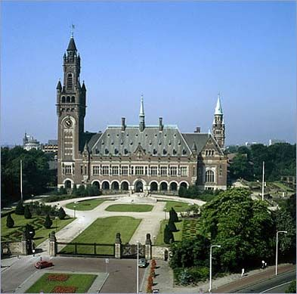
The World Court has a permanent panel of fifteen judges appointed by the UN to nine-year terms to hear cases. To make sure that its judges are not biased, the court pays judges a salary, forbids them from working on any other government or legal project, and makes sure that no more than one judge per country is on the Court. The U.S. has had many judges on the Court over the years.
The World Court, located in The Netherlands.

Adapted from: http://www.icj-cij.org/homepage/index.php, Accessed January, 2013

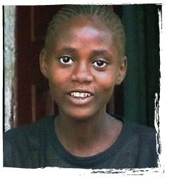
MARTHA’S STORY
As a young child in Sierra Leone, Martha was told that she looked like her mother, so she spent hours in front of the mirror, trying to see in her own features an image of the mother she lost as a toddler. Martha’s father, a successful businessman, cared deeply for his daughter. He bought her new clothes every week and took her to school every morning.
In 2000, when Martha was eight years old, members of a rebel group trying to overthrow the government attacked her village. As the sound of gunfire filled the neighborhood, Martha and her father stayed locked inside their house for over a week, waiting for the fighting to stop.
When things quieted down, rebels occupied the village, and the situation was tense. Martha’s father saw his business drop off, and he was forced to move to a town he thought would be safe from rebel attack. There, he was able to rebuild his business and send money and clothes to his daughter.
With her father gone, Martha moved in with her grandmother, who made a living by selling vegetables in the market. Sometimes Martha had to help her and missed school as a result. Her life became even more difficult when her grandmother had a severe stroke, which left her unable to walk and almost unable to speak. Martha, by then 13 years old, found herself caring for her ill grandmother and had no news from her father.
Though Martha was barely able to keep up with schoolwork, she managed to pass the National Primary School Examination, which allowed her to go on to high school. However, with her father gone and her grandmother no longer able to work, there was no money for the necessary school fees.
Martha’s hopes for continuing her education now depended on her father, and she anxiously waited to hear from him. One morning, she received devastating news: the rebels had murdered her father. “The whole world stopped for me,” says Martha. “For the first time in my life I felt alone. I realized I was an orphan.”
Martha is now staying with her stepmother (a woman her father married before his death and who she refers to as ‘aunty’) and her stepmother’s three children. To help her new family, Martha sells biscuits in the street market, but she longs to go back to school. Luckily, her stepmother’s new husband has shown sympathy toward her and is willing to help.
The Impact of Armed Conflict
Sierra Leone’s civil war (from 1991–2002) affected over 10,000 children like Martha, causing separation from their families and exposing them to violence. Some were injured or killed by landmines. Others were forced to serve as child soldiers. Many more children missed out on schooling, and were often unable to get health care during the conflict.

Questions
- List at least three ways in which armed conflict has affected Martha’s life. List the words or phrases from the text that helped you identify the answer.

- Martha has many responsibilities. What are two of those responsibilities? What words or phrases from the text helped you answer this question. Do you have similar or different responsibilities as Martha at home?

- What else do you think is needed to support children and families involved in armed conflict?

Source: http://teachunicef.org/materials/marthas-story-6-8 Accessed January 2013
International Organization Research Project Guidelines
Directions: Your task is to choose an international organization and conduct a research project in order to write to explain the function of the organization, the issues they are concerned with and how individual citizens or country can participate and/or support the organization.

To complete this project, you will do the following:
- Choose the organization you will research. To choose your organization, think of some issues that you care about and research to find an international organization that deals with one of the issues. For example, if you are concerned with violence prevention and awareness, you might research the organization Save Darfur, which is focused on violence prevention and awareness for the western Sudan area of Darfur.
- Determine the research question.
For example, if UNICEF is the international organization, the research question might be: How does UNICEF support children around the world?
- Begin identifying resources to support your essay. You must use at least three resources and cite the sources to support the ideas in your essay.
- Draft your essay. Your essay must be an informational text that is supported by the evidence you have identified in your three sources.
- Submit a rough draft to the teacher for review and edit.
- Update your draft based on the feedback you received on your rough draft.
- Submit your final draft.

Research Paper Scoring Rubric
Research | Points 1-10
Has a well-developed research question
Records important ideas, concepts, and direct quotations from at least 3 reliable and appropriate information sources.
Uses correct and appropriate citations for every source.
Includes a Works Cited Page.
Total Points ____/40
Organization | Points 1-15
Introduces the topic clearly and explains what is to follow in the essay. Provides a concluding paragraph that supports the information presented in the essay.
Develops the points presented in the introduction through supporting paragraphs.
Total Points ____/30
Style | Points 1-10
A formal style and objective, informational tone is used throughout.
Appropriate language and vocabulary is used to explain the international organization and related concepts.
Appropriate and varied transitions are used to create a connection between paragraphs and concepts.
Total Points ____/30
Rubric Adapted from: http://www.readwritethink.org/files/resources/lesson_images/lesson1155/rubric.pdf

Sources
General International Organization Information: http://www.unodc.org/ngo/list.jsp, Accessed January 2013
iCivics International Organizations Lesson Plan: http://www.icivics.org/teachers/lesson-plans/international-organizations
European Union: https://ec.europa.eu/info/about-european-commission/organisational-structure/locations_en#headquarters and https://europa.eu/european-union/about-eu/easy-to-read_en.
The World Court: http://www.icj-cij.org/homepage/index.php, Accessed January 2013
UNICEF: http://www.unicef.org/whatwedo/index.html#
UNICEF Lesson Plan: http://teachunicef.org/materials/marthas-story-6-8, Accessed January 2013
“Martha’s Story”: http://teachunicef.org/materials/marthas-story-armed-conflict Accessed January 2013
Research Project Resources from ReadThinkWrite: http://www.readwritethink.org/classroom-resources/printouts/essay-rubric-30230.html

International Organizations - Sample Answers
groups of governments or people from different countries working together to solve an issue that crosses country borders

Intergovernmental Organization - an organization formed with groups of governments for a specific purpose | Nongovernmental Organization (NGO) – groups a voluntary citizens' group that is organized on a local, national or international level and works ; they perform a variety of service and humanitarian functions, bring citizen concerns to governments, advocate for certain issues such as human rights or the environment, and encourage political participation; also known as International Non-Governmental Organization (INGO)

Non-Example | Who is involved? | What is their main purpose?
North American Free Trade Agreement (NAFTA) | United States, Canada and Mexico | a formal treaty agreement among the governments of the U.S., Canada, and Mexico to form a large free trade zone in North America and eliminate taxes on the buying and selling of each other’s products

Name of Organization & Year | Where are the headquarters? | Intergovernmental or NGO? | Who is involved? | What is their main purpose? | How can governments or individuals join or support this organization?
European Union  1951  http://europa.eu/index_en.htm | Brussels, Belgium (European Parliament, Council of the European Union, and European Commission) | Intergovernmental | 28 member countries | The EU is a partnership between countries in Europe that is designed to help them avoid conflict by making them dependent on each other. The EU acts as a single voice to represent its member countries to the world. The EU also provides aid to other countries. | A country must meet membership criteria in order to join the EU. An individual can support the organization by working for the EU.
North Atlantic Treaty Organization  1949  http://www.nato.int/cps/en/natolive/index.htm | Brussels, Belgium | Intergovernmental | 29 member countries from North America and Europe | Protect the member countries from attack, keep peace and security around the world even when it involves nonmember countries, and provide natural disaster assistance. | A country must meet membership criteria in order to join the NATO. An individual can support the organization by working for the NATO.
Red Cross/Red Crescent  1863  http://www.ifrc.org/ | Geneva, Switzerland | NGO | 186 countries | To respond to disasters, run programs in their local communities and visit prisoners of war or civilians imprisoned during times of conflict. | Individuals can support the organization in multiple ways: donate money, support through social media, volunteer, work for the organization, and raise awareness.
United Nations  1945  http://www.un.org/en/ | New York, New York | Intergovernmental | 193 countries | Their main purpose is to keep peace, develop friendly relationships among countries and improve the quality of life for the world’s poor people. | Countries can join the UN by decision of the General Assembly upon the recommendation of the Security Council. Individuals can support by donating money, interning for the UN or working for the UN.
United Nations Children’s Fund (UNICEF)  1946  http://www.unicef.org/ | New York, New York | Intergovernmental | 193 countries | UNICEF focuses their work on a variety of children’s issues throughout the world. For example, education, sanitation, protection of children from violence, etc. | Individual citizens can support by donating money, supporting through social media, sign up for the newsletter, and purchasing a UNICEF gift and working or interning for the organization
World Bank  1944  http://www.worldbank.org/ | Washington, D.C. | Intergovernmental | 189 countries | The World Bank helps poor and middle income countries get money they need to build improvements that will help reduce poverty. | Countries can join if they meet membership requirements. Individuals can intern or work at the World Bank.
World Court  1945  http://www.icj-cij.org/en | The Netherlands | Intergovernmental | 193 UN member countries | This organization acts as a world court and handles cases where two nations are in conflict and provides legal advice for UN member nations. | Countries can become member through meeting the requirements to join the UN. Individuals can intern or work at the World Court.

Martha’s Story Questions – Sample Answers
- List at least three ways in which armed conflict has affected Martha’s life. List the words or phrases from the text that helped you identify the answer.
- when Martha was eight years old, members of a rebel group trying to overthrow the government attacked her village
- Martha and her father stayed locked inside their house for over a week, waiting for the fighting to stop.
- Martha’s father saw his business drop off, and he was forced to move to a town he thought would be safe from rebel attack.
- Martha moved in with her grandmother, who made a living by selling vegetables in the market. Sometimes Martha had to help her and missed school as a result

- Martha has many responsibilities. What are two of those responsibilities? What words or phrases from the text helped you answer this question.
Do you have similar or different responsibilities as Martha at home?
- Sometimes Martha had to help her [sell vegetables] and missed school as a result
- Martha, by then 13 years old, found herself caring for her ill grandmother and had no news from her father.
- To help her new family, Martha sells biscuits in the street market, but she longs to go back to school.

Civics Content Vocabulary

Word/Term | Part of Speech | Definition
European Union | proper noun | an organization of European countries formed after World War II to reduce trade barriers and increase cooperation among its members
intergovernmental organization | noun | an organization formed with groups of governments for a specific purpose
international organization | noun | groups of governments or people from different countries working together to solve an issue that crosses country borders
International Red Cross/Red Crescent | proper noun | an organization that helps people around the world respond to natural disasters and that checks on the conditions of prisoners of war
non-governmental organization (NGO) | noun | a voluntary citizens' group that is organized on a local, national or international level and works ; they perform a variety of service and humanitarian functions, bring citizen concerns to governments, advocate for certain issues such as human rights or the environment, and encourage political participation; also known as international non-governmental organization (INGO)
North American Free Trade Agreement (NAFTA) | proper noun | a formal agreement among the governments of the U.S., Canada, and Mexico to form a free trade zone in North America and eliminate taxes on the buying and selling of each other’s products
North Atlantic Treaty Organization (NATO) | proper noun | a group of 28 countries that has agreed to protect each other in case of attack; founded in 1949
treaty | noun | an agreement or arrangement between two or more countries
United Nations (UN) | proper noun | an organization founded in 1943 to keep the peace, develop friendly relationships among countries, and improve the quality of life for the world’s poor people; consists of 193 member countries
United Nations International Children’s Emergency Fund (UNICEF) | proper noun | an agency of the United Nations established in 1946 to help governments improve the health and education of children and their mothers
World Bank | proper noun | an organization that helps poor and middle income countries get the money they need to build improvements that will help reduce poverty
World Court | proper noun | a permanent panel of fifteen judges appointed by the UN to nine-year terms to hear cases; cases argued before the court focus on disputes between nations who agree to accept its decisions
World Health Organization | proper noun | an organization established in 1948 within the United Nations that works to improve health throughout the world
World Trade Organization (WTO) | proper noun | an international body founded in 1995 to promote international trade and economic development by reducing taxes and other restrictions

Essential Teacher Content Background Information
This section addresses the following issues:
- International organizations and citizen participation
- International organizations and citizen participation timeline

1. International organizations and citizen participation

The end of World War II brought with it an emphasis on the role of citizens in world affairs. The staggering loss of life and high casualties due to the war itself as well as the Holocaust brought attention to several issues to which citizens paid attention and shaped their political and civic behavior. Technology also contributed to increased citizen involvement on the world stage because new ways of learning about global issues became more prominent.

Several national and international organizations formed after World War II that encouraged citizen participation in decision making, activism, volunteerism and awareness. Greater attention to international human rights issues, globalization and technology have fostered awareness and participation across a wide range of issues and concerns.

2. International organizations and citizen participation timeline

Date | Event
1945 | The United Nations (UN) is established. Its Charter states that one of its main purposes is the promotion and encouragement of "respect for human rights and for fundamental freedoms for all without distinction as to race, sex, language or religion." The Charter underscores the principle of individual human rights.
1946 | Commission on Human Rights and Commission on the Status of women established by the UN Economic and Social Council (ECOSOC).  The United Nations International Children's Emergency Fund (UNICEF) is created.
1947 | Cold War begins pitting capitalism against communism
1948 | Universal Declaration of Human Rights Drafted
1949 | Convention on the Right to Organize and Collective Bargaining (ILO) is adopted.  Geneva Conventions provide standards for more humane treatment for prisoners of war, the wounded, and civilians.
1951 | Convention on the Status of Refugees (UN) is adopted.
1953 | European Commission on Human Rights and Court of Human Rights are created; Convention on Political Rights of Women (UN) is adopted.
1956 | Draft rules for protection of civilian populations from indiscriminate warfare communicated to governments and National Societies ahead of discussion at International Conference of the Red Cross in New Delhi in 1957
1960 | Start of decade of rapid increase in number of National Societies in the Red Cross and Red Crescent Movement to more than 100 following new-found independence of many former colonies in Africa and Asia. Shift in global politics also involves League in series of man-made disasters, and hundreds of thousands of refugees, from wars in Vietnam, Congo and elsewhere.
1963 | The International Federation of Red Cross and Red Crescent Societies win Nobel Peace Prize
1965 | International Convention on the Elimination of All Forms of Racial Discrimination (UN) is adopted.  UNICEF earmarks half its Africa Budget for education.  Proclamation of Fundamental Principles of the Red Cross -- Humanity, Impartiality, Neutrality, Independence, Voluntary Service, Unity, Universality (incorporated in 1986 into the Statutes of the International Red Cross and Red Crescent Movement).
1966 | International Covenant on Civil and Political Rights and the International Covenant on Economic, Social and Cultural Rights (UN) are adopted and opened for signature. Together these documents further developed rights outlined in the Universal Declaration for Human Rights.
1968 | First World Conference on Human Rights is held in Tehran. The United Nations convened member States to evaluate the failures and successes of human rights promotion since the adoption of the Universal Declaration of Human Rights and to work toward the elimination of racial discrimination and apartheid.
1975 | Final Act of the Helsinki Conference on Security and Cooperation in Europe (CSCE) affirmed the International Convenant on Civil and Political Rights and the International Convenant on Economic, Social and Cultural Rights. This framework for international communication inspired the creation of many NGOs and citizens groups that would help monitor human rights and demand compliance with standards set by the UN and member States.  "Tansley Report" published, meets mixed reaction. Report defines basic role of Red Cross as "provision of emergency help, on an unconditional and impartial basis, whenever and wherever human needs for protection and assistance exist because of natural disaster and conflict".
1976 | International Covenant on Civil and Political Rights and the International Covenant on Economic, Social and Cultural Rights enter into force after sufficient ratification among UN member States.
1977 | A human rights bureau is created within the United States Department of State. Its first reports on human rights are issued that year.
1978 | Children’s services are recognized as women’s issues.
1979 | The Code of Conduct for Law Enforcement Officials (UN) and Convention on the Elimination of All Forms of Discrimination Against Women (UN) are adopted.  The International Year of the Child established by UNICEF.
1980 | U.S. signs the Convention on the Elimination of All Forms of Discrimination Against Women.  UNICEF launches “Women in Development Programme”
1981 | Respect for International Humanitarian Law (IHL) emerges as a central theme for the International Red Cross and Red Crescent Movement.
1984 | Second World Red Cross Conference on Peace, in Aaland, Sweden. Meeting, with East-West tensions, ends with call to "make peace all over the world a reality".
1988 | The United States ratifies the Convention on the Prevention and Punishment of the Crime of Genocide (the "Genocide Convention").
1989 | Convention on the Rights of the Child (UN) and the Second Optional Protocol to the International Covenant on Civil and Political Rights, aiming at the abolition of the death penalty (UN) are adopted.
1947 | Cold War begins pitting capitalism against communism
1948 | Universal Declaration of Human Rights Drafted
1980 | Iran rejects call by the World Court in The Hague to release the American hostages
1989 | Trinidad and Tobago appeal for an International World Court to help it and other small countries fight international drug trafficking.
1990s | Series of UN World Conferences dramatically expand the voice of non-governmental organizations (NGOs) in global political, economic, and environmental debates and equality for women
1990 | Convention on the Rights of the Child becomes international law; first ever world summit for children.
1992 | North America Free Trade Agreement (NAFTA) between U.S., Canada, and Mexico signed with side agreements on labor and the environment, and in the face of intense resistance from labor, women, environmental, and church groups in all three countries.
1993 | Convention on the prohibition of the development, production, stockpiling and use of chemical weapons and on their destruction.
1995 | Beijing Declaration at the World Conference on Women declares "Women’s rights are human rights." The Platform for Action designed at the conference contains dozens of references to human rights pertaining to women.
1996 | A U.N. court sentenced Bosnian Serb army soldier Drazen Erdemovic to 10 years in prison for his role in the massacre of 1,200 Muslims -- the first international war crimes sentence since World War II.
1997 | Convention on the Prohibition of the Use, Stockpiling, Production and Transfer of Anti-Personnel Mines and on their Destruction.
1998 | 50th Anniversary of the Universal Declaration of Human Rights
1999 |  | 50,000 activists in Seattle protest WTO policies in the first of an ongoing series of activists protests of WTO policies at WTO meetings
1999 |  | The World Court rejected Yugoslavia's contention that NATO bombing was unlawful and that the Western alliance was committing genocide. The court also refused to call for a cessation of hostilities.
2000 |  | Churches, NGOs, activists mobilize around the world on the 50th anniversary of the World Bank and IMF [International Monetary Fund] to call for a “Jubilee” cancellation of Third World debts
2000 |  | Wealthy countries agree to partial debt relief with terms of more privatization and free trade
2000 |  | World leaders gather for UN Millennium Summit, committing to the eradication of extreme poverty and other global social goals by 2015
2001 |  | WTO Doha Declaration affirms the right of governments to violate trade rules in order to protect the public health of its citizens.
2001 |  | World Conference Against Racism; some Third World nations and activists link colonialism, poverty, racism, and globalization
2002 |  | UN special session on children
2003 |  | World governments and globalization activists force shutdown of WTO deliberation in Mexico  Mexico appealed to the World Court to stop the execution of 51 of its citizens in the United States.  The World Court ruled that the United States must temporarily stay the execution of three Mexican citizens on U.S. death rows.  An International Court sentences former Bosnian-Serb Col. Dragan Obrenovic (40) to 17 years in prison for his role in the slaughter of more than 7,000 men and boys in Srebrenica, Bosnia.
2004 |  | The International Court of Justice ruled that the United States violated the rights of 51 Mexicans on death row and ordered their cases be reviewed.
2005 |  | NGOs and activists around the world join the “Global Call Against Poverty” to urge government to make trade fair, cancel debts, and address the roots of poverty
2008 |  | Germany filed suit at the World Court asking Italy to stop its legal system from awarding damages to victims of Nazi war crimes.

Timeline sources:
“Ongoing Struggle for Human Rights” available at: http://www.udhr.org/history/timeline.htm Accessed May 2013
“Globalization Timeline: 1940-2005 available at:
http://www.wnccumw.org/PDF%20&%20Word%20Files/Globalization%20Timeline.pdf Accessed May 2013
“Red Cross and Red Cross Movement History” available at: http://www.redcross.int/en/history/
“Timelines: World Court” available at: http://timelinesdb.com/listevents.php?subjid=537&title=World%20Court

