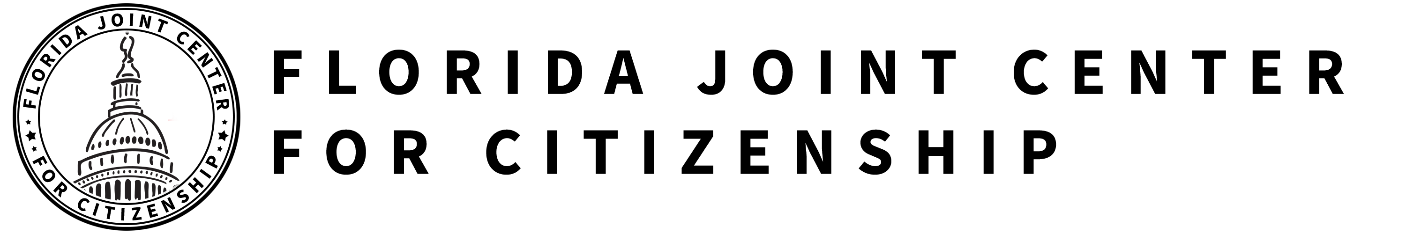

UNDERSTANDING U.S. DOMESTIC AND FOREIGN POLICY
SS.7.C.4.1 Differentiate concepts related to U.S. domestic and foreign policy.

TABLE OF CONTENTS

Lesson Summary 2
Suggested Student Activity Sequence 4
Student Activity Sheets & Reading Materials 7
Sources 20
Answer Keys 21
Civics Content Vocabulary 27
Essential Teacher Content Background Information 28

Lesson Summary

Essential Questions
What is domestic policy? What is foreign policy? What are the differences between domestic and foreign policy?

NGSSS Benchmark
SS.C.7.4.1 Differentiate concepts related to U.S. domestic and foreign policy.

Florida Standards
LAFS.68.RH.1.2 LAFS.68.WHST.1.2 LAFS.68.WHST.4.10
LAFS.7.SL.1.1 MAFS.K12.MP.5.1

Overview
In this lesson, students will differentiate between domestic and foreign policy, understand the goals of domestic and foreign policy and analyze the relationship between the two.

Learning Goals/Benchmark Clarifications
- Students will recognize the difference between domestic and foreign policy.
- Students will identify issues that relate to U.S. domestic and foreign policy.
- Students will analyze the domestic implications of U.S. domestic and foreign policy.
- Students will identify the goals and objectives of U.S. domestic and foreign policy.
- Students will recognize the role of the U.S. State Department in foreign affairs.

Benchmark Content Limits
- Items will not require students to recall details of any specific domestic or foreign policies.

Civics EOC Reporting Category
Reporting Category 3 – Government Policies and Political Processes

Suggested Time Frame
- Three 45-50 minute class periods

Civics Content Vocabulary
- alliances, allies, ambassadors, diplomacy, diplomats, doctrine, domestic affairs, domestic policy, embassies, foreign affairs, foreign policy, HIV/AIDS, international relations, Secretary of State, treaty, U.S. State Department

Instructional Strategies
Close reading of complex text Student inquiry Cooperative learning

Materials
Computer with internet access to project lesson activity sheets
Student activity sheets and readings:
- Domestic and Foreign Policy Key Terms activity sheet
- Foreign Policy – Foreign vs. Domestic and U.S. Foreign Policy activity sheets and Foreign Policy scenarios and Transparency 1 and 2 from iCivics: http://www.icivics.org/teachers/lesson-plans/foreign-policy-war-peace-and-everything-between
- Understanding Foreign and Domestic Policy activity sheet
- The Cabinet reading
- Ten Things You Should Know About U.S Foreign Policy reading
- Voting Cards
Lesson Activities and Daily Schedule
Please use the chart below to track activity completion.

Day | Task # | Steps in Lesson | Description | Completed?  Yes/No
Day One | Task 1 | 1 & 2 | Hook Activity
 | Task 2 | 3-6 | Key Terms Introduction
 | Task 3 | 7-9 | Foreign Policy: Foreign v. Domestic Activity
 | Task 4 | 10-19 | The Cabinet Activity
Day Two | Task 5 | 20 & 21 | Understanding the Types of Foreign Policy Activity
 | Task 6 | 22-24 | Voting Card Activity
Day Three | Task 7 | 25-28 | The State Department Activity
 | Task 8 | 29-36 | 10 Things to Know About U.S. Foreign Policy Activity
 | Task 9 | 37-40 | Domestic and Foreign Policy Political Cartoon
 | Task 10 | 41 | Checking for Understanding

Suggested Student Activity Sequence
- To begin the lesson, place students into pairs and project the following prompt on the board: Work with a partner to define the terms “foreign” and “domestic.”
- Provide time for students to brainstorm and share out.
- Explain to students that in this lesson they will learn about domestic and foreign policy.
- Distribute the “Domestic and Foreign Policy Key Terms” student activity sheet. Explain to students that throughout the lesson they will learn important key terms and they will use their activity sheet to take notes and define the terms.
- Project the definitions for “domestic policy,” “domestic affairs,” “foreign policy,” and “foreign affairs” from the civics content vocabulary and instruct students to write these definitions on their “Domestic and Foreign Policy Key Terms” activity sheet.
- Explain to students that domestic policy includes those laws focusing on domestic affairs. Social welfare, health care, education, civil rights, economic issues and social issues, such as family law, all fall under the domestic policy category. Foreign policy focuses on the nation’s international relations and how the U.S. interacts with other countries. Foreign policy focuses on diplomacy, the work of keeping up relations between the governments of different countries. To accomplish this, the government relies on diplomats, people skilled in diplomacy, to maintain relationships with other countries. The president will sometimes outline his or her foreign policy goals in a written statement, which becomes known as a doctrine.
- Distribute the “Foreign Policy – Foreign vs. Domestic, Worksheet p. 1” student activity sheet from iCivics: http://www.icivics.org/teachers/lesson-plans/foreign-policy-war-peace-and-everything-between.
- Complete the activity sheet as a whole class.
- Pose the following questions for discussion: “Based on the activity sheet, how would you summarize domestic policy and foreign policy? What kinds of issues fall under the categories of domestic and foreign policy? How do you think we can out find that information?”
- Explain to students that the Cabinet is an advisory group to the president made up of the heads of the 15 executive departments. The members of the Cabinet are appointed by the president and confirmed by the Senate. Explain to students that they will look at the Cabinet in order to understand the main issues and goals of domestic and foreign policy.
- Pass out the “Understanding Foreign and Domestic Policy” student activity sheet and explain to the students that they will receive descriptions of three different departments in the Cabinet. Their task is to summarize the issues that the Department is responsible for and then determine if they deal with foreign, domestic or both areas of policy.
- Pass out three Cabinet departments from the “The Cabinet” reading. Teacher note: Prior to the start of class, copy and cut out enough descriptions for each pair to receive three.
- Provide time for students to read their descriptions and fill out their activity sheet.
- Review all 15 Cabinet departments as a whole class. Instruct students to share the information they gathered about their assigned departments and the evidence they found in the text to support their answer.
- Instruct students to take notes on the departments about which they did not read.
- Pose the following questions for discussion: “Which departments are primarily focused on foreign policy? What about domestic policy? Do some of the departments focus on both? Why do you think this is?”
- Direct student attention to the bottom of the “Understanding Domestic and Foreign Policy” activity sheet. Review the focus question at the bottom of the page. Explain to students that by looking at a department’s mission statement and understanding its main responsibilities, they can understand domestic and foreign policy goals. For example, the Department of Health and Human Services (HHS) is the government's main agency for protecting the health of all Americans and providing essential human services. From this statement, it can be inferred that a domestic policy goal is to protect the health and provide essential human services to all Americans.
- Instruct students to work with their partner and write a summary statement to answer the focus question on their activity sheet.
- Pass out the “U.S. Foreign Policy, Worksheet p. 2” activity sheet and project “Transparency 1 and 2” from iCivics.
- Read through the transparencies as a whole class and instruct students to complete the “U.S. Foreign Policy, Worksheet p. 2” activity sheet based on the information provided. After completing the activity, provide the additional key point about foreign policy and instruct students to add the definition of “allies” to their “Domestic and Foreign Policy Key Terms” activity sheet:
- The U.S. will often form alliances with other countries. These alliances or unions between nations are formed for a variety of purposes, often for assistance or protection. Countries in an alliance are called allies.
- Place students into pairs and distribute a set of “Voting Cards” to each pair. Teacher note: Prior to the start of class, copy and cut enough “Voting Cards” for your class.
- Project the “Foreign Policy Scenarios” one at a time. Read each scenario aloud to the class and instruct the students to determine if the scenario deals with a foreign policy issue related to the military, a treaty, or foreign aid. Once the pairs have determined their answer, they will hold up the appropriate card.
- Call on a pair to explain the text that led them to their chosen answer.
- Project the U.S. Department of State’s website: http://www.state.gov. Remind students that the U.S. Department of State is the part of the Cabinet responsible for implementing foreign policy, which is part of the executive branch. Provide students with the following key points about the State Department. Instruct students to take notes on their “Domestic and Foreign Policy Key Terms” activity sheet.
- Secretary of State Mike Pompeo (April, 2018-present) heads the State Department.
- The State Department sends an ambassador to each country with which the U.S. has diplomatic relations (which includes almost every country around the world).
- Ambassadors are located at embassies.
- Keep the Department of State’s website projected http://www.state.gov and click on the link at the top of the page labeled “Policy Issues.” Spend a few minutes looking at the various issues to give students a sense of the variety of issues related to the Department of State.
- Project the Secretary of State’s “Travels With The Secretary” website: http://www.state.gov/secretary/travel/index.htm and explain to the class that this “Travels” website explains the work of the Secretary of State.
- Take students on a brief “tour” of the Secretary’s travels, using the interactive map on the “Travels” website. Explain to the students that the Secretary of State travels to all corners of the world to do his job. His duties as Secretary include acting as the President's representative at all international forums, negotiating treaties and other international agreements, and conducting everyday, face-to-face diplomacy.
- Pass out the “Ten Things You Should Know About U.S. Foreign Policy” reading and a “Complex Text Graphic Organizer” student activity sheet.
- Instruct students to read in order to understand and explain each of the “ten things” in their own words. Once students have summarized each of the “ten things,” instruct students to write a summary statement to answer the question: What does the State Department do?
- Provide time for students to read and complete the “Complex Text Graphic Organizer” activity sheet.
- Have students share out their answers to the question: What does the State Department do?
- Explain to students that events and foreign policy decisions can have an impact on domestic events and policy.
- Return student attention back to the “Complex Text Graphic Organizer” and explain to students that they will fill in the third column to explain a potential relationship between each of the “ten things” and domestic policy.
- Complete one example as a whole class and then instruct students to complete the rest of the graphic organizer independently.
- Have students share out.
- Pose the following question for discussion: “How would you summarize the relationship between foreign and domestic policy?”
- Project the following political cartoon from NAEP: 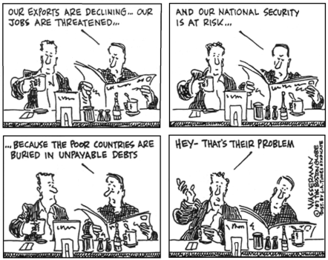
- Pose the following questions for discussion: “What do you think is going on in this cartoon? What is the issue on which it is focusing? How do you know? What is the relationship between domestic and foreign policy in this cartoon?” Teacher note: If your students require additional direction for analyzing this cartoon, please use the National Archives Cartoon Analysis Worksheet: http://www.archives.gov/education/lessons/worksheets/cartoon.html
- Explain to students that foreign policy affects us in the U.S. (e.g., jobs being sent overseas because some foreign countries do not have the same environmental and employment regulations as those found in the U.S. which lowers the cost of production; determining whether events in other countries make it safe for Americans to travel to those or other countries; providing doctors and medicines to combat diseases in other countries). Instruct students to take notes on their graphic organizer.
- Checking for Understanding (Formative Assessment):
Instruct students to write a well-crafted informative response using one or both of the following prompts: Prompt 1
Explain the goals of U.S. foreign policy and the role of the State Department in foreign policy.
Prompt 2
Why do you think the framers of the Constitution gave the President so much power over foreign policy? Provide two reasons to support your opinion.
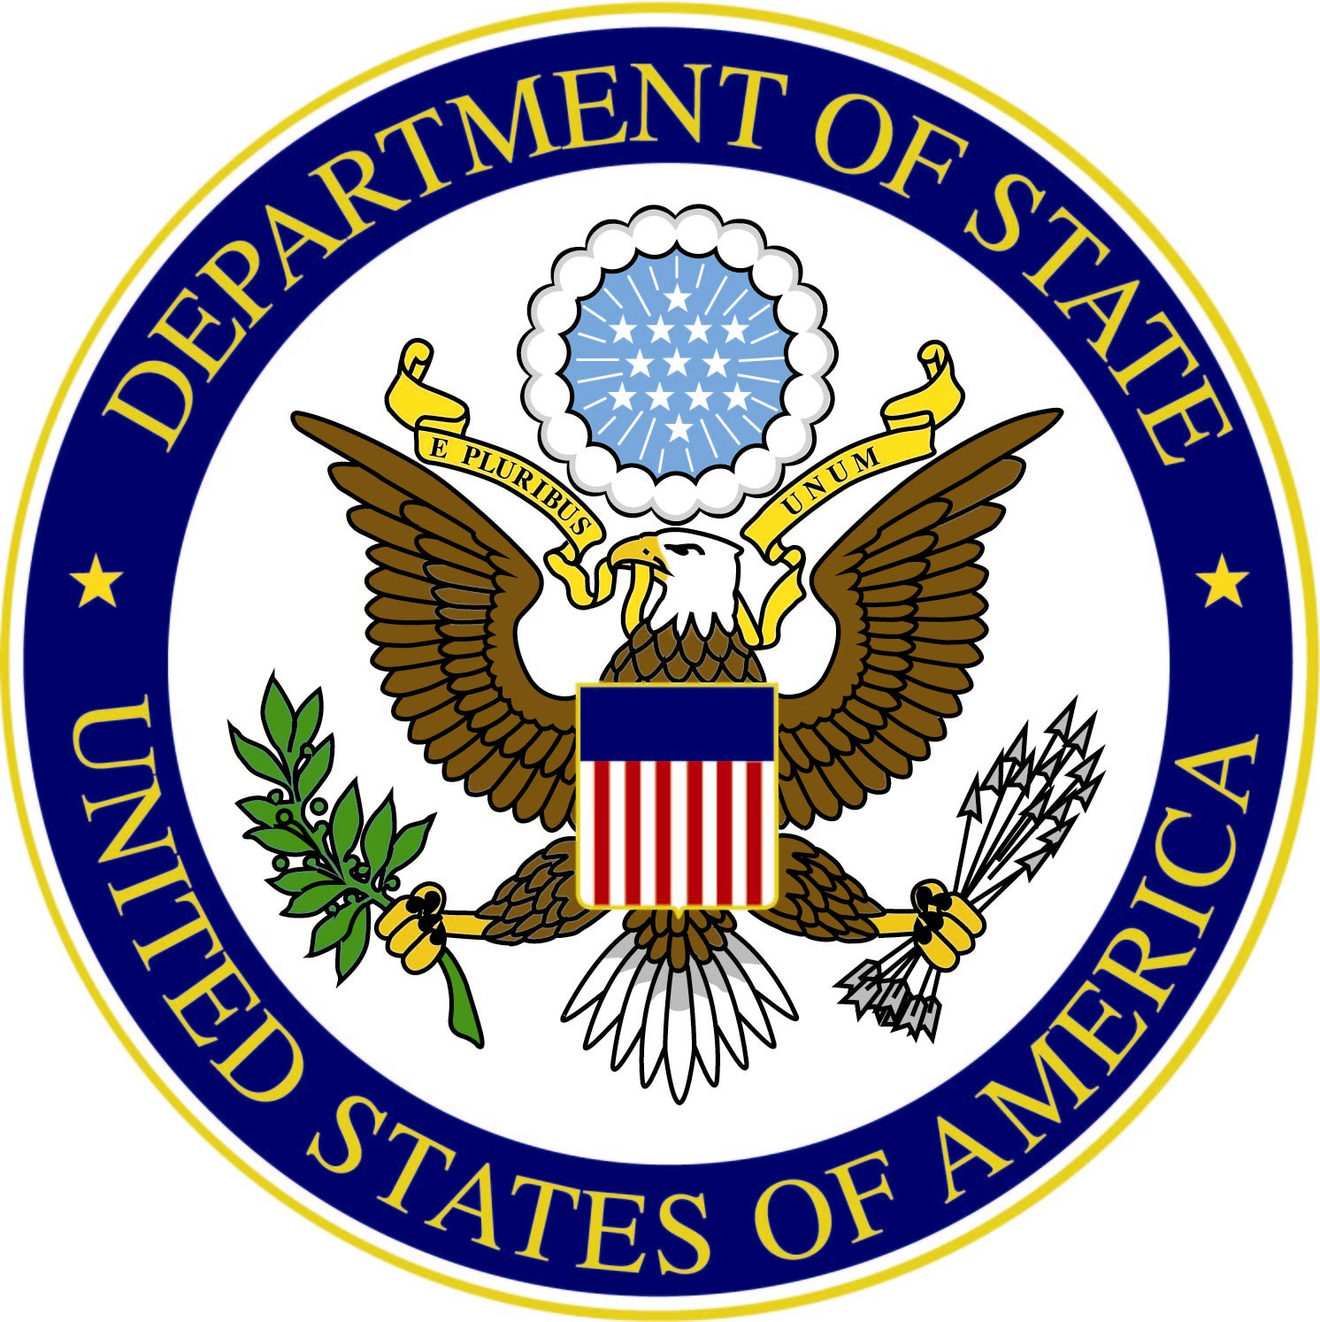DOMESTIC AND FOREIGN POLICY KEY TERMS
Word/Term | Part of Speech | Definition
alliance | noun | a union between nations for assistance and protection
allies | noun
ambassador | noun
diplomacy | noun
diplomat | noun
doctrine | noun
domestic affairs | noun
domestic policy | noun
embassy | noun
foreign affairs | noun
foreign policy | noun
international relations | noun
Secretary of State | proper noun
treaty | noun
U.S. State Department | proper noun

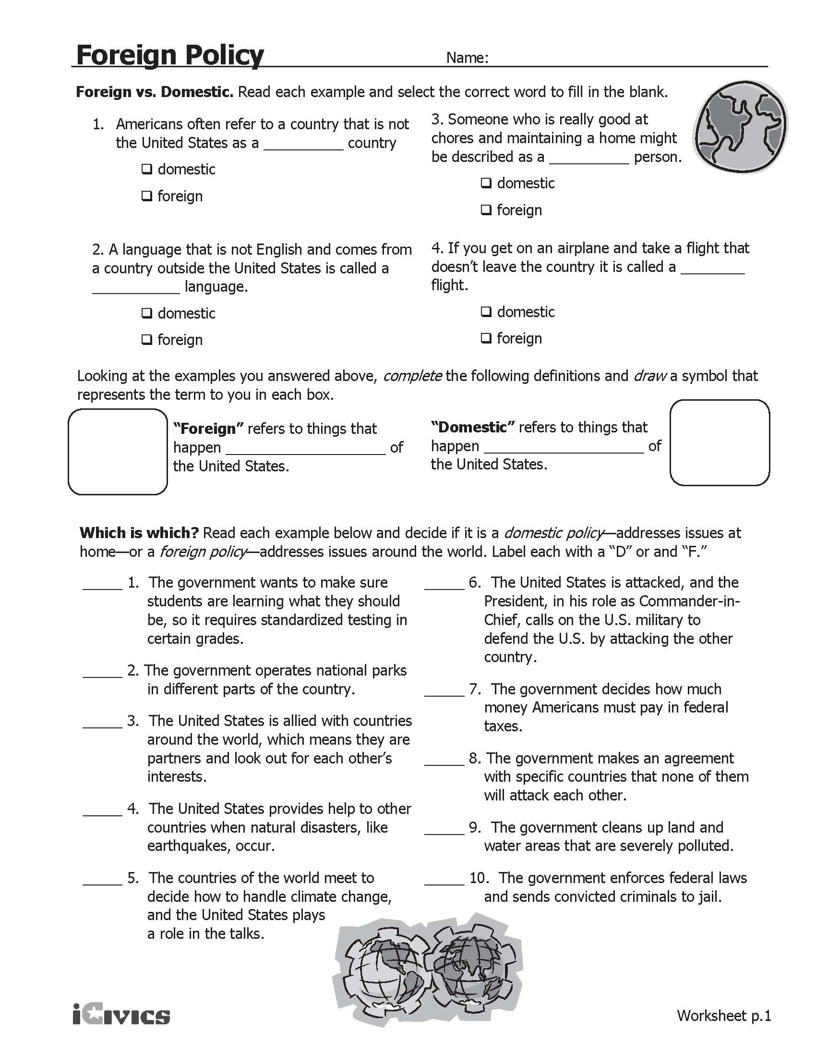
Understanding Foreign and Domestic Policy
Name of the Department | What are the main issues it is concerned with? | Is the department concerned with foreign or domestic policy, or both? What evidence in the text supports your answer?

Based on what you have learned about the Cabinet, how would you summarize the issues and goals related to domestic and foreign policy?

The Cabinet
Department of Agriculture | The U.S. Department of Agriculture (USDA) develops and implements policy on farming, agriculture, and food. Its aims include meeting the needs of farmers and ranchers, promoting agricultural trade and production, managing food safety, protecting natural resources, assisting rural communities, and working to end hunger in America and abroad. It consists of 17 agencies, including the Animal and Plant Health Inspection Service, the Food and Nutrition Service, and the Forest Service. The majority of the department's budget goes towards required programs that provide services required by law, such as nutrition assistance programs, promoting agricultural exports, and conserving our environment. The USDA also plays an important role in overseas aid programs by providing extra foods to developing countries.
Department of Commerce | The Department of Commerce is the government agency in charge of improving living standards for all Americans by promoting economic development and technological innovation. The Department supports U.S. business and industry through a number of services, including gathering economic data and improving understanding of the environment and oceanic life, and ensuring the effective use of scientific and technical resources. The agency also creates technology policy, and promotes U.S. exports by enforcing international trade agreements.
Department of Defense | The mission of the Department of Defense (DOD) is to provide the military forces needed to prevent war and to protect the security of our country. The DOD consists of the Departments of the Army, Navy, and Air Force, the Joint Chiefs of Staff and the Defense Intelligence Agency. The DOD protects national interests through war-fighting, providing humanitarian aid, and performing peacekeeping and disaster relief services.
Department of Education | The mission of the Department of Education is to promote student achievement and preparation for competition in a global economy by fostering educational excellence and ensuring equal access to educational opportunity. The Department administers federal financial aid for education, collects data on America's schools to guide improvements in education quality, and works to complement the efforts of state and local governments, parents, and students.
Department of Energy | The mission of the Department of Energy (DOE) is to advance the national, economic, and energy security of the United States. The DOE promotes America's energy security by encouraging the development of reliable, clean, and affordable energy. It manages federal funding for scientific research to further the goal of discovery and innovation - ensuring American economic competitiveness and improving the quality of life for Americans. The DOE is also tasked with ensuring America's nuclear security, and with protecting the environment by providing a responsible resolution to the legacy of nuclear weapons production.
Department of Health and Human Services | The Department of Health and Human Services (HHS) is the government's main agency for protecting the health of all Americans and providing essential human services, especially for those who are least able to help themselves. Agencies of this department conduct health and social science research, work to prevent disease outbreaks, assure food and drug safety, and provide health insurance. In addition to administering Medicare and Medicaid, which provide health insurance to 25% of Americans, HHS also oversees the National Institutes of Health, the Food and Drug Administration, and the Centers for Disease Control.
Department of Homeland Security | The missions of the Department of Homeland Security are to prevent and disrupt terrorist attacks; protect the American people and key resources; and respond to and recover from incidents that do occur. The Department of Homeland Security includes the U.S. Customs Service, the U.S. Coast Guard, the U.S. Secret Service, the Transportation Security Administration, and the Federal Emergency Management Agency. DHS patrols borders, protects travelers and our transportation systems, enforces immigration laws, and responds to disasters and emergencies. The agency also promotes preparedness and emergency prevention among citizens.
Department of Housing and Urban Development | The Department of Housing and Urban Development (HUD) is the agency responsible for national policies and programs that address America's housing needs, that improve and develop the nation's communities, and that enforce fair housing laws. The Department plays a major role in supporting homeownership for lower- and moderate-income families through its mortgage insurance and rent subsidy programs. Offices within HUD include the Federal Housing Administration, which provides mortgage and loan insurance; the Office of Fair Housing and Equal Opportunity, which ensures all Americans equal access to the housing of their choice; and the Community Development Block Grant Program, which helps communities with economic development, job opportunities, and housing rehabilitation. HUD also administers public housing and homeless assistance.
Department of the Interior | The Department of the Interior (DOI) is the nation's main conservation agency. Its mission is to protect America's natural resources, offer recreation opportunities, conduct scientific research, conserve and protect fish and wildlife, and honor our trust responsibilities to American Indians, Alaskan Natives, and our responsibilities to island communities. DOI manages one-fifth of the land in the United States, and manages hundreds of dams and reservoirs. Agencies within the DOI include the Bureau of Indian Affairs, the Minerals Management Service, and the U.S. Geological Survey. The DOI manages the national parks and is in charge with protecting endangered species.
Department of Justice | The mission of the Department of Justice (DOJ) is to enforce the law and defend the interests of the United States according to the law; to ensure public safety against threats foreign and domestic; to provide federal leadership in preventing and controlling crime; to seek just punishment for those guilty of unlawful behavior; and to ensure fair and impartial administration of justice for all Americans. The Attorney General represents the United States in legal matters, advises the President and the heads of the executive departments of the government, and occasionally appears in person before the Supreme Court.
Department of Labor | The Department of Labor oversees federal programs for ensuring a strong American workforce. These programs address job training, safe working conditions, minimum hourly wage and overtime pay, employment discrimination, and unemployment insurance. The Department of Labor's mission is to foster and promote the welfare of the job seekers, wage earners, and retirees of the United States by improving their working conditions, advancing their opportunities for profitable employment, protecting their retirement and health care benefits, helping employers find workers, strengthening free collective bargaining, and tracking changes in employment, prices, and other national economic measurements.
Department of State | The Department of State plays the lead role in developing and implementing the President's foreign policy. Major responsibilities include United States representation abroad, foreign assistance, foreign military training programs, countering international crime, and a wide assortment of services to U.S. citizens and foreign nationals seeking entrance to the U.S. The U.S. maintains diplomatic relations with approximately 180 countries — each posted by civilian U.S. Foreign Service employees — as well as with international organizations.
Department of Transportation | The mission of the Department of Transportation (DOT) is to ensure a fast, safe, efficient, accessible and convenient transportation system that meets our vital national interests and enhances the quality of life of the American people.
Department of the Treasury | The Department of the Treasury is responsible for promoting economic success and making sure the U.S. and international financial systems are safe and secure. The Department operates and maintains the production of coin and currency, the collection of taxes, and the borrowing of funds necessary to run the federal government. The Department works with other federal agencies, foreign governments, and international financial institutions to encourage global economic growth, raise standards of living, and, to the extent possible, predict and prevent economic and financial crises. The Treasury Department also performs a critical role in enhancing national security by improving the protections of our financial systems and carrying out economic restrictions against foreign threats to the U.S.
Department of Veterans Affairs | The Department of Veterans Affairs is responsible for administering benefit programs for veterans, their families, and their survivors. These benefits include retirement funds, education, disability compensation, home loans, life insurance, vocational rehabilitation, survivor support, medical care, and burial benefits.
Adapted from: The Cabinet: http://www.whitehouse.gov/our-government/executive-branch#cabinet Accessed April 2013.
U.S. State Department: http://www.state.gov/
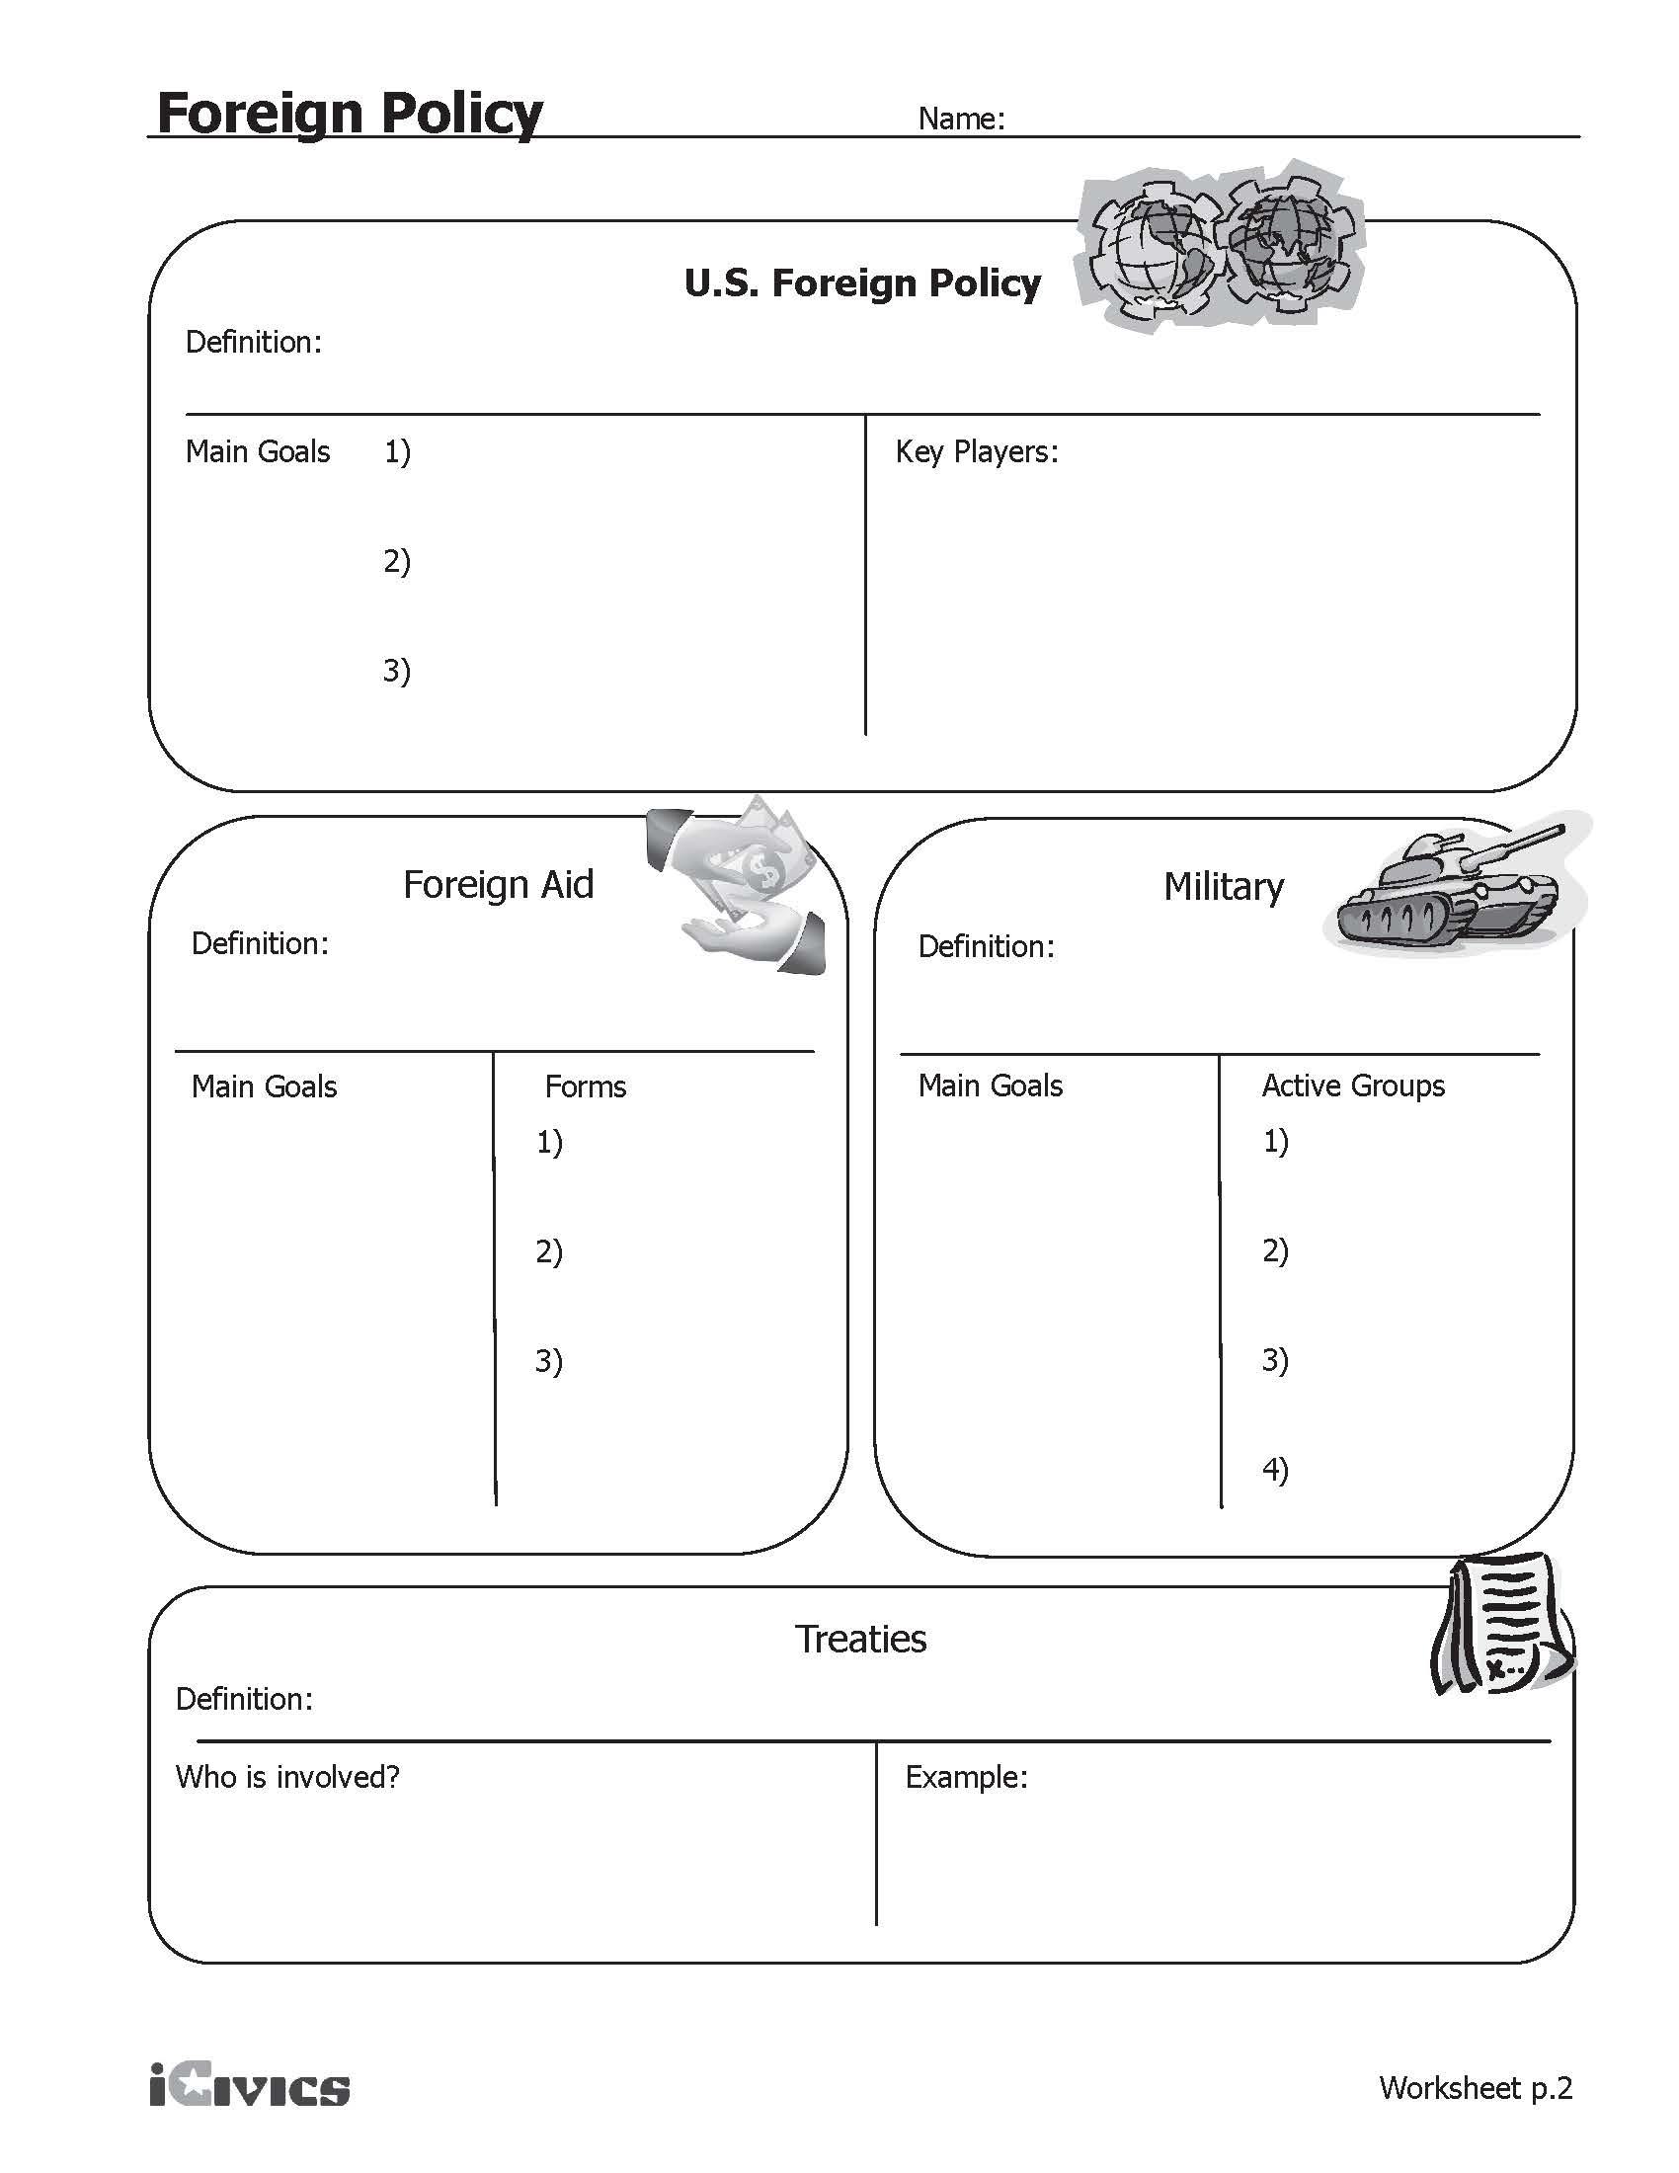
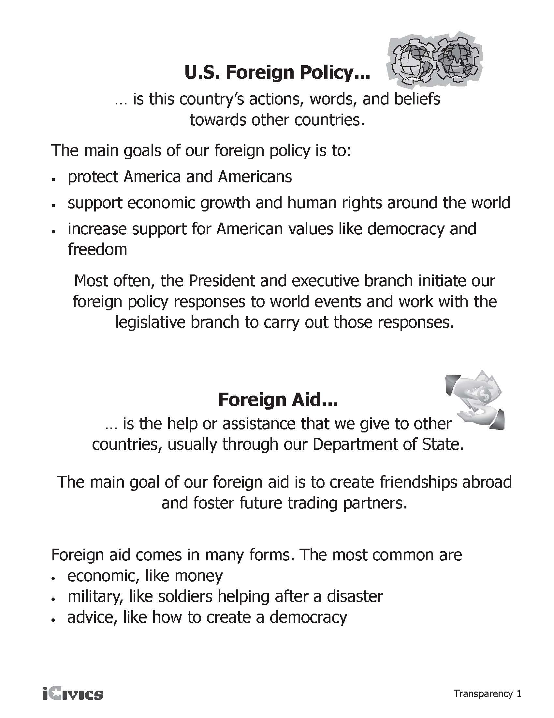

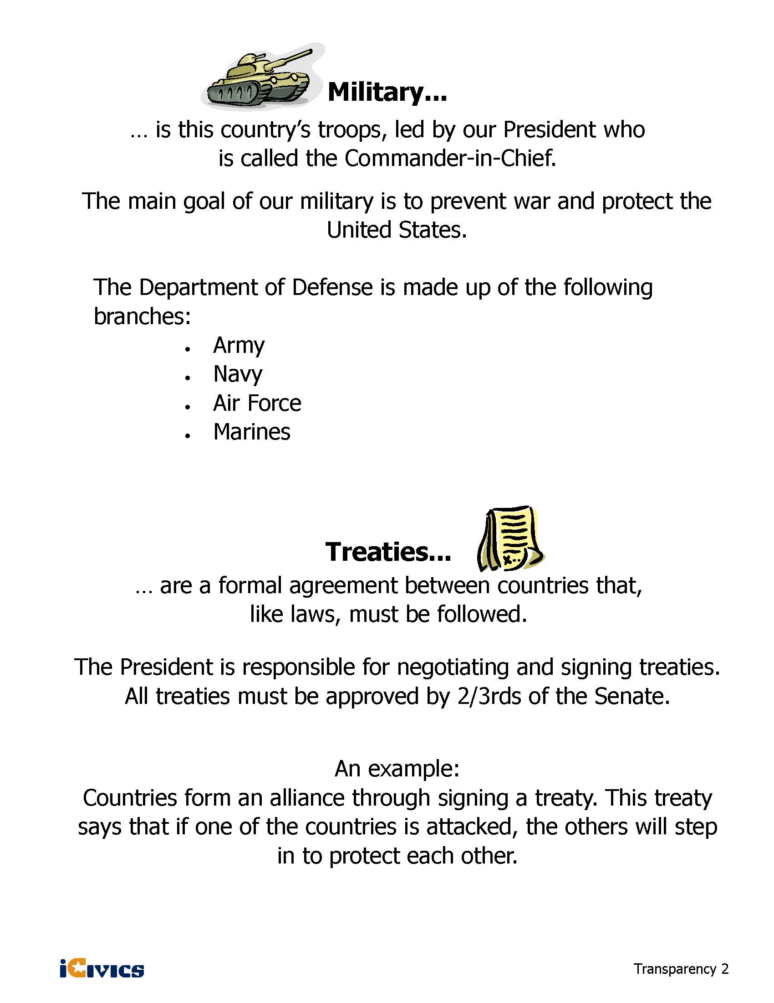

Ten Things You Should Know About U.S. Foreign Policy
U.S. Department of state BUREAU OF PUBLIC AFFAIRS
What does the U.S. Department of State do for the American people with regard to foreign policy? With just over one percent of the entire federal budget, it has a huge impact on how Americans live and how the rest of the world engages with America.
The State Department’s main goals are:
- advancing U.S. national security
- promoting our economic interests
- reaffirming our country’s exceptional role in the world

For example:
1. We create American jobs. We directly support 20 million U.S. jobs by promoting new and open markets for U.S. firms, protecting intellectual property, negotiating new U.S. airline routes worldwide, and competing for foreign government and private contracts.
2. We support American citizens abroad. In 2014, we provided emergency assistance to U.S. citizens in countries experiencing natural disasters or civil unrest. We assisted in 6,537 international adoptions and worked on more than 1,300 child abduction cases -- resulting in the return of over 374 American children.
3. We promote democracy and foster stability around the world. Stable democracies are less likely to pose a threat to their neighbors or to the United States. In South Sudan, Libya and many other countries we worked through various means to foster democracy and peace.
4. We help to make the world a safer place. Under the New START (Strategic Arms Reduction) Treaty, we are reducing the number of deployed nuclear weapons to levels not seen since the 1950s. Our nonproliferation programs have destroyed stockpiles of missiles, munitions and material that can be used to make a nuclear weapon. The State Department has helped more than 40 countries clear millions of square meters of landmines.
5. We save lives. Strong bipartisan support for U.S. global health investments has led to worldwide progress against HIV/AIDS, tuberculosis, malaria, smallpox and polio. Better health abroad reduces the risk of instability and enhances our national security.
6. We help countries feed themselves. We help other countries plant the right seeds in the right way and get crops to markets to feed more people. Strong agricultural sectors lead to more stable countries.
7. We help in times of crisis. From earthquakes in Haiti, Japan and Chile to famine in the Horn of Africa, our dedicated emergency professionals deliver assistance to those who need it most.
8. We promote the rule of law and protect human dignity. We help people in other countries find freedom and shape their own destinies. Reflecting U.S. values, we advocate for the release of prisoners of conscience, prevent political activists from suffering abuse, train police officers to combat sex trafficking and equip journalists to hold their governments accountable.
9. We help Americans see the world. In 2014, we issued 14.1 million passports and passport cards for Americans to travel abroad. We facilitate the lawful travel of international students, tourists and business people to the U.S., adding greatly to our economy. We keep Americans apprised of dangers or difficulties abroad through our travel warnings.
10. We are the face of America overseas. Our diplomats, development experts, and the programs they implement are the source of American leadership around the world. They are the embodiments of our American values abroad. They are a force for good in the world.
Complex Text Graphic Organizer:
Ten Things You Should Know About U.S. Foreign Policy

Directions: After reading, cite specific examples from the text that explain each of the ten items about the U.S. State Department by listing the item number and summarizing the evidence. Once you have completed the reading and listed your evidence, write a statement in the “Summary Statement” box that summarizes what you think the U.S. State Department does.

Summarize specific examples from the text explaining each of the “Ten Things You Should Know.”
Item # | Summary of Text | Domestic Connection
Summary Statement

Foreign Policy Scenarios
1. Upon President Wilson’s request on April 6, 1917, Congress declared war on Germany and gave the President the power to lead the army and navy to fight Germany in World War I.
2. In 2003, President George W. Bush decided to focus support on a worldwide initiative to help countries prevent and treat HIV/AIDS.
3. In 1949, after World War II, the United States and other democratic countries formed NATO, the North Atlantic Treaty Organization. It said that if any country was attacked by an outside nation, they would help defend each other.
4. The U.S. government provides advice and help for countries wanting to start new democracies by showing them how to run fair elections.
5. In 1968, the major countries of the world agreed to the “Nuclear Non-Proliferation Treaty,” which is aimed at limiting the spread of nuclear weapons. As of 2010, over 180 countries have joined.
6. In 1990, Iraqi leader Saddam Hussein led Iraqi troops to invade and take over neighboring Kuwait. In January 1991, Congress authorized President George H. W. Bush to lead U.S. troops into Kuwait and force the Iraqi troops to leave.
7. In response to the January 2010 earthquake that devastated Haiti, the United States has given the country significant aid in the form of food, water, and medical care.
8. The U.S. has a program aimed at helping people in developing countries have access to safe drinking water.
9. On December 7, 1941, Japan attacked a U.S. navy base on Pearl Harbor, Hawaii, a U.S. territory at the time. This act would bring the U.S. into World War II. The next day, Congress passed a war declaration giving President Roosevelt the power the lead the entire U.S. military against Japan.
10. In June 1950, communist North Korea invaded South Korea. The U.S. was supporting South Korea at the time. As a result of the invasion, President Truman sent U.S. troops as part of a United Nations mission to fight on behalf of South Korea.
11. In 1919, President Wilson wanted the U.S. to agree to the Treaty of Versailles, the overall peace treaty ending the war in Europe, and to join the League of Nations. The U.S. Senate rejected these actions, so the U.S. did not ratify the treaty or join the League of Nations.
12. After World War II ended in 1945, the U.S. gave more than $13 billion to help rebuild countries and support their democratic governments.
13. In 1993, the U.S., Canada, and Mexico agreed to the North American Free Trade Agreement (NAFTA), whose goal is to make it easier to trade among the three countries.
14. On September 11, 2001, Al-Qaeda terrorists attacked the United States. President George W. Bush asked Congress for a resolution asking to use military force against those responsible; this led to U.S. troops fighting in Afghanistan, where Al-Qaeda leaders were based.
15. In 1945 the U.S. was the first country to approve of the document that created the United Nations, an international organization created after World War II that tries to keep world peace.

Adapted from: iCivics Lesson Plan – Foreign Policy: War & Peace and Everything In Between http://www.icivics.org/teachers/lesson-plans/foreign-policy-war-peace-and-everything-between

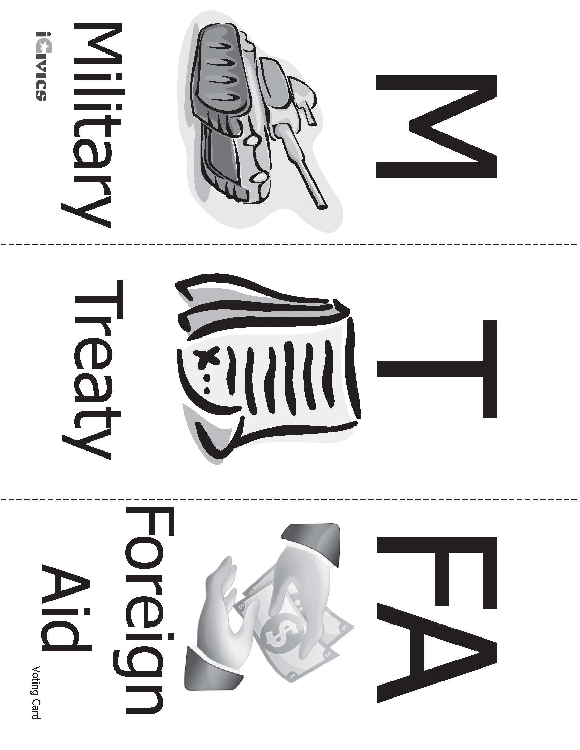
Sources

iCivics Lesson Plan – Foreign Policy: War & Peace and Everything In Between: http://www.icivics.org/teachers/lesson-plans/foreign-policy-war-peace-and-everything-between
The Cabinet: http://www.whitehouse.gov/our-government/executive-branch#cabinet, Accessed April 2013
U.S. State Department: http://www.state.gov/
Ten Things You Should Know About U.S. Foreign Policy, adapted from: http://www.state.gov/r/pa/pl/2013/202844.htm , Accessed April, 2013
Political Cartoon: Source: National Assessment of Educational Progress (NAEP) / Copyright ® 1987 Tribune Media Services, Inc. All rights reserved.
National Archives Cartoon Analysis Worksheet: http://www.archives.gov/education/lessons/worksheets/cartoon.html
Understanding Foreign and Domestic Policy – Sample Answers
Name of the Department | What are the main issues it is concerned with? | Is the department concerned with foreign or domestic policy, or both? What evidence in the text supports your answer?
Department of Agriculture | The U.S. Department of Agriculture (USDA) develops and implements policy on farming, agriculture, and food. Its aims include meeting the needs of farmers and ranchers, promoting agricultural trade and production, managing food safety, protecting natural resources, assisting rural communities, and working to end hunger in America and abroad. | Primarily domestic, but both.  Domestic – The majority of the department's budget goes towards required programs that provide services required by law, such as nutrition assistance programs, promoting agricultural exports, and conserving our environment.  Foreign - The USDA also plays an important role in overseas aid programs by providing extra foods to developing countries.
Department of Commerce | The Department of Commerce is the government agency in charge of improving living standards for all Americans by promoting economic development and technological innovation. | Domestic - The Department supports U.S. business and industry through a number of services, including gathering economic data and improving understanding of the environment and oceanic life, and ensuring the effective use of scientific and technical resources.
Department of Defense | The DOD protects national interests through war-fighting, providing humanitarian aid, and performing peacekeeping and disaster relief services. | Foreign - The mission of the Department of Defense (DOD) is to provide the military forces needed to prevent war and to protect the security of our country.
Department of Education | The mission of the Department of Education is to promote student achievement and preparation for competition in a global economy by fostering educational excellence and ensuring equal access to educational opportunity. | Domestic - The Department administers federal financial aid for education, collects data on America's schools to guide improvements in education quality, and works to complement the efforts of state and local governments, parents, and students.
Department of Energy | The mission of the Department of Energy (DOE) is to advance the national, economic, and energy security of the United States. | Domestic - The DOE promotes America's energy security by encouraging the development of reliable, clean, and affordable energy. It manages federal funding for scientific research to further the goal of discovery and innovation - ensuring American economic competitiveness and improving the quality of life for Americans. The DOE is also tasked with ensuring America's nuclear security, and with protecting the environment by providing a responsible resolution to the legacy of nuclear weapons production.
Department of Health and Human Services | The Department of Health and Human Services (HHS) is the government's main agency for protecting the health of all Americans and providing essential human services, especially for those who are least able to help themselves. | Domestic - In addition to administering Medicare and Medicaid, which provide health insurance to 25% of Americans, HHS also oversees the National Institutes of Health, the Food and Drug Administration, and the Centers for Disease Control.
Department of Homeland Security | The missions of the Department of Homeland Security are to prevent and disrupt terrorist attacks; protect the American people and key resources; and respond to and recover from incidents that do occur. | Foreign and Domestic - DHS patrols borders, protects travelers and our transportation systems, enforces immigration laws, and responds to disasters and emergencies. The agency also promotes preparedness and emergency prevention among citizens.
Department of Housing and Urban Development | The Department of Housing and Urban Development (HUD) is the agency responsible for national policies and programs that address America's housing needs, that improve and develop the nation's communities, and that enforce fair housing laws. The Department plays a major role in supporting homeownership for lower- and moderate-income families through its mortgage insurance and rent subsidy programs. | Domestic - The Department of Housing and Urban Development (HUD) is the agency responsible for national policies and programs that address America's housing needs…
Department of the Interior | The Department of the Interior (DOI) is the nation's main conservation agency. Its mission is to protect America's natural resources, offer recreation opportunities, conduct scientific research, conserve and protect fish and wildlife, and honor our trust responsibilities to American Indians, Alaskan Natives, and our responsibilities to island communities. | Domestic - DOI manages one-fifth of the land in the United States, and manages hundreds of dams and reservoirs.
Department of Justice | The mission of the Department of Justice (DOJ) is to enforce the law and defend the interests of the United States according to the law; to ensure public safety against threats foreign and domestic; to provide federal leadership in preventing and controlling crime; to seek just punishment for those guilty of unlawful behavior; and to ensure fair and impartial administration of justice for all Americans. | Domestic - The mission of the Department of Justice (DOJ) is to enforce the law and defend the interests of the United States according to the law…  Foreign – ensure public safety against threats foreign..
Department of Labor | The Department of Labor oversees federal programs for ensuring a strong American workforce. These programs address job training, safe working conditions, minimum hourly wage and overtime pay, employment discrimination, and unemployment insurance. | Domestic - The Department of Labor's mission is to foster and promote the welfare of the job seekers, wage earners, and retirees of the United States by improving their working conditions,…
Department of State | Major responsibilities include United States representation abroad, foreign assistance, foreign military training programs, countering international crime, and a wide assortment of services to U.S. citizens and foreign nationals seeking entrance to the U.S. | Foreign - The Department of State plays the lead role in developing and implementing the President's foreign policy.
Department of Transportation | The mission of the Department of Transportation (DOT) is to ensure a fast, safe, efficient, accessible and convenient transportation system that meets our vital national interests and enhances the quality of life of the American people. | Domestic - The mission of the Department of Transportation (DOT) is to ensure a fast, safe, efficient, accessible and convenient transportation system that meets our vital national interests…
Department of the Treasury | The Department of the Treasury is responsible for promoting economic success and making sure the U.S. and international financial systems are safe and secure. | Both - The Department operates and maintains the production of coin and currency, the collection of taxes, and the borrowing of funds necessary to run the federal government. The Department works with other federal agencies, foreign governments, and international financial institutions to encourage global economic growth, raise standards of living, and, to the extent possible, predict and prevent economic and financial crises.
Department of Veterans Affairs | The Department of Veterans Affairs is responsible for administering benefit programs for veterans, their families, and their survivors. | Domestic - …administering benefit programs for veterans, their families, and their survivors…
Based on what you have learned about the Cabinet, how would you summarize the issues and goals related to domestic and foreign policy?
In order by Cabinet department:
Domestic Policy Goals: Meeting the needs of farmers and ranchers, promoting agricultural trade and production, managing food safety, protecting natural resources, assisting rural communities, and working to end hunger in America; improving living standards for all Americans; promote student achievement and preparation for competition in a global economy; advance the national, economic, and energy security of the United States; protecting the health of all Americans and providing essential human services; improve and develop the nation's communities; protect America's natural resources, honor our trust responsibilities to American Indians, Alaskan Natives, and our responsibilities to island communities; defend the interests of the United States according to the law; ensure a strong American workforce; ensure a fast, safe, efficient, accessible and convenient transportation system; promoting economic success; and taking care of our veterans.

Foreign Policy Goals: Working to end hunger abroad; protecting national interests through war-fighting, providing humanitarian aid, and performing peacekeeping and disaster relief services; prevent and disrupt terrorist attacks; defend the interests of the United States according to the law; representing the U.S. abroad, providing foreign assistance and training programs, and countering international crime.

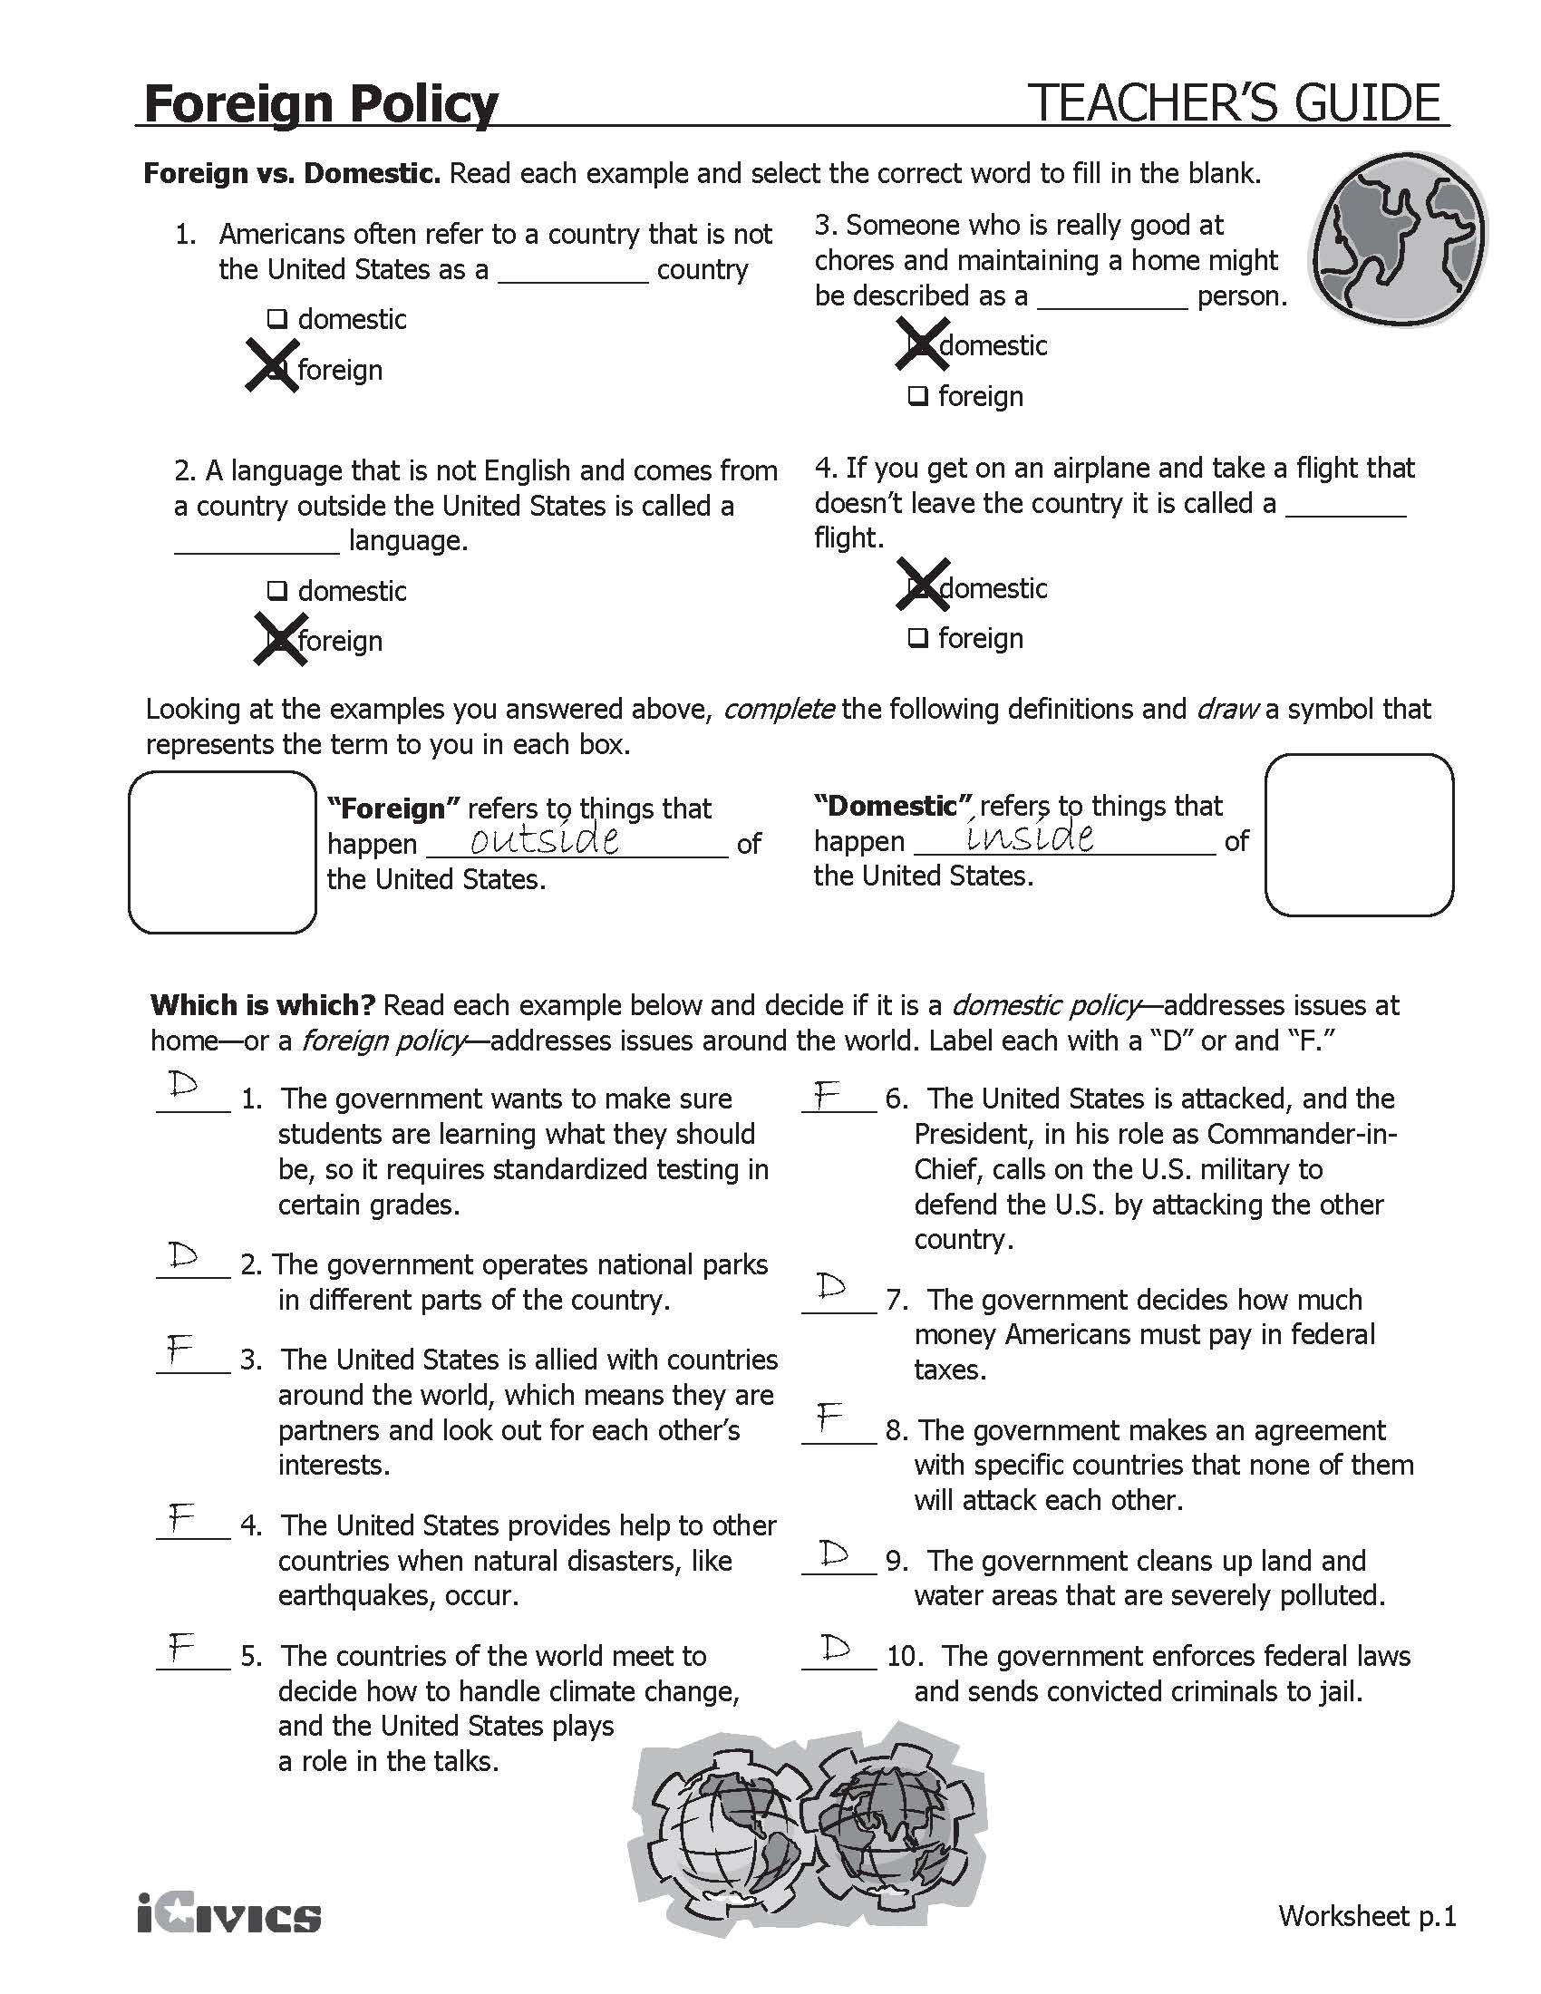

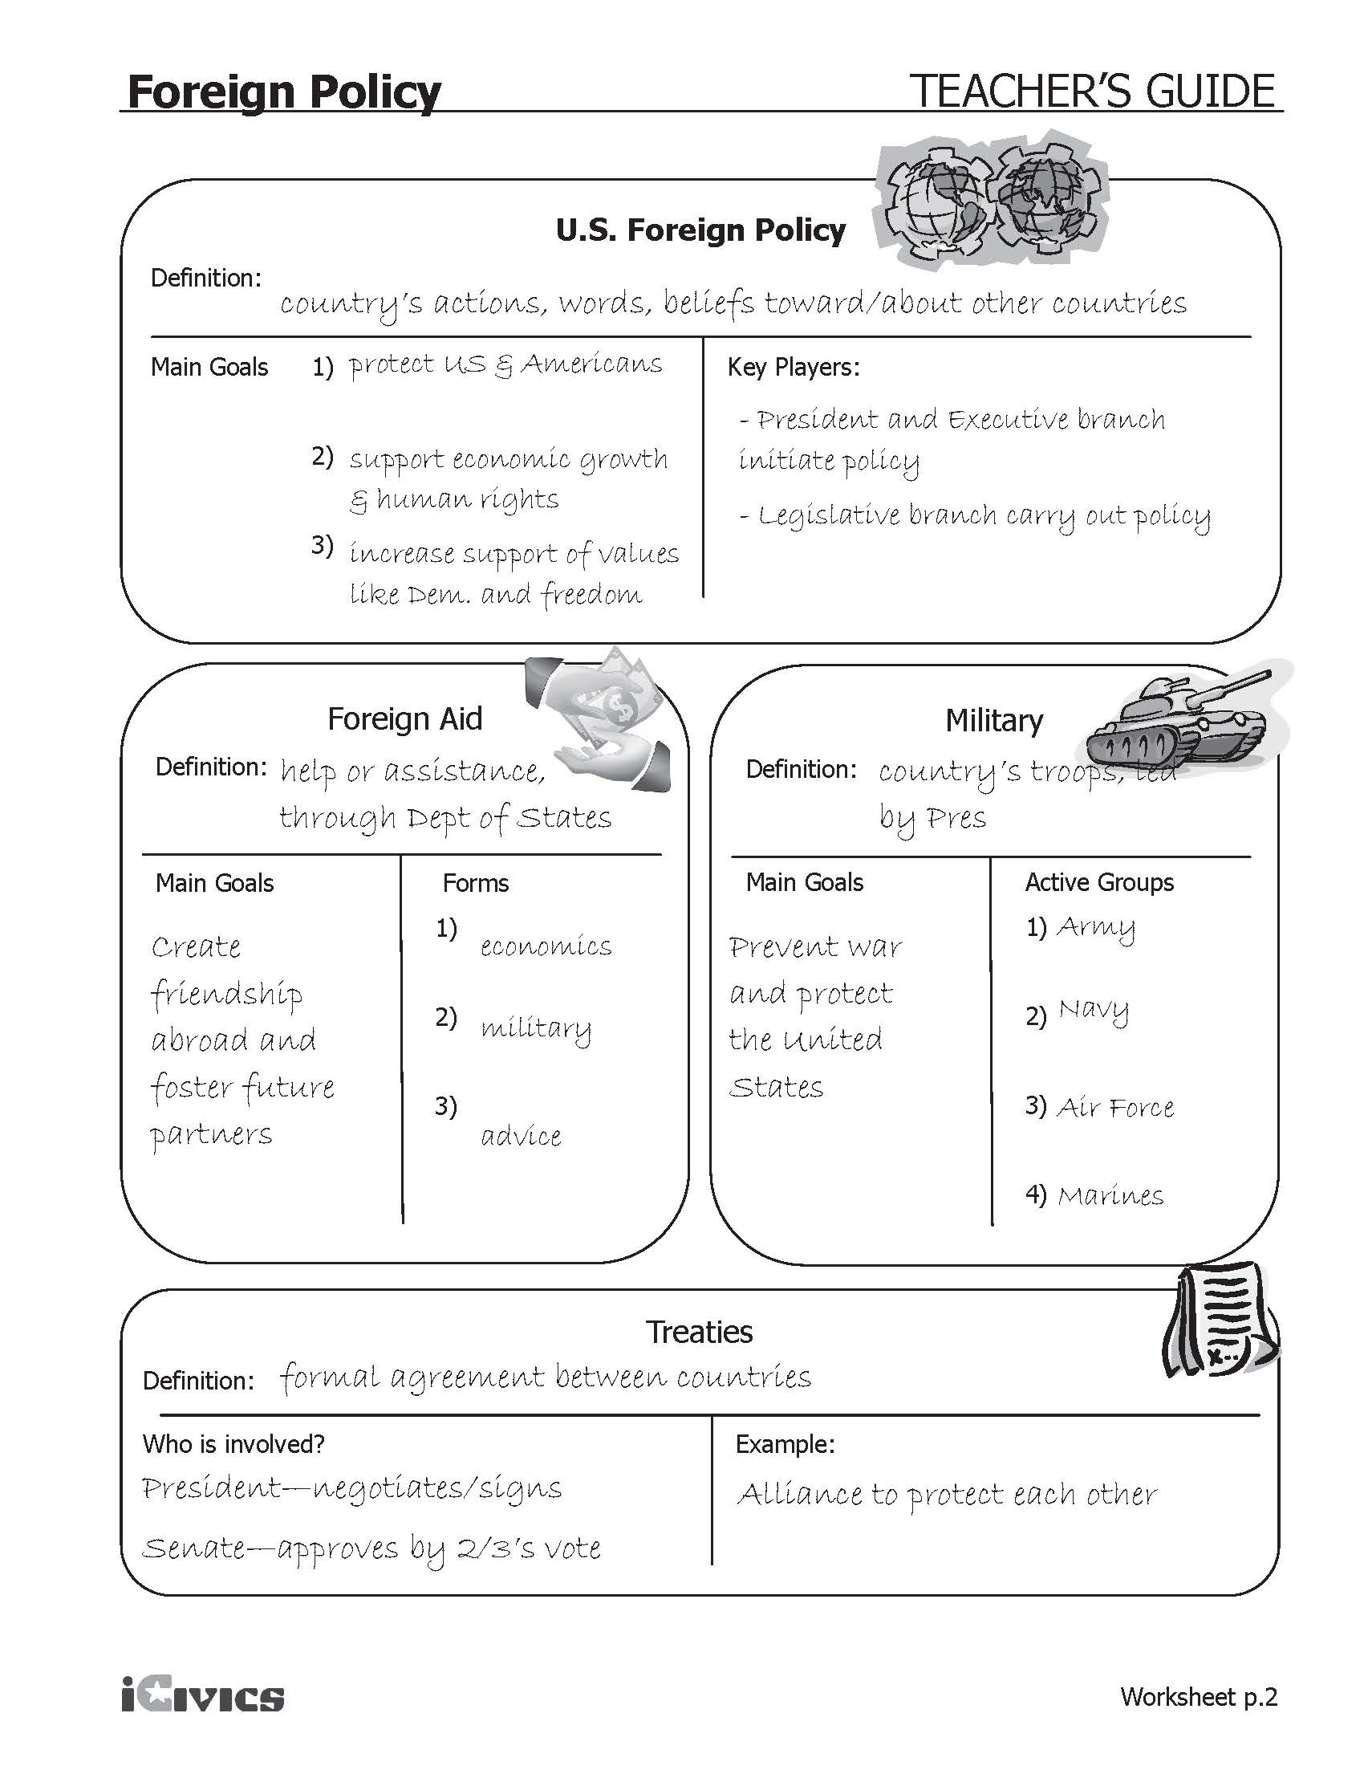
Foreign Policy Scenarios – Sample Answers
1. Upon President Wilson’s request on April 6, 1917, Congress declared war on Germany and gave the President the power to lead the army and navy to fight Germany in World War I. (military)
2. In 2003, President George W. Bush decided to focus support on a worldwide initiative to help countries prevent and treat HIV/AIDS. (foreign aid)
3. In 1949, after World War II, the United States and other democratic countries formed NATO, the North Atlantic Treaty Organization. It said that if any country was attacked by an outside nation, they would help defend each other. (treaty)
4. The U.S. government provides advice and help for countries wanting to start new democracies by showing them how to run fair elections. (foreign aid)
5. In 1968, the major countries of the world agreed to the “Nuclear Non-Proliferation Treaty,” which is aimed at limiting the spread of nuclear weapons. As of 2010, over 180 countries have joined. (treaty)
6. In 1990, Iraqi leader Saddam Hussein led Iraqi troops to invade and take over neighboring Kuwait. In January 1991, Congress authorized President George H. W. Bush to lead U.S. troops into Kuwait and force the Iraqi troops to leave. (military)
7. In response to the January 2010 earthquake that devastated Haiti, the United States has given the country significant aid in the form of food, water, and medical care. (foreign aid)
8. The U.S. has a program aimed at helping people in developing countries have access to safe drinking water. (foreign aid)
9. On December 7, 1941, Japan attacked a U.S. navy base on Pearl Harbor, Hawaii, a U.S. territory at the time. This act would bring the U.S. into World War II. The next day, Congress passed a war declaration giving President Roosevelt the power the lead the entire U.S. military against Japan. (military)
10. In June 1950, communist North Korea invaded South Korea. The U.S. was supporting South Korea at the time. As a result of the invasion, President Truman sent U.S. troops as part of a United Nations mission to fight on behalf of South Korea. (military)
11. In 1919, President Wilson wanted the U.S. to agree to the Treaty of Versailles, the overall peace treaty ending the war in Europe, and to join the League of Nations. The U.S. Senate rejected these actions, so the U.S. did not ratify the treaty or join the League of Nations. (treaty)
12. After World War II ended in 1945, the U.S. gave more than $13 billion to help rebuild countries and support their democratic governments. (foreign aid)
13. In 1993, the U.S., Canada, and Mexico agreed to the North American Free Trade Agreement (NAFTA), whose goal is to make it easier to trade among the three countries. (treaty)
14. On September 11, 2001, Al-Qaeda terrorists attacked the United States. President George W. Bush asked Congress for a resolution asking to use military force against those responsible; this led to U.S. troops fighting in Afghanistan, where Al-Qaeda leaders were based. (military)
15. In 1945 the U.S. was the first country to approve of the document that created the United Nations, an international organization created after World War II that tries to keep world peace. (treaty)

Civics Content Vocabulary

Word/Term | Part of Speech | Definition
alliance | noun | a union between nations for assistance and protection
allies | noun | nations united with another for some common purpose such as assistance and protection
ambassador | noun | a person sent as the chief representative of his or her own government in another country
diplomacy | noun | the work of keeping good relations between the governments of different countries
diplomat | noun | a person employed or skilled in diplomacy
doctrine | noun | the principles in a system of belief
domestic affairs | noun | issues or concerns in one’s own country
domestic policy | noun | a government’s decisions about issues within the country
embassy | noun | the residence or office of a country’s ambassador
foreign affairs | noun | issues or concerns about other countries around the world
foreign policy | noun | a government’s decisions about relationships with other countries
HIV/AIDS | noun | the virus that causes AIDS, spread through body fluids
international relations | noun | relationship between nations around the world
Secretary of State | proper noun | the head of the U.S. Department of State; a member of the President’s Cabinet
treaty | noun | an agreement or arrangement between two or more countries
U.S. State Department | proper noun | the federal department in the U.S. government that makes foreign policies; part of the executive branch of the federal government

Essential Teacher Content Background Information

This section addresses the following issues:
- Differentiating between domestic and foreign policy
- Four principles pertaining to domestic and foreign policy
- The Cabinet

1. Differentiating between domestic and foreign policy

The policy making process is outlined in the U.S. Constitution. Article I of the U.S. Constitution provides instruction on both the policy process as well as those areas of public policy for which Congress is responsible. Article I, Section 8 outlines those policy areas within Congress’ purview. Before are those clauses included in Article I, Section 8 that directly or indirectly impact the Benchmark SS.7.C.4.1 as outlined in the Florida Department of Education Civics EOC Item Specifications:

The Congress shall have Power To lay and collect Taxes, Duties, Imposts and Excises, to pay the Debts and provide for the common Defence and general Welfare of the United States; but all Duties, Imposts and Excises shall be uniform throughout the United States;
To borrow money on the credit of the United States;
To regulate Commerce with foreign Nations, and among the several States, and with the Indian Tribes;
To establish an uniform Rule of Naturalization, and uniform Laws on the subject of Bankruptcies throughout the United States;
To define and punish Piracies and Felonies committed on the high Seas, and Offenses against the Law of Nations;
To declare War, grant Letters of Marque and Reprisal, and make Rules concerning Captures on Land and Water;
To raise and support Armies, but no Appropriation of Money to that Use shall be for a longer Term than two Years;
To provide and maintain a Navy;
To make Rules for the Government and Regulation of the land and naval Forces;
To provide for calling forth the Militia to execute the Laws of the Union, suppress Insurrections and repel Invasions;
To make all Laws which shall be necessary and proper for carrying into Execution the foregoing Powers, and all other Powers vested by this Constitution in the Government of the United States, or in any Department or Officer thereof.

This last clause is called the “necessary and proper” or “elastic” clause. The clause enables Congress to take whatever action that it believes needs to be taken in representing the needs of the American people. Most public policy emerges from the “elastic clause” because these policy concerns were not anticipated by the founders.

2. Four principles pertaining to domestic and foreign policy

This listing of congressional powers demonstrates four principles about public policy:

- Congress has the power to make laws and policies with the sole purpose of impacting citizen and non-citizen behavior in the U.S. This area of policy is domestic policy.
Domestic policy includes those laws focusing on domestic affairs. Social welfare, health care, education, civil rights, economic issues, and social issues, such as family law, all function in the domestic policy realm.
- Congress has the power to make laws and policies with the purpose of impacting citizen and non-citizen behavior outside the U.S. and international relations. This area of policy is foreign policy.
Foreign policy focuses on the relationship between the U.S. and other nations, and the factors affecting that relationship. Including in the foreign policy process are various policy instruments that are anchored in diplomacy. These policy instruments include alliances and treaties, both of which speak to formal agreements between two or more countries, that take place under the purview of the Secretary of State (a Cabinet-level position that oversees the Department of State).
- Foreign policy and domestic policy are often related. How the U.S. interacts with other nations is often related to domestic policy. For example, Congress’ use of its power to raise and support armies articulated in Article I, Section 8, is related to international relations. The greater the domestic threat from foreign enemies, the greater the likelihood that Congress will increase military spending. In the 1990s, for example, military spending declined after the fall of Communism (except in Cuba and China). At the same time, international relations changed for the U.S. with the fall of Communism as more nations became democracies after the fall of Communism which was symbolized with the fall of the Berlin Wall in 1990.
- Foreign policy and domestic policy impact one another even if they are made specifically within the domestic or foreign policy realm.
There are certain domestic policy areas impacting other nations directly or indirectly. For example, federal and state-level environmental policies affect air and water quality in the U.S. and in other nations. Domestic policies relating to naturalization affect migration and immigration patterns. Similarly, relationships between the U.S. and other nations impacts and is impacted by trade between those nations.
3. The Cabinet

This table represents a complete list of all current Cabinet departments in the order that they were created.

Department Name | Year Created | Notes
State | 1789 | Originally named Department of Foreign Affairs in July 1789, and renamed Department of State in September 1789.
Treasury | 1789
War | 1791 | Named the Department of the Army 1947  Named the Department of Defense 1949
Office of Attorney General | 1789 | Named the Department of Justice in 1870
Interior | 1849
Agriculture | 1862
Labor and Commerce | 1903 | Renamed Department of Commerce when the Department of Labor was created in 1913
Labor | 1913 | The first female Cabinet secretary was Frances Perkins, Secretary of Labor under Franklin Roosevelt's administration
Health, Education and Welfare | 1953 | In 1979, the Department of Education was created, at which point the Department of Health and Human Services was created in 1980 as a department separate from Education.
Housing and Urban Development | 1965
Transportation | 1966
Energy | 1977
Education | 1979 | See Department of Health, Education and Welfare above
Veteran's Affairs | 1988
Homeland Security | 2003

There are several positions that hold the status of Cabinet rank even though they are not Cabinet level departments. These include the Vice-President and the White House Chief of Staff.
The following offices hold Cabinet-level rank, although they are not connected to Cabinet-level departments.

Name | Year Created
Council of Economic Advisers | 1946
Environmental Protection Agency | 1970
Office of Management and Budget | 1921
United States Trade Representative | 1963
United States Ambassador to the United Nations | 1945

