

**PROCESSES & LAWMAKING**

**SS.7.C.3.8** Analyze the structure, functions, and processes of the legislative, executive, and judicial branches.

**SS.7.C.3.9** Illustrate the lawmaking process at the local, state, and federal levels.

**TABLE OF CONTENTS**

Lesson Summary2

**Suggested Student Activity Sequence4**

**Student Activity Sheets & Reading Materials8**

**Sources19**

**Answer Keys20**

**Civics Content Vocabulary24**

**Essential Teacher Content Background Information26**

***Lesson Summary***

***Essential Question***

What are the processes of the three branches? How are laws made at each level of government?

***NGSSS Benchmarks***

SS.7.C.3.8 Analyze the structure, functions, and processes of the legislative, executive, and judicial branches.

SS.7.C.3.9 Illustrate the lawmaking process at the local, state, and federal levels.

***Florida Standards***

LAFS.68.RH.1.3 LAFS.68.RH.3.7 LAFS.68.RH.3.9 LAFS.68.RH.3.8

LAFS.68.WHST.1.1 LAFS.68.WHST.1.2 LAFS.68.WHST.2.4 LAFS.68.WHST.2.6

LAFS.68.WHST.4.10 LAFS.7.SL.1.1 LAFS.7.SL.1.2 LAFS.7.SL.2.4

MAFS.K12.MP.6.1

***Overview***

In this lesson, students will learn about the specific processes for each branch of government and how laws are made at each level of government.

***Learning Goals/Benchmark Clarifications***

* Students will examine the processes of the legislative (e.g., how a bill becomes a law, appointment confirmation, committee selection), executive (e.g., executive order, veto, appointments), and judicial (e.g., judicial review, court order, writ of certiorari, summary judgment) branches of government.
* Students will compare local, state, and federal lawmakers (city/county commissioners/council members; state legislators [representatives and senators]; and U.S. congressmen/congresswomen [representatives and senators]).
* Students will distinguish among ordinances, statutes, and acts on the local, state, and federal levels.
* Students will compare and contrast the lawmaking process at the local, state, and federal levels.

***Benchmark Content Limits***

* Items will not require students to recall specific individual names related to the three branches of government at any level.
* Items will not require students to recall the content of specific legislation, executive actions, or court proceedings.
* Items will not include any specific city/county ordinances.
* Items will not include any state processes other than those of Florida.

***Civics EOC Reporting Category***

Reporting Category 4 – Organization and Function of Government

***Suggested Time Frame***

* Five 45-50 minute class periods

***Civics Content Vocabulary***

* act, appointment, appointment confirmation, bicameral, bill, cabinet, Chief Justice, city commissioner or council member, committee selection, conference committee, constituents, county commissioner or council member, court order, executive order, home rule, how a bill becomes a law, impeach, judgment, judicial review, jurisdiction, law, majority leader, majority party, majority vote, mayor, minority leader, minority party, nominate, ordinance, pardon, President pro tempore of the Senate, presidential appointment, school board, Speaker of the House, special committee, special interest groups, standing committee, state legislator, state representative, state senator, statute, summary judgment, United States representative, United States senator, veto, writ of certiorari

***Instructional Strategies***

Close reading of complex text and video Collaborative learning Compare/Contrast

***Materials***

Internet access to view the Schoolhouse Rock “How a Bill Becomes a Law” video

Projector to show a variety of handouts and student activity sheets

Media center or computer lab access to complete the “Who Represents Me?” activity sheet.

Copies of the Three Branches Processes placards

Pencils

Student activity sheets and reading material:

* Three Branches Graphic Organizer from SS.7.C.3.3 lesson plan (or on page 20 of this lesson)
* How A Bill Becomes A Law at the Federal Level
* Civics Content Vocabulary
* Three Branches of Government Processes
* Who Represents Me?
* State and Local Government
* The Great State reading from iCivics: <http://www.icivics.org/teachers/lesson-plans/great-state>
* How Laws are Made in Florida Cities

***Lesson Activities and Daily Schedule***

Please use the chart below to track activity completion.

|  |  |  |  |  |
| --- | --- | --- | --- | --- |
| **Day** | **Task #** | **Steps in Lesson** | **Description** | **Completed?**  **Yes/No** |
| **Day One** | Task 1 | 1-3 | Hook Activity |  |
| Task 2 | 4-7 | The Three Branches and Leadership Roles |  |
| Task 3 | 8-20 | How a Bill Becomes a Law |  |
| **Day Two** | Task 3 | 8-20 | How a Bill Becomes a Law  (continued) |  |
| Task 4 | 21 | Checking for Understanding A |  |
| **Day Three** | Task 5 | 22-30 | Processes of the Three Branches |  |
| **Day Four** | Task 6 | 31-42 | Who Represents Me? Activity |  |
| Task 7 | 43 | Checking for Understanding B |  |
| **Day Five** | Task 7 | 44-54 | The Great State Reading |  |
| Task 8 | 55-57 | Lawmaking at the Local Level |  |
| Task 8 | 58 | Checking for Understanding C |  |

***Suggested Student Activity Sequence***

1. To begin this lesson, project the following statement on the board: “There is a law in the United States that makes it illegal to pay different wages to men and women if they perform equal work in the same workplace.”
2. Pose the following question to the students: “How did this idea become a law?” Allow students time to brainstorm and share out some ideas.
3. Explain to students that there is a specific process for how an idea becomes a law and that process is one of many for the three branches of government.
4. Display the “Three Branches” student activity sheet/graphic organizer from SS.7.C.3.3 and have students place their graphic organizer on their desk. Review the structure and major functions of each branch. Teacher note: If you completed the lesson plan for SS.7.C.3.3, they will already have the graphic organizer and this can serve as a quick review. If you did not do the lesson plan for SS.7.C.3.3, use the version located on page 20. It will be important to spend an adequate amount of time reviewing this information so that your students have an understanding of each branch.
5. Explain to students that there are important leadership roles and titles associated with each branch.
6. Provide students with an overview of the leadership roles for the legislative, executive, and judicial branches. Teacher note: Utilize the definitions from the Civics Content Vocabulary and information from the Essential Teacher Content Background Information to provide some information related to each position.

Be sure to include the following positions and key points:

* + House of Representatives –
    1. Speaker of the House, Majority Leader, Minority Leader
    2. Members are referred to as “Representative”
  + Senate –
    1. President Pro Tempore, Majority Leader, Minority Leader
    2. Members are referred to as “Senator”
  + Executive Branch – President, Vice President, Cabinet
  + Judicial Branch – Chief Justice of the Supreme Court, Associate Justices

1. Instruct students to list the appropriate leadership positions under the correct branch of government on the “Three Branches” graphic organizer (See Sample Answers section to guide this process).
2. Explain to students that, as a whole class, they will learn about another process: how a bill becomes a law.
3. Pass out the “How a Bill Becomes a Law at the Federal Level” student activity sheet and explain to students that they will watch “I’m Just a Bill” from Schoolhouse Rock. While they watch the video they need to write down any key words or phrases they hear that explain the process of how a bill becomes a law. Instruct students to list these key words or phrases in the box at the top of the activity sheet.
4. Watch the video. ‘I’m Just a Bill’ at <https://www.youtube.com/watch?v=2nKyihoV9z8>.
5. Ask students to share the key terms they heard during the video. (Some key terms/phrases are: idea, bill, congressman, introduced to Congress, committee, discussed, debated, House of Representatives, Senate, vote, White House, president, veto.)
6. Pass out or project copies of the “Civics Content Vocabulary” and ask students to identify any additional terms that might fit with the process of how a bill becomes a law (Some examples are: act, bicameral, bill, how a bill becomes a law, special interest groups, U.S. Representative, and U.S. Senator).
7. Write the key words on the board and add any additional terms from the list that students did not share. Instruct students to add the additional terms to their activity sheet.
8. Review any key words that students are unfamiliar with. For example, remind students of the term “committee” and what it means in terms of Congress and this process.
9. Watch the video again and instruct students to try to put the steps of how a bill becomes a law in order. Instruct them to use pencil and write down the steps in the numbered boxes on the “How a Bill Becomes a Law at the Federal Level” activity sheet.
10. Ask students to share some of the steps they heard while watching the video for a second time.
11. Project the boxes from the “How a Bill Becomes a Law at the Federal Level” student activity sheet on the board and as a whole class write out the steps for how a bill becomes a law. Teacher note: Utilize the sample answers for this activity sheet to put steps in the correct order and to provide additional content information.
12. Explain to students that bills that become laws can also be known as acts (at the federal level), statutes (at the state level) or ordinances (at the local level).
13. Direct student attention to Step 2, Committee Action on the activity sheet.
14. Pass out the “Three Branches of Government Processes” student activity sheet and share the following key points about committees. Instruct students to add this information to their activity sheet under the Legislative row.
    * Committees in Congress allow for deliberation and debate with a reduced number of members rather than all of the members of either house debating ever bill.
    * The committee system also reflects the notion that members need to spend time on issues important to their district in order to serve their constituents well.
    * In their deliberations, committees hold hearings, conduct research, and write policy. Special interest groups often testify during these hearings in their efforts to shape legislation as it is being written. Some bills are not forwarded to the full house for a vote as the committee may recommend that a bill not receive further consideration. In other cases, the committee votes favorably on the bill and it is forwarded to the full house for a vote.
    * There are five different types of committees; listed below are three.
      1. Standing - Permanent legislative panels that consider bills and issues, Members of one house, and both parties
      2. Special - Performs a special function beyond the authority or capacity of a standing committee; Members of one house, and one party
      3. Conference - Temporary committee formed to reconcile differences in legislation passed by both chambers; Members of the House of Representatives and the Senate
    * The majority party in each house determines committee selection. They determine the amount of members from each party and new Representatives and Senators are assigned to committees based on the available spaces.
15. Checking for Understanding A (Formative Assessment):

Instruct students to write a well-crafted response to one of the following prompts:

Prompt 1

Thousands of bills are proposed each year and less than five percent of the proposed bills actually become laws. Citing evidence from the video and your handout, explain why you think there is a low passage rate.

Prompt 2

Based on what you have learned, why do you think the process of a bill becoming a law at the federal level has many steps? Cite evidence from the video and your handout to explain your answer.

1. Share with students that there are other processes involved with the branches of government.
2. Project the “Three Branches of Government Processes” activity sheet.
3. Direct student attention to the vocabulary box at the top of the page and read aloud the 14 terms in the box.
4. Ask students to mark the terms they have already learned about: how a bill becomes a law, standing committee, special committee, conference committee, and committee selection.
5. Explain to students that they will complete a Carousel Activity/Gallery Walk to learn about the other processes listed in the vocabulary box. Explain to students that they can complete this activity independently or with a partner. Teacher note: Prior to the start of this activity you will need to print, cut and post the placards on pages 25-28.
6. Direct students to the placards around the room so that the students are spread out.
7. Instruct students to read the placard and summarize the main idea under the correct branch of government.
8. Provide time for students to complete the activity.
9. Review as a whole class.
10. Ask students to take out their three branches graphic organizer and remind students of the basic structure and functions of the three branches.
11. Project the graphic organizer on the board throughout this section of the lesson.
12. Ask a student to name the president and to explain whom he represents. Lead students to the understanding that the president represents the people of the United States. His job is to make decisions in the best interest of the entire nation.
13. Ask the students to name the U.S. Senators from Florida. (Bill Nelson & Marco Rubio) Point out to students that Senator Nelson and Senator Rubio serve the United States while making sure they keep the interests of Florida in mind.
14. Project Senator Nelson (<http://rickscott.senate.gov/>) and/or Senator Rubio’s (<http://www.rubio.senate.gov/public/>) website and point out to students that on both sites there is information about Florida (stories, photos, maps).
15. Ask students why both websites have so much information about Florida. Lead students to the idea that they are the constituents, people politicians have been elected to represent, of both senators.
16. Return the students’ attention back to the graphic organizer and ask them if they know how many U.S. congressional districts are in Florida (27) and if they know who their representative is. Teacher note: Anticipate that most students will not know the answer to either question.
17. Pass out the “Who Represents Me?” student activity sheet and explain to the students that it is important to know who represents them, what these representatives do, and to understand that they are considered constituents for many different people and levels of government.
18. Review the handout with the students and explain that they will conduct research to understand their representatives at the federal, state, county, city, and school board levels. Instruct students to determine who their representative is at every level of government and to write a summary sentence explaining the primary job of the position.
19. Review the “President” and “U.S. Senate” categories as a whole class and fill in the answers.
20. Provide students with time to complete the worksheet in class or at home.
21. Ask students to share some of the information they learned while completing the research assignment. Pose the following questions for discussion: “Why is it important to know who represents you? Do you think most people know this information? Why or why not? Should everyone know this information? How do lawmakers differ between levels of government? How are they similar?”
22. Checking for Understanding B (Formative Assessment):

Instruct students to write a well-crafted response to the following prompt:

Prompt

Based on what you have learned during your research for the “Who Represents Me?” assignment, compare the primary responsibility of lawmakers at the federal, state, and local levels. Be sure to include information you researched related to your local city/county commission or council, state legislators and U.S. congressmen.

1. Ask students if they know the structure of the state government. Instruct them to look at their completed “Who Represents Me?” handout for some clues.
2. Pass out the “State & Local Government” activity sheet and “The Great State” reading from iCivics (<http://www.icivics.org/teachers/lesson-plans/great-state>).
3. Explain to students that they will read the passage as a whole class and that during the reading they need to underline the words or phrases that explain the structure of the state government.
4. Read the introductory paragraphs aloud and ask students to summarize the main ideas.
5. Ask a student to read “The State Legislative Branch” paragraph aloud.
6. Point out the federal legislative branch on the board and ask the students, “Based on what you have read, is the structure of the legislative branch at the state level different than at the federal level?” (no) “What are the two houses of the state legislature called?” (the Senate and the House of Representatives).
7. Instruct students to write the Senate and the House of Representatives on their activity sheet under the Legislative Branch.
8. Ask a student to point out from the reading “What is the job of the state legislature?” Instruct students to circle the lines that explain the function of the legislative branch. Explain to students that members of the state legislature (Florida House of Representatives and Florida Senate) are also known as state legislators.
9. Continue this process with the following two sections: “The State Executive Branch” and “The State Judicial Branch”.
10. Ask students to place their “How A Bill Becomes A Law at the Federal Level” handout on their desks and remind students of the process of how a bill becomes a law at the federal level.
11. Share with students that the process for passing a state law is the same as passing it at the federal level.
12. Have students look at their “Who Represents Me?” handout.
13. Ask the students to consider who plays a role in the lawmaking process at the federal and state levels. Based what they have learned about the federal level, they know that Congress and the president play a role in the federal lawmaking process. Who is involved in the state lawmaking process? (state legislature and governor) What about the local level? Based on what they know about who represents them at the county and city level, can they guess who is involved in making laws at the local level? (city/county commissioners/council members)
14. Project the “How Laws Are Made in Florida’s Cities” handout and provide an overview of how ordinances are proposed and passed in Florida’s cities. Instruct students to take notes on the space provided on the “State & Local Government” activity sheet.
15. Checking for Understanding C (Formative Assessment):

Instruct students to write a well-crafted response using the following prompt:

Prompt

Using what you have learned in this lesson, write two informational paragraphs. In the first paragraph, summarize the lawmaking process at the federal, state and local levels. In the second paragraph, compare the three processes. Be sure to include specific evidence from your activity sheets, readings, and notes from direct instruction.

**Who Represents Me?**

**Directions:** Conduct research to determine who represents you and what they do at every level of government. Use the following links to get started: <http://www.myfloridahouse.gov/Sections/Representatives/myrepresentative.aspx?Address=&City=&Zip5=&>

<http://www.fl-counties.com/directory>

|  |  |  |
| --- | --- | --- |
| **Federal**  **Government**  **Description: Macintosh HD:Users:vmcvey:Downloads:MC900174377.WMF** | **President** | **____________________________________________** |
| **Write a summary sentence describing the main responsibility of this position:** | |
| **U.S. Senate** | **1. _________________________________________**  **2. _________________________________________** |
| **Summary Sentence:** | |
| **U.S. House of Representatives** | **Congressional District #_________**  **My Representative is:**  **______________________________________________** |
| **Summary Sentence:** | |
| **State**  **Government**  **Description: Macintosh HD:Users:vmcvey:Downloads:MC900101112.WMF** | **Governor** | **______________________________________________** |
| **Summary Sentence:** | |
| **Florida State Senate** | **Florida Senate District #__________**  **My Florida Senator is:**  **____________________________________________** |
| **Summary Sentence:** | |
| **Florida House of Representatives** | **Florida House District #______________**  **My Florida Representative is:**  **____________________________________________** |

|  |  |
| --- | --- |
| **County**  **Government**  **Description: Macintosh HD:Users:vmcvey:Downloads:MC900189589.JPG** | **The county I live in is: ___________________________________________**  **The county district I live in is: _________________________________**  **My representative from this district is:**  **________________________________________________________________________________________**  **(Circle One)**  **The county I live in has a: County Commission County Council** |
| **Summary Sentence:** |
| **Municipal (City) GovernmentDescription: Macintosh HD:Users:vmcvey:Downloads:MP900442423 (1).JPG** | **The municipality I live in is: ______________________________________________**  **(Circle One)**  **My municipal government is called a: city town village**  **(Circle the options that best describe your city)**  **The city I live in has a: City Council City Commission**  **Mayor City Manager**  **The district I live in is: _____________________________________________** |
| **Summary Sentence:** |
| **School BoardDescription: Macintosh HD:Users:vmcvey:Downloads:MC900382578.JPG** | **The school district I live in is: ___________________________________________**  **The school board district I live in is: ___________________________________**  **The school board member for this district is:**  **_____________________________________________________________________________________** |
| **Summary Sentence:** |
| Adapted from Who Represents Me? Webquest from iCivics: <http://www.icivics.org/web-quests/who-represents-me> | |

**How A Bill Becomes Law At the Federal Level**

Key terms or phrases from the video:

|  |  |  |  |  |
| --- | --- | --- | --- | --- |
| 1. | 2. | 3. | 4. | 5. |
| 6. | 7. | 8. | 9 | 10. |

Name: ______________________________________ Date: _______________________________

**Processes of the Federal Branches**

Directions: Place each process and its definition under the correct branch of government.

executive order how a bill becomes a law appointment confirmation standing committee

judicial review writ of certiorari veto appointments special committee

court order committee selection summary judgment conference committee impeach

|  |  |  |
| --- | --- | --- |
| **LEGISLATIVE** | **EXECUTIVE** | **JUDICIAL** |

|  |
| --- |
| **IMPEACHMENT PROCESS**  The Constitution gives the House of Representatives the right to impeach the president. Impeachment means that a charge of misconduct is filed against the president. A majority of the members of the House must vote for these charges in order to impeach the president.  After the charges of misconduct are filed, the Senate has the power to try impeachment cases like a court. Two-thirds of the senators must vote for conviction. The president may be removed from office and never allowed to hold a government position again if the Senate finds him guilty.  The17th president, Andrew Johnson was impeached by the House of Representatives while in office. However, only thirty-five senators found him guilty, thirty-six were needed in order to find him guilty. President Bill Clinton became the second president to be impeached by the House in 1998. Later, the Senate found him not guilty.  <http://www.congressforkids.net/Executivebranch_impeachment.htm> |
| **APPOINTMENTS &**  **APPOINTMENT CONFIRMATIONS**  The president has the power to appoint ambassadors (a person sent as the chief representative of his or her own government to another country), cabinet members (head of executive departments of government and official advisers to the president), and federal judges, including U.S. Supreme Court justices. The power to appoint federal judges gives a president the opportunity to place persons who agree with the president's views on law and the role of the judicial system in a lifelong position at the federal courts.  Appointments are confirmed by a majority vote (more than 50%) of the Senate. Once the president has made a nomination it goes to the Senate and it sent to the committee related to the position. For example, The Senate Judiciary Committee reviews federal judge and Supreme Court justice nominees. The committee reviews the nominee and researches their background. They also hold hearings where the nominee and other witnesses testify, and then they vote on whether or not they recommend the nominee to the full Senate. The full Senate then holds their own hearings on the nominee and they take a vote to determine whether or not the nominee will be confirmed. The White House is notified once a vote is taken. If the Senate confirms the nominee, that person will go to the White House to be sworn in and take an oath of office.  <http://legal-dictionary.thefreedictionary.com/Presidential+Powers>  <https://www.law.georgetown.edu/library/research/guides/executivenominationprocess.cfm> , Accessed July, 2015  <http://usgovinfo.about.com/od/supremecourtjustuces/a/scotusconfirm.htm> |

|  |
| --- |
| **EXECUTIVE ORDER**  An executive order is an order that comes from the U.S. President or a government agency and must be obeyed like a law. While there is no specific line in the U.S. Constitution that allows these orders, there is a "grant of executive power" given in Article II of the Constitution.  Presidents have used that language, along with their power as commander and chief over the nation's military, to issue executive orders related to changing domestic policy or even going to war. Executive orders have the same power as laws.  Most executive orders are created so that a president can make decisions without Congress. The legislative branch does not approve executive orders and cannot overturn them. If Congress doesn’t like an executive order, they can pass a law to cut funding for the order's implementation. But even then, the president can veto such a defunding law.  <http://www.cnbc.com/2014/01/28/executive-orders-what-they-are-and-how-they-work.html> |
| **VETO**  Article I, Section 7, of the U.S. Constitution states that "every bill" and "every order, resolution or vote to which the concurrence of the Senate and the House of Representatives may be necessary" must be presented to the president for approval. If the president disapproves of the legislation and declines to sign the bill, he issues a veto, returning the bill back to Congress. This veto power gives the executive branch a central role in the legislative process.  According to the U.S. Constitution, the president has ten days (not counting Sundays) in which to consider legislation presented for approval. The president has three options:  1. sign the bill, making it law;  2. veto the bill; or  3. take no action on the bill during the ten-day period.  If the president vetoes a bill, Congress can over-ride the veto with another vote for the bill. If two-thirds (2/3) of both houses of Congress vote in favor of the bill, it becomes law.  If the president takes no action, the bill automatically becomes law after ten days. If Congress ends their session before the ten days are up and the president has not signed the bill, however, the bill is said to have been pocket vetoed and the bill dies.  <http://legal-dictionary.thefreedictionary.com/veto> |

|  |
| --- |
| **JUDICIAL REVIEW**  In 1803, the U.S. Supreme Court case *Marbury v. Madison* established that the Supreme Court has the power to determine whether or not the actions of the other two branches of government are legal and in line with the U.S. Constitution. This is called judicial review.  With the power of judicial review, the Supreme Court became the chief interpreter of the U.S. Constitution. It also made the judicial branch an equal branch to the legislative and executive branches. With the power of judicial review, the judicial branch can check the actions of the legislative and executive branches and made sure their actions are in line with the Constitution.  Since Marbury v. Madison, the U.S. Supreme Court has relied on the power of judicial review to make sure that government actions are constitutional.  <http://www.uscourts.gov/uscourts/educational-resources/get-involved/legal-concepts/judicial-review.pdf> |
| **WRIT OF CERTIORARI**  A writ of certiorari orders a lower court to deliver its records on a case so that the higher court may review it. A court of appeals (not a trial court) has the power to review cases and a writ of certiorari is the formal process by which that power gets used. The U.S. Supreme Court uses this process to pick most of the cases that it hears.  The U.S. Supreme Court only hears a small number of cases each year. To appeal a case to the Supreme Court a party applies a request for a writ of certiorari to the Supreme Court. These requests are granted when at least three members believe that the case involves a significant federal question, which impacts the public interest. If the Supreme Court denies a request it is saying that it will let the lower court’s decision stand.  <http://dictionary.law.com/default.aspx?selected=164> |

|  |
| --- |
| **COURT ORDER &**  **SUMMARY JUDGMENT**  A court order is a legal document where a court tells a person to perform a specific act, prohibits (stops) him from performing an act, sets a court date, or legally establishes something. For example, a court order may require an individual to pay a specific amount of money to another party. It may also stops a person from doing something, such as walking across another party’s property. Some court orders are used to set a date explaining when parties involved in a case are expected to appear in court.  In many cases, court orders are given in writing and signed by a judge. In some places, however, a judge’s signature isn’t enough; an order has to be signed by another person with the power to sign official legal documents.  Depending on the type of case, a person may suffer consequences for failing to follow the instructions in a court order. For example, a person may lose a case if he fails to show up in court at the date and time specified in a court order. If a defendant fails to appear for his trial, he may be arrested and put in jail.  One type of court order is a summary judgment. A summary judgment is a decision made by a trial court judge without the case going to trial. After a lawsuit is filed, the plaintiff (the party suing) or the defendant (the party being sued) can file a motion for a summary judgment. This would occur when one party claims that there is no need for a trial because the facts and evidence are one-sided, making it clear which party would win a trial. If a judge orders a summary judgment, it is viewed as a final judgment and can be appealed to a higher court.  <http://www.wisegeek.com/what-is-a-court-order.htm#didyouknowout>  <http://research.lawyers.com/summary-judgment-motion.html> |

Name_____________________________________________________________ Date_________________

**STATE & LOCAL GOVERNMENT**

**State Government**

|  |  |  |
| --- | --- | --- |
| **Legislative Branch** | **Executive Branch** | **Judicial Branch** |
| ____________________________  ____________________________ | ____________________________ | ____________________________ |
|  |  |  |

**Local Government**

|  |
| --- |
| ________________________________________________________________________________________________________________________________________________________________________________________________________________________________________________________________________________________________________________________________________________________________________________________________________________________________________________________________________________________________________________________________________________________________________________________________________________________________________________________________________________________________________________________________________________ |

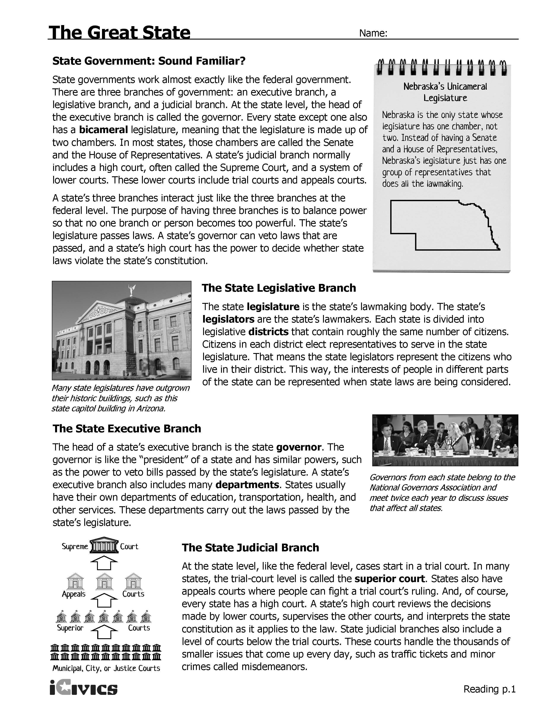

**How Laws Are Made in Florida’s Cities**

In Florida, a city is recognized with certain rights and privileges, the most important being home rule. Home rule is self-government by citizens at the local level. Every city is governed or run by a group of people who make and change laws. These people run the city because the people in the city voted in an election to let them do so. The people elected to run the city are usually called mayor, councilmember or commissioner.

The Florida Constitution recognizes that cities may enact their own laws, known as ordinances at the local level, as long as they do not conflict with state or federal law. In order to propose and vote on ordinances, city councils and commissions create a meeting schedule. Most councils or commissions meet monthly or bi-monthly. Although cities throughout Florida are different, there are common procedures for proposing and passing ordinances, as outlined in the Florida Statutes.

* Proposed ordinances must be presented to the council or commission in writing.
* A proposed ordinance can only be about one subject and that subject must be clear in the title of the proposed ordinance.
* 10 days prior to a vote on a proposed ordinance, a notice must be posted in a local newspaper that states the date, time, and place of the meeting at which the proposed ordinance will be voted on, the title of the proposed ordinance, and a place where citizens can view the full text of the proposed ordinance. This notice must also let citizens know that any interested or concerned citizens will have an opportunity to be heard during the meeting.
* During the meeting, only a majority of the city council or commission members are required to be present. This majority represents a quorum. In order for an ordinance to be passed, a majority of the quorum must vote in favor of it.
* Votes on the proposed ordinance are kept as official record.
* Any ordinance becomes effective as outlined in the proposal or 10 days after the vote.

Sources: [www.floridaleagueofcities.com](http://www.floridaleagueofcities.com), <http://www.floridaleagueofcities.com/docs/default-source/Civic-Education/abcs-of-city-government---elementary-level-curriculum-grades-2-5.pdf> and <http://www.floridaleagueofcities.com/resources/publications/official's-manual>

***Sources***

Schoolhouse Rock – How a Bill Becomes a Law video: <https://www.youtube.com/watch?v=2nKyihoV9z8> or <http://video.disney.com/watch/i-m-just-a-bill-4be36bc4830f7e5bc7f6b2d6>

How a Bill Becomes a Law handout: <http://www.genome.gov/12513982> & <http://kids.clerk.house.gov/grade-school/lesson.html?intID=17>

Who Represents Me? Activity Adapted from Who Represents Me? Webquest from iCivics: <http://www.icivics.org/web-quests/who-represents-me>

Three Branches Processes/Carousel Activity:

<http://www.congressforkids.net/Executivebranch_impeachment.htm>

<http://legal-dictionary.thefreedictionary.com/Presidential+Powers>

<https://www.law.georgetown.edu/library/research/guides/executivenominationprocess.cfm>, Accessed July, 2015

<http://usgovinfo.about.com/od/supremecourtjustuces/a/scotusconfirm.htm>

<http://www.cnbc.com/2014/01/28/executive-orders-what-they-are-and-how-they-work.html>

<http://legal-dictionary.thefreedictionary.com/veto>

<http://www.uscourts.gov/uscourts/educational-resources/get-involved/legal-concepts/judicial-review.pdf>

<http://dictionary.law.com/default.aspx?selected=164>

<http://www.wisegeek.com/what-is-a-court-order.htm#didyouknowout>

<http://research.lawyers.com/summary-judgment-motion.html>

The Great State Reading: <http://www.icivics.org/teachers/lesson-plans/great-state>

Florida State Government Images: <http://www.floridamemory.com/items/show/44071>, <http://www.floridamemory.com/items/show/94967> and <http://www.floridamemory.com/items/show/47097>

How Laws Are Made in Florida’s Cities: [www.floridaleagueofcities.com](http://www.floridaleagueofcities.com), <http://www.floridaleagueofcities.com/docs/default-source/Civic-Education/abcs-of-city-government---elementary-level-curriculum-grades-2-5.pdf> and <http://www.floridaleagueofcities.com/resources/publications/official's-manual>

**U.S. CONSTITUTION – Sample Answers**

**ARTICLE III**

**Judicial Branch**

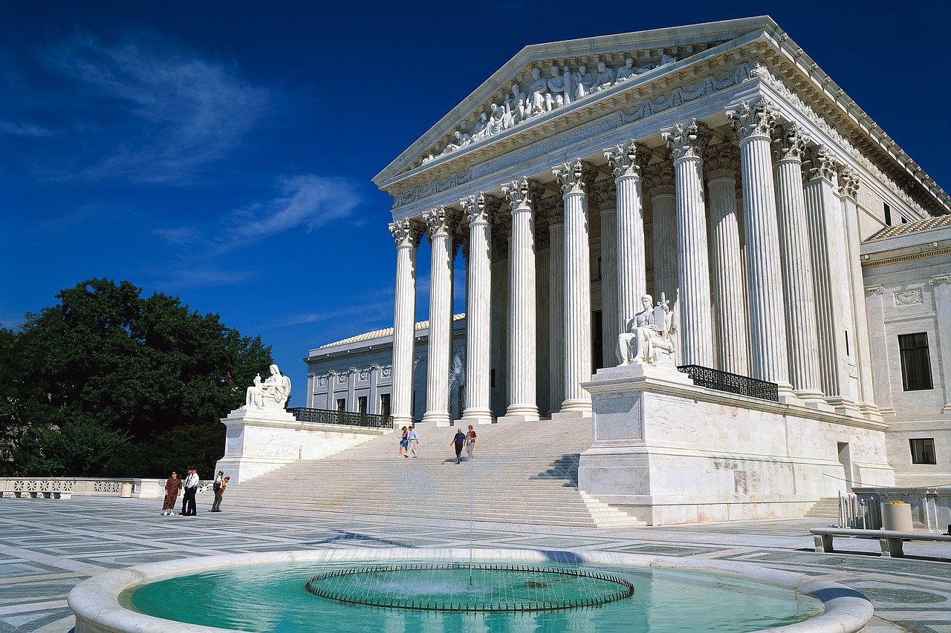

**Interpret Laws**

**Supreme Court**

**QUALIFICATIONS**

**ARTICLE II**

**Executive Branch**

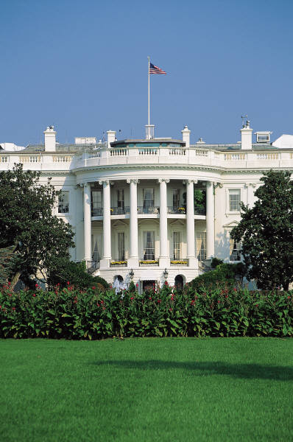

**Enforce Laws**

**President**

**ARTICLE I**

**Legislative Branch**

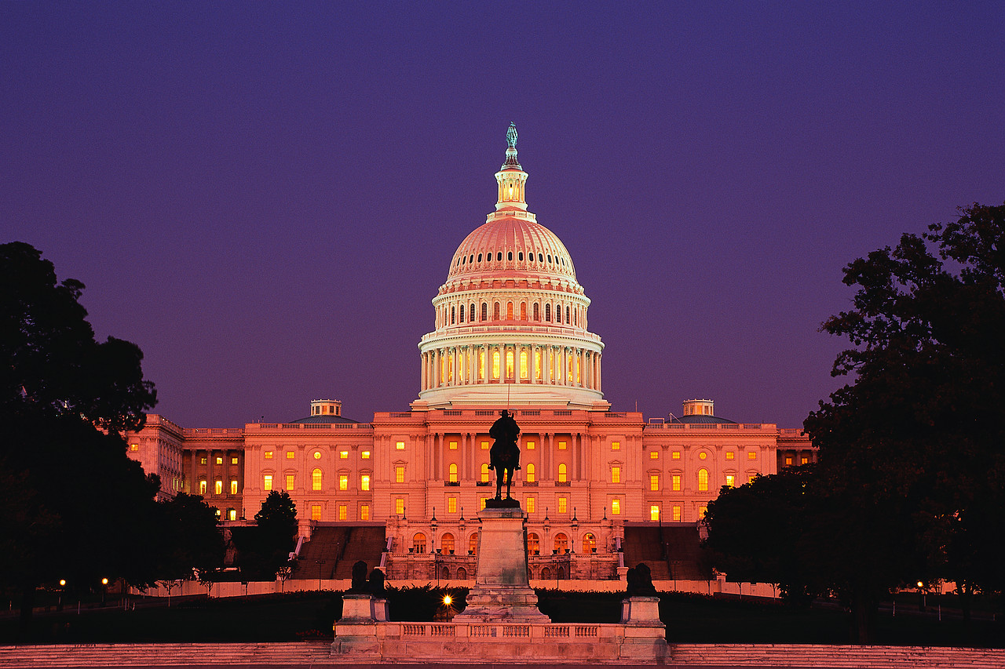

**Make** **Laws**

**House of Representatives**

**Senate**

|  |  |  |
| --- | --- | --- |
| **House -** 25 years old, citizen for 7 years, must live in the state they represent | Natural born citizen, 35 years old and lives in the U.S. for at least 14 years | Good behavior |
| **Senate -** 30 years old, citizen for 9 years, they must live in the state they represent |

**POWERS & FUNCTIONS**

|  |  |  |
| --- | --- | --- |
| Have the power to change laws in order to protect voters; Determine naturalization laws; Congress has the power to coin money, create the postal service, army, navy and lower federal courts, and to declare war  Specific to the House - Power of impeachment,  Bills start here involving taxes  Specific to the Senate - Impeachment trial & decide whether or not to remove from office; approve treaties for ratification | The President is Commander in Chief, Chief Executive, and Chief Diplomat. He has the power to appoint positions, grant pardons and make treaties.  The President gives the State of the Union and can convene Congress in special circumstances  Vice President is president of the Senate and votes in order to break a tie | The Supreme Courts holds the power of original jurisdiction and appellate jurisdiction.  The federal courts will decide arguments over how to interpret the Constitution, all laws passed by Congress, arguments involving states, and in agreements with other nations. |

Speaker of the House; Majority Leader; Minority Leader Vice President & Cabinet Chief Justice; Associate Justices

Representatives; President pro tempore, Senators

**How A Bill Becomes Law At the Federal Level – SAMPLE ANSWERS**

Key terms or phrases from the video:

idea, congressman, introduced to Congress, committee, discussed, debated, House of Representatives, Senate, vote, White House, president, veto

|  |  |  |  |  |
| --- | --- | --- | --- | --- |
| 1. A Bill Is Introduced  A citizen writes or meets with their representative to share an idea for a new law. A member of Congress introduces legislation and becomes the sponsor.  For this chart, the bill will begin in the House of Representatives. | 2. Committee Action  When a bill is introduced, it is referred to a standing committee. When the bill reaches committee, the committee members—groups of Representatives who are experts on topics such as agriculture, education, or international relations—review, research, and revise the bill before voting on whether or not to send the bill back to the House floor. | 3. Subcommittee Hearing  If committee members would like more information before deciding if the bill should be sent to the House floor, the bill is sent to a subcommittee. While in subcommittee, the bill is closely examined and expert opinions are gathered before it is sent back to the committee for approval. | 4. Mark Up  When the hearings are completed, the subcommittee may meet to "mark up" the bill; that is, make changes and amendments prior to recommending the bill to the full committee. If a subcommittee votes not to report legislation to the full committee, the bill dies. If the committee votes for the bill, it is sent to the floor. | 5. Committee Action to Report A Bill  When the committee has approved a bill, it is sent—or reported—to the House floor. Once reported, a bill is ready to be debated by the U.S. House of Representative |
| 6. Debate & Voting  When a bill is debated, Representatives discuss the bill and explain why they agree or disagree with it. Then, a reading clerk reads the bill section by section and the Representatives recommend changes. When all changes have been made, the bill is ready to be voted on. If a majority of the Representatives say or select yes, the bill passes in the U.S. House of Representatives. The bill is then certified by the Clerk of the House and delivered to the U.S. Senate. | 7. Referral to the Senate  When the House passes a bill, it is referred to the Senate, where it usually follows the same route through committee and floor action. This chamber may approve the bill as received, reject it, ignore it, or change it. Senators vote by voice. Those who support the bill say “yea,” and those who oppose it say “nay.” If a majority of the Senators say “yea,” the bill passes in the U.S. Senate and is ready to go to the President. | 8. Conference Committee  A conference committee is formed to reconcile the differences between the House and Senate versions. If the conferees are unable to reach agreement, the legislation dies. | 9. Final Action  After both the House and Senate have approved a bill in identical form, it is sent to the president. If the president approves of the legislation, he signs it and it becomes law. Or, if the president takes no action for ten days, while Congress is in session, it automatically becomes law. If the president opposes the bill he can veto it; or if he takes no action after the Congress has adjourned its second session, it is a "pocket veto" and the legislation dies. | 10. Overriding a Veto  If the president vetoes a bill, Congress may attempt to "override the veto." If both the Senate and the House pass the bill by a two-thirds majority, the president's veto is overruled and the bill becomes a law. |

Adapted from - <http://www.genome.gov/12513982> & <http://kids.clerk.house.gov/grade-school/lesson.html?intID=17>

Name: ______________________________________ Date: _______________________________

**Processes of the Federal Branches – Sample Answers**

Directions: Place each process and its definition under the correct branch of government.

executive order how a bill becomes a law appointment confirmation standing committee

judicial review writ of certiorari veto appointments special committee

court order committee selection summary judgment conference committee impeach

|  |  |  |
| --- | --- | --- |
| **LEGISLATIVE**   * **How a bill becomes a law** * **Impeachment Process** – House of Representatives has to the power to impeach, the Senate holds the trial to convict. * **Appointment confirmation** – the Senate has the power to confirm appointments through a series of hearings and then voting by the full Senate * **Standing committee** – a permanent committee that reviews bills, standing committees are in both houses and have members from both parties * **Special committee** – a committee brought together to meet and research a specific issue, not necessarily related to legislation. There are special committees in each house. * **Conference committee** – a temporary committee with members from both houses brought together to create a final version of a bill so that both houses of Congress pass an identical bill. * **Committee selection** – the majority party in each house determines Committee selection. They determine the amount of members from each party and new Representatives and Senators are assigned to committees based on the available spaces. | **EXECUTIVE**   * **Executive order –** the power of the president to make an order that must be followed like a law * **Veto –** the president has the power to veto legislation, sending a bill back to Congress for another vote, or issuing a pocket veto * **Appointments** – the president has the power to appoint certain federal government officials, including Supreme Court justices | **JUDICIAL**   * **judicial review - t**he power to determine whether or not the actions of the other two branches of government are legal and in line with the U.S. Constitution * **writ of certiorari -** A writ of certiorari orders a lower court to deliver its records on a case so that the higher court may review it. A court of appeals (not a trial court) has the power to review cases and a writ of certiorari is the formal process by which that power gets used. * **court order -** a legal document where a court tells a person to perform a specific act, prohibits (stops) him from performing an act, sets a court date, or legally establishes something. * **summary judgment -** when one party claims in a trial court that there is no need for a trial because the facts and evidence are one-sided, making it clear which party would win a trial. A judge can order a summary judgment. It is viewed as a final judgment and can be appealed to a higher court. |

**STATE & LOCAL GOVERNMENT – Sample Answers**

**State Government**

|  |  |  |
| --- | --- | --- |
| **Legislative Branch** | **Executive Branch** | **Judicial Branch** |
| Florida House of Representatives  Florida Senate | Governor | Florida Supreme Court |
| Pass laws  Represent citizens who lives in their districts | Veto laws  Includes many departments, these departments carry out the laws made by the legislative branch | Decide whether state laws violate the state’s constitution  District courts  Courts of Appeal  Supreme Court  The FL Supreme Court reviews decisions by lower courts, supervises the other courts and interprets the state constitution. |

**Local Government**

|  |
| --- |
| Home rule is self-government by citizens at the local level.  Every city is governed or run by a group of people who make and change laws (called ordinances)  The people elected to run the city are usually called mayor, councilmember or commissioner.  Ordinances cannot conflict with state or federal law.  In order to propose and vote on ordinances, city councils and commissions create a meeting schedule. In order for an ordinance to be passed, a majority of the quorum must vote in favor of it. |

***Civics Content Vocabulary***

|  |  |  |
| --- | --- | --- |
| **Word/Term** | **Part of Speech** | **Definition** |
| **act** | noun | legislation that has passed both houses of Congress, has been signed into law by the president, or passed despite his veto, and therefore becomes law |
| **appointment** | noun | job or duty that is given to a person |
| **appointment confirmation** | noun | the process of the Senate approving the president’s choices for certain positions within the government |
| **bicameral** | adjective | having two chambers (e.g. the two houses of Congress, the Senate and the House of Representatives) |
| **bill** | noun | a proposal for a law |
| **Cabinet** | noun | people appointed by the president to head executive departments of government and act as official advisers to the president |
| **Chief Justice** | proper noun | the head justice; the Chief Justice is “first among equals” |
| **city commissioner or council member** | noun | a member of the governing body of a city |
| **committee selection** | verb | how representatives and senators are chosen for their assigned committees |
| **conference committee** | noun | a temporary panel composed of House and Senate members, which is formed for the purpose of reconciling differences in legislation that has passed both chambers. Conference committees are usually convened to resolve differences on major and controversial legislation. |
| **constituents** | noun | people public officials are elected to represent |
| **county commissioner or council member** | noun | a member of the governing body of a county |
| **court order** | noun | a formal statement from a court that orders someone to do or stop doing something |
| **executive order** | noun | an order that comes from the U.S. President or a government agency and must be obeyed like a law |
| **home rule** | noun | self-government by citizens at the local level |
| **how a bill becomes a law** | noun | the process of how a proposed law (“bill”) moves through Congress and the president in order to become a law |
| **impeach** | verb | to bring formal charges of wrongdoing against a public official (such as the U.S. President) |
| **judgment** | noun | a formal decision given by a court |
| **judicial review** | noun | the power of the judicial branch to review the actions of the executive and legislative branches and determine whether or not they are unconstitutional (this includes laws passed by Congress); the U.S. Supreme Court case Marbury v. Madison established this power such actions are consistent with the U.S. Constitution |
| **jurisdiction** | noun | the right and power for courts to hear a case, interpret and apply the law |
| **law** | noun | a rule established by government or other source of authority to regulate people’s conduct or activities |
| **majority leader** | noun | a position where a Member of Congress is elected by the majority party to serve as the chief spokesperson for that party and to manage and schedule the business of either house |
| **majority party** | noun | the political party with the most elected members |
| **majority vote** | noun | more than half (50%) of the votes |
| **mayor** | noun | the head of government for a city or town |
| **minority leader** | noun | a position where a member of Congress is elected by the minority party to serve as the chief spokesperson for the party and to support the majority party in managing and scheduling the business of either house |
| **minority party** | noun | the political party second in the number of elected members |
| **nominate** | verb | to suggest a person for a position or office |
| **ordinance** | noun | a law enacted by a city or county affecting local affairs such as traffic, noise, and animal control |
| **pardon** | noun | the formal act of forgiving someone or excusing a mistake |
| **President pro tempore of the Senate** | proper noun | the person who presides over the Senate when the Vice President is not present |
| **presidential appointment** | noun | the power of the U.S. President to choose members of his or her cabinet, ambassadors to other nations, and other officials in his or her administration |
| **school board** | noun | the group of persons elected to manage local public schools |
| **Speaker of the House** | proper noun | an office identified in Article I, Section 2 of the U.S. Constitution; the leader of the U.S. House of Representatives, usually the highest ranking member of the majority party |
| **special committee** | noun | a permanent committee established under the standing rules of both houses of Congress that focuses specific subject areas (e.g. Special Committee on Aging) |
| **special interest groups** | noun | a group of people who are concerned with a particular issue and who try to influence legislators to act in their favor, also known as an interest group |
| **standing committee** | noun | permanent committee that focuses on specific subject areas (e.g. Education and the Workforce Committee) |
| **state legislator** | noun | a member of the Florida House of Representatives (state representative) or Florida Senate (state senator) |
| **state representative** | noun | a member of the lower house of a state legislature (the Florida House of Representatives) |
| **state senator** | noun | a member of the upper house of a state legislature (the Florida Senate) |
| **statute** | noun | a law enacted at the state level |
| **summary judgment** | noun | a judgment decided by a trial court without that case going to trial; a summary judgment is an attempt to stop a case from going to trial |
| **U. S. Representative** | proper noun | a member of the U.S House of Representatives; representatives are elected in districts throughout each state |
| **U. S. Senator** | proper noun | a member of the U.S. Senate elected to represent an entire state, there are two senators per state |
| **veto** | noun | a decision by an executive authority such as a president or governor to reject a proposed law or statue |
| **writ of certiorari** | noun | the procedure to see if the U.S. Supreme Court will hear a case; a writ of certiorari is issued when a higher level court agrees to hear an appeal of an inferior court’s decision |

***Essential Teacher Content Background Information***

|  |
| --- |
| **This section addresses the following issues:**  **1. Making the Laws: The Legislature…………………………………………………………………4**  **The United States Congress……………………………………………………………………..4**  **How Congress works: The committee system………………………………………….4**  **How Congress works: The party leadership system………………………………..5**  **The Florida Legislature…..……………………………………………………………………..6**  **2. Enforcing the Laws: The Chief Executive………………………………………………………6**  **The President of the United States………………………………………………….……....6**  **The President’s Cabinet………………………………………………………………………...….7**  **The Florida Governor………………………………………………………………………….…..8**  **3. Adjudicating the Laws: The Courts………………………………………………………………...9**  **The National Court System………………………………………………….…………………..9**  **The Court System in Florida…………………………………………………………………….9**  **The Supreme Court of Florida…………………………………………………………..……..10**  **Lower Courts in Florida…..……………………………………………………………………..10**  **4. Florida Local Government……………………………………………………………………………..10**  **Florida cities………………………………………………………………………………………..…..11**  **County Courts…………………………………………………………………………………………..11** |

**1. Making the Laws: The Legislature**

Lawmaking is central to U.S. government. The separation of powers and checks and balances system gives priority to the lawmaking process; legislators are elected at every level of government, which gives direct power to citizens in deciding who makes the laws.

**The United States Congress**

Congress today is comprised of a 435 member House of Representatives and a 100 member Senate. The Constitution guarantees each state two Senators and at least one member of the U.S. House of Representatives. Legislation must be passed by at least one half of the membership of each chamber voting to approve (218 in the House; 51 in the Senate). Proposed laws, or bills, are then considered by the president. Bills that are approved by the president become laws, which are called acts.

**How Congress works: The committee system**

Committees in Congress allow for deliberation and debate with a reduced number of members than the entire body. Trying to get 435 people to deliberate on a decision of national importance, or even 100, would be nearly impossible. The committee system also reflects the notion that members need to spend time on issues important to their district in order to serve their constituents well. Committees allow representatives to specialize on issues within a specific policy area. In their deliberations, committees hold hearings, conduct research, and write policy. Special interest groups often testify during these hearings in their efforts to shape legislation as it is being written. Some bills are not forwarded to the full house for a vote as the committee may recommend that a bill not receive further consideration. In other cases, the committee votes favorably on the bill and it is forwarded to the full house for a vote.

There are five different committee types in Congress. Members serve each committee type from one or both houses and/or one or both parties. Information on parties in Congress is found below as follows:

|  |  |  |
| --- | --- | --- |
| **Committee Type** | **Committee Purpose** | **Committee Membership** |
| Standing | Permanent legislative panels that consider bills and issues | Members of one house, and both parties |
| Select | Temporary committee that addresses a specific issue; once that committee’s business is complete, the committee dissolves | Members of one house, and both parties |
| Special | Performs a special function beyond the authority or capacity of a standing committee | Members of one house, and one party |
| Joint | Policy exploration with a narrow jurisdiction | Members of the House of Representatives and the Senate |
| Conference | Temporary committee formed to reconcile differences in legislation passed by both chambers. | Members of the House of Representatives and the Senate |

**How Congress works: The party leadership system**

Political parties are mentioned nowhere in the Constitution. Still, political parties play key roles in the organization of Congress, particularly committees.

The Democratic and Republican parties are the only parties recognized in Congress. Members of Congress may be elected from minor parties, or be elected as independents (both situations are rare) although they are not granted leadership opportunities.

There is a majority and a minority party in Congress. The majority party is determined based on which political party has the most members based on the most recent election. The minority party is the party with the lesser membership, also based on the most recent election.

Majority parties in Congress enjoy unique leadership opportunities. For example, the majority party selects the Speaker of the House of Representatives, which is the only office chosen by Representatives named in the U.S. Constitution. The Senate majority party elects the “President pro tempore”, or “pro tem,” who serves in the absence of the Vice-President as president of the Senate. Majority party members also chair all standing and select committees, while the larger share of seats on each of these committees also comes from the majority party. Together, the majority party can guide the policy process because it holds leadership positions in each house, chairs all policy committees, and holds the majority on each of these committees. The Vice-President breaks ties in the Senate.

Party membership also relates to the purpose of the committee. Special committees are limited to members of one house and one party because special committees work toward a particular party’s goal, such as shaping a party’s position on a proposed policy, or getting members of that party re-elected to that house of Congress in the next election cycle. Similarly, when the committee’s purpose is to address matters of importance to all Congress members, both parties are represented from both houses. Conference committees have members from both houses and both parties because these committees negotiate agreements on bill differences between the two chambers. As both chambers must agree on the same version of all bills passed by Congress, members of both parties and houses should participate in the discussion over any revisions so that, once compromise is reached, each of conference committee members will recommend to their respective houses and parties that they support the agreed-upon version.

**The Florida Legislature**

Lawmaking in Florida follows a system similar to that practiced by the U.S. Congress. There is both a committee system and party leadership system in each legislative house. Party leadership posts are assigned based on majority and minority party membership. The majority party leadership appoints standing committee chairs. Committees are structured so that the majority party in the house holds the majority of seats on each standing committee.

Article IV of the U.S. Constitution guarantees to every state a republican (representative) form of government where the legislature and executive are elected by the people. Florida has a bicameral (two house) legislature comprised of a 120 member House of Representatives and a 40 member Senate. Both houses are term limited to eight years each, where members are allowed to serve eight years in each house (whether consecutive or non-consecutive terms) over their lives (total=16 years). House terms are two years each while Senate terms are four years each. Florida’s governor is limited to two four-year terms. The Florida legislature is a part-time legislature that meets 60 days each year beginning in early March and finishing in early May.

Being a bicameral legislature, a majority of each house of the Florida legislature must agree on all proposed laws, or bills, introduced before being forwarded to the governor. Bills passed by the Florida legislature and signed by the governor are called statutes.

**Enforcing the Laws: The Chief Executive**

The Founders’ fear that public officials, especially executives acting alone, would abuse their power is reflected in the checks and balances system linked to the presidency. There is only one unchecked power given to the president. Many argue that this unchecked power is actually a check on the legislative and judicial branches.

**The President of the United States**

The table below shows how the president’s powers are checked by Congress.

|  |  |  |
| --- | --- | --- |
| **Presidential Power** | **Congressional Check** | **Consequences** |
| Chief Executive | Congress enacted laws | The president may ask Congress to enact a law that it does not want to enact |
| Commander-in-Chief of the armed forces | Congress declares war  Congress raises and supports armies and navies | Congress may choose to reduce or eliminate part or all of the armed forces |
| Nominates high level officials | Senate confirms nominations; nominees who are confirmed are then appointed to their positions. | The Senate may reject presidential nominations  The Senate may stall the nominations process  The president may withdraw a nomination that he suspects will not be confirmed by the Senate  The nominee may withdraws his or her nomination if he or she suspects that the nomination will be rejected by the Senate |
| Negotiates treaties | Senate approves treaties for ratification | The Senate may reject a treaty that the president has negotiated |
| Vetoes congressional bills | Congress may override a president’s veto with a 2/3 vote of each house of Congress. | The president may be compelled to enforce a law that he earlier rejected. |

The president’s one unchecked power is the power to pardon. A presidential pardon cannot be vetoed or overturned, and may be viewed as a check on the courts or the legislature in that the president is pardoning someone who has already been convicted by the courts or who might later be impeached by the legislature. Gerald Ford is well known for pardoning former President Richard Nixon once he resigned the presidency on August 8, 1974 after the House of Representatives Judiciary Committee voted to recommend impeachment against Nixon on July 27, 1974. The presidential pardoning power does not extend to someone who has been impeached.

**The President’s Cabinet**

The president’s Cabinet was established in Article II, Section 2 of the U.S. Constitution, which states that: The President of the United States….may require the Opinion, in writing, of the principal Officer in each of the executive Departments, upon any subject relating to the Duties of their respective Office (Capitalization in the original). The Constitution does not provide for a specific number of, or duties for, Cabinet departments.

Each executive department head is titled “Secretary” with the exception of the Department of Justice, which is headed by the Attorney General. Department Secretaries must be confirmed by a majority vote in the Senate. Cabinet secretaries have no set terms of office although they normally resign should the president who nominated them leave office.

Below is a list of all current Cabinet departments in the order that they were created.

|  |  |  |
| --- | --- | --- |
| **Department Name** | **Year Created** | **Notes** |
| State | 1789 | Originally named Department of Foreign Affairs in July 1789, and renamed Department of State in September 1789. The first female Secretary of State was Madeline Albright who was nominated by President Bill Clinton in 1996. As of 2013, there have been three female Secretaries of State (Madeline Albright, Condoleeza Rice and Hillary Clinton) and two African-American Secretaries of State (Colin Powell (2001-2005) and Condoleeza Rice). |
| Treasury | 1789 | A statue of Alexander Hamilton is placed outside the U.S. Treasury Department building to honor Mr. Hamilton as the first Secretary of the Treasury. |
| War | 1791 | Named the Department of the Army 1947  Named the Department of Defense 1949 |
| Office of Attorney General | 1789 | Named the Department of Justice in 1870; the first Hispanic Attorney General was Alberto Gonzales (2005-2007). |
| Interior | 1849 |  |
| Agriculture | 1862 |  |
| Labor and Commerce | 1903 | Renamed the Department of Commerce when the Department of Labor was created in 1913 |
| Labor | 1913 | The first female Cabinet secretary was Frances Perkins who served as Secretary of Labor from 1933-1945, during Franklin Roosevelt’s presidency. |
| Health, Education and Welfare | 1953 | In 1979, the Department of Education was created, at which point the Department of Health and Human Services was created in 1980 as a department separate from Education. |
| Housing and Urban Development | 1965 | Former U.S. Senator Mel Martinez served as Secretary of Housing and Urban Development from 2001-2003) before resigning that position to run for U.S. Senate representing Florida, a position in which he served from 2005-2009. |
| Transportation | 1966 |  |
| Energy | 1977 |  |
| Education | 1979 | See Department of Health, Education and Welfare above; the U.S. Department of Education has the smallest budget of all Cabinet-level departments. |
| Veteran’s Affairs | 1988 | The Department of Veteran’s Affairs was first formed as the Veterans Administration in 1930 and elevated to Cabinet-level status in 1988. |
| Homeland Security | 2003 | The Department of Homeland Security was created in response to the September 11, 2001 terrorist attacks on the United States. |

Several positions hold Cabinet rank even though they are not secretaries of Cabinet level departments. These include the Vice-President of the United States, White House Chief of Staff, the Office of Management and Budget and the U.S. Ambassador to the United Nations.

**The Florida Governor**

Article IV of the Florida Constitution outlines the Governor’s core duties as follows:

The supreme executive power shall be vested in a governor, who shall be

commander-in-chief of all military forces of the state not in active service of the United

States. The governor shall take care that the laws be faithfully executed, commission all officers of the state and counties, and transact all necessary business with the officers of government. The governor may require information in writing from all executive or administrative state, county or municipal officers upon any subject relating to the duties of their respective offices. The governor shall be the chief administrative officer of the state responsible for the planning and budgeting for the state.

The state lawmaking process is also similar to the federal process. There is a provision for an override of a governor’s veto requiring a 2/3 vote in each house.

The governor serves with a cabinet comprising three statewide elected officers: Chief Financial Officer, Attorney General, and Commissioner of Agriculture and Consumer Services.

**Adjudicating the Laws: The Courts**

The U.S. court system is comprised of several parts. The U.S. Constitution creates the U.S. Supreme Court; all other courts, which are inferior to the U.S. Supreme Court, are created, supported and mandated by Congress.

**The National Court System**

The vague nature of the judiciary branch is that there is no set number of judges on the U.S. Supreme Court (Tradition keeps the number at nine; this number is not a constitutional requirement) or on any other court, and there is no set number of courts. It is up to Congress to choose the number of U.S. Supreme Court members and on other courts. The U.S. Constitution requires that U.S. Supreme Court justices “hold their offices during good behavior” which translates to lifetime appointments unless removed by Congress.

Cases that are first heard by the U.S. Supreme Court (“original jurisdiction”) tend to involve disputes, which may include conflicts between two states, between the president and Congress, or cases where a state is a party. All other cases come before the U.S. Supreme Court in its role as the highest court of appeal. The U.S. Constitution is very specific as to which types of cases may come before it as cases of original jurisdiction, which cannot be rejected. The Constitution is otherwise vague as to which types of cases are to be heard on appeal. All cases are decided with a majority vote.

The bulk of the Court’s work is appellate cases. Any case submitted on appeal may be rejected; in a typical year, the U.S. Supreme Court is asked to grant a hearing (“writ of certiorari”) to approximately 10,000 appeals cases; it accepts about 1%, or 75-80 cases, which require four votes in order to be “granted cert”. For cases not granted a writ of certiorari, the decision made at the most recent court is deemed the final decision in that case. Cases decided by the U.S. Supreme Court may not be appealed.

The power of the courts changed considerably in the early 19th century when the U.S. Supreme Court took on the role of interpreter of the U.S. Constitution. In Marbury v. Madison 5 U.S. 137 (1803) (Summary available at [www.oyez.org](http://www.oyez.org), “Marbury v. Madison”), the U.S. Supreme Court decided that it had the sole right to decide whether an Act of Congress violated the U.S. Constitution. In essence, the Court decided that it had the power to make “case law” where the Court interprets what the U.S. Constitution means and whether, based on that meaning, a law is nullified because it is incongruent with the U.S. Constitution. This process of making law through cases has broadened the role of the U.S. Supreme Court because it gives the Court powers beyond those stated in the U.S. Constitution. Since Marbury v. Madison, the Court has also undertaken statutory review, where the Court decides what a law or statute means. In these instances, the Court is deciding what a law means and thus, how it should be implemented.

**The Court System in Florida**

The court system in Florida is mixed. Judges presiding at the county and city level are elected, while Florida’s state court judges are appointed through a merit retention system where they are appointed by the governor and retained every seven years by the people through a yes/no ballot. The court system is divided into multiple units including a supreme court, district courts of appeal, circuit courts and county courts.

The following information is adapted from “Florida’s State Court System” available on the Florida Supreme Court “Public Information Link” (<http://www.floridasupremecourt.org/pub_info/system2.shtml>).

**The Supreme Court of Florida**

Florida’s highest Court in Florida is the Supreme Court, which is composed of seven Justices. At least five Justices must participate in every case and at least four must agree for a decision to be reached. The Supreme Court must review final court orders imposing death sentences, district court decisions declaring a State statute or provision of the State Constitution invalid and other matters. The Court is responsible for disciplining and removing judicial officers.

**Lower Courts in Florida**

The Supreme Court never hears the bulk of trial court decisions that are appealed. Rather, three-judge panels of district courts of appeal review them. In each district court, the district court judges within the district select a chief judge.   
 District courts of appeal may hear appeals from final judgments and review certain non-final orders. By general law, the district courts have been granted the power to review final actions taken by state agencies in carrying out the duties of the executive branch of government. District courts may issue summary judgments, which are judgments issued without a trial.

Decisions of the district courts of appeal represent the final appellate review of litigated cases. A person who is displeased with a district court's express decision may ask for review in the Florida Supreme Court and then in the U.S. Supreme Court, but neither tribunal is required to accept the case for further review. Most are denied.

Most jury trials take place before one judge sitting as judge of the circuit court. The circuit courts are sometimes referred to as courts of general jurisdiction, in recognition of the fact that most criminal and civil cases originate at this level. The Florida Constitution provides that a circuit court shall be established to serve each judicial circuit established by the Legislature, of which there are twenty. Within each circuit, there may be any number of judges, depending upon the population and caseload of the particular area.

Circuit courts have general trial jurisdiction over matters not assigned by statute to the county courts and also hear appeals from county court cases. Circuit courts are simultaneously the highest trial courts and the lowest appellate courts in Florida's judicial system.

**Florida Local Government**

Florida’s local governments are comprised of counties and municipalities such as cities, towns and villages.

An elected board of county commissioners governs in each of Florida’s 67 counties. Counties must carry out constitutionally mandated responsibilities and those established by the state. County-level constitutional services include law enforcement and jail administration, tax collection, property appraisal, state court administration and election supervision. Counties oversee road maintenance, public health, and solid waste disposal, among other responsibilities. County commissions determine other county services. Orange County, Florida’s county government is unique in that Orange County has a countywide elected mayor. Otherwise, Florida’s county commissioners choose their own commission chair from among their membership. Commission chairs oversee commission meetings.

Each county has its own school district that has elected school boards that govern the day-to-day operations of K-12 public education. School districts are a special-purpose local government. Funding is provided through property taxes and state revenues.

Florida also has special districts of which there are two types. Independent districts are created by the legislature for a specific purpose to be provided in a certain area such as water management districts, fire service, inland navigation, and ditch maintenance. The funding and governance of each is set by the legislature. Dependent special districts are created by cities and counties, are governed by the city or county elected commission, and derive their authority, funding and support from that government. There are about 600 independent and 300 dependent special districts throughout Florida.

**Florida cities**

Cities are independent municipal governments founded by citizens who choose its name. Ordinances are the laws that govern cities. The city charter serves as a constitution. The charter sets forth the boundaries of the municipality, its form of government, the size of the council and governmental processes. In Florida, the legislature approves the municipality through a special act, and the charter is approved by the citizens through a referendum.

In Florida a city is recognized with certain rights and privileges; the most important is home rule. Florida’s constitution recognizes that cities may enact their own ordinances and self-govern as long as the city’s law does not conflict with state and federal law. Home rule powers do not extend to fiscal home rule because the state reserves all taxing authority to itself.

Self-government at the city level occurs with mayors, who serve as cities’ chief executives, and city councils, who serve as city legislatures. City charters determine how much power mayors have. Some mayors function within “strong mayor” forms of government, while other cities utilize the “weak mayor” form of government. Rules regarding the length of terms, whether terms are limited, and, in how many persons will serve on city councils, are outlined in city charters.

**County Courts**

Florida’s constitution establishes a court in each of Florida's 67 counties. The number of judges in each county court varies with population and caseload. To be eligible for the office of county judge, a person must be eligible to vote in that county and have been a member of The Florida Bar for five years; in counties with a population of 40,000 or less, a person must only be a member of The Florida Bar to be a county judge. County judges are eligible for assignment to circuit court, and are frequently assigned within the judicial circuit that embraces their counties.

The trial jurisdiction of county courts is established by statute. The jurisdiction of county courts extends to civil disputes involving $15,000 or less. The majority of non-jury trials in Florida take place before one judge sitting as a judge of the county court. The county courts are sometimes referred to as "the people's courts," because a large part of the courts' work involves citizen disputes, such as traffic offenses, misdemeanors, and small monetary disputes.