STRUCTURE AND FUNCTION OF GOVERNMENT
SS.7.C.3.3 Illustrate the structure and function (three branches of government established in Articles I, II, and III with corresponding powers) of government in the United States as established in the Constitution.

TABLE OF CONTENTS

Lesson Summary 2
Suggested Student Activity Sequence 4
Student Activity Sheets & Reading Materials 7
Sources 17
Answer Keys 18
Civics Content Vocabulary 24
Essential Teacher Content Background Information 25

Lesson Summary

Essential Question
What is the structure and function of the United States government?

NGSSS Benchmark
SS.7.C.3.3 Illustrate the structure and function (three branches of government established in Articles I, II, and III with corresponding powers) of government in the United States as established in the Constitution

Florida Standards
LAFS.68.RH.1.2 LAFS.68.RH.1.2 LAFS.68.RH.2.4 LAFS.68.RH.3.1
LAFS.68.WHST.1.1 LAFS.68.WHST.1.2 LAFS.68.WHST.4.10 LAFS.7.SL.1.1
LAFS.7.SL.2.4

Overview
In this lesson, students will learn how the federal government is organized into three branches, how each branch has its own roles and powers, and where these powers originate in the U.S. Constitution.

Learning Goals/Benchmark Clarifications
- Students will recognize the structure of the legislative, executive, and judicial branches.
- Students will compare the roles and responsibilities of the three branches of the federal government.
- Students will identify the general powers described in Articles I, II, and III of the U.S. Constitution.

Benchmark Content Limits
- Items will not include comparison of U.S. government to other forms of government.

Civics EOC Reporting Category
Reporting Category 4 – Organization and Function of Government

Suggested Time Frame
- Three 45-50 minute class periods

Civics Content Vocabulary
- appellate jurisdiction, armed forces, article, coining money, concurrent powers, declaration of war, delegated powers, elastic clause, enumerated powers, executive branch, foreign relations, immigration, impeach, implied powers, judicial branch, legislative branch, naturalization laws, necessary and proper clause, original jurisdiction, president, presidential appointments, regulate, trade, U.S. Congress, U.S. House of Representatives, U.S. Senate, U.S. Supreme Court

Instructional Strategies
Close reading of complex text Directed note taking Collaborative learning

Materials
Computer with internet access to project lesson activity sheets
Student activity sheets and reading materials:
- Lesson Vocabulary
- Directed Note-Taking, Understanding Article I
- Understanding Article I – The Legislative Branch
- Understanding the Executive Branch – Article II of the U.S. Constitution
- Understanding the Judicial Branch – Article III of the U.S. Constitution
- Three Branches Graphic Organizer

Lesson Activities and Daily Schedule
Please use the chart below to track activity completion.

Day | Task # | Steps in Lesson | Description | Completed?  Yes/No
Day One | Task 1 | 1-3 | Hook Activity
 | Task 2 | 4 | Vocabulary Overview
 | Task 3 | 5-17 | Understanding the Legislative Branch: Reading, and Activity Sheet
Day Two | Task 3 | 5-17 | Understanding the Legislative Branch: Reading, and Activity Sheet  (continued)
 | Task 4 | 18 | Checking for Understanding A
 | Task 5 | 19-23 | Understanding the Executive and Judicial Branches Reading
Day Three | Task 6 | 24-27 | Class Discussion about the Executive and Judicial Branches
 | Task 7 | 28-32 | Three Branches Graphic Organizer
 | Task 8 | 33 | Checking for Understanding B

Suggested Student Activity Sequence

- To begin this lesson, explain to students that the structure and function of our government is outlined in the U.S. Constitution and the best way to understand the three federal branches is to read and understand Articles I, II, and III of the U.S. Constitution.
- Project an image of the U.S. Constitution (http://constitutioncenter.org/media/files/constitution-full-text.pdf) or have students take out their own copies and place them on their desks.
- Scroll through the document and ask students to brainstorm what they notice about Article I in comparison to the other articles. (length) Ask them what they think might be discussed in this article.
- Pass out the “Lesson Vocabulary” handout and review each term with the students. Teacher note: This lesson will require students to read multiple complex texts; it will be helpful for students to have the vocabulary terms in front of them while they work through this lesson.
- Pass out the “Article I: Understanding the Legislative Branch” reading and explain to students that Article I of the U.S. Constitution outlines the structure, function and powers of the legislative branch. Explain to students that the term “function” means to understand the branch’s roles and responsibilities and that the structure of a branch includes the qualifications for the branch.
- Pass out the “Directed Note Taking, Understanding Article I” student activity sheet and explain to the students that they will complete a directed note taking activity in order to understand each section of Article I.
- Review the directions as a whole class. Explain to students that for each article section, they will identify any key terms from their “Lesson Vocabulary” handout that are mentioned, summarize the key points of the section and place those points in the appropriate box: structure, function and/or power of the legislative branch. Explain to students that some of the sections do not have information related to structure, function or power, so there will be blank columns for some sections.
- Model the introduction and first section of the reading with the students. To do this, read the introductory paragraph and review the main idea with students (three separate branches of government, different powers in the law making process and the ability to check each other).
- Read aloud Article I, Section 1.
- Ask students to identify any key terms and if the section discusses a structure, function and/or power of the legislative branch. Teacher note: Utilize the Sample Answers section to guide student understanding.
- Place students into pairs and inform them that they will complete the rest of the reading activity by completing a modified Think, Pair, Share activity.
- Instruct students to read Section 2 and to complete the Section 2 row of the graphic organizer independently.
- Provide them with time to then review their answers with their partner and reach a consensus on the right answers for Section 2.
- Monitor student work while they work independently and then review their answers with their partner.
- Ask pairs to share the answers for Section 2.
- Repeat this strategy for Sections 3-10.
- Review “Article I, Section 8” from the “Article I: Understanding the Legislative Branch” reading as a whole class. Instruct students to share out the vocabulary terms they identified in this section. Reinforce the concepts of “delegated powers” and “implied powers” with the class. Explain to students that Congress also has “concurrent powers” that they share with the states.
- Checking for Understanding A (Formative Assessment): Refer students back to the guiding question – “According to the reading, what is the structure, function and power of the legislative branch?” Instruct students to write a summary statement answering this question using what they have learned from the reading and activity sheet. Instruct students to include the following information in their summary: a clear introduction, information and examples from the text, related civics content vocabulary, and an appropriate concluding statement.
- Project the U.S. Constitution and show students Articles I, II, and III again. Ask students, “If Article I was about the legislative branch, what do you think Articles II and III will be about?” (executive and judicial branches).
- Ask students to brainstorm some of the information they think they know about both of these branches.
- Place students in pairs or groups of three and pass out the “Understanding the Executive Branch, Article II of the U.S Constitution” or “Understanding the Judicial Branch, Article III of the U.S Constitution” student activity sheets to each group so that half of the groups read Article II and the other half reads Article III.
- Explain to students that they will read excerpts of the actual text from the U.S. Constitution and answer questions in order to understand the structure, function and power of the executive and judicial branches.
- Provide time for the student groups to read through and answer the questions about their assigned branch.
- Ask students to take out a new piece of notebook paper and prepare to take notes while each group shares what they learned about the executive branch or judicial branch.
- Ask the groups that read Article II to summarize what they learned and put key points on the board. Summarize key points so that students understand the structure, function, and power of the executive branch.
Key points for the executive branch – Teacher note: Points in black should be answers that students generate from the reading, points in blue are additional content pieces that should be included. The five powers of the president listed in blue are not in the test item specifications or the U.S. Constitution, however they are a helpful way for students to organize their understanding of the powers of the president.
- The President and Vice President (and Cabinet) make up the executive branch
- The qualifications to be president are: be a natural born citizen, at least 35 years old, and have lived in the U.S. for at least 14 years
- The powers of the president fall into five broad categories:
  - Chief Executive – the president is in charge of executive departments and offices
  - Commander in Chief – commander of the military
  - Chief Diplomat – the president has the power to make treaties; the executive branch decides on the United States’ foreign relations or dealings with other countries in order to achieve national goals
  - Power to Nominate – the president can nominate for high offices
  - Power to Pardon - the president can grant pardons
- The key function of the executive branch is to enforce and implements laws
- The president presents to Congress a State of the Union
- Point out to students that in Article II, Section 2, there is mention of the Senate regarding treaties and appointments. Explain to students that the president can make treaties and appointments, but the Senate must approve them.
- Complete the same process for the judicial branch. Key points for the judicial branch - (points in black should be answers that students generate from the reading, points in blue are additional content pieces that should be included).
- The judicial branch is comprised of the Supreme Court and inferior courts that Congress may establish
- The qualifications for judges, both of the supreme and inferior courts, is good behavior
- Powers of the Supreme Court
  - Original Jurisdiction - the power of a court to be the first to hear a case on a specific topic; for the U.S. Supreme Court this involves cases concerning conflicts between Congress and the president and in cases in which a state is a party
  - Appellate Jurisdiction – the power to hear appeals of cases which have been tried in lower courts; this applies to all cases not under original jurisdiction
- The key function of the judicial branch is to interpret laws.
- The federal courts will decide arguments over how to interpret the U.S. Constitution, all laws passed by Congress, arguments involving states, and in agreements with other nations.
- Pass out a blank “Three Branches Graphic Organizer” student activity sheet to each student and explain that they will use what they have learned from the readings and class discussion to fill in the graphic organizer with the structure (including qualifications), function, and powers of each branch.
- Ask students to take out their “Directed Note Taking, Understanding Article I” student activity sheet on the legislative branch and use their notes to fill in the graphic organizer. Teacher Note: Utilize the blank graphic organizer with steps included to guide the process.
- Provide time for students to complete the executive branch and judicial branch sections of the graphic organizer.
- Review as a whole class.
- Ask students to write an appropriate title for the graphic organizer.
- Checking for Understanding B (Formative Assessment):
Instruct students to write a well-crafted response using one of the following prompts:
Prompt 1
Although many people believe that the three branches of government are equal, the legislative branch is actually the most powerful. Use evidence from your readings and graphic organizer to argue why you think this statement is correct or incorrect.
Prompt 2
Explain what you think are the most important functions and powers of each branch. Use evidence from your readings and graphic organizer to explain your argument.

Extension Suggestion: Instruct students to complete the following reflective prompt to gauge their comfort level with the lesson content. Prompt - Reflect on your learning during this lesson and explain one thing you learned that you were surprised about and one thing that is still confusing to you.
Lesson Vocabulary
1. | appellate jurisdiction | noun | the power to hear appeals of cases which have been tried in lower courts
2. | armed forces | noun | the nation’s military (Air Force, Army, Coast Guard, Marines, National Guard and Navy)
3. | article | noun | a numbered chapter or section of a contract, treaty, or constitution
4. | coining money | verb | the power of the legislative branch to print money (coins and bills) for use
5. | concurrent powers | noun | powers shared by the national, state, and/or local government
6. | declaration of war | noun | the power of Congress to vote to go to war with another country
7. | delegated powers | noun | the powers specifically named and assigned to the federal government or prohibited to be exercised by the states under the U.S. Constitution, also known as enumerated powers
8. | elastic clause | noun | the power of Congress to pass all laws they deem necessary and proper for carrying out its enumerated powers (also known as implied powers)
9. | enumerated powers | noun | the powers specifically named and assigned to the federal government or prohibited to be exercised by the states under the U.S. Constitution, also known as delegated powers
10. | executive branch | noun | the branch of government that enforces the laws made by the legislative branch
11. | foreign relations | noun | the power of the executive branch to decide on the United States’ dealings with other countries in order to achieve national goals
12. | immigration | noun | the movement of people from one country into another country
13. | impeach | verb | to bring formal charges of wrongdoing against a public official (such as the U.S. President)
14. | implied powers | noun | powers not written in the U.S. Constitution but are necessary and proper in order for the federal government to carry out the expressed powers; Article 1, Section 8, Clause 18 gives Congress the power to do what it deems “necessary and proper” to carry out the delegated powers
15. | judicial branch | noun | the branch of government that interprets the laws made by the legislative branch
16. | legislative branch | noun | the branch of government that creates laws
17. | naturalization laws | noun | laws made by Congress that people from other countries must follow in order to become legal citizens of the United States
18. | necessary and proper clause | noun | the power of Congress to make laws they view as necessary and proper to carry out their enumerated powers; also known as the elastic clause
19. | original jurisdiction | noun | the power of a court to be the first to hear a case on a specific topic
20. | presidential appointments | noun | the power of the U.S. President to choose members of his or her cabinet, ambassadors to other nations, and other officials in his or her administration
21. | regulate | verb | to control, govern, or direct according to rule
22. | trade | verb | to buy and sell goods or services
23. | U.S. Congress | proper noun | the national legislative body of the U.S., consisting of the Senate, or upper house, and the House of Representatives, or lower house
24. | U.S. House of Representatives | proper noun | the lower house of the U.S. Congress
25. | U.S. Senate | proper noun | the upper house of the U.S. Congress
26. | U.S. Supreme Court | proper noun | the highest court of the United States; it sits at the top of the federal court system

Understanding Article I | The Legislative Branch

The framers of the Constitution separated the powers of government into three branches, granting legislative power (the power to pass laws) to Congress, executive power (the power to enforce the laws) to the president, and judicial power (the power to interpret the laws) to the courts. The framers believed that this separation of powers would make sure that no one person or branch would be able to create, enforce and interpret the laws, and that each branch would be a check on the power of the other two branches.

Article I, Section 1 - “All legislative Powers herein granted shall be vested in a Congress of the United States, which shall consist of a Senate and House of Representatives” The federal government’s power is limited to what is written in the Constitution. These are known as "enumerated powers." If the Constitution does not specifically give a power to the federal government, the power is left to the states.

Article I, Section 1 requires that Congress be bicameral, that is, it should be divided into two houses, the Senate and the House of Representatives. The creation of two legislative houses reflected a compromise between the power of the states and the power of the people. The number of seats in the House of Representatives is based on population. The Senate gives power to the states equally, with two senators from each state.

Article I, Section 2 – This section specifies that the House of Representatives be composed of members who are chosen every two years by the people of the states. There are only three qualifications: a representative must be at least 25 years old, have been a citizen of the United States for at least seven years, and must live in the state from which he or she is chosen. Article I, Section 2, creates the way in which congressional districts are to be divided among the states. This section also establishes that every 10 years, every adult in the country must answer a survey. Based on the surveys, Congress must determine how many representatives (at least one required) are to come from each state and how federal resources are to be distributed among the states.

Article I, Section 2, also specifies other operating rules for the House of Representatives. The House of Representatives chooses its own speaker, who is in line to become president, if neither the president nor the vice president is able to serve. Lastly, this section specifies that only the House of Representatives holds the power of impeachment. House members may charge a president, vice president or any civil officer of the United States with certain high crimes. The trial on the charges is then held in the Senate.

Article I, Section 3 – The Senate, which now has 100 members, has two senators from each state. To be a senator, a person must be more than 30 years old, must have been an American citizen for at least nine years, and must live in the state he or she represents. Senators may serve for an unlimited number of six-year terms.

Senatorial elections are held on a staggered basis so that one-third of the Senate is elected every two years. The vice president of the United States is also the president of the Senate. He or she normally has no vote, but may vote in a tiebreaker if the Senate is divided on a proposed bill or nomination. The Senate also chooses officers to lead them through their work. One is the president pro tempore (president for a time), who presides over the Senate when the vice president is not available and is in the line of succession should the president or the vice president be unable to serve.

Although the House of Representatives brings charges of impeachment to remove a president, vice president or other civil officer, such as a federal judge, it is the Senate that is responsible for conducting the trial and deciding whether the individual is to be removed from office.

Article I, Section 4 – Article I, Section 4, gives state legislatures the task of determining how congressional elections are held. For example, the state legislature determines scheduling of an election, how voters may register and where they may cast their ballots. Congress has the right to change state rules and provide national protection for the right to vote. As a general rule, Congress determines how frequently it will meet. The Constitution provides only that it meet at least once a year. (Amendment 20, Section 2, now provides that the first meeting of Congress begins at noon on Jan. 3 of each year, unless the members specify differently.)

Article I, Section 5 – The House of Representatives and the Senate can each judge whether or not an election of one of their members is legitimate. The House and Senate can also establish their own rules, punish members for disorderly behavior and, if two-thirds agree, expel a member.

To do business, each chamber needs a majority of members present. A full majority need not vote, but must be present and capable of voting. Both bodies must keep and publish a journal of their proceedings, including how members voted. Congress may decide that some discussions and votes are to be kept secret, but if one-fifth of the members demand that a vote be recorded, it must be.

Article I, Section 6 – Members of Congress are to be paid for their work from the U.S. Treasury. To ensure the separation of powers among the legislative, judicial and executive branches of government, Article I, Section 6, prohibits, or forbids, a senator or representative from holding any other federal office during his or her service in Congress.

Article I, Section 7 – The House of Representatives must begin the process when it comes to raising and spending money. It is the house where all taxing and spending bills start and only the House may introduce a bill that involves taxes. This section also outlines the process of how a bill becomes law.

Article I, Section 8 –The powers of Congress are limited to those listed, or enumerated, and those that are "necessary and proper" or “implied” to carry them out. This is known as the elastic clause. All other lawmaking powers are left, or delegated, to the states. The most important of the specific powers that the Constitution enumerates to Congress is the power to set taxes and other means of raising federal revenue, and to authorize the spending of all federal funds.

In addition, Congress has the power to regulate trade, coin money, create the postal service, army, navy and lower federal courts, and to declare war. Congress also has the responsibility of determining naturalization, how immigrants become citizens. Such laws must apply uniformly and cannot be modified by the states.

Article I, Section 9 – This section specifically prohibits Congress from legislating in certain areas. In the first clause, the Constitution bars Congress from banning the importation of slaves before 1808. In the second and third clauses, the Constitution specifically guarantees rights to those accused of crimes.

Article I, Section 9, also requires that Congress produce a regular accounting of the monies the federal government spends. It also specifically bans Congress from granting a title of nobility to any person and prohibits public officials from accepting a title of nobility, office, or gift from any foreign country or monarch without congressional approval.

Article I, Section 10 – This section limits the power of the states. States may not enter into a treaty with a foreign nation; that power is given to the president, with the advice and consent of two-thirds of the Senate present. States cannot make their own money, nor can they grant any title of nobility. No state, without approval from Congress, may collect taxes on imports or exports, build an army or keep warships in times of peace, nor otherwise engage in war unless invaded or in immediate danger.

Directions: Record notes containing the most important information relevant to the guiding question.
Directed Note-Taking | Understanding Article I | The Legislative Branch | Page 1
National Constitution Center

 | Guiding Question: According to the reading what is the structure, function and power of the legislative branch?
Introduction
Section # | Key Terms | Add your notes to the appropriate column
 |  | Structure (Including Qualifications) | Function (Roles & Responsibilities) | Power
1
2
3
4
5

Directed Note-Taking | Understanding Article I | The Legislative Branch | Page 2
National Constitution Center

Section # | Key Terms | Add your notes to the appropriate column
 |  | Structure (Including Qualifications) | Function (Roles & Responsibilities) | Power
6
7
8
9
10

Understanding the Executive Branch | Article II of the U.S Constitution
Directions: Work with your partner to read each passage from Article II and answer the questions.
Section. 1. The executive Power shall be vested in a President of the United States of America. He shall hold his Office during the Term of four Years, and, together with the Vice President, chosen for the same Term, be elected, | Who is in charge of the executive branch and how long is their term?
No Person except a natural born Citizen, or a Citizen of the United States, at the time of the Adoption of this Constitution, shall be eligible to the Office of President; neither shall any Person be eligible to that Office who shall not have attained to the Age of thirty five Years, and been fourteen Years a Resident within the United States | What are the qualifications to be President?
Before he enter on the Execution of his Office, he shall take the following Oath or Affirmation:--"I do solemnly swear (or affirm) that I will faithfully execute the Office of President of the United States, and will to the best of my Ability, preserve, protect and defend the Constitution of the United States." | What does this section of Article II, Section I explain?
Section. 2. The President shall be Commander in Chief of the Army and Navy of the United States, and of the Militia of the several States, when called into the actual Service of the United States; he may require the Opinion, in writing, of the principal Officer in each of the executive Departments, upon any Subject relating to the Duties of their respective Offices, and he shall have Power to grant Reprieves and Pardons for Offences against the United States, except in Cases of Impeachment. He shall have Power, by and with the Advice and Consent of the Senate, to make Treaties, provided two thirds of the Senators present concur; | What powers are outlined in this section? What vocabulary term(s) are related to this section?
and he shall nominate, and by and with the Advice and Consent of the Senate, shall appoint Ambassadors, other public Ministers and Consuls, Judges of the supreme Court, and all other Officers of the United States, whose Appointments are not herein otherwise provided for, and which shall be established by Law: but the Congress may by Law vest the Appointment of such inferior Officers, as they think proper, in the President alone, in the Courts of Law, or in the Heads of Departments. | According to this passage of Article II, Section 2, which positions can the president appoint? What vocabulary term(s) are related to this section?
Section. 3. He shall from time to time give to the Congress Information of the State of the Union, and recommend to their Consideration such Measures as he shall judge necessary and expedient; he may, on extraordinary Occasions, convene both Houses, or either of them, and in Case of Disagreement between them, with Respect to the Time of Adjournment, he may adjourn them to such Time as he shall think proper; | According to Article II, Section 3, outline the president’s involvement with Congress?
he shall receive Ambassadors and other public Ministers; he shall take Care that the Laws be faithfully executed, and shall Commission all the Officers of the United States. | What job responsibilities are described in this statement?
Section. 4. The President, Vice President and all civil Officers of the United States, shall be removed from Office on Impeachment for, and Conviction of, Treason, Bribery, or other high Crimes and Misdemeanors. | How can the President or Vice President be removed from office?

Understanding the Judicial Branch | Article III of the U.S Constitution
Directions: Work with your partner to read each passage from Article II and answer the questions.
Section. 1. The judicial Power of the United States shall be vested in one supreme Court, and in such inferior Courts as the Congress may from time to time ordain and establish. | What is established in Article III, Section 1? What vocabulary term is related to this section?
The Judges, both of the supreme and inferior Courts, shall hold their Offices during good Behaviour, and shall, at stated Times, receive for their Services a Compensation, which shall not be diminished during their Continuance in Office. | What are the qualifications for judges to hold their office?
Section. 2. The judicial Power shall extend to all Cases, in Law and Equity, arising under this Constitution, the Laws of the United States, and Treaties made, or which shall be made, under their Authority;--to all Cases affecting Ambassadors, other public Ministers and Consuls;--to all Cases of admiralty and maritime Jurisdiction;--to Controversies to which the United States shall be a Party;--to Controversies between two or more States;-- between a State and Citizens of another State,--between Citizens of different States,--between Citizens of the same State claiming Lands under Grants of different States, and between a State, or the Citizens thereof, and foreign States, Citizens or Subjects. | What types of cases does the Supreme Court hear?
In all Cases affecting Ambassadors, other public Ministers and Consuls, and those in which a State shall be Party, the supreme Court shall have original Jurisdiction. | What important power is explained in this section?
In all the other Cases before mentioned, the supreme Court shall have appellate Jurisdiction, both as to Law and Fact, with such Exceptions, and under such Regulations as the Congress shall make. | What important power is explained in this section?
The Trial of all Crimes, except in Cases of Impeachment, shall be by Jury; and such Trial shall be held in the State where the said Crimes shall have been committed; but when not committed within any State, the Trial shall be at such Place or Places as the Congress may by Law have directed. | What type of trial is being described in this passage?  Where do these trials take place?
Section. 3. Treason against the United States, shall consist only in levying War against them, or in adhering to their Enemies, giving them Aid and Comfort. No Person shall be convicted of Treason unless on the Testimony of two Witnesses to the same overt Act, or on Confession in open Court. | What crime is being described in Article III, Section 3? Define this crime in your own words.

U.S. CONSTITUTION
ARTICLE III
_____________Branch
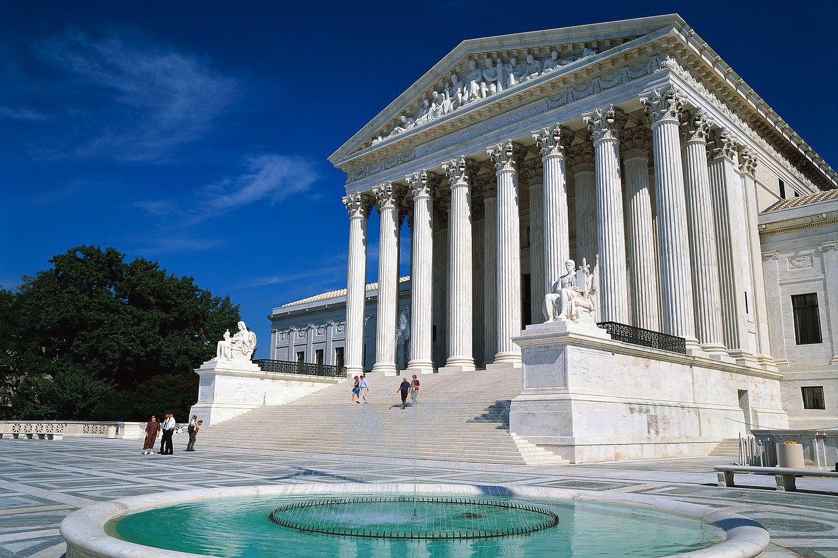
_____________________Laws

______________________

QUALIFICATIONS
ARTICLE II
_____________Branch
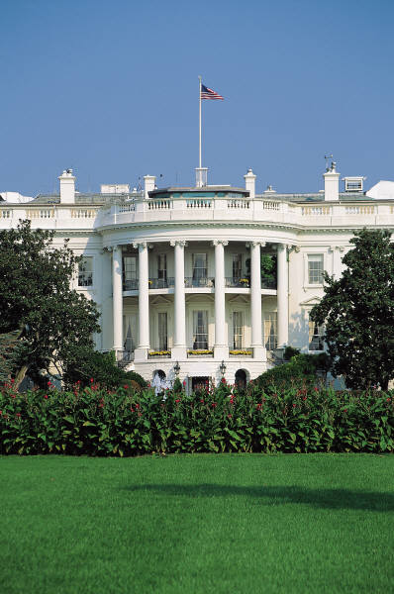
_____________________Laws

______________________

ARTICLE I
_____________Branch
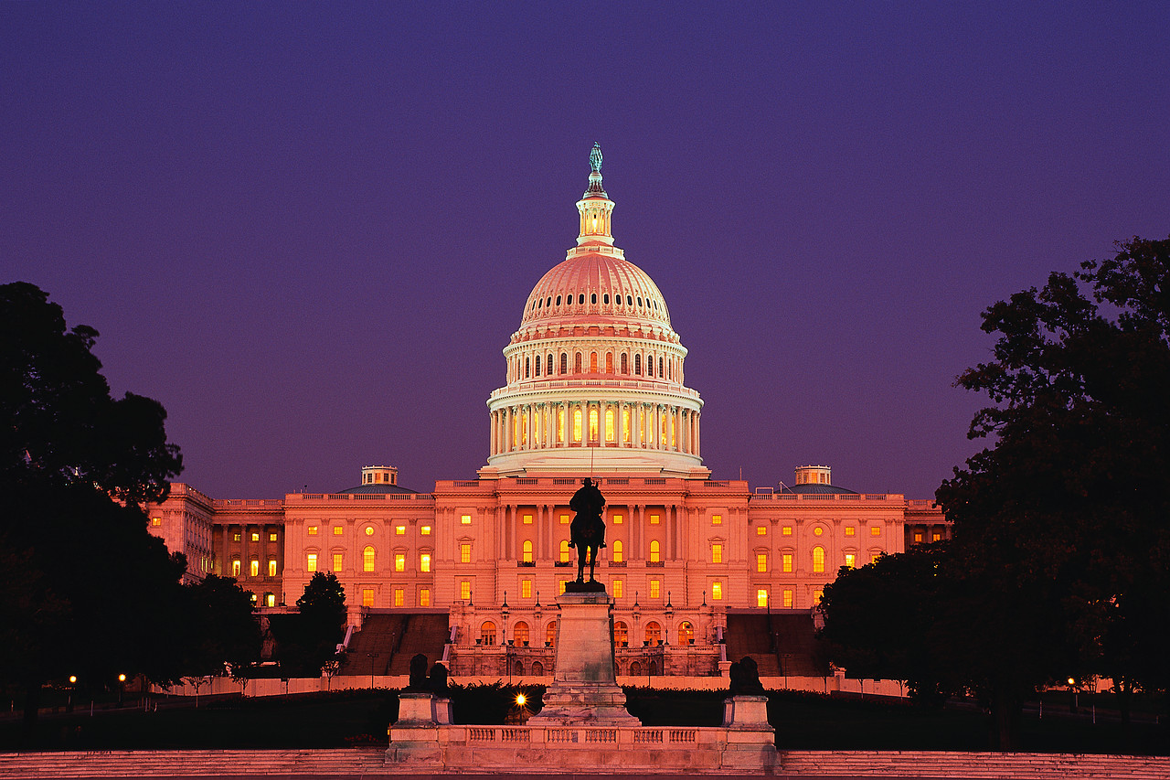
_____________________Laws

______________________

_______________________
POWERS & FUNCTIONS

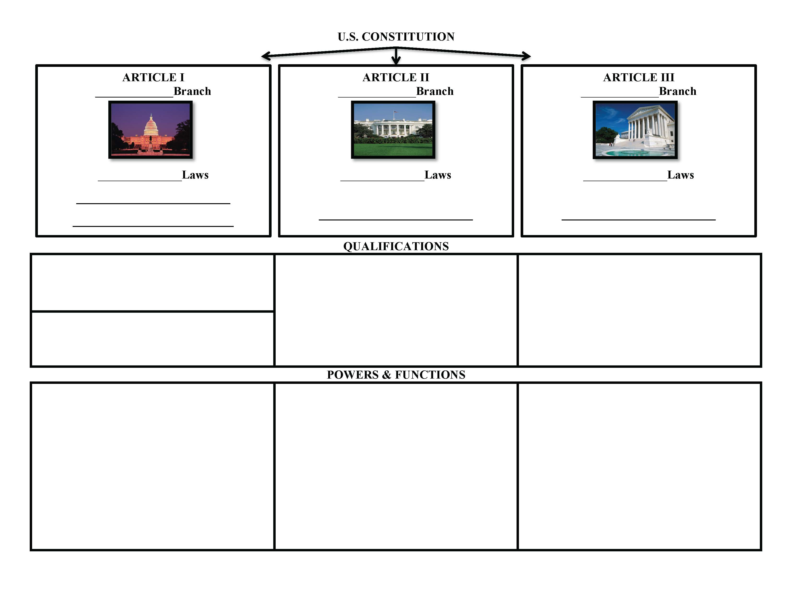
Step #5 – Repeat the process (Steps 1-4) for the Executive and Judicial Branches.
Step #6 – Add a title to the graphic organizer.

Step #3 – Write the qualifications for each branch. For the legislative branch, separate the House and the Senate in different boxes.
Step #1 – Start with the legislative branch, write the name of the branch that matches the Article and the key function regarding laws
Step #4 – Write the function and powers for each branch.
Step #2 – Write the institution(s) that represents the branch.
Sources
U.S. Constitution link - http://constitutioncenter.org/media/files/constitution-full-text.pdf
Understanding the Legislative, Executive, and Judicial Branch Readings - http://constitutioncenter.org/constitution/the-articles
Directed Note-Taking Template Adapted from: Just, Read! Florida - http://www.fldoe.org/academics/standards/just-read-fl/

Sample Answers
Understanding Article I | The Legislative Branch – SAMPLE ANSWERS
National Constitution Center & Annenberg Classroom

 | Guiding Question: According to the reading what is the structure, function and power of the legislative branch?
Introduction | three separate branches of government, different powers in the law making process and the ability to check each other
Section # | Key Terms | Add your notes to the appropriate column
 |  | Structure | Function | Power
1 | - Enumerated powers  - U.S. Congress  - U.S. House of Representatives  - U.S. Senate | Congress is divided into a House of Representatives and a Senate |  | The federal government’s power comes directly from the Constitution
2 | - House of Representatives  - impeach | - Term and qualifications for the House of Representatives are explained - (25 years old, citizen for 7 years, must live in the state they represent)  - Explains how districts are determined  - The House of Representatives has a Speaker |  | - Power of impeachment
3 | - U.S. Senate  - impeach | - The Senate has 100 members, 2 from each state (30 years old, citizen for 9 years, live in the state they represent) | - Vice President is president of the Senate and vote to break ties  - Senate conducts impeachment trial | - Senate decides whether or not to remove someone from office
4 |  |  | - State legislatures decide how congressional elections are held  - Congress decides how frequently it will meet | - Congress has the power to change election rules to protect voters
5 |  | - Each house can judge elections, create their own rules to manage themselves, must have a majority present in order to conduct business and keep a journal of their activities
6 |  | - Members are paid by the U.S. Treasury, they cannot hold another office while serving in Congress
7 |  |  | - The House is where all taxing and spending bills start  - How a bill becomes law | - Only the House can introduce a bill that involves taxes
8 | - Elastic clause  - Implied powers  - Necessary and proper  - Delegated powers  - Enumerated Powers  - Regulate trade  - Declaration of war  - Coin money  - Naturalization laws  - Immigration |  | - Determine naturalization laws | - Specific and “necessary and proper” powers are listed in this section  - Any other powers are for the states  - Most important powers are the ability to set taxes and spending of federal money  - Congress has the power to coin money, create the postal service, army, navy and lower federal courts, and to declare war.
9 |  |  | - Congress could not ban slavery until 1808  - Guarantees the rights of the accused  - Congress has to account for money being spent  - Congress cannot give titles
10 |  |  |  | - Explains the power of the states

Understanding the Executive Branch | Article II of the U.S Constitution - Sample Answers
Directions: Work with your partner to read each passage from Article II and answer the questions.
Section. 1. The executive Power shall be vested in a President of the United States of America. He shall hold his Office during the Term of four Years, and, together with the Vice President, chosen for the same Term, be elected, | Who is in charge of the executive branch and how long is their term?  The President and Vice President, they serve for a four year term.
No Person except a natural born Citizen, or a Citizen of the United States, at the time of the Adoption of this Constitution, shall be eligible to the Office of President; neither shall any Person be eligible to that Office who shall not have attained to the Age of thirty five Years, and been fourteen Years a Resident within the United States | What are the qualifications to be President?  Natural born citizen, 35 years old, lives in the U.S. for at least 14 years
Before he enter on the Execution of his Office, he shall take the following Oath or Affirmation:--"I do solemnly swear (or affirm) that I will faithfully execute the Office of President of the United States, and will to the best of my Ability, preserve, protect and defend the Constitution of the United States." | What does this section of Article II, Section I explain?  That the President must take an oath of office
The President shall be Commander in Chief of the Army and Navy of the United States, and of the Militia of the several States, when called into the actual Service of the United States; he may require the Opinion, in writing, of the principal Officer in each of the executive Departments, upon any Subject relating to the Duties of their respective Offices, and he shall have Power to grant Reprieves and Pardons for Offences against the United States, except in Cases of Impeachment. He shall have Power, by and with the Advice and Consent of the Senate, to make Treaties, provided two thirds of the Senators present concur; | What powers are outlined in this section?  - Commander in Chief  - In charge of executive departments  - Grant pardons, except for impeachment  - Make Treaties  What vocabulary term(s) are related to this section? (armed forces)
and he shall nominate, and by and with the Advice and Consent of the Senate, shall appoint Ambassadors, other public Ministers and Consuls, Judges of the supreme Court, and all other Officers of the United States, whose Appointments are not herein otherwise provided for, and which shall be established by Law: but the Congress may by Law vest the Appointment of such inferior Officers, as they think proper, in the President alone, in the Courts of Law, or in the Heads of Departments. | According to this passage of Article II, Section 2, which positions can the president appoint? What vocabulary term(s) are related to this section? (presidential appointments)  - Ambassadors  - Ministers and consuls  - Supreme Court Judges  - Other offices of the U.S.
Section. 3. He shall from time to time give to the Congress Information of the State of the Union, and recommend to their Consideration such Measures as he shall judge necessary and expedient; he may, on extraordinary Occasions, convene both Houses, or either of them, and in Case of Disagreement between them, with Respect to the Time of Adjournment, he may adjourn them to such Time as he shall think proper; | According to Article II, Section 3, outline the president’s involvement with Congress?  - Give Congress a State of the Union  - Convene Congress for special circumstances
he shall receive Ambassadors and other public Ministers; he shall take Care that the Laws be faithfully executed, and shall Commission all the Officers of the United States. | What job responsibilities are being described in this statement?  - Receives Ambassadors and other ministers  - Ensures that laws are being properly executed
Section. 4. The President, Vice President and all civil Officers of the United States, shall be removed from Office on Impeachment for, and Conviction of, Treason, Bribery, or other high Crimes and Misdemeanors. | How can the President or Vice President be removed from office?  - impeachment  - convicted of treason, bribery, or other high crimes

Understanding the Judicial Branch | Article III of the U.S Constitution - Sample Answers
Directions: Work with your partner to read each passage from Article II and answer the questions.
Section. 1. The judicial Power of the United States shall be vested in one supreme Court, and in such inferior Courts as the Congress may from time to time ordain and establish. | What is established in Article III, Section 1?  The Supreme Court and other courts that Congress can establish. Vocabulary term: U.S. Supreme Court
The Judges, both of the supreme and inferior Courts, shall hold their Offices during good Behaviour, and shall, at stated Times, receive for their Services a Compensation, which shall not be diminished during their Continuance in Office. | What are the qualifications for judges to hold their office?  Good behavior
Section. 2. The judicial Power shall extend to all Cases, in Law and Equity, arising under this Constitution, the Laws of the United States, and Treaties made, or which shall be made, under their Authority;--to all Cases affecting Ambassadors, other public Ministers and Consuls;--to all Cases of admiralty and maritime Jurisdiction;--to Controversies to which the United States shall be a Party;--to Controversies between two or more States;-- between a State and Citizens of another State,--between Citizens of different States,--between Citizens of the same State claiming Lands under Grants of different States, and between a State, or the Citizens thereof, and foreign States, Citizens or Subjects. | What are the types of arguments that the Supreme Court hear?  The federal courts will decide arguments over how to interpret the Constitution, all laws passed by Congress, and our nation’s rights and responsibilities in agreements with other nations. In addition, federal courts can hear disputes that may arise between states, between citizens of different states, and between states and the federal government.
In all Cases affecting Ambassadors, other public Ministers and Consuls, and those in which a State shall be Party, the supreme Court shall have original Jurisdiction. | What important concept is explained in this section?  Original jurisdiction
In all the other Cases before mentioned, the supreme Court shall have appellate Jurisdiction, both as to Law and Fact, with such Exceptions, and under such Regulations as the Congress shall make. | What important concept is explained in this section?  Appellate jurisdiction
The Trial of all Crimes, except in Cases of Impeachment, shall be by Jury; and such Trial shall be held in the State where the said Crimes shall have been committed; but when not committed within any State, the Trial shall be at such Place or Places as the Congress may by Law have directed. | What type of trial is being described in this passage?  Jury trial  Where do these trials take place?  The state where the crime was committed.
Section. 3. Treason against the United States, shall consist only in levying War against them, or in adhering to their Enemies, giving them Aid and Comfort. No Person shall be convicted of Treason unless on the Testimony of two Witnesses to the same overt Act, or on Confession in open Court. | What crime is being described in Article III, Section 3? Define this crime in your own words.  Treason - going to war against the United States or giving “aid or comfort” to an enemy.

U.S. CONSTITUTION - Sample Answers
ARTICLE III
Judicial Branch
Interpret Laws

Supreme Court

QUALIFICATIONS
ARTICLE II
Executive Branch
Enforce Laws

President

ARTICLE I
Legislative Branch
Make Laws

House of Representatives
Senate
House - 25 years old, citizen for 7 years, must live in the state they represent | Natural born citizen, 35 years old and lives in the U.S. for at least 14 years | Good behavior
Senate - 30 years old, citizen for 9 years, they must live in the state they represent
POWERS & FUNCTIONS
Have the power to change laws in order to protect voters; Determine naturalization laws; Congress has the power to coin money, create the postal service, army, navy and lower federal courts, and to declare war  Specific to the House - Power of impeachment,  Bills start here involving taxes  Specific to the Senate - Impeachment trial & decide whether or not to remove from office; approve treaties for ratification | The President is Commander in Chief, Chief Executive, and Chief Diplomat. He has the power to appoint positions, grant pardons and make treaties.  The President gives the State of the Union and can convene Congress in special circumstances  Vice President is president of the Senate and votes in order to break a tie | The Supreme Courts holds the power of original jurisdiction and appellate jurisdiction.  The federal courts will decide arguments over how to interpret the Constitution, all laws passed by Congress, arguments involving states, and in agreements with other nations.

Civics Content Vocabulary
Word/Term | Part of Speech | Definition
appellate jurisdiction | noun | the power to hear appeals of cases which have been tried in lower courts
armed forces | noun | the nation’s military (Air Force, Army, Coast Guard, Marines, National Guard and Navy)
article | noun | a numbered chapter or section of a contract, treaty, or constitution
coining money | verb | the power of the legislative branch to print money (coins and bills) for use
concurrent powers | noun | powers shared by the national, state, and/or local government
declaration of war | noun | the power of Congress to vote to go to war with another country
delegated powers | noun | the powers specifically named and assigned to the federal government or prohibited to be exercised by the states under the U.S. Constitution, also known as enumerated powers
elastic clause | noun | the power of Congress to pass all laws they deem necessary and proper for carrying out its enumerated powers (also known as implied powers)
enumerated powers | noun | the powers specifically named and assigned to the federal government or prohibited to be exercised by the states under the U.S. Constitution, also known as delegated powers
executive branch | noun | the branch of government that enforces the laws made by the legislative branch
foreign relations | noun | the power of the executive branch to decide on the United States’ dealings with other countries in order to achieve national goals
immigration | noun | the movement of people from one country to another country
impeach | verb | to bring formal charges of wrongdoing against a public official (such as the U.S. President)
implied powers | noun | powers not written in the U.S. Constitution but are necessary and proper in order for the federal government to carry out the expressed powers; Article 1, Section 8, Clause 18 gives Congress the power to do what it deems “necessary and proper” to carry out the delegated powers
judicial branch | noun | the branch of government that interprets the laws made by the legislative branch
legislative branch | noun | the branch of government that creates laws
naturalization laws | noun | laws made by Congress that people from other countries must follow in order to become legal citizens of the United States
necessary and proper clause | noun | the power of Congress to make laws they view as necessary and proper to carry out their enumerated powers; also known as the elastic clause
original jurisdiction | noun | the power of a court to be the first to hear a case on a specific topic
presidential appointments | noun | the power of the U.S. President to choose members of his or her cabinet, ambassadors to other nations, and other officials in his or her administration
regulate | verb | to control, govern, or direct according to rule
trade | verb | to buy and sell goods or services
U.S. Congress | proper noun | the national legislative body of the U.S., consisting of the Senate, or upper house, and the House of Representatives, or lower house
U.S. House of Representatives | proper noun | the lower house of the U.S. Congress
U.S. Senate | proper noun | the upper house of the U.S. Congress
U.S. Supreme Court | proper noun | the highest court of the United States; it sits at the top of the federal court system

Essential Teacher Content Background Information

This section addresses the following issues:

- Overview of the structure and functions of the three branches of government outlined in the U.S. Constitution
- The structure and functions of the legislative branch
- The structure and functions of the executive branch
- The structure and functions of the judiciary branch of government
- Graphic Representation: The Functions of Congress, the Executive and the Judiciary

1. Overview of the structure and functions of the three branches of government outlined in the U.S. Constitution

The U.S. Constitution is comprised of seven articles, each of which concerns a power of government. The first three articles deal with the three branches of government in the order that the Founders intended would reflect the amount of power that each branch would have under the new system. The legislative power, being the most powerful, is listed first, while the executive power is listed second. The judiciary power is listed third (the power of the courts to overturn laws was not established until Marbury v. Madison in 1803, and is not found in the U.S. Constitution). It was the Founders’ intention that the courts would not be powerful.

The legislative power is the strongest of the three powers of government because the nation is based on the rule of law. Persons responsible for enforcing and adjudicating the laws work in response to the lawmaking process. The executive branch must enforce laws in place while it may not enforce laws that are not in place. Similarly, the courts may not adjudicate laws that do not exist. This means that the executive and judiciary branches are reactive—they function in response to the proactive legislature which makes the legislature the most powerful branch of government. Additionally, the U.S. Constitution provides for the legislature to affect the membership of the other two branches. For example, if the Electoral College fails to extend a majority to one of the presidential candidates (Now a presidential/vice-presidential team since ratification of the 12th Amendment in 1804), the U.S. House of Representatives selects the president while the U.S. Senate elects the vice-president. The U.S. Senate confirms all Cabinet members, and other high level executive branch officials, following presidential nomination. Article III of the U.S. Constitution provides for a Supreme Court while the Congress creates all lower courts. The U.S. Senate confirms all Supreme Court and high level justices who are nominated by the president. Taken together, the legislature was created to be the most powerful branch of government followed by the executive branch, and then the judiciary branch.

2. The structure and functions of the legislative branch

The U.S. Congress was created as a bicameral, or two-house, legislature. “Camera” means “chamber” in Latin. The House of Representatives provides for representation based on the population in each state. Each state is guaranteed a minimum of one Representative regardless of size. The U.S. Senate is comprised of two Senators per state.

Article I of the U.S. Constitution outlines the structure, functions and processes of Congress. Article I is comprised of 10 sections, and is the longest article in the U.S. Constitution. Section 1, a single sentence, states that Congress shall be the legislative branch, while Sections 2-6 provide for membership in Congress including qualifications and elections of members and terms of office (Two years for House members; six years for Senators. There are no term limits for Congress members). Section 7 and Section 8 deal with the powers of Congress. Section 7 notes that “All bills for raising Revenue shall originate in the House of Representatives…” (capitalization in original). This means that all tax bills must begin where the people have the most power because House members serve at the district level, and serve for two year terms. Section 8 enumerates the powers of Congress including the power to tax, declare war, raise and support armies, and regulate commerce, among other powers. Section 9 deals with the end of slave importation (1808), writs of habeas corpus, and other concerns. Finally, Section 10 identifies the powers denied the states. Article I is then organized by defining the institution, identifying the parameters of securing and retaining membership, outlining the powers of the institution, and denying specific powers to the states.

3. The structure and functions of the executive branch

The executive branch is outlined in Article II. Similar to Article I, the Article begins with identifying the holders of executive power (the president and vice-president), followed by the method of selection. The president and vice-president are selected through an elaborate mechanism called the Electoral College which grants each state the same number of votes as it has seats in Congress.

Article II, Section 2 follows with the powers of the president. The president has five constitutional powers including serving as Commander-in-Chief of the armed forces and chief executive. The president also has the power to nominate persons for high office such as Cabinet secretaries, ambassadors, Supreme Court justices, and other offices, and negotiate treaties. Finally, the president has the power to pardon. Section 3 notes that the president must deliver an address to Congress on the State of the Union “from time to time”. While the Constitution does not require that the State of the Union be an annual event, presidents have established that tradition. The State of the Union is usually presented to Congress in January or February. Finally, in Section 4, the Constitution defines the circumstances under which the president can be removed from office. Together, Article II is organized so that the office is identified followed by the selection process followed by the powers of the office.

4. The structure and functions of the judiciary branch of government

The judiciary branch is outlined in Article III, the shortest of the first three articles. Similar to Articles I and II, Article III begins with an identification of the judicial power (the Supreme Court, and all inferior courts) along with the term of office (life with good behavior) in Section 1. Section 2 outlines the role of the office that includes the circumstances in which the Supreme Court is the court of “original jurisdiction” (the first place that the case is heard); otherwise, the Supreme Court is the highest appeals court in the United States. Section 3 defines treason.

5. Graphic Representation: The Functions of Congress, the Executive and the Judiciary
Article I: Congress | Article II: The Executive | Article III: The Judiciary
Makes all laws | Preserves, protects and defends the Constitution | Determines under which jurisdiction any given case falls
Lays and collects taxes | Faithfully executes the laws of the United States | Oversees cases involving original jurisdiction as outlined in Article III
Has sole power to declare war | Executes the instructions of Congress | Oversees all appellate cases; (appellate cases may be rejected by the U.S.
Confirms high level nominations to the executive and judiciary branches | Nominates high level members of the executive and judiciary branches. | Oversees the trials of impeachments
Oversees, investigates, and makes the rules for the government and its officers | Executes the spending authorized by Congress
Has the power to raise and support armed forces | Highest civilian officer of the armed forces
Approves treaties for ratification | Appoints judges with the advice and consent of the Senate
Originates cases of impeachment (House); Holds impeachment hearings (Senate) | Has the power to grant pardons for crimes against the United States
Has the power to coin and print money | Negotiates treaties
Regulates immigration and naturalization
Regulates commerce

Note: This matrix provides information found in Articles I, II and III of the U.S. Constitution. Since the Constitution was ratified, constitutional amendments and U.S. Supreme Court decisions have impacted the structure and function of each branch. However, SS.7.C.3.3 focuses solely on information found in Articles I, II and III. Information about structural and functional changes made since the Constitution was ratified may be found in other lessons, including but not limited to lessons tied to benchmarks SS.7.C.3.8, SS.7.C.3.9, SS.7.C.3.11 and SS.7.C.3.12. Further, SS.7.C.1.7 focuses on separation of powers and checks and balances which impacted the design of the U.S. Constitution. Materials focusing on separation of powers and checks and balances are found in the lesson linked to SS.7.C.1.7.

