SOURCES AND TYPES OF LAW
SS.7.C.3.10 Identify sources and types (civil, criminal, constitutional, military) of law.

TABLE OF CONTENTS

Lesson Summary 2
Suggested Student Activity Sequence 3
Student Activity Sheets & Reading Materials 5
Sources 12
Answer Keys 13
Civics Content Vocabulary 16
Essential Teacher Content Background Information 17

Lesson Summary
Essential Question
What are the sources and types of law?
NGSSS Benchmark
SS.7.C.3.10 Identify sources and types (civil, criminal, constitutional, military) of law.
Florida Standards
LAFS.68.RH.1.1 LAFS.68.RH.1.2 LAFS.68.RH.2.4 LAFS.68.RH.3.7
LAFS.68.RH.3.9 LAFS.68.WHST.1.2 LAFS.7.WHST.4.10 LAFS.7.SL.1.1
LAFS.7.SL.1.2
Overview
In this lesson, students will recognize and compare types of law and understand their sources.
Learning Goals/Benchmark Clarifications
- Students will use examples of historical law codes to identify how laws originated and developed in Western society.
- Students will recognize constitutional, statutory, case, and common law as sources of law.
- Students will compare civil, criminal, constitutional, and/or military law.
Benchmark Content Limits
- Items will not require specific recall of historical law codes.
Civics EOC Reporting Category
Reporting Category 1 – Origins and Purposes of Law and Government
Suggested Time Frame
- Two 45-50 minute class periods
Civics Content Vocabulary
- case law, civil law, Code of Hammurabi, common law, constitutional law, criminal law, juvenile law, Magna Carta, military law, regulation, source, statutory law, type
Instructional Strategies
Close reading of complex text Video as text Context clues
Materials
Computer with internet access to project lesson activity sheets
Student activity sheets:
- Sources and Types of Law
- Sources of Law, Worksheet 2 from Sources of Law lesson plan from iCivics: http://www.icivics.org/teachers/lesson-plans/sources-law
Student readings:
- Sources of Law reading from Sources of Law lesson plan from iCivics: http://www.icivics.org/teachers/lesson-plans/sources-law
Lesson Activities and Daily Schedule
Please use the chart below to track activity completion.
Day | Task # | Steps in Lesson | Description | Completed?  Yes/No
Day One | Task 1 | 1-5 | Hook Activity
 | Task 2 | 6-8 | Code of Hammurabi Discussion
 | Task 3 | 9-16 | Magna Carta Discussion and Summary Statement
 | Task 4 | 17-27 | Sources of Law Reading and Activities
Day Two | Task 5 | 28-38 | Types of Law Reading and Activities
 | Task 6 | 39-41 | Law Scenarios
 | Task 7 | 42 | Checking for Understanding

Suggested Student Activity Sequence
- To begin this lesson, ask students to brainstorm some of the different laws they know.
- Allow time for students to brainstorm and share out.
- Write down the laws that are shared on the board.
- Pose the following questions for discussion: “What do you notice about the laws we have on the board? Can you organize them in different categories?”
- Explain to students that they will learn about different types of laws and their sources.
- Project the map of Iraq and Syria from this page: https://kids.nationalgeographic.com/explore/countries/iraq/and explain to students that they will learn about an ancient system of laws that began in Mesopotamia, land that is now Iraq and Syria.
- Pass out the “Sources and Types of Laws” student activity sheet and direct student attention to the Code of Hammurabi questions at the top of the first page. Read the questions aloud to the class.
- Use the following key points to provide direct instruction to the class about the Code of Hammurabi. Instruct students to answer the questions on the activity sheet.
  - The Code of Hammurabi is a written code of rules that guided the society of Babylon around 1772 B.C.
  - The Code included 282 laws that dealt with everyday life. It was the first time a written set of laws governed a society.
  - This act of writing laws down and creating a structure and process for laws greatly influenced how other societies developed their own laws.
  - This is true for the U.S. and is evident by the U.S. Constitution. The U.S. Constitution is a series of laws written to guide society in the United States.
- Project an image of the Magna Carta: https://www.archives.gov/exhibits/featured-documents/magna-carta.
- Ask students if they can identify the document.
- Share with students the following key points about the Magna Carta and instruct students to take notes on their activity sheet:
- In order to avoid a war, King John of England signed the Magna Carta in 1215.
- The Magna Carta is also known as the Great Charter of Freedoms.
- The Magna Carta was written by a group of English nobility (barons) because they wanted to protect their rights and property against the king.
- During the American Revolution, the Magna Carta was one inspiration for the colonists to seek their independence from the king of England.
- The colonists believed they were entitled to the same rights as Englishmen, rights guaranteed in the Magna Carta. They embedded those rights into the laws of their states and later into the U.S. Constitution and Bill of Rights.
- Direct student attention to the two quotes from the Magna Carta on their activity sheet.
- Read through both quotes as a whole class and provide students with time to summarize both quotes in their own words.
- Lead students to the understanding that both of these quotes are examples of how the Magna Carta inspired the founders of our nation and the writing of the U.S. Constitution. For example, the Fifth Amendment to the Constitution ("no person shall . . . be deprived of life, liberty, or property, without due process of law.") was inspired by the second quote from the Magna Carta.
- Pose the following question for discussion: “The core source of American law is the U.S. Constitution. Based on what you have learned about the Code of Hammurabi and the Magna Carta, how did the documents influence the U.S. Constitution?”
- Provide time for students to write a summary statement on their activity sheet.
- Pass out the “Sources of Law, Reading pgs. 1 and 2” from iCivics: http://www.icivics.org/teachers/lesson-plans/sources-law.
- Read aloud the first paragraph as a whole class.
- Pose the following question for discussion: “Based on the information provided in the first paragraph, what is the main question about laws that will be answered by this reading?”
- Lead students to the understanding that this reading will explain different sources of law: constitutional, case, and statutory.
- Place students into pairs and instruct them to read the “Constitutions,” “Statutes” and “Regulations” sections. While reading, instruct students to mark text that helps them define the concepts of “constitutional law,” “statutory law” and “regulations.”
- Provide time for students to read and define the concepts.
- Read as a whole class the “Judicial Precedent and Interpretation” section.
- Ask the students to share aloud the main ideas from the section.
- Lead students to the understanding that judicial precedent and cases become sources of law called case law and common law. Case law is law established by the outcome of former cases and common law is legal precedent based on customs and prior legal decisions; it is used in civil cases. Instruct students to add these definitions to their activity sheet.
- Pose the following question for discussion: “What can you summarize about sources of law in the U.S.?”
- Instruct students to take notes during the discussion in the “Summary Statement” row on their activity sheet.
- Explain to students that these sources of law are used to create different types of law: civil, constitutional, criminal, juvenile, and military.
- Direct student attention to the “Types of Law” section on their activity sheet. Explain to students that their task is to read and mark text that helps them summarize each of the concepts related to the types of law on the activity sheet.
- Point out the “constitutional law” rows under Sources of Law and Types of Law. Explain to students that constitutional law is a source of law and it is also a type of law.
- Provide students with the following key points about constitutional law and instruct them to take notes on their activity sheet in the “constitutional law” row under Types of Law. Key points to include:
- Constitutional law defines the powers between states.
- Constitutional law deals with the relationship between the government and citizens.
- Pass out the “Sources of Law, Reading pgs. 3 and 4” from iCivics.
- Read aloud the first paragraph as a whole class.
- Instruct students to work with their partner to read, mark text and explain in their own words the following concepts: civil law, criminal law, juvenile law and military law.
- Provide time for students to complete the reading and activity sheet.
- Monitor student work while they are reading and completing the activity sheet.
- Pose the following questions for discussion: “How do these different types of law compare? How are they different?”
- Have students share out and provide them with the following key comparisons:
  - Civil and criminal law are the types of law that most often impact U.S. citizens.
  - Juvenile law and criminal law are both concerned with crime, but juvenile law only applies to people under the age of 18.
  - Military law is for military members and does not apply to civilians.
  - Constitutional law deals with issues related to the government and the states and the government and its citizens.
  - Criminal law deals with crime and civil law deals with issues that are not related to crime.
- Project the “Sources of Law, Worksheet 2” activity sheet from iCivics.
- Explain to students that they will look at scenarios and determine the type of law that is being described.
- Read each scenario aloud to the class and instruct students to identify the type of law being described and the text in the scenario that led them to their answer.
- Checking for Understanding (Formative Assessment):
Instruct students to write a well-crafted informative response using one of the following prompts:
Prompt 1
Explain the five different sources of law you have learned about in this lesson by explaining each source in your own words and supporting each explanation with evidence from the reading.
Prompt 2
Explain the different types of law you have learned about in this lesson by explaining each type in your own words, supporting each explanation with evidence from the reading and explaining how each type of law compares with the other types you have learned about.
Sources and Types of Law | Page One
Historical Sources
Code of Hammurabi | 1. What is the Code of Hammurabi?
 | 2. What is the connection between the Code of Hammurabi and the U.S. Constitution?
Magna Carta | Notes from Class Discussion
 | 1. "No freeman shall be taken, imprisoned, … nor will We proceed against or prosecute him, except by the lawful judgment of his peers and by the law of the land."
 | 2. "… to no one will We deny or delay, right or justice."
Summary Statement about Historical Sources of Law & the U.S. Constitution

Sources and Types of Law | Page Two
Directions: Read Sources of Law, Pages 1 and 2 to understand the different sources of law. Mark text that helps you define the civics content vocabulary terms and then define the terms in your own words.
Sources of Law
Constitutional Law
Statutory Law
Regulations
Case Law
Common Law
Summary Statement about Sources of Law:

Types of Law
Civil Law
Constitutional Law
Criminal Law
Juvenile Law
Military Law
Summary Statement about Types of Law:

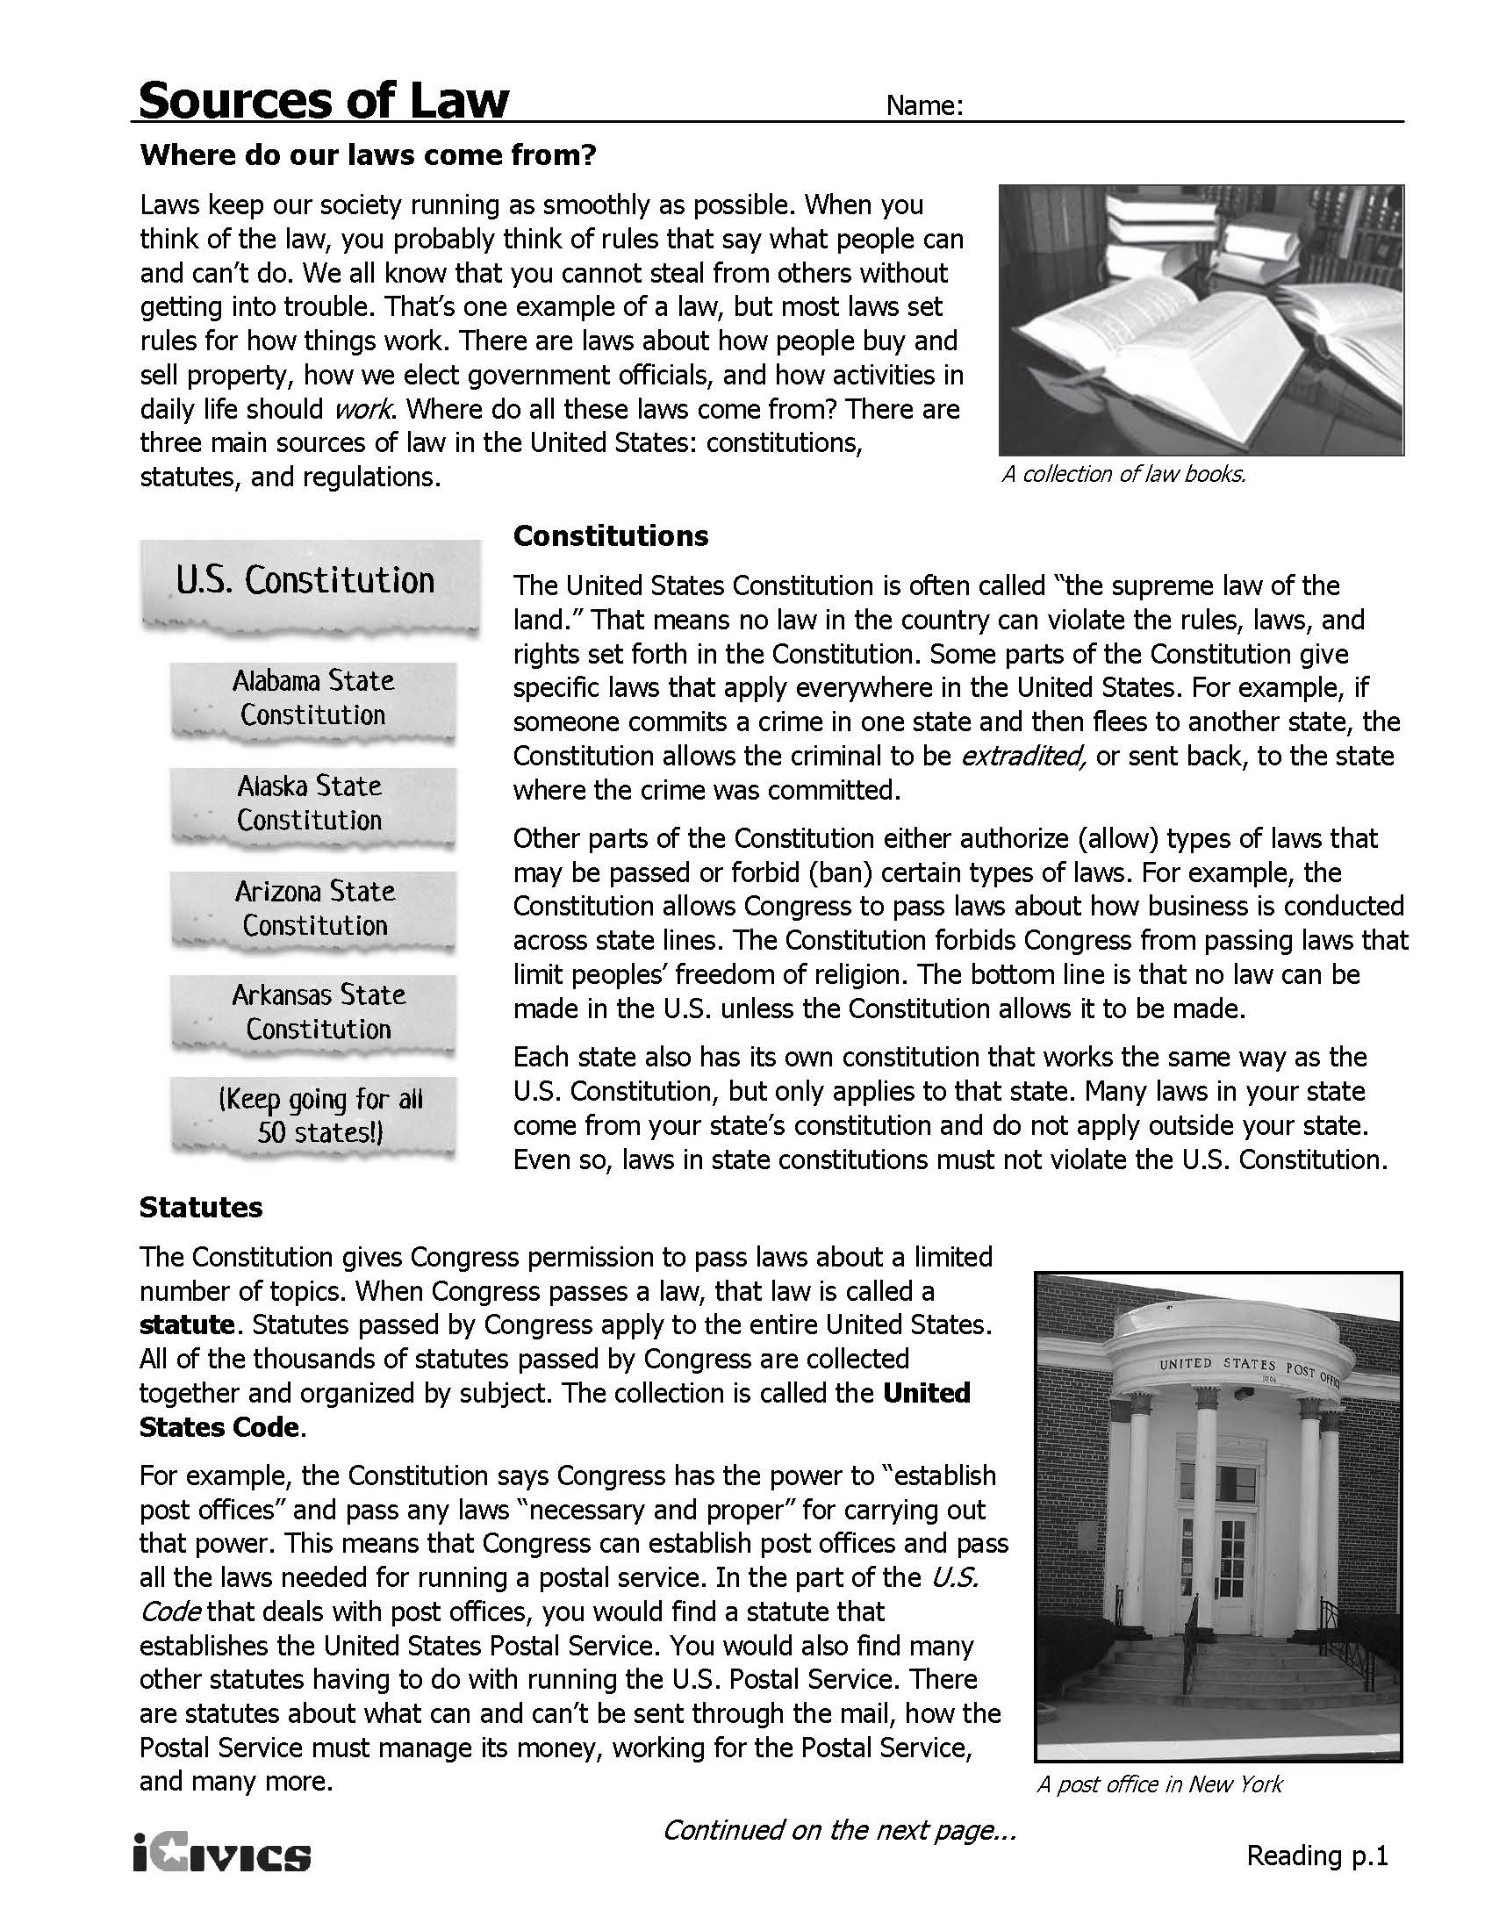

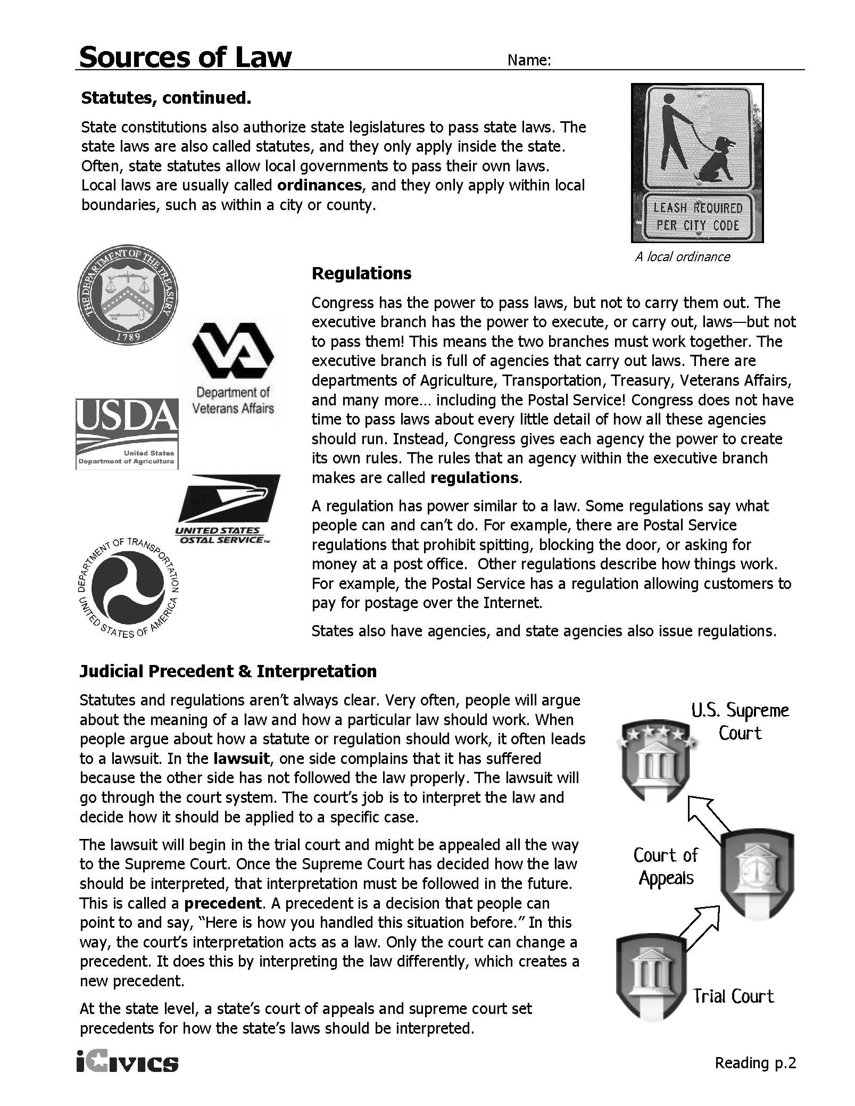
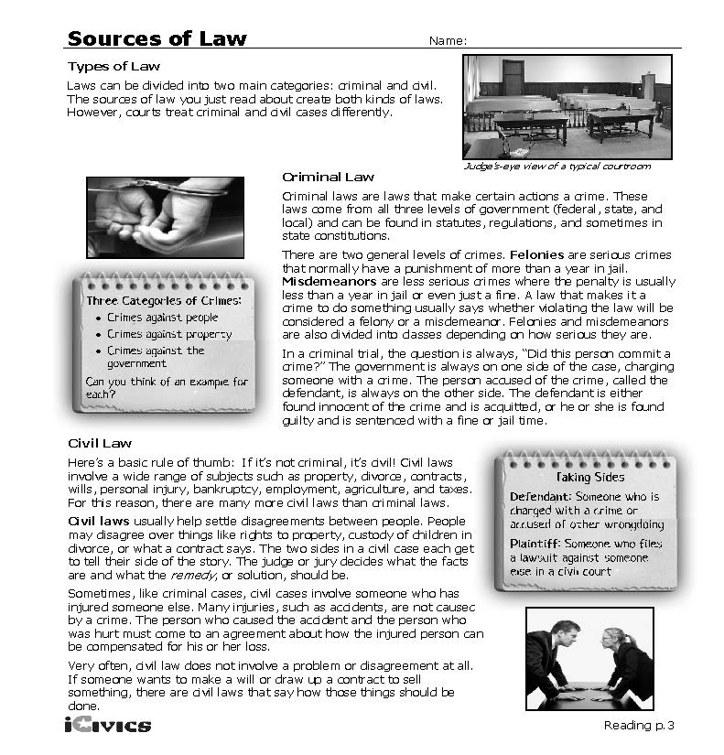

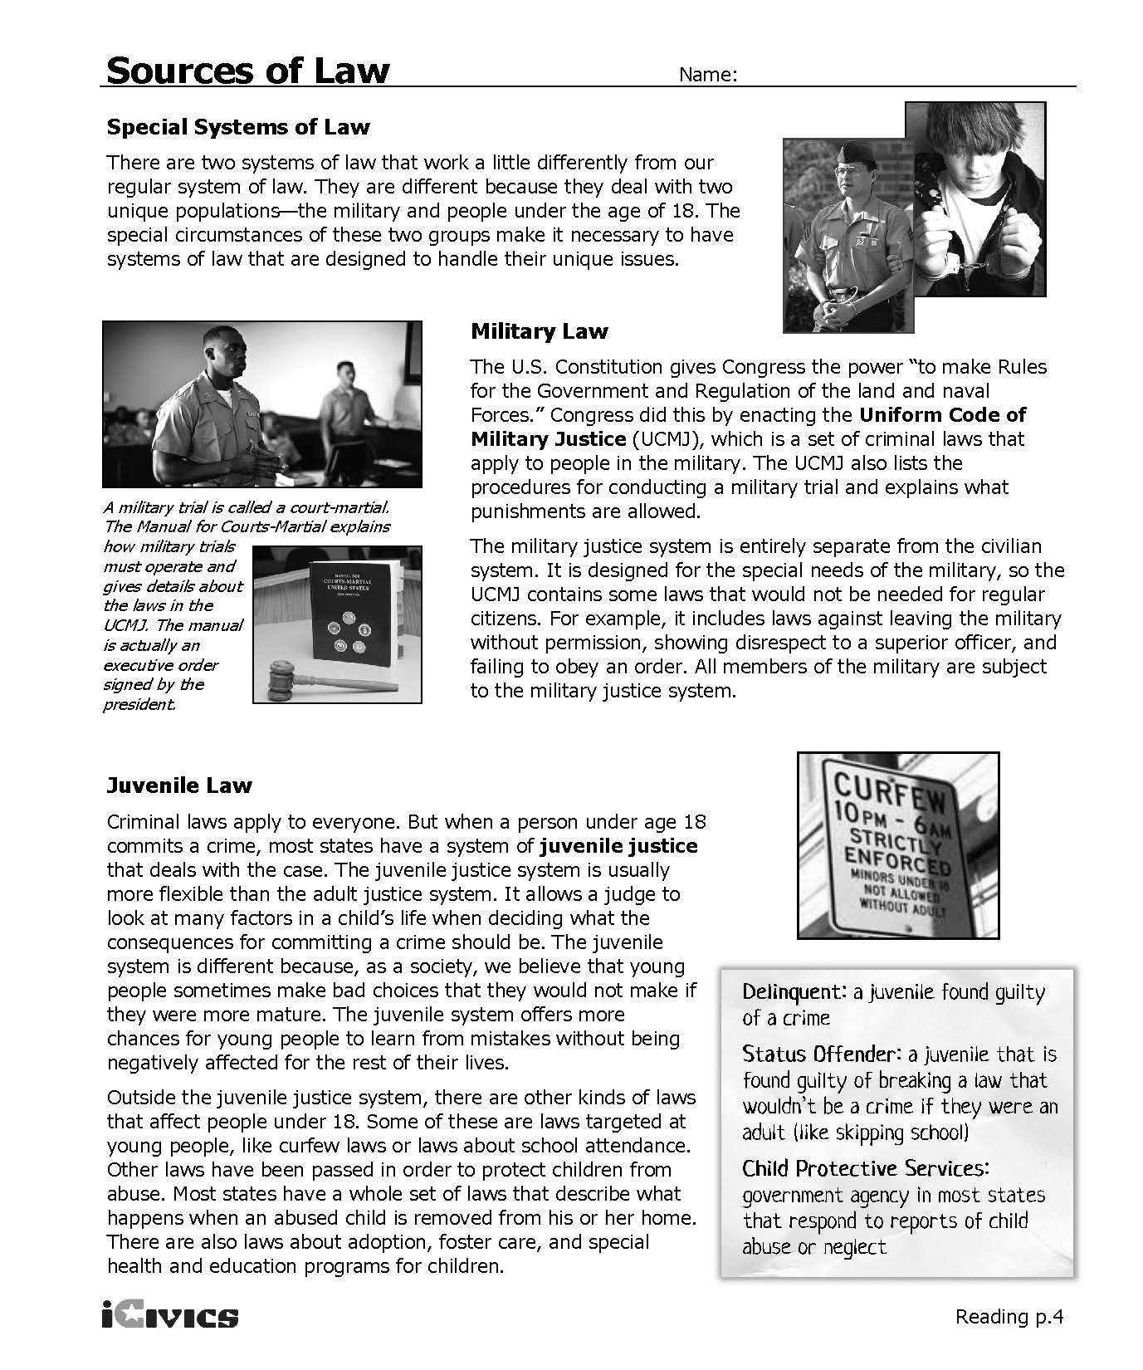
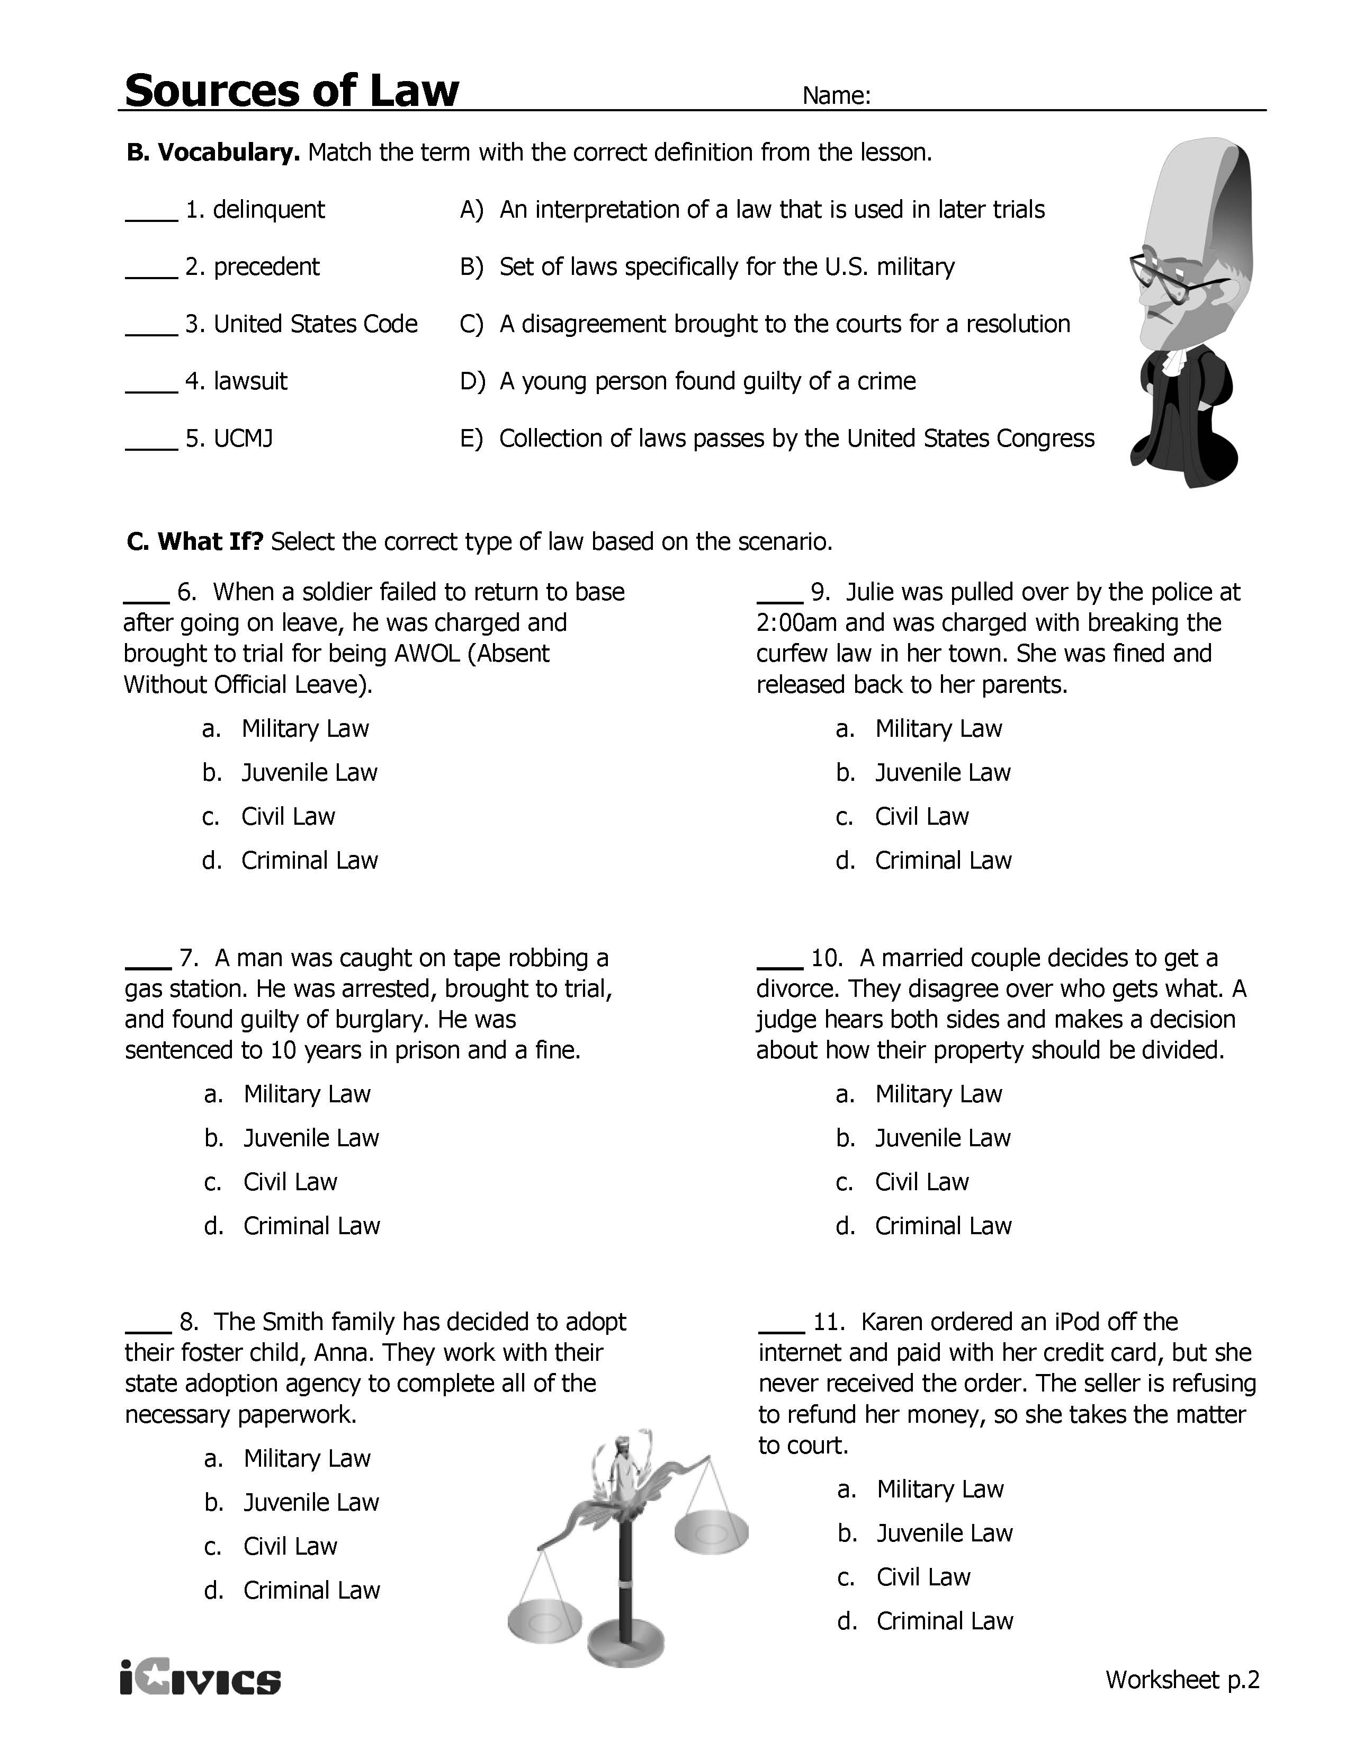
Sources
Sources of Law lesson plan from iCivics: http://www.icivics.org/teachers/lesson-plans/sources-law
Notes on Mesopotamia from National Geographic Education Video: http://www.natgeoeducationvideo.com/film/1011/mesopotamia, Accessed April 2013
Magna Carta image and notes: https://www.archives.gov/exhibits/featured-documents/magna-carta
Constitutional law notes:
http://teacher.scholastic.com/scholasticnews/indepth/upfront/grolier/constitutional_law.htm, Accessed April 2013

Sources and Types of Law | Page One | Sample Answers
Historical Sources
Code of Hammurabi | 1. What is the Code of Hammurabi? - a written code of rules that guided an ancient society around 1772 B.C., 282 laws that dealt with everyday life, it was a code that most likely inspired other civilizations
 | 2. What is the connection between the Code of Hammurabi and the U.S. Constitution? The Code of Hammurabi was the first set of written rules to govern a society, the U.S. Constitution is the written set of rules governing the United States.
Magna Carta | "No freeman shall be taken, imprisoned, … nor will We proceed against or prosecute him, except by the lawful judgment of his peers and by the law of the land."
 | Freemen will be judged by the law of the land.
 | "… to no one will We deny or delay, right or justice."
 | Justice will not be denied to anyone.
Summary Statement about Historical Sources of Law & the U.S. Constitution | The U.S. Constitution was influenced by historical law codes. For example, the Hammurabi Code began the system of written laws and the Magna Carta was used as inspiration for some of the individual rights we have today.

Sources and Types of Law | Page Two | Sample Answers
Directions: Read Sources of Law, Pages 1 and 2 to understand the different sources of law. Mark text that helps you define the civics content vocabulary terms and then define the terms in your own words.

Sources of Law
Constitutional Law | The Constitution is the supreme law of the land and states can only create laws that do not conflict with the Constitution. As a type of law, constitutional law deals with issues between the federal government and states, between two or more states, and between the government and citizens.
Statutory Law | The Constitution gives Congress permission to pass laws about a limited number of topics. These laws are called statutes. These statutes apply to the entire United States.
Regulations | The rules that an agency of the executive branch makes are called regulations.
Case Law | Case law is law established by the outcome of former cases.
Common Law | Common law is legal precedent based on customs and prior legal decisions; it is used in civil cases.
Summary Statement about Sources of Law: | Laws come from different sources. However the U.S. Constitution is the supreme law of the land. From the Constitution, statutes and regulations are created. Courts interpret laws and create case and common law.

Types of Law
Civil Law | Civil laws help settle disagreements between people. Civil laws deal with subjects such as: property, divorce, contracts, wills, personal injury, bankruptcy, employment, agriculture, and taxes.
Constitutional Law | Constitutional law defines the powers between states and deals with the relationship between the government and citizens.
Criminal Law | Criminal law makes certain actions a crime and comes from all three levels of government. Criminal law falls into two categories: felonies (serious crimes) and misdemeanors (less serious crimes). When someone breaks a criminal law, they are charged with a crime. When someone is brought to trial for a crime, the government is on one side charging the person with the crime and the person accused of the crime is called the defendant.
Juvenile Law | Juvenile law is for people under the age of 18 who commit a crime. The juvenile system is usually more flexible than the adult system, so that juveniles have more chances for young people to learn from their mistakes. There are also laws about school attendance, curfews and child abuse.
Military Law | Military laws are special laws for people in the U.S. military. Congress created the Uniform Code of Military Justice, which is a set of criminal laws that apply to people in the military. This code also includes procedures for a military trial and punishments. It also includes laws that are not needed for non-military laws.
Summary Statement about Types of Law: | There are different types of law in the United States. Constitutional law deals with issues related to the government, states and its citizens. Criminal law deals with crime and civil law deals with issues that are not related to crime. Juvenile law mainly deals with criminal law for people under the age of 18, as well as some other issues. Military law is especially for military members and has its own set of rules for criminal actions.

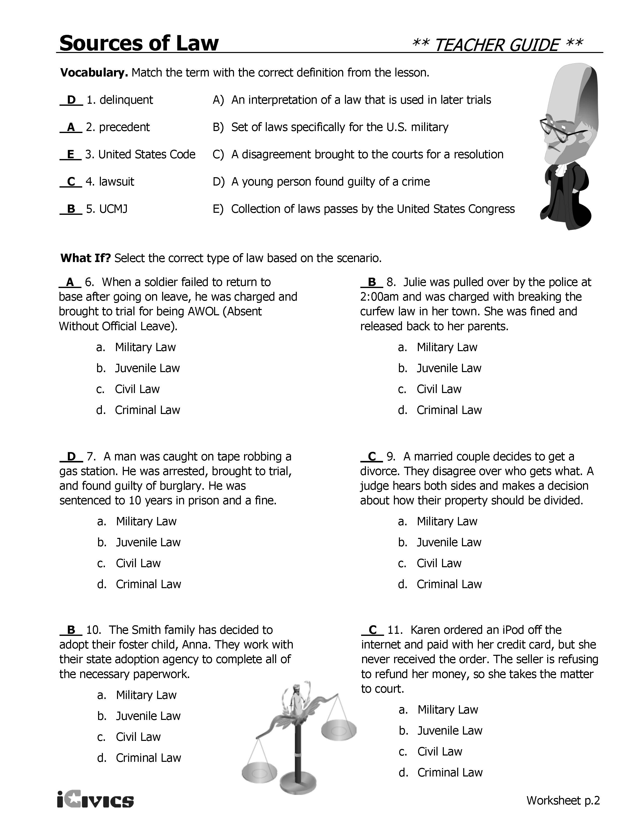

Civics Content Vocabulary

Word/Term | Part of Speech | Definition
case law | noun | law established based on the outcome of former court cases
civil law | noun | law that deals with relationships between people (rather than relationships between people and the government)
Code of Hammurabi | proper noun | a written code of rules that guided the ancient society of Babylon; dates back to 1772 B.C.
common law | noun | law based on customs and prior legal decisions; used in civil cases
constitutional law | noun | law that focuses on interpreting the U.S. Constitution
criminal law | noun | law that deals with crimes and the punishments for those crimes
juvenile law | noun | law that deals with people who are under the age of 18
Magna Carta | proper noun | a government document that limited the power of the king of England and protected the rights of the nobility; written by the English nobles in 1215
military law | noun | laws that apply only to people in the military
regulation | noun | a rule that a government agency makes to enforce a law
source | noun | a main reference or point of origin
statutory law | noun | laws passed by Congress or a state legislature
type | noun | a particular category, kind, or group

Essential Teacher Content Background Information

This section addresses the following issues:

- Why do sources and types of law form the basis for public policy in the U.S.?
- Sources of law
- Types of law

1. Why do sources and types of law form the basis for public policy in the U.S.?

The U.S. is governed by the rule of law. There are several sources and types of law that form the basis for public policy in the U.S. The U.S. government avoids an arbitrary approach to governance in anchoring public policy in multiple sources and types of law. The sources and types of law that anchor policy making reflect core values and approaches including preventing government abuse of power, core civil liberties and civil rights, separation of powers, consent of the governed, and social contract among others.

2. Sources of law

Sources of law speak to who makes laws. There are sources of law that are made by elected officials at the local, state and national level, and by appointed officials.

The core source of American law is the U.S. Constitution. The Constitution extends specific powers to the three branches and powers of government (legislative, executive, judicial) and divides powers between the national and state governments. From these constitutional orientations emerge the distribution of who is empowered to make law and the nature of the law that is made.

Laws made by elected officials include ordinances (local laws), ordinances (state laws) and acts (federal laws). The supremacy clause found in Article Six of the U.S. Constitution speaks to the notion that the higher levels of government decide how much power lower level governments will have. The Supremacy Clause states that:

This Constitution, and the Laws of the United States which shall be made in Pursuance thereof; and all Treaties made, or which shall be made, under the Authority of the United States, shall be the supreme Law of the Land; and the Judges in every State shall be bound thereby, any Thing in the Constitution or Laws of any State to the Contrary notwithstanding.

The core focus of the Supremacy Clause is that laws made at levels below the national level may not conflict with national laws. Beyond the Supremacy Clause, the notion that higher level governments make laws impacting lower level governments, in essence, deciding what kind of laws that lower level governments may or may not make, is key to understanding sources of law. The national government may decide the powers of the state governments and the state governments may decide which powers that the local governments within those states may have. Laws may be made only for the political units in which they are elected (state laws impact the state in which those legislators are elected; county ordinances impact only the county in which those ordinances are made, etc.).

Yet the U.S. Constitution includes limits what the national, state and local governments may do. For example, Article I, Section 8 outlines the specific powers of Congress (thereby denying those powers to the states, such as raising and supporting armies) while the Tenth Amendment to the U.S. Constitution states that powers not specifically delegated to Congress are reserved to the states. Controversies have emerged as to whether the Article I, Section 8 “necessary and proper” (or “elastic”) clause gives powers to Congress that are not enumerated (listed).

Regulations are a source of law that extend lawmaking powers to appointed administrators. Heads of administrative agencies use their expertise to decide how laws will be implemented which broadens their power.

The U.S. Supreme Court is the highest U.S. court. Decisions made by lower courts may be overturned by the U.S. Supreme Court and cannot be appealed. The U.S. Supreme Court is the nation’s final interpreter of the U.S. Constitution. It decides the meaning and scope of constitutional law. Judicial decisions are used as the basis for future judicial decisions; these earlier decisions (precedents) insure that constitutional interpretation is not arbitrary or capricious.

3. Types of law
There are several types of law that are used in the U.S. These types of law include civil, criminal, constitutional, military and juvenile. Each type of law impacts certain populations and impact different types of conflicts.

Civil and criminal law are the types of law that most often impact U.S. citizens. Civil laws are those types of laws that involve conflicts between citizens such as property and contract disputes while criminal law focuses on those laws involving individuals accused and/or convicted of committing crimes. Criminal law is handled by the government against which the crime was alleged to have been committed; for instance, a person accused of committing a state statute will be prosecuted by the state while a person convicted of a federal crime will be incarcerated in a federal prison. Persons convicted of violating criminal law may be incarcerated while persons losing their cases in civil court may be subject to fines, financial penalties, and other punishments, but are not subject to incarceration.

Military law impacts only persons in the military; constitutional protections, such as those listed in the Bill of Rights, do not apply to military law although several aspects of constitutional law have parallels in military law.

Juvenile law impacts those who are less than 18 years old. Juvenile law is associated with various aspects of the law where juveniles are treated differently than adults because juveniles do not have the same obligations and responsibilities as do adult citizens. Juveniles also do not have the same powers as adult citizens, which also impacts how they are treated by the legal system.

