****

**RIGHTS IN THE U.S. CONSTITUTION**

**SS.7.C.2.4** Evaluate rights contained in the Bill of Rights and other amendments to the Constitution.

**TABLE OF CONTENTS**

Lesson Summary2

Suggested Student Activity Sequence4

**Student Activity Sheets & Reading Materials6**

Sources15

Answer Keys16

**Civics Content Vocabulary21**

**Essential Teacher Content Background Information22**

***Lesson Summary***

***Essential Question***

What rights are protected by the Bill of Rights and other amendments to the U.S. Constitution?

***NGSSS Benchmark***

SS.7.C.2.4 Evaluate rights contained in the Bill of Rights and other amendments to the Constitution.

***Florida Standards***

LAFS.68.RH.1.1 LAFS.68.RH.1.2 LAFS.68.RH.3.7 LAFS.68.WHST.1.1

LAFS.68.WHST.2.4 LAFS.68.WHST.3.7 LAFS.68.WHST.4.10 LAFS.7.SL.1.1

***Overview***

In this lesson, students will understand what is in the Bill of Rights, what rights the Bill of Rights and other amendments protect, and how the Bill of Rights influences both individuals and society.

***Learning Goals/Benchmark Clarifications***

* Students will recognize that the Bill of Rights comprises the first ten amendments to the U.S. Constitution.
* Students will recognize the five freedoms protected by the First Amendment.
* Students will evaluate how the Bill of Rights influences individual actions and social interactions.
* Students will use scenarios to identify rights protected by the Bill of Rights.
* Students will use scenarios to recognize violations of the Bill of Rights or other constitutional amendments.

***Benchmark Content Limits***

* Items will not require students to cite specific court cases or specific amendments to the U.S. Constitution.

***Civics EOC Reporting Category***

Reporting Category 2 – Roles, Rights, and Responsibilities of Citizens

***Suggested Time Frame***

* Four 45-50 minute class periods

***Civics Content Vocabulary***

* Bill of Rights, cruel and unusual punishment, double jeopardy, due process, eminent domain, equal protection under the law, First Amendment, pleading the fifth, right to bear arms, right to legal counsel, search and seizure, suffrage, trial by jury, unenumerated rights (Ninth Amendment)

***Instructional Strategies***

Reading of complex text Video as text Directed note taking Collaborative learning

***Materials***

Projector to display word documents, websites and video “Why is the First Amendment Important” from Constituting America:   
<https://www.youtube.com/watch?v=ySlSsDkAUC4>

Blank copier paper for foldable activity

Chart paper

Student activity sheets and reading materials:

* You’ve Got Rights! student activity sheet from iCivics
* The U.S. Bill of Rights Guided Notes
* Blogging the Bill of Rights Template
* Bill of Rights Scenarios
* Applying the Bill of Rights

***Lesson Activities and Daily Schedule***

Please use the chart below to track activity completion.

|  |  |  |  |  |
| --- | --- | --- | --- | --- |
| **Day** | **Task #** | **Steps in Lesson** | **Description** | **Completed?**  **Yes/No** |
| **Day One** | Task 1 | 1-4 | Hook Activity: You’ve Got Rights!  Part One |  |
| Task 2 | 5-11 | Bill of Rights Guided Notes |  |
| Task 3 | 12-15 | First Amendment Video |  |
| **Day Two** | Task 4 | 16-19 | Bill of Rights Foldable Activity |  |
| Task 5 | 20 & 21 | You’ve Got Rights! Part Two |  |
| **Day Three** | Task 6 | 22-32 | Blogging the Bill of Rights |  |
| **Day Four** | Task 7 | 33-38 | Bill of Rights Today |  |
| Task 8 | 39 | Checking for Understanding |  |

***Suggested Student Activity Sequence***

1. To begin this lesson, pass out copies of the “You’ve Got Rights!” student activity sheet from iCivics: <https://www.icivics.org/teachers/lesson-plans/youve-got-rights?referer=node/674&page_title=The%20Constitution>
2. Read the paragraph aloud at the top of the activity sheet.
3. Instruct students to complete the “Pamphlet of Protections” checklist independently.
4. Have students share out by taking a poll of which right received the most votes from students.
5. Pass out the “United States Bill of Rights Guided Notes” student activity sheet.
6. Explain to students that the Bill of Rights is the first ten amendments, or changes, to the U.S. Constitution.
7. Explain to students that as a whole class they will read through the text of each amendment and write the central idea on the spaces below each amendment.
8. Begin with the First Amendment and read the text aloud to the whole class. Explain to students that the First Amendment contains five freedoms.
9. Reread the First Amendment and ask students to identify what they think are the five freedoms. Instruct students to add the five freedoms to their activity sheet.
10. Read through the rest of the amendments one at a time.
11. Call on students to summarize the central idea(s) in each amendment. Teacher note: Utilize the Sample Answers section for this activity sheet to guide your discussion.
12. Write the following questions on the board:

* How does the First Amendment impact our lives?
* Why are the freedoms of press, speech, and assembly so important?
* Why is the right to petition so important?

1. Explain to students that they will watch a video about the First Amendment. Their task is to take notes on the three questions while watching the video.
2. Play the “Why is the First Amendment Important” from Constituting America:   
   <https://www.youtube.com/watch?v=ySlSsDkAUC4>
3. Provide time for students to review their notes and write answers for the video viewing questions in complete sentences. Have students share out.
4. Pass out a letter size piece of white copy paper to each student. Instruct the students to fold the paper in half four times so that they create a 4-column/4-row table. The paper should have 16 boxes.
5. Instruct students to position their paper horizontally. Instruct students to write “The Bill of Rights” in the first box and to write their name in the last box.
6. Explain to students that their task is to create a visual representation of the five freedoms in the First Amendment and for each additional amendment contained in the Bill of Rights. Show students the example on page 14.
7. Have students share their foldable and explain some of the visual representations they created.
8. Have students take out the “You’ve Got Rights!” student activity sheet.
9. Pose the following questions for discussion: “How does your list compare with the Bill of Rights? Did you mark rights on your activity sheet that do not match any of the amendments in the Bill of Rights? Why do you think this is?”
10. Project the “Rights Listed in Amendments” handout and scroll down to the second graphic organizer.
11. Explain to students that amendments have been added to the U.S. Constitution to deal with the issue of suffrage (the right to vote) and ensuring that all citizens have equal protection under the law.
12. Project the following questions on the board: “How do the rights contained in the Bill of Rights influence individual actions and social interactions? Why do you think this is? Can you think of examples from real life of how the Bill of Rights impacts actions and social interactions?”
13. Provide time for students to work with their group and answer each question.
14. Have students share out.
15. Keep students in their cooperative groups and give each group a large piece of chart paper.
16. Pass out the “Blog Template” and the “Bill of Rights Scenarios” student activity sheets.
17. Have the students format the chart paper exactly how the template looks. Teacher note: If students use a rectangle shaped piece of paper, have them fold the paper and outline the folds instead of drawing the template “free hand.” This will help save on time.
18. Explain to students that they will complete a simulated blogging activity about how the rights contained in the Bill of Rights are protected and identifying situations when they are violated.
19. Provide the following steps for the blogging activity:
    * STEP 1: Have the students write their Scenario in the rectangle located at the top of the “blog” page.
    * STEP 2: Have the students design a visual or “avatar” and a name to represent their group as a blogger. Have the students draw this image in the first square next to the Scenario.
    * STEP 3: Have the students pass their blog to the group closest to them.
    * STEP 4: Have the group who has just received the blog to draw their visual or “avatar” in the second square under the scenario.
    * STEP 5: Have the group write their opinion/response to the scenario in the rectangle next to their visual or “avatar”. Make sure the students address the violation, and give an opinion.
20. Repeat steps 3-5 until all groups have “blogged” about each scenario.
21. Pass out the “Applying the Bill of Rights” student activity sheet. Conclude the blogging activity by having students complete this activity sheet independently.
22. Distribute “The Bill of Rights Today” student activity sheet and divide students into groups of four.
23. Have student groups research current events that illustrate the individual rights and protections guaranteed by the Bill of Rights. Encourage students to look at the local paper or TV station. If computers are available, suggest websites especially for students, such as:

<http://www.cnn.com/cnn10>

<http://magazines.scholastic.com>

<http://www.bbc.co.uk/newsround/>

If computers are not available, give students copies of their local paper.

1. Have the student groups find at least four stories and instruct them to complete the “Bill of Rights Today” student activity sheet.
2. Provide time for students to research and complete the activity sheet.
3. Pose the following questions for discussion: “Choose one of the stories you read and explain the issue. What amendment from the Bill of Rights is related to this story? How might this issue affect your life?”
4. Checking for Understanding (Formative Assessment):

Instruct students to write a well-crafted response to the following prompt:

Prompt

Your friend complains to you about learning about the Bill of Rights. “Who cares about learning about a document that was written hundreds of years ago!” she says. Write an argument explaining the importance of learning about the Bill of Rights to your friend. Explain the role the Bill of Rights plays in protecting rights and what can happen when rights are violated. Cite examples from at least three amendments contained in the Bill of Rights.

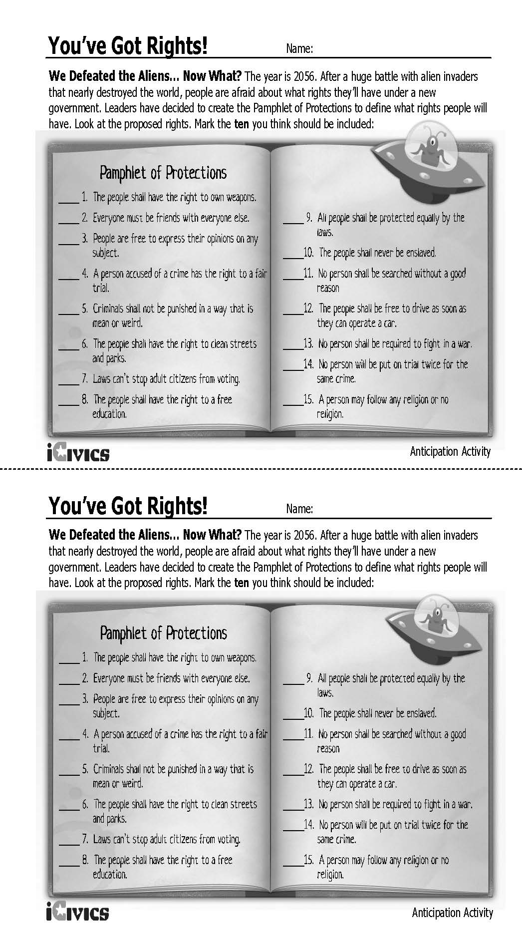

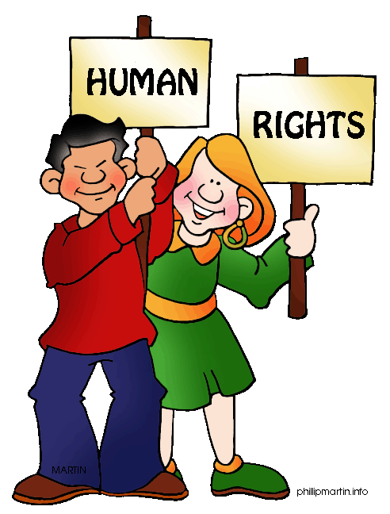**The United States Bill of Rights Guided Notes**

**Amendment I**

Congress shall make no law respecting an establishment of religion, or prohibiting the free exercise thereof; or abridging the freedom of speech, or of the press; or the right of the people peaceably to assemble, and to petition the government for a redress of grievances.

\_\_\_\_\_\_\_\_\_\_\_\_\_\_\_\_\_\_\_\_\_\_\_\_\_\_\_\_\_\_\_\_\_\_\_\_ \_\_\_\_\_\_\_\_\_\_\_\_\_\_\_\_\_\_\_\_\_\_\_\_\_\_\_\_\_\_\_\_\_\_\_\_\_\_\_\_\_

\_\_\_\_\_\_\_\_\_\_\_\_\_\_\_\_\_\_\_\_\_\_\_\_\_\_\_\_\_\_\_\_\_\_ \_\_\_\_\_\_\_\_\_\_\_\_\_\_\_\_\_\_\_\_\_\_\_\_\_\_\_\_\_\_\_\_\_\_\_\_\_\_\_\_\_

\_\_\_\_\_\_\_\_\_\_\_\_\_\_\_\_\_\_\_\_\_\_\_\_\_\_\_\_\_\_\_\_\_\_\_\_

**Amendment II**

A well regulated militia, being necessary to the security of a free state, the right of the people to keep and bear arms, shall not be infringed.

**Amendment III**

No soldier shall, in time of peace be quartered in any house, without the consent of the owner, nor in time of war, but in a manner to be prescribed by law.

\_\_\_\_\_\_\_\_\_\_\_\_\_\_\_\_\_\_\_\_\_\_\_\_\_\_\_\_\_\_\_\_\_\_\_\_\_\_\_\_\_\_\_\_\_\_\_\_\_\_\_\_\_\_\_\_\_\_\_\_\_\_\_\_\_\_\_\_\_\_\_\_\_\_\_\_\_\_\_\_\_\_\_\_\_

**Amendment IV (four)**

The right of the people to be secure in their persons, houses, papers, and effects, against unreasonable searches and seizures, shall not be violated, and no warrants shall issue, but upon probable cause, supported by oath or affirmation, and particularly describing the place to be searched, and the persons or things to be seized.

\_\_\_\_\_\_\_\_\_\_\_\_\_\_\_\_\_\_\_\_\_\_\_\_\_\_\_\_\_\_\_\_\_\_\_\_\_\_\_\_\_\_\_\_\_\_\_\_\_\_\_\_\_\_\_\_\_\_\_\_\_\_\_\_\_\_\_\_\_\_\_\_\_\_\_\_\_\_\_\_\_\_\_\_\_

**Amendment V (five)**

No person shall be held to answer for a capital, or otherwise infamous crime, unless on a presentment or indictment of a grand jury, except in cases arising in the land or naval forces, or in the militia, when in actual service in time of war or public danger; nor shall any person be subject for the same offense to be twice put in jeopardy of life or limb; nor shall be compelled in any criminal case to be a witness against himself, nor be deprived of life, liberty, or property, without due process of law; nor shall private property be taken for public use, without just compensation.

\_\_\_\_\_\_\_\_\_\_\_\_\_\_\_\_\_\_\_\_\_\_\_\_\_\_\_\_\_\_\_\_\_\_\_\_\_\_\_\_\_\_\_\_\_\_\_\_\_\_\_\_\_\_\_\_\_\_\_\_\_\_\_\_\_\_\_\_\_\_\_\_\_\_\_\_\_\_\_\_\_\_\_\_\_

\_\_\_\_\_\_\_\_\_\_\_\_\_\_\_\_\_\_\_\_\_\_\_\_\_\_\_\_\_\_\_\_\_\_\_\_\_\_\_\_\_\_\_\_\_\_\_\_\_\_\_\_\_\_\_\_\_\_\_\_\_\_\_\_\_\_\_\_\_\_\_\_\_\_\_\_\_\_\_\_\_\_\_\_\_

\_\_\_\_\_\_\_\_\_\_\_\_\_\_\_\_\_\_\_\_\_\_\_\_\_\_\_\_\_\_\_\_\_\_\_\_\_\_\_\_\_\_\_\_\_\_\_\_\_\_\_\_\_\_\_\_\_\_\_\_\_\_\_\_\_\_\_\_\_\_\_\_\_\_\_\_\_\_\_\_\_\_\_\_\_

\_\_\_\_\_\_\_\_\_\_\_\_\_\_\_\_\_\_\_\_\_\_\_\_\_\_\_\_\_\_\_\_\_\_\_\_\_\_\_\_\_\_\_\_\_\_\_\_\_\_\_\_\_\_\_\_\_\_\_\_\_\_\_\_\_\_\_\_\_\_\_\_\_\_\_\_\_\_\_\_\_\_\_\_\_

**Amendment VI (six)**

In all criminal prosecutions, the accused shall enjoy the right to a speedy and public trial, by an impartial jury of the state and district wherein the crime shall have been committed, which district shall have been previously ascertained by law, and to be informed of the nature and cause of the accusation; to be confronted with the witnesses against him; to have compulsory process for obtaining witnesses in his favor, and to have the assistance of counsel for his defense.

\_\_\_\_\_\_\_\_\_\_\_\_\_\_\_\_\_\_\_\_\_\_\_\_\_\_\_\_\_\_\_\_\_\_\_\_ \_\_\_\_\_\_\_\_\_\_\_\_\_\_\_\_\_\_\_\_\_\_\_\_\_\_\_\_\_\_\_\_\_\_\_\_\_\_\_\_\_

\_\_\_\_\_\_\_\_\_\_\_\_\_\_\_\_\_\_\_\_\_\_\_\_\_\_\_\_\_\_\_\_\_\_\_\_

**Amendment VII (seven)**

In suits at common law, where the value in controversy shall exceed twenty dollars, the right of trial by jury shall be preserved, and no fact tried by a jury, shall be otherwise reexamined in any court of the United States, than according to the rules of the common law.

\_\_\_\_\_\_\_\_\_\_\_\_\_\_\_\_\_\_\_\_\_\_\_\_\_\_\_\_\_\_\_\_\_\_\_\_\_\_\_\_\_\_\_\_\_\_\_\_\_\_\_\_\_\_\_\_\_\_\_\_\_\_\_\_\_\_\_\_\_\_\_\_\_\_\_\_\_\_\_\_\_\_\_\_\_

**Amendment VIII (eight)**

Excessive bail shall not be required, nor excessive fines imposed, nor cruel and unusual punishments inflicted.

\_\_\_\_\_\_\_\_\_\_\_\_\_\_\_\_\_\_\_\_\_\_\_\_\_\_\_\_\_\_\_\_\_\_\_\_\_\_\_\_\_

\_\_\_\_\_\_\_\_\_\_\_\_\_\_\_\_\_\_\_\_\_\_\_\_\_\_\_\_\_\_\_\_\_\_\_\_\_\_\_\_

**Amendment IX (nine)**

The enumeration in the Constitution, of certain rights, shall not be construed to deny or disparage others retained by the people.

\_\_\_\_\_\_\_\_\_\_\_\_\_\_\_\_\_\_\_\_\_\_\_\_\_\_\_\_\_\_\_\_\_\_\_\_\_\_\_\_\_\_\_\_\_\_\_\_\_\_\_\_\_\_\_\_\_\_\_\_\_\_\_\_\_\_\_\_\_\_\_\_\_\_\_\_\_\_\_\_\_\_\_\_\_

\_\_\_\_\_\_\_\_\_\_\_\_\_\_\_\_\_\_\_\_\_\_\_\_\_\_\_\_\_\_\_\_\_\_\_\_\_\_\_\_\_\_\_\_\_\_\_\_\_\_\_\_\_\_\_\_\_\_\_\_\_\_\_\_\_\_\_\_\_\_\_\_\_\_\_\_\_\_\_\_\_\_\_\_\_

**Amendment X (ten)**

The powers not delegated to the United States by the Constitution, nor prohibited by it to the states, are reserved to the states respectively, or to the people.

\_\_\_\_\_\_\_\_\_\_\_\_\_\_\_\_\_\_\_\_\_\_\_\_\_\_\_\_\_\_\_\_\_\_\_\_\_\_\_\_\_\_\_\_\_\_\_\_\_\_\_\_\_\_\_\_\_\_\_\_\_\_\_\_\_\_\_\_\_\_\_\_\_\_\_\_\_\_\_\_\_\_\_\_\_

Description: pe02667_Description: j0231793Description: j0233409

***Description: Macintosh HD:Users:vmcvey:Desktop:BOR Foldable .pdf***

**Rights Listed in Amendments**

The Bill of Rights, the first ten amendments to the U.S. Constitution, also lists many individual rights. The Bill of Rights guarantees that the government will not interfere with these rights of the people. These rights can also be referred to as freedoms. For example, you have the right to exercise the religion of your choice and you have the freedom from the government establishing a religion.

|  |  |
| --- | --- |
| 1st Amendment | Freedom of religious exercise; freedom from government establishing religion. Freedom of speech. Freedom to assemble. Freedom to petition the government. Freedom of the press. |
| 2nd Amendment | Right to bear arms for a well regulated militia |
| 3rd Amendment | Freedom from quartering (housing) soldiers |
| 4th Amendment | Freedom from unreasonable searches and seizures. Warrants must only be issued upon probable cause, and shall be specific |
| 5th Amendment | Criminal indictments must be by grand jury. Freedom from double jeopardy. Freedom from testifying against oneself. Right to face accusers. Right to due process. Right of just compensation for takings |
| 6th Amendment | Right to speedy trial. Right to impartial jury. Right to be informed of the charges upon which the accused is held. Right to face accusers. Right to produce witnesses for the accused. Right to legal counsel. |
| 7th Amendment | Right to jury trial in civil cases. Facts found by a jury cannot be reexamined by another court. |
| 8th Amendment | Freedom from excessive bail or fines. Freedom from cruel or unusual punishment |
| 9th Amendment | Individuals have rights in addition to the rights listed in the other amendments and Constitution. The right to privacy is among those identified by the U.S. Supreme Court as being a 9th Amendment right. |
| 10th Amendment | The federal government has only those powers specifically granted by the Constitution, any power not listed is left to the states or the people. |

Over time, other amendments have been added to the U.S. Constitution to reflect additional rights that must be guaranteed to the people.

|  |  |
| --- | --- |
| 13th Amendment | Right to not be a slave. |
| 14th Amendment | Right to citizenship of any person born or naturalized in the United States. Right to equal protection of the national and state laws. Right to be free of any law that abridges the privileges or immunities of a citizen. Right to be free of any law that deprives a person of life, liberty, or property without due process. |
| 15th Amendment | Right to vote extended to racial and ethnic minorities. |
| 17th Amendment | Right to vote for Senators. |
| 19th Amendment | Right to vote extended to women. |
| 23rd Amendment | Right to vote for presidential electors if a resident of Washington, D.C. |
| 24th Amendment | Right to vote without a poll tax. |
| 26th Amendment | Right to vote guaranteed for any citizen at least 18 years old. |

**Blogging the Bill of Rights**

|  |  |
| --- | --- |
| **IMAGE**  (Draw your picture to represent that you are the owner of this blog) | **Scenario**  Write the scenario provided to you by your teacher. |
| **IMAGE**  (Draw your picture to represent your blog) | **ROUND 1**  **Rights Violated**  In this box write which right was violated and your opinion. |
| **IMAGE**  (Draw your picture to represent your blog) | **ROUND 2**  **Amendment Protected**  In this box write which amendment protects this right and your opinion. |
| **IMAGE**  (Draw your picture to represent your blog) | **ROUND 3**  **Example**  In this box write about a similar situation in which this right can be violated. |
| **IMAGE**  (Draw your picture to represent your blog) | **ROUND 4**  **Argument**  In this box write how you disagree with the right mentioned above and how it was not violated. Give another right that has been violated in this scenario. |
| **IMAGE**  (Draw your picture to represent your blog) | **ROUND 5**  **Correction**  In this box correct the argument in the box above, explain how the right was violated and your opinion about the scenario. |

|  |
| --- |
| **Scenario 1**  To protest the policies of President Ronald Reagan and some businesses in Dallas, Texas, Gregory Lee Johnson soaked an American flag with gasoline and set it on fire during the Republican National Convention in Texas in 1989. No one was hurt, but some witnesses said they were seriously offended, and Johnson was arrested and charged with breaking the law. |
| **Scenario 2**  In 1961, a California law made it a crime for a person to be addicted to drugs and required that they serve a minimum sentence of 90 days in jail if they are charged with the crime. Lawrence Robinson was convicted under the law and sentenced to at least 90 days in jail. Robinson claimed that the 90 day jail sentence was cruel and unusual punishment. |
| **Scenario 3**  William Malloy was arrested for gambling in 1959 by the Hartford, Connecticut police. After pleading guilty, he was sentenced to one year in jail and fined $500. After 90 days, he was let out of jail and placed on two years probation. Sixteen months later, a Connecticut Superior Court ordered Malloy to testify about gambling and other criminal activities in Hartford County. When Malloy refused, on the grounds that it might incriminate him on other charges, he was put in jail and held there until he was willing to answer questions. |
| **Scenario 4**  A man named Parker was arrested and put on trial for second degree murder in Oregon in 1966. During the trial, the bailiff who was assigned to watch over the jury, made statements about Parker to some of the jurors. Some jurors overheard him say: “Oh, that wicked fellow, he is guilty," and to another juror, "If there is anything wrong [in finding him guilty] the Supreme Court will correct it." Parker was found guilty of murder by ten votes of a 12 person jury. Parker argued that the bailiff’s comments prevented him from a fair trial. |
| **Scenario 5**  In 2007, the District of Columbia (Washington, D.C.) passed legislation banning the registration of handguns, requiring licenses for all pistols, and requiring that all legal firearms be kept unloaded and disassembled or trigger locked. A security guard named Dick Anthony Heller sued the District of Columbia claiming that this law violated his rights. |

Applying the Bill of Rights

Directions: For each scenario, write a complete sentence explaining which right has been violated in the scenario, then name the constitutional amendment that protects the right.

1. Juanita lives near a factory that puts foul-smelling smoke in the air. Juanita and her neighbors call a meeting at Juanita’s house to discuss what they can do about the smoke. However, the police block the entrance to the home and tell people that they do not have the right to hold a meeting.

Right violated:

\_\_\_\_\_\_\_\_\_\_\_\_\_\_\_\_\_\_\_\_\_\_\_\_\_\_\_\_\_\_\_\_\_\_\_\_\_\_\_\_\_\_\_\_\_\_\_\_\_\_\_\_\_\_\_\_\_\_\_\_\_\_\_\_\_\_\_\_\_\_\_\_\_\_\_\_\_\_\_\_\_

Amendment that protects the right:

\_\_\_\_\_\_\_\_\_\_\_\_\_\_\_\_\_\_\_\_\_\_\_\_\_\_\_\_\_\_\_\_\_\_\_\_\_\_\_\_\_\_\_\_\_\_\_\_\_\_\_\_\_\_\_\_\_\_\_\_\_\_\_\_\_\_\_\_\_\_\_\_\_\_\_\_\_\_\_\_\_

1. The government lacked money to support the nation’s military forces. To save money, General Pulp ordered that troops be placed in the homes of people living close to military bases. Midge lived next to an army base, and two soldiers moved into her house, even though she did not want them there.

Right violated:

\_\_\_\_\_\_\_\_\_\_\_\_\_\_\_\_\_\_\_\_\_\_\_\_\_\_\_\_\_\_\_\_\_\_\_\_\_\_\_\_\_\_\_\_\_\_\_\_\_\_\_\_\_\_\_\_\_\_\_\_\_\_\_\_\_\_\_\_\_\_\_\_\_\_\_\_\_\_\_

Amendment that protects the right:

1. Brendan is accused of armed robbery and given a trial. The jury finds Brendan not guilty. The next day the prosecutor decides that the verdict was not correct, and he orders Brendan arrested and tried for the crime again.

Right violated:

\_\_\_\_\_\_\_\_\_\_\_\_\_\_\_\_\_\_\_\_\_\_\_\_\_\_\_\_\_\_\_\_\_\_\_\_\_\_\_\_\_\_\_\_\_\_\_\_\_\_\_\_\_\_\_\_\_\_\_\_\_\_\_\_\_\_\_\_\_\_\_\_\_\_\_\_\_\_\_\_\_

Amendment that protects the right:

\_\_\_\_\_\_\_\_\_\_\_\_\_\_\_\_\_\_\_\_\_\_\_\_\_\_\_\_\_\_\_\_\_\_\_\_\_\_\_\_\_\_\_\_\_\_\_\_\_\_\_\_\_\_\_\_\_\_\_\_\_\_\_\_\_\_\_\_\_\_\_\_\_\_\_\_\_\_\_\_\_

1. Mike is in his house watching television when two police officers knock at the door. They accuse Mike of having stolen property, enter the house, and take several things that they say do not belong to Mike. When he asks if the police officers have permission to take his things, they just laugh and leave with the property.

Right violated:

\_\_\_\_\_\_\_\_\_\_\_\_\_\_\_\_\_\_\_\_\_\_\_\_\_\_\_\_\_\_\_\_\_\_\_\_\_\_\_\_\_\_\_\_\_\_\_\_\_\_\_\_\_\_\_\_\_\_\_\_\_\_\_\_\_\_\_\_\_\_\_\_\_\_\_\_\_\_\_\_\_

Amendment that protects the right:

\_\_\_\_\_\_\_\_\_\_\_\_\_\_\_\_\_\_\_\_\_\_\_\_\_\_\_\_\_\_\_\_\_\_\_\_\_\_\_\_\_\_\_\_\_\_\_\_\_\_\_\_\_\_\_\_\_\_\_\_\_\_\_\_\_\_\_\_\_\_\_\_\_\_



***Sources***

You’ve Got Rights! from iCivics: <https://www.icivics.org/teachers/lesson-plans/youve-got-rights?referer=node/674&page_title=The%20Constitution>

The United States Bill of Rights Guided Note, Bill of Rights Foldable and Blogging the Bill of Rights Activity adapted from Jennifer Adkison, Orange County Public Schools

Why the First Amendment is Important video from Constituting America: <https://www.youtube.com/watch?v=ySlSsDkAUC4>  
Blogging the Bill of Rights Scenarios: <http://caselaw.lp.findlaw.com/scripts/getcase.pl?navby=case&court=us&vol=385&invol=363>, <https://www.quimbee.com/cases/parker-v-gladden>, [www.oyez.org](http://www.oyez.org), [www.landmarkcases.org](http://www.landmarkcases.org)

Bill of Rights Institute: Being An American Lesson Resources: <http://billofrightsinstitute.org/wp-content/uploads/2013/02/BAA-Bill-of-Rights-Updated.pdf>

**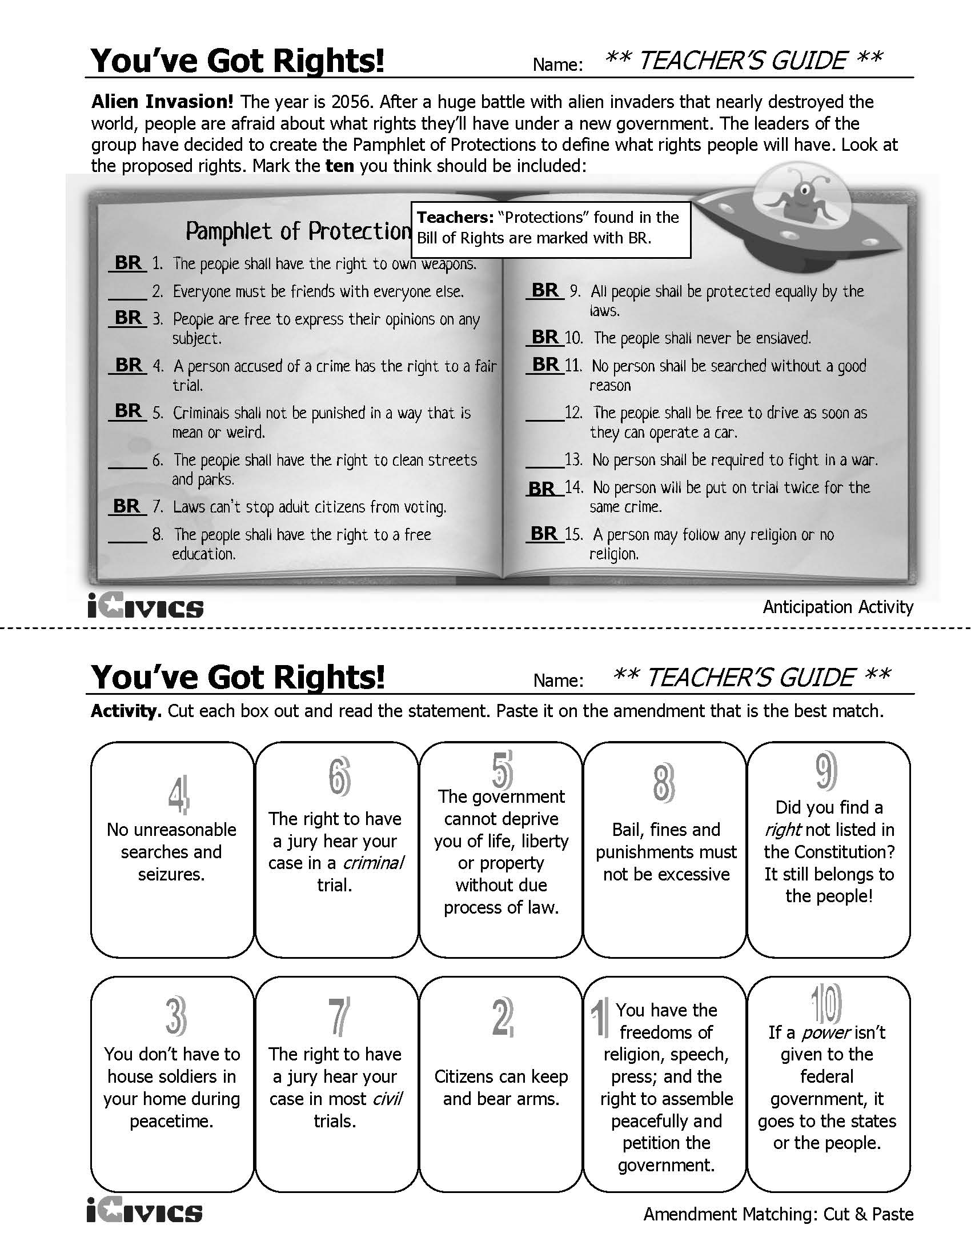**

**The United States Bill of Rights Guided Notes – Sample Answers**

**Amendment I**

Congress shall make no law respecting an establishment of religion, or prohibiting the free exercise thereof; or abridging the freedom of speech, or of the press; or the right of the people peaceably to assemble, and to petition the government for a redress of grievances.

FREEDOM OF RELIGION\_\_\_\_\_\_\_\_\_\_\_\_\_\_ FREEDOM OF SPEECH\_\_\_\_\_\_\_\_\_\_\_\_\_\_\_\_\_

FREEDOM OF ASSEMBLY\_\_\_\_\_\_\_\_\_\_\_\_ RIGHT TO PETITION\_\_\_\_\_\_\_\_\_\_\_\_\_\_\_\_\_\_\_\_\_\_\_\_

FREEDOM OF THE PRESS\_\_\_\_\_\_\_\_\_\_\_\_\_\_\_\_\_\_\_\_\_

**Amendment II**

A well regulated militia, being necessary to the security of a free state, the right of the people to keep and bear arms, shall not be infringed.

THE RIGHT TO BEAR ARMS FOR A WELL REGULATED MILITIA

**Amendment III**

No soldier shall, in time of peace be quartered in any house, without the consent of the owner, nor in time of war, but in a manner to be prescribed by law.

THE RIGHT FOR CITIZENS NOT TO QUARTER (HOUSE) SOLDIERS

**Amendment IV (four)**

The right of the people to be secure in their persons, houses, papers, and effects, against unreasonable searches and seizures, shall not be violated, and no warrants shall issue, but upon probable cause, supported by oath or affirmation, and particularly describing the place to be searched, and the persons or things to be seized.

Protects citizens against unreasonable searches and seizures (capture of items)

A POLICE OFFICER MUST HAVE A warrant given to him by a judge and Probable cause is also needed

**Amendment V (five)**

No person shall be held to answer for a capital, or otherwise infamous crime, unless on a presentment or indictment of a grand jury, except in cases arising in the land or naval forces, or in the militia, when in actual service in time of war or public danger; nor shall any person be subject for the same offense to be twice put in jeopardy of life or limb; nor shall be compelled in any criminal case to be a witness against himself, nor be deprived of life, liberty, or property, without due process of law; nor shall private property be taken for public use, without just compensation.

YOU DO NOT HAVE TO TESTIFY AGAINST YOURSELF – THIS IS ALSO KNOWN AS PLEADING THE FIFTH

You must have *due process* of law *(*day in court*)* before you are convicted

The government cannot take your land unless it pROVIDES JUST COMPENSATION, ThE ACT OF GOVERNMENT TAKING LAND is known as Eminent Domain

You cannot be tried for the same crime twice—called “Double Jeopardy”

**Amendment VI (six)**

In all criminal prosecutions, the accused shall enjoy the right to a speedy and public trial, by an impartial jury of the state and district wherein the crime shall have been committed, which district shall have been previously ascertained by law, and to be informed of the nature and cause of the accusation; to be confronted with the witnesses against him; to have compulsory process for obtaining witnesses in his favor, and to have the assistance of counsel for his defense.

Right to speedy trial by a jury ; jurors are selected for their lack of bias (impartial)

You must be told of charges

You must be provided a lawyer if you cannot afford one, THIS IS KNOWN AS HAVING THE RIGHT TO LEGAL COUNSEL

**Amendment VII (seven)**

In suits at common law, where the value in controversy shall exceed twenty dollars, the right of trial by jury shall be preserved, and no fact tried by a jury, shall be otherwise reexamined in any court of the United States, than according to the rules of the common law.

You have the right to sue someone in court, AND HAVE A TRIAL BY jury, when the value in the argument is more than $20

**Amendment VIII (eight)**

Excessive bail shall not be required, nor excessive fines imposed, nor cruel and unusual punishments inflicted.

No excessive bail

No cruel and unusual punishment

**Amendment IX (nine)**

The enumeration in the Constitution, of certain rights, shall not be construed to deny or disparage others retained by the people.

THIS DEALS WITH UNENUMERATED RIGHTS AND THE FACT THAT The first 8 amendments to the Constitution are not the only rights that the people have, .

**Amendment X (ten)**

The powers not delegated to the United States by the Constitution, nor prohibited by it to the states, are reserved to the states respectively, or to the people.

Powers not in the Constitution, or forbidden, are given to the states or the people.

Description: pe02667_

Description: j0233409Description: j0231793

Blogging the Bill of Rights – Scenarios – Sample Answers

|  |
| --- |
| **Scenario 1**  In a political demonstration during the Republican National Convention in Texas in 1989, protesting the policies of President Ronald Reagan and of certain businesses based in Dallas, Texas, Gregory Lee Johnson soaked an American flag with gasoline and set it on fire. No one was hurt, but some witnesses said they were seriously offended, and Johnson was arrested and charged with breaking the law.  **Texas v. Johnson, 1st Amendment (Freedom of Speech) – the U.S. Supreme Court determined that flag burning was protected speech under the 1st Amendment.** |
| **Scenario 2**  In 1961, a California law made it a crime for a person to be addicted to drugs and required a minimum sentence of 90 days in jail if a person is charged with the crime. Lawrence Robinson was convicted under the law and sentenced to at least 90 days in jail. Robinson claimed that the 90 day jail sentence was cruel and unusual punishment.  **Robinson v. California, 8th Amendment – The U.S. Supreme Court determined that a 90 day jail sentence for drug addiction was “cruel and unusual punishment.”** |
| **Scenario 3**  William Malloy was arrested for gambling in 1959 by the Hartford, Connecticut police. After pleading guilty, he was sentenced to one year in jail and fined $500, but the sentence was suspended after 90 days and Malloy was placed on two years probation. Sixteen months later, a Connecticut Superior Court ordered Malloy to testify about gambling and other criminal activities in Hartford County. When Malloy refused, on the grounds that it might incriminate him on other charges, he was put in jail and held until willing to answer questions.  **Malloy v. Hogan, Fifth Amendment – the court sided with Malloy.** |
| **Scenario 4**  A man named Parker was arrested and put on trial for second degree murder in Oregon in 1966. During the trial, the bailiff who was assigned to watch over the jury, made statements about Parker to some of the jurors. Some jurors overheard him say: “Oh, that wicked fellow, he is guilty," and to another juror, "If there is anything wrong [in finding him guilty] the Supreme Court will correct it." Parker was found guilty of murder by ten votes of a 12 person jury. Parker argued that the bailiff’s comments prevented him from a fair trial.  **Gladden v. Parker, 6th Amendment - the U.S. Supreme Court determined that the bailiff’s comments did prevent Parker from receiving a fair trial.** |
| **Scenario 5**  In 2007, the District of Columbia (Washington, D.C.) passed legislation banning the registration of handguns, requiring licenses for all pistols, and requiring that all legal firearms be kept unloaded and disassembled or trigger locked. A security guard named Dick Anthony Heller sued the District of Columbia claiming that this law violated his rights.  **District of Columbia v. Heller, 2nd Amendment, and The U.S. Supreme Court determined that the D.C. law violated the 2nd Amendment.** |

APPLYING THE BILL OF RIGHTS – Sample Answers

1. Juanita lives near a factory that puts foul-smelling smoke in the air. Juanita and her neighbors call a meeting at Juanita’s house to discuss what they can do about the smoke. However, the police block the entrance to the home and tell people that they have not right to hold a meeting.

Right violated: \_\_Right to assembly\_\_\_\_\_\_\_\_\_\_\_\_\_\_\_\_\_\_\_\_\_\_\_\_\_\_\_\_\_\_\_\_\_\_\_\_\_\_\_\_\_\_

Amendment that protects the right: \_\_1st Amendment\_\_\_\_\_\_\_\_\_\_\_\_\_\_\_\_\_\_\_\_\_\_\_\_\_\_\_\_\_

1. The government lacked money to support the nation’s military forces. To save money, General Pulp ordered that troops be placed in the homes of people living close to military bases. Midge lived next to an army base, and two soldiers moved into her house, even though she did not want them there.

Right violated: \_\_\_\_No Quartering of Soldiers\_\_\_\_\_\_\_\_\_\_\_\_\_\_\_\_\_\_\_\_\_\_\_\_\_\_\_\_\_\_\_\_\_

Amendment that protects the right: \_\_\_3rd Amendment\_\_\_\_\_\_\_\_\_\_\_\_\_\_\_\_\_\_\_\_\_\_\_\_\_\_\_

1. Brendan is accused of armed robbery and given a trial. The jury finds Brendan innocent. The next day the prosecutor decides that the verdict was not correct, and he orders Brendan arrested and tried for the crime again.

Right violated: \_\_Double Jeopardy\_\_\_\_\_\_\_\_\_\_\_\_\_\_\_\_\_\_\_\_\_\_\_\_\_\_\_\_\_\_\_\_\_\_\_\_\_\_\_\_\_\_\_

Amendment that protects the right: \_\_\_5th Amendment\_\_\_\_\_\_\_\_\_\_\_\_\_\_\_\_\_\_\_\_\_\_\_\_\_\_\_\_

1. Mike is in his house watching television when two policemen knock at the door. They accuse Mike of having stolen property, enter the house, and take several things that they say do not belong to Mike. When he asks if the policemen have permission to take his things, they just laugh and leave with the property.

Right violated: \_\_\_Unreasonable Search and Seizure\_\_\_\_\_\_\_\_\_\_\_\_\_\_\_\_\_\_\_\_\_\_\_\_\_\_

Amendment that protects the right: \_\_\_\_\_4th Amendment\_\_\_\_\_\_\_\_\_\_\_\_\_\_\_\_\_\_\_\_\_\_\_\_

***Civics Content Vocabulary***

|  |  |  |
| --- | --- | --- |
| **Word/Term** | **Part of Speech** | **Definition** |
| **Bill of Rights** | proper noun | the first ten amendments of the U.S. Constitution |
| **cruel and unusual punishment** | phrase | punishment prohibited by the Eighth Amendment to the U.S. Constitution; includes torture or other forms of punishment too severe for the crime committed |
| **double jeopardy** | phrase | the prosecution of a defendant for a criminal offense for which he has already been tried; prohibited in the Fifth Amendment to the U. S. Constitution |
| **due process** | phrase | the right of people accused of crimes to have laws that treat them fairly, so that they cannot lose their life or freedom without having their legal rights protected |
| **eminent domain** | phrase | the right of the government to take private property for public use; the Fifth Amendment requires that people be paid fairly (compensated) for their property if it is taken by the government |
| **equal protection under the law** | phrase | a guarantee under the 14th Amendment that a state must treat a citizen or class of citizens the same as it treats other citizens or classes in like circumstances |
| **First Amendment** | proper noun | an amendment to the U.S. Constitution prohibiting Congress from establishing a religion, and from interfering with freedom of religious exercise, press, speech, assembly, or petition |
| **pleading the fifth** | phrase | the right of a person to refuse to testify under oath in a court of law on the grounds that the answers could be used as evidence against him to convict him of a criminal offense |
| **right to bear arms** | phrase | the idea in the Second Amendment that people have an individual right to own and carry weapons |
| **right to legal counsel** | phrase | the right of a defendant to be assisted by an attorney, and if he cannot afford his own lawyer, the government must appoint one for him; established in the Sixth Amendment |
| **search and seizure** | phrase | the process by which police or other authorities who suspect that a crime has been committed do a search of a person's property and collect evidence related to the crime; protection from illegal search and seizure is in the Fourth Amendment |
| **suffrage** | noun | the right to vote; protected in the 15th, 19th, 24th and 26th Amendments |
| **trial by jury** | phrase | a trial in which the issue is determined by a judge and a jury, usually with 12 members, whose job is to determine facts and make a judgment of guilty or not guilty; protected in the Sixth Amendment |
| **unenumerated rights** | phrase | according to the Ninth Amendment, any right that is not specifically addressed in the Constitution still may be protected (e.g., privacy) |

***Essential Teacher Content Background Information***

|  |
| --- |
| **This section addresses the following issues:**   1. The U.S. Bill of Rights: Substance, Background and Ratification 2. Extension of the Bill of Rights to the States 3. The Florida Declaration of Rights: Substance, Background and Ratification |

**1. The U.S. Bill of Rights: Substance, Background and Ratification**

The “Bill of Rights” is the first ten amendments of the U.S. Constitution; the Bill of Rights was ratified in 1791. It was intended to protect the people from the federal government abusing its power, specifically as to the rights of political and religious expression, the rights and protections accorded individuals accused of crimes, private property protection, and the rights of the people as they relate to federal and state laws. The Bill of Rights also includes rights related to gun ownership and the housing (quartering) of soldiers.

While the Bill of Rights was not included in the original U.S. Constitution, the notion that the federal government would abuse its powers relative to the people was very much a part of the constitutional debate. The Anti-Federalists, who advocated states ’ rights and decentralized government, strongly opposed the federal, shared powers arrangement advocated by the Federalists reflected in the U.S. Constitution. The Anti-Federalists feared that the failure of the Federalists to include rights that would protect the people from the federal government would result in that government abusing its newly acquired power. The Anti-Federalists suggested a compromise position where, once the Constitution was ratified, a series of amendments enumerating specific protections would be considered by the new Congress.

The first word of the Bill of Rights, “Congress”, speaks to the focus of the Bill of Rights on the federal government. Under the Bill of Rights, citizens are guaranteed the right to free speech, free press, free religious exercise, assembly, and the right to petition the government. Citizens are also guaranteed that Congress will not establish a religion, which is a right related to, though different from, free religious exercise. The Bill of Rights also protects those accused of a crime in that they are entitled to due process of law, and are protected from incriminating themselves, “cruel and unusual” punishment, unreasonable search and seizure and being tried twice for committing the same crime. The concept of “due process” also includes the right to legal representation in criminal trials, the right to face one’s accuser, and the right to trial by jury. The Bill of Rights also protects property rights in that citizens may not be forced to house military personnel during peacetime and only during wartime by an Act of Congress, and that citizens’ property may only be taken with “just compensation”.

The Ninth Amendment recognizes that the Bill of Rights does not include all rights that are protected by the Bill of Rights. The Ninth Amendment states that rights that are not otherwise listed (enumerated) remain extended to the people. Rights not listed in the first eight amendments that have been recognized by the U.S. Supreme Court as Ninth Amendment rights include the right to privacy and the right to have children.

Other rights that have been extended to citizens linked to political expression include the right to vote (suffrage). These rights are enumerated in the 14th, 15th, 19th and 26th amendments as they extend to specific populations, as well as other voting rights related to election procedures (24th Amendment). *For more information related to the 14th, 15th, 19th, 24th, and 26th amendments, see the lesson for SS.7.C.3.7 – Analyze the impact of the 13th, 14th, 15th, 19th, 24th, and 26th amendments on participation of minority groups in the American political process.*

**2. Extension of the Bill of Rights to the States**

The Bill of Rights has been subject to extensive interpretation by the U.S. Supreme Court. Many argue that the most notable interpretation occurred when the Court decided, in Gitlow v. New York (1925), that the 14th amendment could serve as a tool for applying the Bill of Rights to state law. The 14th amendment includes “No State shall make or enforce any law which shall abridge the privileges or immunities of citizens of the United States; nor shall any State deprive any person of life, liberty, or property, without due process of law; nor deny to any person within its jurisdiction the equal protection of the laws.” The Gitlow case extended the “equal protection” and “due process” clauses of the Bill of Rights to the states on a selective basis. Because states may not deny U.S. citizens their due process and equal protection rights under the 14th amendment, U.S. citizens are protected when state laws deny them their rights under the federal Bill of Rights.

The process where the U.S. Supreme Court interprets state laws according to the protections established in the Bill of Rights is called “selective incorporation”—the court “selects” cases dealing with specific laws that, if found to violate the federal Bill of Rights, are “incorporated” into the Bill of Rights. This holds true even though the Bill of Rights was intended to protect citizens from the federal government and not the state governments.

Below is a table of key cases where state laws have been found to violate the Bill of Rights:

|  |  |  |  |
| --- | --- | --- | --- |
| **Case** | **Year** | **Provision** | **Amendment** |
| Gitlow v. New York | 1925 | Freedom of Speech | First |
| Near v. Minnesota | 1931 | Freedom of the Press | First |
| Powell v. Alabama | 1932 | Right to counsel in capital cases | Sixth |
| De Jonge v. Oregon | 1937 | Freedom of assembly; Right to petition | First |
| Cantwell v. Connecticut | 1940 | Free exercise of religion | First |
| Everson v. Board of Education | 1947 | No establishment of religion | First |
| In re Oliver | 1948 | Right to public trial | Sixth |
| Wolf v. Colorado | 1949 | Rights against unreasonable search and seizure | Fourth |
| Mapp v. Ohio | 1961 | Exclusionary rule | Fourth (and Fifth) |
| Robinson v. California | 1962 | Right against cruel and unusual punishment | Eighth |
| Gideon v. Wainwright | 1963 | Right to counsel in felony cases | Sixth |
| Malloy v. Hogan | 1964 | Right against self-incrimination | Fifth |
| Pointer v. Texas | 1965 | Right to confront witnesses | Sixth |
| Griswold v. Connecticut | 1965 | Privacy | First, Third, Fourth, Fifth, Sixth, Ninth |
| Miranda v. Arizona | 1966 | Protection from self-incrimination | Fifth |
| Parker v. Gladden | 1966 | Right to impartial jury | Sixth |
| In re Gault | 1966 | Right to due process | Fourteenth |
| Klopfer v. North Carolina | 1967 | Right to speedy trial | Sixth |
| Washington v. Texas | 1967 | Right to compulsory process | Sixth |
| Duncan v. Louisiana | 1968 | Right to jury trial in cases involving serious crime | Sixth |
| Benton v. Maryland | 1969 | Right against double jeopardy | Fifth |
| Tinker v. Des Moines | 1969 | Right to symbolic political expression | First |
| Argersinger v. Hamlin | 1972 | Right to counsel in any criminal case with potential sentence of incarceration | Sixth |
| Hazelwood v. Kuhlmeier | 1988 | Freedom of the press | First |
| District of Columbia v. Heller | 2007 | Gun ownership/gun control | Second |

**3. The Florida Declaration of Rights: Substance, Background and Ratification**

The Florida Declaration of Rights was added to Florida’s original 1833 Constitution in 1865. The current Declaration of Rights was included in Florida’s current constitution, which was ratified in 1968. Since Florida’s current constitution was put into place, the Declaration of Rights has been amended several times, most recently in 2004. The Florida Declaration of Rights is Article I, the first section of the current Florida Constitution. Many of the rights enumerated in the Florida Declaration of Rights are the same as, or similar to, the rights enumerated in the U.S. Bill of Rights. Recent additions to the Florida Declaration of Rights include the right to privacy (1998), access to public records and public meetings (2002), a taxpayer’s Bill of Rights (1992), and fair compensation for medical liability (2004).