CITIZENSHIP
SS.7.C.2.1 Define the term “citizen,” and identify legal means of becoming a U.S. citizen.

TABLE OF CONTENTS

Lesson Summary 2
Suggested Student Activity Sequence 3
Student Activity Sheets & Reading Materials 6
Sources 10
Answer Keys 11
Civics Content Vocabulary 14
Essential Teacher Content Background Information 15

Lesson Summary
Essential Question
What does it mean to be a citizen? How is citizenship obtained?

NGSSS Benchmark
SS.7.C.2.1 Define the term “citizen,” and identify legal means of becoming a U.S. citizen.

Florida Standards
LAFS.68.RH.1.2 LAFS.68.RH.1.3 LAFS.68.RH.3.7 LAFS.68.WHST.1.2
LAFS.68.WHST.2.4 LAFS.68.WHST.4.10 LAFS.7.SL.1.1 LAFS.7.SL.1.2

Overview
In this lesson, students will understand the legal means of becoming a U.S. citizen.

Learning Goals/Benchmark Clarifications
- Students will define citizenship as stated in the Fourteenth Amendment.
- Students will describe the process of becoming a naturalized citizen.
- Students will evaluate the impact of the naturalization process on society, government, or the political process

Benchmark Content Limits
- Items will not require students to list the steps of the naturalization process.

Civics EOC Reporting Category
Reporting Category 2 – Roles, Rights, and Responsibilities of Citizens

Suggested Time Frame
- Three 45-50 minute class periods

Civics Content Vocabulary
- 14th Amendment, alien, citizen, immigrant, law of blood, law of soil, legal permanent resident, naturalization, resident

Instructional Strategies
Close reading of complex text Inquiry of primary sources

Materials
Computer with projector to display images and activity sheets
Construction paper and markers for all students
Student activity sheets and reading materials:
- Understanding Citizenship
- Citizenship Just the Facts Reading from iCivics: https://www.icivics.org/teachers/lesson-plans/citizenship-just-facts
- Preparing for the Oath

Lesson Activities and Daily Schedule
Please use the chart below to track activity completion.
Day | Task # | Steps in Lesson | Description | Completed?  Yes/No
Day One | Task 1 | 1-6 | Hook Activity
 | Task 2 | 7-14 | 14th Amendment Activity
 | Task 3 | 15-26 | Citizenship: Just the Facts
Day Two | Task 3 | 15-26 | Citizenship: Just the Facts  (continued)
 | Task 4 | 27 | Checking for Understanding A
 | Task 5 | 28-33 | Impact of Naturalization Discussion
Day Three | Task 7 | 34-39 | Oral History Analysis Activity
 | Task 8 | 40 | Checking for Understanding B
Suggested Student Activity Sequence

- To begin this lesson, project the following questions on the board: “What does it mean to be a member of something? How does it feel to be a member of something?”
- Have students brainstorm and write down their answers on the board.
- Explain to students that being a citizen of the United States means, in a way, that they are “members” of this country. Ask the students to think about what it means to be a “member” of the U.S. and how it compares to being a member of something else to which a person can belong.
- Project the following images, one at a time:
Click on each link to view larger versions of each image to display to the class.
https://www.co.portage.wi.us/Home/ShowPublishedImage/1979/636076437190600000 | https://bit.ly/2WwOz73 | http://www.tampabay.com/news/humaninterest/naturalization-ceremony-at-trop-gives-240-new-citizens-reason-to-cheer/2194080
- Pose the following questions for discussion, for each image: “What does the image represent? How do you know? What does this image have to do with U.S. citizenship?”
- Allow students time to share out. Guide students to the understanding that passports are only issued to U.S. citizens (a privilege of citizenship) and must be carried when outside the U.S. to prove one’s American citizenship; that the Statue of Liberty symbolizes U.S. citizenship for Americans and people around the world; and that the third image is from a naturalization ceremony, where legal immigrants officially become U.S. citizens.
- Project the following text from Section 1 of the 14th Amendment and pass out the “Understanding Citizenship” student activity sheet.
All persons born or naturalized in the United States, and subject to the jurisdiction thereof, are citizens of the United States and of the State wherein they reside. No State shall make or enforce any law which shall abridge the privileges or immunities of citizens of the United States; nor shall any State deprive any person of life, liberty, or property, without due process of law; nor deny to any person within its jurisdiction the equal protection of the laws.
- Read the passage aloud to the class. Pause when needed to clarify any terms or to assist with comprehension.
- Read the passage again and instruct students to follow along using their activity sheet and highlight any words that help them define the term “citizen”.
- Have students share out the words they highlighted.
- Project the following simplified explanation of Section 1 of the 14th Amendment from Kids Laws, http://kids.laws.com/14th-amendment (no longer available): The 14th Amendment is a very important amendment that defines what it means to be a U.S. citizen and protects certain rights of the people. The Citizenship Clause gives individuals born in the United States – but especially at that time, African Americans – the right to citizenship. Before the 14th amendment, African Americans could not become citizens, and this limited the rights of those who were able to escape slavery and become free. This clause allows all people born in the United States to be U.S. citizens. Once you have American citizenship, it cannot be taken from you by Congress or other authorities, unless you lie to the government during the process to get U.S. citizenship. Otherwise, everyone who becomes an American citizen stays an American citizen, unless they give it up themselves.
- Read the passage aloud to the class. Pause when needed to clarify any terms or to assist with comprehension.
- Have students read the passage aloud for a second time. Instruct different students to each read a sentence. Instruct students to highlight the words from this passage that helps define the term “citizen”.
- Instruct students to use the words or phrases they highlighted from both passages and then write a definition of citizen in their own words and in complete sentences on their activity sheet.
- Pass out the “Citizenship: Just the Facts” reading from iCivics.
- Instruct students to read the first paragraph independently and write down the three ways of becoming a citizen in the United States on their activity sheet.
- Ask a student to share the three ways.
- Share the following key points and instruct students to take notes on their student activity sheet:
  - Being born in the United States is also known as the “law of soil.”
  - Being born to a mother or father who is a U.S. citizen is also known as the “law of blood.”
  - Going through the naturalization process allows immigrants to become U.S. citizens.
  - An immigrant is a person who comes to a country to live there permanently.
  - There are also people who are considered aliens. Aliens are persons living in the U.S. who are not citizens. Aliens can be in the U.S. for temporary purposes (a job or visiting for a certain period of time) or as a legal permanent resident (someone who is permanently living in the U.S. legally but not a citizen).
- Instruct students to read the second paragraph independently and summarize the naturalization process on their student activity sheet.
- Ask a few students to share their summaries.
- Provide any needed clarification using the key points about the naturalization process below:
- Be 18 years old
- Have already been granted legal permanent residency
- Have continuous residency in the U.S. for five years
- Be of good moral character
- Be able to speak and read basic English
- Demonstrate knowledge of U.S. history and government by passing an exam
- Be faithful to the principles of the U.S. Constitution
- Have a favorable disposition toward the U.S.
- Take the Oath of Allegiance
- Pose the following question to the students: “What does it mean to be a resident?”
- Instruct students to add the definition of resident to their notes.
- Have students look closely at the Oath of Allegiance in the “Citizenship: Just the Facts” reading.
- Read it aloud together, making sure to go over the vocabulary words highlighted in the document.
- Pose the following questions for discussion: “Citing evidence from the text, how would you explain the Oath of Allegiance in your own words? Why do you think the Oath is part of the naturalization process? What are new citizens promising to do by making this pledge?”
- Checking for Understanding A (Formative Assessment)
Instruct students to write a well-crafted informative response the following prompt:
Prompt
Explain the three different ways of becoming a citizen in the United States.
Extension Suggestions: 1. Instruct students to complete the “Citizenship: Just the Facts Worksheet.” 2. Have students create a storyboard illustrating the three ways of becoming a citizen.
- Pose the following questions for discussion and instruct students to take notes on their “Understanding Citizenship” activity sheet: “How would you describe the process of becoming a naturalized citizen? What do you think it means that people choose to go through this process? What do you think is the impact of the naturalization process?”
- Project the “Persons Naturalized by State of Residence: Fiscal Years 2010 to 2012” from the Department of Homeland Security: https://www.dhs.gov/sites/default/files/publications/Naturalizations_2012.pdf. Teacher Note: This table is located at the top of page 3.
- Pose the following questions for discussion: “What information is being presented in this table? How do you know? How would you summarize what you are seeing? Where do naturalized citizens live? What do you notice about Florida? How might states be impacted by naturalized citizens?” (population diversity, more naturalized citizens owning businesses, working in the community, running for office, voting). Instruct students to take notes during this discussion on their “Understanding Citizenship” activity sheet.
- Project the following statistic from ImmigrationPolicy.org: In 2013, 19.9% of registered voters in Florida were “New Americans” (naturalized citizens or U.S. born children of immigrants), https://www.americanimmigrationcouncil.org/research/new-americans-florida.
- Pose the following questions for discussion: “How might this group impact an election? If you were running for office in Florida, would it be important for you to know that 18.8% of the registered voters were “New Americans”? Might it impact the issues you focus on in your campaign?”
- Allow students to brainstorm and share out. Lead students to the understanding that candidates running for office will typically become familiar with the background of the voters where they are seeking office. Due to the fact that almost 20% of the voters in Florida were naturalized or born of immigrant parents in 2008, candidates would most likely focus on issues that new citizens care about in order to gain their vote. For example, a candidate might make immigration policy a focus of their campaign.
- Move students into the media center or provide each group with computer and internet access.
- Pass out the “Preparing for the Oath” student activity sheet, project the Smithsonian’s Preparing for the Oath website and instruct students they will view videos concerning new citizens.
- Assign each group one of the following naturalized citizens: Maria del Carmen Cossu (https://www.youtube.com/watch?v=n_bqv6zDZms), Magdalena Mieri (https://www.youtube.com/watch?v=IwE7dJwWlIc), or Gunter Waibel (https://www.youtube.com/watch?v=d4n5DEdO5Aw&t=17s). Teacher note: If computer access in unavailable for student groups, watch all three videos as a class and then divide the students into small groups.
- Ask students to watch the video oral history of their assigned citizen and answer the questions on the “Preparing for the Oath” student activity sheet.
- Give students paper and markers and instruct each group to draw a picture of the object each person brought to his/her interview.
- Have a spokesperson from each group report out to the class about the person whose oral history they heard. Make sure they answer all of the questions from their activity sheet. Probe student responses if you think they need to elaborate more on what they watched and discussed. Make sure that students display their illustrations of the objects shown in the interviews.
- Checking for Understanding B (Formative Assessment):
Instruct students to write a well-crafted response using the following prompt:

Prompt
The naturalization process has created millions of new American citizens over many decades of this country’s history. What is the impact of the naturalization process on the U.S.?

Understanding Citizenship

14th Amendment, Section 1 | All persons born or naturalized in the United States, and subject to the jurisdiction thereof, are citizens of the United States and of the State wherein they reside. No State shall make or enforce any law which shall abridge [take away] the privileges or immunities of citizens of the United States; nor shall any State deprive any person of life, liberty, or property, without due process of law; nor deny to any person within its jurisdiction the equal protection of the laws.
From Kids Law | The 14th Amendment is a very important amendment that defines what it means to be a U.S. citizen and protects certain rights of the people. The Citizenship Clause gives individuals born in the United States – but especially at that time, African Americans – the right to citizenship. Before the 14th amendment, African Americans could not become citizens, and this limited the rights of those who were able to escape slavery and become free. This clause allows all people born in the United States to be U.S. citizens. Once you have American citizenship, it cannot be taken from you by Congress or other authorities, unless you lie to the government during the process to get U.S. citizenship. Otherwise, everyone who becomes an American citizen stays an American citizen, unless they give it up themselves.
Definition of citizenship
What is a citizen?

Citizenship: Just the Facts
Three Ways of Becoming a Citizen of the United States

Naturalization Process
Using complete sentences, explain the naturalization process.

Impact of the Naturalization Process Discussion
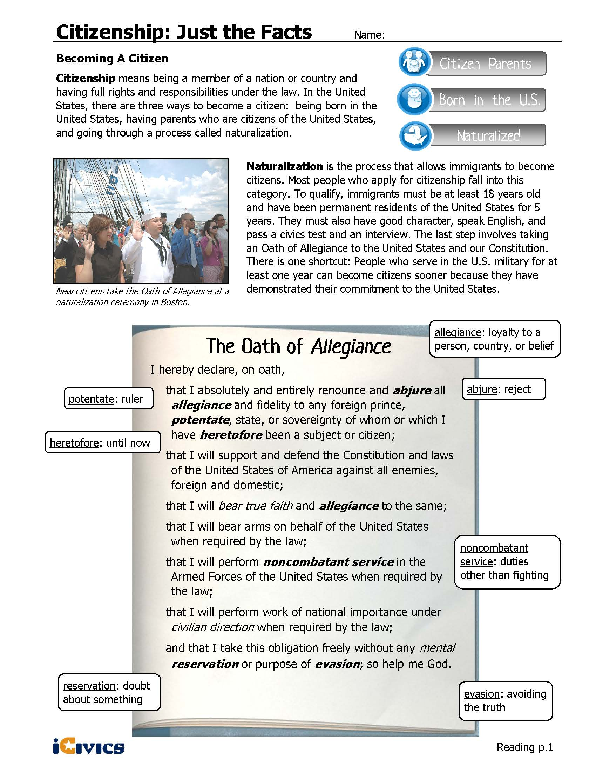
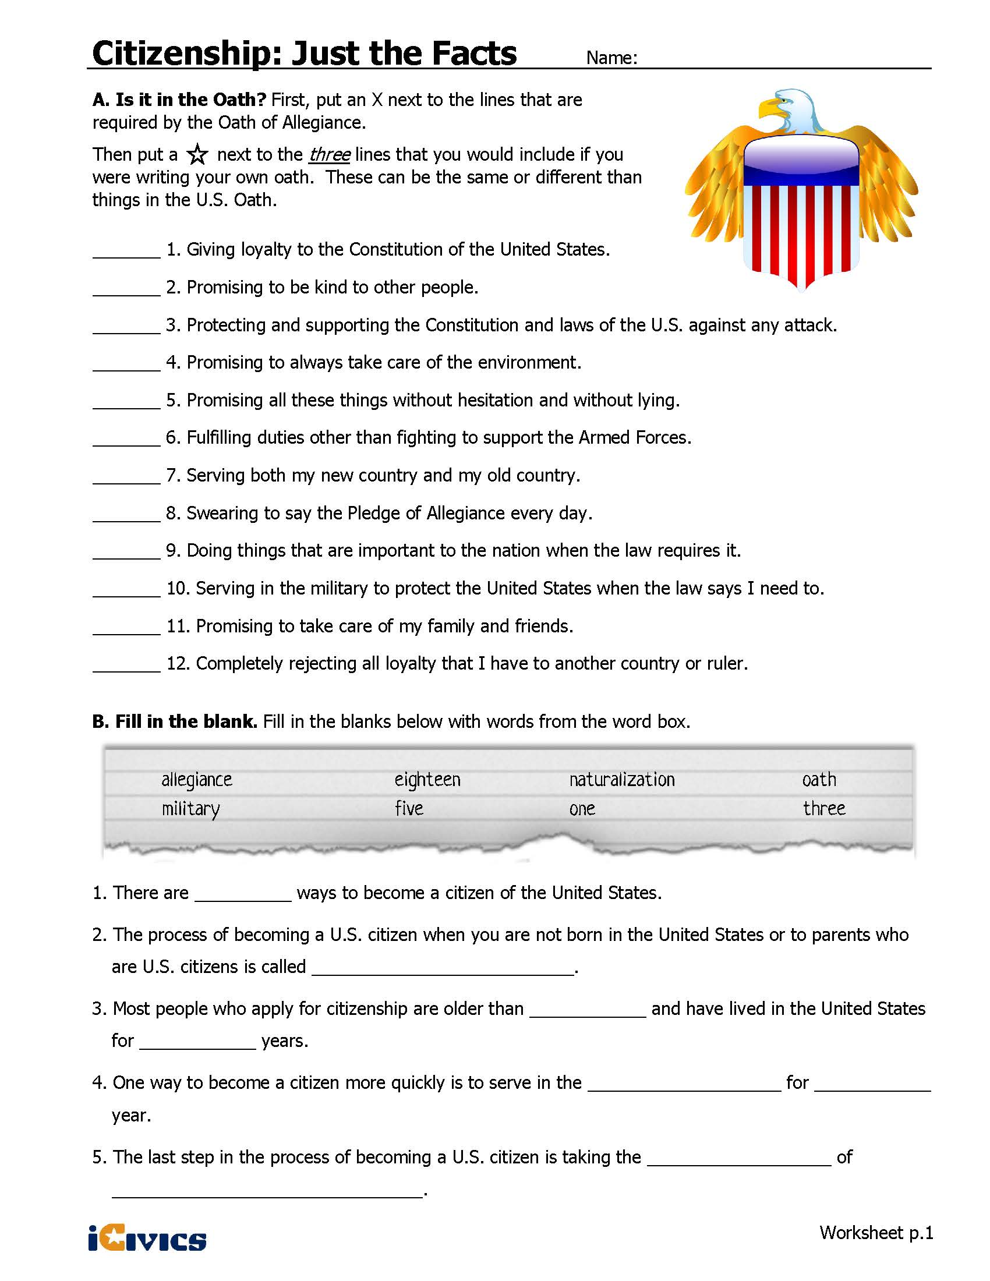

Preparing for the Oath
http://americanhistory.si.edu/citizenship/oralhistories.html
Directions: In your group, watch the oral history for your assigned citizen. While watching, answer the following questions.

1. Who is speaking (also called, “the informant”)?

2. When did the informant come to the U.S.?

3. When did the informant become a naturalized citizen?

4. What procedural steps did the informant complete to get his or her naturalization?

5. Does the informant reveal any emotions about naturalization such as excitement, sadness, or happiness?

6. Why did the informant want to become a naturalized citizen?

7. What object did the informant bring to the interview?

8. Briefly describe the object’s appearance, including size, color, and shape.

9. Why did the informant bring this object?

10. What was the impact of naturalization on the informant?

Sources
Hook Activity Images: Passport - http://0.tqn.com/d/businesstravel/1/0/t/1/-/-/Us-passport.jpg (accessed March 2013), Statue of Liberty - http://statueofliberty.org/Statue_of_Liberty_Picture_05.html (accessed March, 2013), Naturalization Ceremony Image - http://www.tampabay.com/news/humaninterest/naturalization-ceremony-at-trop-gives-240-new-citizens-reason-to-cheer/2194080
Simplified version of the 14th Amendment: 14th Amendment from Kids Laws http://kids.laws.com/14th-amendment, Accessed March, 2013.
Citizenship: Just the Facts from iCivics: https://www.icivics.org/teachers/lesson-plans/citizenship-just-facts
White House Naturalization Ceremony Video: http://www.whitehouse.gov/photos-and-video/video/2012/07/04/president-obama-speaks-naturalization-ceremony
Preparing for the Oath Analysis & Videos: http://americanhistory.si.edu/citizenship/oralhistories.html#MCC.
Persons Naturalized by State of Residence: Fiscal Years 2010 to 2012 from the Department of Homeland Security: http://www.dhs.gov/sites/default/files/publications/ois_natz_fr_2012.pdf
Immigration Policy Center, Florida Statistics:
https://www.americanimmigrationcouncil.org/research/new-americans-florida

Understanding Citizenship – Sample Answers

14th Amendment, Section 1 | All persons born or naturalized in the United States, and subject to the jurisdiction thereof, are citizens of the United States and of the State wherein they reside. No State shall make or enforce any law which shall abridge [take away] the privileges or immunities of citizens of the United States; nor shall any State deprive any person of life, liberty, or property, without due process of law; nor deny to any person within its jurisdiction the equal protection of the laws.
From Kids Law | The 14th Amendment is a very important amendment that defines what it means to be a U.S. citizen and protects certain rights of the people. The Citizenship Clause gives individuals born in the United States – but especially at that time, African Americans – the right to citizenship. Before the 14th amendment, African Americans could not become citizens, and this limited the rights of those who were able to escape slavery and become free. This clause allows all people born in the United States to be U.S. citizens. Once you have American citizenship, it cannot be taken from you by Congress or other authorities, unless you lie to the government during the process to get U.S. citizenship. Otherwise, everyone who becomes an American citizen stays an American citizen, unless they give it up themselves.
Definition of citizen | A citizen is someone who has citizenship, a legal member of a state and/or country. In the U.S. a person is a citizen if they have been born in the U.S. or have gone through the naturalization process.

Citizenship: Just the Facts
Three Ways of Becoming a Citizen of the United States
Law of soil – being born in the United States | Law of blood – being born to a parent who is a U.S. citizen | Going through the naturalization process

Naturalization Process
Using complete sentences, explain the naturalization process.
The naturalization process requires many steps. To go through the process, the applicant must be at least 18 years old, have already been granted legal permanent residency and have been a resident for at least 5 years. The applicant must also be of good character and be able to speak and read English. The applicant must take a civics and history test and take an oath of allegiance.

Impact of the Naturalization Process
Answers will vary.

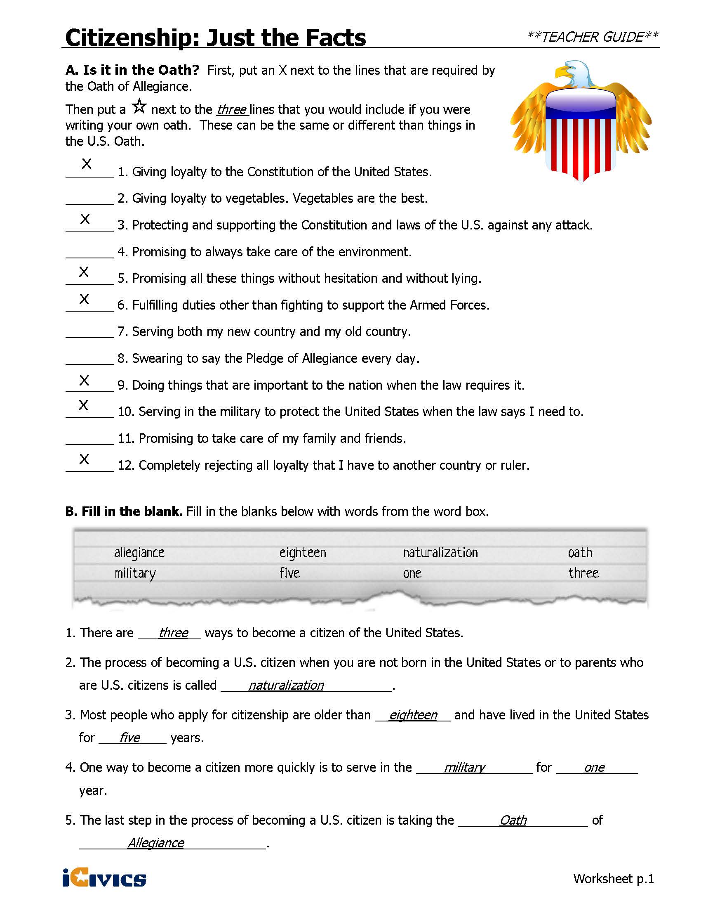

Preparing for the Oath – Sample Answers
Maria del Carmen Cossu – Sample Answers
1. Who is speaking (also called, “the informant”)? Maria del Carmen Cossu
2. When did the informant come to the U.S.? 1987
3. When did the informant become a naturalized citizen? 2008
4. What procedural steps did the informant complete to get his or her naturalization? Paperwork, study for the exam, complete the application, interview with an immigration officer, and attended swearing in.
5. Does the informant reveal any emotions about naturalization such as excitement, sadness, or happiness? It was very emotional. She was excited and proud.
6. Why did the informant want to become a naturalized citizen? She was able to become more involved in government and society.
7. What object did the informant bring to the interview? A portable alter from Peru that travelers used throughout Peru.
8. Briefly describe the object’s appearance, including size, color, and shape. Approximately the size of a shoebox, painted with flowers and leaves.
9. Why did the informant bring this object? The portable alter reminds her of Peru. She keeps it to remind her of her home country now that she is living in the U.S.
10. What was the impact of naturalization on the informant? She was able to vote for the first time in 2010.
Magdalena Mieri – Sample Answers
1. Who is speaking (also called, “the informant”)? Magdalena Mieri
2. When did the informant come to the U.S.? 1992
3. When did the informant become a naturalized citizen? 2004
4. What procedural steps did the informant complete to get his or her naturalization? Filling out paperwork, paying fees, studying for the interview, completing the interview, and attending the ceremony.
5. Does the informant reveal any emotions about naturalization such as excitement, sadness, or happiness? Sadness to give up her home country but excitement to become involved in civic society in the U.S.
6. Why did the informant want to become a naturalized citizen? In order to vote and become involved in civic society.
7. What object did the informant bring to the interview? A pin
8. Briefly describe the object’s appearance, including size, color, and shape. A turquoise and silver flower pin that looks similar to the Argentinian flag.
9. Why did the informant bring this object? The pin represents Argentina and she wore it to her naturalization ceremony. Although she is a U.S. citizen, in her heart she will always be part of Argentina. The pin was made by Navajo Indians. Her first experience in the U.S. was learning about native cultures, so she felt it was a good representation of her home country and her new country.
10. What was the impact of naturalization on the informant? It was an emotional impact. She felt that she is part of the society.
Gunter Waibel – Sample Answers
1. Who is speaking (also called, “the informant”)? Gunter Waibel
2. When did the informant come to the U.S.? When he was 24.
3. When did the informant become a naturalized citizen? Not shared in the video.
4. What procedural steps did the informant complete to get his or her naturalization? There are a lot of steps along the way. You have to be eligible to be naturalized. He had his green card (residency) for five years, completed a background check, completed his interview, took the exam and went to the ceremony.
5. Does the informant reveal any emotions about naturalization such as excitement, sadness, or happiness? It was a moving event (naturalization ceremony). He was emotional about the ceremony.
6. Why did the informant want to become a naturalized citizen? His friends and life were in the U.S. and he wanted to have a personal sense of security. When he found out he was having a child, he wanted to make sure that he didn’t have to leave the country.
7. What object did the informant bring to the interview? U.S. flag socks.
8. Briefly describe the object’s appearance, including size, color, and shape. Men’s socks with white stars with a blue background at the top and red and white stripes on the bottom.
9. Why did the informant bring this object? His wife gave him the socks for the naturalization ceremony. They are a fun memory of celebrating the naturalization ceremony.
10. What was the impact of naturalization on the informant? It makes him look differently at others who have become naturalization. He is appreciative of others who have gone through the process.
Civics Content Vocabulary

Word/Term | Part of Speech | Definition
14th Amendment | proper noun | an amendment to the U.S. Constitution that defines citizenship, grants citizenship to former slaves, and defines voters as males at least 21 years of age
alien | noun | any person not a citizen or national of a country
citizen | noun | a legal member of a state and/or country
immigrant | noun | a person who comes to a country to live there permanently
law of blood | noun | a person's citizenship at birth is the same as that of his or her biological mother or father
law of soil | noun | a person's citizenship at birth is determined by the country where he or she was born
legal permanent resident | noun | someone who is legally and permanently living in the U.S., but not a citizen
naturalization | noun | the process by which an immigrant becomes a citizen
resident | noun | someone who lives in a place for a minimum period of time

Essential Teacher Content Background Information

This section addresses the following issues:

- Definition of citizenship
- Citizenship in the United States
- Becoming a naturalized U.S. citizen
- Exceptions to the naturalization process
- The naturalization examination (see “d” above”)
- The impact of naturalization on society, government and the political process.
- Citizenship and residency in Florida

1. Definition of citizenship

A citizen is one who has specific rights and obligations within a political unit such as being a citizen of a country or a state. All countries have their own definitions and expectations of citizenship, although there are several similarities and differences across countries and types of government. For example, it is common for democracies to grant citizenship to all persons born within their jurisdictions although not all democracies have the same procedures for granting naturalization, nor do all democracies grant the same rights to naturalized citizens.

2. Citizenship in the United States

Citizenship in the United States may be achieved through two methods: citizenship by birth and citizenship by naturalization. Citizenship by birth may be achieved through the “jus sanguine”, which translates to “law of blood” or “jus solis”, which translates to “law of soil”. U.S. citizens who become citizens through “law of blood” are those whose biological parents are U.S. citizens, whether by birth or naturalization. Citizenship by “law of soil” is citizenship based on where one is born. A person born in the U.S. (or a location under U.S. control such as a U.S. military base overseas) is a citizen by “law of soil” even if that child’s biological mother (see footnote #1 for explanation) is not a U.S. citizen.

Both methods for achieving citizenship are mentioned in the 14th Amendment to the U.S. Constitution. The 14th Amendment was ratified in 1868 and is the first time that citizenship is defined in the U.S. Constitution.

The U.S. Constitution as ratified in 1788 mentions citizenship 13 times although it does not define it. For example, the U.S. Constitution limits office holding only to those who are U.S. citizens and requires that the president be a natural born citizen. The original U.S. Constitution fails to define who is a citizen.

Below is an excerpt of Section 1 of the 14th amendment:

“All persons born or naturalized in the United States, and subject to the jurisdiction thereof, are citizens of the United States and of the State wherein they reside.”

“Aliens” are persons living in the U.S. who are not citizens. Non-citizens include resident aliens, who live legally in the U.S., and illegal immigrants.

3. Becoming a naturalized U.S. citizen

A person who is not born a U.S. citizen may become a citizen through the naturalization process. The U.S. Congress has the power to make naturalization laws for the United States.

Immigrants seeking to become naturalized citizens, one must meet the following conditions:
- The person is over 18 years old
- Must have been a resident of the United States for five years, without leaving for more than 30 months combined and for no more than 12 consecutive months throughout the five-year period.
- Must file a petition for naturalization
- Must take an examination that shows that they can read, speak and write English, and demonstrate knowledge of American history and the U.S. Constitution.
- Must be able to prove that they are of good moral character
- Two U.S. citizens must confirm that the citizenship applicant will be a good citizen and will be loyal to the U.S.
Once a-f above has been met, the citizenship applicant must take the following Oath of Allegiance:
"I hereby declare, on oath, that I absolutely and entirely renounce and abjure all allegiance and fidelity to any foreign prince, potentate, state, or sovereignty of whom or which I have heretofore been a subject or citizen; that I will support and defend the Constitution and laws of the United States of America against all enemies, foreign and domestic; that I will bear true faith and allegiance to the same; that I will bear arms on behalf of the United States when required by the law; that I will perform noncombatant service in the Armed Forces of the United States when required by the law; that I will perform work of national importance under civilian direction when required by the law; and that I take this obligation freely without any mental reservation or purpose of evasion; so help me God."

4. Exceptions to the naturalization process

The Child Citizenship Act of 2000 took effect on February 27, 2001. It allows non-U.S. citizen children under 18 who have at least one U.S. citizen parent, and who live in the legal and physical custody of that parent, to be granted automatic naturalized citizenship. The child must reside in the United States, and be a lawful permanent resident, at the time that citizenship is granted.

5. The naturalization examination (see “d” above”)

The Naturalization Examination:
The following materials will help citizen applicants prepare for the U.S. Citizen and Immigration Services Naturalization Civics and History Examination:
Questions may be found at:
http://www.uscis.gov/USCIS/Office%20of%20Citizenship/Citizenship%20Resource%20Center%20Site/Publications/100q.pdf

Examination preparation flash cards may be found at:
http://www.uscis.gov/USCIS/Office%20of%20Citizenship/Citizenship%20Resource%20Center%20Site/Publications/PDFs/M-623_red_slides.pdf

6. The impact of naturalization on society, government and the political process.

The immigration debate has long been central to American politics. Concerns over who should be allowed to legally live in the U.S. without naturalizing (resident aliens), who is eligible to pursue naturalization, and who is at risk for deportation, has shaped conflict between and within political parties, Congress and the president, and between the national and state governments. This debate has also impacted campaigns as voter groups, such as Latinos, often hold immigration views that differ from those held by non-Latinos. Further, Latinos live in the four states with the largest populations, which enhances their political impact through representation in Congress and in the Electoral College, which elects the president.

The immigration debate focuses, in part, on the DREAM Act (“Development, Relief and Education for Alien Minors”) which was introduced in Congress in 2001 and did not pass. The Act targets non-citizen youth on a path to citizenship. Critics suggest that the DREAM Act would bring about meaningful reform for only a few eligible illegal immigrants who fear deportation.

7. Citizenship and residency in Florida

The 14th Amendment’s definition of citizenship includes the following:

1. National citizenship comes before state citizenship
2. Citizens are entitled to rights granted by the national government
3. Citizens are entitled to rights granted by their own state’s government

Citizenship does not exist at the state level; there are no Florida citizens.

There are rights reserved to Florida residents. Residency in Florida is established once a person has lived in Florida for six months. Persons who have established residency in Florida have the right to receive a homestead (residential property tax) exemption on their home provided that they live there at least six months per year, and to receive college scholarships and other financial assistance reserved for Florida residents. Persons who live in Florida, but who have not yet established Florida residency, do have certain rights, such as voting (29 days residency) and securing a driver’s license (no minimum residency). Florida, like all other states, may not grant citizenship to aliens.

