THE RULE OF LAW
SS.7.C.1.9 Define the rule of law and recognize its influence on the development of the American legal, political, and governmental systems.

TABLE OF CONTENTS

Lesson Summary 2
Suggested Student Activity Sequence 4
Student Activity Sheets & Reading Materials 8
Sources 22
Answer Keys 23
Civics Content Vocabulary 30
Essential Teacher Content Background Information 31

Lesson Summary
Essential Questions
What does “rule of law” mean? What is the impact of the “rule of law” on society?

NGSSS Benchmark
SS.7.C.1.9 Define the rule of law and recognize its influence on the development of the American legal, political, and governmental systems.

Florida Standards
LAFS.68.RH.1.2 LAFS.68.RH.3.7 LAFS.68.WHST.1.2 LAFS.68.WHST.4.10
LAFS.7.SL.1.1 LAFS.7.SL.1.2 LAFS.7.SL.2.4 MAFS.K12.MP.1.1

Overview
In this lesson, students will understand the concept of “rule of law” and why we have laws, focusing on the notion that all citizens are subject to the law.

Learning Goals/Benchmark Clarifications
- Students will distinguish between the characteristics of a society that operates under the rule of law and one that does not.
- Students will assess the importance of the rule of law in protecting citizens from arbitrary and abusive uses of government power.
- Students will evaluate the impact of the rule of law on governmental officials and institutions (accountability to the law, fair procedures, decisions based on the law, consistent application, enforcement of the law, and transparency of institutions).

Benchmark Content Limits
- Items will not require students to judge the appropriateness of specific laws.

Civics EOC Reporting Category
Reporting Category 1 – Origins and Purposes of Law and Government

Suggested Time Frame
- Four 45-50 minute class periods

Civics Content Vocabulary
- citizen, law, rule of law

Instructional Strategies
Video as text Guided discussion Role-play Reading complex text

Materials
Computer with internet to project websites, videos, and student activity sheets
Copies of the U.S. Constitution and Bill of Rights: http://constitutioncenter.org/media/files/constitution-full-text.pdf
Art supplies for “Illustrators” role during guided discussion
Student activity sheets and reading materials:
- Video Viewing Guide and Guided Discussion
- Rule of Law activity sheets: Skits 1-6, Did You Get It? Skit Reinforcement, and Rule of Law Graphic Organizer from iCivics: http://www.icivics.org/teachers/lesson-plans/rule-law
- Rule of Law Case Studies

Lesson Activities and Daily Schedule
Please use the chart below to track activity completion.

Day | Task # | Steps in Lesson | Description | Completed?  Yes/No
Day One | Task 1 | 1-6 | Hook Activity
 | Task 2 | 7-10 | Rule of Law Video
 | Task 3 | 11-19 | Video Guided Discussion
Day Two | Task 4 | 20 | Checking for Understanding A
 | Task 5 | 21-30 | Rule of Law Skits
Day Three | Task 5 | 21-30 | Rule of Law Skits  (continued)
 | Task 6 | 31-39 | Rule of Law Graphic Organizer
Day Four | Task 7 | 40-45 | Rule of Law Case Studies
 | Task 8 | 46 | Checking for Understanding B

Suggested Student Activity Sequence

- To begin this lesson, list the following questions on the board: “What is the definition of law? How do laws differ from rules? Who makes laws? (government) Who makes rules? (private parties – e.g., government agencies, schools, parents) Where do laws and rules apply? What are some laws you have encountered today? (traffic laws, consumer laws, environmental laws, mandatory school attendance laws) Why do we have laws? (promote order and stability -- prevent confusion/disorder; protect human rights; promote fairness; promote values; resolve conflicts; represent will of majority; protect rights of minorities; protect environment; govern relations between and among individuals and groups)
- Instruct students to write the questions on their own notebook paper and brainstorm answers for each question independently.
- Have students share out and review the answers as a whole class.
- Show students the following clip from the movie Frost/Nixon depicting the 1977 interview between President Richard Nixon and journalist David Frost: https://www.youtube.com/watch?v=L_0Icc6cmRk.
- Project the following quotations from Presidents John Adams and Richard Nixon:
“a government of laws and not of men.” - John Adams
“When the President does it, it is not illegal.” – Richard Nixon
- Pose the following questions to students and instruct them to write a brief response: “Based on both quotes, how would you summarize John Adams’ and Richard Nixon’s points of view? Are they similar or different?”
- Write the phrase “rule of law” on the board and instruct students to brainstorm and share out what they think this phrase means.
- Explain to students that they will watch a video explaining the concept of “rule of law” in detail.
- Pass out the “Video Viewing Guide and Guided Discussion” student activity sheet and explain to students that they will take notes on the following questions while watching the video:
- According to the video, what does the rule of law mean?
- How does the rule of law protect citizens?
- How does the rule of law impact lawmakers and courts?
- Play the following “The Law Rules” video about the rule of law from the Center for Teaching the Rule of Law: https://www.youtube.com/watch?v=DEFB8WBIw5A. Teacher note: This video was moved from the organization’s homepage to their YouTube page. This is a 11:20 minute video; you can stop the video at the 8:30 mark. The Virginia Bar Association produced this video and although the video references Virginia court cases and examples, the general principles and ideas pertain to the entire country.
- After the video, arrange the desks in a circle. Teacher Note: If your class furniture does not allow for the circle arrangement, divide the room so that half the students are on one side and the other half are on the other side.
- Explain to students that they will complete a guided discussion activity. Explain that in this guided discussion each student will be assigned a role and responsibility. Students will be one of the following:
  - Commentator – In this role, students will use the evidence they gathered from the video to respond to the “Video Viewing Guide” questions.
  - Observer/Recorder – In this role, students will record the responses of the Commentators and make connections between the Commentators’ answers and the real world. They will also prepare answers for any questions that are raised by the Commentators.
  - Illustrators – In this role, students will listen to the responses by the Commentators and create a visual representation of the comments they hear.
- Assign one side of the circle the role of “Commentator.” Assign the other side the role of “Observer/Recorder.” Within the “Observer/Recorder” group, assign a few students the role of “Illustrator” and provide them with markers and paper. Teacher note: Assign yourself the role of “Facilitator.” In this role, your task is to keep time and move students along through the discussion by limiting student responses to 30 seconds.
- Project the guiding questions from the video.
- Instruct all of the students in the Commentators role to respond to one or more of the video guiding questions, one at a time. While the Commentators are responding, the Observers/Recorders need to record the comments they hear on their activity sheet and try to identify connections between their comments and the real world (school, family, personal experience, and/or current events). Instruct the “Illustrators” to create visual representations of the comments they hear. This can be in the form of cartoons, symbols, drawings, etc.
- Explain that a Commentator may “pass” the first time when his or her turn comes to speak, but everyone must comment once before this segment of the activity ends. Explain that Commentators may ask questions, but the Facilitator may not answer them; that is the responsibility of the students assigned to the Observer/Recorder role.
- Instruct the Observers/Recorders to respond to any comments or questions from the Commentator group and to share their connections between the video and the real world. Instruct the “Illustrators” to share their visual representations.
- Guide the discussion by using some of the key points from the video:
- We are a nation of laws ... not a nation of people.
- All citizens are treated fairly and equally under the same set of laws.
- Laws allow people to enjoy a peaceful existence with others.
- U.S. laws are based on the Constitution and protected by the courts.
- No one is above the law ... no one is below the law.
- The “rule of law” is like the rules of the road ... individuals must follow the laws to protect the safety of all.
- The “rule of law” is an agreement that everyone will play by the rules.
- We are governed by rules that are in the best interest of our country ... not in the best interest of us personally.
- In America, we follow the “rule of law.” We do not serve men or women; we serve “the law.”
- Debrief the activity with the students by posing the following question for discussion: “Has your understanding or answers to the video guiding questions changed after this activity?”
- Checking for Understanding A (Formative Assessment):
Instruct students to write a well-crafted informative response to the following prompt:
Prompt
Use evidence from the video to explain the concept of “rule of law.” As part of the explanation, explain how the rule of law protects citizens.
- Explain to students that they will be applying their knowledge of the rule of law by performing and watching skits.
- Explain to students that they will learn about six factors that make up the rule of law, and there will be one skit for each factor. Explain that the skits will show what would happen if there was NO rule of law. Teacher note: These factors were adapted from the U.S. Agency for International Development.
- Move students into skit groups and assign each group a “Skit Script” from the iCivics Rule of Law Lesson: http://www.icivics.org/teachers/lesson-plans/rule-law. Teacher note: There are six different scripts and the amount of roles for each skit varies; be sure to preview the scripts before breaking students into groups.
- Allow the groups to read and practice the skits for 10 minutes.
- Regroup the class and distribute a “Did You Get it? Skit Reinforcement” student activity sheet to each student.
- Begin the skit performances with “Skit #1: Order and Security.”
- Instruct students to turn their attention to their “Did You Get It? Skit Reinforcement” activity sheet and answer the questions for “Skit #1: Order and Security.”
- Review as a whole class.
- Complete this process for the remaining skits.
- Pose the following questions for discussion: “The skits gave us examples of a society with no rule of law, how would these skits be different if they were examples of a society with a rule of law? (sense of order, fairness, equal application of the law) How would your character’s actions change? In general, what does a society with a rule of law look like? What are some examples from real life?”
- Pass out the “Rule of Law Graphic Organizer” student activity sheet from iCivics to each student.
- Instruct students to use the bold words on the “Did You Get It? Skit Reinforcement” activity sheet to fill in the blanks on the “Rule of Law Graphic Organizer” activity sheet.
- Provide time for students to complete the activity sheet. Teacher note: If additional support is needed, have students complete the “Review Worksheet, Pages 1 and 2” student activity sheets.
- Direct student attention to the titles on the “Rule of Law Graphic Organizer” activity sheet. Share with the students the following alternative titles for each and provide additional key points on each title using the Essential Content Background section:
- Accountability to the law – Checks and balances
- Fair procedures – procedural fairness
- Decisions based on the law - legitimacy
- Consistent application – equal application of the law
- Enforcement of the law – order and security
- Transparency of institutions – access to justice
- Instruct students to add the alternative titles and additional notes to their activity sheet.
- Instruct students to write a statement summarizing the six factors of the rule of law in their own words and on their own notebook paper.
- Project the quotation from President John Adams from the beginning of the lesson:
“I prefer a government of laws and not of men.” - John Adams
- Pose the following questions for discussion: “Based on evidence from the video and what you have learned from the skits, why do you think President Adams would make this statement? What might occur with a government of men? What is the impact of the rule of law on government?”
- Lead students to the understanding that the “rule of law” creates a government where people and institutions are accountable to the law, fair procedures are used, decisions are based on the law and these decisions are applied consistently. The “rule of law” protects citizens from governments unnecessarily or randomly abusing laws.
- Explain to students that they will be looking at case studies related to the rule of law.
- Move students into small working groups and pass out “Case Study #1” to half of the groups and “Case Study #2” to the other half.
- Instruct students to work in their groups to preview the guiding questions, read their “Case Study,” answer the guiding questions and select a spokesperson to share the group’s case with the rest of the class.
- Provide time for the groups to share a summary of their case study by answering the following questions:
- What is their case study about?
- What amendment was at issue in the case study?
- What was the problem in the case study scenario?
- What did the group decide the court’s ruling should be?
- Instruct students to take notes on each case study on their own notebook paper. Teacher note: Utilize the Sample Answers section to ensure that students are providing accurate information.
- Share the outcome of each court case with the class after each case study has been presented and pose the following questions for discussion: “What evidence or reasons from the case did you find that could support the courts decision? Do you agree or disagree with the outcome of the case?”
- Checking for Understanding B (Formative Assessment)
Instruct students to write a well-crafted informative response to the following prompt:
Prompt
President Theodore Roosevelt made the following statement: “No man is above the law and no man is below it…” Using what you have learned in this lesson and citing specific examples from the videos and lesson activities, explain this quote in your own words and how it relates to the concept of rule of law.
Video Viewing Guide & Guided Discussion

Rule of Law Video | Specific Evidence from the Video | Complete Sentence
According to the video, what does the rule of law mean?
How does the rule of law protect citizens?
Guided Discussion Notes

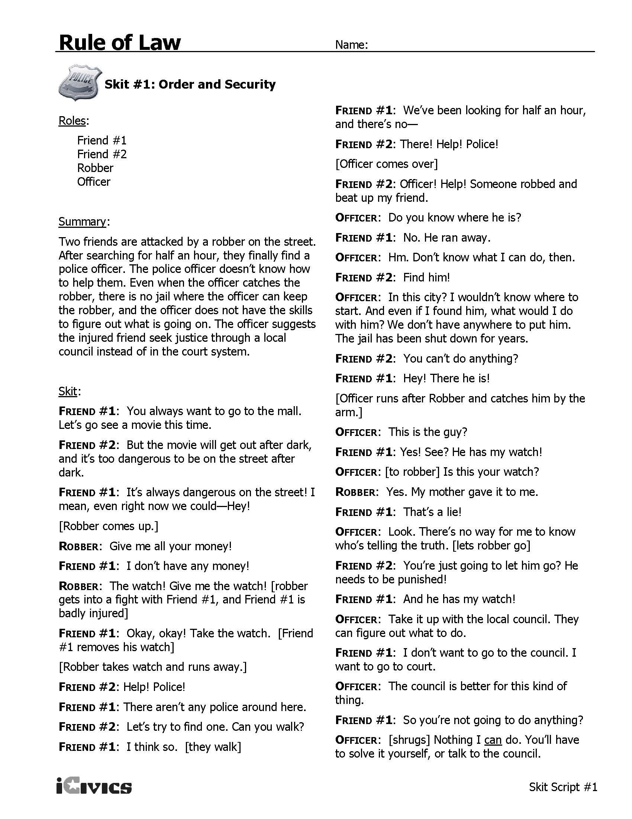
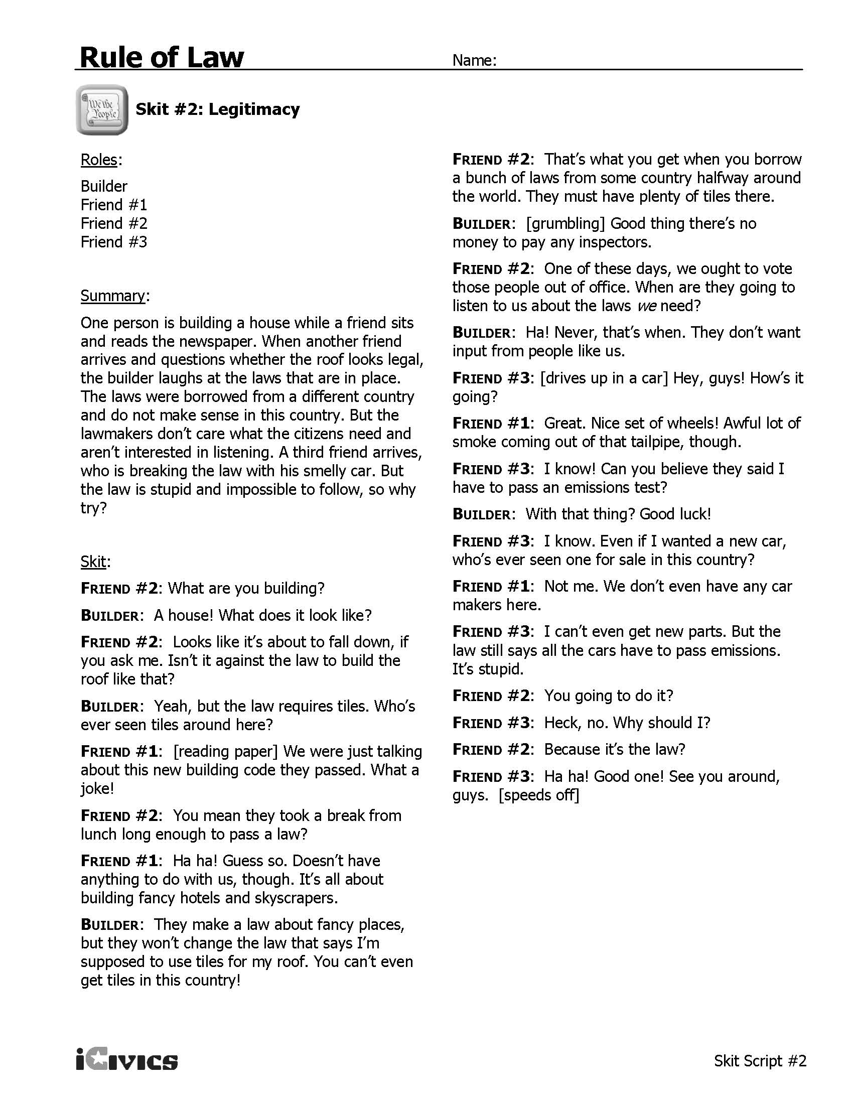
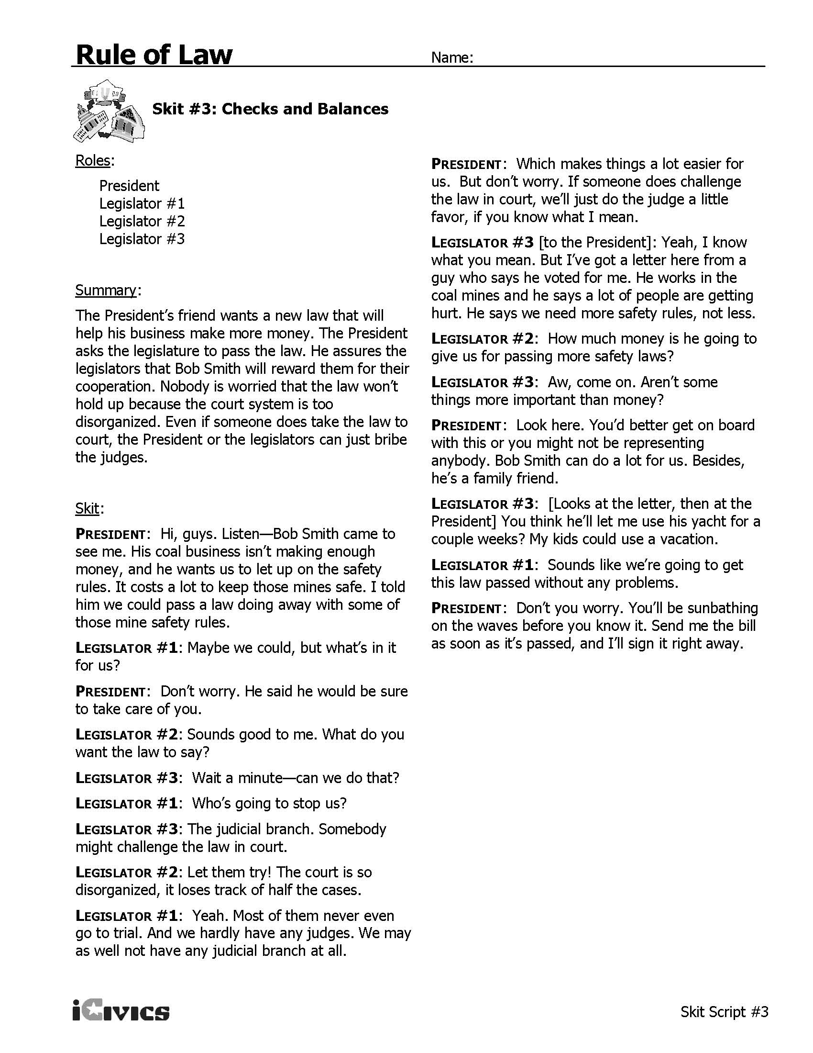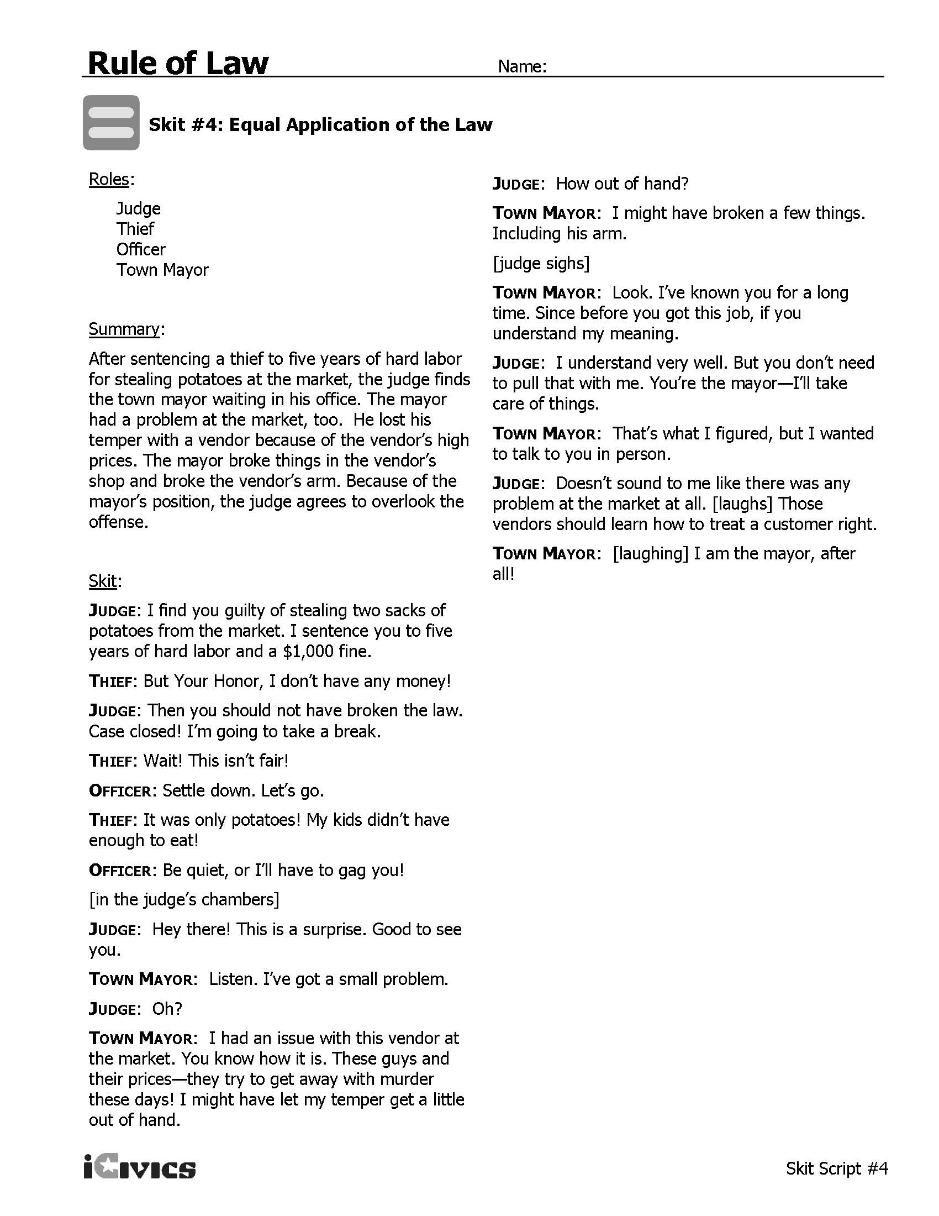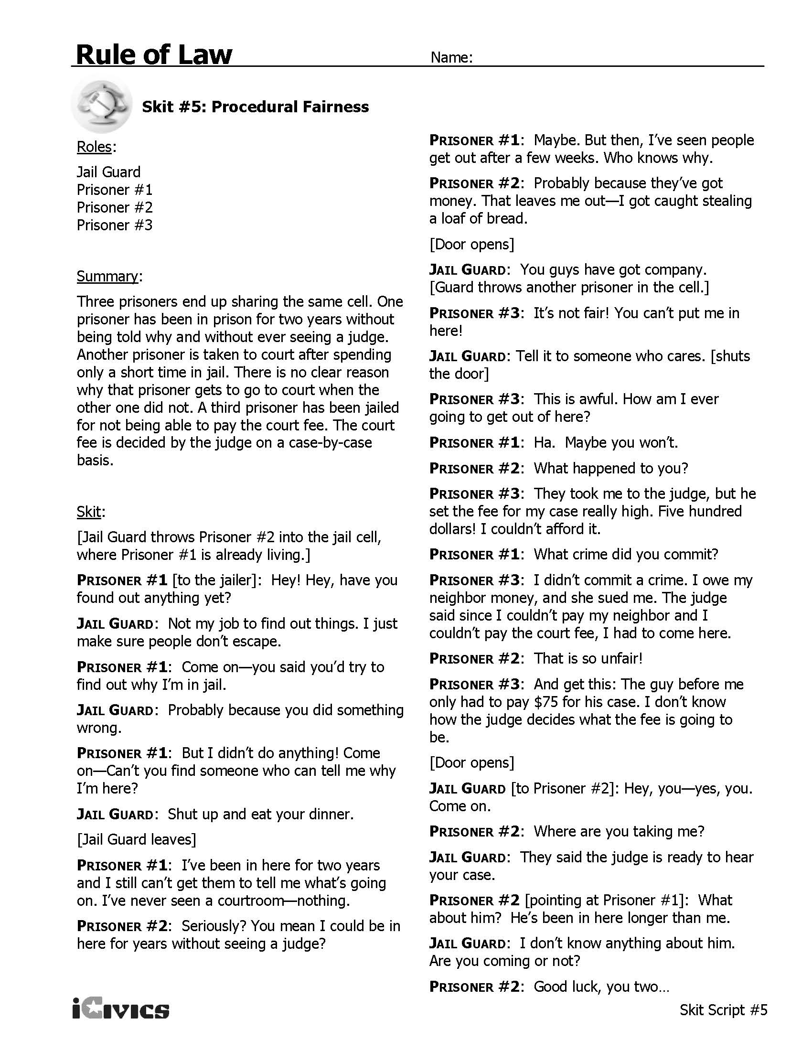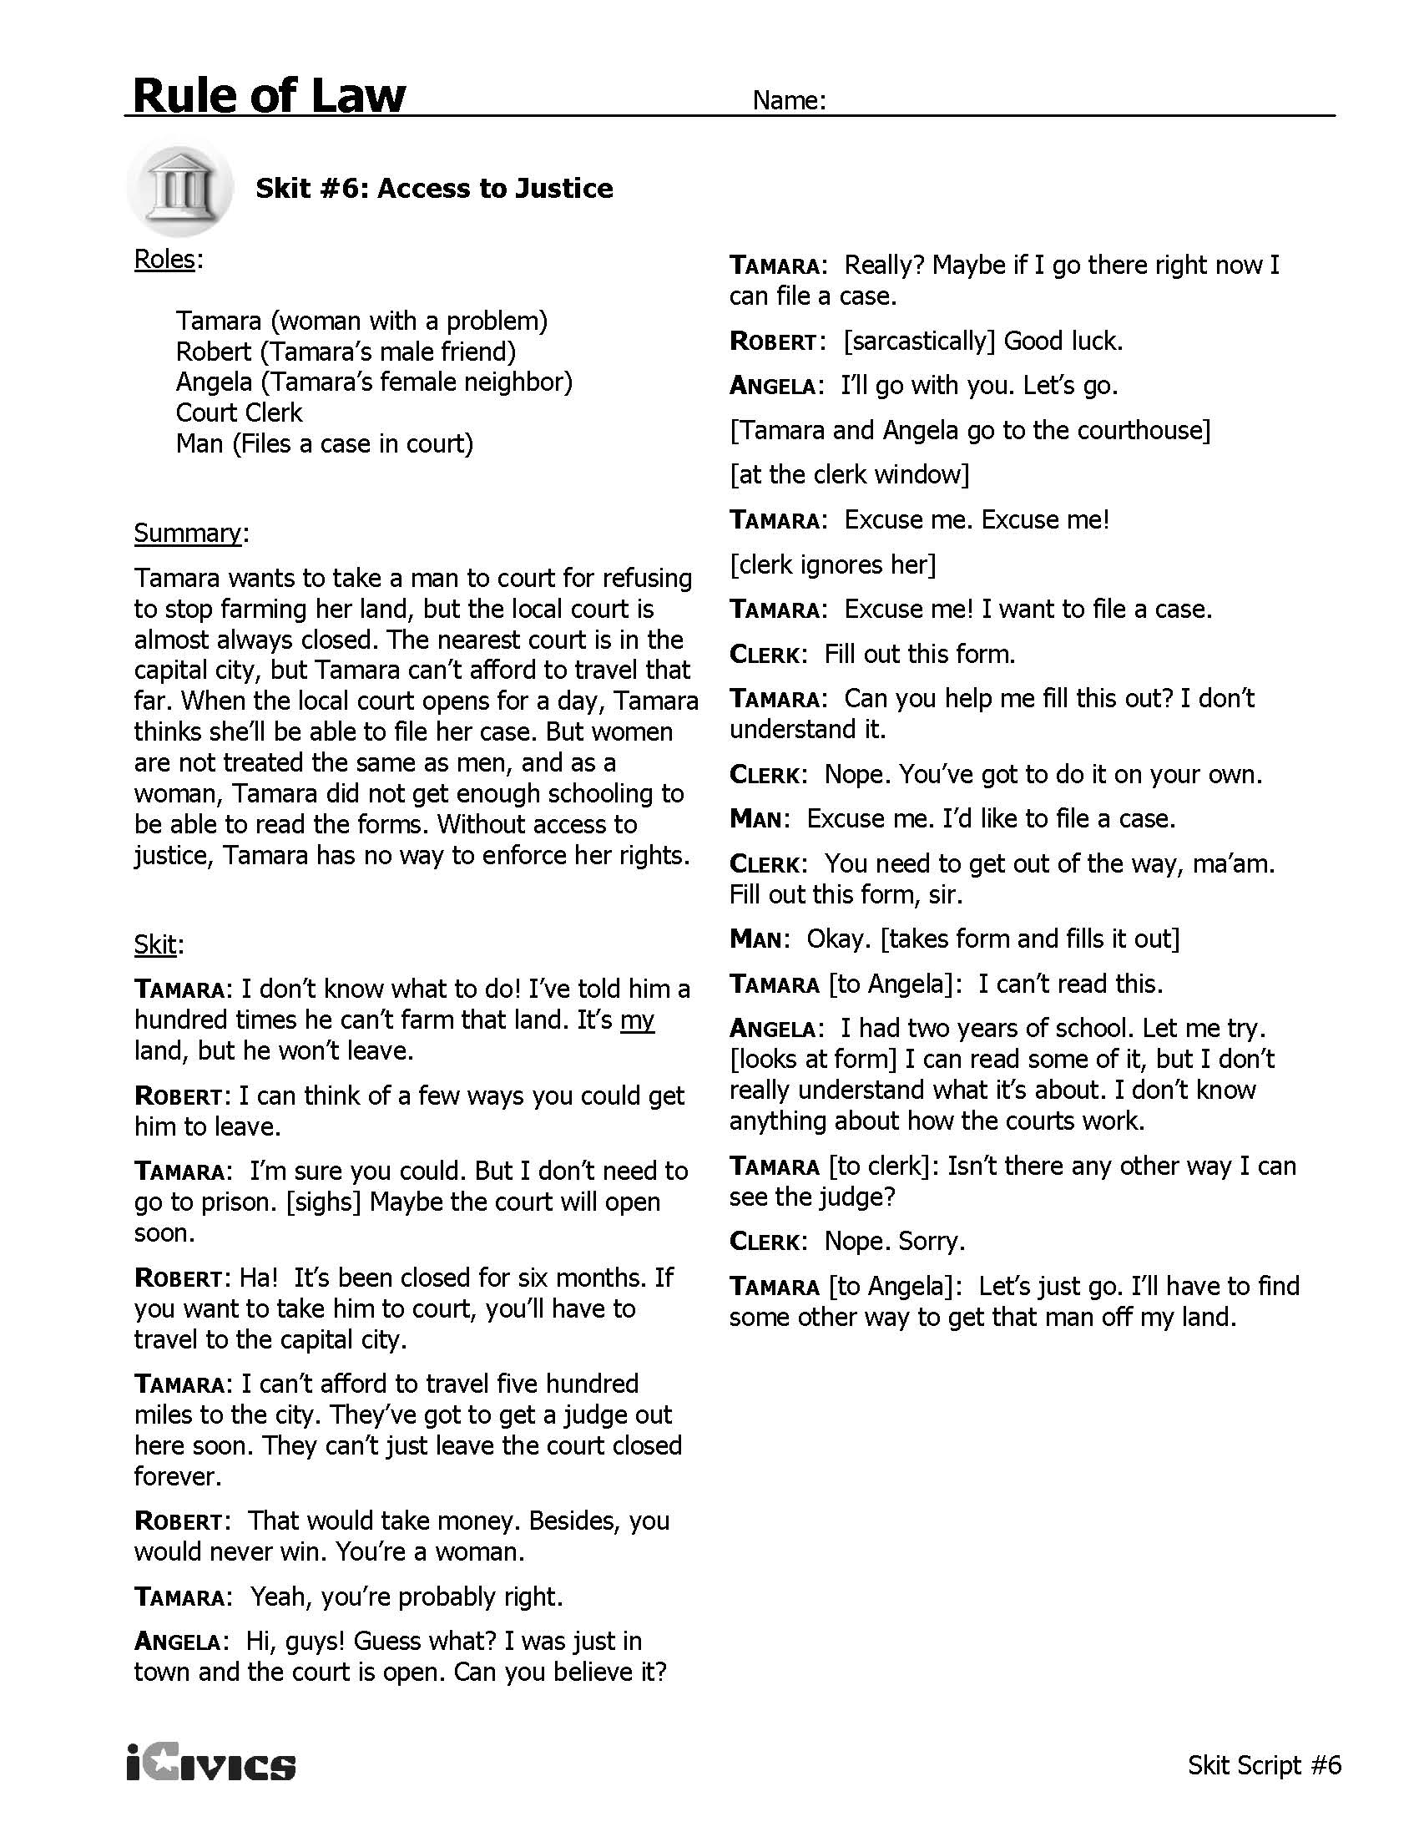
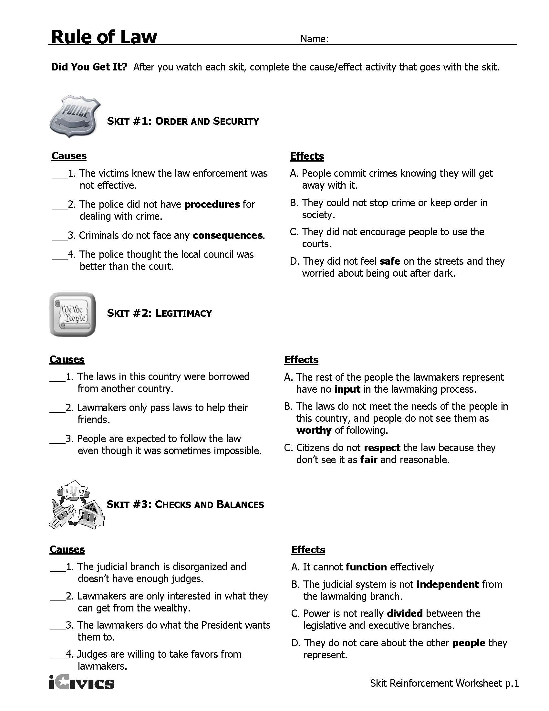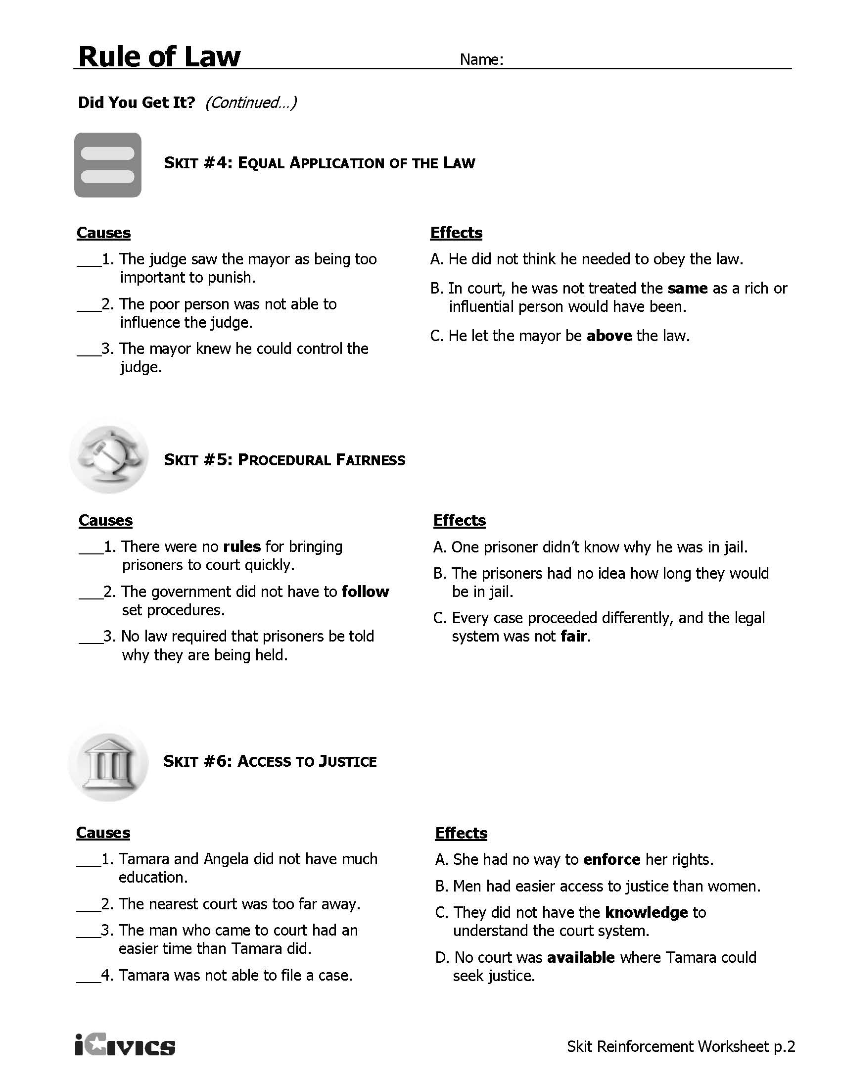
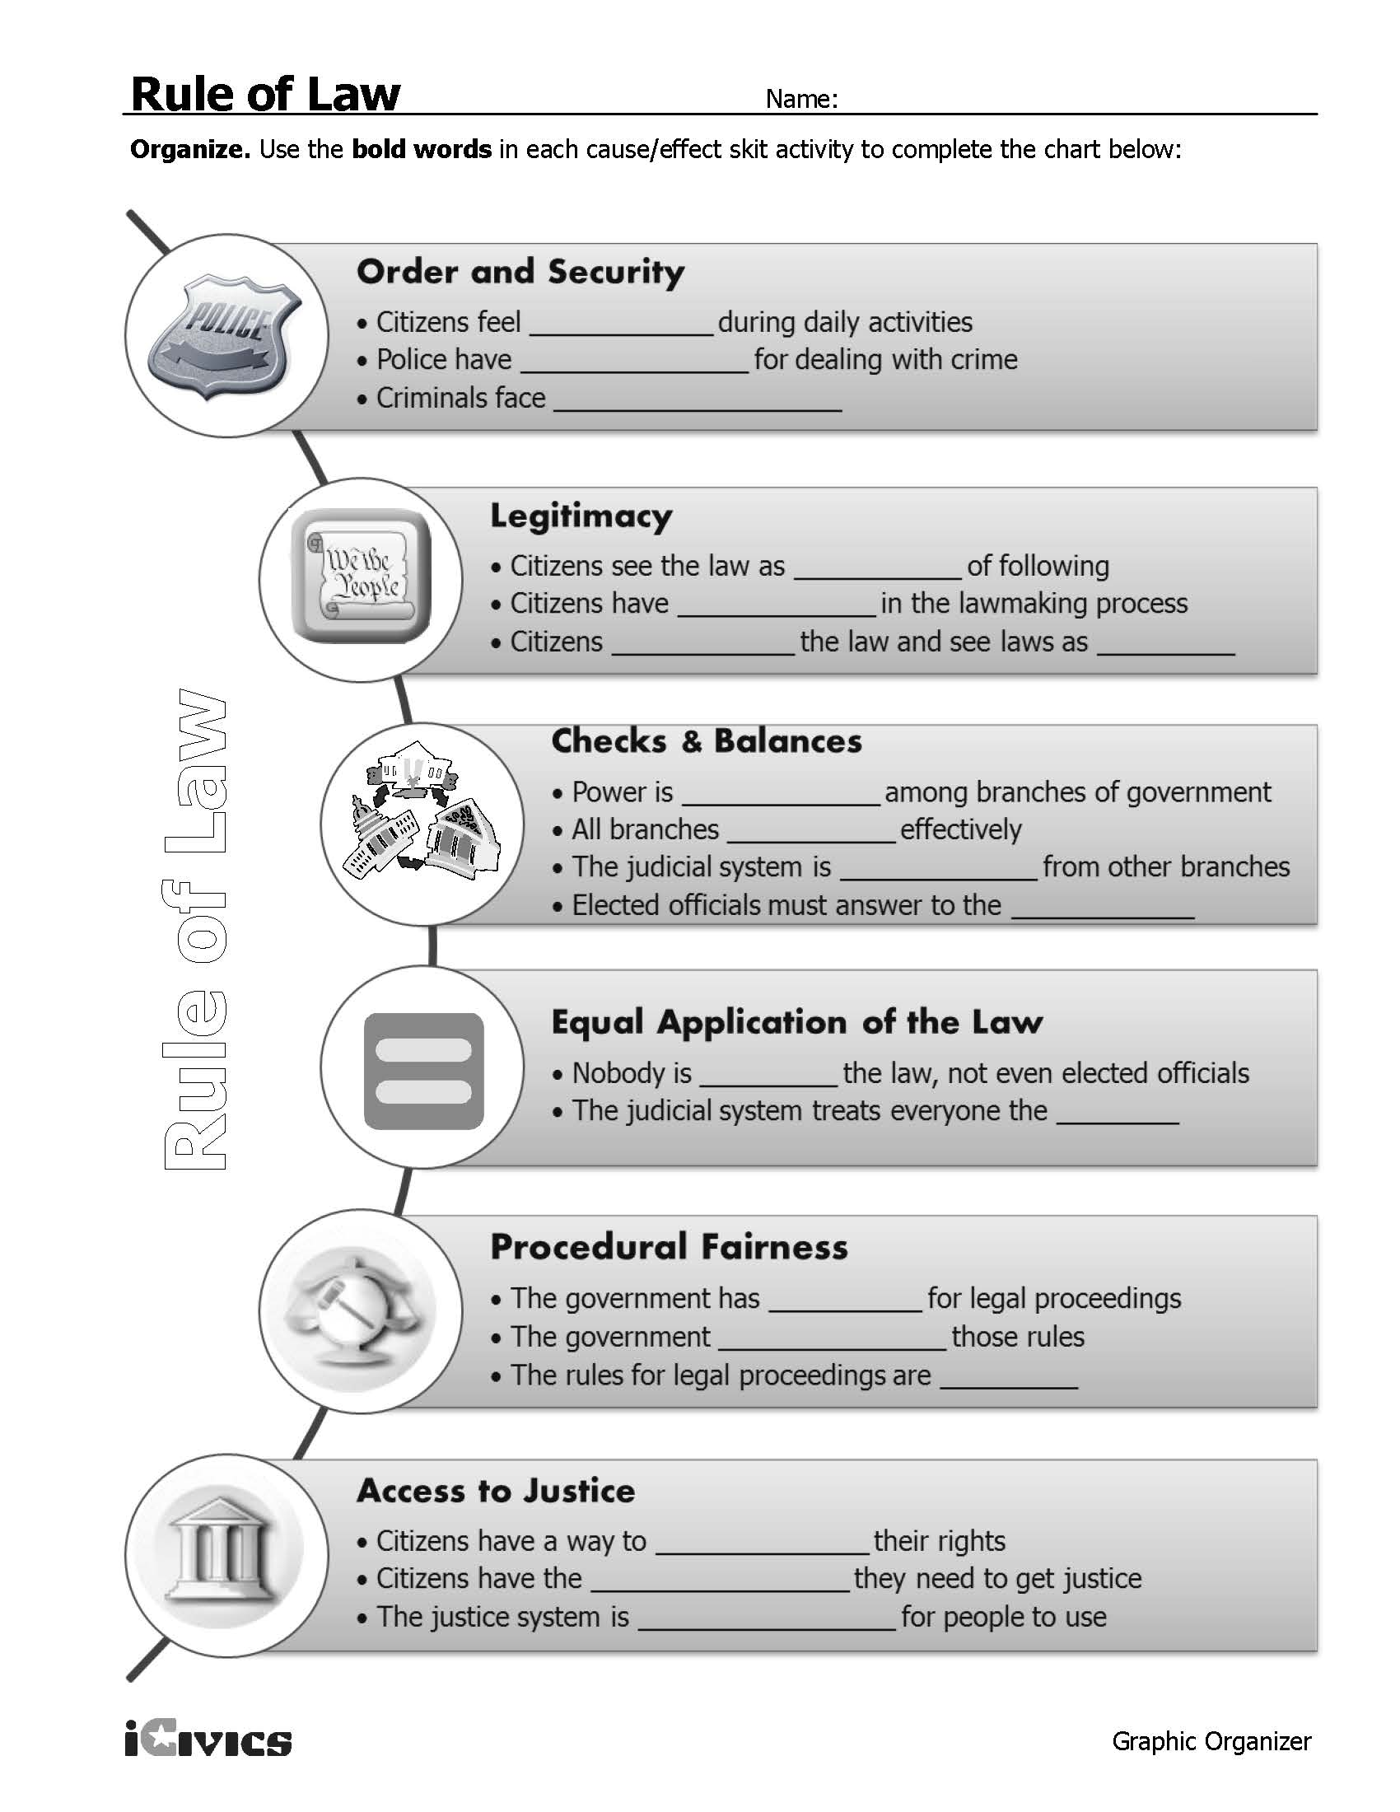
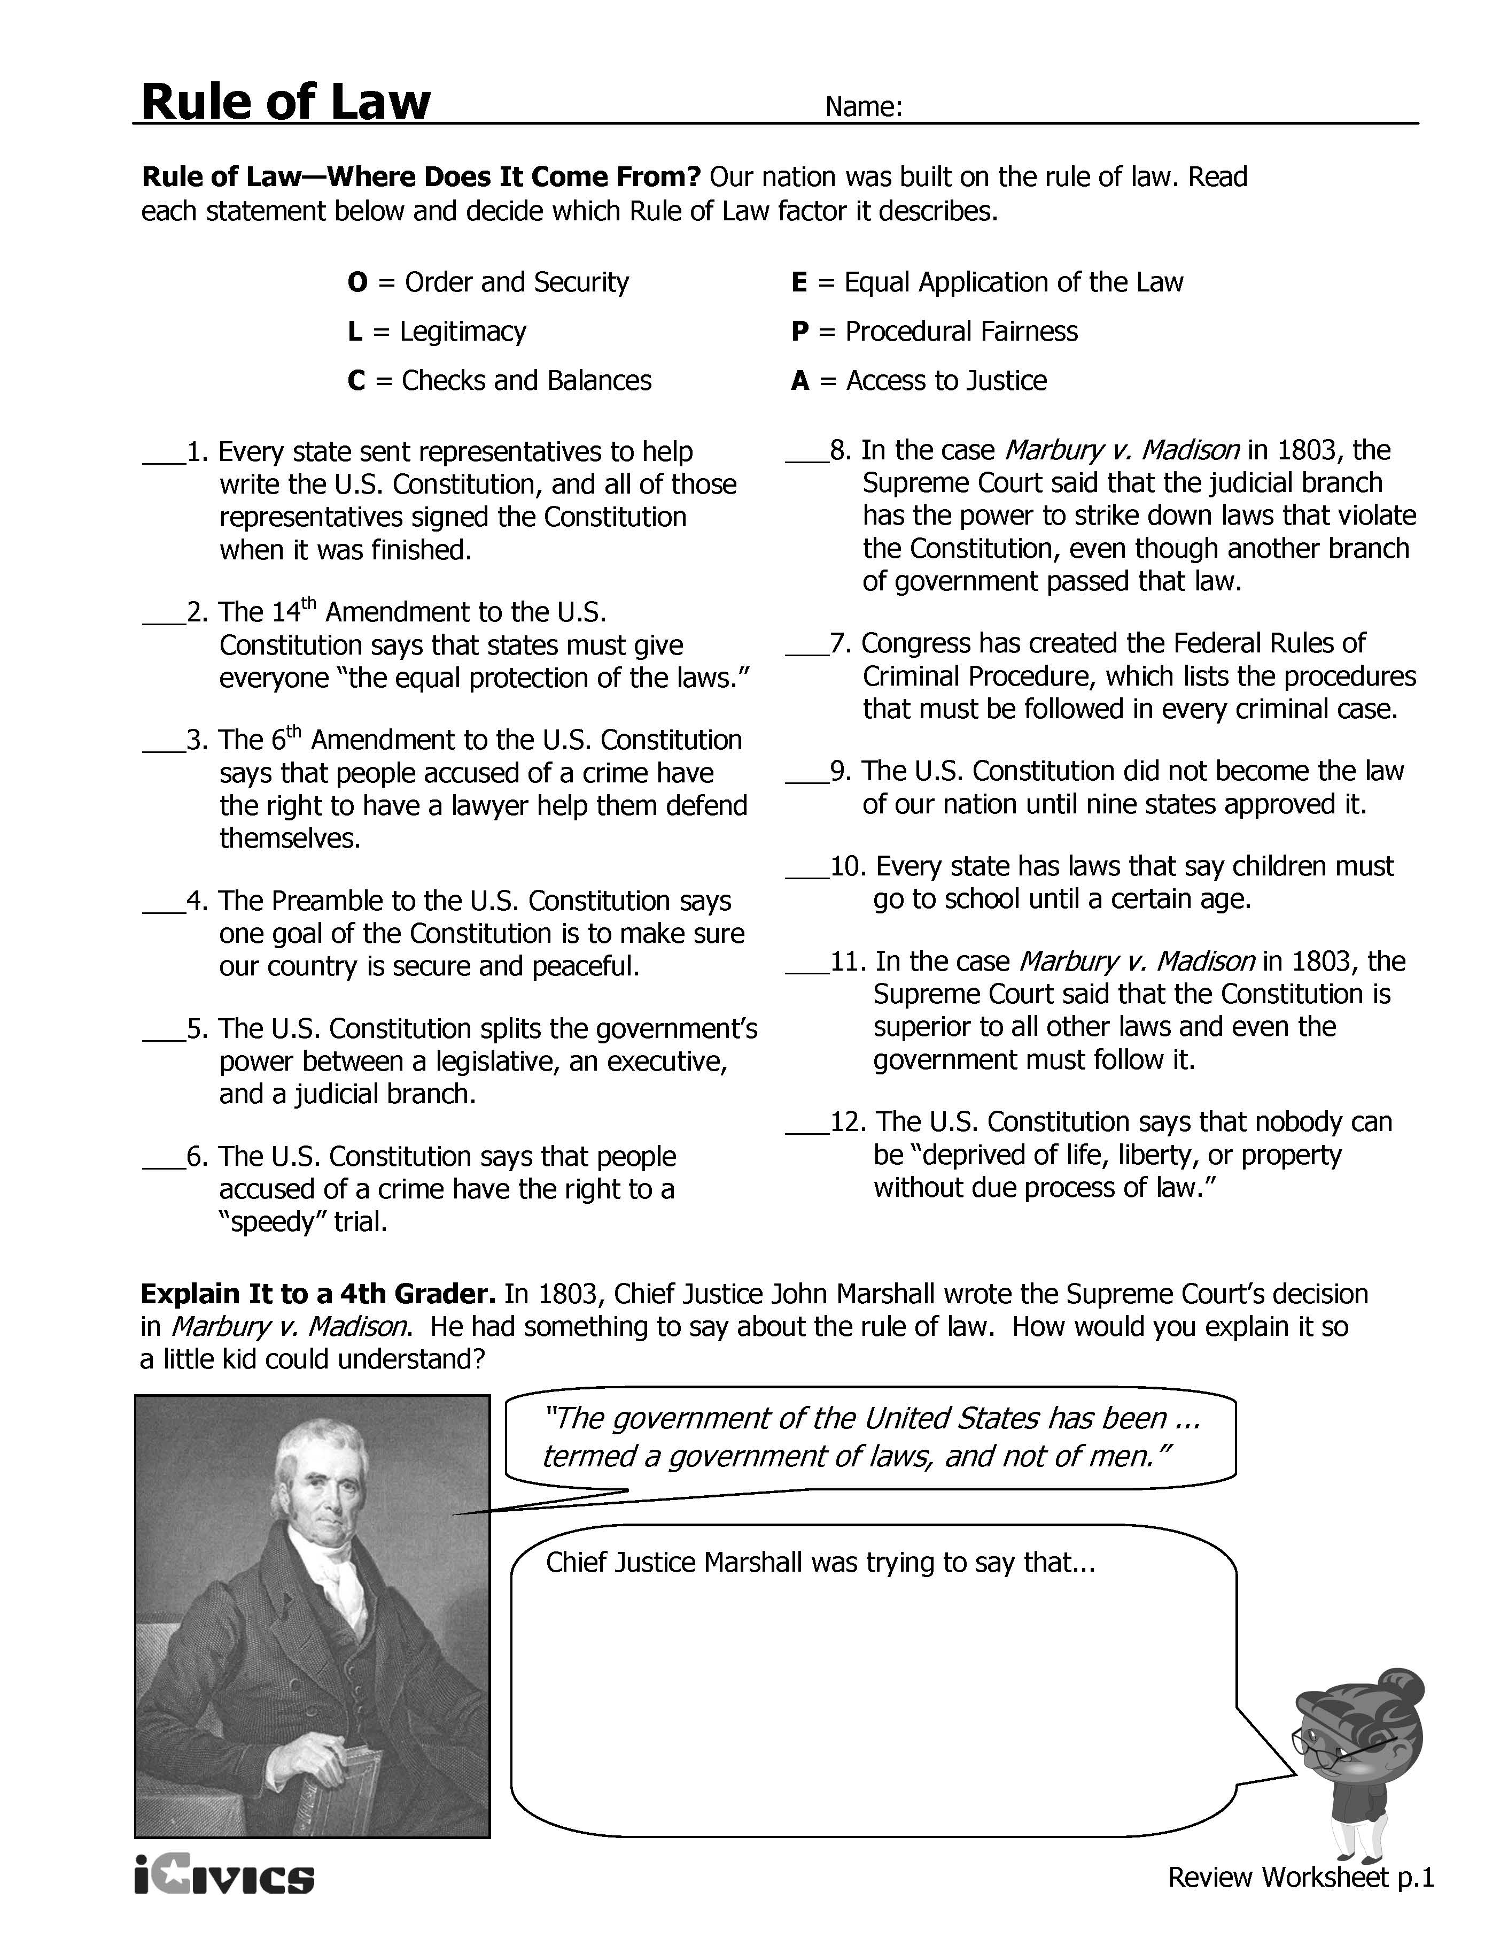
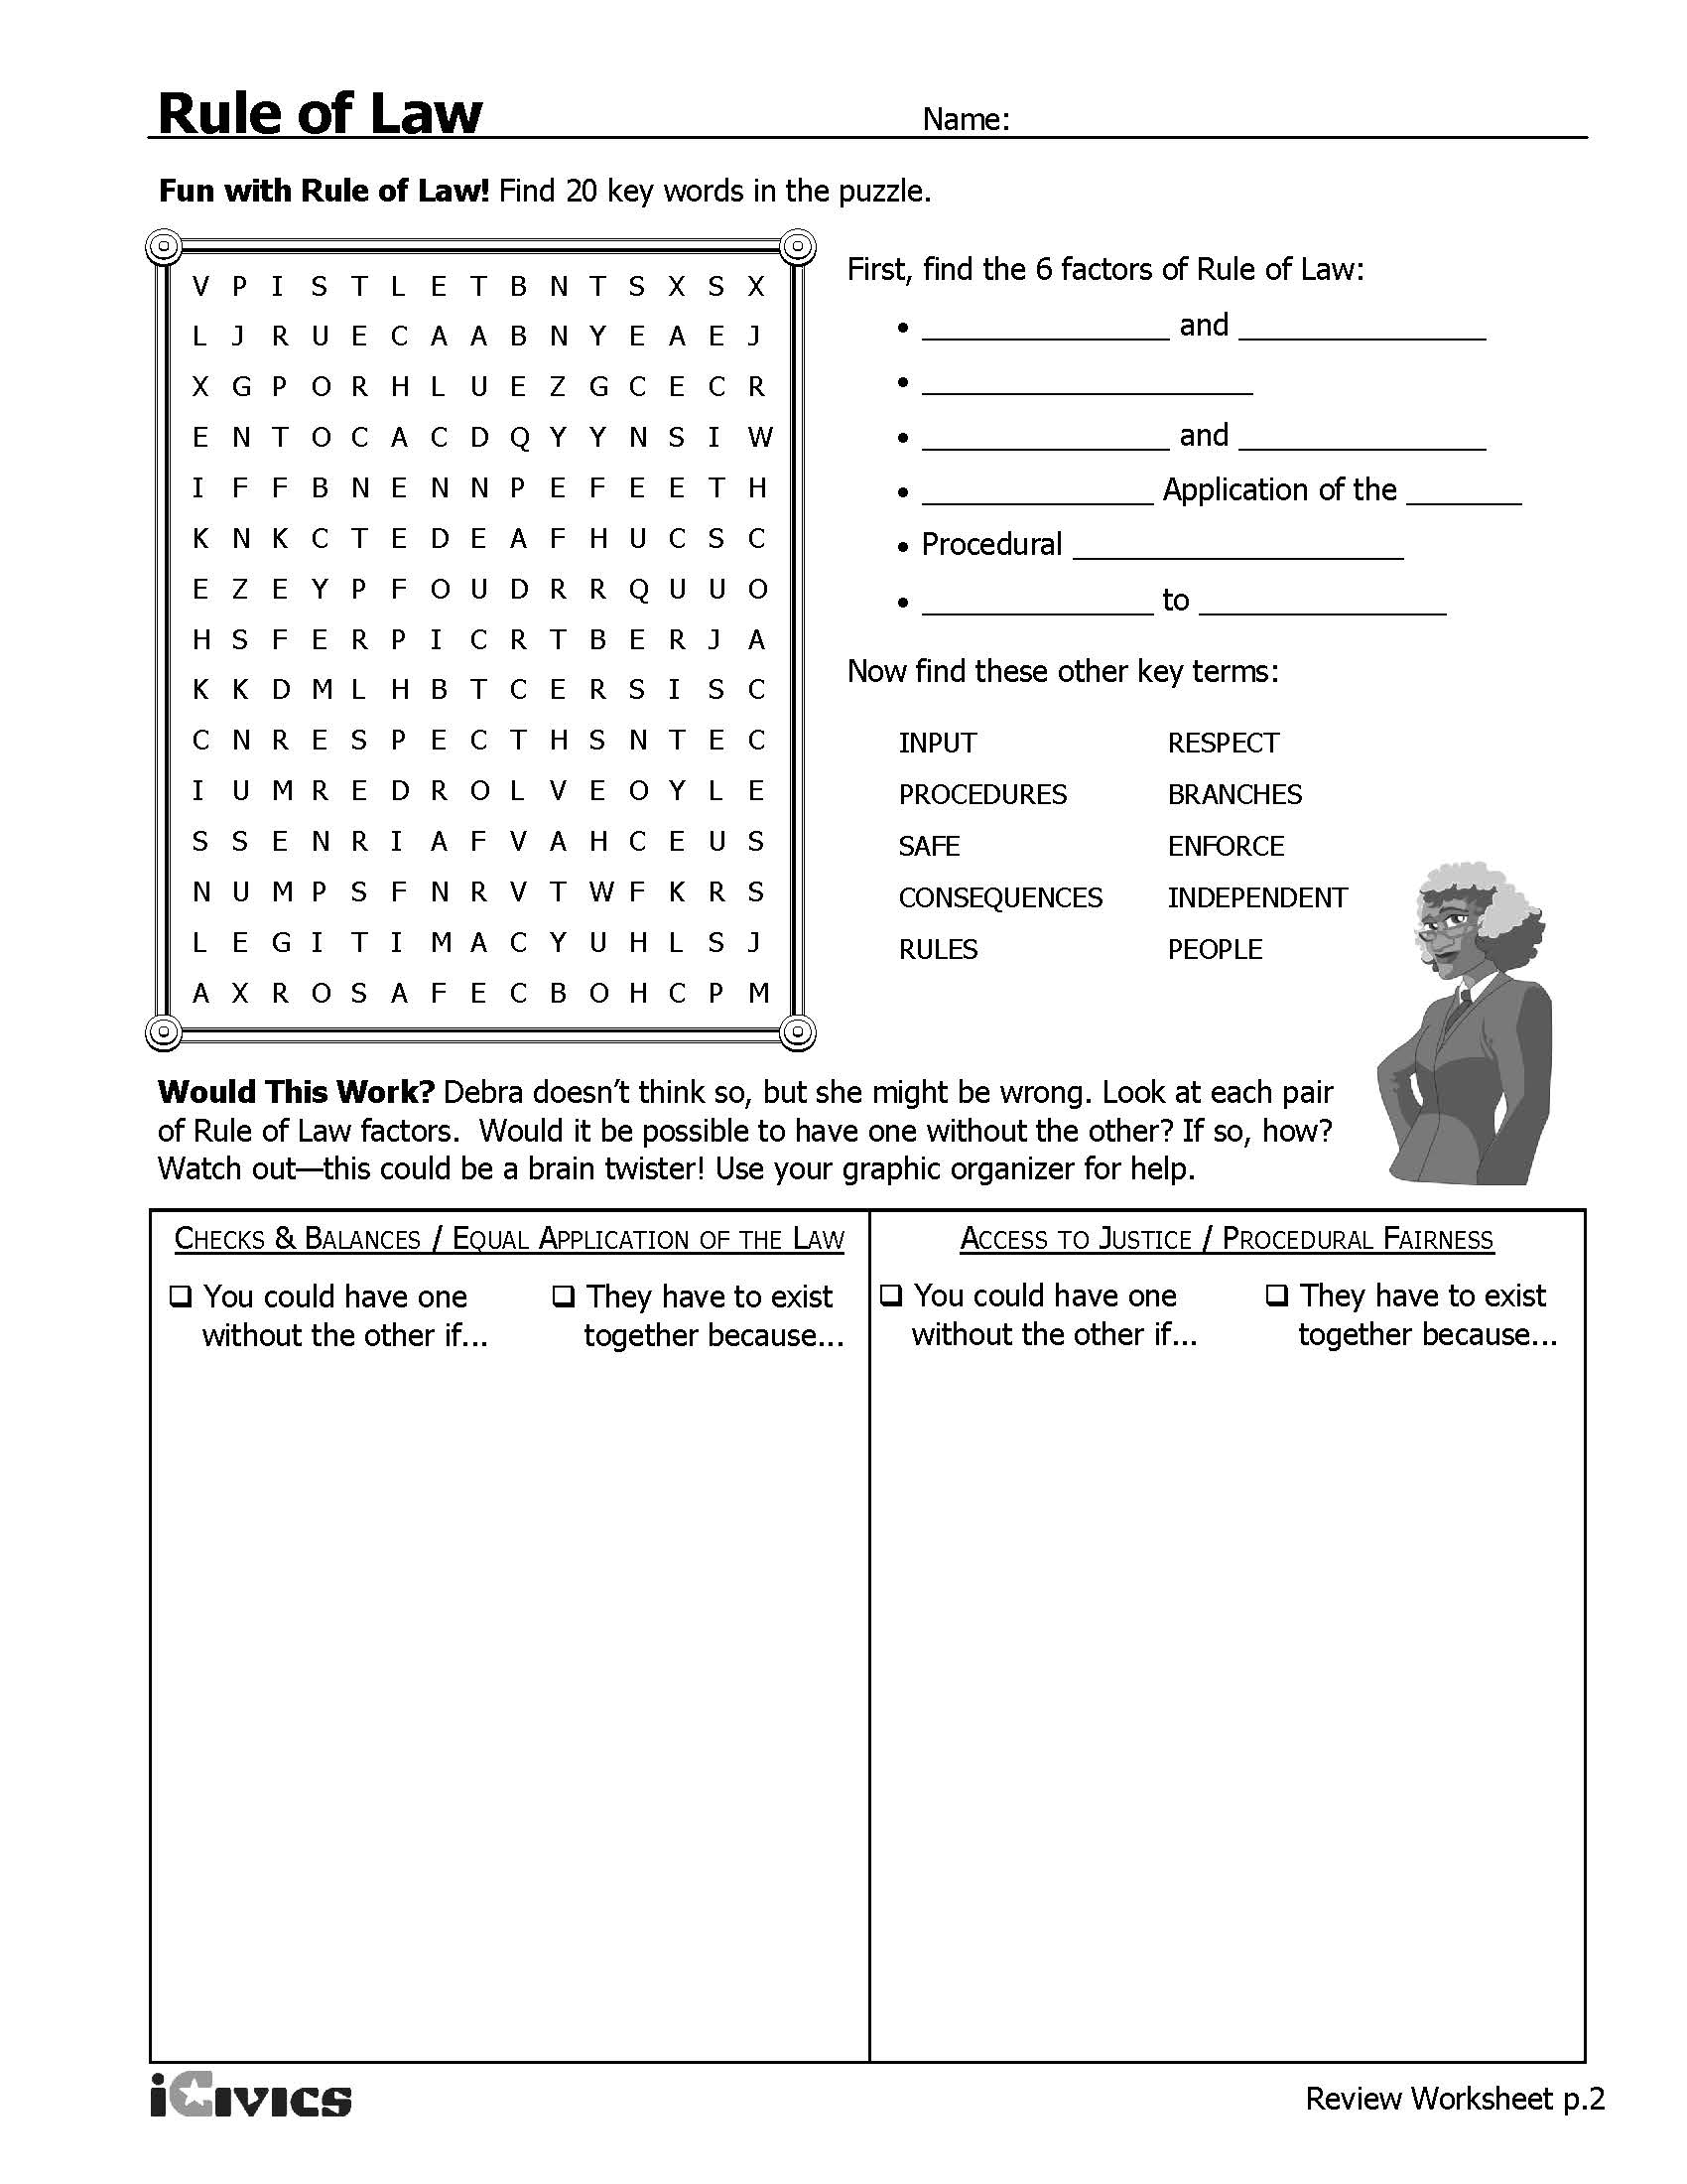

Rule of Law Case Study #1

A judge issued a warrant for Glen’s arrest based on a robbery and when police attempted to execute the warrant at the address listed on the warrant, the residents of that address gave the police a different address where they could find Glen. When the police knocked on the door of the new address, which belonged to Glen’s grandparents, Glen answered the door. The police immediately arrested Glen and read him the Miranda warnings. The police then entered the home and asked Glen’s grandfather, Mr. Brooks, if he owned the home. Mr. Brooks said that he did and that Glen lived with him but did not pay rent. Mr. Brooks gave the police permission to search Glen’s room. The police did not get Glen’s permission to search his room but he did tell the police which rooms he had slept in. In one of those bedrooms, the police found a backpack that had no clear indicators of who owned it (like a monogram or nametag) and was unlocked. The police searched the backpack and found evidence of the robbery. Glen admitted that the backpack was his and claimed that he found the evidence.

Listed below is the text of the Fourth Amendment. What does the Fourth Amendment protect?
The right of the people to be secure in their persons, houses, papers, and effects, against unreasonable searches and seizures, shall not be violated, and no Warrants shall issue, but upon probable cause, supported by Oath or affirmation, and particularly describing the place to be searched, and the persons or things to be seized.

How is this case related to the Fourth Amendment?

What do you think the court held in this case? Could the police officer search the backpack?

Based on Glenn v. Commonwealth, 275 Va. 123, 654 S.E.2d 910 (2008). http://www.thecenterforruleoflaw.org/case-7.html
Rule of Law Case #2

The police brought Shawn, who is 14 years old, to the police station because he was the main suspect in a murder that happened around 3 a.m., approximately two hours earlier. The police read Shawn his Miranda warnings two times, but he waived them both times. One of the detectives asked Shawn twice if he wanted his parents present, but Shawn refused both times. Shawn had never been in trouble with law enforcement before. He was not under the influence of alcohol or drugs. Shawn was a fluent English speaker and had completed eighth grade. Shawn then confessed to the murder and, right after doing so, again told the police that he understood his rights.

Listed below is the text of the Fifth Amendment. What does the Fifth Amendment protect?
No person shall be held to answer for a capital, or otherwise infamous crime, unless on a presentment or indictment of a Grand Jury, except in cases arising in the land or naval forces, or in the Militia, when in actual service in time of War or public danger; nor shall any person be subject for the same offence to be twice put in jeopardy of life or limb; nor shall be compelled in any criminal case to be a witness against himself, nor be deprived of life, liberty, or property, without due process of law; nor shall private property be taken for public use, without just compensation.

How is this case related to the Fifth Amendment?

How do you think the court ruled when Shawn tried to take back his confession?

Based on Rodriguez v. Commonwealth, 40 Va. App. 144 (2003). http://www.thecenterforruleoflaw.org/case-10.html
Sources
Frost/Nixon Interview Clip: https://www.youtube.com/watch?v=L_0Icc6cmRk
The Center for Teaching the Rule of Law, The Law Rules video: https://www.youtube.com/watch?v=DEFB8WBIw5A
Rule of Law Lesson Plan from iCivics: http://www.icivics.org/teachers/lesson-plans/rule-law
U.S Constitution Text: http://constitutioncenter.org/media/files/constitution-full-text.pdf
Street Law at the University of Washington Law School: http://www.law.washington.edu/Streetlaw/lessons.aspx#introlaw
Rule of Law Case Studies: http://www.thecenterforruleoflaw.org/case-7.html and http://www.thecenterforruleoflaw.org/case-10.html
John Adams Quote: http://www.john-adams-heritage.com/quotes/
Theodore Roosevelt Quote: http://www.theodoreroosevelt.org/site/c.elKSIdOWIiJ8H/b.9297493/k.7CB9/Quotations_from_the_speeches_and_other_works_of_Theodore_Roosevelt.htm, Accessed April 2013

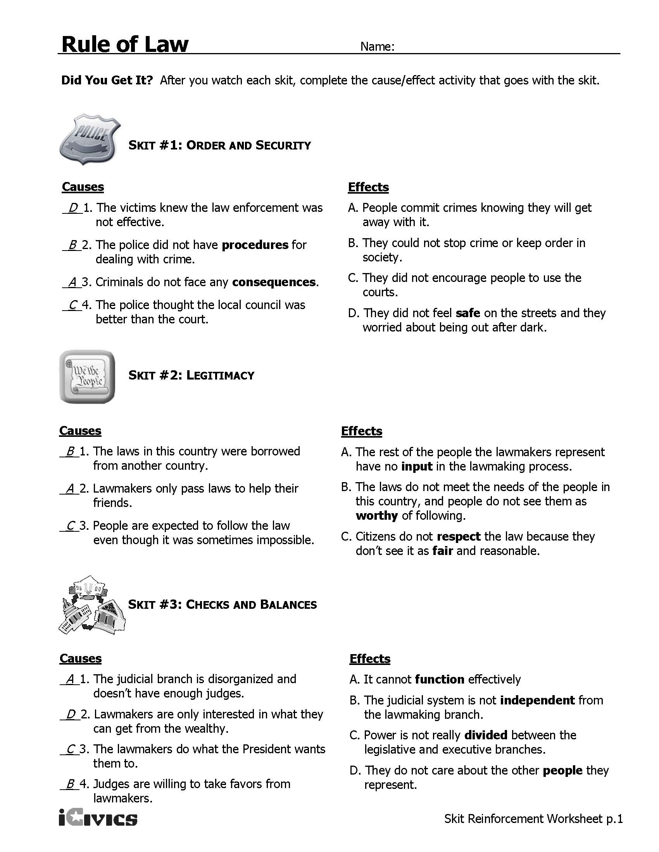
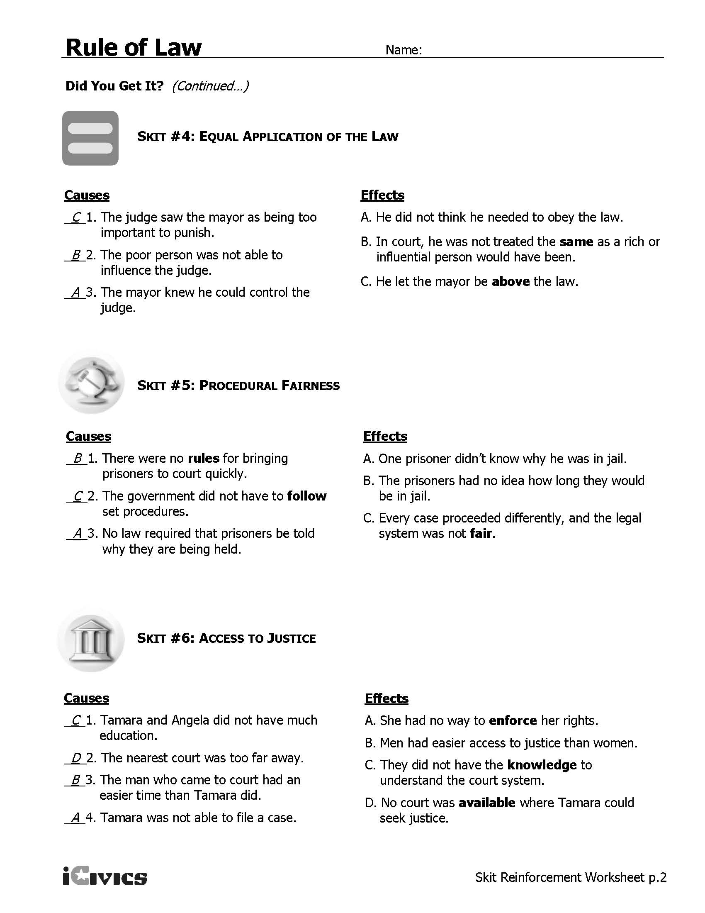
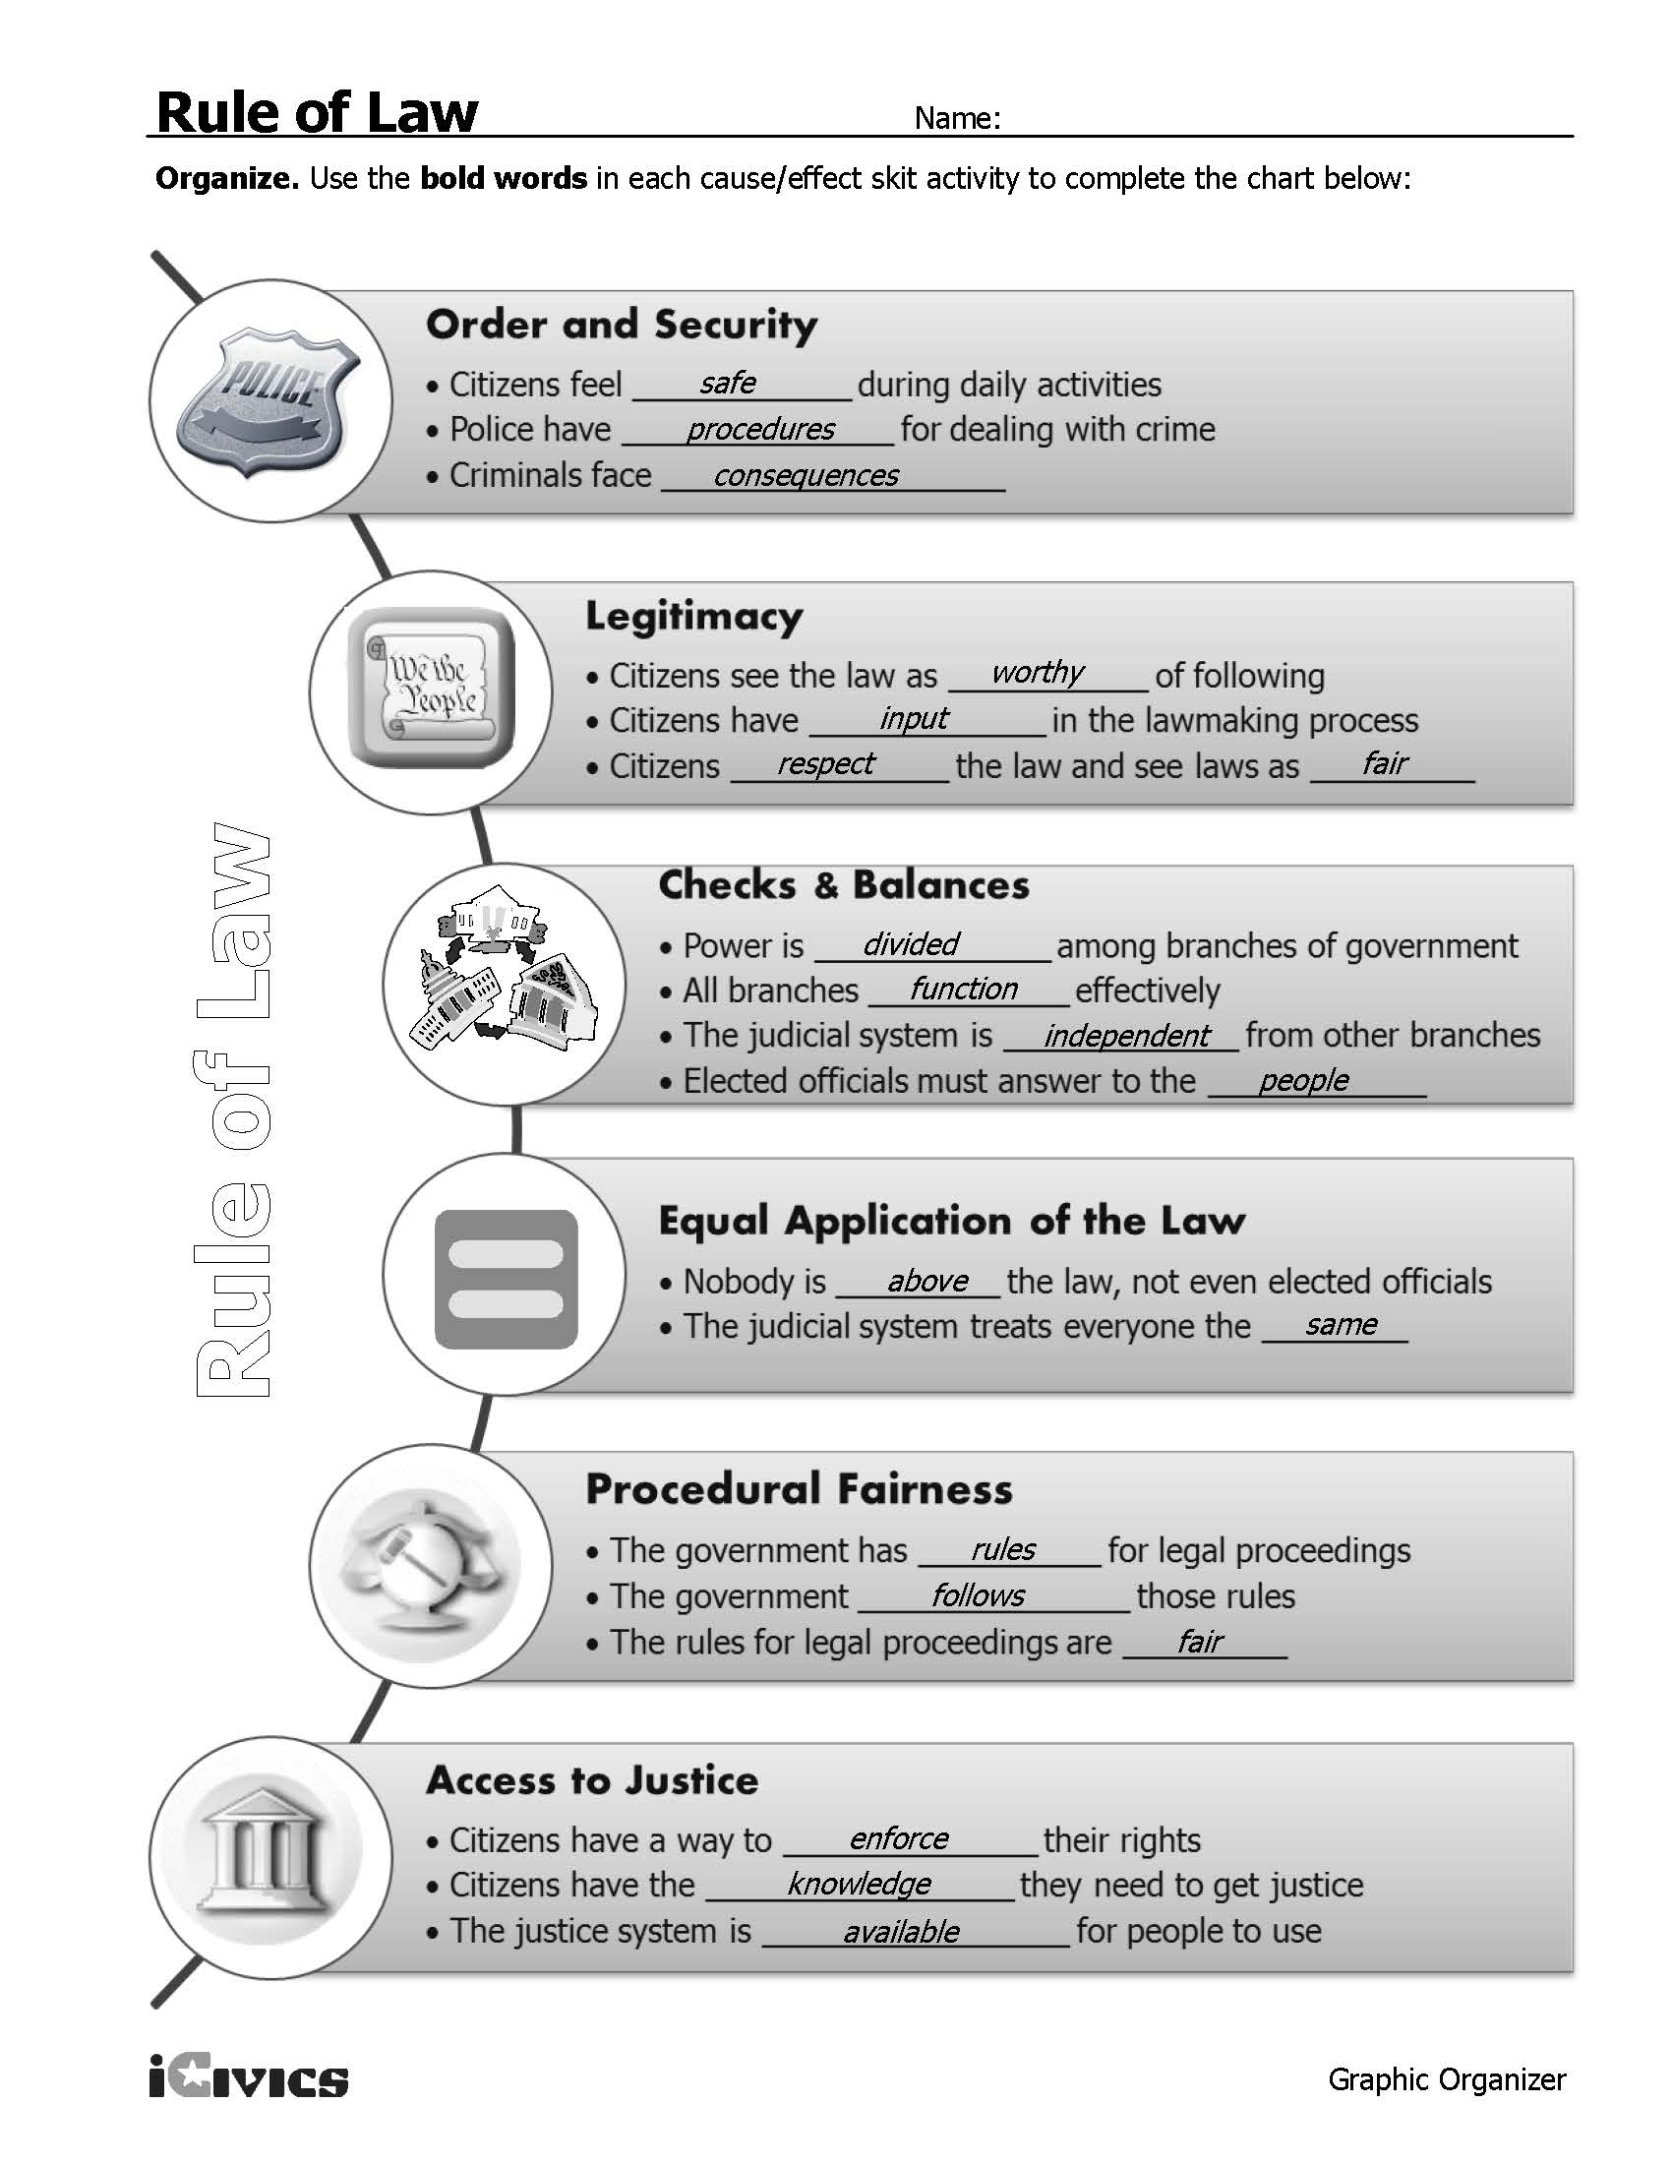

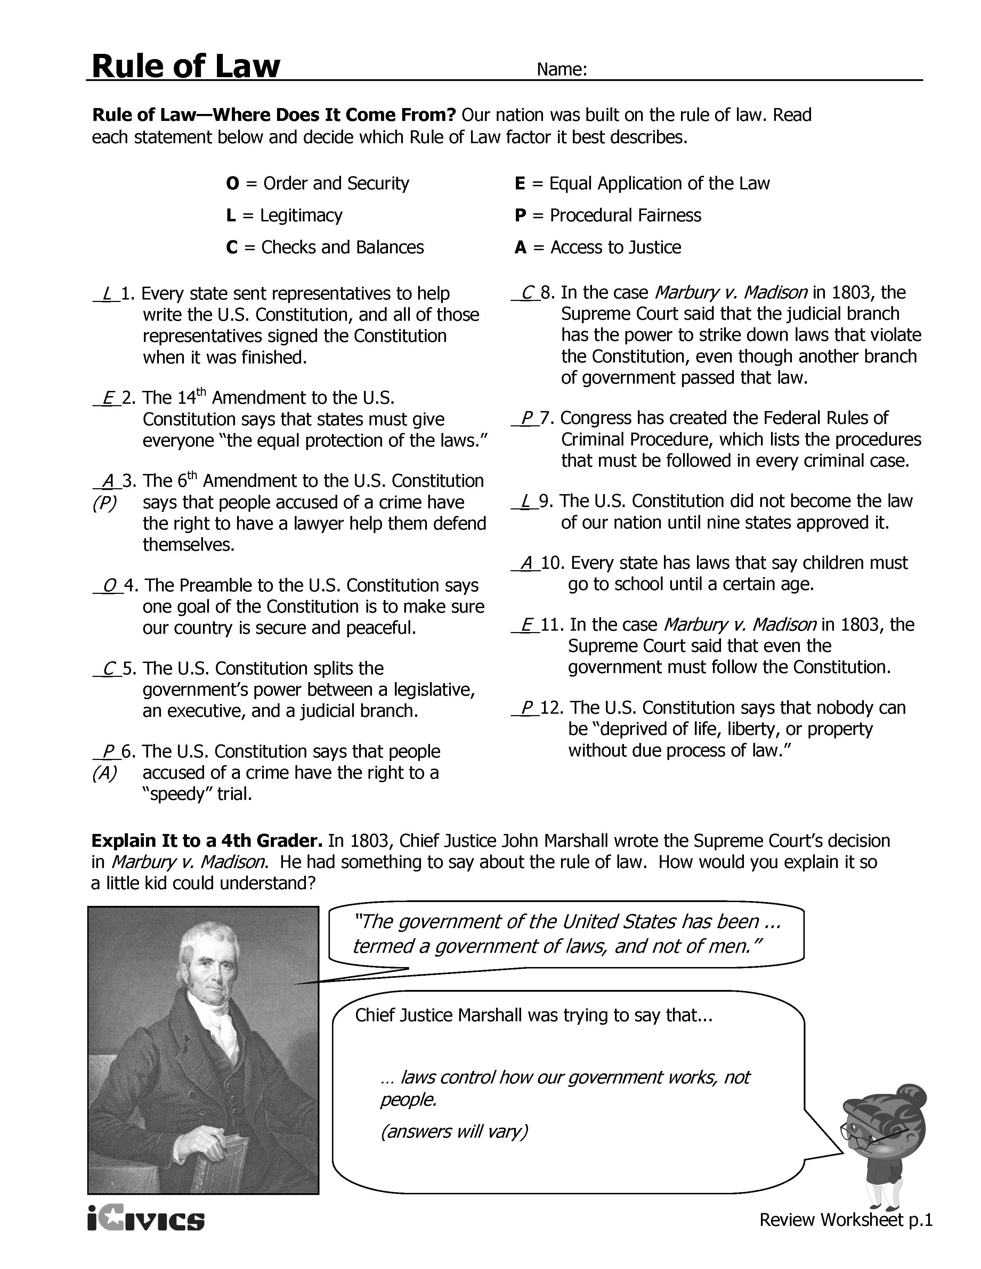

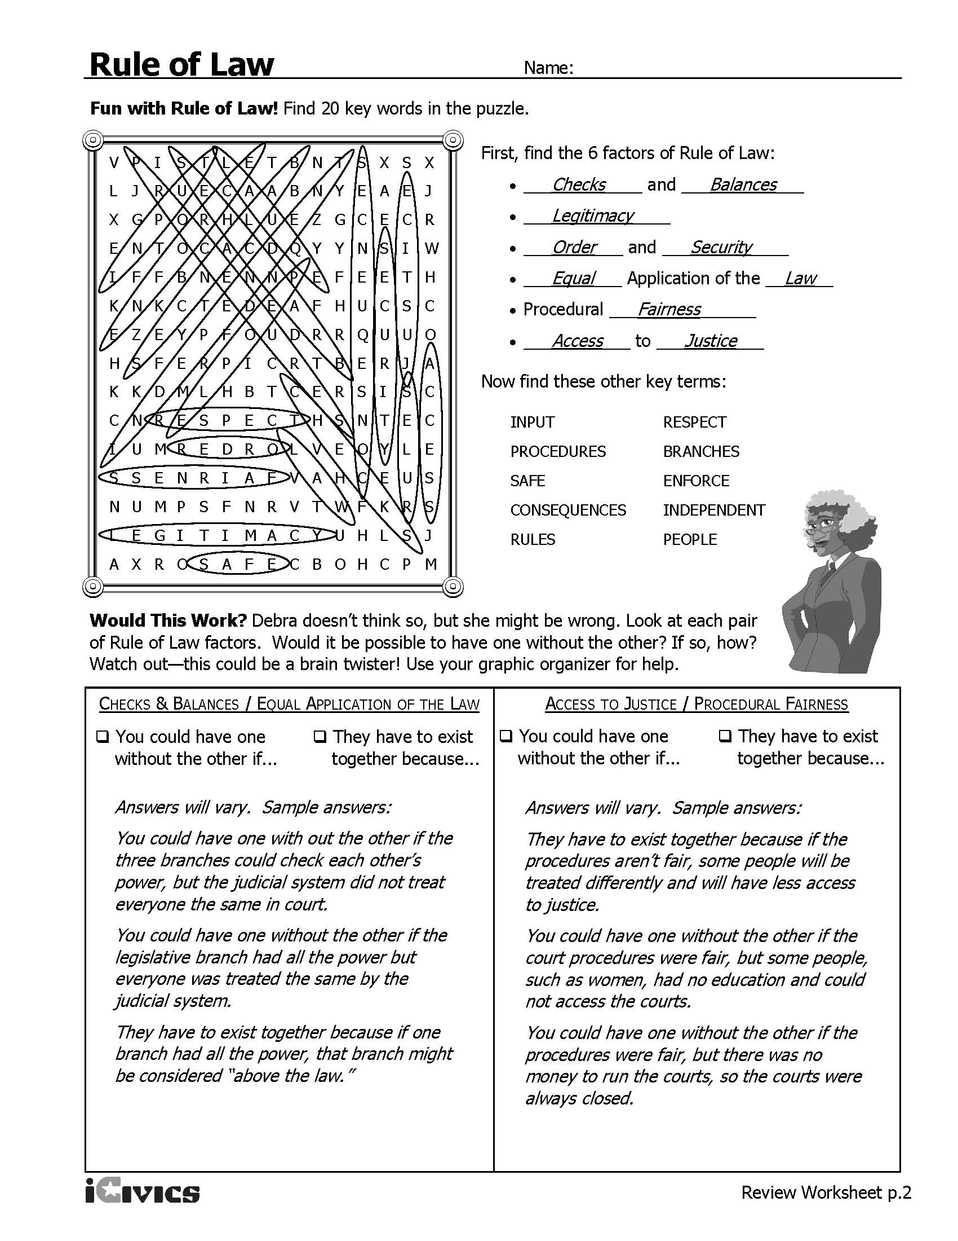

Rule of Law Case #1 – Sample Answers

A judge issued a warrant for Glen’s arrest based on a robbery and when police attempted to execute the warrant at the address listed on the warrant, the residents of that address gave the police a different address where they could find Glen. When the police knocked on the door of the new address, which belonged to Glen’s grandparents, Glen answered the door. The police immediately arrested Glen and read him the Miranda warnings. The police then entered the home and asked Glen’s grandfather, Mr. Brooks, if he owned the home. Mr. Brooks said that he did and that Glen lived with him but did not pay rent. Mr. Brooks gave the police permission to search Glen’s room. The police did not get Glen’s permission to search his room but he did tell the police which rooms he had slept in. In one of those bedrooms, the police found a backpack that had no clear indicators of who owned it (like a monogram or nametag) and was unlocked. The police searched the backpack and found evidence of the robbery. Glen admitted that the backpack was his and claimed that he found the evidence.

Listed below is the text of the Fourth Amendment. What does the Fourth Amendment protect?
The right of the people to be secure in their persons, houses, papers, and effects, against unreasonable searches and seizures, shall not be violated, and no Warrants shall issue, but upon probable cause, supported by Oath or affirmation, and particularly describing the place to be searched, and the persons or things to be seized.
[The right of the people to be secure in their persons, houses, papers, and effects, against unreasonable searches and seizures, shall not be violated, and no warrants shall issue, but upon probable cause, supported by oath or affirmation, and particularly describing the place to be searched, and the persons or things to be seized.]

How is this case related to the Fourth Amendment? [This case deals with the issues of search and seizure and the Fourth Amendment is concerned with the right of people to be secure and protected against unreasonable searches and seizures.]

What do you think the court held in this case? Could the police officer search the backpack? [The Supreme Court of Virginia held that Mr. Brooks could consent to the search of his house – even the spaces occupied by Glen – because he was the homeowner. The Court concluded that even though Mr. Brooks did not have actual authority to consent to the search of the backpack, he had apparent authority to do so. Apparent authority exists when, in light of all of the circumstances, the facts available to the police at the time of the search would lead a reasonable police officer to believe that the third party, in this case Mr. Brooks, had authority to consent. Because the backpack had no indication of who owned it on it and was in a place open to all occupants of the house, the Court concluded that Mr. Brooks had apparent authority to consent.]

Based on Glenn v. Commonwealth, 275 Va. 123, 654 S.E.2d 910 (2008)

Rule of Law Case #2 – Sample Answers

The police brought Shawn, who is 14 years old, to the police station because he was the main suspect in a murder that happened around 3 a.m., approximately two hours earlier. The police read Shawn his Miranda warnings two times, but he waived them both times. One of the detectives asked Shawn twice if he wanted his parents present, but Shawn refused both times. Shawn had never been in trouble with law enforcement before. He was not under the influence of alcohol or drugs. Shawn spoke English fluently and had completed eighth grade. Shawn then confessed to the murder and, right after doing so, again told the police that he understood his rights.

Listed below is the text of the Fifth Amendment. What does the Fifth Amendment protect?
No person shall be held to answer for a capital, or otherwise infamous crime, unless on a presentment or indictment of a Grand Jury, except in cases arising in the land or naval forces, or in the Militia, when in actual service in time of War or public danger; nor shall any person be subject for the same offence to be twice put in jeopardy of life or limb; nor shall be compelled in any criminal case to be a witness against himself, nor be deprived of life, liberty, or property, without due process of law; nor shall private property be taken for public use, without just compensation.
The Fifth Amendment protects against self-incrimination.

How is this case related to the Fifth Amendment? [The Fifth Amendment protects against self-incrimination and in this case, Shawn waived his Miranda rights and confessed to the crime.]

What do you think the court ruled when Shawn tried to take back his confession? [The Court held that “despite [Shawn’s] age and the absence of a parent, counsel, or other interested adult, the totality of the circumstances supports the trial court’s finding that [Shawn’s] waiver of his Miranda rights was knowing and intelligent under the specific facts of this case.”]

Additional Key Points:
What circumstances do you think were important to the court? [His age, his fluency with English, the grade level that he had completed, that he was not under the influence of drugs or alcohol, the lack of evidence of police coercion, the fact that he had the opportunities to have his parents present, the duration of the interview.]

Based on Rodriguez v. Commonwealth, 40 Va. App. 144 (2003).

Civics Content Vocabulary

Word/Term | Part of Speech | Definition
citizen | noun | a legal member of a state and/or country
law | noun | a rule established by government or other source of authority to regulate people’s conduct or activities
rule of law | noun | the idea that those who govern must follow the laws; no one is above the law

Essential Teacher Content Background Information

This section addresses the following issues:

- The role of the rule of law in a democracy
- The forms that the rule of law takes in a democracy

1. The role of the rule of law in a democracy

The principle of the rule of law dominates the formation of government institutions in democracies. The concept of democracy is the notion that the people rule through their government. There are several ways that the people rule through their government including, but not limited to, electing their legislators and chief executives, using their protected freedoms such as speech, peaceable assembly and petitioning the government, and exercising their responsibilities as citizens.

In a democracy, the government is responsible for protecting all citizens through the rule of law. The rule of law is the notion that all citizens are protected from arbitrary and abusive uses of government power. The rule of law applies to non-citizens as well although not all aspects of the rule of law guaranteed to citizens are guaranteed to non-citizens. There are certain aspects of the rule of law that are applied differently to certain citizens such as minors (juveniles) and the mentally disabled.

In the U.S., the rule of law is found in the U.S. Constitution, the Bill of Rights, and other amendments to the U.S. Constitution. The U.S. Constitution provides for separation of powers and checks and balances, which are meant to protect citizens from government abusing its power. Separation of powers separates the three aspects of the lawmaking process (legislative, executive, judicial) from one another. Individuals are not allowed to hold more than one public office at the same time while only U.S. citizens may hold public office.

Still, separation of powers alone does not prevent arbitrary and abusive uses of government power. Tempering the potential for abuse of government power is achieved with checks and balances. Other aspects of the rule of law are also addressed through the separation of powers and checks and balances systems.

2. The forms that the rule of law takes in a democracy

The terms associated with various aspects of the rule of law may vary based on the organization or institution using them. Below is a matrix that clarifies potential sources of confusion.

Term in EOCA Item Specifications | Meaning | Alternative Term/Term used by iCivics
Accountability to the law | Accountability refers to the processes, norms, and structures that hold the population and public officials legally responsible for their actions and that impose sanctions if they violate the law. Accountability is essential if systemic threats to the rule of law are to be corrected. This involves ensuring there are consequences for criminal behavior; …and horizontal accountability (state institutions overseeing the actions of one another) and vertical accountability (citizens overseeing the actions of the state)...The concentration of power in any one branch, institution, or level of government often leads to abuse of power and corruption that horizontal and vertical accountability mechanisms can help prevent.  Adapted from “What is accountability to the law?” available at U.S. Institute of Peace (www.usip.org) | Checks and balances
Fair procedures | Procedural fairness includes that decisions will be made on the basis of a set of established rules that are known. For example, if there were no laws about wearing hats in public, it would be unfair for a person who wore hats in public to be punished by the legal system.  Adapted from HSC Legal Studies available at the State Library of New South Wales (http://www.sl.nsw.gov.au/) | Procedural fairness
Decisions based on the law | A person who is affected by a decision made by the legal system has a right to present their views and facts that support that view (evidence) to the decision maker before the decision is made. It also means that a person who is accused of doing something wrong has a right to be told what it is they are said to have done wrong and to be shown the evidence against them so that they can defend themselves against the accusation.  Adapted from HSC Legal Studies available at the State Library of New South Wales (http://www.sl.nsw.gov.au/) | Legitimacy
Consistent application | Equality before the law is the notion that each person should be treated in the same way by the legal system no matter who they are. For example, the legal system must not make a different decision because a person is richer or poorer than another person, or because a person comes from another country. It means that everyone should be able to access the law and the legal system equally. It also means that the law applies equally to everyone. No person is above the law, no matter what position they hold in society.  Adapted from HSC Legal Studies available at the State Library of New South Wales (http://www.sl.nsw.gov.au/) | Equal application of the law
Enforcement of the law | Human security is one of the defining aspects of any rule of law society. Protecting human security, mainly assuring the security of persons and property, is a fundamental function of the state. Not only does violence impose wounds on society, it also prevents the achievement of other aims, such as exercising fundamental human rights, and ensuring access to opportunities and justice. In extreme situations, violence might become the norm if legal rules are not enforced. Under the rule of law, the state must effectively prevent crime and violence of every sort, including political violence and vigilante justice. It encompasses three dimensions: absence of crime; absence of civil conflict, including terrorism and armed conflict; and absence of violence as a socially acceptable means to redress personal grievances.  Adapted from “Order and Security” available at the World Justice Project (www.worldjusticeproject.org). | Order and security
Transparency of institutions | Transparency is what happens in the legal system can be seen and understood by the general public, that courts and tribunals are open to the public, rather than their decisions being made behind closed doors.  Adapted from HSC Legal Studies available at the State Library of New South Wales (http://www.sl.nsw.gov.au/)  Access to justice is more than improving an individual’s access to courts or guaranteeing legal representation. Access to justice is defined as the ability of people to seek and obtain a remedy through formal or informal institutions of justice for grievances in compliance with human rights standards. There is no access to justice where citizens (especially marginalized groups) fear the system, see it as alien, and do not access it; where the justice system is financially inaccessible; where individuals have no lawyers; where they do not have information or knowledge of rights; or where there is a weak justice system.  Adapted from “What is access to justice?” available at U.S. Institute of Peace (www.usip.org) | Access to justice

