COLONIAL CONCERNS
AND THE WRITING OF THE DECLARATION OF INDEPENDENCE
SS.7.C.1.3 Describe how English policies and responses to colonial concerns led to the writing of the Declaration of Independence

TABLE OF CONTENTS

Lesson Summary 2
Suggested Student Activity Sequence 4
Student Activity Sheets & Reading Materials 6
Sources 11
Answer Keys 12
Civics Content Vocabulary 13
Essential Teacher Content Background Information 14

Lesson Summary
Essential Question
What led to the writing of the Declaration of Independence?

NGSSS Benchmark
SS.7.C.1.3 Describe how English policies and responses to colonial concerns led to the writing of the Declaration of Independence

Florida Standards
LAFS.68.RH.1.1 LAFS.68.RH.1.2 LAFS.68.RH.2.5 LAFS.68.RH.3.7
LAFS.68.WHST.1.2 LAFS.68.WHST.2.4 LAFS.68.WHST.4.10 LAFS.7.SL.1.1
LAFS.7.SL.1.2

Overview
In this lesson, students will understand how the relationship between the English and the colonists led to the writing of the Declaration of Independence.

Learning Goals/Benchmark Clarifications
- Students will trace the causal relationships between English/British policies, English responses to colonial grievances, and the writing of the Declaration of Independence.
- Students will recognize the underlying themes of English colonial policies concerning taxation, representation, and individual rights that formed the basis of the American colonists’ desire for independence.

Benchmark Content Limits
- Items will focus on the period from the French and Indian War (1754) to 1776.
- Specific acts and/or events may be referenced; however, items should not assess student knowledge of specific details as acts and/or events.

Civics EOC Reporting Category
Reporting Category 1 – Origins and Purposes of Law and Government

Suggested Time Frame
- Two 45-50 minute class periods

Civics Content Vocabulary
- duty, export, goods, import, individual rights, legislature, levy, oppression, Parliament, representation, tax, taxation without representation

Instructional Strategies
Close reading of complex text Collaborative learning Video as text

Materials
Computer with internet access to project lesson activity sheets
Highlighters for all students
Student activity sheets:
- Viewing Guide
- 1754-1776: The Road to the Declaration of Independence
Student reading materials:
- Hey, King: Get Off Our Backs! from iCivics: http://www.icivics.org/teachers/lesson-plans/hey-king-get-our-backs
- The Road to the Declaration of Independence

Lesson Activities and Daily Schedule
Please use the chart below to track activity completion.

Day | Task # | Steps in Lesson | Description | Completed?  Yes/No
Day One | Task 1 | 1-8 | Hook Activity
 | Task 2 | 9-17 | Background Information Reading and Map Overview
 | Task 3 | 18-24 | The Road to the Declaration of Independence Reading
Day Two | Task 4 | 25-28 | The Road to the Declaration of Independence Reading  (continued)
 | Task 5 | 29 | Checking for Understanding

Suggested Student Activity Sequence

- To begin this lesson, pass out the “Viewing Guide” student activity sheet and show students the engraving below. Ask students to answer the following questions in complete sentences on their activity sheet: What do you think is going on in this engraving? What is the issue on which it is focusing? How do you know?
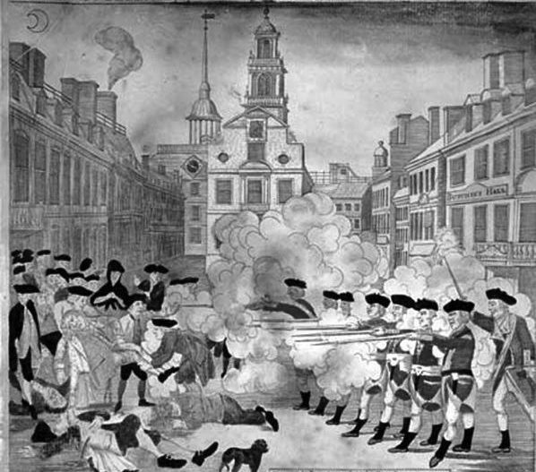
The bloody massacre perpetrated in King Street Boston on March 5th 1770 by a party of the 29th Regt. Engraving by Paul Revere: http://www.loc.gov/pictures/item/2008661777/
Teacher note: For a larger and color version of the engraving, use the following link: https://www.loc.gov/pictures/resource/cph.3g04600/
- Share with students that this is a depiction of the Boston Massacre in 1770. The Boston Massacre occurred when a large crowd of colonists crowded around and harassed English soldiers. In response, the soldiers fired their guns into the crowd killing five people and injuring six.
- Show students the “Too Late To Apologize: A Declaration” video from Soomo Publishing (safe for classroom use) about the events leading up to the Declaration of Independence based on One Republic’s “Too Late To Apologize”: https://www.youtube.com/watch?v=uZfRaWAtBVg . During the video, instruct students to take notes on the “Viewing Guide” activity sheet to answer the guiding questions.
- Pose the following questions for discussion: “What is this video depicting? How do you know? Did any images or lyrics stand out to you? What questions do you have after watching this video? Do you think the painting might be connected to the video in some way? How?”
- Discuss with students that the video depicts the relationship between the English government and the colonies leading up to the Declaration of Independence.
- Pose the following questions to the students: “The final image in the video is of the Declaration of Independence, do we understand what led up to the writing of this document? What do we think we know? What else do we need to know?”
- Lead students to the understanding that the essential question of this lesson is: “What led to the writing of the Declaration of Independence?”
- Post this question on the board.
- Pass out the “Hey, King: Get Off Our Backs!” reading from iCivics: http://www.icivics.org/teachers/lesson-plans/hey-king-get-our-backs.
- Explain to students that the reading will provide some background information on the relationship between England and the colonists.
- Instruct students to mark the text that provides them with an understanding of the relationship between England and the colonists.
- Read the passage aloud to the class.
- Have students share out some of the evidence they marked that helped them understand the relationship.
- Project the following map from eduplace: http://www.eduplace.com/ss/maps/pdf/colonies.pdf.
- Review the thirteen colonies with the students so that they have an idea of the geography of the colonies and cities that appear in the lesson. Key places to point out: Boston, Massachusetts, New England, New Jersey, New York, North Carolina, Philadelphia and Virginia.
- Pass out the “1754-1776: The Road to the Declaration of Independence” student activity sheet.
- Instruct students to write a summary statement for the “Hey, King: Get Off Our Backs!” reading in the box marked: Background Information.
- Pass out the “The Road to the Declaration of Independence” reading.
- Ask students to survey the reading and pose the following questions for discussion: “How is this text organized? How do you know? What is the time period that is being covered?” (timeline, 1754-1776)
- Read the directions on the activity sheet. Explain to students that they will understand the relationship between England and the colonies by looking at a timeline and identifying English policies or acts and the colonial perspectives or reactions for each time period.
- Complete the 1754-1763 section as a whole class. Teacher note: Use the Sample Answers section to guide completion.
- Place students into pairs.
- Instruct the pairs to complete the 1764 and 1765 sections.
- Have students share out.
- Instruct the pairs to complete the rest of the reading and activity sheet.
- Have students share their answers for the third column on the activity sheet: Colonial Concern(s). Instruct students to explain the evidence from their text that helped them determine their answer.
- Lead students to the understanding that the colonial concerns can be grouped into three main concerns: taxation, representation, and individual rights.
- Return student attention back to the “Colonial Concern(s)” and provide them with time to adjust their answers to reflect the three main concerns of taxation, representation, and individual rights.
- Checking for Understanding (Formative Assessment):
Instruct students to write a well-crafted informative response using one of the following prompts:
Prompt 1
Using what you have learned during this lesson and citing specific examples from the reading, explain the main concerns of the colonists that led to the writing of the Declaration of Independence.
Prompt 2
In 1963 Dr. Martin Luther King, Jr. wrote the following statement as part of his Letter in Birmingham Jail: We know through painful experience that freedom is never voluntarily given by the oppressor; it must be demanded by the oppressed. Based on what you have learned and citing specific examples the reading and activity sheet, how does this statement relate to the events leading up to the writing of the Declaration of Independence?
Viewing Guide
Engraving | Specific Evidence from Engraving | Complete Sentence
What do you think is going on in this engraving?
What is the issue on which it is focusing?
Engraving – Additional Notes/Evidence from Group Discussion

Video | Specific Evidence from the Video | Complete Sentence
What is the issue on which the video is focusing?
What do you think is going on in the video?
What are two key points depicted in the video?
Video – Additional Notes/Evidence from Group Discussion

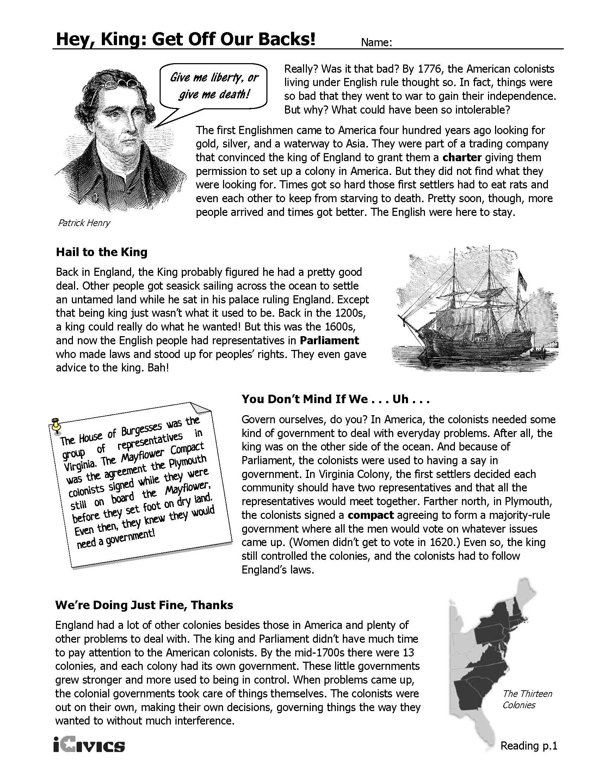
1754-1776: The Road to the Declaration of Independence
Background Information: Write a statement summarizing what you learned from the Hey, King: Get Off Our Backs!

Directions: For each time frame, summarize the activities of the English and the colonists in separate, complete sentences. In the third column use a word or phrase to summarize the colonists’ concern(s).
Time Frame | Summary of English and Colonial Activities in Complete Sentences | Colonial Concern(s)
1754-1763
1764
1765
1766 & 1767
1768 & 1769
1770-1773
1774
1775
1776 | - The Declaration of Independence is written and signed

The Road to the Declaration of Independence
1754 - 1763 | The French and Indian War began between the English and French over land in the Ohio River Valley. Colonists fought for England. The English won the war, but the war left them in debt and needing money. England looked at the colonies as a source of money and it led to a series of actions by King George and the English legislature, called Parliament that angered the colonists. In October of 1763, through the Proclamation of 1763, England banned colonists from settling west of the Appalachian mountains.  Near the end of the war, English officials were given search warrants that allowed them to search warehouses, homes, and ships of colonists without a reason. A colonist and Boston lawyer, James Otis decided to challenge whether or not the warrants were legal in court. He argued that they violated the individual rights of the colonists.
1764 | In April of 1764 Parliament taxed sugar that was imported, or brought into the colonies, to pay off the war debt and to help pay for the expenses of running the colonies. This act increased the duties, or taxes, on imported sugar and other items such as textiles, coffee, wines and indigo (dye). In response to this, Boston businesses start boycotting some English goods.  In the fall of 1764, Parliament ordered colonies to stop printing their own money. Colonists opposed the order because they feared it would upset the economy.
1765 | In March of 1765, Parliament passed the Stamp Act. Under the Stamp Act, all printed materials were taxed, including; newspapers, pamphlets, bills, legal documents, licenses, almanacs, dice and playing cards. The money collected from the tax did not go to colonial legislatures but directly to England. Later on in the same month, Parliament ordered colonial legislatures to pay for English soldiers that are located in the colonies. It also required colonists to house British troops and supply them food.  In May, Patrick Henry, a colonist, gave a speech to the Virginia legislature saying that only the Virginia legislature, not Parliament, can tax Virginians. In July, a secret group of colonists called the Sons of Liberty formed in some towns. They were opposed to the Stamp Act and they used violence and intimidation to force all of the English stamp agents to resign. They also stopped many colonists from ordering English goods. In the fall, representatives from nine of the colonies met in New York and prepared a petition to be sent to King George III and Parliament. The petition requested that the Stamp Act and the Acts of 1764 stop being enforced. The petition stated that only colonial legislatures can tax colonists and that taxation without representation violated the colonists' basic civil rights.
1766 & 1767 | In March of 1766, Parliament ended the Stamp Act, but it also passed the Declaratory Act. This act stated that England had total power to legislate any laws governing the colonies. In the summer of 1767, Parliament passed the Townshend Revenue Act. This act taxed many items imported into the colonies, such as: paper, tea, glass, lead and paints. In response, colonists decide to refuse to purchase, or boycott, some of these items.
1768 & 1769 | In February of 1768, Samuel Adams from Massachusetts wrote a letter against taxation without representation, the idea that it is unfair to tax someone without giving them representation in government, and called for resistance to the Townshend Act. He encouraged other colonies to support the letter. In September, English ships sail into Boston Harbor and English troops set up permanent residence in Boston to keep order.  In 1769, Philadelphia businesses join the boycott against British goods. Later in the year, New Jersey, Rhode Island, North Carolina also joins the boycott.
1770 - 1773 | In March of 1770, the Boston Massacre happened. This event occurred when a large crowd of colonists crowded around and harassed English soldiers. In response, the soldiers fired their guns into the crowd killing five people and injuring six. After the incident, the troops are withdrawn out of Boston. The same day as the Boston Massacre, Parliament ended all taxes on imports except for tea.  In May of 1773 Parliament made the British East India Company the only company allowed to import tea into the colonies. This is called the Tea Act. Months later, in response to the Tea Act, a group of colonists board English ships in Boston, and dump hundreds of chests of tea into the harbor. This becomes known as the Boston Tea Party.
1774 | In response to the Boston Tea Party, Parliament passed a series of laws. Colonists call them the Intolerable Acts. The first of the acts closed the port of Boston until all the damage caused by the Tea Party is paid back. The English also put Massachusetts under military rule and more troops arrived in the colony. The second of the acts made it illegal for royal officials to be brought to trial in the colonies. Instead, their trials were held in England. The third act ended the colonial government in Massachusetts and instead allowed the royal governor to appoint the colonial legislature. The fourth act ordered colonists to house troops, even in colonists’ homes. In the fifth and final act, Parliament gave land claimed by Massachusetts, Connecticut, and Virginia to Canada.  In response to these acts, the First Continental Congress met in September in Philadelphia. Every colony, except Georgia, sent representatives. The Congress declared that these acts should not be obeyed and they began forming militias in the colonies. The Congress agreed to boycott English imports and to stop exporting goods to England.
1775 | In early 1775, Massachusetts began forming militia units and Parliament declared the colony to be in a state of rebellion. A month later, King George passed an act ordering the New England (Connecticut, Massachusetts, New Hampshire and Rhode Island) colonies to trade only with England.  On April 18, Paul Revere rode from Boston to warn colonists that English troops were coming to take weapons away from the colonists. The following day, on April 19, both sides begin fighting at Lexington and Concord in Massachusetts. This is the first battle of the Revolutionary War and is referred to as “the shot heard ‘round the world.”  The following month, the Second Continental Congress met in Philadelphia. The Congress named George Washington as the commander in chief of the Continental (colonial) Army.  On June 17th, the first major battle, the Battle of Bunker Hill, occurred between the English and colonial troops. England won the battle.  After the battle, the Second Continental Congress sent a petition to King George asking him to reach an agreement with the colonists so that fighting does not have to continue. The King refused to read the petition. Instead King George proclaimed that the colonists were rebelling and he ordered troops to end the rebellion. In addition, Parliament ordered an end to colonial trade.
1776 | In January of 1776 Thomas Paine published Common Sense. The 50-page pamphlet criticized King George and argued for colonial independence. In April, the Continental Congress declared colonial shipping ports open to all traffic except the English. Throughout the year, battles between England and the colonists continued.  On June 7, Richard Henry Lee, from Virginia, presented a formal plan calling for the colonies to declare its independence from England. On June 11, Congress created a committee to draft a declaration of independence. Thomas Jefferson is chosen by the committee to prepare the first draft of the declaration, which he completed in one day. On June 28, Jefferson's Declaration of Independence is presented to the Congress. On July 4, the Congress formally supported Jefferson's Declaration, with copies sent to all of the colonies. The actual signing of the document occurred on August 2 with most of the 55 members of Congress placing their names on the document.
Adapted from: http://www.historyplace.com/unitedstates/revolution/rev-col.htm http://www.crfcelebrateamerica.org/index.php/story/69-timeline-for-american-independence, Accessed April, 2013, and http://militaryhistory.about.com/od/americanrevolution/a/amrevcauses.htm
Sources
The bloody massacre perpetrated in King Street Boston on March 5th 1770 by a party of the 29th Regt. Engraving by Paul Revere: http://www.loc.gov/pictures/item/2008661777/ and http://www.earlyamerica.com/review/winter96/enlargement.html
Too Late To Apologize: A Declaration: http://soomopublishing.com/declaration/
Hey, King: Get Off Our Backs! from iCivics: http://www.icivics.org/teachers/lesson-plans/hey-king-get-our-backs
Thirteen Colonies map from eduplace: http://www.eduplace.com/ss/maps/pdf/colonies.pdf
Letter from Birmingham Jail: http://teachingamericanhistory.org/library/document/letter-from-birmingham-city-jail-excerpts/
The Road to the Declaration of Independence, Adapted from: http://www.crfcelebrateamerica.org/index.php/story/69-timeline-for-american-independence, Accessed April 2013, http://www.historyplace.com/unitedstates/revolution/rev-col.htm and http://militaryhistory.about.com/od/americanrevolution/a/amrevcauses.htm

1754-1776: The Road to the Declaration of Independence – Sample Answers
Background Information: Write a statement summarizing what you learned from the Hey, King: Get Off Our Backs!
The colonists sailed to America from England. In England, there was a king and a Parliament. Parliament made laws and stood up for peoples’ rights. In America, the colonists needed some kind of government to deal with everyday problems. Some colonies started to create their own governments, but the king still ruled over all of the colonies. Over time, England spent more time dealing with other issues and the colonies all developed their own governments.

Directions: For each year or set of years, summarize the activities of the English and the colonists in separate, complete sentences. In the third column use a word or phrase to summarize the colonists’ concern(s).
Year(s) | Summary of English and Colonial Activities in Complete Sentences | Colonial Concern(s)
1754-1763 | - After the French and Indian War, the British began restricting the activities of the colonists.  - Boston lawyer James Otis argued that these actions violated the individual rights of the colonists. | Individual Rights
1764 | - The British begin taxing sugar and other imports. They also stop colonists from printing their own money.  - The colonists decide to boycott the taxed goods. | Taxation
1765 | - The Stamp Act is passed and money from this tax goes to the British Parliament.  - The colonists send a petition to King George asking to repeal the Stamp Act because taxation without representation violates the colonists’ rights. | Representation, Individual Rights, Taxation
1766 & 1767 | - The British pass more laws taxing the colonists.  - Some colonists decide to boycott some of the British goods. | Taxation
1768 & 1769 | - Colonists begin supporting the idea that taxation without representation is wrong and they also begin boycotting more British goods.  - The British send troops to Boston to keep order in the Massachusetts colony. | Taxation and Representation
1770-1773 | - British troops kill five colonists and injure six in the Boston Massacre. Parliament gets rid of all taxes on imports except for tea but then they only allow one British company to be import tea to the colonies.  - In response, a group of colonists board British ships in Boston, and dump hundreds of chests of tea into the harbor. | Taxation
1774 | - The British pass a series of acts that closed the port of Boston, put Massachusetts under military rule, made it illegal to bring soldiers to trial in the colonies, ended the colonial government in Massachusetts, allowed soldiers to stay in colonists’ homes and gave land to Canada.  - The colonists convene the First Continental Congress and oppose the acts, begin organizing colony militias and stop importing and exporting with England. | Rights, Taxation, Representation
1775 | - The British and the colonists begin fighting in the Revolutionary War.  - The Second Continental Congress sends a petition to King George to come to an agreement so that the fighting can stop.  - The King instead orders the troops to end the colonial rebellion. He also ends all trade for the colonies. | Individual Rights
1776 | - The British and colonists continue to battle.  - Congress agrees to pursue independence. | Individual Rights
 | - The Declaration of Independence is signed

Civics Content Vocabulary

Word/Term | Part of Speech | Definition
duty | noun | a tax
export | noun | goods sent to another country
goods | noun | merchandise or objects for sale or trade
import | noun | goods brought into the country
individual rights | noun | rights guaranteed or belonging to a person
legislature | noun | governing body responsible for making laws
levy | verb | to collect by legal authority
oppression | noun | the use of authority or power in a cruel or unjust manner
Parliament | proper noun | the English legislature
representation | noun | a person or group acting on behalf of another person or group
tax | noun | money charged by a government for specific facilities or services
taxation without representation | noun | the idea that it is unfair to tax someone without giving them a voice in government

Essential Teacher Content Background Information

This section addresses the following issues:

- Core Themes in the Declaration of Independence Reflecting Colonial Concerns
- Reasons for Drafting the Declaration of Independence
- Declaration of Independence Timeline

1. Core Themes in the Declaration of Independence Reflecting Colonial Concerns

There are three core themes, and multiple subthemes, found in the Declaration of Independence. It is a common misunderstanding that the Declaration of Independence formed a government which it did not. This concept is important because the Declaration of Independence focuses instead of what the colonists found to be unacceptable governance. These unacceptable governance practices fell into three broad categories:

A. Power was concentrated in one place (unitary government). The concentration of power contributed to the abuse of power. The form of government that created this concentration of power was going to be avoided for this reason. Generally speaking, the new government that would be created would do its best to avoid the abuse of power.

For example, the preamble includes the following phrase:

“….whenever any Form of Government becomes destructive of these ends, it is the Right of the People to alter or to abolish it, and to institute new Government, laying its foundation on such principles and organizing its powers in such form, as to them shall seem most likely to effect their Safety and Happiness.”

B. The colonists were denied acceptable representation in the legislature (“He has refused to pass other Laws for the accommodation of large districts of people, unless those people would relinquish the right of Representation in the Legislature, a right inestimable to them and formidable to tyrants only.”). Accordingly, the new government would guarantee representation in the legislature. Many historians and political scientists argue that the colonists identified representation in the legislature to be of key importance because the legislative power is the greatest among the three powers of government (legislative, executive, judicial). The legislative power is the greatest among the three powers of government because only laws can be enforced or adjudicated. The absence of laws means no adjudication or enforcement.

C. States’ rights were denied. King George III denied the states a voice in governance (“He has refused to pass other Laws for the accommodation of large districts of people.”). This meant that the new government would respect states’ rights for, among other reasons, states are closest to the people, and would more likely garner the people’s consent.

Together, the Declaration of Independence outlined the colonists’ concerns about how King George III treated them. While the Declaration does not itself form a government, it does indicate what the colonists would avoid (abuse or power, or tyranny) or pursue (representation in the legislature, states’ rights) when they did form governments in the future. The two governments that were eventually formed were organized under the Articles of Confederation (1781-1789) and the U.S. Constitution (1789-present).

2. Reasons for Drafting the Declaration of Independence

The colonists’ decision to draft the Declaration of Independence followed several years of conflict between the British crown and the colonists. Historians argue that this relationship started to deteriorate in 1763 following the end of the Seven Years War. The Seven Years War resulted in significant debt for the British government. As a way to emerge from this debt, the British Parliament passed several laws that taxed the colonists including the Stamp Act (1765) and the Townshend Acts (1767). In 1774, the Parliament passed the Coercive Acts as a way to punish the colonists living in Massachusetts for the Boston Tea Party. The Coercive Acts compelled the First Continental Congress to meet in Philadelphia to agree on a response, which included a boycott of British goods and petitioning the king for a repeal of these acts. King George III did not respond to the colonists’ requests for relief on the principle that the colonists did not have the right to make such requests. The colonists generated a second petition in 1775 which was rejected by the king, and Common Sense was published in early 1776.

Between 1763 and 1776, the relationship between the colonists and the king deteriorated. The deterioration of this relationship was tied to taxes enacted by the British Parliament, and the king’s refusal to redress the colonists’ grievances.

3. Declaration of Independence Timeline

Source: “Brief History of the Declaration of Independence” by Robert Longley; available at: http://usgovinfo.about.com/cs/historicdocuments/a/bldechist.htm

May 1775 - The Second Continental Congress convenes in Philadelphia. A "petition for redress of grievances," sent to King George III of England by the First Continental Congress in 1774, remains unanswered.
June - July 1775 - Congress establishes the Continental Army, a first national monetary currency and a post office to serve the "United Colonies."
August 1775 - King George declares his American subjects to be "engaged in open and avowed rebellion" against the Crown. The English Parliament passes the American Prohibitory Act, declaring all American sea-going vessels and their cargo the property of England.
January 1776 - Colonists by the thousands buy copies of Thomas Paine's "Common Sense," stating the cause of American independence.
March 1776 - Congress passes the Privateering Resolution, allowing colonists to arm vessels in order to "cruize [sic] on the enemies of these United Colonies."
April 6, 1776 - American seaports were opened to trade and cargo from other nations for the first time.
May 1776 - Germany, through a treaty negotiated with King George, agrees to hire mercenary soldiers to help put down any potential uprising by American colonists.
May 10, 1776 - Congress passes the "Resolution for the Formation of Local Governments," allowing colonists to establish their own local governments. Eight colonies agreed to support American independence.
May 15, 1776 - The Virginia Convention passes a resolution that "the delegates appointed to represent this colony in General Congress be instructed to propose to that respectable body to declare the United Colonies free and independent states."
June 7, 1776 - Richard Henry Lee, Virginia's delegate to the Continental Congress, presents the Lee Resolution reading in part: "Resolved: That these United Colonies are, and of right ought to be, free and independent States, that they are absolved from all allegiance to the British Crown, and that all political connection between them and the State of Great Britain is, and ought to be, totally dissolved."
June 11, 1776 - Congress postpones consideration of the Lee Resolution and appoints the "Committee of Five" to draft a final statement declaring the case for America's independence. The Committee of Five is composed of: John Adams of Massachusetts, Roger Sherman of Connecticut, Benjamin Franklin of Pennsylvania, Robert R. Livingston of New York and Thomas Jefferson of Virginia.
July 2, 1776 - By the votes of 12 of the 13 colonies, with New York not voting, Congress adopts the Lee Resolution and begins consideration of the Declaration of Independence, written by the Committee of Five.
July 4, 1776 - Late in the afternoon, church bells ring out over Philadelphia heralding the final adoption of the Declaration of Independence.
August 2, 1776 - The delegates of the Continental Congress sign the clearly printed or "engrossed" version of the Declaration.

