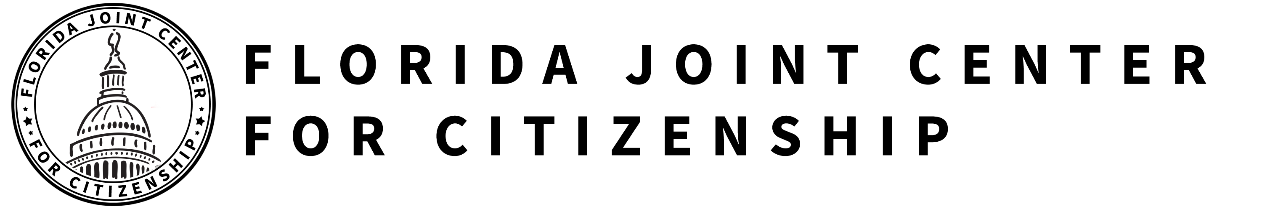

INFLUENCES ON COLONISTS’ VIEWS OF GOVERNMENT
SS.7.C.1.2 Trace the impact that the Magna Carta, English Bill of Rights, Mayflower Compact, and Thomas Paine’s Common Sense had on the colonists’ views of government.

TABLE OF CONTENTS

Lesson Summary 2
Suggested Student Activity Sequence 3
Student Activity Sheets & Reading Materials 5
Sources 10
Answer Keys 11
Civics Content Vocabulary 13
Essential Teacher Content Background Information 14

Lesson Summary
Essential Question
What were some of the key influences on the colonists’ views of government?

NGSSS Benchmark
SS.7.C.1.2 Trace the impact that the Magna Carta, English Bill of Rights, Mayflower Compact, and Thomas Paine’s Common Sense had on colonists’ views of government.

Florida Standards
LAFS.68.RH.1.1 LAFS.68.RH.1.2 LAFS.68.RH.2.4 LAFS.68.RH.3.7
LAFS.68.WHST.1.2 LAFS.68.WHST.4.10 LAFS.7.SL.1.1 LAFS.7.SL.1.2

Overview
In this lesson, students will learn about the ideas that influenced the colonists’ views of government.

Learning Goals/Benchmark Clarifications
- Students will identify the important ideas contained in the Magna Carta, English Bill of Rights, Mayflower Compact, and Common Sense.
- Students will evaluate the impact that the Magna Carta, English Bill of Rights, Mayflower Compact, and Common Sense had on the purposes of government.

Benchmark Content Limits
- Items will not require students to address the origin of ideas in the Magna Carta, English Bill of Rights, Mayflower Compact, and Common Sense.

Civics EOC Reporting Category
Reporting Category 1 – Origins and Purposes of Law and Government

Suggested Time Frame
- Two 45-50 minute class periods

Civics Content Vocabulary
- Common Sense, compact, English Bill of Rights, due process, limited government, limited monarchy, Magna Carta, Mayflower Compact, Preamble, rights, rule of law, self-government, Thomas Paine

Instructional Strategies
Guided reading Collaborative learning Inquiry with primary sources

Materials
Computer with internet access to project lesson activity sheets
Student activity sheets and reading materials:
- Colonial Influences: Anticipation Activity, Reading pgs. 1 and 2, and Activity from iCivics: http://www.icivics.org/teachers/lesson-plans/colonial-influences
- Understanding the Influence student activity sheet
- Evaluating the Impact on Government student activity sheet

Lesson Activities and Daily Schedule
Please use the chart below to track activity completion.
Day | Task # | Steps in Lesson | Description | Completed?  Yes/No
Day One | Task 1 | 1-4 | Hook Activity
 | Task 2 | 5-17 | Colonial Influences Reading
Day Two | Task 3 | 18-27 | Evaluating the Impact on Government Activities
 | Task 4 | 28 | Checking for Understanding

Suggested Student Activity Sequence

- To begin this lesson, place students into pairs and pass out the “Colonial Influences, Anticipation Activity” student activity sheet from iCivics: http://www.icivics.org/teachers/lesson-plans/colonial-influences.
- Explain to students that the U.S. Constitution is based on the “big ideas” listed on the activity sheet. Instruct students to work with their partner to brainstorm what they know about each “big idea” and to write their understanding for each term on the activity sheet.
- Have students share out.
- Lead students to the definitions for each “big idea” from the Civics Content Vocabulary section. Instruct students to write each definition in “The Class Definition” row of their activity sheet.
- Pass out the “Colonial Influences, Reading pgs. 1 and 2” from iCivics: http://www.icivics.org/teachers/lesson-plans/colonial-influences and the “Understanding Influences” student activity sheet.
- Read the first two paragraphs aloud as a whole class.
- Pose the following questions for discussion: “What is the main idea from the first two paragraphs? What does this tell you about who influenced the colonists ideas about government?”
- Explain to students that they will read about five different historical documents that have influenced the colonists’ ideas about government. Their task is to read about each document, explain its main purpose, identify the “big idea” that emerged from the document and explain the relationship between the big idea and the document in their own words.
- Instruct students to work with their partner to read the Magna Carta section and complete the corresponding row on their activity sheet.
- Pose the following questions for discussion: “What is the big idea that emerged from the Magna Carta? What evidence in the text led you to your answer?”
- Explain to students that the Magna Carta provided the idea of limited government, but more specifically a limited monarchy. A limited monarchy is a system of government in which the king or queen shares authority with an elected legislature and agrees to be bound by a constitution or a set of laws. Instruct students to add this term to the back of their activity sheet.
- Direct student attention to the Mayflower Compact section of the reading. Ask the students to define the term “compact”. Lead students to the understanding that a compact is an official agreement made by two or more parties. Instruct students to add this definition to the back of their student activity sheet.
- Provide time for students to complete the reading and activity sheet for the Mayflower Compact, English Bill of Rights, and Cato’s Letters.
- Read together the section for Common Sense. Instruct students to write down the main purpose of the pamphlet on their activity sheet.
- Share with students that Thomas Paine’s Common Sense supported the colonists seeking independence from England. The pamphlet supported the idea of self-government for the colonists and spoke out against the king restricting the colonists’ rights. Instruct students to take notes on their activity sheet.
- Pose the following question for discussion: “How would you summarize the important ideas contained in the Magna Carta, English Bill of Rights, Mayflower Compact, Cato’s Letters and Common Sense?”
- Instruct students to write a summary statement on their activity sheet.
- Explain to students that now that they know the big ideas of each document, they will look at how these ideas impacted the colonists’ views of government by looking at how these ideas are incorporated into the U.S. Constitution and Bill of Rights.
- Pass out the “Evaluating the Impact on Government” student activity sheet and explain to students that their task is to read each passage from the U.S. Constitution and Bill of Rights, summarize the passage in their own words, determine the big idea that influenced the passage and write down the evidence that led them to their answer.
- Provide time for students to work with their partner to complete the activity sheet.
- Monitor student work.
- Point out to students that the last passage of the “Evaluating the Impact on Government” student activity sheet is from the Preamble of the U.S. Constitution.
- Project the text for the Preamble: We the People of the United States, in Order to form a more perfect Union, establish Justice, insure domestic Tranquility, provide for the common defence, promote the general Welfare, and secure the Blessings of Liberty to ourselves and our Posterity, do ordain and establish this Constitution for the United States of America.
- Explain to students that the Preamble outlines the purposes of our government:
  - form a more perfect union by creating a government that works for all (self-government and rule of law),
  - establish justice to ensure there is a fair system of laws (rule of law, due process),
  - insure domestic tranquility which means to promote peace in the country (rights),
  - protect the country from other countries or people that might try to harm us by providing for the common defense (rights),
  - promote the general welfare by creating a better life for all (self-government and rule of law), and
  - to secure the blessings of liberty to ourselves and our posterity which means to secure liberty and freedom to this and future generations (rights).
- Pose the following questions for discussion: “Do the big ideas we have learned about in this lesson relate to the purposes of government that are outlined in the Preamble? What does this tell you about the impact of these big ideas?”
- Instruct students to work with their partner to brainstorm and write answers on their own notebook paper.
- Have students share out and discuss as a whole class.
- Checking for Understanding (Formative Assessment):
Instruct students to write a well-crafted informative response using one of the following prompts:
Prompt 1
Explain how the big ideas that emerged from the historical documents you read about in this lesson have been incorporated into the U.S. Constitution.
Prompt 2
Explain how the Magna Carta, English Bill of Rights, Mayflower Compact, and Common Sense have impacted the purposes of government.
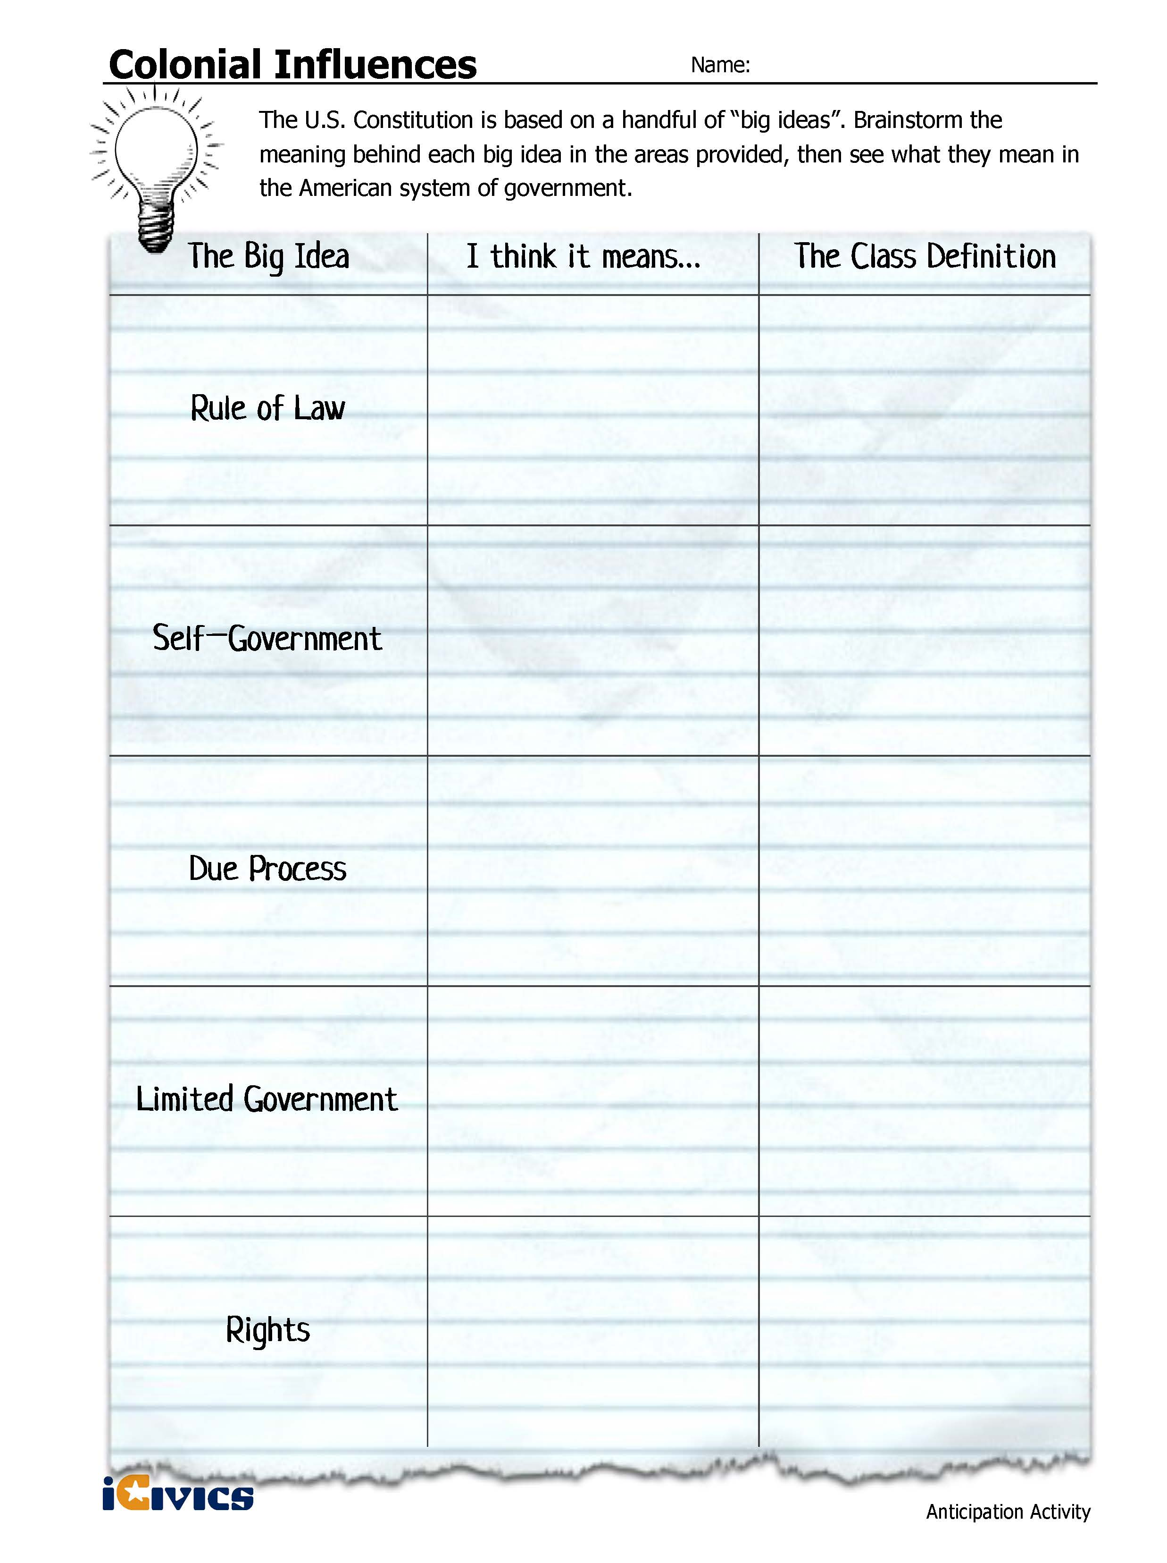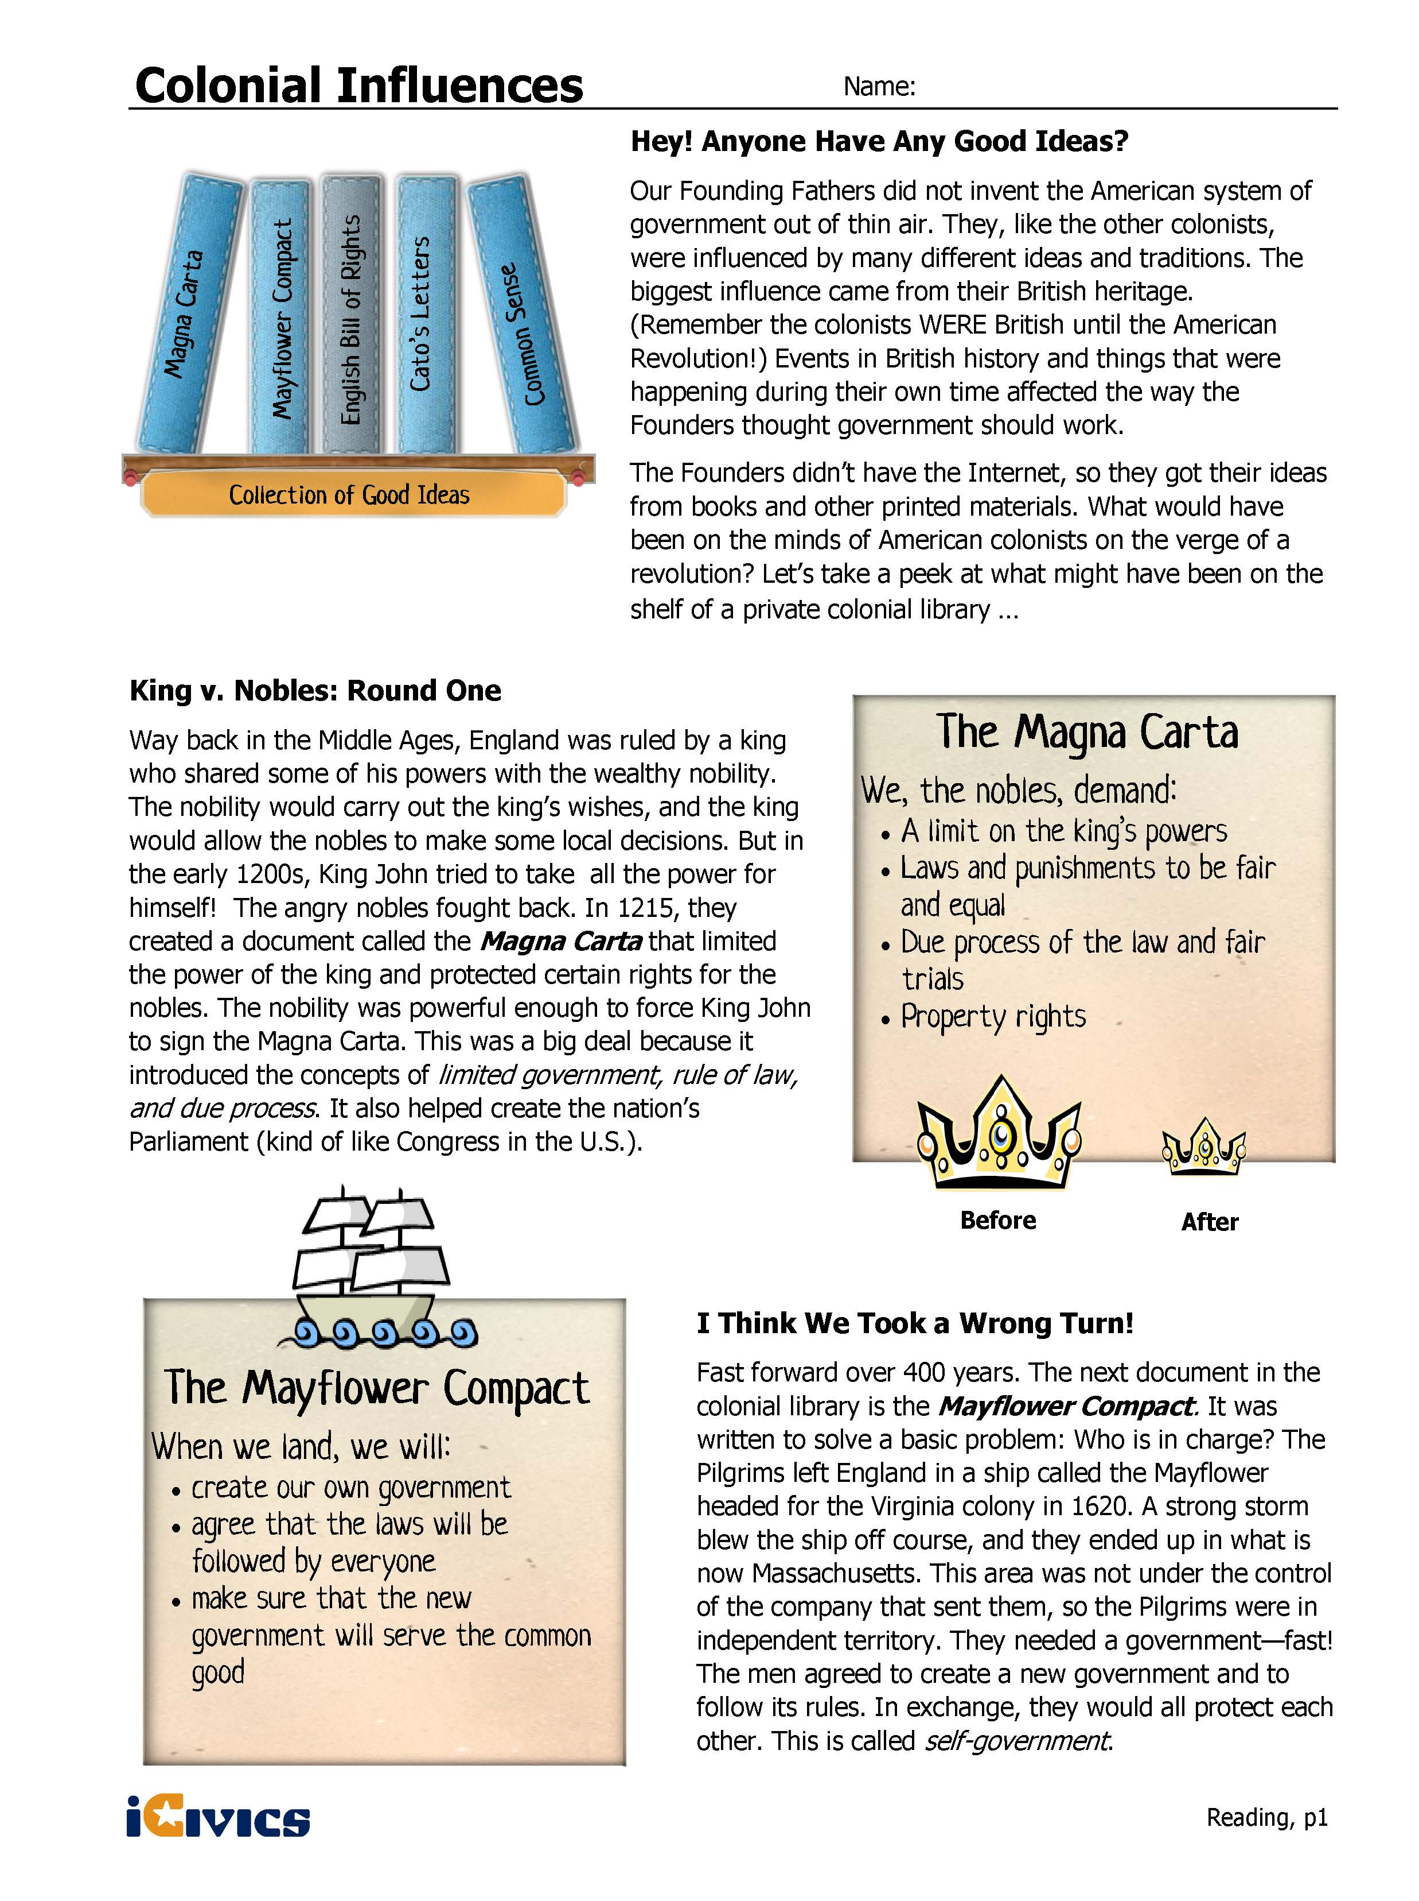

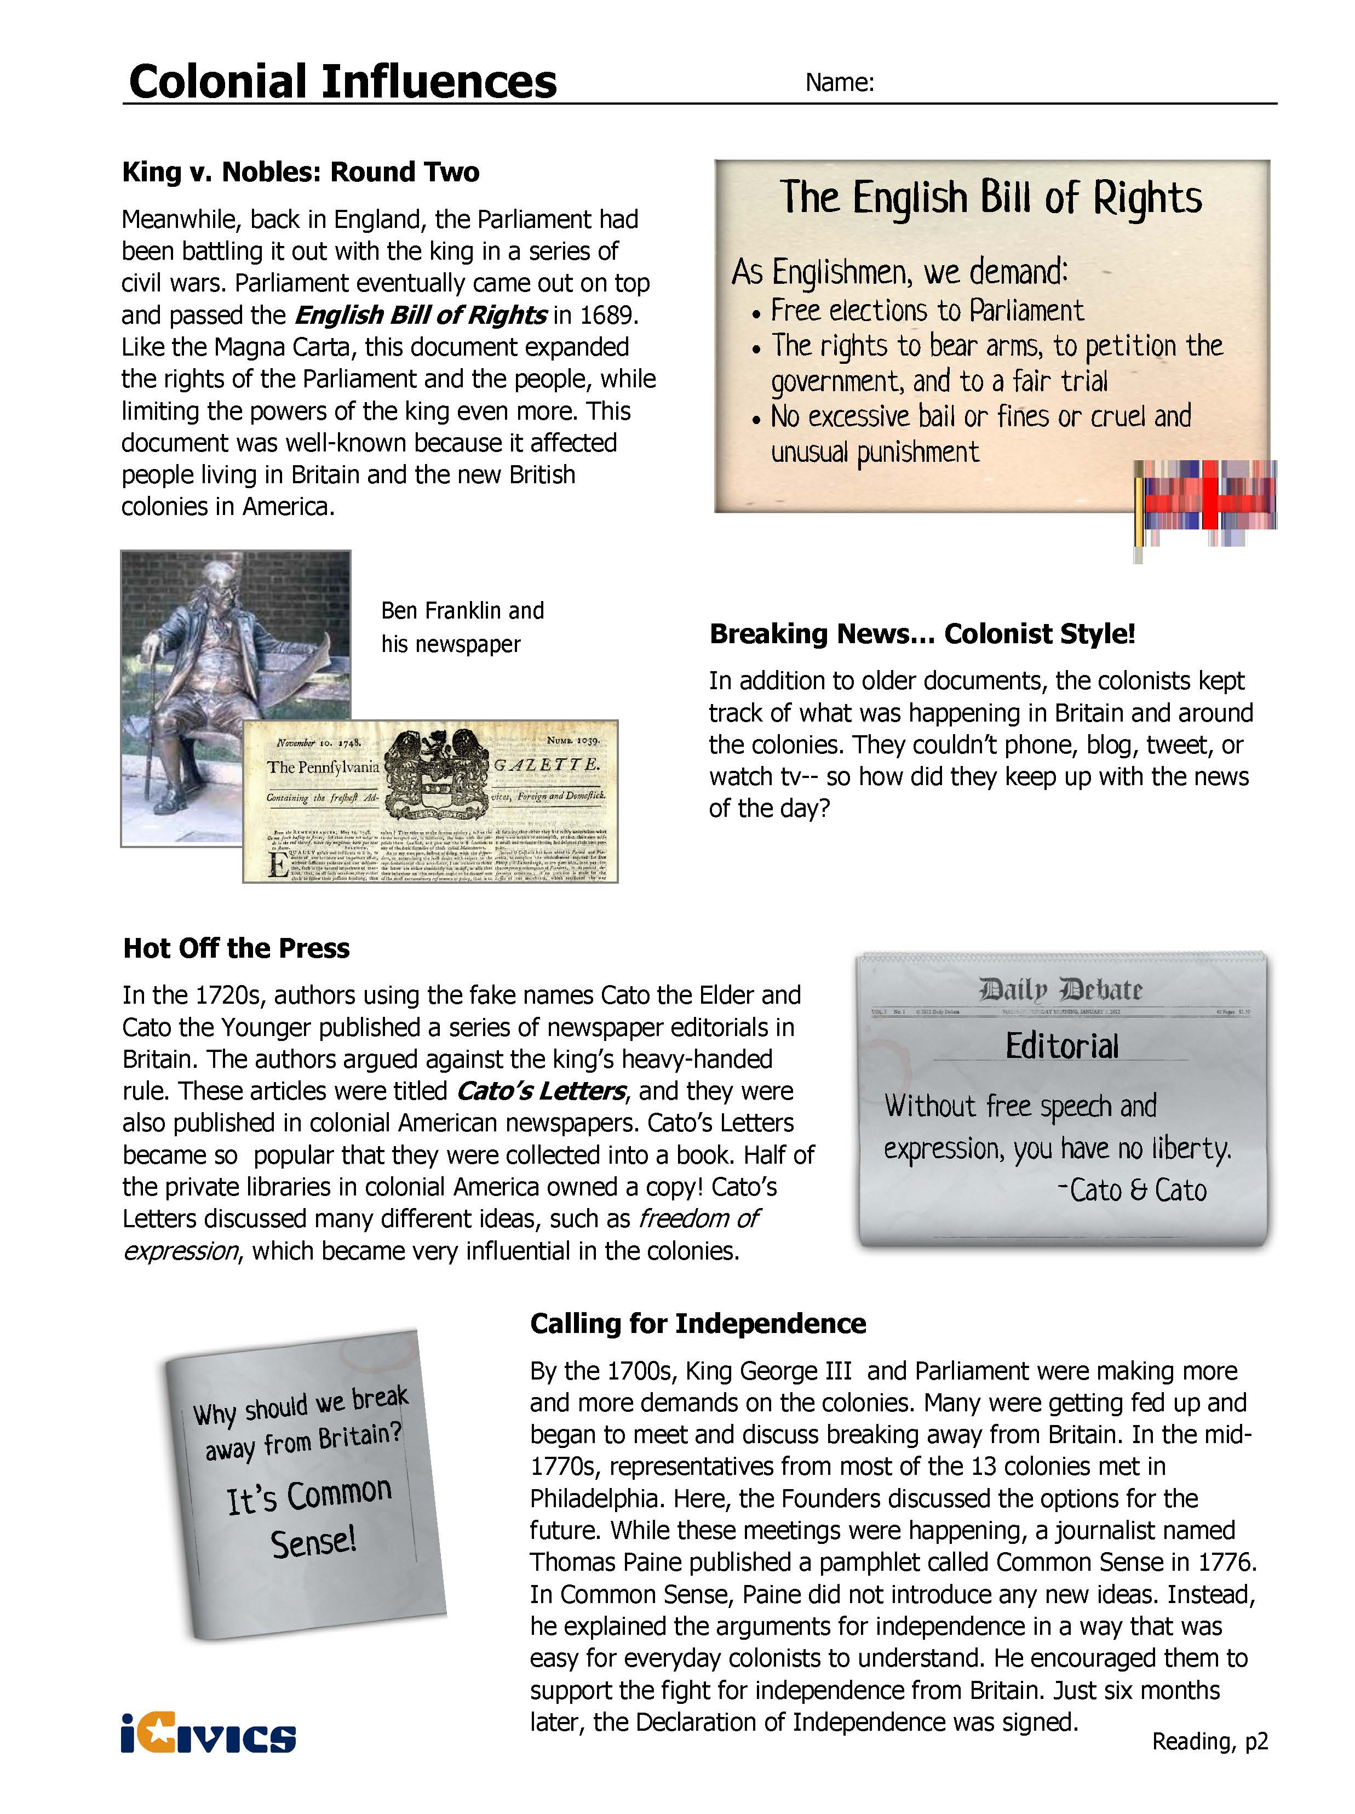
Understanding the Influence
Directions: Using your reading, explain the main purpose of each document, identify the “big idea” that emerged from the document and explain the big idea and its relationship to the document in your own words.

Document | Main purpose of the document | Big idea from the document | Explanation of big idea
Magna Carta
Mayflower Compact
English Bill of Rights
Cato’s Letters
Common Sense
Summary Statement

Evaluating the Impact on Government
Directions: Using what you have learned about the big ideas from each document, determine how these influences appear in the U.S. Constitution. Read each passage below, mark text that helps you identify the main idea, and write the main idea in your own words. Then, determine which of the following concepts influenced the passage and the evidence from the text that supports your answer.

Passage | What does this mean in your own words | Big Idea | Evidence from text
“This Constitution and the laws of the United States ... shall be the supreme law of the land.” All government officials “shall be bound by an oath to support this constitution.” – Article VI
The first ten amendments in the Bill of Rights guarantees certain rights and freedoms that include:
Freedom of speech, the press, and religion, right to petition the government and to bear arms
The U.S. Constitution created three branches of government. Each branch is given the power to check, or limit the power of the other two. The system of checks and balances keeps any one branch from getting too powerful.
“No person shall...be deprived of life, liberty, or property, without due process of law”
U.S. Constitution, 5th Amendment
“We the People of the United States...do ordain and establish this Constitution for the United States of America.”
Adapted from iCivics Colonial Influences: http://www.icivics.org/teachers/lesson-plans/colonial-influences
Source
Colonial Influences Lesson Plan from iCivics: http://www.icivics.org/teachers/lesson-plans/colonial-influences

Understanding the Influence – Sample Answers
Directions: Using your reading, explain the main purpose of each document, identify the “big idea” that emerged from the document and explain the big idea and its relationship to the document in your own words.

Document | Main purpose of the document | Big idea from the document | Explanation of big idea
Magna Carta | The Magna Carta’s main purpose was to limit the power of the king and protect certain rights for the nobles. | limited government | The Magna Carta limited the king’s power and provided the people with rights and due process.
Mayflower Compact | The Mayflower Compact was created to give the Puritans a government.  A compact is an official agreement made by two or more parties. | self-government | Through the Mayflower Compact, the Puritans agreed to laws that will be followed by everyone and make sure that the new government will serve the common good.
English Bill of Rights | The English Bill of Rights expanded the rights of the Parliament and the people and limited the rights of the king. | rights | The English Bill of Rights created free elections, the right to bear arms, petition the government and a fair trial. It also ended excessive bail and cruel and unusual punishment.
Cato’s Letters | Cato’s Letters were newspaper editorials that focused on freedom of expression. | rights | Cato’s Letters supported the right to freedom of expression and speech.
Common Sense | Common Sense communicated the ideas for independence and made it easy to understand for everyday colonists. | self-government, rights | Common Sense supported the idea of the colonies being independent from England in order to self govern and protect their rights.

Evaluating the Impact on Government – Sample Answers
Directions, Using what you have learned about the big ideas from each document, determine how these influences appear in the U.S. Constitution. Read each passage below, mark text that helps you identify the main idea, and write the main idea in your own words. Then, determine which of the following concepts influenced the passage and the evidence from the text that supports your answer.
Passage | What does this mean in your own words | Big Idea | Evidence from text
“This Constitution and the laws of the United States ... shall be the supreme law of the land.” All government officials “shall be bound by an oath to support this constitution.” – Article VI | The Constitution is the supreme law of the land and all government officials are required to follow the Constitution. | Rule of Law | supreme law of the land, all government officials shall by bound
The first ten amendments in the Bill of Rights guarantees certain rights and freedoms that include:  Freedom of speech, the press, and religion, right to petition the government and to bear arms | The Bill of Rights guarantees certain rights and freedoms. | Rights | Bill of Rights guarantees certain rights and freedoms
The U.S. Constitution created three branches of government. Each branch is given the power to check, or limit the power of the other two. The system of checks and balances keeps any one branch from getting too powerful. | The U.S. Constitution has three branches of government that are limited and can check each other. | Limited government | Each branch is given the power to check, or limit the power of the other two.
“No person shall...be deprived of life, liberty, or property, without due process of law”  U.S. Constitution, 5th Amendment | No person shall be deprived due process. | Due process | due process of law
“We the People of the United States...do ordain and establish this Constitution for the United States of America.” | We the people establish the Constitution. | Self-government | We the People

Civics Content Vocabulary

Word/Term | Part of Speech | Definition
Common Sense | proper noun | a pamphlet published by Thomas Paine in 1776 to convince the American colonists to support becoming independent from England
compact | noun | an official agreement made by two or more parties
due process | noun | the right of people accused of crimes to have laws that treat them fairly, so that they cannot lose their life or freedom without having their legal rights protected
English Bill of Rights | proper noun | a government document that expanded the powers of the English Parliament and expanded the rights of the people, as well as further limited the rights of the king; written by the members of the English Parliament in 1689
limited government | proper noun | a government that has been limited in power by a constitution, or written agreement
limited monarchy | noun | a system of government in which the king or queen shares authority with an elected legislature and agrees to be bound by a constitution or a set of laws, also known as a constitutional monarchy
Magna Carta | proper noun | a government document that limited the power of the king of England and protected the rights of the nobility; written by the English nobles in 1215
Mayflower Compact | proper noun | an agreement between individuals that created a government that would provide order and protect the rights of the colonists; written by a group of English Puritans in Massachusetts in 1620
Preamble | proper noun | the introduction to the U.S. Constitution
rights | noun | a set of things that people believe they should be free to do
rule of law | noun | the idea that those who govern must follow the laws; no one is above the law
self-government | noun | popular or representative system where the people create and run their own government
Thomas Paine | proper noun | the colonial journalist who wrote Common Sense in 1776

Essential Teacher Content Background Information

This section addresses the following issues:

- Core documents that impacted the colonists’ view of government
- Document analysis of the Magna Carta, English Bill of Rights, Mayflower Compact, and Common Sense
- Mayflower Compact text (spelling and capitalization in original)

1. Core documents that impacted the colonists’ view of government

Several core documents impacting the colonists’ views of government reflect Enlightenment values. These documents include the English Magna Carta, the English Bill of Rights, the Mayflower Compact and Common Sense by Thomas Paine.

2. Document analysis of the Magna Carta, English Bill of Rights, Mayflower Compact, and Common Sense

Document Name | Date | Document Country of Origin | Purpose of Document | Core Themes and Influences
Magna Carta (The Great Charter of Freedoms) | 1215 | England | Required King John of England to protect certain rights  Limited King’s powers  Protected subjects’ privileges  (Note: While these goals were not achieved, the document became an important symbol for those who wished to show that the king was bound by law) | Writ of habeas corpus  Rule of constitutional law  Development of common law
Bill of Rights (An Act Declaring the Rights and Liberties of the Subject and Settling the Succession of the Crown) | 1689 | England | Restate in statutory form the Declaration of Rights presented by the Convention Parliament to William and Mary inviting them to become joint sovereigns of England | Lists rights for citizens and permanent residents of a constitutional monarchy  Included the right to petition the monarch  Included the right to bear arms in defense  Emphasizes the importance of the consent of the people  Influenced the U.S. Bill of Rights (1791)
Mayflower Compact | 1620 | American colonies | Set up a government and write first written laws for the new settlers arriving at Plymouth Rock (now Provincetown Harbor, Cape Cod, Massachusetts) | Fair and equal laws for the general good of the settlement  Will of the majority  Social contract where the settlers consented to follow the Compact’s rules for the sake of the survival of the new colony  John Adams and others have referred to it as the foundation of the U.S. Constitution
Common Sense by Thomas Paine (published anonymously) | 1776 | American colonies | Placed the blame for the British colonists on King George III  Challenged the authority of the British government and the royal monarchy  Published anonymously, the document advocated that the colonists declare their independence from the British crown | Advocated a movement for sovereignty of the people, a written constitution, and effective governmental checks and balances

3. Mayflower Compact text (spelling and capitalization in original)

In the name of God, Amen. We whose names are underwritten, the loyal subjects of our dread Sovereign Lord King James, by the Grace of God of Great Britain, France and Ireland, King, Defender of the Faith, etc.

Having undertaken, for the Glory of God and advancement of the Christian Faith and Honour of our King and Country, a Voyage to plant the First Colony in the Northern Parts of Virginia, do by these presents solemnly and mutually in the presence of God and one of another, Covenant and Combine ourselves together into a Civil Body Politic, for our better ordering and preservation and furtherance of the ends aforesaid; and by virtue hereof to enact, constitute and frame such just and equal Laws, Ordinances, Acts, Constitutions and Offices, from time to time, as shall be thought most meet and convenient for the general good of the Colony, unto which we promise all due submission and obedience. In witness whereof we have hereunder subscribed our names at Cape Cod, the 11th of November, in the year of the reign of our Sovereign Lord King James, of England, France and Ireland the eighteenth, and of Scotland the fifty-fourth. Anno Domini 1620.

