Bank Item Number | G.C.4.1.L1
Benchmark | SS.7.C.4.1
Cognitive Complexity | Low
Item | What is a responsibility of the U.S. Senate in foreign policy?
A | nominating ambassadors
B | introducing tax bills
C | negotiating treaties
D | ratifying treaties

Bank Item Number | G.C.4.1.L1
Benchmark | SS.7.C.4.1
Cognitive Complexity | Low
Item | What is a responsibility of the U.S. Senate in foreign policy?
A | nominating ambassadors | Incorrect-It is the president’s sole responsibility to nominate ambassadors, who must then be confirmed by the U.S. Senate.
B | introducing tax bills | Incorrect-Article I, Section 7 of the U.S. Constitution requires that tax bills be introduced in the House of Representatives although the Senate may “propose or concur” amendments. Tax bills are also examples of domestic policy, not foreign policy.
C | negotiating treaties | Incorrect- It is the president’s sole responsibility to negotiate treaties on behalf of the United States. Treaties cannot take effect until they have been ratified by the Senate.
D | ratifying treaties | Correct-It is the U.S. Senate’s sole responsibility to ratify treaties.

Bank Item Number | G.C.4.1.M1
Benchmark | SS.7.C.4.1
Cognitive Complexity | Moderate
Item | Which action is an example of a domestic policy decision?
A | The Senate votes to ratify a treaty.
B | The president nominates an ambassador.
C | Congress votes to increase the income tax.
D | The president asks Congress to declare war.

Bank Item Number | G.C.4.1.M1
Benchmark | SS.7.C.4.1
Cognitive Complexity | Moderate
Item | Which action is an example of a domestic policy decision?
A | The Senate votes to ratify a treaty. | Incorrect-Treaties are negotiated agreements between and among nations; ratification of a treaty is a foreign policy decision.
B | The president nominates an ambassador. | Incorrect-Ambassadors represent the United States in foreign relations. Nations with which the United States has a diplomatic relationship will be represented by an ambassador. There are also U.S. ambassadors to international organizations such as the United Nations.
C | Congress votes to increase the income tax. | Correct-Raising the income tax is a domestic policy decision because Congress is making a decision as to what United States citizens and residents will pay in income tax.
D | The president asks Congress to declare war. | Incorrect-A declaration of war is a foreign policy decision because the United States cannot declare war on itself as a nation or part of the nation such as a state or territory.

Bank Item Number | G.C.4.1.M2
Benchmark | SS.7.C.4.1
Cognitive Complexity | Moderate
Item | The statement below was made by Secretary of State Hillary Clinton during a January 23, 2013 Senate hearing.  It has been one of the great honors of my life to lead the men and women of the State Department … nearly 70,000 serving here in Washington, more than 270 posts around the world. They get up and get to work every day, often in difficult and dangerous circumstances, because they believe, as we believe, the United States is the most extraordinary force for peace and progress the world has ever known.  Source: U.S. Department of State  Based on the statement, which is a goal of U.S. policy?
A | diplomatic alliances
B | homeland security
C | citizen protection
D | avoiding conflict

Bank Item Number | G.C.4.1.M2
Benchmark | SS.7.C.4.1
Cognitive Complexity | Moderate
Item | The statement below was made by Secretary of State Hillary Clinton during a January 23, 2013 Senate hearing.  It has been one of the great honors of my life to lead the men and women of the State Department … nearly 70,000 serving here in Washington, more than 270 posts around the world. They get up and get to work every day, often in difficult and dangerous circumstances, because they believe, as we believe, the United States is the most extraordinary force for peace and progress the world has ever known.  Source: U.S. Department of State  Based on the statement, which is a goal of U.S. policy?
A | diplomatic alliances | Correct-The use of the phrase “force for peace and progress the world has ever known” focuses on the importance of diplomatic alliances between the United States and other “posts” around the world.
B | homeland security | Incorrect-Homeland security focuses on the interests of the United States and its citizens. The focus of homeland security is keeping people safe, and not promoting peace and progress.
C | citizen protection | Incorrect-Citizen protection focuses on the interests of U.S. citizens and not on promoting peace and progress around the world.
D | avoiding conflict | Incorrect-According to the statement, persons working for the State Department may face conflict in their efforts to promote peace and progress.

Bank Item Number | G.C.4.1.M3
Benchmark | SS.7.C.4.1
Cognitive Complexity | Moderate
Item | The political cartoon below illustrates a foreign policy issue.  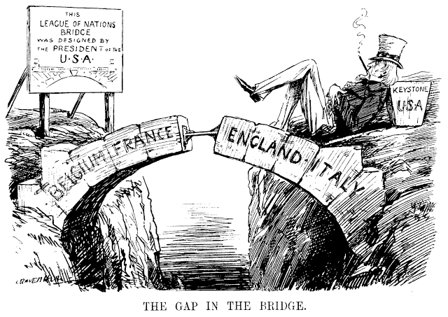  Source: Public Domain  What issue is illustrated in the cartoon?
A | The Cabinet did not ratify a treaty.
B | The President did not ratify a treaty.
C | The U.S. Senate did not ratify a treaty.
D | The Secretary of State did not ratify a treaty.

Bank Item Number | G.C.4.1.M3
Benchmark | SS.7.C.4.1
Cognitive Complexity | Moderate
Item | The political cartoon below illustrates a foreign policy issue.  Source: Public Domain  What issue is illustrated in the cartoon?
A | The Cabinet did not ratify a treaty. | Incorrect-The Cabinet does not have the power to ratify treaties; the U.S. Senate has the sole power to ratify treaties.
B | The President did not ratify a treaty. | Incorrect-The president does not have the power to ratify treaties; the president has the power to negotiate treaties although the U.S. Senate has the sole power to ratify treaties.
C | The U.S. Senate did not ratify a treaty. | Correct-The U.S. Senate did not ratify the “League of Nations” which was formed by a treaty for the several nations identified in the bridge to support one another. According to the cartoon, the U.S. president negotiated the treaty (“Designed by the president of the U.S.A.). The United States did not join the “League of Nations” which means that the Senate refused to confirm the treaty.
D | The Secretary of State did not ratify a treaty. | Incorrect-The Cabinet does not have the power to ratify treaties; the U.S. Senate has the sole power to ratify treaties.

Bank Item Number | G.C.4.1.H1
Benchmark | SS.7.C.4.1
Cognitive Complexity | High
Item | Below is a graph about high school graduation rates in the United States.  Source: Adapted from National Center for Education Statistics  Which long term domestic policy goal is reflected in the graph?
A | career preparation
B | physical fitness
C | racial equality
D | public safety

Bank Item Number | G.C.4.1.H1
Benchmark | SS.7.C.4.1
Cognitive Complexity | High
Item | Below is a graph about high school graduation rates in the United States.  Source: Adapted from National Center for Education Statistics  Which long term domestic policy goal is reflected in the graph?
A | career preparation | Correct-Educational success leads to improved career and professional opportunities.
B | physical fitness | Incorrect-The focus on public high school students’ graduation rate is not related to physical fitness, which, while taught in public school, does not play an direct, long term role in long term economic success.
C | racial equality | Incorrect-The focus on public high school students’ graduation success does not address racial equality even though racial equality may play a role in public high school students’ success.
D | public safety | Incorrect-The focus on public high school students’ graduation success does not address public safety even though being safe may play an important role in high school students’ success.

