Bank Item Number |  | G.C.3.1.L1
Benchmark |  | SS.7.C.3.1
Cognitive Complexity |  | L
Item |  | How does monarchy differ from other forms of government?
A |  | Leaders are named in the constitution.
B |  | Leaders are chosen by the upper class.
C | * | Leaders are born into ruling families.
D |  | Leaders are given power by kings.

Bank Item Number |  | G.C.3.1.M1
Benchmark |  | SS.7.C.3.1
Cognitive Complexity |  | M
Item |  | The picture below shows a government leader.  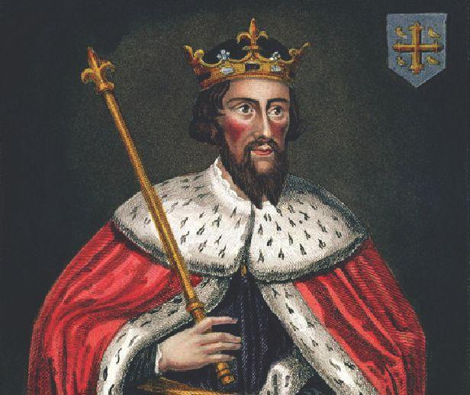  Source: Wikimedia Commons  Which form of government would have this type of leader?
A |  | democracy
B | * | monarchy
C |  | oligarchy
D |  | theocracy

Bank Item Number |  | G.C.3.1.M2
Benchmark |  | SS.7.C.3.1
Cognitive Complexity |  | M
Item |  | What do a republic and a direct democracy have in common?
A |  | rule by a single political party
B | * | rule by the people
C |  | a small group of leaders
D |  | a single leader

Bank Item Number |  | G.C.3.1.M3
Benchmark |  | SS.7.C.3.1
Cognitive Complexity |  | M
Item |  | The scenario below describes a government decision.  ---------------------------  A self-appointed council amends the country’s constitution.  ---------------------------  Based on the scenario, which form of government is taking action?
A |  | dictatorship
B |  | monarchy
C | * | oligarchy
D |  | republic

Bank Item Number |  | G.C.3.1.H1
Benchmark |  | SS.7.C.3.1
Cognitive Complexity |  | H
Item |  | The image below includes a statement influenced by an 1848 book.  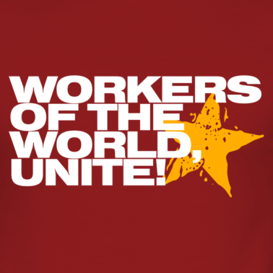  What modern political action could be influenced by the statement?
A | * | A communist country invades a democratic country.
B |  | A representative democracy amends its constitution.
C |  | A queen speaks before Parliament to officially open Parliament.
D |  | A dictator orders the invasion of a neighboring country.

