Bank Item Number | G.C.3.1.L1
Benchmark | SS.7.C.3.1
Cognitive Complexity | Low
Item | How does monarchy differ from other forms of government?
A | Leaders are named in the constitution.
B | Leaders are chosen by the upper class.
C | Leaders are born into ruling families.
D | Leaders are given power by kings.

Bank Item Number | G.C.3.1.L1
Benchmark | SS.7.C.3.1
Cognitive Complexity | Low
Item | How does monarchy differ from other forms of government?
A | Leaders are named in the constitution. | Incorrect-In monarchies leaders are not named in their country’s constitution; monarchs come to power because monarchs are born into ruling families.
B | Leaders are chosen by the upper class. | Incorrect- In monarchies leaders are not chosen by the upper class; monarchs are born into ruling families.
C | Leaders are born into ruling families. | Correct-In monarchies rulers are born into ruling families. This means that only those born into ruling families may rule although these persons born into ruling families are selected based on the order of their birth.
D | Leaders are given power by kings. | Incorrect- In monarchies leaders are not chosen by kings; monarchs are born into ruling families.

Bank Item Number | G.C.3.1.M1
Benchmark | SS.7.C.3.1
Cognitive Complexity | Moderate
Item | The picture below shows a government leader.  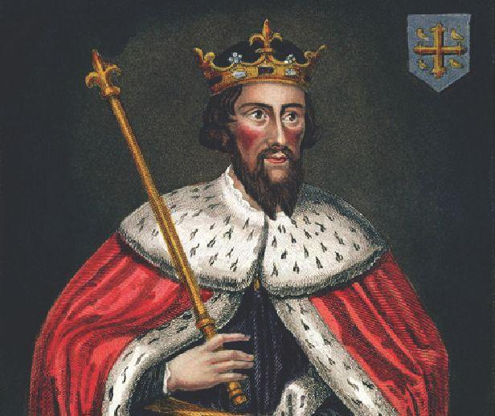  Source: Wikimedia Commons  Which form of government would have this type of leader?
A | Democracy
B | Monarchy
C | Oligarchy
D | Theocracy

Bank Item Number | G.C.3.1.M1
Benchmark | SS.7.C.3.1
Cognitive Complexity | Moderate
Item | The picture below shows a government leader.  Source: Wikimedia Commons  Which form of government would have this type of leader?
A | Democracy | Incorrect-The crown and robe are symbols of royalty and not democracy, which focuses on the people ruling and equality under the law.
B | Monarchy | Correct-The crown and robe are symbols of royalty. The crown is a symbol of a monarchy. This image shows a king; kings are monarchs.
C | Oligarchy | Incorrect-The crown and robe are symbols of royalty and not oligarchy. An oligarchy is a form of government where most political power is held by a small group in a society, usually the wealthy. The crown and robe are symbols of monarchy but the crown and robe are not, taken together, symbols of wealth.
D | Theocracy | Incorrect-A theocracy is a form of government where a religious leader rules in the name of their religion. The crown and robe are symbols of a monarchy and not a theocracy.

Bank Item Number | G.C.3.1.M2
Benchmark | SS.7.C.3.1
Cognitive Complexity | Moderate
Item | What do a republic and a direct democracy have in common?
A | rule by a single political party
B | rule by the people
C | a small group of leaders
D | a single leader

Bank Item Number | G.C.3.1.M2
Benchmark | SS.7.C.3.1
Cognitive Complexity | Moderate
Item | What do a republic and a direct democracy have in common?
A | rule by a single political party | Incorrect-Both republican (representative) governments and democratic (rule by the people) governments tend to have two or more political parties in society and government
B | rule by the people | Correct- Both republican (representative) governments and democratic (rule by the people) governments share in common that both are based on the principle that the people rule themselves through their government
C | a small group of leaders | Incorrect-Both republican (representative) governments and democratic (rule by the people) governments share in common that both are based on the principle that the people rule themselves through their government. This principle does not agree with the idea that a small group of leaders rule.
D | a single leader | Incorrect- Both republican (representative) governments and democratic (rule by the people) governments share in common that both are based on the principle that the people rule themselves through their government. This principle does not agree with the idea that one person rules.

Bank Item Number | G.C.3.1.M3
Benchmark | SS.7.C.3.1
Cognitive Complexity | Moderate
Item | The scenario below describes a government decision.  ---------------------------  A self-appointed council amends the country’s constitution.  ---------------------------  Based on the scenario, which form of government is taking action?
A | Dictatorship
B | Monarchy
C | Oligarchy
D | Republic

Bank Item Number | G.C.3.1.M3
Benchmark | SS.7.C.3.1
Cognitive Complexity | Moderate
Item | The scenario below describes a government decision.  ---------------------------  A self-appointed council amends the country’s constitution.  ---------------------------  Based on the scenario, which form of government is taking action?
A | Dictatorship | Incorrect-Nations with dictatorships do not have constitutions.
B | Monarchy | Incorrect-Persons who rule in monarchies rule because they were born into ruling families; monarchs do not appoint themselves.
C | Oligarchy | Correct- An oligarchy is a form of government where most political power is held by a small group in a society that is self-appointed, and is usually wealthy.
D | Republic | Incorrect-A republican, or representative, form of government is based on the principle of rule by the people. Persons who serve in government in republics are persons who are elected and not self-appointed.

Bank Item Number | G.C.3.1.H1
Benchmark | SS.7.C.3.1
Cognitive Complexity | High
Item | The image below includes a statement influenced by an 1848 book.  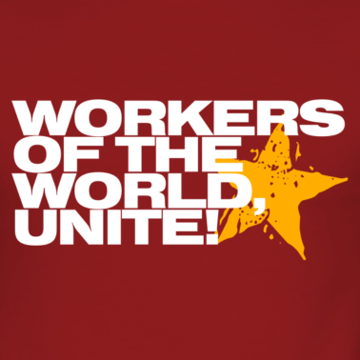  What modern political action could be influenced by the statement?
A | A communist country invades a democratic country.
B | A representative democracy amends its constitution.
C | A queen speaks before Parliament to officially open Parliament.
D | A dictator orders the invasion of a neighboring country.

Bank Item Number | G.C.3.1.H1
Benchmark | SS.7.C.3.1
Cognitive Complexity | High
Item | The image below includes a statement influenced by an 1848 book.  What modern political action could be influenced by the statement?
A | A communist country invades a democratic country. | Correct- Communism seeks to spread its message throughout the world. Countries that are not communist, such as democratic countries, will become communist if communism spreads to those countries, such as through invasion. Communist countries invading democratic countries brings workers together (“unite”).
B | A representative democracy amends its constitution. | Incorrect-The focus on “the world” in the quote suggests that an event within a single nation (“a representative democracy”) is not the correct response.
C | A queen speaks before Parliament to officially open Parliament. | Incorrect- The focus on “the world” in the quote suggests that an event within a single nation (“a queen speaks before Parliament”) is not the correct response. Parliaments function as legislatures within single countries.
D | A dictator orders the invasion of a neighboring country. | Incorrect- The focus on “the world” in the quote suggests that an event within a single nation (“a dictator”) is not the correct response. Dictators rule single countries.

