Bank Item Number |  | G.C.2.9.L1
Benchmark |  | SS.7.C.2.9
Cognitive Complexity |  | L
Item |  | Which is a constitutional requirement to run for Congress?
A |  | U.S. permanent resident
B |  | at least 25 years old
C |  | at least 30 years old
D |  | U.S. citizen

Bank Item Number |  | G.C.2.9.M1
Benchmark |  | SS.7.C.2.9
Cognitive Complexity |  | M
Item |  | After serving as a U.S. Senator, Laura decided to run for governor of Florida. Liz, Laura’s opponent, claims in court that Laura is not qualified to run. A judge rules in Liz’s favor. What was the basis for the lawsuit?
A |  | Laura has never owned land in Florida.
B |  | Laura is not a Florida resident.
C |  | Laura is not yet 40 years old.
D |  | Laura has never voted.

Bank Item Number |  | G.C.2.9.M2
Benchmark |  | SS.7.C.2.9
Cognitive Complexity |  | M
Item |  | The newspaper headline below describes a government process.  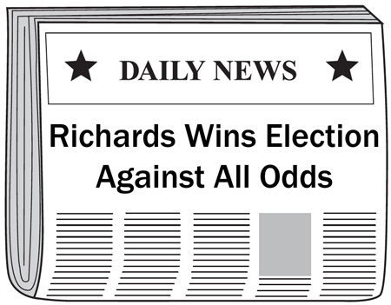  Why might this have been a difficult election for Richards to win?
A |  | Richards is a homeowner.
B |  | Richards is a party leader.
C |  | Richards has less political experience than his opponent.
D |  | Richards has less employment experience than his opponent.

Bank Item Number |  | G.C.2.9.M3
Benchmark |  | SS.7.C.2.9
Cognitive Complexity |  | M
Item |  | A local newspaper endorsed Mayor Sanford in a state senate race over his opponent. Why might the newspaper endorse Mayor Sanford?
A |  | Mayor Sanford owns a local farm.
B |  | Mayor Sanford is an elected official.
C |  | Mayor Sanford is an experienced teacher.
D |  | Mayor Sanford owns a local radio station.

Bank Item Number |  | G.C.2.9.H1
Benchmark |  | SS.7.C.2.9
Cognitive Complexity |  | H
Item |  | The poster below is from a recent election.  Doug is pro-immigration!  Doug is pro-military!  Vote for Doug  Based on the poster, what conclusion can be drawn about the candidate?
A |  | Doug is running for judge.
B |  | Doug is running for mayor.
C |  | Doug is running for president.
D |  | Doug is running for city council.

