Bank Item Number | G.C.2.4.L1
Benchmark | SS.7.C.2.4
Cognitive Complexity | Low
Item | Which three rights are guaranteed by the Bill of Rights?
A | freedom of speech, right to work, right to petition the government
B | right to bear arms, right to a speedy trial, right to an education
C | freedom of speech, right to bear arms, right to a speedy trial
D | right to vote, right to work, right to a speedy trial

Bank Item Number | G.C.2.4.L1
Benchmark | SS.7.C.2.4
Cognitive Complexity | Low
Item | Which three rights are guaranteed by the Bill of Rights?
A | freedom of speech, right to work, right to petition the government | Incorrect-The right to work is not found anywhere in the U.S. Constitution or its amendments.
B | right to bear arms, right to a speedy trial, right to an education | Incorrect-The right to an education is not found anywhere in the U.S. Constitution or its amendments.
C | freedom of speech, right to bear arms, right to a speedy trial | Correct-The right to freedom of speech is found in the First Amendment, the right to bear arms is found in the Second Amendment and the right to a speedy trial is found in the Sixth Amendment.
D | right to vote, right to work, right to a speedy trial | Incorrect-The right to work is not found anywhere in the U.S. Constitution or its amendment while the right to vote was added to the U.S. Constitution several times after the Bill of Rights was added to the U.S. Constitution.

Bank Item Number | G.C.2.4.M1
Benchmark | SS.7.C.2.4
Cognitive Complexity | Moderate
Item | The image below symbolizes a right protected by the Bill of Rights.  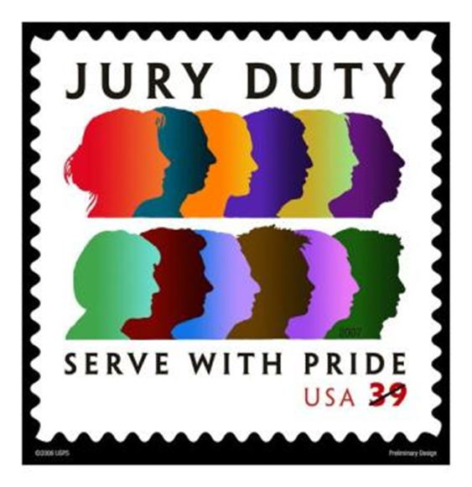  Source: United States Postal Service  What constitutional right does this image symbolize?
A | speedy trial
B | trial by peers
C | legal representation
D | peaceable assembly

Bank Item Number | G.C.2.4.M1
Benchmark | SS.7.C.2.4
Cognitive Complexity | Moderate
Item | The image below symbolizes a right protected by the Bill of Rights.  Source: United States Postal Service  What constitutional right does this image symbolize?
A | speedy trial | Incorrect-The right to a speedy trial is guaranteed by the Sixth Amendment but that right is not symbolized in the image.
B | trial by peers | Correct-The right to a trial by jury of one’s peers is guaranteed by the Sixth Amendment. Juries represent peers in the criminal justice system.
C | legal representation | Incorrect-The right to legal representation is guaranteed by the Sixth Amendment but that right is not symbolized in the image.
D | peaceable assembly | Incorrect-The right to peaceable assembly is guaranteed in the First Amendment and is not symbolized in the image.

Bank Item Number | G.C.2.4.M2
Benchmark | 2.4
Cognitive Complexity | Moderate
Item | Why does the U.S. Supreme Court continue to debate the constitutionality of the death penalty?
A | Citizens are protected from unreasonable search and seizure.
B | Citizens are protected from cruel and unusual punishment.
C | Citizens are protected against double jeopardy.
D | Citizens are protected against unfair trials.

Bank Item Number | G.C.2.4.M2
Benchmark | 2.4
Cognitive Complexity | Moderate
Item | Why does the U.S. Supreme Court continue to debate the constitutionality of the death penalty?
A | Citizens are protected from unreasonable search and seizure. | Incorrect-Citizens are protected from unreasonable search and seizure although this protection is not a factor in U.S. Supreme Court debates about the death penalty.
B | Citizens are protected from cruel and unusual punishment. | Correct- Citizens are protected from cruel and unusual punishment, and this protection is an important factor in U.S. Supreme Court debates about the death penalty.
C | Citizens are protected against double jeopardy. | Incorrect- Citizens are protected from double jeopardy although this protection is not a factor in U.S. Supreme Court debates about the death penalty.
D | Citizens are protected against unfair trials. | Incorrect- Citizens are protected from unfair trials although this protection is not a factor in U.S. Supreme Court debates about the death penalty.

Bank Item Number | G.C.2.4.M3
Benchmark | SS.7.C.2.4
Cognitive Complexity | Moderate
Item | Which constitutional principle is applied when police inform suspects of their rights?
A | due process of law
B | eminent domain
C | double jeopardy
D | trial by jury

Bank Item Number | G.C.2.4.M3
Benchmark | SS.7.C.2.4
Cognitive Complexity | Moderate
Item | Which constitutional principle is applied when police inform suspects of their rights?
A | due process of law | Correct-The right to due process includes the Fifth Amendment and Sixth Amendment protections established in Gideon v. Wainwright that arrested persons be informed of their rights by police.
B | eminent domain | Incorrect-Eminent domain is the right of the government to take property for a public purpose.
C | double jeopardy | Incorrect-Protection from double jeopardy is a constitutionally protected right. Double jeopardy is about being tried twice for the same crime, and not about informing suspects of their rights.
D | trial by jury | Incorrect-Trial by jury is a constitutionally protected right although trial by jury is not about informing suspects of their rights which happens at an earlier stage in the judicial process compared with trial by jury.

Bank Item Number | G.C.2.4.H1
Benchmark | SS.7.C.2.4
Cognitive Complexity | High
Item | The statement below was made by President Dwight Eisenhower upon signing Public Law 396 in 1954 which added “under God” to the Pledge of Allegiance.  To anyone who truly loves America, nothing could be more inspiring than to contemplate this rededication of our youth, on each school morning, to our country's true meaning.  Source: Dwight D. Eisenhower Presidential Library and Museum  Which First Amendment protections have been cited in opposition to this change?
A | establishment and free exercise
B | establishment and association
C | speech and free exercise
D | association and speech

Bank Item Number | G.C.2.4.H1
Benchmark | SS.7.C.2.4
Cognitive Complexity | High
Item | The statement below was made by President Dwight Eisenhower upon signing Public Law 396 in 1954 which added “under God” to the Pledge of Allegiance.  To anyone who truly loves America, nothing could be more inspiring than to contemplate this rededication of our youth, on each school morning, to our country's true meaning.  Source: Dwight D. Eisenhower Presidential Library and Museum  Which First Amendment protections have been cited in opposition to this change?
A | establishment and free exercise | Correct-The addition of the phrase “under God” to the pledge and the statement that students will recite the pledge each morning has been cited by opponents that requiring students in school to recite the Pledge of Allegiance violates the free exercise and establishment clauses of the First Amendment.
B | establishment and association | Incorrect-The freedom of association (peaceable assembly) included in the First Amendment has not been cited as a concern associated with the Pledge of Allegiance.
C | speech and free exercise | Incorrect- The freedom of speech included in the First Amendment has not been cited as a concern associated with the Pledge of Allegiance.
D | association and speech | Incorrect- Neither the freedom of speech or the freedom of association (peaceable assembly), while both included in the First Amendment, have not been cited as concerns associated with the Pledge of Allegiance.

