Bank Item Number |  | G.C.2.2.L1
Benchmark |  | SS.7.C.2.2
Cognitive Complexity |  | L
Item |  | What right do citizens have?
A |  | attending public schools
B |  | owning property
C |  | holding a job
D |  | voting

Bank Item Number |  | G.C.2.2.M1
Benchmark |  | SS.7.C.2.2
Cognitive Complexity |  | M
Item |  | A citizen received the notification below in the mail.  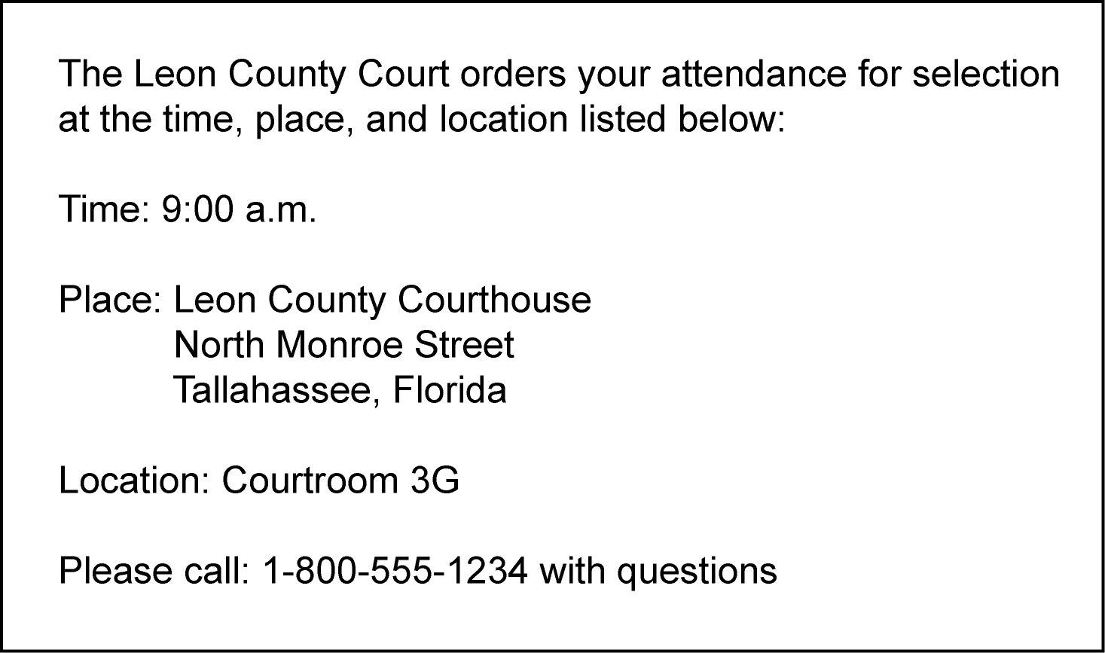  What civic responsibility does this notification represent?
A |  | getting a driver's license
B |  | appearing for jury duty
C |  | paying income tax
D |  | registering to vote

Bank Item Number |  | G.C.2.2.M2
Benchmark |  | SS.7.C.2.2
Cognitive Complexity |  | M
Item |  | Which type of service project would help promote the common good?
A |  | planning a neighborhood recycling program
B |  | participating in a neighborhood party
C |  | completing homework on time
D |  | visiting public libraries

Bank Item Number |  | G.C.2.2.M3
Benchmark |  | SS.7.C.2.2
Cognitive Complexity |  | M
Item |  | Which example is NOT a responsibility of citizenship?
A |  | volunteering in the community
B |  | attending civic meetings
C |  | voting in elections
D |  | paying taxes

Bank Item Number |  | G.C.2.2.H1
Benchmark |  | SS.7.C.2.2
Cognitive Complexity |  | H
Item |  | The image below describes a citizen obligation.  Source: United States Postal Service  Based on this image, what can be presumed about citizen obligations?
A |  | Citizens support attending civic meetings.
B |  | Citizens support securing individual rights.
C |  | Citizens resist registering for selective service.
D |  | Citizens resist contributing to the common good.

