Bank Item Number | G.C.2.11.L1
Benchmark | SS.7.C.2.11
Cognitive Complexity | Low
Item | Which option presents a clear point of view?
A | bias
B | metaphor
C | propaganda
D | symbolism

Bank Item Number | G.C.2.11.L1
Benchmark | SS.7.C.2.11
Cognitive Complexity | Low
Item | Which option presents a clear point of view?
A | bias | Correct-Bias is a way to present a clear point of view by focusing on one side of an issue.
B | metaphor | Incorrect-A metaphor is a way to represent an issue or idea. Bias may be represented by the metaphor but bias is not a required characteristic of a metaphor.
C | propaganda | Incorrect-Propaganda is a communication that seeks to influence behavior. Propaganda may include bias although bias is not a required characteristic of propaganda.
D | symbolism | Incorrect-Symbolism is a way to represent an issue or idea. Symbolism may include bias but bias is not a required characteristic of symbolism.

Bank Item Number | G.C.2.11.M1
Benchmark | SS.7.C.2.11
Cognitive Complexity | Moderate
Item | Which source would give the most accurate information about the views held by an incumbent running for Congress?
A | special interest group ratings of that Congress member
B | a television commercial sponsored by a political party
C | the voting record of the candidate while in Congress
D | flyers sent through the mail by the candidate

Bank Item Number | G.C.2.11.M1
Benchmark | SS.7.C.2.11
Cognitive Complexity | Moderate
Item | Which source would give the most accurate information about the views held by an incumbent running for Congress?
A | special interest group ratings of that Congress member | Incorrect-Special interest group ratings are not as accurate as other sources because the special interest group will likely provide only information that best represents the special interest group’s focus.
B | a television commercial sponsored by a political party | Incorrect-Political party television commercials are not as accurate as other sources because the political parties will likely provide only information that best represents the political party’s focus.
C | the voting record of the candidate while in Congress | Correct-The voting record of a member of Congress running for re-election or for a different office is the most accurate representation of the candidate’s viewpoint because the entire voting record suggests viewpoints on all types of bills and other issues.
D | flyers sent through the mail by the candidate | Incorrect-The candidate is not an accurate representation of the candidate’s record as the candidate will likely provide only information that best represents the candidate and not a complete picture.

Bank Item Number | G.C.2.11.M2
Benchmark | SS.7.C.2.11
Cognitive Complexity | Moderate
Item | The passage below is from a U.S. Supreme Court decision.  The Federal Communications Commission (FCC) has for many years imposed …a “fairness doctrine,” requiring that public issues be presented by broadcasters and that each side of those issues be given fair coverage.  Source: Red Lion Broadcasting Co., Inc. v. Federal Communications Commission (1969)  Based on the passage, what is a goal of the FCC regulation?
A | to limit bias in political communication
B | to promote bias in political communication
C | to limit symbolism in political communication
D | to promote symbolism in political communication

Bank Item Number | G.C.2.11.M2
Benchmark | SS.7.C.2.11
Cognitive Complexity | Moderate
Item | The passage below is from a U.S. Supreme Court decision.  The Federal Communications Commission (FCC) has for many years imposed …a “fairness doctrine,” requiring that public issues be presented by broadcasters and that each side of those issues be given fair coverage.  Source: Red Lion Broadcasting Co., Inc. v. Federal Communications Commission (1969)  Based on the passage, what is a goal of the FCC regulation?
A | to limit bias in political communication | Correct-Presenting issues to the public in a fair way that gives attention to each side and limits bias.
B | to promote bias in political communication | Incorrect-Presenting issues to the public in a fair way that gives attention to each side discourages bias because the public is made away of multiple perspectives on an issue.
C | to limit symbolism in political communication | Incorrect-The passage does not reference symbolism in political communication; the “fairness doctrine” would not affect symbolism in political communication.
D | to promote symbolism in political communication | Incorrect-The passage does not reference symbolism in political communication. The concept of “fairness” in reporting would not promote or limit symbolism.

Bank Item Number | G.C.2.11.M3
Benchmark | SS.7.C.2.11
Cognitive Complexity | Moderate
Item | Below is a statement made by Secretary of Defense Donald Rumsfeld.  …the news media seem to want to carry the negative.  Source: Interview with Jerry Agar, KMBX News Radio 980, June 27, 2005.  What type of political communication is being referenced in the statement?
A | bias
B | persuasion
C | propaganda
D | symbolism

Bank Item Number |  | G.C.2.11.M3
Benchmark |  | SS.7.C.2.11
Cognitive Complexity |  | Moderate
Item |  | Below is a statement made by Secretary of Defense Donald Rumsfeld.  …the news media seem to want to carry the negative.  Source: Interview with Jerry Agar, KMBX News Radio 980, June 27, 2005.  What type of political communication is being referenced in the statement?
A |  | bias | Correct- Bias is a way to present a clear point of view by focusing on one side of an issue. Here, the statement focuses on the negative side.
B |  | persuasion | Incorrect-Persuasion is a way to influence someone. Persuasion may be positive or negative.
C |  | propaganda | Incorrect-Propaganda is intended to influence a specific action, which may be positive or negative.
D |  | symbolism | Incorrect-Symbolism is a way to represent an issue or idea. Symbolism may be positive or negative.

Bank Item Number | G.C.2.11.H1
Benchmark | SS.7.C.2.11
Cognitive Complexity | High
Item | The poster below was placed in public buildings, businesses and schools by a civil rights group.  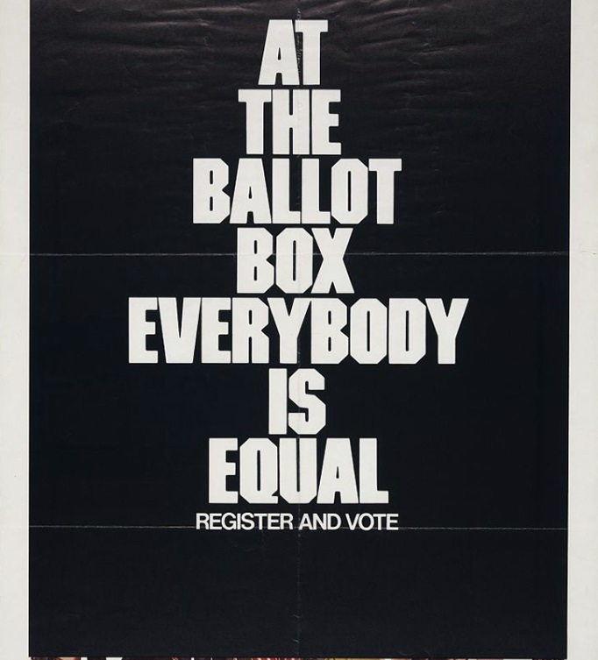  What is a long term policy goal of the interest group?
A | electing candidates
B | regulating elections
C | improving citizens’ lives
D | influencing political appointments

Bank Item Number | G.C.2.11.H1
Benchmark | SS.7.C.2.11
Cognitive Complexity | High
Item | The poster below was placed in public buildings, businesses and schools by a civil rights group.  What is a long term policy goal of the interest group?
A | electing candidates | Incorrect-Candidates, if elected, make policy. A policy goal might be related to electing a specific candidate. There is no policy suggested by the poster.
B | regulating elections | Incorrect-The focus of the poster is on voting. While elections are regulated there is no information in the poster that regulating elections is a policy goal of the interest group.
C | improving citizens’ lives | Correct-The poster is encouraging people to vote. People often vote for the candidates that they believe will improve their lives more than the candidate’s competitors.
D | influencing political appointments | Incorrect-The appointment process involves an executive, such as a president, making the appointment. There are some appointed positions that require confirmation by a legislative body, such as the U.S. Senate.

