Bank Item Number | G.C.1.3.L1
Benchmark | SS.7.C.1.3
Cognitive Complexity | Low
Item | Which document addressed colonial concerns about English policies?
A | Declaration of Independence
B | Mayflower Compact
C | U.S. Constitution
D | Bill of Rights

Bank Item Number | G.C.1.3.L1
Benchmark | SS.7.C.1.3
Cognitive Complexity | Low
Item | Which document addressed colonial concerns about English policies?
A | Declaration of Independence | Correct-The Declaration of Independence listed the colonists’ concerns about English policies and the impact of those English policies on the lives of the colonists.
B | Mayflower Compact | Incorrect-The Mayflower Compact is a colonial document that focuses on the importance of forming civil governments.
C | U.S. Constitution | Incorrect-The U.S. Constitution was written long after the British colonists declared independence from Great Britain.
D | Bill of Rights | Incorrect-The Bill of Rights are the first ten amendments to the U.S. Constitution, which were added to the U.S. Constitution in 1791.

Bank Item Number | G.C.1.3.M1
Benchmark | SS.7.C.1.3
Cognitive Complexity | Moderate
Item | The stamp below is from the front page of a 1765 newspaper.  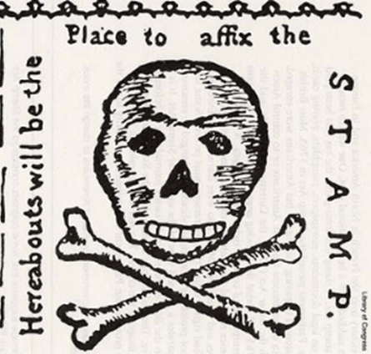  Source: Library of Congress  What was the significance of the stamp on the newspaper?
A | It demonstrated that Parliament ignored the colonists’ media communications.
B | It demonstrated that Parliament controlled the colonists’ press outlets.
C | It represented the colonists’ opposition to English tax policies.
D | It represented the colonists’ fulfillment of English tax policies.

Bank Item Number | G.C.1.3.M1
Benchmark | SS.7.C.1.3
Cognitive Complexity | Moderate
Item | The stamp below is from the front page of a 1765 newspaper.  Source: Library of Congress  What was the significance of the stamp on the newspaper?
A | It demonstrated that Parliament ignored the colonists’ media communications. | Incorrect-There is no reference to Parliament in the stamp, or its role in responding to the colonists’ media communications.
B | It demonstrated that Parliament controlled the colonists’ press outlets. | Incorrect-There is no reference to Parliament in the stamp, or its control over press outlets.
C | It represented the colonists’ opposition to English tax policies. | Correct-The colonists opposed English tax policies which included the requirement that stamps be placed on the front of the newspaper in order for that newspaper to be eligible to be sold.
D | It represented the colonists’ fulfillment of English tax policies. | Incorrect-The use of the skull and crossbones suggests opposition to the requirement that the stamp be attached to the newspaper in order for it to be sold.

Bank Item Number | G.C.1.3.M2
Benchmark | SS.7.C.1.3
Cognitive Complexity | Moderate
Item | The political cartoon below was created by Benjamin Franklin in1754.  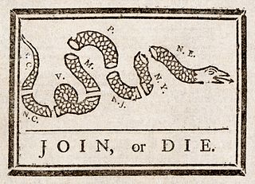  Source: Library of Congress  Which action did colonists use this cartoon to support?
A | Declaring independence from the British monarchy.
B | Declaring loyalty to the British monarchy.
C | Dissolving colonial legislatures.
D | Dissolving colonial charters.

Bank Item Number | G.C.1.3.M2
Benchmark | SS.7.C.1.3
Cognitive Complexity | Moderate
Item | The political cartoon below was created by Benjamin Franklin in1754.  Source: Library of Congress  Which action did colonists use this cartoon to support?
A | Declaring independence from the British monarchy. | Correct-The cartoon is encouraging the colonists in each state to join together to declare independence and afterwards form an independent nation (the Articles of Confederation)
B | Declaring loyalty to the British monarchy. | Incorrect-The “joining” described in the cartoon represents the colonies to join together, and not for the colonies to join with the British monarchy.
C | Dissolving colonial legislatures. | Incorrect-The “joining” described in the cartoon represents the colonies joining together and not for the colonial legislatures to dissolve.
D | Dissolving colonial charters. | Incorrect-The “joining” described in the cartoon represents the colonies joining together and not for the colonial charters to dissolve.

Bank Item Number | G.C.1.3.M3
Benchmark | SS.7.C.1.3
Cognitive Complexity | Moderate
Item | The quotes below are from historical documents.  “For imposing Taxes on us without our Consent”  “All bills for raising Revenue shall originate in the House of Representatives…”  Source: Declaration of Independence  Source: Article I Section 7 U.S. Constitution  What is the relationship between these concepts?
A | Both declare to the world why the colonists wanted freedom from England.
B | Both represent actions taken by the colonists to enforce English policies.
C | Both are in response to English policies imposed upon the colonists.
D | Both are responses by England to the actions of the colonists.

Bank Item Number | G.C.1.3.M3
Benchmark | SS.7.C.1.3
Cognitive Complexity | Moderate
Item | The quotes below are from historical documents.  “For imposing Taxes on us without our Consent”  “All bills for raising Revenue shall originate in the House of Representatives…”  Source: Declaration of Independence  Source: Article I Section 7 U.S. Constitution  What is the relationship between these concepts?
A | Both declare to the world why the colonists wanted freedom from England. | Incorrect-The statement from the Declaration of Independence focuses on why the colonists wanted freedom from England although the statement from Article I does not.
B | Both represent actions taken by the colonists to enforce English policies. | Incorrect-Neither action taken by the colonists to enforce English policies is reflected in either concept.
C | Both are in response to English policies imposed upon the colonists. | Correct-Both quotes reflect policies imposed on the colonists by the English including taxes enacted without the consent of the colonists. The House of Representatives (elected directly by the people) is responsible for introducing tax bills.
D | Both are responses by England to the actions of the colonists. | Incorrect- Both statements focus on the responses of the colonists to English policies; neither quote represents how England responded to colonial actions.

Bank Item Number | G.C.1.3.H1
Benchmark | SS.7.C.1.3
Cognitive Complexity | High
Item | Why did Parliament eventually repeal the Stamp Act, which taxed goods such as newspapers and playing cards?
A | The colonists established a blockade against British goods.
B | The colonists were able to produce their own goods.
C | The colonists started destroying British goods.
D | The colonists began boycotting British goods.

Bank Item Number | G.C.1.3.H1
Benchmark | SS.7.C.1.3
Cognitive Complexity | High
Item | Why did Parliament eventually repeal the Stamp Act, which taxed goods such as newspapers and playing cards?
A | The colonists established a blockade against British goods. | Incorrect-The colonists did not establish a blockage against British goods although they took other actions to show their opposition to British policies.
B | The colonists were able to produce their own goods. | Incorrect-The colonists needed goods beyond those that they were able to produce.
C | The colonists started destroying British goods. | Incorrect-The colonists destroyed certain British goods (such as the Boston Tea Party) but Parliament did not repeal the Stamp Act because of the Boston Tea Party.
D | The colonists began boycotting British goods. | Correct-The colonists boycotted British goods which eventually led Parliament to repeal the Stamp Act.

