Holocaust Education through a Civics Lens

Wagner-Rogers Bill

This lesson plan was developed to facilitate teaching and learning the history of the Holocaust and the required instructional approach as outlined in state statute 1003.42.2(g)1 . In addition, this lesson is aligned to the expectations of state statute 1003.42.2(g)2: Holocaust Education Week.

Teacher Notes: N/A

Lesson Benchmark Alignment Appendix

All accompanying links are found in the lesson plan below

Lesson Title | Florida Civics Benchmarks | Duration of Lesson
Aid for Refugees: The Failure of the Wagner-Rogers Bill | SS.7.C.4.3 | 1 Class Period
Other Course Applications:
US Government
US History

Essential Questions
How can the United States give aid to people suffering from human rights violations?
What responsibility does the United States have to help people from other countries facing human rights violations?

Learning Goals
In this lesson students will apply their knowledge of the legislative process by examining a proposed bill from Congress regarding refugee quotas at the start of World War II. Students will complete a close read activity using a primary source document (Wagner-Rogers Bill) to determine the author’s purpose. Through this lesson they will be able to connect how the United States attempted to respond to the Jewish refugee crisis.

Note: The Florida Joint Center for Citizenship (free teacher account) offers lessons on benchmark SS.7.C.4.3 under the “Resources” tab.

Content Notes for Teachers
During the 1920s, the U.S. Congress passed laws limiting how many immigrants could enter the country each year. Anti-immigrant viewpoints remained into the 1930s influencing how Americans responded to the refugee crisis caused by the Nazi regime.
By 1938, hundreds of thousands of European Jews looked to the United States for refuge. Between July 1, 1938 and June 30, 1939, the US State Department granted the maximum number of immigration visas allowable (27,370) to German-born individuals, filling the German quota for the first time during the era of Nazi rule. Over 309,000 Germans remained on the waiting list for German-quota visas by mid-1939.
On February 9, 1939, two U.S. representatives and two U.S. Senators sponsored identical bills in the House and Senate to admit 20,000 German refugee children under the age of fourteen over a two-year period. The bill did not specify that the children would be Jewish although it was understood that Jewish children were targeted by the bill.
Source: Excerpted from “Wagner-Rogers Bill”, Holocaust Encyclopedia, United States Holocaust Memorial Museum

Florida Civics Benchmarks
SS.7.C.4.3 - Describe examples of how the United States has dealt with international conflict
Benchmark Clarifications:
- Students will identify specific examples of international conflicts in which the United States has been involved.
- Students will identify the reasons for the United States becoming involved in past international conflicts.
- Students will analyze primary source documents pertaining to international incidents to determine the course of action taken by the United States.
- Students will identify the different methods used by the United States to deal with international conflicts.

Instructional Strategies/Lesson Activity
Hook Activity
- Show the following video to students:
  - A Second a Day
- Ask students to write their response to the following question regarding the video shown above:
  - What would be the appropriate humanitarian response to help this child refugee?
- Students will write this on paper and share out to the class.

Activity
Part 1
- Provide each student with a copy of the Wagner-Rogers Bill - Close Read document.
- Students will be required to have 3 different colors of highlighter markers (yellow, green, and orange)
- The Wagner-Rogers Bill - Close Read document is set up in a three column format. The inside column is the explicit text from S.J. Resolution 64 of the US Senate on the admittance of German refugee children during World War II.
- The outer columns contain background information, instructions, guiding questions, student response sections and various images from the time period.
Part 2
- 1st Read of the document
  - Students will silently read through the document
  - As they read through the document have them highlight everywhere refugees are referenced or mentioned with a yellow highlighter.
  - When they are finished reading, have them share out what they highlighted in the text
  - After sharing, have the students answer the “first read” question, “What was the text mostly about?”
  - Have the students share their answers to the question
- 2nd Read of the document
  - Read through the document out loud to the class
  - As you read, have students highlight, in a green highlighter or a second color, everywhere the United States is attempting to help the refugee children
  - When they are finished reading, have them share out what they highlighted in the text
  - After sharing, have students answer the “second read” question, “How did the author help us understand what the United States should do to help the refugees?”
  - Have students share their answers to the question

- 3rd Read of the document
  - Students will silently read through the document for a second time or the teacher may have various students read portions of the text
  - As they are reading have them highlight, in orange highlighter or a third color, everywhere the author is explaining why the United States should help the refugees
  - When they are finished reading, have them share out what they highlighted in the text
  - After sharing, have students answer the “third read” question, “Do you agree with the author? Why?”
  - Have students share their answers to the question

Closing Activity (two options)
Option 1
- Inform students that this bill eventually died in committee, and did not pass either house in Congress.
- Ask students:
  - What else might the US government have done to help the refugees?
- Answers to the question may be recorded through a handwritten activity (i.e. paper or index card) or anonymously through a digital source.
Option 2
- Inform students of the following fact:
  - If a member of Congress wants the U.S. Congress to initiate aid to affected people during an international crisis, that member of Congress will need to persuade members to agree to the proposal. Some of those members will undoubtedly hold differing political, social, and economic views.
*Reference the USHMM website for further information regarding these views.
- Ask students the following questions:
- In his resolution, how did Senator Wagner anticipate the arguments of his opponents and try to overcome their objections in advance?
- What else might Senator Wagner have done to win the support of his colleagues?
- Answers to the question may be recorded through a handwritten activity (i.e. paper or index card) or anonymously through a digital source.

Assignment(s)
- Hook Activity quick response on the Second Day video
- Wagner-Rogers Bill - Close Read Document
- Closing Activity

Assessment and Monitoring (Checks for content and desired effect)
- Teacher observation and questioning of groups and individuals at each step of the instructional process and during transitions between activities.
- Check for understanding of the content through various responses to the guiding questions on the close read document.

Adaptations for Unique Student Needs
- Provide read aloud of the resources
- Allow for closed captioning on all video resources
- Provide additional print and/or video resources

Resources and Materials
- A Second a Day YouTube Video
- Wagner-Rogers Bill - Close Read document
- Text of S.J. Resolution 64 of the US Senate
- Wagner-Rogers Bill Test Items

Note: The Florida Joint Center for Citizenship (free teacher account) offers lessons on benchmark SS.7.C.4.3 under the “Resources” tab.

Name: _____________________________

Wagner-Rogers Bill - Background Info.
* In 1924, the US Congress passed the Johnson-Reed Act, restricting the number of immigrants who could enter the US each year. This law limited how many could come by country of origin.

*Adolf Hitler and his Nazi Party rose to power in Germany in 1933 and began to mistreat Germans they deemed enemies, especially Jews. As a result, many fled, but few countries wanted to let in large numbers of refugees.

* On Nov. 9 1938, the Nazis launched violent riots attacking Jews throughout Germany. This event became known as Kristallnacht. The number of Jews seeking refuge in other lands rose higher.

* The Wagner-Rogers Bill was introduced in Congress in Feb. 1939. Its goal was to provide safe haven for refugee children from lands ruled by Nazi Germany.
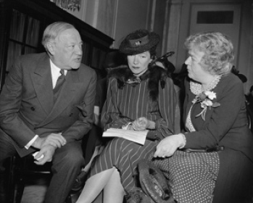
S.J. RES. 64
IN THE SENATE OF THE UNITED STATES
FEBRUARY 9, 1939
Mr. Wagner introduced the following joint resolution; which was read twice and referred to the Committee on Immigration
JOINT RESOLUTION

To authorize the admission into the United States of a limited number of German refugee children.

Whereas there is now in progress a world-wide effort to facilitate the emigration from Germany of men, women, and children of every race and creed suffering from conditions which compel them to seek refuge in other lands; and

Whereas the most pitiful and helpless sufferers are children of tender years; and

Whereas the admission into the United States of a limited number of these children can be accomplished without any danger of their becoming public charges, or dislocating American industry or displacing American labor; and
Whereas such action by the United States would constitute the most immediate and practical contribution by our liberty-loving people to the cause of human freedom, to which we are inseverably bound by our institutions, our history, and our profoundest sentiments: Now, therefore, be it

1 Resolved by the Senate and House of Representatives
2 of the United States of America in Congress assembled,
3 That not more than ten thousand immigration visas may be
4 issued during each of the calendar years 1939 and 1940,
5 in addition to those authorized by existing law and not-
6 withstanding any provisions of law regarding priorities or
7 preferences, for the admission into the United States of
8 children fourteen years of age or under, who reside, or at
9 any time since January 1, 1933, have resided, in any ter-
10 ritory now incorporated in Germany, and who are other-
11 wise eligible: Provided, That satisfactory assurances are
12 given that such children will be supported and properly
13 cared for through the voluntary action of responsible citi-
14 zens or responsible private organizations of the United States
15 and consequently will not become public charges.

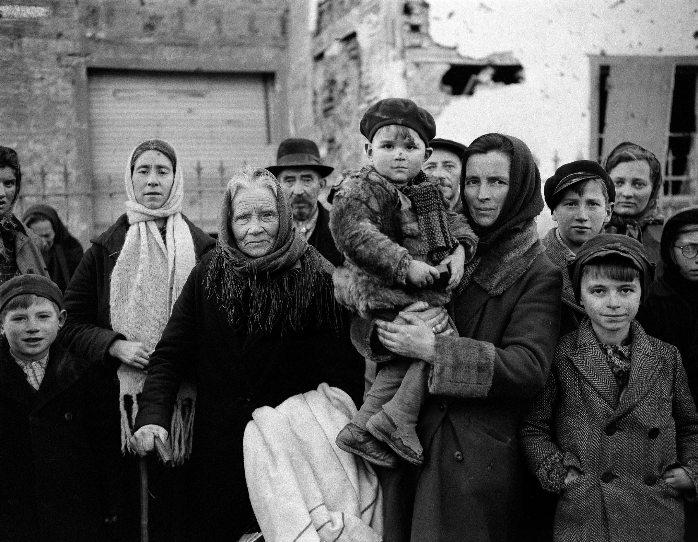
1st Read - What Does it Say?
* Use a Yellow Highlighter
* Mark places where refugees are referenced or mentioned
What was the text mostly about?
Answer:

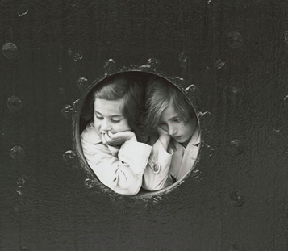
2nd Read - How Does the Text Work?
* Use a Green Highlighter
* Mark where the United States is doing something to help the refugees
How did the author help us understand what the United States should do to help the refugees?
Answer:

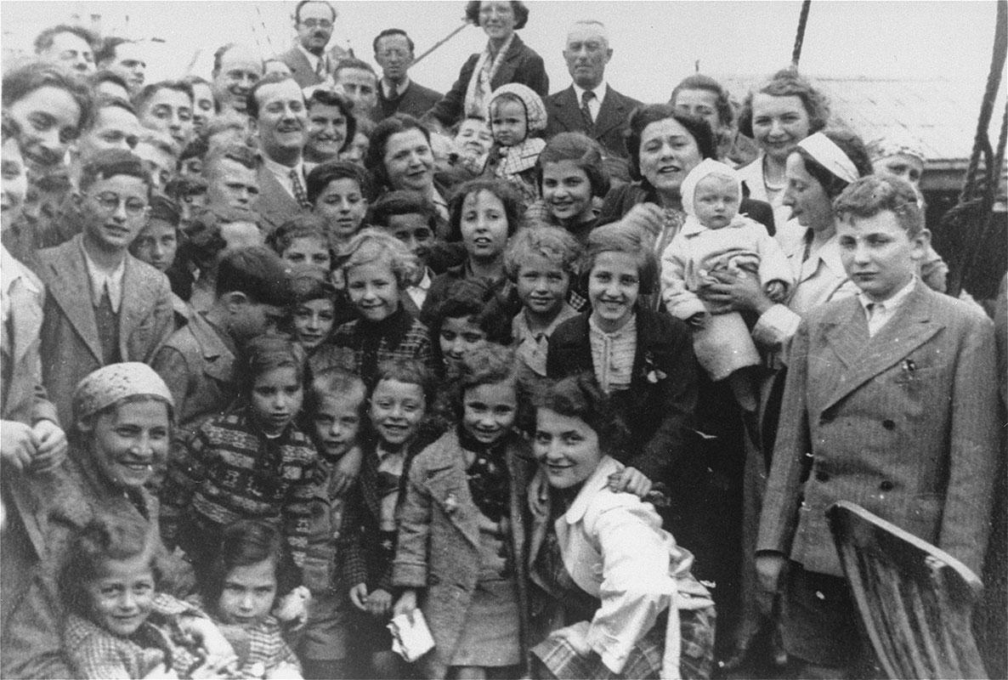
3rd Read - What Does it Say?
* Use an Orange Highlighter
* Mark where the author is explaining why the United States should help the refugees
Do you agree with the author? Why?
Answer:

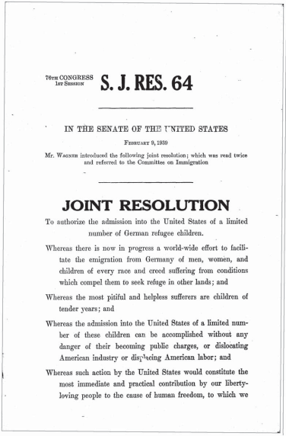
ushmm.org/americans IMMIGRATION AND REFUGEES: DEBATING THE WAGNER-ROGERS BILL 4
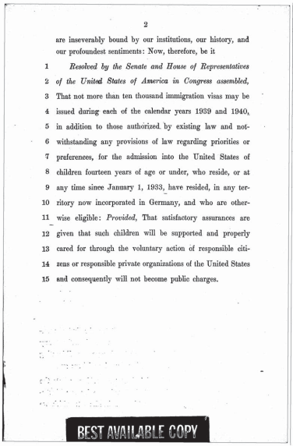
ushmm.org/americans IMMIGRATION AND REFUGEES: DEBATING THE WAGNER-ROGERS BILL 5

Test Items
Benchmark | Benchmark Clarification | Cognitive Complexity
3.8 | BC 1 | L

Question | Which action is carried out by Congress?
A. | Signing executive orders
B. | Negotiating treaties
C. | Passing laws
D. | Appointing judges

Question | Which action is carried out by Congress?
A. | Signing executive orders | Incorrect-Signing executive order is a power that belongs to the president and not Congress.
B. | Negotiating treaties | Incorrect-Article II of the U.S. Constitution gives the president, and not Congress, the power to negotiate treaties.
C. | Passing laws | Correct-Article I of the U.S. Constitution gives Congress the power to pass laws.
D. | Appointing judges | Incorrect-Appointing judges is an executive and not a legislative power.

Benchmark | Benchmark Clarification | Cognitive Complexity
4.2 | BC 1 | L

Question | Which international organization was founded, in part, to address child poverty and discrimination against children?
A. | WTO
B. | League of Nations
C. | UNICEF
D. | World Bank

Question | Which international organization was founded, in part, to address child poverty and discrimination against children?
A. | WTO | Incorrect: The purpose of the WTO (World Trade Organization) is to support international trade, economic growth and development.
B. | League of Nations | Incorrect: The League of Nations was formed to promote peace among member nations following World War I. The purpose of the League of Nations was to prevent a second world war. The United States did not join the League of Nations.
C. | UNICEF | Correct: UNICEF was created following World War II with a focus on the needs of children. UNICEF is concerned with barriers that children may face including poverty, violence and discrimination.
D. | World Bank | Incorrect: The World Bank provides financial and technical assistance to reduce poverty in developing countries around the world.

Benchmark | Benchmark Clarification | Cognitive Complexity
4.3 | BC 3 | M

Question | Below is an excerpt from a document introduced in the U.S. Senate on February 9, 1939:  JOINT RESOLUTION  To authorize the admission into the United States of a limited number of German refugee children.  What was the purpose of the joint resolution?
A. | To persuade the United Nations to increase funding to Germany
B. | To permit the World Court to reduce military presence in Germany
C. | To offer a humanitarian response to an international issue
D. | To enable the implementation of an international treaty

Question | Below is an excerpt from a document introduced in the U.S. Senate on February 9, 1939:  JOINT RESOLUTION  To authorize the admission into the United States of a limited number of German refugee children.  What was the purpose of the joint resolution?
A. | To persuade the United Nations to increase funding to Germany | Incorrect-The joint resolution makes no mention of giving funds to Germany. The purpose of the joint resolution is to bring children into Germany.
B. | To permit the World Court to reduce military presence in Germany | Incorrect-The U.S. Senate does not have the power to decide the actions taken by the World Court. The World Court does not have control over any military.
C. | To offer a humanitarian response to an international issue | Correct-A decision by Congress to admit children who are refugees from another country suggests that there is a need for a humanitarian response to an issue to which the U.S. decides to become involved.
D. | To enable the implementation of an international treaty | Incorrect-The executive branch is responsible for implementing treaties ratified by the U.S. Senate.

Benchmark | Benchmark Clarification | Cognitive Complexity
4.3 | BC 3 | M

Question | Below is an excerpt from a bill signed by President Calvin Coolidge on May 24, 1924:  Exclusion from United States.  Sec. 13. (a) No immigrant shall be admitted to the United States unless he (1) has an unexpired immigration visa or was born subsequent to the issuance of the immigration visa of the accompanying parent, (2) is of the nationality specified in the visa in the immigration visa, …(4) is otherwise admissible under the immigration laws.  Source: Immigration Act (Johnson-Reed Act) of 1924  About which group was the focus of the legislation?
A. | Citizens
B. | State governors
C. | Prime ministers
D. | Aliens

Question | Below is an excerpt from a bill signed by President Calvin Coolidge on May 24, 1924:  Exclusion from United States.  Sec. 13. (a) No immigrant shall be admitted to the United States unless he (1) has an unexpired immigration visa or was born subsequent to the issuance of the immigration visa of the accompanying parent, (2) is of the nationality specified in the visa in the immigration visa, …(4) is otherwise admissible under the immigration laws.  Source: Immigration Act (Johnson-Reed Act) of 1924  About which group was the focus of the legislation?
A. | Citizens |  | Incorrect-U.S. citizens, whether naturalized or native born, do not need visas to travel to the United States.
B. | State governors |  | Incorrect-To be a state governor one needs to be a U.S. citizen. U.S. citizens, whether naturalized or native born, do not need visas to travel to the United States.
C. | Prime ministers |  | Incorrect-Article II of the U.S. Constitution gives the president the power to receive foreign ambassadors, which would include prime ministers. Heads of government do not need visas to travel to the United States because of this provision.
D. | Aliens |  | Correct-An alien is a non-citizen. The excerpt focuses on immigrants who need visas. Aliens would be the category of persons seeking immigration to the United States and who would need visas to do so.

Benchmark | Benchmark Clarification | Cognitive Complexity
4.3 | BC 3 | H

Question | The statement below is taken from a statement issued by President Franklin Roosevelt on March 24, 1944.  We call upon the free peoples of Europe and Asia temporarily to open their frontiers to all victims of oppression. We shall find havens of refuge for them, and we shall find the means for their maintenance and support until the tyrant is driven from their homelands and they may return.  Based on the statement, which of the following events might be justified by future presidents?
A. | Signing an executive order extending rights to illegal aliens
B. | Ratifying a treaty with a nation practicing discrimination
C. | Passing a bill that limiting prosecution of illegal aliens
D. | Confirming a Secretary of State who holds similar views

Question | The statement below is taken from a statement issued by President Franklin Roosevelt on March 24, 1944.  We call upon the free peoples of Europe and Asia temporarily to open their frontiers to all victims of oppression. We shall find havens of refuge for them, and we shall find the means for their maintenance and support until the tyrant is driven from their homelands and they may return.  Based on the statement, which of the following events might be justified by future presidents?
A. | Signing an executive order extending rights to illegal aliens | Correct-Future presidents might use their executive order power to find ways to provide “havens of refuge” to “victims of oppression”.
B. | Ratifying a treaty with a nation practicing discrimination | Incorrect-Presidents do not have the power to ratify treaties; that power is held by the U.S. Senate.
C. | Passing a bill that limiting prosecution of illegal aliens | Incorrect-Presidents do not have the power to pass bills; that power is held by the U.S. Congress.
D. | Confirming a Secretary of State who holds similar views | Incorrect-Presidents do not have the power to confirm Cabinet members; that power is held by the U.S. Senate.

Benchmark | Benchmark Clarification | Cognitive Complexity
4.3 | BC 3 | H

Question | Below is a statement found on the website of the United States Citizenship and Immigration Services (USCIS):  U.S. Citizenship and Immigration Services administers the nation’s lawful immigration system, safeguarding its integrity and promise by efficiently and fairly adjudicating requests for immigration benefits while protecting Americans, securing the homeland, and honoring our values.  Which group is most likely to be affected by an executive order expanding the power of the USCIS?
A. | U.S. citizens seeking to remain in Florida
B. | Immigrants seeking to remain in Florida
C. | Immigrants seeking United Nations protection
D. | U.S. citizens seeking United Nations protection

Question | Below is a statement found on the website of the United States Citizenship and Immigration Services (USCIS):  U.S. Citizenship and Immigration Services administers the nation’s lawful immigration system, safeguarding its integrity and promise by efficiently and fairly adjudicating requests for immigration benefits while protecting Americans, securing the homeland, and honoring our values.  Which group is most likely to be affected by an executive order expanding the power of the USCIS?
A. | U.S. citizens seeking to remain in Florida | Incorrect-American citizens may travel freely across state lines.
B. | Immigrants seeking to remain in Florida | Correct-Immigrants may be required to leave the United States without permission to stay in the United States. Immigrants, if in the United States with permission, may travel freely across state lines. An immigrant who is in the United States without permission may be asked to leave the United States no matter in which state they are living.
C. | Immigrants seeking United Nations protection | Incorrect-The USCIS is responsible for administering U.S. policy and not international law or requirements established by the United Nations.
D. | U.S. citizens seeking United Nations protection | Incorrect-The USCIS is responsible for administering U.S. policy and not international law or requirements established by the United Nations.

