STUDENTS INVESTIGATING PRIMARY SOURCES
Thinking Through Timelines: World War I
How do the political cartoons depict the United States’ involvement in World War I?
A Short Activity for High School U.S. History
Benchmark Correlations
SS.912.A.4.5: Examine causes, course, and consequences of United States involvement in World War I.
Benchmark Clarification: Students will identify the reasons for United States involvement in World War I and how involvement in the war was justified to the American public.
LAFS.910.RH.1.2- Determine the central ideas or information of a primary or secondary source; provide an accurate summary of how key events or ideas develop over the course of the text.
LAFS.1112.RH.1.2-Determine the central ideas or information of a primary or secondary source; provide an accurate summary that makes clear the relationships among the key details and ideas.

Activity Documents, Handouts and Materials
- Student Copies of World War I political cartoons, pages 3-6
- Thinking Through Timelines: World War I handout
- Whole Class Projected World War I political cartoons, pages 8-11
- Sticky Notes

Full Document Citations
Appeal of League of Nations, 9/26/1918; Berryman Political Cartoon Collection, 1896 - 1949; Records of the U.S. Senate, 1789 - 2015; National Archives Building, Washington, DC. National Archives Identifier: 6011503.
[https://catalog.archives.gov/id/6011503]
[https://www.docsteach.org/documents/document/appeal-league-nations]

Now is the Time for American Calmness, 8/19/1914; Berryman Political Cartoon Collection, 1896 - 1949; Records of the U.S. Senate, Record Group 46; National Archives Building, Washington, DC. National Archives Identifier: 6011069.
[https://catalog.archives.gov/id/6011069]
[https://www.docsteach.org/documents/document/now-time-american-calmness]

President Calls Congress April 2 to Act on Grave National Policy, 03/21/1917; Berryman Political Cartoon Collection, 1896 - 1949; Records of the U.S. Senate, Record Group 46; National Archives Building, Washington, DC. National Archives Identifier: 306092.
[https://catalog.archives.gov/id/306092]
[https://www.docsteach.org/documents/document/president-calls-congress-april-2-to-act-on-grave-national-policy]

Reporting for Duty, 4/2/1917; Berryman Political Cartoon Collection, 1896 - 1949; Records of the U.S. Senate, 1789 - 2015, Record Group 46; National Archives Building, Washington, DC. National Archives Identifier: 6011220.
[https://catalog.archives.gov/id/6011220]
[https://www.docsteach.org/documents/document/reporting-for-duty]

Activity Vocabulary
Allied Powers – an alliance of countries that fought in World War I, including Russia, France, British Empire, Japan, Italy (joined in 1915), the U.S. (joined in 1917), and others
armistice – a formal agreement between parties to stop fighting
Central Powers – an alliance of countries that included Germany, Austria-Hungary, Turkey, and Bulgaria
power to declare war – Article I, Section 8, of the U.S. Constitution grants Congress the power to declare war
unrestricted submarine warfare – a type of warfare used by Germany during World War I; submarines would attack and sink other ships and vessels without warning
World War I – a war between the Allied Powers and the Central Powers that lasted from 1914-1918

- Place students into working groups of 3-4 students and create a timeline on the board using the following dates and big ideas:
Date Big Idea
- July, 1914 Beginning of World War I in Europe
- February, 1917 Germany Declares Unrestricted Submarine Warfare
- April, 1917 The United States Enters World War I
- November, 1918 The Armistice
- Pass out four sticky notes and copies of the four political cartoons (see pages 3-6) to each student group.
- Explain to students that they will use the details in each cartoon to try and place the cartoons in chronological order, matching one cartoon to each big idea listed on the timeline.
- Instruct students to use the sticky notes to write the big idea from the timeline, list the details in the cartoon that led them to their decision and to place the sticky note on the cartoon.
- Provide 4-5 minutes for students to place their cartoons in chronological order and write on their sticky notes. Rotate through the groups to monitor the activity.
- Keep students in their working groups and pass out the Thinking Through Timelines: World War I handout.
- Ask students to hold up the cartoon they think belongs with “July, 1914-Beginning of World War I in Europe”.
- Select one or two students to share why they chose the cartoon to match the first big idea. After a few students share, project the correct cartoon. See page 8.
- Instruct students to visually scan the cartoon and write down the details they notice on their handout that connects the cartoon with the big idea. Have students share out. Teacher Note: Use the Answer Key to guide this discussion.
- Direct student attention to the question at the bottom of the cartoon. Work as a whole class to answer the question and instruct students to write the answer on their handout. Teacher Note: Use the Answer Key to guide this discussion.
- Repeat this process for the next three dates on the timeline, using the cartoons and questions on pages 9-11.
- Direct student attention to the bottom of the Thinking Through Timelines: World War I handout. Instruct students to work independently to respond to the question.
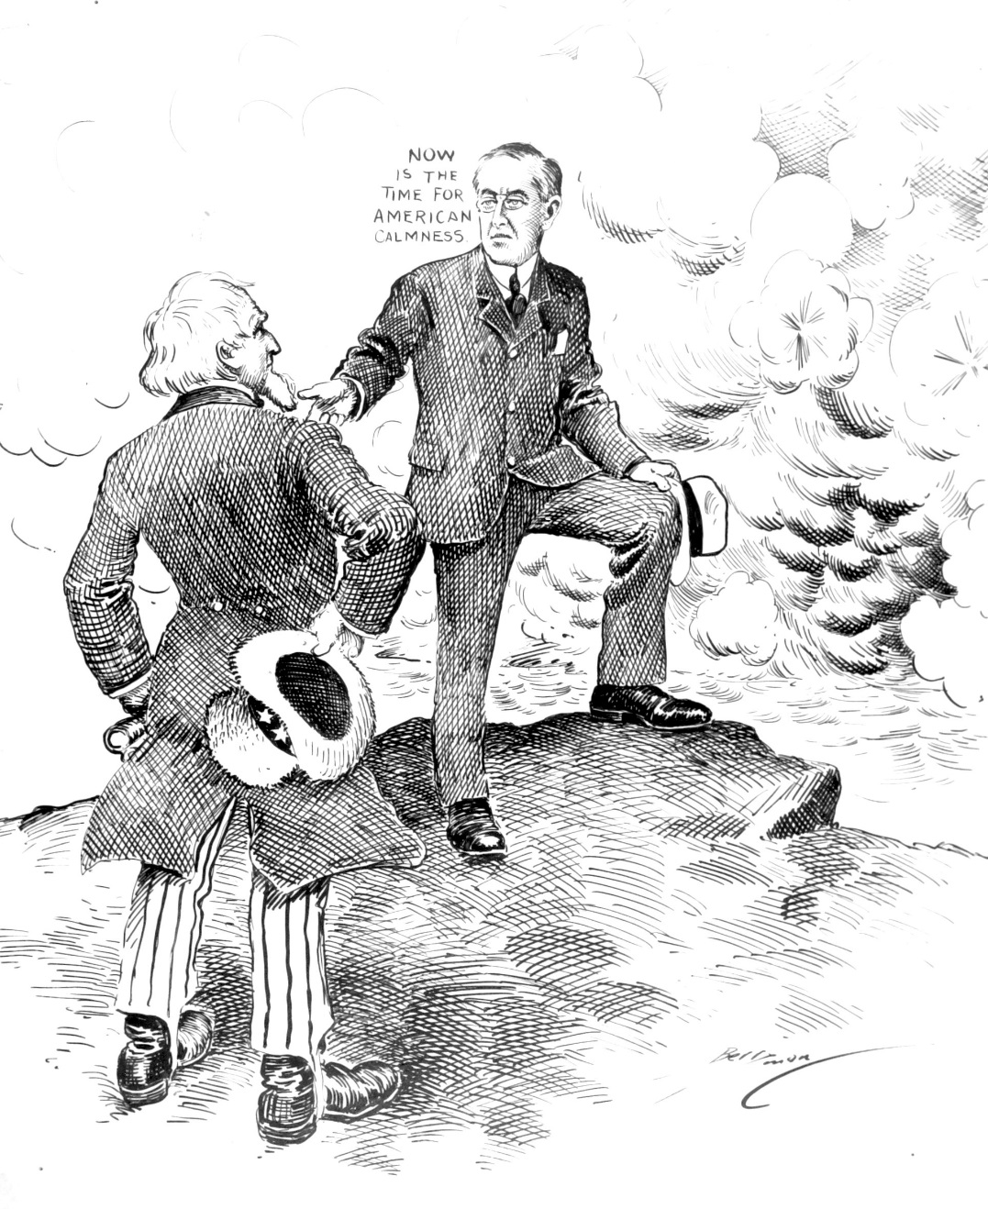
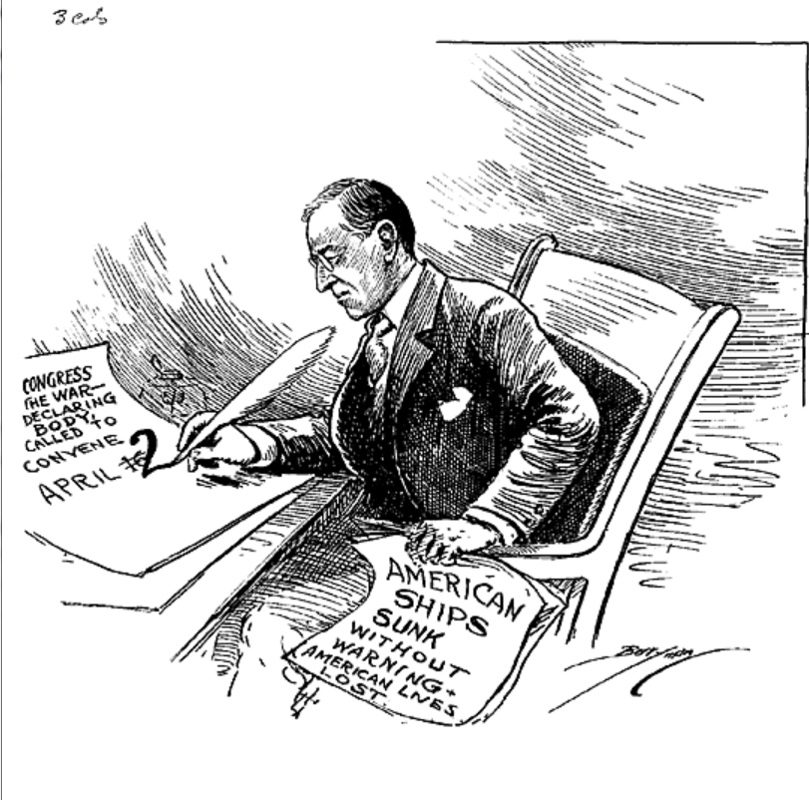
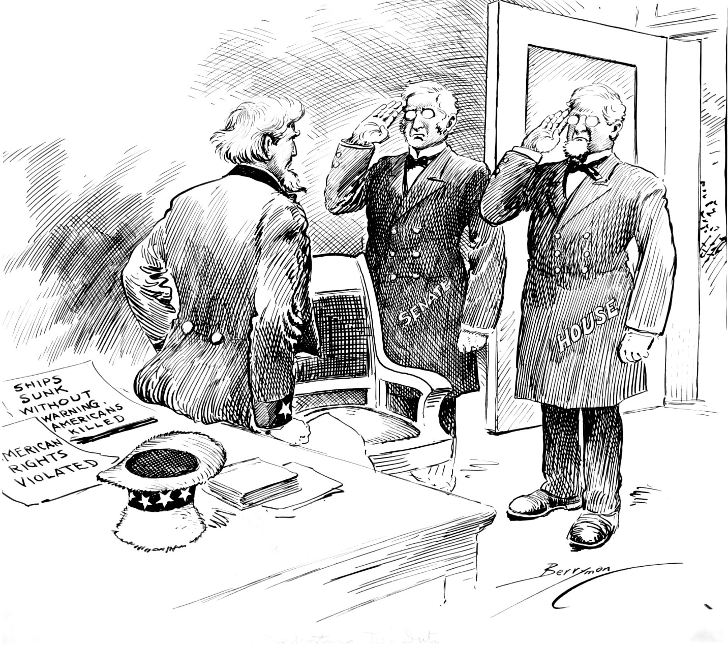
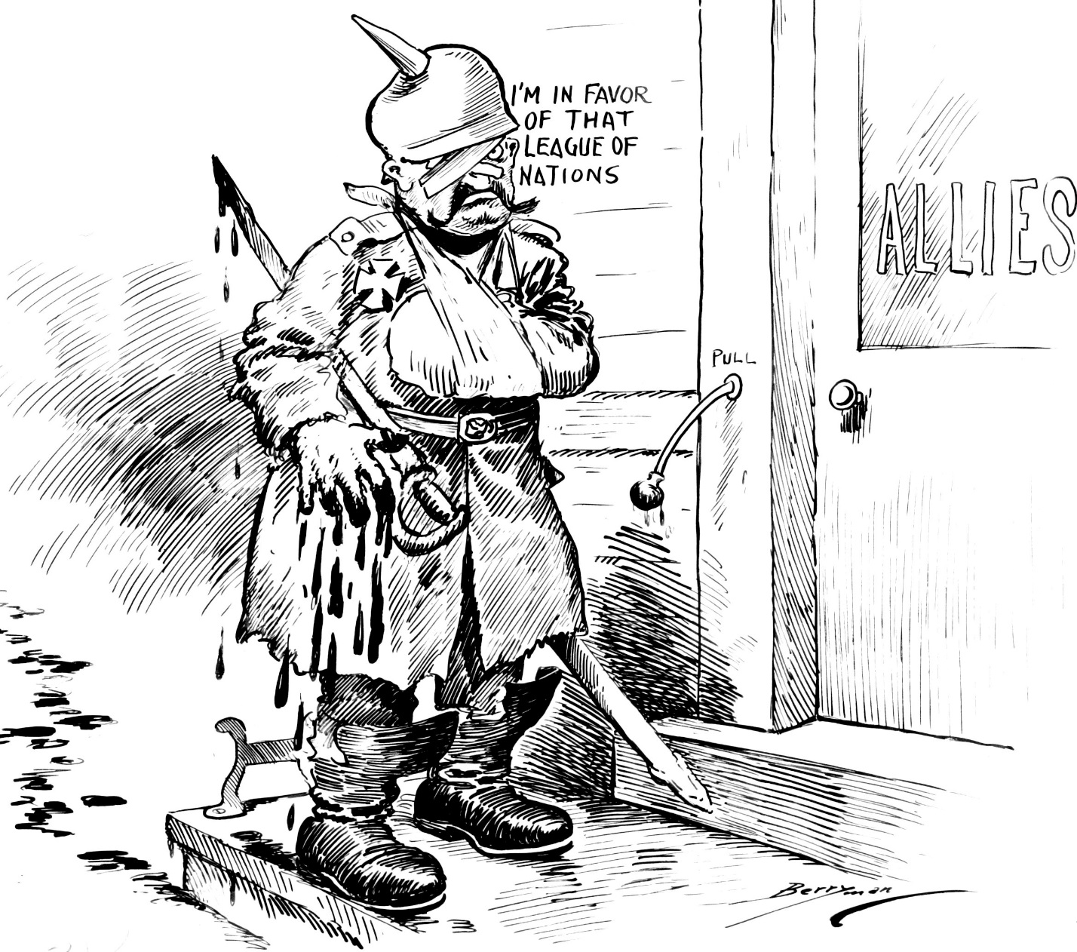

Name: __________________________________________________ Date: ______________
Thinking Through Timelines: World War I
Directions: As you discuss each political cartoon, write the date and Big Idea for each cartoon. Take notes on the evidence from the cartoon that connects to the Big Idea. Finally, respond to the question on each political cartoon in the space provided.
Big Ideas
July, 1914 - Beginning of World War I in Europe February, 1917 - Unrestricted Submarine Warfare
April, 1917 - U.S. Enters World War I November, 1918 - The Armistice
Date: _______________________  Big Idea ____________________________  Evidence of the Big Idea  ________________________  ________________________  ________________________  ________________________  ________________________  Question Notes  ________________________  ________________________  ________________________  ________________________  ________________________  ________________________  ________________________  ________________________ | Date: _______________________  Big Idea ____________________________  Evidence of the Big Idea  ________________________  ________________________  ________________________  ________________________  ________________________  Question Notes  ________________________  ________________________  ________________________  ________________________  ________________________  ________________________  ________________________  ________________________ | Date: _______________________  Big Idea ____________________________  Evidence of the Big Idea  ________________________  ________________________  ________________________  ________________________  ________________________  Question Notes  ________________________  ________________________  ________________________  ________________________  ________________________  ________________________  ________________________  ________________________ | Date: _______________________  Big Idea ____________________________  Evidence of the Big Idea  ________________________  ________________________  ________________________  ________________________  ________________________  Question Notes  ________________________  ________________________  ________________________  ________________________  ________________________  ________________________  ________________________  ________________________

How do the political cartoons depict the United States’ involvement in World War I?

July, 1914 - Beginning of World War I in Europe
World War I began between the Allied Powers and the Central Powers in Europe.
How did the U.S. respond when World War I broke out among the nations of Europe during the summer of 1914?

February, 1917 – Germany Declares Unrestricted Submarine Warfare

This cartoon was published in the Washington Evening Star over 2 ½ years after the start of World War I in Europe.
What evidence in this cartoon explains one reason why the United States entered World War I?

April, 1917 - U.S. Enters World War I

This cartoon anticipates Congress exercizing its Constitutional War Powers when it convened on April 2, 1917.

What evidence in this cartoon depicts the constitutional terms of entering the war?

November, 1918 – The Armistice

The arrival of U.S. troops in France in the summer of 1917 helped stop an attack on Paris and forced the German armies to retreat.
Details of this cartoon suggests a major consequence of World War I. What do the details of this cartoon say about this topic?

Thinking Through Timelines: World War I – Sample Answers
Directions: As you discuss each political cartoon, write the date and Big Idea for each cartoon. Take notes on the evidence from the cartoon that connects to the Big Idea. Finally, respond to the question on each political cartoon in the space provided.
Big Ideas
July, 1914 - Beginning of World War I in Europe February, 1917 - Unrestricted Submarine Warfare
April, 1917 - U.S. Enters World War I November, 1918 - The Armistice
Date: July, 1914  Big Idea  Beginning of WWI in Europe  Evidence of the Big Idea  Storm clouds ahead; calm weather where they are standing  Woodrow Wilson is standing on the edge of land (the U.S.)  Uncle Sam is holding binoculars  Question Notes  At the beginning of the war, the United States did not take an active role in fightting or sending troops into battle. The cartoon includes the text “Now is the time for American calmness.” | Date: February, 1917  Big Idea  Unrestricted Submarine Warfare  Evidence of the Big Idea  “American ships sunk without warning – American lives lost”  Question Notes  The text on the two pieces of paper in this cartoon explain why the U.S. entered World War I. The first one is already written and says: “American ships sunk without warning – American lives lost.” President Wilson is writing a second note asking Congress to convene on April 2nd. The cartoon illustrates that unrestricted submarine warfare is one reason why the U.S. entered World War I. | Date: April, 1917  Big Idea  U.S. Enters World War I  Evidence of the Big Idea  “Senate” and “House” figures are saluting Uncle Sam  Notes about submarine warfare are behind Uncle Sam  Question Notes  By having the House and the Senate appear before Uncle Sam, the cartoon is depicting that Congrsss has the power to declare war. | Date: November, 1918  Big Idea The Armistice  Evidence of the Big Idea  A German soldier is knocking on the door of the Allied Powers, eager to bring an end to World War I. The soldier’s appearance and facial expression show he is feeling defeated.  Question Notes  One consequence of World War I is that Germany lost and the Allied Powers won. Germany was now at the mercy of the Allied Powers. That is why the German soldier in the cartoon is knocking on the door of the Allied Powers.

How do the political cartoons depict the United States’ involvement in World War I?
The political cartoons show that at the beginning of World War I, the United States was not directly involved in the war. One reason the United States decided to enter the war was unrestricted submarine warfare. The United States Congress has the power to officially declare war. At the end of the war, Germany lost to the Allied Powers, including the United States.

