STUDENTS INVESTIGATING PRIMARY SOURCES
Suiting Up
How does this political cartoon illustrate the concept of checks and balances?
A Short Activity for High School and Middle School
Benchmark Correlations
SS.912.C.1.5 – Evaluate how the Constitution and its amendments reflect the political principles of rule of law, checks and balances, separation of powers, republicanism, democracy, and federalism.
Benchmark Clarification: Students will evaluate how the political principles of rule of law, checks and balances, separation of powers, republicanism, democracy, and federalism are applied within the framework of constitutional government.
SS.912.C.3.3 – Analyze the structures, functions, and processes of the legislative branch as described in Article I of the Constitution.
Benchmark Clarification: Students will analyze the role of the legislative branch in terms of its relationship with the judicial and executive branch of the government.
SS.912.C.3.4 – Analyze the structures, functions, and processes of the executive branch as described in Article II of the Constitution.
Benchmark Clarification: Students will analyze the role of the executive branch in terms of its relationship with the judicial and legislative branch of the government.
LAFS.910.RH.1.2- Determine the central ideas or information of a primary or secondary source; provide an accurate summary of how key events or ideas develop over the course of the text.
LAFS.1112.RH.1.2 – Determine the central ideas or information of a primary or secondary source; provide an accurate summary that makes clear the relationships among the key details and ideas.

SS.7.C.1.7 – Describe how the Constitution limits the powers of government through separation of powers and checks and balances.
Benchmark Clarification: Students will be able to recognize examples of separation of powers and checks and balances.
SS.7.C.3.8 – Analyze the structure, functions, and processes of the legislative, executive, and judicial branches.
Benchmark Clarification: Students will examine the processes of the legislative, executive, and judicial branches of government.
LAFS.68.RH.1.2 – Determine the central ideas or information of a primary or secondary source; provide an accurate summary of the source distinct from prior knowledge or opinions.

Activity Documents and Handouts
- Untitled (Suit of Armor) Political Cartoon
- Suiting Up Handout

Full Document Citation
Untitled [Suit of Armor], cartoon by Clifford Berryman, April 15, 1930; U. S. Senate Collection, Record Group 46; National Archives Building, Washington DC. National Archives Identifier: 6012025.
[https://catalog.archives.gov/id/6012025]
[https://www.docsteach.org/documents/document/latest-spring-style]

Activity Vocabulary
checks and balances – a principle of the federal government, according to the U.S. Constitution, that allows each branch of government to limit the power of the other branches
symbol – an image or object used to represent ideas or qualities

Teacher Note
Before starting this activity, view the Teacher Background Information on the political cartoon.
- Project on the board the full page “Untitled” political cartoon and pass out the Suiting Up handout as students enter the room. Instruct students to follow along and complete the handout throughout the activity. Teacher Note: Use the Sample Answers to guide the discussion.
- Direct students to visually scan the document and identify three items that stand out to them. (Examples could include: two men in conversation, display window, suit of armor)
- Have a few students share out and write the items on the board. Be sure to point out the text on the cartoon to the students, including: “Latest Spring Style To Be Worn By Gentlemen Nominated to Be Members of the U.S. Supreme Court.”
- Share with students that everything they see in this image was a choice made by the artist, Clifford Berryman, to convey his message.
- Review the definition of the term “symbol”. Pose the following questions for discussion: Which of the items we identified is a symbol? What do you think the symbol means or represents? (Suit of armor: symbolizes protection, the expectation of going into battle, combat, war)
- Direct student attention to the following text from Article 2, Section 2 of the U.S. Constitution on their handout:
He shall have Power, by and with the Advice and Consent of the Senate, to make Treaties, provided two thirds of the Senators present concur; and he shall nominate, and by and with the Advice and Consent of the Senate, shall appoint Ambassadors, other public Ministers and Consuls, Judges of the supreme Court, and all other Officers of the United States, whose Appointments are not herein otherwise provided for, and which shall be established by Law:
- Instruct students to work with their shoulder partner to identify the two-step process for nominating justices (judges) to the Supreme Court and the branches of government involved in each step.
- Have students share out. (1.President [executive branch] submits his/her choice for a new Supreme Court Justice to the Senate [legislative branch] and 2. The Senate must give consent in order for the president’s choice to be confirmed)
- Review the definition of checks and balances as a whole class.
- Pose the following questions for discussion: Why are two branches of government involved in selecting justices for the Supreme Court? How does the concept of checks and balances relate to selecting justices? What does the nominee need to be protected from? Is the Supreme Court nomination process always a fight? (no) How does the dialogue or text in the cartoon convey this? (“Not a bad idea, eh?” Suggests that this is a new idea, the sign announces that this is the Latest Spring Style, which implies that this is a new style in tune with the trends of today, the armor is not labeled as a timeless style or wardrobe staple.)
- Direct students to work with their shoulder partner to answer the questions on their handout: How is the nomination process an example of checks and balances? (Having two branches of government involved in nominating and confirming justices makes sure that neither branch can decide on their own and have more power in the process than the other branch) Why might the nominee need a suit of armor? (The nomination process can be difficult and hard on the nominee)
- Have students share out.
Enrichment Suggestion #1 – Pass out the Comic Strip handout and instruct students to create an image and write a summary statement depicting before and after this cartoon. Ideas could include: BEFORE: The President, representing one political party could be depicted making an announcement in the Rose Garden of his/her Supreme Court nominee, the members of the other political party in the Senate could be depicted as booing OR After hearing the President’s nomination, the members of the Senate Judiciary Committee are depicted as readying their “weapons” or doing research for tough questions and AFTER: The Senate confirmation hearing, the nominee in the suit of armor could be ducking as questions in the shape of arrows fly at the nominee OR The president counseling the nominee in the suit of armor after the Senate vote where the nominee is rejected.
Enrichment Suggestion #2 – Instruct students to look for articles about a recent Supreme Court nomination. Pose the following question for discussion: How could you update this cartoon to reflect how this process is playing out/played out, in the present?
Enrichment Suggestion #3 – Direct student attention back to the text from the U.S. Constitution on their handout. Point out to students that the U.S. Constitution makes no mention of the percentage of votes needed to confirm a Supreme Court nominee. The practice is 50% +1, but it is not mandated. However, to ratify a treaty requires 2/3 of the Senate to vote in favor of ratification. Pose the following question for discussion: Why do you think this is?
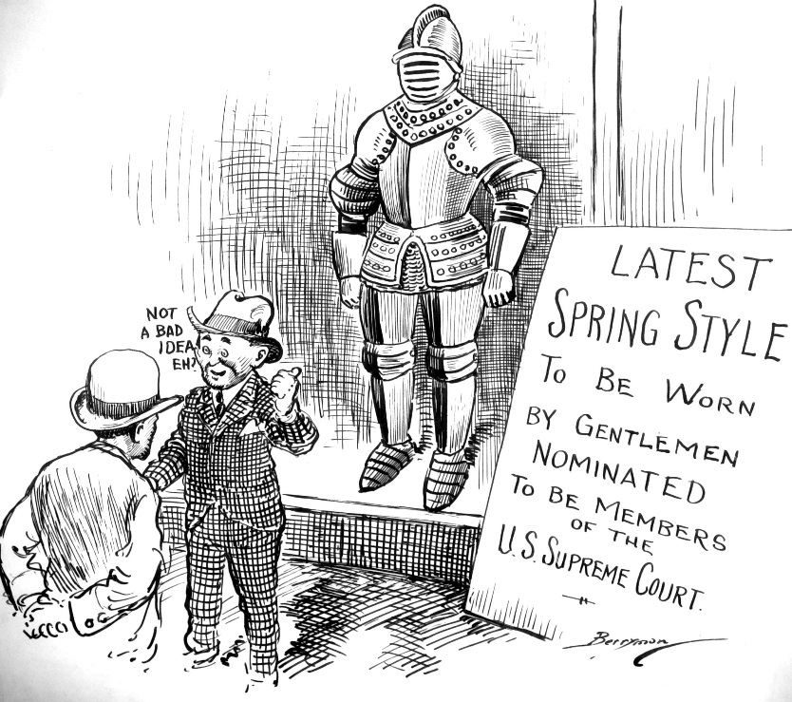

Untitled
Teacher Background Information

Untitled
April 15, 1930
6012025

Background from NARA Catalog
The resignation of former Chief Justice William Howard Taft in early February focused attention on possible candidates to replace shim. The Senate had to review and approve of the President's nomination for a new Chief Justice, and these Senate committee reviews were notoriously meticulous. In preparation for the reviews, cartoonist Clifford Berryman suggests a full suit of armor for the candidates.

Representing Congress: Clifford K. Berryman’s Political Cartoons: pages 11, 54

Name: ________________________________________________________ Date:______________________
Suiting Up

List three items that stand out to you: _____________________________________________________
_____________________________________________________
_____________________________________________________

Symbol: ___________________________________________________________________________________________________________

Example | Meaning

Read the text below from Article II, Section II of the U.S. Constitution. Mark the text that explains the two-step process for nominating U.S. Supreme Court Justices.
He shall have Power, by and with the Advice and Consent of the Senate, to make Treaties, provided two thirds of the Senators present concur; and he shall nominate, and by and with the Advice and Consent of the Senate, shall appoint Ambassadors, other public Ministers and Consuls, Judges of the supreme Court, and all other Officers of the United States, whose Appointments are not herein otherwise provided for, and which shall be established by Law:
List the steps for the nomination process:
1. ___________________________________________________________________________________________________________________
______________________________________________________________________________________________________________________

2. ___________________________________________________________________________________________________________________
______________________________________________________________________________________________________________________

Checks and Balances: a principle of the federal government, according to the U.S. Constitution, that allows each branch of government to limit the power of the other branches

How is the nomination process an example of checks and balances?
______________________________________________________________________________________________________________________
______________________________________________________________________________________________________________________
______________________________________________________________________________________________________________________

Why might the nominee need a suit of armor?
______________________________________________________________________________________________________________________
______________________________________________________________________________________________________________________
______________________________________________________________________________________________________________________

Notes
______________________________________________________________________________________________________________________
______________________________________________________________________________________________________________________
______________________________________________________________________________________________________________________
______________________________________________________________________________________________________________________
______________________________________________________________________________________________________________________
______________________________________________________________________________________________________________________

Suiting Up – Sample Answers

List three items that stand out to you: two men in conversation
display window
suit of armor

Symbol: an image or object used to represent ideas or qualities

Example | Meaning
suit of armor | protection, expectation of going into battle, combat, war

Read the text below from Article II, Section II of the U.S. Constitution. Mark the text that explains the two-step process for nominating U.S. Supreme Court Justices.
He shall have Power, by and with the Advice and Consent of the Senate, to make Treaties, provided two thirds of the Senators present concur; and he shall nominate, and by and with the Advice and Consent of the Senate, shall appoint Ambassadors, other public Ministers and Consuls, Judges of the supreme Court, and all other Officers of the United States, whose Appointments are not herein otherwise provided for, and which shall be established by Law:
List the steps for the nomination process:
1. President [executive branch] submits his/her choice for a new Supreme Court Justice to the Senate [legislative branch]

2. The Senate must give consent in order for the president’s choice to be confirmed.

Checks and Balances: a principle of the federal government, according to the U.S. Constitution, that allows each branch of government to limit the power of the other branches

How is the nomination process an example of checks and balances?
Having two branches of government involved in nominating and confirming justices makes sure that either branch can’t decide on their own and have more power in the process than the other branch

Why might the nominee need a suit of armor?
The nomination process can be difficult and hard on the nominee.
Notes
______________________________________________________________________________________________________________________
______________________________________________________________________________________________________________________
______________________________________________________________________________________________________________________
______________________________________________________________________________________________________________________
______________________________________________________________________________________________________________________
______________________________________________________________________________________________________________________

Comic Strip
___________________________________________________  ___________________________________________________  ___________________________________________________  ___________________________________________________  ___________________________________________________ |  | ___________________________________________________  ___________________________________________________  ___________________________________________________  ___________________________________________________  ___________________________________________________

