What are two ways of becoming a U.S. citizen?

SS.2.C.2.1
Identify what it means to be a United States citizen either by birth or naturalization.

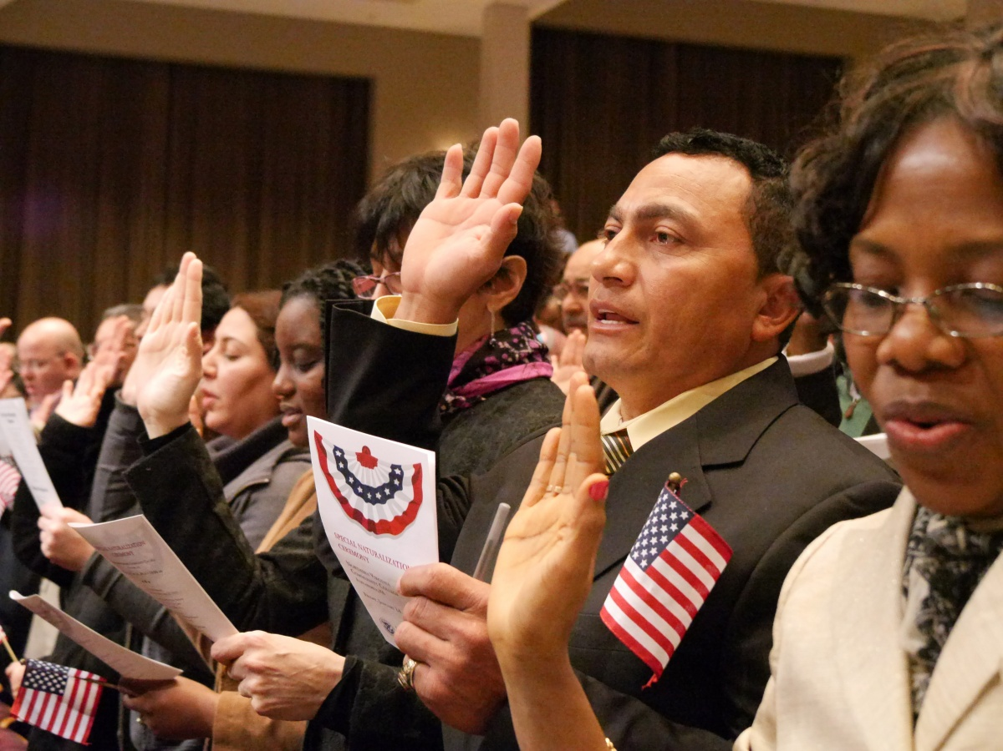
http://www.dhs.gov/blog/2014/01/24/secretary-johnson-welcomes-new-us-citizens

LAFS.2.SL.1.2 – Recount and describe key ideas or details from a text read aloud or information presented orally or through other media.
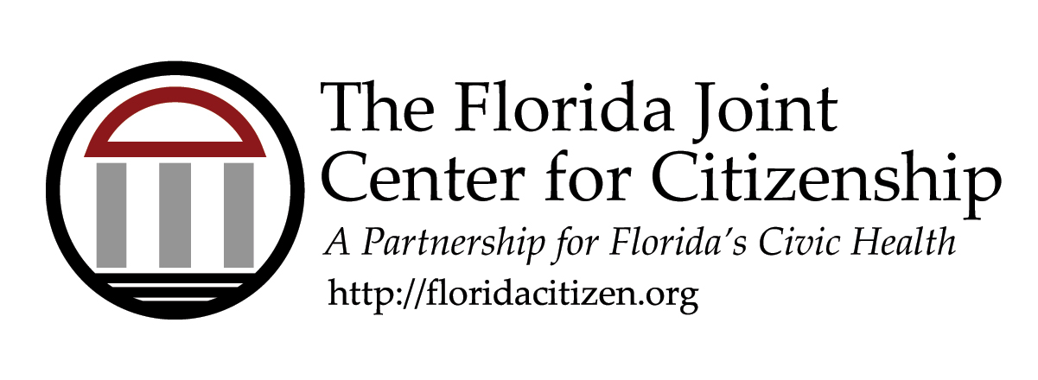

SS.2.C.2.1
Identify what it means to be a United States citizen either by birth or naturalization.

Correlated Florida Standards (See Full Text on Cover Page)
- LAFS.2.SL.1.2
Essential Question
What are two ways of becoming a U.S. citizen?
Learning Goal/Objective
- Students will understand two different paths toward becoming a citizen of the United States.
Overview
Students will receive direct instruction on natural born and naturalized citizenship. Students will apply their understanding by categorizing different scenarios by citizenship status.
Materials
- Path to Being a Citizen PowerPoint Presentation
- Natural Born or Naturalized? handout
- Two Paths handout
- Scissors
- Glue
Time
- 15-20 minutes with additional time for extension activities
Activity Sequence
INTRODUCTION/HOOK
- Project the definition of a citizen.
Citizen – a legal (official) member of a country.
- Pose the following question for discussion: How do you think you become a citizen of the United States?
ACTIVITY
- Project the Power Point “Paths to Being a Citizen” and review slides 1-3 as a whole class.
- Pass out scissors, glue, the Natural Born or Naturalized? handout and Two Paths handout.
- Click to Slide 4 on the Power Point and explain to students that they will apply what they have learned about two ways of being a citizen of the United States by reading each scenario and placing each person on the correct path.
CLOSURE
- Review the answers as a whole class.
OPTIONAL EXTENSION SUGGESTION
- Watch the Brain Pop Jr. video on Ellis Island and complete the related activities: https://jr.brainpop.com/socialstudies/citizenship/ (login required)
- Have students interview parents, siblings, or friends about what is means to be a citizen of a country. Teacher Note: You may choose to have students ask about being a citizen of the United States, but keep in mind that they may have family members or friends that are citizens of other countries.

Natural Born or Naturalized?

I was born in the United States | 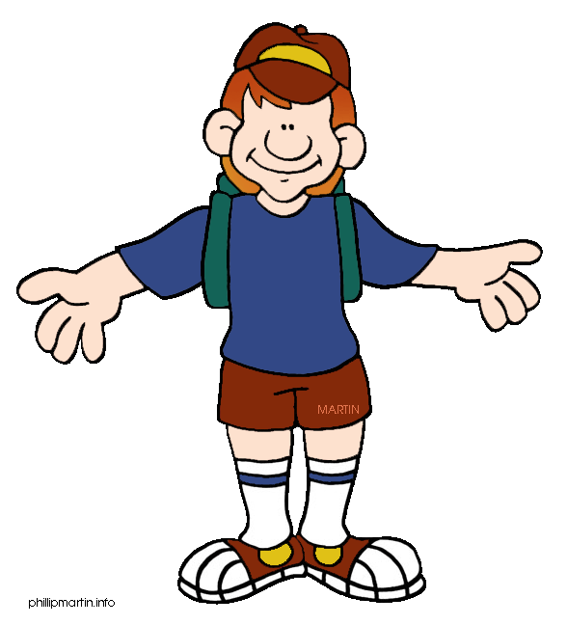  My parents and I were born in Canada.
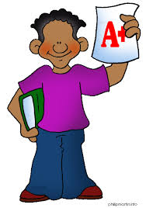  Yeah! I passed my citizenship test!! | I was born in France but my parents were born in the U.S.
My dad is a Captain in the U.S. Army and I was born on a U.S. military base in Japan. | Born in Italy: I pledged an oath to the U.S. when I was 18

Naturalized Citizen
Natural Born Citizen

