Holocaust Education through a Civics Lens

Preventing Genocide

This lesson plan was developed to facilitate teaching and learning the history of the Holocaust and the required instructional approach as outlined in state statute 1003.42.2(g)1 . In addition, this lesson is aligned to the expectations of state statute 1003.42.2(g)2: Holocaust Education Week.

Teacher Notes: N/A

Lesson Benchmark Alignment Appendix

All accompanying links are found in the lesson plan below

Lesson Title | Florida Civics Benchmarks | Duration of Lesson
Preventing Genocide | SS.7.C.2.2 and SS.7.C.4.2 | 1 Class Period
Other Course Applications:
US Government
World History

Essential Questions
What motivates members of the public to promote the idea of the common good?
What are the responsibilities of citizenship?
How does promoting the common good fulfill the responsibilities of citizenship?
What is the role of the United Nations in stopping genocide?

Learning Goals
In this lesson students will apply their knowledge of the rule of law and forms of government by comparing two forms of government (autocracy and representative democracy) and their impact of the rule of law comparing Nazi Germany to the United States government. This will be completed by using a student friendly reading and then constructing a two column comparison chart.

Note: The Florida Joint Center for Citizenship (free teacher account) offers lessons on benchmark SS.7.C.2.2 and benchmark SS.7.C.4.2.

Content Notes for Teachers
Genocide was first recognized as a crime under international law in 1946 by the United Nations. It was codified as an independent crime in the 1948 Convention on the Prevention and Punishment of the Crime of Genocide (the Genocide Convention).
The definition of the crime of genocide as contained in Article II of the Genocide Convention was the result of a negotiating process and reflects the compromise reached among United Nations Member States in 1948 at the time of drafting the Convention. Genocide is defined in the same terms as in the Genocide Convention in the Rome Statute of the International Criminal Court (Article 6). Many States have also criminalized genocide in their domestic law; others have yet to do so.
The Genocide Convention establishes in Article I that the crime of genocide may take place in the context of an armed conflict, international or non-international, but also in the context of a peaceful situation. The target of destruction must be the group, as such, and not its members as individuals. Genocide can also be committed against only a part of the group, as long as that part is identifiable (including within a geographically limited area) and “substantial.”
The recognition of the crimes of the Holocaust opened an era of increased international cooperation in an effort to prevent future genocides and human rights abuses. The adoption of the Genocide Convention (1948) and the creation of the International Military Tribunal are examples, as are the creation of numerous human rights oriented NGOs.

Source: Excerpted from “Genocide”, Office on Genocide Prevention and the Responsibility to Protect, United Nations.
Florida Civics Benchmarks
SS.7.C.2.2 - Evaluate the obligations citizens have to obey laws, pay taxes, defend the nation, and serve on juries.
Benchmark Clarifications:
- Students will distinguish between an obligation or duty and a responsibility as it relates to citizenship. Responsibilities may include, but are not limited to, voting, attending civic meetings, petitioning government, and running for office.
- Students will recognize the concept of the common good as a rationale for fulfilling the obligations and/or responsibilities of citizenship.
- Students will evaluate the obligations and/or responsibilities of citizens as they relate to active participation in society and government.
- Students will examine the significant contributions of citizens to a democratic society.
- Students will use scenarios to assess specific obligations of citizens.
- Students will identify the consequences or predict the outcome on society of citizens who do not fulfill their citizenship responsibilities.
- Students will evaluate the impact of civic participation on society, government, or the political process.

SS.7.C.4.2 - Recognize government and citizen participation in international organizations.
Benchmark Clarifications:
- Students will identify major international organizations in which government plays a role.
- Students will recognize that international organizations may be located in the United States.
- Students will describe ways that individual citizens and government can seek participation in international organizations.
- Students will examine the ways that government and individuals may support international organizations.

Instructional Strategies/Lesson Activity
Hook Activity
- Have students read the following quote from Elie Wiesel, on the occasion of his accepting the Nobel Prize for Peace in 1986.
“...I swore never to be silent whenever wherever human beings endure suffering and humiliation. We must take sides. Neutrality helps the oppressor, never the victim. Silence encourages the tormentor, never the tormented. Sometimes we must interfere. When human lives are endangered, when human dignity is in jeopardy, national borders and sensitivities become irrelevant. Wherever men and women are persecuted because of their race, religion, or political views, that place must – at that moment – become the center of the universe.”

- Emphasize the phrase“we must interfere” in Wiesel’s quote (highlighted in yellow above). Ask students the following question:
- What does Elie Wiesel mean by “we must interfere” when human rights are threatened?

Activity
Part 1
- Students will work as a class to fill in a pyramid to demostrate how international organizations were formed from a problem or issue that arose from the Holocaust.
- You may either draw Pyramid 1 on the board or display using any other source that will project the pyramid to the class.
- You may also provide a printout of the pyramid using Pyramid 2.
- Provide the following definition of genocide at the top of the pyramid:
“...genocide means any of the following acts committed with intent to destroy, in whole or in part, a national, ethnical, racial or religious group, as such:
(a) Killing members of the group;
(b) Causing serious bodily or mental harm to members of the group;
(c) Deliberately inflicting on the group conditions of life calculated to bring about its physical destruction in whole or in part;
(d) Imposing measures intended to prevent births within the group;
(e) Forcibly transferring children of the group to another group.”
Source: Convention on the Prevention and Punishment of the Crime of Genocide, United Nations General Assembly resolution 260 A (III) 9 December 1948)

Part 2
- The second section of the pyramid will give a bulleted list of the events which were being carried out by the Nazis that would constitute genocide. *Use the Pyramid Graphic Organizer Answer Key for reference.

Part 3
- The third section of the pyramid will describe specific people who helped to fight genocide during the Holocaust.
- Students will use the following website to reference these specific people.
Resources - The Jewish Foundation for the Righteous (scroll down the page to the colorful posters)
- Organize students into 8 groups.
- Assign one poster to each group.
- Each student in the group will independently read the individual stories described on the posters (click the image to enlarge).
- All group members will compile a list of specific acts that person did to fight genocide.
- A member from each group will share out what the specific person did to fight genocide to the class.
*Suggestions for whole class sharing: students write the information within the pyramid drawn on the board, write the information on a sticky note and stick on the board, or use a digital posting source (i.e. Jamboard, Padlet or Pinup)

Part 4
- The bottom section of the pyramid will introduce the development of the United Nations and how they help to prevent the act of genocide.
- Reference the Establishment of the United Nations document regarding the United Nations’ steps to prevent genocide.
- Use this document to describe how different aspects of the establishment of the United Nations relate to the Holocaust
- Use the Pyramid Graphic Organizer Answer Key for reference.

Closing Activity
- Introduce students to the only Holocaust survivor to be elected to Congress, Tom Lantos, using the following video about Congressman Tom Lantos told by Mrs. Annette Tilleman Lantos.
Brief Background Information: Congressman Lantos was the only person to survive the Holocaust and serve in the United States Congress. He represented a California congressional district from 1981 until his death in 2008. Among Congressman Lantos’ accomplishments is that he established the Human Rights Caucus in the U.S. House of Representatives and chaired the House Foreign Affairs Committee. In 2008 the U.S. Congress established the Congressional Human Rights Caucus, now known as the Tom Lantos Human Rights Commission. The mission of the Tom Lantos Human Rights Commission is "to promote, defend and advocate internationally recognized human rights norms in a nonpartisan manner, both within and outside of Congress, as enshrined in the Universal Declaration of Human Rights and other relevant human rights instruments." Both Democratic and Republican members of Congress are members of the Tom Lantos Human Rights Commission.

- At the end of the video, have students respond to the following question:
- How can people interfere when human rights are violated?

Assignment(s)
- International Organizations pyramid graphic organizer
- Protecting Human Rights question

Assessment and Monitoring (Checks for content and mastery)
- Teacher observation and questioning of groups and individuals at each step of the instructional process and during transitions between activities.
- Check for understanding of the content through various responses to poster prompts.

Adaptations for Unique Student Needs
- Provide read aloud of the resources
- Provide additional print and/or video resources
Resources and Materials
- Pyramid 1
- Pyramid 2
- Pyramid Graphic Organizer Answer Key
- Establishment of the United Nations document
- Congressman Tom Lantos
- Preventing Genocide Test Items

Note: The Florida Joint Center for Citizenship (free teacher account) offers lessons on benchmark SS.7.C.2.2 and benchmark SS.7.C.4.2.

Pyramid Graphic Organizer 1

Issue?

What happened?

What did individuals do?

Organization created to address isssue?

Pyramid Graphic Organizer 2

Problem or
Issue
*Definition*

What Happened?
*Briefly describe the events which were taking place during the Holocaust*

What did individuals do?
*Students will share the information obtained through reading the individual stories on the JFR website*

Organization created to address isssue?
*Briefly describe the establishment of the United Nations and Unicef (both outlined in the item specs)*

Pyramid Graphic Organizer Answer Key

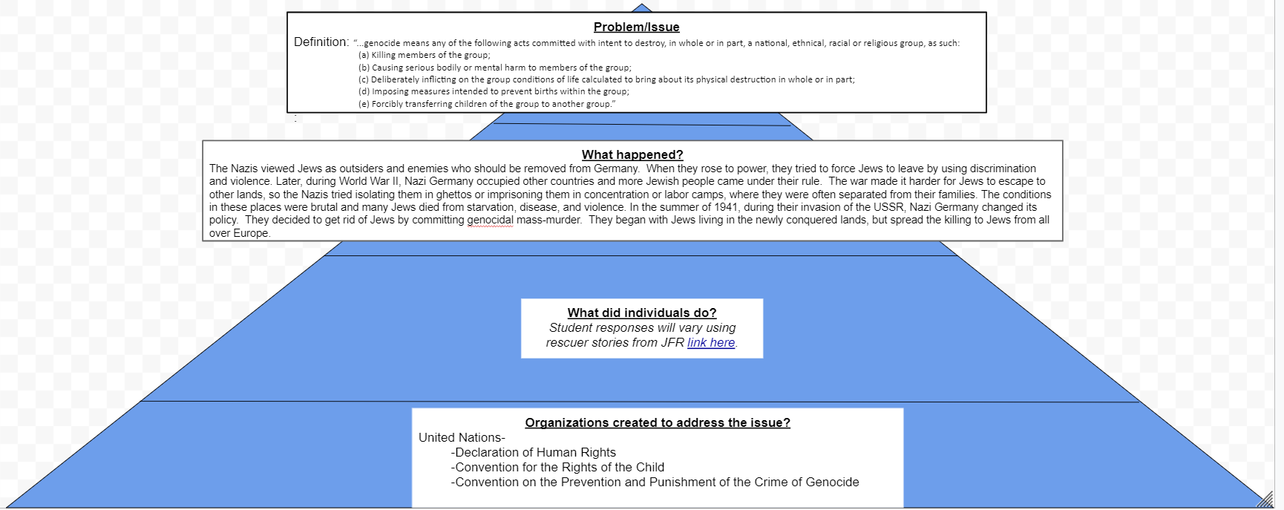

The Establishment of the United Nations, 1945
The United Nations is an international organization founded in 1945. It is currently made up of 193 Member States. The mission and work of the United Nations are guided by the purposes and principles contained in its founding Charter. The name "United Nations", coined by United States President Franklin D. Roosevelt was first used in the Declaration by United Nations of 1 January 1942, during the Second World War, when representatives of 26 nations pledged their Governments to continue fighting together against the Axis Powers.
Founded: October 24, 1945, San Francisco, CA
Headquarters: New York, NY
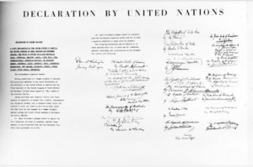
Declaration by United Nations issued in Washington, DC, on 01 January 1942
Source: un.org

United Nations Charter
“to reaffirm faith in fundamental human rights, in the dignity and worth of the human person, in the equal rights of men and women and of nations large and small.”
- Excerpt from United Nations Preamble

United Declaration of Human Rights
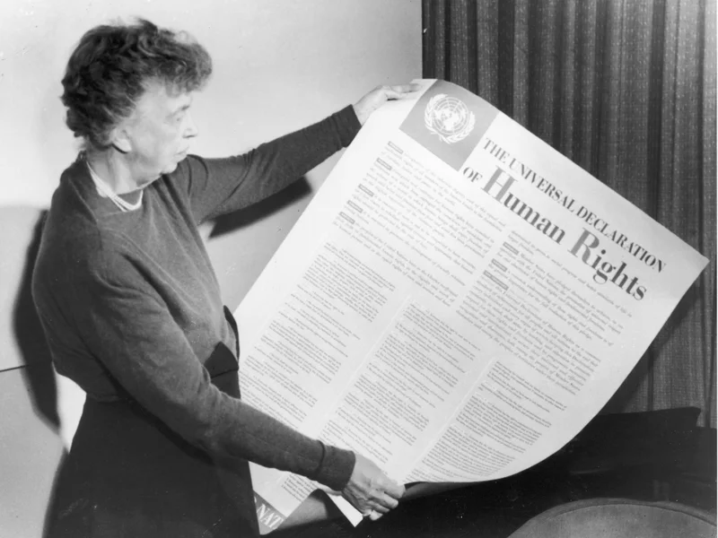
Whereas recognition of the inherent dignity and of the equal and inalienable rights of all members of the human family is the foundation of freedom, justice and peace in the world,

Whereas disregard and contempt for human rights have resulted in barbarous acts which have outraged the conscience of mankind, and the advent of a world in which human beings shall enjoy freedom of speech and belief and freedom from fear and want has been proclaimed as the highest aspiration of the common people,

Whereas it is essential, if man is not to be compelled to have recourse, as a last resort, to rebellion against tyranny and oppression, that human rights should be protected by the rule of law,
- Excerpt from Universal Declaration of Human Rights Preamble
*Image Source: Former First Lady Eleanor Roosevelt holds up a copy of The Universal Declaration of Human Rights, adopted by the United Nations in December 1948. Fotosearch/Getty Images. Captured from npr.org
Related articles from Universal Declaration of Human Rights
Article 1.
All human beings are born free and equal in dignity and rights. They are endowed with reason and conscience and should act towards one another in a spirit of brotherhood.

Article 2.
Everyone is entitled to all the rights and freedoms set forth in this Declaration, without distinction of any kind, such as race, color, sex, language, religion, political or other opinion, national or social origin, property, birth or other status. Furthermore, no distinction shall be made on the basis of the political, jurisdictional or international status of the country or territory to which a person belongs, whether it be independent, trust, non-self-governing or under any other limitation of sovereignty.

Article 3.
Everyone has the right to life, liberty and security of person.

Article 4.
No one shall be held in slavery or servitude; slavery and the slave trade shall be prohibited in all their forms.

Article 5.
No one shall be subjected to torture or to cruel, inhuman or degrading treatment or punishment.

Article 7.
All are equal before the law and are entitled without any discrimination to equal protection of the law. All are entitled to equal protection against any discrimination in violation of this Declaration and against any incitement to such discrimination.

Article 9.
No one shall be subjected to arbitrary arrest, detention or exile.

Convention on the Rights of the Child
“Considering that the child should be fully prepared to live an individual life in society, and brought up in the spirit of the ideals proclaimed in the Charter of the United Nations, and in particular in the spirit of peace, dignity, tolerance, freedom, equality and solidarity”
- Preamble to Convention on the Rights of the Child

Related Articles from Preamble to Convention on the Rights of the Child
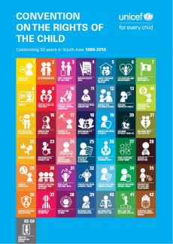
Article 2
1. States Parties shall respect and ensure the rights set forth in the present Convention to each child within their jurisdiction without discrimination of any kind, irrespective of the child's or his or her parent's or legal guardian's race, color, sex, language, religion, political or other opinion, national, ethnic or social origin, property, disability, birth or other status.

2. States Parties shall take all appropriate measures to ensure that the child is protected against all forms of discrimination or punishment on the basis of the status, activities, expressed opinions, or beliefs of the child's parents, legal guardians, or family members

Article 6
1. States Parties recognize that every child has the inherent right to life.

2. States Parties shall ensure to the maximum extent possible the survival and development of the child.

*Image Source: unicef.org

Test Items
Benchmark | Benchmark Clarification | Cognitive Complexity
4.2 | BC 1 | L

Question | Which organization was founded, in part, to protect international human rights?
A. | World Trade Organization
B. | League of Nations
C. | United Nations
D. | World Bank

Question | Which organization was founded, in part, to protect international human rights?
A. | World Trade Organization | Incorrect-The World Trade Organization was formed to deal with the rules of trade between nations.
B. | League of Nations | Incorrect-The League of Nations was formed to establish a “league of friendship” among member nations.
C. | United Nations | Correct-The United Nations was formed, in part, to protect human rights and in an effort to prevent another Holocaust.
D. | World Bank | Incorrect-The World Bank was formed to provide financial and technical assistance to developing countries and to address world poverty.

Benchmark | Benchmark Clarification | Cognitive Complexity
4.2 | BC 1 | L

Question | Which international organization was founded, in part, to address child poverty and discrimination against children?
A. | WTO
B. | League of Nations
C. | UNICEF
D. | World Bank

Question | Which international organization was founded, in part, to address child poverty and discrimination against children?
A. | WTO | Incorrect: The purpose of the WTO (World Trade Organization) is to support international trade, economic growth and development.
B. | League of Nations | Incorrect: The League of Nations was formed to promote peace among member nations following World War I. The purpose of the League of Nations was to prevent a second world war. The United States did not join the League of Nations.
C. | UNICEF | Correct: UNICEF was created following World War II with a focus on the needs of children. UNICEF is concerned with barriers that children may face including poverty, violence and discrimination.
D. | World Bank | Incorrect: The World Bank provides financial and technical assistance to reduce poverty in developing countries around the world.

Benchmark | Benchmark Clarification | Cognitive Complexity
4.2 | BC 4 | M

Question | Below is a quote by Raphael Lemkin in 1943:  …genocide is intended …to signify a coordinated plan of different actions aiming at the destruction of essential foundations of the life of national groups, …. The objectives of such a plan would be …the destruction of the personal security, liberty, health, dignity, and even the lives of the individuals belonging to such groups.  The purpose of which international organization includes preventing genocide, as defined by Raphael Lemkin?
A. | World Health Organization
B. | League of Nations
C. | World Trade Organization
D. | United Nations

Question | Below is a quote by Raphael Lemkin in 1943:  …genocide is intended …to signify a coordinated plan of different actions aiming at the destruction of essential foundations of the life of national groups, …. The objectives of such a plan would be …the destruction of the personal security, liberty, health, dignity, and even the lives of the individuals belonging to such groups.  The purpose of which international organization includes preventing genocide, as defined by Raphael Lemkin?
A. | World Health Organization | Incorrect: The purpose of the World Health Organization is to focus on the health needs of citizens in almost 200 countries.
B. | League of Nations | Incorrect: The League of Nations was formed to promote peace among member nations following World War I. The purpose of the League of Nations was to prevent a second world war. The United States did not join the League of Nations.
C. | World Trade Organization | Incorrect: The purpose of the World Trade Organization is to support international trade, economic growth and development.
D. | United Nations | Correct: The United Nations Genocide Convention was adopted by the United Nations soon after the United Nations was formed.

Benchmark | Benchmark Clarification | Cognitive Complexity
4.2 | BC 4 | M

Question | Below is a statement by Elie Wiesel in 1986:  I swore never to be silent whenever wherever human beings endure suffering and humiliation. We must take sides.  Why might Elie Wiesel support taking sides when human beings are suffering?
A. | Because taking sides supports equal protection
B. | Because taking sides supports the common good
C. | Because taking sides limits due process
D. | Because taking sides limits equal protection

Question | Below is a statement by Elie Weisel in 1986:  I swore never to be silent whenever wherever human beings endure suffering and humiliation. We must take sides.  Why might Elie Wiesel support taking sides when human beings are suffering?
A. | Because taking sides supports confederal governments | Incorrect: There are those who support confederal governments although there may be other types of governments that are preferred.
B. | Because taking sides supports the common good | Correct: Elie Wiesel’s comments focus on taking sides to reduce human suffering, which supports the common good.
C. | Because taking sides limits due process | Incorrect: One way to address human suffering in some forms is to guarantee and protect due process.
D. | Because taking sides limits equal protection | Incorrect: One way to address human suffering, such as segregation, is to guarantee equal protection of the laws.

Benchmark | Benchmark Clarification | Cognitive Complexity
4.3 | BC 4 | H

Question | In 1938 President Franklin Roosevelt called together a conference to encourage the representatives of 32 participating countries to form an organization to address refugee issues. The conference established the Intergovernmental Committee on Refugees (ICR). The goals of the ICR were to support refugee resettlement, especially for refugees who had left countries discriminating against them because of their religion.  Which modern political action would President Roosevelt support?
A. | President John F. Kennedy stating, “And so, my fellow Americans: ask not what your country can do for you--ask what you can do for your country.” in his inaugural address on January 20, 1961.
B. | President Barack Obama stating, “America respects the right of all peaceful and law-abiding voices to be heard around the world, even if we disagree with them.” in his speech to Cairo University on June 4, 2009.
C. | President Lyndon Johnson stating, “Our fathers believed that if this noble view of the rights of man was to flourish, it must be rooted in democracy. The most basic right of all was the right to choose your own leaders.” in a speech to Congress on March 15, 1965.
D. | President Dwight Eisenhower stating, “I thank you for the many opportunities you have given me for public service in war and peace. I trust that in that service you find some things worthy; as for the rest of it, I know you will find ways to improve performance in the future.” in his farewell address on January 17, 1961.

Question | In 1938 President Franklin Roosevelt called together a conference to encourage the representatives of 32 participating countries to form an organization to address refugee issues. The conference established the Intergovernmental Committee on Refugees (ICR). The goals of the ICR were to support refugee resettlement, especially for refugees who had left countries discriminating against them because of their religion.  Which modern political action would President Roosevelt support?
A. | President John F. Kennedy stating, “And so, my fellow Americans: ask not what your country can do for you--ask what you can do for your country.” in his inaugural address on January 20, 1961. | Incorrect-The response focuses on citizens serving their country while the scenario focuses on political leaders responding to the needs of victims of religious discrimination.
B. | President Barack Obama stating, “America respects the right of all peaceful and law-abiding voices to be heard around the world, even if we disagree with them.” in his speech to Cairo University on June 4, 2009. | Incorrect-The response focuses on political tolerance while the scenario focuses on political leaders responding to the needs of victims of religious discrimination.
C. | President Lyndon Johnson stating, “Our fathers believed that if this noble view of the rights of man was to flourish, it must be rooted in democracy. The most basic right of all was the right to choose your own leaders.” in a speech to Congress on March 15, 1965. | Incorrect-The response focuses on voting rights in the United States while the scenario focuses on an international organization.
D. | President Dwight Eisenhower stating, “I thank you for the many opportunities you have given me for public service in war and peace. I trust that in that service you find some things worthy; as for the rest of it, I know you will find ways to improve performance in the future.” in his farewell address on January 17, 1961. | Correct-In his farewell address, President Eisenhower focused on public service in an international context. The purpose of the ICR was to engage in public service in an international context as well.

