STUDENTS INVESTIGATING PRIMARY SOURCES
Picturing Separation of Powers
How do the political cartoons relate to the concept of separation of powers?
A Short Activity for High School and Middle School
Benchmark Correlations
SS.912.C.1.5 – Evaluate how the Constitution and its amendments reflect the political principles of rule of law, checks and balances, separation of powers, republicanism, democracy, and federalism.
Benchmark Clarification: Students will identify and/or explain the three branches of government established by the Constitution and how the terms separation of power and checks and balances apply.
LAFS.910.RH.1.2- Determine the central ideas or information of a primary or secondary source; provide an accurate summary of how key events or ideas develop over the course of the text.
LAFS.1112.RH.1.2 – Determine the central ideas or information of a primary or secondary source; provide an accurate summary that makes clear the relationships among the key details and ideas.

SS.7.C.1.7 – Describe how the Constitution limits the powers of government through separation of powers and checks and balances.
Benchmark Clarification: Students will describe and distinguish between the concepts of separation of powers and checks and balances.
LAFS.68.RH.1.2 – Determine the central ideas or information of a primary or secondary source; provide an accurate summary of the source distinct from prior knowledge or opinions.

Activity Documents and Handouts
- This is the team that will win every time Political Cartoon
- Hope this won’t develop into a neighborhood feud Political Cartoon
- Cartoon Comparison Worksheet

Full Document Citations
This is the team that will win every time, cartoon by Clifford Berryman, March 27, 1898; U.S. Senate Collection, Record Group 46; National Archives Building, Washington DC. National Archives Identifier: 6010254.
[https://catalog.archives.gov/id/6010254]
[https://www.docsteach.org/documents/document/team-win]

Hope This Won’t Develop Into A Neighborhood Feud, cartoon by Clifford Berryman, May 18, 1948; U.S. Senate Collection, Record Group 46; National Archives Building, Washington DC. National Archives Identifier: 6012421.
[https://catalog.archives.gov/id/6012421]
[https://www.docsteach.org/documents/document/hope-this-wont-develop-neighborhood-feud]

Activity Vocabulary
FBI – Federal Bureau of Investigation, an agency of the Justice Department responsible for investigating violations of federal laws
separation of powers – the structure of the federal government, according to the U.S. Constitution, that sets up three branches with their own distinct powers and responsibilities
symbol – an image or object used to represent ideas or qualities

Teacher Note
Before starting this activity, view the Teacher Background Information on the political cartoons.
- Project the full page “This is the team that will win every time” political cartoon on the board and pass out the Cartoon Comparison handout to students as they enter the room
- Direct students to visually scan the document and identify three items that stand out to them in the document and write them on their worksheet. (Examples could include: Uncle Sam, American flag, a team of three horses.)
- Have a few students share out and write the items on the board. Teacher Note: Be sure to include the text used in the cartoon, “Senate, Executive, House”, and add it to the list on the board.
- Pose the following questions for discussion: “Are there any words or phrases used by the cartoonist to identify objects or people within the cartoon? (Senate, Executive, House)
- Direct student attention to the list of items on the board. Explain that everything in this cartoon was a choice made by the artist to convey his message. Remind students of the definition of the term “symbol”. Pose the following questions for discussion: Which of the items that we identified are symbols? What do you think each symbol means/represents?
- Have students brainstorm both questions with their shoulder partner and write down their ideas on the worksheet.
- Have a few students share out. Teacher Note: Be sure to point out the following symbols and meanings - Uncle Sam: represents the United States of America (“Uncle Sam”=U.S., or United States); 2 American Flags: represent the United States of America, the use of multiple flags could signify pride in one’s country; A team of three horses: one horse represents the Senate, one horse represents the president, one horse represents the House, a team of horses represents the idea of a team working together. The choice of horses could be intended to convey a message of strength and power, as horses are strong animals.; Chariot: an ancient form of transportation, often used during wartime, may represent the idea of war or power; Racetrack: symbolizes competition, indicates that there is something to be won; and Dust behind chariot: indicates speed, may represent the idea of moving quickly into something.
- Pass out the “Hope This Won’t Develop Into a Neighborhood Feud” political cartoon and repeat Steps 2-7. Teacher Note: Sample Answers Include, Step 2 (man with a beard, man with a bow tie, a building with columns, lawn and fence), Step 4 (Executive, legislative, separation of powers, Congress, Truman – President Harry Truman), Step 5 (Man labeled Congress: represents Congress, the legislative branch of government; building with columns: represents the White House, symbol of the executive branch; lawn on either side: represents two branches of government, legislative, and executive; fence: stands for the idea of separation of powers, can be symbol for boundaries, restrictions, protection; both men on the executive side of the fence: represents the idea of Congress infringing on the powers of the executive branch)
- Have students work with their shoulder partner to choose three words to describe the relationship between Congress and the president as depicted by the artist in each cartoon and write the words in the appropriate boxes on their worksheet. Teacher Note: For Cartoon One: Some words could include: harmonious, friendly, effective, productive, cooperative; For Cartoon Two: tense, hostile, unfriendly, uncooperative, combative, argumentative
- Pose the following questions for discussion: What does the term “separation of powers” mean? What can we learn about the relationship between the executive and the legislative branches from the artist’s point of view in these two cartoons? How do the cartoons relate to this concept? Teacher Note: Possible ideas could include: The executive and legislative branches can move the country forward when they work together. But, this is also a relationship that is not conflict free. While there is a separation of powers in our government, there may be disagreements on how authority is divided and/or shared. The two cartoons illustrate different ways separation of powers can be viewed.
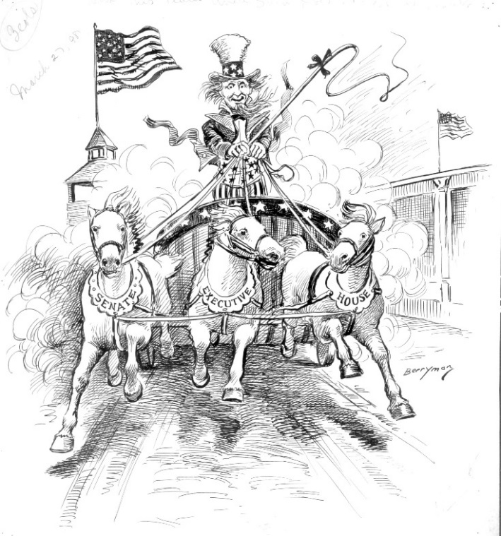

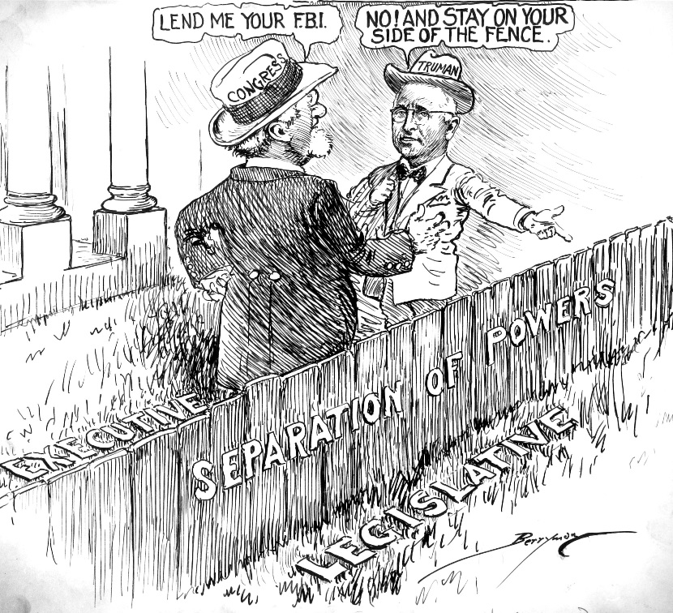

This is the team that will win every time
Teacher Background Information

“This is the team that will win every time”
March 27, 1898
6010254

Background from NARA Catalog
The USS Maine exploded on February 15, 1898 and caused Congress to shift its sentiments from majority anti-war to overwhelmingly pro-war. Two months later, on April 11, President McKinley asked Congress for authority to send American troops to Cuba for the purpose of ending the civil war. Cartoonist Clifford Berryman emphasizes his faith in the balance of the war powers by showing a three-part team made up of the House, Senate, and Executive Office leading the way to victory in the Spanish-American War.

Representing Congress: Clifford K. Berryman’s Political Cartoons eBook: pages 7, 53

Hope This Won’t Develop Into a Neighborhood Feud
Teacher Background Information
“Hope This Won’t Develop Into a Neighborhood Feud”
May 18, 1948
6012421

Background from NARA Catalog
This cartoon by Clifford Berryman illustrates the struggle between the Senate and President Truman during 1948. In May 1948, Truman nominated five incumbent members of the Atomic Energy Commission to remain at their posts within the organization. These individuals required congressional confirmation and the Senate refused to give such confirmation until they were privy to FBI reports on each of the individuals. Truman refused such investigations as an encroachment by the legislative branch on the executive.

Representing Congress: Clifford K. Berryman’s Political Cartoons eBook: pages 8, 53

Name: _________________________________________________________________________________ Date: _____________________________________
Cartoon Comparison

Cartoon Title: ______________________________________________________ Cartoon Title: ______________________________________________________

Visual Scan Items
Visual Scan Items

Symbol Meaning

Symbol Meaning

Write a summary statement about the relationship between the executive and the legislative branches based on your understanding of the cartoons.
Three Relationship Words

Three Relationship Words

Name: _________________________________________________________________________________ Date: _____________________________________
Cartoon Comparison – SAMPLE ANSWERS

Cartoon Title: This is the team that will win every time Cartoon Title: Hope This Won’t Develop Into a Neighborhood Feud

Visual Scan Items
man with a beard, man with a bow tie, a building with columns, lawn and fence
Visual Scan Items
Uncle Sam, American flag, a team of three horses

Symbol Meaning
Man labeled Congress Congress, legislative branch
Truman President Harry Truman
Building with columns White House, executive branch
Fence separation of powers
Symbol Meaning
Uncle Sam United States
American Flags United States
Team of Three Horses Senate, president, House of Representatives; teamwork; strength
Write a summary statement about the relationship between the executive and the legislative branches based on your understanding of the cartoons.
The executive and legislative branches have separate powers, sometimes the two branches work together happily and other times it is a relationship with conflict.
Three Relationship Words
tense, hostile, unfriendly, uncooperative, combative, and argumentative

Three Relationship Words
harmonious, friendly, effective, productive, cooperative

