STUDENTS INVESTIGATING PRIMARY SOURCES
Pestering with a Purpose: Arguing Women’s Right to Vote
How is this document an illustration of civic and political participation?
A Short Activity for High School U.S. Government Courses
Benchmark Correlations
SS.912.C.2.2 – Evaluate the roles, rights, and responsibilities of United States citizens and determine methods of active participation in society, government and the political system.
Benchmark Clarification: Students will explain the different ways in which United States citizens can exercise political and civic participation.
Benchmark Clarification: Students will analyze the importance of political and civil participation by citing historical examples of citizens petitioning for their rights (e.g., Civil Rights Movement, Women’s Suffrage Movement).
LAFS.1112.RH.1.2 – Determine the central ideas or information of a primary or secondary source; provide an accurate summary that makes clear the relationships among the key details and ideas.

Activity Documents
- Memorial of Alice Wadsworth of the National Association Opposed to Woman Suffrage, Full Document and Annotated Page 2
* The document has been modified from its original version. This handout includes a cropped version of page 2 of the original document, paragraph numbers and a word bank to assist with reading comprehension.

Full Document Citation
Memorial of Alice Wadsworth of the National Association Opposed to Woman Suffrage, 12/11/1917; Petitions and Memorials, 1813-1968; Records of the House of Representatives, Record Group 233; Center for Legislative Archives. National Archives Identifier: 595295.
[https://catalog.archives.gov/id/595295]
[https://www.docsteach.org/documents/document/memorial-of-alice-wadsworth]

Activity Vocabulary
amendment – a change to a constitution
cajolery – persuasion by flattery
feminism – the belief that men and women should have equal rights and opportunities
futile - pointless
impotent – lacking power or ability
pickets - a person engaged in a demonstration or strike
ratification – the process of formally approving something
Socialist – a person who believes in a form of government where major industries are owned and controlled by the government rather than by individual people and companies
suffrage – the right to vote

Teacher Note: This activity involves a role-play between a local government leader and a concerned citizen. Preselect a student to participate in the role-play as the concerned citizen. The goal of the role-play is to have students consider the importance of resilience in civic engagement. Often – on all levels of politics – deeply held positions meet resistance and even rejection. In this activity students will consider productive responses to opposition and be encouraged to evaluate next steps in response to it by reflecting on the actions of suffrage opponents. Prearrange with the selected student that you will respond negatively to his or her ideas by such means as emphasizing that his or her opinion is “in the minority and of no concern to most people” and that “we in local government see you as a pest.”

- Post the following prompt on the board: In your opinion, what is a problem in the community that you would address with local government leaders? Be prepared to share this opinion with your local government leader. (Examples could include: potholes, a dangerous intersection, rundown recreational facilities, or beach litter.)
- Give students a minute to think of a problem and what they would say to their local government leader. Explain that one student will participate in a role-play to share their problem.
- Start the role-play with the following statement: “I’m your local government leader. Now I’m going to invite a citizen to speak with me about an issue of concern.”
- Invite the pre-selected student to explain the issue he or she views as a problem in the community. As stated in the Teacher Note above, after listening to the student share his or her opinion initiate a dialogue in which you – as the local government leader - dismiss the issue and discourage the student from pursuing it.
- Debrief the role-play experience with students using the following questions: How did my response as the local government leader challenge (insert student’s name) as a concerned citizen? What should (insert student’s name) next step be after this meeting with a government leader? Lead students to the understanding that they have a voice in government and the right to petition the government.
- Split the class into four groups.
- Project the “Memorial of Alice Wadsworth of the National Association Opposed to Woman Suffrage Letter”. Remind students of the definition of suffrage (the right to vote) and that suffrage is a civil rights issue.
- Direct students to visually scan both pages of the document and identify three items that stand out to them in the document. (Examples could include: underlined words, column of names, letter, the use of one’s husband’s name, date, location, a signature, printed on letterhead.)
- Have a few students share out. Guide the discussion to emphasize the following points about the National Association Opposed to Woman Suffrage: the name of the organization states their view on woman suffrage, the signatures on this letter are all from women, it was a national organization, and the letter has underlined text to emphasize points.
- Distribute the annotated version of page two of the “Memorial of Alice Wadsworth of the National Association Opposed to Woman Suffrage Letter”.
- Assign each group one of the following paragraphs: Paragraph 2, Paragraphs 3 and 4, Paragraph 5, and Paragraph 8.
- Assign each group to read their paragraph(s) and summarize what they’ve read in their own words, using 10-15 words on their own notebook paper. (For more assistance on this strategy, view the GIST strategy.)
- Direct each group to share their summary with the whole class.
- Pose the following questions for discussion: What do all of these summaries have in common? Based on your reading of this document, how do the authors value the civic participation of others? Based on the fact that the 19th Amendment was ratified soon after this letter was written giving women the right to vote, what conclusions can you draw about the importance of civic and political participation even when one holds the minority opinion? Or if the opinion ends up on the “losing” side of historical or political action? Is the effort still worthwhile?

Enrichment Suggestion – Use the following questions to engage students in further discussion: What might be the motivation of these women to take this point of view? What motivates the majority to dissuade the minority from civic and political participation? What are some historical and current examples of this behavior?
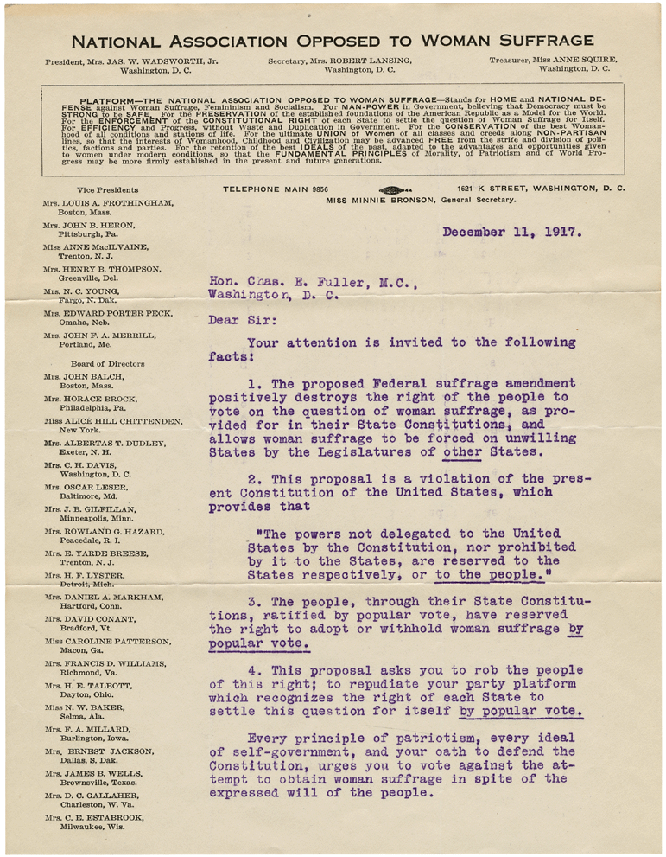

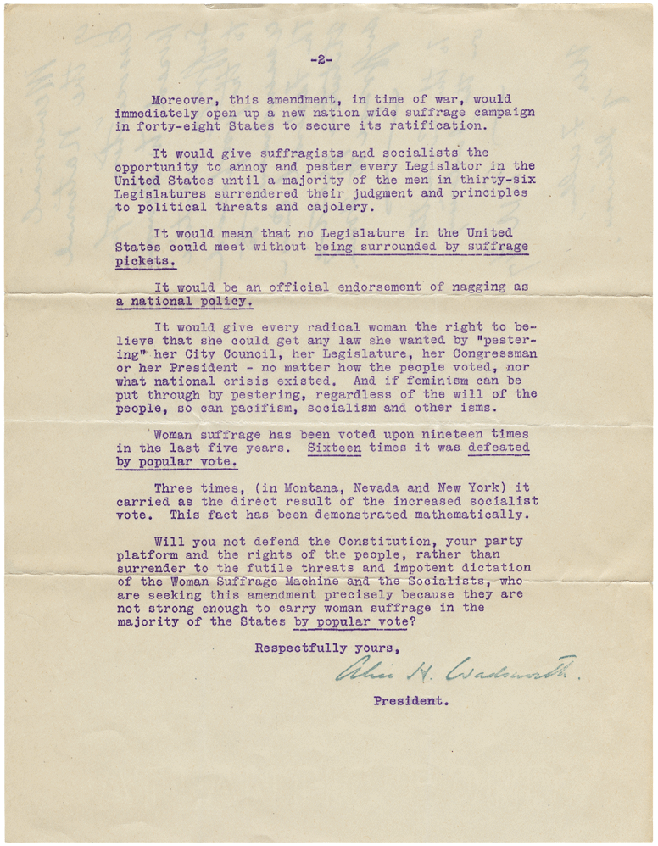

NATIONAL ASSOCIATION OPPOSED TO WOMAN SUFFRAGE – ANNOTATED PAGE 2*
*The document has been modified from its original version. This handout includes a cropped version of page 2 of the original document, paragraph numbers and a word bank to assist with reading comprehension.
amendment – a change to a constitution
cajolery – persuasion by flattery
feminism – the belief that men and women should have equal rights and opportunities
futile - pointless
impotent – lacking power or ability
pickets - a person engaged in a demonstration or strike
ratification – the process of formally approving something
Socialist – a person who believes in a form of government where major industries are owned and controlled by the government rather than by individual people and companies
suffrage – the right to vote
8
7
6
5
4
3
2
1

