Holocaust Education through a Civics Lens

Nazi Propaganda

This lesson plan was developed to facilitate teaching and learning the history of the Holocaust and the required instructional approach as outlined in state statute 1003.42.2(g)1 . In addition, this lesson is aligned to the expectations of state statute 1003.42.2(g)2: Holocaust Education Week.

Teacher Notes: There is a digital and a non-digital version of this lesson. Each version contains the same content and primary sources. It is up to the teacher to decide which lesson will be used for this activity.

Lesson Benchmark Alignment Appendix

All accompanying links are found in the lesson plan below. Resources below the lesson plan for your convenience are from the non-digital version of this lesson.

Lesson Title | Florida Civics Benchmarks | Duration of Lesson
Nazi Propaganda | SS.7.C.2.11 and SS.7.C.2.13 | 1 Class Period
Other Course Applications:
US Government
World History

Essential Questions
How did the Nazis use propaganda to push their ideology and win support from the German public?
How did the Nazis use propaganda to create support for a unified, race-based community of the German people?
How did the Nazis use propaganda to create a negative image of Jews that portrayed them as dangerous outsiders?
Learning Goals
During this lesson students will define propaganda and how propaganda is used to support a government’s agenda. Students will apply critical reading and thinking skills to various media presentations through analysis of the techniques commonly used in Nazi propaganda. Students will analyze how Nazis used propaganda to indoctrinate and manipulate the German people.

Note: The Florida Joint Center for Citizenship (free teacher account) offers lessons on benchmark SS.7.C.2.11 and SS.7.C.2.13 under the “Resources” tab.
Content Notes for Teachers
Propaganda is the dissemination of information to influence or control large groups of people. In totalitarian regimes like Nazi Germany, propaganda played a significant role in consolidating power in the hands of the controlling party.
Shortly after rising to power in 1933, Adolf Hitler created the Reich Ministry of Public Enlightenment and Propaganda (RMVP). Nearly all aspects of German culture were subject to the Propaganda Ministry's control, including films, theater, music, the press, and radio broadcasts. Given tremendous leeway by Hitler, and utilizing modern techniques and technologies, the RMVP quickly set out an ambitious agenda to indoctrinate the German people in Nazi ideology and to influence the behavior of the entire society. These carefully-crafted messages were designed to mobilize the German population to support all Nazi military and social efforts, including the deportation of Jews and others to concentration camps.
There were several audiences for Nazi propaganda. Germans were reminded of the struggle against foreign enemies and Jewish subversion. During periods preceding legislation or executive measures against Jews, propaganda campaigns created an atmosphere tolerant of violence against Jews. Propaganda also encouraged passivity and acceptance of the impending measures against Jews, as these appeared to depict the Nazi government as stepping in and “restoring order.”
Propaganda also sought to elicit political loyalty and so-called race consciousness among the ethnic German populations. It also sought to mislead foreign governments—including the European Great Powers—that Nazi Germany was making understandable and fair demands for concessions and annexations.
Source: Excerpted from Nazi Propoganda and Nazi Propoganda Bibliography, U.S. Holocaust Memorial Museum.
Florida Civics Benchmarks
SS.7.C.2.11 - Analyze media and political communications (bias, symbolism, propaganda)
Benchmark Clarifications:
- Students will use scenarios to identify bias, symbolism, and propaganda.
- Students will evaluate how bias, symbolism, and propaganda can impact public opinion.

SS.7.C.2.13 - Examine multiple perspectives on public and current issues.
Benchmark Clarifications:
- Students will identify groups that influence public perspectives. Students will use scenarios to understand the reaction or perspective of different groups.
- Students will examine how multiple perspectives shape participation in the political process.
Instructional Strategies/Lesson Activity
Hook Activity
- Teachers will show the following video to the students:
  - Encyclopedia Britannica’s Adolf Hitler's campaign for chancellor and Joseph Goebbels's role in promoting his propaganda and terror
- Ask students:
  - What is propaganda?
- A few students will answer the question, and the teacher should provide the correct definition. If needed you may display the following presentation from the United States Holocaust Memorial Museum that gives a definition of propaganda.

Activity
Note: There is a digital and a non-digital version of this lesson. Each version contains the same content and primary sources. It is up to the teacher to decide which lesson will be used for this activity.
Part 1 - Before Class
- Digital Version: Print and post the Digital Propaganda Posters with the QR codes throughout the classroom or in the hallway for students to analyze.
- Non Digital Version: Print and post the Non-digital Propaganda Posters without the QR codes throughout the classroom or in the hallway for students to analyze.

Part 2 - Explanation of Lesson
- Both: Teachers will display the instructions for the activity on the board
  - Digital Version: Propaganda Scavenger Hunt Instructions
  - Non Digital Version: Propaganda Scavenger Hunt Instructions
- Digital Version: Teacher will pass out the handout titled Scavenger Hunt Clues to each student. This document is a half sheet of paper, and serves as a checklist for the students.
- Non Digital Version: Teacher will pass out the handout titled Scavenger Hunt Clues & Questions. This document is a full sheet of paper, and is where the students record their answers to the questions.
Part 3 - Analyzing the Posters
- Digital Version: The students will read each clue and determine which is the correct propaganda poster to analyze. When the student comes to the correct poster, he/she will analyze the poster and its information, then use their digital device to scan the QR code. This link will provide the questions to that specific poster. NOTICE: in the digital version it is up to the teacher to determine what is the best way to have the students answer the questions. Suggestions include, but are not limited to making a Google Form or have them write the answers on paper. As the students complete each poster, they will mark the appropriate box on their Scavenger Hunt Clues to indicate they have completed all necessary tasks at that poster.
- Non Digital Version: The students will read each clue and determine which poster is the correct propaganda poster to analyze. When the student comes to the correct poster, he/she will analyze the poster and its information, then record the answers on his/her Scavenger Hunt Clues & Questions handout.
- Both: This rotation will occur until all posters have been analyzed and the questions have been answered.

Closing Activity
- Students will choose one of the six propaganda posters, and complete the following prompt on an exit ticket:
  - Choose one of the six posters you analyzed and identify an example from the United States, either historical or contemporary that expresses a similar idea.
Assignment(s)
- Digital version - paper or online version of the questions
- Non-digital version - Scavenger Hunt Clues & Questions
- Exit ticket prompt
Assessment and Monitoring (Checks for content and mastery)
- Teacher observation and questioning of groups and individuals at each step of the instructional process and during transitions between activities.
- Check for understanding of the content through various responses to the analytical questions.
Adaptations for Unique Student Needs
- Provide read aloud of the resources
- Provide additional print and/or video resources
Resources and Materials
- Encyclopedia Britannica’s Adolf Hitler's campaign for chancellor and Joseph Goebbels's role in promoting his propaganda and terror
- USHMM Propaganda Presentation
- Digital Version: Propaganda Scavenger Hunt Instructions
Scavenger Hunt Clues
Propaganda Scavenger Hunt Posters (digital)
Scavenger Hunt Questions for students to answer
- Non Digital Version: Propaganda Scavenger Hunt Instructions
Scavenger Hunt Clues & Questions
Propaganda Scavenger Hunt Posters (non-digital)
- Nazi Propaganda Test Items

Note: The Florida Joint Center for Citizenship (free teacher account) offers lessons on benchmark SS.7.C.2.11 and SS.7.C.2.13 under the “Resources” tab.

Basic Needs in Germany

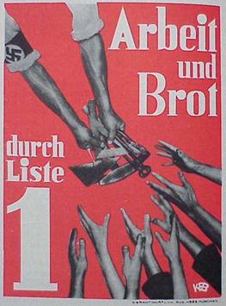
Description:
- Poster text - “Work and Bread through List 1” (List 1 refers to the Nazi Party on the election ballot)
- During the Great Depression, which left 7 million Germans without work, the Nazi Party sought votes by portraying itself as the party that could create jobs and put food on German tables.

Dehumanizing Imagery

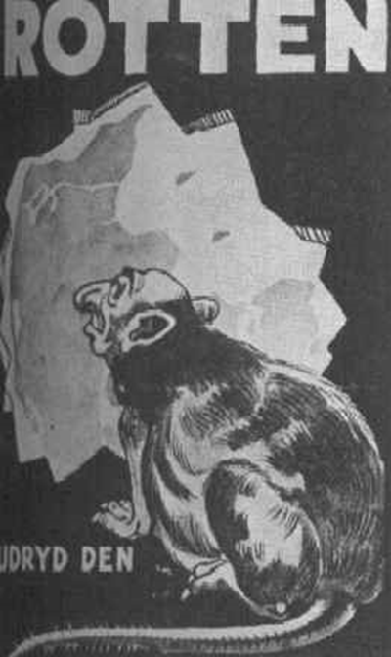
Description: Danish Nazi Poster Text Translation - “Rat: Exterminate it”

Identification: Jews as Enemies

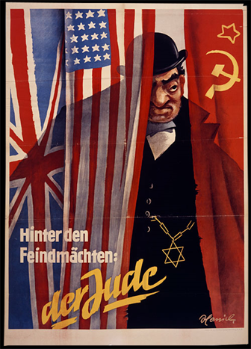
Description:
- Poster text translation - “Behind the Enemy Powers: The Jew”
- During World War II, Nazi Germany fought against several other nations. The Nazis claimed that there was a main enemy lurking behind all of their other opponents.

Identification: Jews as Racial Outsiders

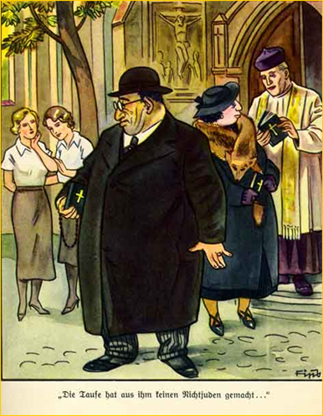
Description:
- The image above is a page out of a children’s book titled “The Poison Mushroom”
- The girls in the background are dressed as if they are members of a Hitler Youth girls’ group.
- The gentleman in the background is a Catholic priest
- The woman and man are husband and wife
- The girls are observing that these Jewish converts to Christianity had not become gentiles (non-Jews).

Pro Hitler Message

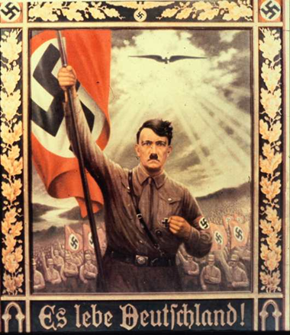
Description:
- Poster text - “Long Live Germany!”
- This image portrays Adolf Hitler as a larger-than-life heroic leader.
- Members of the Nazi party are following Hitler enthusiastically.
- The image shows the heavens opening and shining the light of approval on Hitler’s leadership.

Youth Called to Service

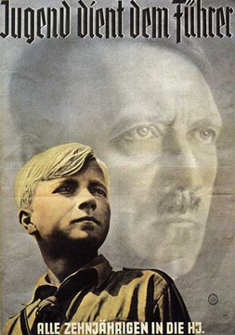
Description:
- Poster Text - “Youth Serves the Leader: All Ten year-olds in the Hitler Youth”
- In the early 1920’s, the Nazi party established a youth movement (The Hitler Youth) with the aim of teaching young people Nazi ideology. By the mid 1930s, the Nazis required all German youth to join.

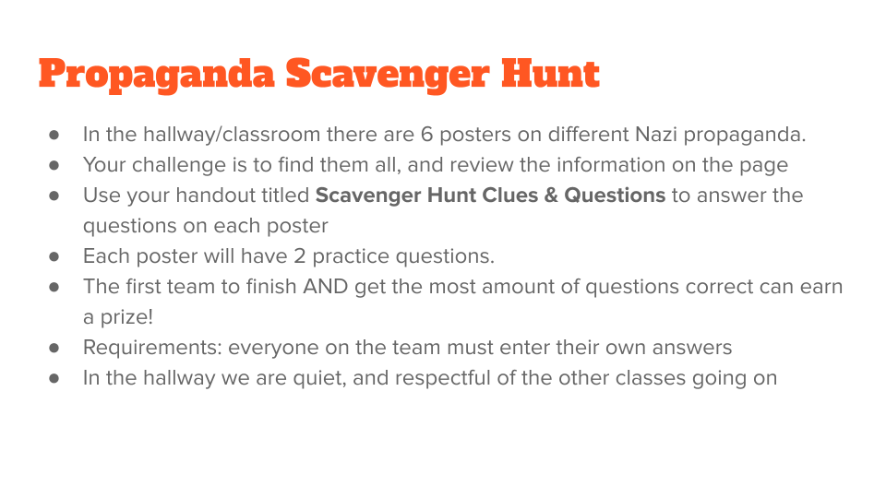

Propaganda Scavenger Hunt Questions
1. Clue: The giving and receiving of “bread.”
Title of Poster:
1. Who is giving and who is receiving?
2. If the poster is talking about “bread,” why are the Nazis handing out tools?
2. Clue: Getting rid of pests
Title of Poster:
1. Who is being compared to rats?
2. Why would showing someone as a rat make it easier to persecute them?
3. Clue: Hide ‘n Peek
Title of Poster:
1. What nations are represented by the three flags?
2. Why would the Nazis claim the Jew is the enemy rather than the enemy nations?
4. Clue: You Gotta Have Faith
Title of Poster:
1. How do we know that the couple in the picture are Christian believers?
2. Why do the girls claim that these people are still Jews?
5. Clue: Our Savior
Title of Poster:
1. How is Hitler being portrayed in this image?
2. What do the rays of light represent in this image?
6. Clue: Youth of the Nation
Title of Poster:
1. What are the young boy and Hitler looking toward?
2. Why is Hitler shown as a spiritual presence rather than a physical presence?
Test Items
Benchmark | Benchmark Clarification | Cognitive Complexity
2.11 |  | L

Question | Which option represents a communication that seeks to influence behavior?
A. | Newspapers
B. | Propaganda
C. | Legislatures
D. | Political parties

Question | Which option represents a communication that seeks to influence behavior?
A. | Newspapers | Incorrect-Newspapers may include communications that influence behavior. Newspapers represent a way to communicate information.
B. | Propaganda | Correct-Propaganda includes elements that week to influence behavior.
C. | Legislatures | Incorrect-Legislatures are not a form of communication that may be affected by communication.
D. | Political parties | Incorrect-Political parties are not a form of communication although political parties often communicate political information.

Benchmark | Benchmark Clarification | Cognitive Complexity
2.11 |  | L

Question | Which option outlines a communication that represents an issue or idea?
A. | Symbolism
B. | Television
C. | Presidents
D. | Constitution

Question | Which option outlines a communication that represents an issue or idea?
A. | Symbolism | Correct-Symbolism is a way to represent an issue or idea.
B. | Television | Incorrect-Television is a form of communication that represents one way to communicate symbolism.
C. | Presidents | Incorrect-Presidents communicate messages that may include symbolism.
D. | Constitution | Incorrect-The Constitution protects the right of communication but the Constitution is not a form of communication.

Benchmark | Benchmark Clarification | Cognitive Complexity
2.11 |  | M

Question | Which of the following is an example of using propaganda to acquire power?
A. | Selecting a nominee for the bureaucracy
B. | Enacting legislation that limits expression
C. | Publishing books that appeal to the public
D. | Prosecuting a criminal case before a jury

Question | Which of the following is an example of using propaganda to acquire power?
A. | Selecting a nominee for the bureaucracy | Incorrect-Persons already holding power may select individuals to serve in the bureaucracy
B. | Enacting legislation that limits expression | Incorrect-Persons already holding power may enact legislation
C. | Publishing books that appeal to the public | Correct-Messages that appeal to the public may result in the public giving power to the person represented by or creating that message
D. | Prosecuting a criminal case before a jury | Incorrect-The scenario presented does not involve using propaganda to acquire power

Benchmark | Benchmark Clarification | Cognitive Complexity
2.11 |  | M

Question | Below is an excerpt from a book published in 1925:  Propaganda must always address itself to the broad masses of the people. (...) All propaganda must be presented in a popular form and must fix its intellectual level so as not to be above the heads of the least intellectual of those to whom it is directed.  According to the author, to which group should propaganda be directed?
A. | Legislators
B. | Cabinet secretaries
C. | Diplomats
D. | The public

Question | Below is an excerpt from a book published in 1925:  Propaganda must always address itself to the broad masses of the people. (...) All propaganda must be presented in a popular form and must fix its intellectual level so as not to be above the heads of the least intellectual of those to whom it is directed.  According to the author, to which group should propaganda be directed?
A. | Legislators | Incorrect-The author focuses on the “broad masses of the people”, which does not represent legislators, who hold government positions.
B. | Cabinet secretaries | Incorrect-The author focuses on the “broad masses of the people”, which does not represent Cabinet secretaries, who hold government positions.
C. | Diplomats | Incorrect-The author focuses on the “broad masses of the people”, which does not represent diplomats, who hold government positions.
D. | The public | Correct-The author focuses on the “broad masses of the people”, which represents the public.

Benchmark | Benchmark Clarification | Cognitive Complexity
2.11 |  | H

Question | Below is an excerpt from a book published in 1925:  Propaganda must not investigate the truth objectively and, in so far as it is favourable to the other side, present it according to the theoretical rules of justice; yet it must present only that aspect of the truth which is favourable to its own side.  Which of the following actions would limit the effect of the events described in the quote?
A. | Lobbying justices to enforce current law.
B. | Publishing articles that demonstrate political bias
C. | Outlawing groups from using their symbols in public.
D. | Lobbying bureaucrats to enact legislation

Question | Below is an excerpt from a book published in 1925:  Propaganda must not investigate the truth objectively and, in so far as it is favourable to the other side, present it according to the theoretical rules of justice; yet it must present only that aspect of the truth which is favourable to its own side.  Which of the following actions would limit the effect of the events described in the quote?
A. | Lobbying justices to enforce current law. | Incorrect-The court system is responsible for adjudicating the law; the executive branch is responsible for enforcing the law.
B. | Publishing articles that demonstrate political bias | Incorrect-Publishing articles to demonstrate political bias would enhance, and not limit, the events described in the scenario.
C. | Outlawing groups from using their symbols in public | Correct-Legislation that limits the use of symbols would limit the effect of propaganda.
D. | Lobbying bureaucrats to enact legislation | Incorrect-Bureaucrats are responsible for enforcing legislation, not enacting legislation.

Benchmark | Benchmark Clarification | Cognitive Complexity
2.11 |  | H

Question | In 2018, a European court upheld a German law that prohibited propaganda that supported a specific viewpoint. What is the long-term goal of the precedent set by the European court?
A. | Advancing human rights
B. | Limiting economic opportunities
C. | Limiting educational opportunities
D. | Promoting international relations

Question | In 2018, a European court upheld a German law that prohibited propaganda that supported a specific viewpoint. What is the long-term goal of the precedent set by the European court?
A. | Advancing human rights | Correct-Limiting expression, such as political expression, is justified when that expression threatens human rights.
B. | Limiting economic opportunities | Incorrect-Limiting expression, such as political expression, may lead to limited economic opportunities although the court’s decision would not establish that precedent.
C. | Limiting educational opportunities | Incorrect-Limiting expression, such as political expression, may lead to limited educational opportunities although the court’s decision would not establish that precedent.
D. | Promoting international relations | Incorrect-The court decision focused on a law within a single country and not on relationships among several nations.

