Holocaust Education through a Civics Lens

Loss of Natural Rights

This lesson plan was developed to facilitate teaching and learning the history of the Holocaust and the required instructional approach as outlined in state statute 1003.42.2(g)1 . In addition, this lesson is aligned to the expectations of state statute 1003.42.2(g)2: Holocaust Education Week.

Teacher Notes: N/A

Lesson Benchmark Alignment Appendix

All accompanying links are found in the lesson plan below

Lesson Title | Florida Civics Benchmarks | Duration of Lesson
Loss of Rights in Nazi Germany | SS.7.C.1.4 and SS.7.C.3.6 | 2 Class Periods
Other Course Applications:
US Government
US History
World History
European History

Essential Questions
How does the government protect or limit natural rights?
How did the German government under Nazi rule limit the rights of Jewish people?
How did Nazi limits on the rights of Jewish people affect daily life?
Why did the Nazis engage in these abusive acts?

Learning Goals
In this lesson students will learn about how the Nazi regime used various social, political and legal tools to exclude Jews from society. Students will view seven scenarios in Nazi Germany that depict a loss of rights. Each scenario will include several artifacts such as images, data, or text, that the students will use to determine which rights are being denied.

Note: The Florida Joint Center for Citizenship (free teacher account) offers lessons on benchmarks SS.7.C.1.4 and SS.7.C.3.6 under the “Resources” tab.

Content Notes for Teachers
Nazi persecution of German Jews before World War II imposed social and economic displacement and Jewish removal from German soil. Most of the anti-Jewish campaign was carried out in the full glare of world publicity. Its typical manifestations were discriminatory legislation, economic deprivation, public defamation, administrative harassment, and social ostracism rather than physical torture and murder.
A distinctive feature of Nazi policy before World War II was an interplay between repression and normalcy that focused on tightening and untightening antisemitic pressure. Spurts of intense antisemitic activity were buffered by prolonged periods of deceptive stabilization. By and large, the pre-war antisemitic campaign crested at three junctures:
- The boycott of April 1, 1933, and the ensuing wave of racial legislation aimed at Jewish employees in the public services and the various professions.
- The Nuremberg Laws of September 15, 1935, which put the final seal on Jewish emancipation in Germany and defined Jewishness in racial terms.
- The state-organized pogrom on the night of November 9-10, 1938, the so-called Kristallnacht ("Crystal Night").
Source: Excerpted from “How did the Nazis treat the Jews for the first Years after their accession? FAQs. The Holocaust Resource Center., Yad Vashem

Florida Civics Benchmarks
SS.7.C.1.4 - Analyze the ideas (natural rights, role of the government) and complaints set forth in the Declaration of Independence. (Benchmark Clarifications- explain the concept of natural rights as expressed in the Declaration of Independence)
Benchmark Clarifications:
- Students will explain the concept of natural rights as expressed in the Declaration of Independence.
- Students will identify the natural rights specifically expressed in the Declaration of Independence (life, liberty, and the pursuit of happiness).
- Students will analyze the relationship between natural rights and the role of government: 1. People are endowed by their Creator with certain unalienable rights; 2. Governments are instituted among men to secure these rights; 3. Governments derive their just powers from the consent of governed; and 4. Whenever any form of government becomes destructive of these ends, it is the right of the people to alter or abolish it, and to institute new government.
- Students will recognize the connection between specific grievances in the Declaration of Independence and natural rights’ violations.
- Students will recognize colonial complaints as identified in the Declaration of Independence (imposing taxes without the consent of the people, suspending trial by jury, limiting judicial powers, quartering soldiers, and dissolving legislatures).

SS.7.C.3.6 - Evaluate constitutional rights and their impact on individuals and society. (Benchmark Clarifications- recognize how individual rights shape involvement in the social, political, and economic systems, and evaluate the impact of the government upholding and/or restricting individual constitutional rights.)
Benchmark Clarifications:
- Students will recognize how individual rights shape involvement in the social, political, and economic systems.
- Students will recognize how the social, political, and economic systems in the United States are dependent upon individual rights.
- Students will use scenarios to recognize and/or evaluate options for exercising constitutional rights.
- Students will evaluate the impact of the government upholding and/or restricting individual constitutional rights.

Instructional Strategies/Lesson Activity
Prior to Beginning the Lesson
- Decide how students will interact with the material (i.e. gallery walk, at a table, digital)
- Gallery Walk Option: print the gallery materials, then attach to poster paper, and attach to the walls around the classroom
- Table Option: print the gallery materials; one for each of the seven groups
- Digital Option: use any of the multiple digital programs for students to view the gallery materials

Day One
Hook Activity
- Share with students the excerpt of the preamble to the Declaration of Independence provided.
- Guide students through the reading of the excerpt of the preamble to the Declaration of Independence
- Debrief with students using the reflection question and possible responses provided.
  - What are the natural rights according to the Declaration of Independence?
  - What are citizen expectations from the government pertaining to these rights?
  - What are some specific examples of natural rights?
  - Why might the government take away these rights?

Activity 1
- Place students in groups of two or three

Activity 2
- Inform students that they will view materials showing how the German government under Nazi control denied the rights of Jewish citizens before the start of World War II

Activity 3
- Assign each group to one of the gallery materials (see “Resources and Materials” below for links)

Activity 4
- Inform students that at each of the gallery stations, they will analyze all the pieces (visuals, data, and/or texts) after which they will identify and write at the bottom of the paper the right(s) that were taken away by the German government
- Explain to students that they will write their answer(s) at the BOTTOM of the paper
- Give students no more than 3 minutes at each station

Activity 5
- At the end of the 3 minutes at each gallery station, have students fold the paper at the bottom under, so that their group’s answer is not visible for other students to view
- Instruct students to move to the next station

Activity 6
- Repeat the steps in Activity 4 & 5 until all seven of the stations are complete
- When the rotations are complete, collect all materials and secure them for the next day

Day Two
Activity 1
- Display the gallery materials from the activities the previous day
Activity 2
- Distribute the Loss of Rights and Daily Living document to each student
Activity 3
- Review each of the gallery materials with students, and have them fill in the appropriate information on the Loss of Rights and Daily Living document
- Use the Loss of Rights and Daily Living - TEACHER KEY for answer clarification
Activity 4
- After completing the appropriate information on the document, instruct students to answer the Essential Question - “Why did the Nazis engage in these abusive acts?” individually located on the Loss of Rights and Daily Living worksheet.
Activity 5
- Collect the completed worksheets from students
Assignment(s)
- Loss of Rights and Daily Living document

Assessment and Monitoring (Checks for content and mastery)
- Check for understanding of natural rights philosophy
- Teacher observation of groups during gallery walk and during transitions between stops at each station
- Check group for understanding of gallery content.
- Debrief students by having students complete “Loss of Rights and Daily Living” worksheet.

Adaptations for Unique Student Needs
- Provide students with their own copies of the gallery materials
- Group students based on learning levels for added guidance through the analysis
- Provide students with a sentence stem to help answer the Essential Question

Resources and Materials
Materials for Gallery Walk
-Coerced Emigration
-Targeted Violence
-Social and Political Isolation
-Potential Internment
-Loss of Citizenship
-Economic Discrimination
-Segregation

Debriefing Worksheet
- Loss of Rights and Daily Living
- Loss of Rights and Daily Living - TEACHER KEY
- Loss of Natural Rights Test Items

Note: The Florida Joint Center for Citizenship (free teacher account) offers lessons on benchmarks SS.7.C.1.4 and SS.7.C.3.6 under the “Resources” tab.

U.S. Declaration of Independence (preamble excerpt)

We hold these truths to be self-evident, that all men are created equal, that they are endowed by their Creator with certain unalienable Rights, that among these are Life, Liberty and the pursuit of Happiness.

—That to secure these rights, Governments are instituted among Men, deriving their just powers from the consent of the governed, —That whenever any Form of Government becomes destructive of these ends, it is the Right of the People to alter or to abolish it, and to institute new Government, laying its foundation on such principles and organizing its powers in such form, as to them shall seem most likely to effect their Safety and Happiness.

U.S. Declaration of Independence (preamble excerpt)

We hold these truths to be self-evident, that all men are created equal, that they are endowed by their Creator with certain unalienable Rights, that among these are Life, Liberty and the pursuit of Happiness.

—That to secure these rights, Governments are instituted among Men, deriving their just powers from the consent of the governed, —That whenever any Form of Government becomes destructive of these ends, it is the Right of the People to alter or to abolish it, and to institute new Government, laying its foundation on such principles and organizing its powers in such form, as to them shall seem most likely to effect their Safety and Happiness.

Probing Questions | Possible Student Responses
What are natural rights according to the U.S. Declaration of Independence? | Life, liberty, pursuit of happiness
What are citizen expectations from government pertaining to these rights? | Government will protect these rights
What are some specific examples of natural rights? | Due process  Freedom of speech  Freedom of religion  Police/safety/military protection
Why might the government take away these rights? | Safety and security

COERCED EMIGRATION PRE-WORLD WAR II
VISUAL

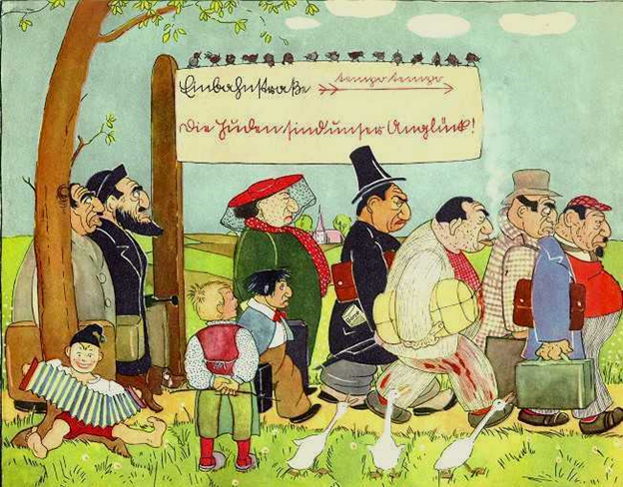

Source: Mills, Mary (1999) ‘Propaganda and Children During the Hitler Years’ (12 October 1999), Yad Vashem [Online].
Available at: http://www.yadvashem.org/download/education/conf/Millsishedwithoutpic.pdf (Accessed 14 June 2017).

TEXT

Testimony of Joseph B. Levy- Holocaust Survivor
During the mass arrests of Jews in the summer of 1938, we wrote our sons and nephews in the United States to receive the appropriate affidavits [sworn written statements] to ensure our emigration.... One could have assumed that the German authorities, interested in the emigration of the hated Jews, would not stand in our way and would enable us to arrange for our departure. But soon enough we and those who shared our fate found out that the situation was entirely different. New decrees [orders] were issued daily. One had to prepare endless paperwork, visit many offices. The growing pressure of emigrants filled these offices and caused hours and days of waiting in line. In addition, there was the rude and hostile attitude of officials....
- Joseph B. Levy

Source: Levy, Joseph B. "Testimony of Joseph B. Levy ." Yadvashem.org. Yad Vashem, n.d. Web. 14 June 2017.

DATA
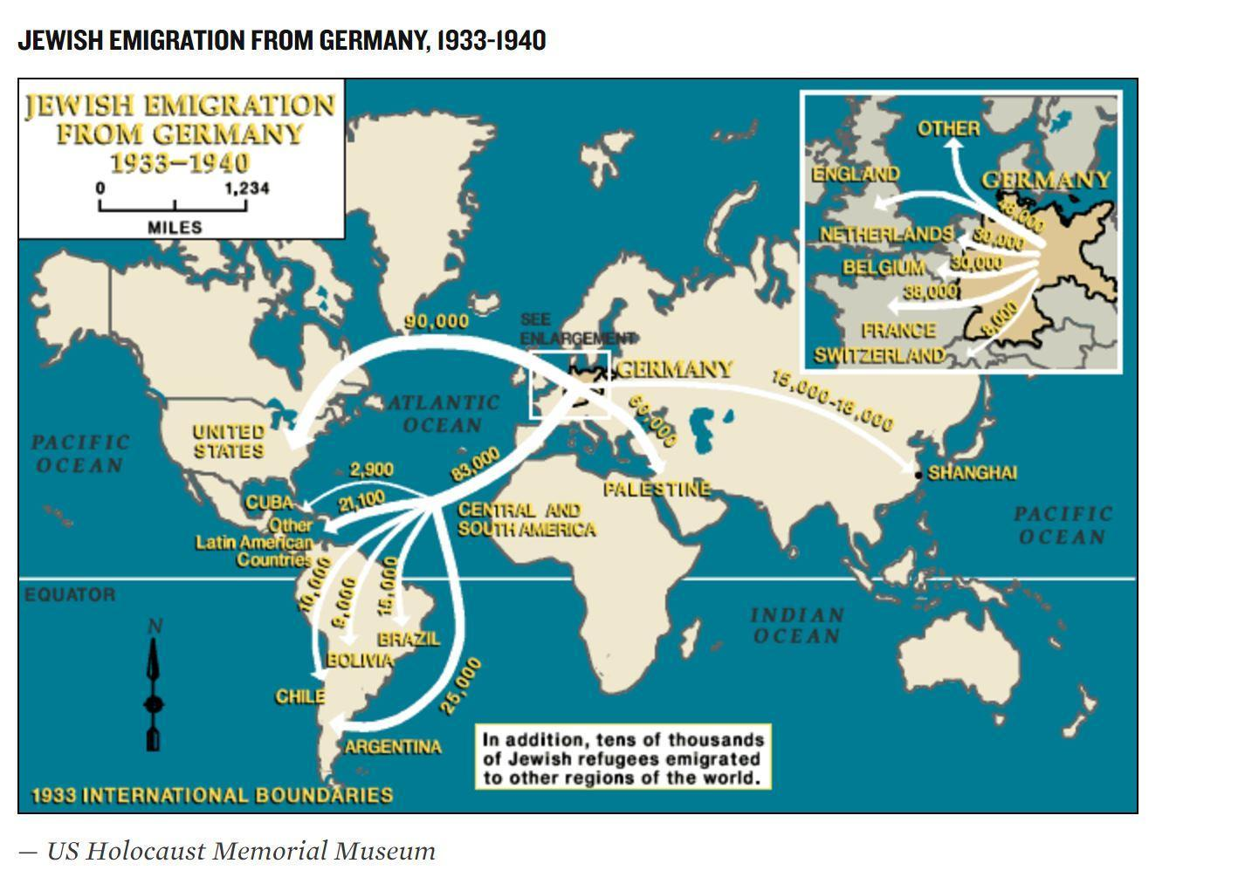

GERMAN ECONOMIC DISCRIMINATION PRE-WORLD WAR II

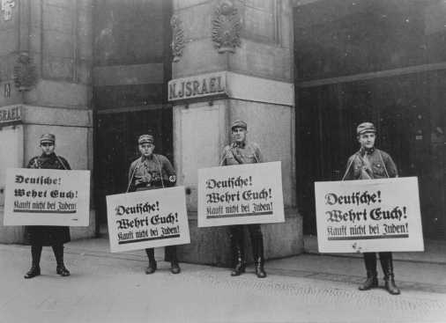
VISUAL

SA men in front of Jewish-owned store urge a boycott with signs reading "Germans! Defend Yourselves! Don't buy from Jews!" Berlin, Germany, April 1, 1933. — National Archives and Records Administration, College Park, Md.
*Source: United States Holocaust Memorial Museum

TEXT
Johanna (Hanne) Hirsch -

1933-39: In April 1933 our [photography] studio, like the other Jewish businesses in Karlsruhe, was plastered with signs during the anti-Jewish boycott: "Don't buy from Jews." At school, a classmate made me so furious with her taunts that I ripped her sweater. After the November 1938 pogroms the studio was busy making photos for the new ID cards marked "J" that Jews had to carry. The studio remained open until December 31 when all Jewish businesses had to be closed.

*Source: United States Holocaust Memorial Museum

DATA
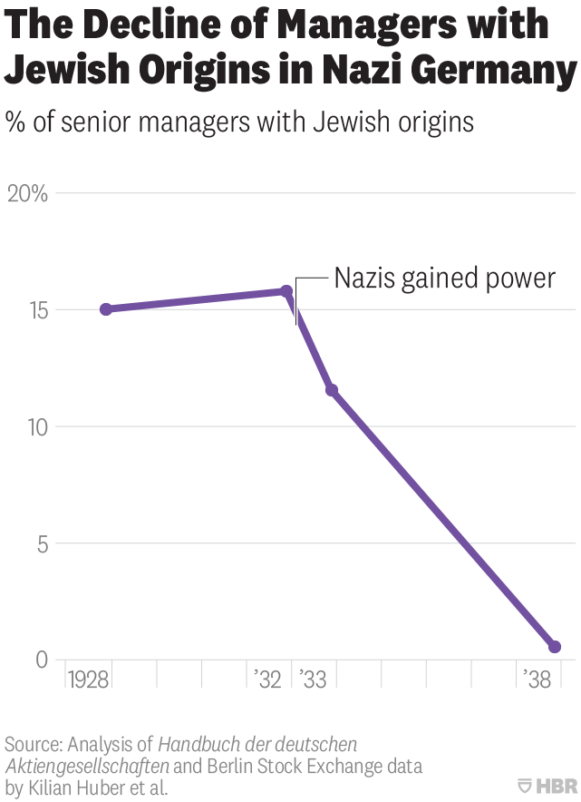
Firms with Jewish managers compared to other firm managers without Jewish origin.
Source: Harvard Business Review

LOSS OF CITIZENSHIP IN GERMANY PRE-WORLD WAR II
VISUAL

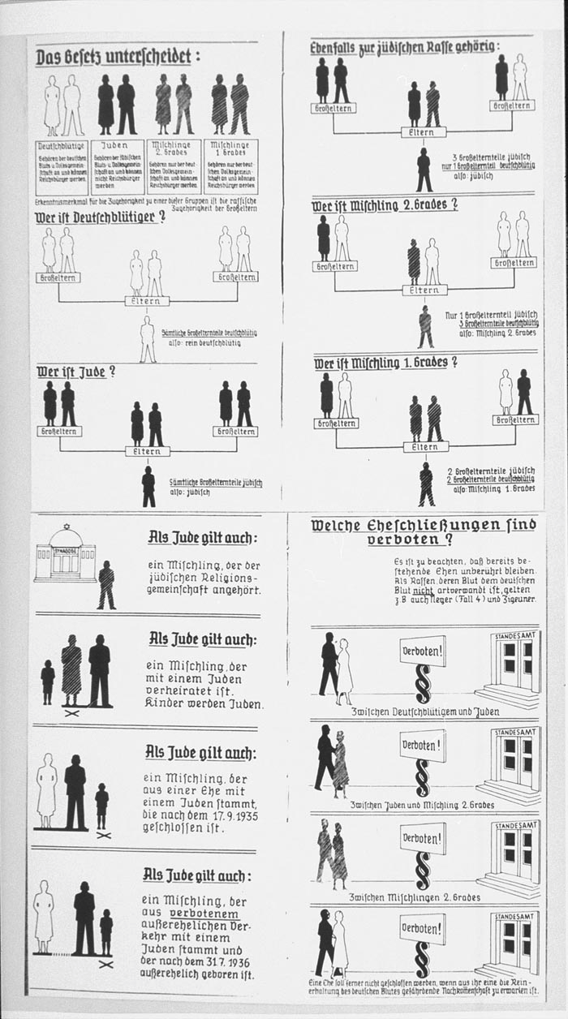  An instructional chart used to aid German citizens in the determination of racial status for citizenship purposes.  *Source: United States Holocaust Memorial Museum | 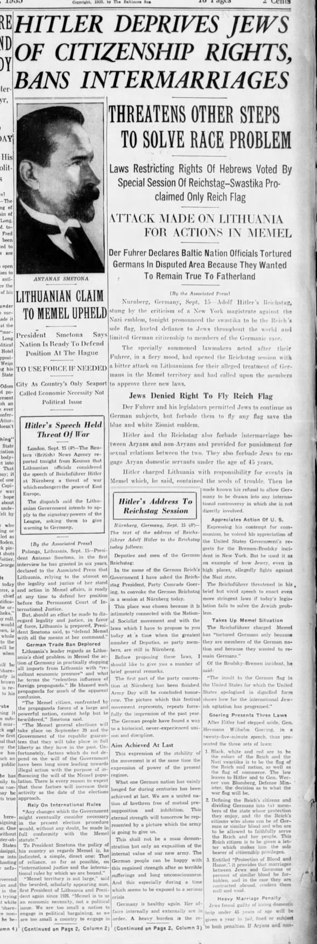  A newspaper article printed in the Baltimore Sun describes Hitler announcing the Nuremberg Race Laws. 1935  *Source: United States Holocaust Memorial Museum

TEXT
The Reich Citizenship Law of September 15, 1935
The Reichstag has unanimously adopted the following law, which is herewith promulgated.
(1) A citizen of the Reich is only that subject who is of German or kindred blood and who, through his conduct, shows that he is both willing and able to faithfully serve the German people and Reich.
(2) The right to citizenship is acquired by the granting of Reich citizenship papers.
(3) Only the citizen of the Reich enjoys full political rights in accordance with the provision of the law.
*The “Reich” was a term used by the Nazis to mean the German nation.
*Source: German History In Documents and Images
POTENTIAL INTERNMENT PRE-WORLD WAR II

VISUAL

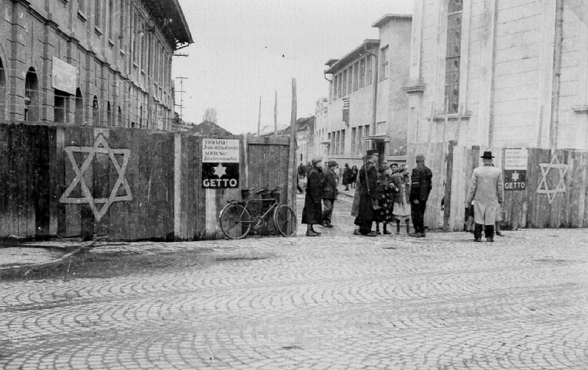
A Hungarian gendarme checks a woman entering the Munkács ghetto
*Source: Yad Vashem: The World Holocaust Rememberance Center

TEXT
“The first concentration camps in Germany were established soon after Hitler's appointment as chancellor in January 1933. In the weeks after the Nazis came to power, The SA (Sturmabteilung; commonly known as Storm Troopers), the SS (Schutzstaffel; Protection Squadrons—the elite guard of the Nazi party), the police, and local civilian authorities organized numerous detention camps to incarcerate real and perceived political opponents of Nazi policy.”

There were three types of ghettos:

Closed ghettos (situated primarily in German-occupied Poland and the occupied Soviet Union) were closed off by walls, or by fences with barbed wire. The German authorities compelled Jews living in the surrounding areas to move into the closed ghetto, thus exacerbating the extremely crowded and unsanitary conditions. Starvation, chronic shortages, severe winter weather, inadequate and unheated housing, and the absence of adequate municipal services led to repeated outbreaks of epidemics and to a high mortality rate. Most ghettos were of this type.

Open ghettos had no walls or fences, but there were restrictions on entering and leaving. These existed in German-occupied Poland and the occupied Soviet Union, as well as in Transnistria, that province of Ukraine occupied and administrated by Romanian authorities.

Destruction ghettos were tightly sealed off and existed for between two and six weeks before the Germans and/or their collaborators deported or shot the Jewish population concentrated in them. These existed in German-occupied Soviet Union (especially in Lithuania and the Ukraine), as well as Hungary.

*Source: United States Holocaust Memorial Museum - Encyclopedia

DATA
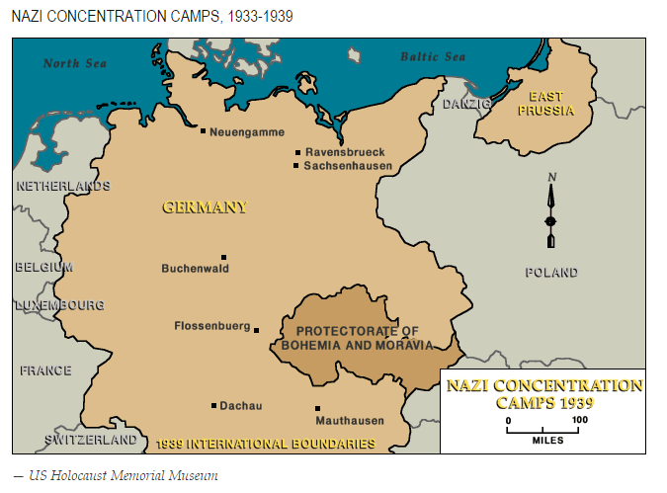
*Source: United States Holocaust Memorial Museum

GERMAN SEGREGATION PRE-WORLD WAR II

VISUAL
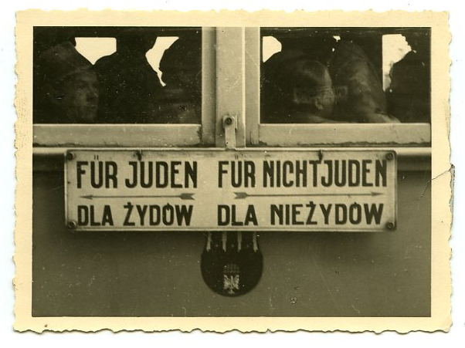
“This photograph reflects the social and physical segregation imposed on Jews through Hitler’s legislation. The photograph, taken and donated by liberator Thomas A. Ligon, shows a sign on the side of a segregated train car. The sign, which has arrows to designate different sections of the car, translates to, “For Jews” and “For non-Jews,” a designation that became the basis for increasingly severe anti-Jewish legislation passed after 1934.”
Source: Virginia Holocaust Museum

TEXT
Law for the Protection of German Blood and German Honor of September 15, 1935
(Translated from Reichsgesetzblatt I, 1935, pp. 1146-7.)
Moved by the understanding that purity of German blood is the essential condition for the continued existence of the German people, and inspired by the inflexible determination to ensure the existence of the German nation for all time, the Reichstag has unanimously adopted the following law, which is promulgated herewith:
Article 1
1. Marriages between Jews and subjects of the state of German or related blood are forbidden. Marriages nevertheless concluded are invalid, even if concluded abroad to circumvent this law.
2. Annulment proceedings can be initiated only by the state prosecutor.
…
Article 4
1. Jews are forbidden to fly the Reich or national flag or display Reich colors.
2. They are, on the other hand, permitted to display the Jewish colors. The exercise of this right …
Nuremberg, September 15, 1935
At the Reich Party Congress of Freedom
The Führer and Reich Chancellor
[signed] Adolf Hitler
The Reich Minster of the Interior
[signed] Frick
The Reich Minister of Justice
[signed] Dr. Gürtner
The Deputy of the Führer
[signed] R. Hess

GERMAN SOCIAL & POLITICAL ISOLATION PRE-WORLD WAR II
VISUAL
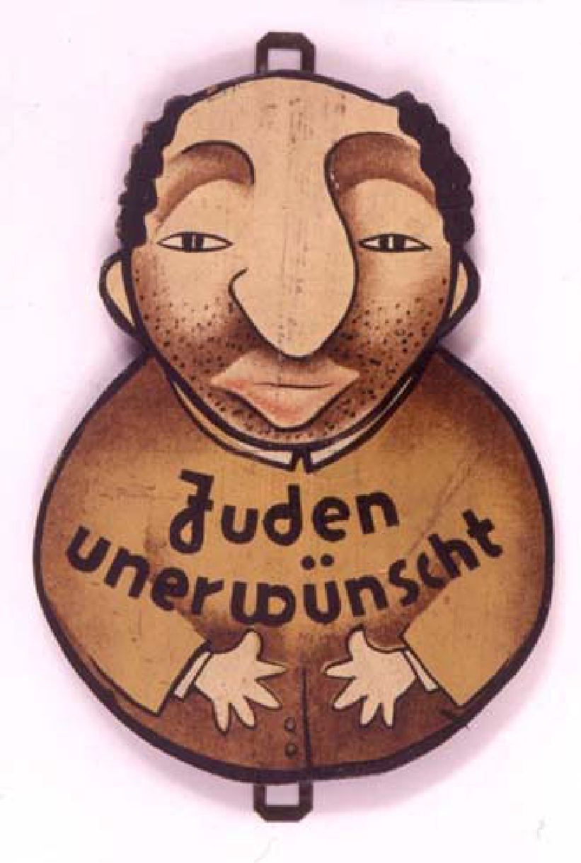
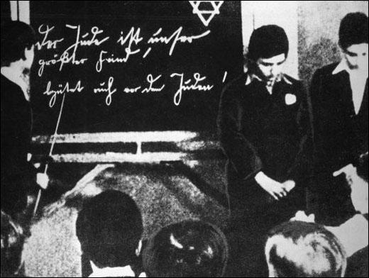
Jewish-German children forced to stand in front of the class (c. 1935)
Source: Spartacus Educational

A Sign in a Public House Which Reads:''Jews are Not Wanted Here''
Source: Artifacts Collection of the Yad Vashem Museum
TEXT

Jewish children in German schools suffered terribly from bullying: "The children called me Judenschwein (Jewish pig)... When I came home I was crying and said, What is a Judenschwein? Who am I? I didn't know who I was. I was only a kid. I didn't know what I was, Jew or not Jew. There were many times when I was beaten up coming from school. I remember one teacher who had something against me because I was a Jew in his class. Every time when I must have been unruly, he used to pull me up front and bend me over and whip me with a bamboo stick."

*Source: Eric A. Johnson & Karl-Heinz Reuband, What We Knew: Terror, Mass Murder and Everyday Life in Nazi Germany (2005) page 4
TARGETED VIOLENCE PRE-WORLD WAR II

VISUAL

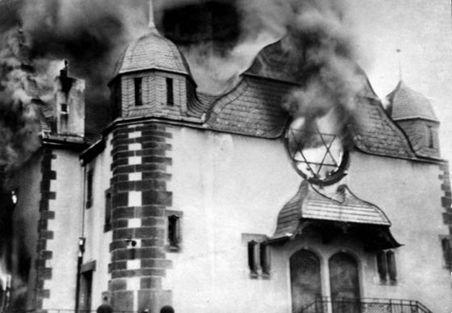
During Kristallnacht, the Night of Broken Glass, a synagogue burns in Siegen, Germany. November 10, 1938.

*Source: The Pictorial History of the Holocaust, Yitzhak Arad, Ed., Macmillan Publishing Co., NY, 1990, p. 58, courtesy of Shamash: The Jewish Internet Consortium.

TEXT

This is an excerpt from the diary of Klaus Langer, in which Langer describes his experiences during Kristallnacht.
November 11, 1938
The past three days brought significant changes in our lives. On November 7, a German legation member was assassinated in Paris. He died two days later. The day following, on November 10 [sic], came the consequences. At three o’clock the synagogue and the Jewish youth center were put on fire. Then they began to destroy Jewish businesses. During the morning, private homes also were being demolished. Fires were started at single homes belonging to Jews. At six-thirty in the morning the Gestapo came to our home and arrested Father and Mother [. . .] Mother returned after about one and a half hours. Dad remained and was put in prison. In the morning, I went to the Ferse home. Bobby was at the synagogue and at the youth center in the morning and saw how they burned…
*Source: Zapruder, Alexandra. Salvaged pages: young writers diaries of the Holocaust. New Haven: Yale U Press, 2015. Print 2017.

DATA
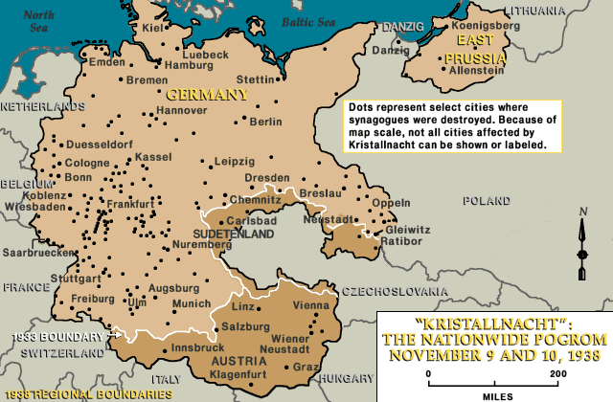
*Source: United States Holocaust Memorial Museum

LOSS OF RIGHTS and DAILY LIVING

 | RIGHTS TAKEN AWAY | HOW DOES THIS LOSS AFFECT DAILY LIVING?
Segregation
Economic Discrimination
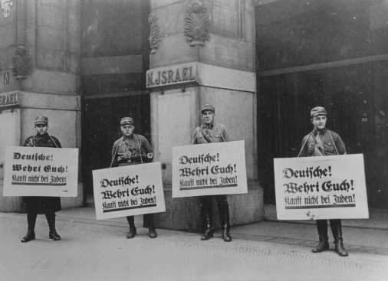
Social and Political Isolation
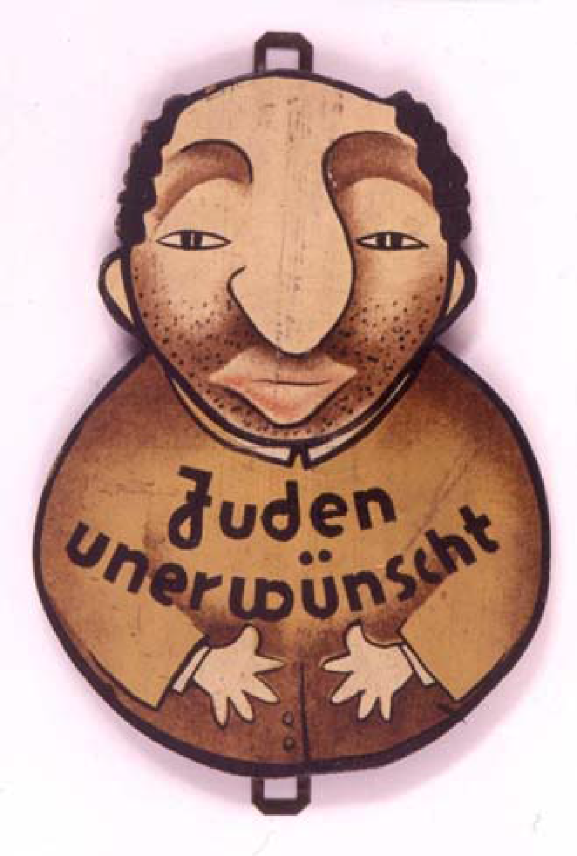
Loss of Citizenship
“A citizen of the Reich [nation] is only that subject who is of German or kindred blood and who, through his conduct, shows that he is both willing and able to faithfully serve the German people and Reich.”

Potential Internment

Coerced Emigration
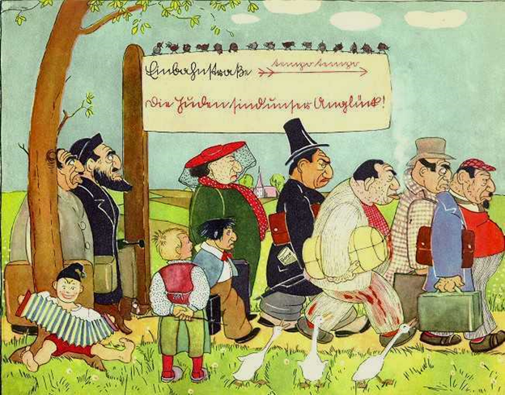
Targeted Violence
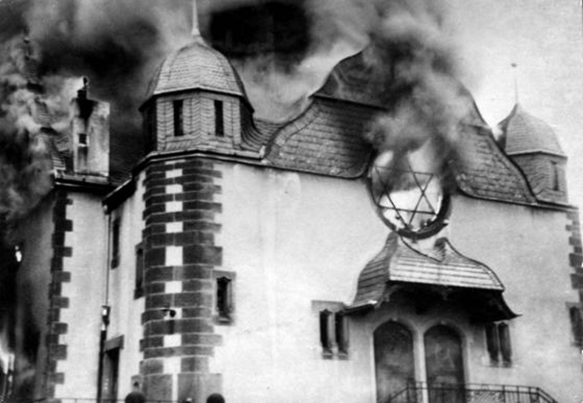
Essential Question: Why did the Nazis engage in these abusive acts?

LOSS OF RIGHTS and DAILY LIVING

 | RIGHTS TAKEN AWAY | HOW DOES THIS LOSS AFFECT DAILY LIVING?
Segregation | Right to marriage  Right to education  Right to fly the flag of the nation | - Right to be apart of society  - Not being able to be with the one you love or having a family  - Not being able to express support for your nation of citizenship  - Not being able to interact with your friends
Economic Discrimination | Right to earn a living  Right to own a business  Right to express your profession | - Cannot support yourself or your family  - Are not able to improve you status of living
Social and Political Isolation | Right to education  Freedom of movement  Right to socialize | - Being made a social outcast in society  - not being able to socialize with your friends in public  - deprivation of development because of lack of education
Loss of Citizenship  “A citizen of the Reich [nation] is only that subject who is of German or kindred blood and who, through his conduct, shows that he is both willing and able to faithfully serve the German people and Reich.” | Right to citizenship  Right to government benefits  Identity rights  Loss of national pride  Freedom of movement | - loss of political rights such as voting, running for public office, not attaining a job in the civil service  - losing a sense of heredity  - not being able to drive
Potential Internment | Freedom of movement  Right to privacy  Freedom of speech  Loss of property | - complete loss of independence (i.e. house, freedom, possessions)  - being cut off from family
Coerced Emigration | Right to privacy  Right to property | - you would be susceptible to public shaming  - knowing that you would be leaving your home nation
Targeted Violence | Right to life  Right to property  Freedom of expression  Right to property | - daily feeling anxiety and fear  - loss of property  - having a loss of pride  - spiritual loss  - loss of community ties
Essential Question: Why did the Nazis engage in these abusive acts?

The Nazis wanted to create conditions that would force the Jews to choose to leave Germany.

Test Items
Benchmark | Benchmark Clarification | Cognitive Complexity
1.4 | BC 3 | L

Question | Who has the power to protect natural rights?
A. | Interest Groups
B. | Immigrants
C. | Citizens
D. | Government

Question | Who has the power to protect natural rights?
A. | Interest Groups | Incorrect-Interest groups are not part of government; government is responsible for protecting natural rights and has the power to do so.
B. | Immigrants | Incorrect-Immigrants, once naturalized, are eligible to serve in government. However, the government has both the power and responsibility to protect natural rights.
C. | Citizens | Incorrect-Unless those citizens are part of the government, citizens have the responsibility to protect natural rights, but not the power.
D. | Government | Correct-The government has the power to protect natural rights to which the people are entitled.

Benchmark | Benchmark Clarification | Cognitive Complexity
1.4 | BC 3 | M

Question | Which of the following scenarios describes government oppression?
A. | A law is passed that denies certain residents from displaying their nation’s flag.
B. | A manager of a clothing store decides to stop selling shirts that customers do not like.
C. | A principal allows students to publish an article in the school newspaper.
D. | A court permits a group to march in a neighborhood.

Question | Which of the following scenarios describes government oppression?
A. | A law is passed that denies certain residents from displaying their nation’s flag. | Correct-Denying one part of a nation’s population the right to do something that other citizens (who are otherwise the same) can do is a form of government oppression.
B. | A manager of a clothing store decides to stop selling shirts that customers do not like. | Incorrect-Managers of private businesses do not make decisions on behalf of an entire society as governments do.
C. | A principal allows students to publish an article in the school newspaper. | Incorrect-Permitting the publication of an article in a school newspaper is an example of allowing the expression of ideas.
D. | A court permits a group to march in a neighborhood. | Incorrect-Courts permitting groups to march is an example of government allowing freedom of expression

Benchmark | Benchmark Clarification | Cognitive Complexity
1.4 | BC 2 | High

Question | The statement below was made by Trude Levi during an interview in 2003.  Because I did not return to Hungary, I lost my nationality. I became stateless. An outcast. No papers, no residence permit, no work permit. I often worked illegally, was cold and hungry, traveled with a false passport. It took me 12 more years to obtain a nationality and become a recognized civil being again.  Based on the statement, which purpose of government outlined in the U.S. Declaration of Independence (1776) was denied to Trude Levi?
A. | Protecting the right to liberty
B. | Protecting the right to property
C. | Protecting the right to employment
D. | Protecting the right to citizenship

Question | The statement below was made by Trude Levi during an interview in 2003.  Because I did not return to Hungary, I lost my nationality. I became stateless. An outcast. No papers, no residence permit, no work permit. I often worked illegally, was cold and hungry, traveled with a false passport. It took me 12 more years to obtain a nationality and become a recognized civil being again.  Based on the statement, which purpose of government outlined in the U.S. Declaration of Independence (1776) was denied to Trude Levi?
A. | Protecting the right to liberty | Correct-The U.S. Declaration of Independence explains the concept of natural rights to include the right to liberty
B. | Protecting the right to property | Incorrect- The U.S. Declaration of Independence explains the concept of natural rights which does not include the right to property
C. | Protecting the right to employment | Incorrect- The U.S. Declaration of Independence explains the concept of natural rights which does not include the right to employment
D. | Protecting the right to citizenship | Incorrect- The U.S. Declaration of Independence explains the concept of natural rights which does not include the right to citizenship

Benchmark | Benchmark Clarification | Cognitive Complexity
1.4 | BC 3 | H

Question | The headline below describes an event.  July 1, 1939  Child Refugee Bill Fails in Senate  Which action might occur due to this event?
A. | The president issues a veto of existing refugee law
B. | The bureaucracy votes to improve travel protections for child refugees.
C. | The bureaucracy implements current child refugee law.
D. | The House of Representatives confirms the United Nations Commissioner for Human Rights

Question | The headline below describes an event focusing on human rights.  July 1, 1939  Child Refugee Bill Fails in Senate  Which action might occur due to this event?
A. | The president issues a veto of existing refugee law | Incorrect-The president’s veto power is limited to legislation passed by both houses of Congress. The bill in this instance did not pass.
B. | The bureaucracy votes to improve travel protections for child refugees. | Incorrect-The bureaucracy does not vote on policy.
C. | The bureaucracy implements current child refugee law. | Correct-The bureaucracy is required to implement current law unless the law is changed.
D. | The House of Representatives confirms the United Nations Commissioner for Human Rights | Incorrect-The House of Representatives does not have the power to confirm officers in international organizations.

Benchmark | Benchmark Clarification | Cognitive Complexity
3.6 | BC 4 | L

Question | Which option represents government restricting individual rights?
A. | Forced internment
B. | Property rights
C. | Economic freedom
D. | Civil liberties

Question | Which option represents government restricting individual rights?
A. | Forced internment | Correct-Forced internment is a government decision to confine a group of people against their will
B. | Due process | Incorrect-Due process is required of government to ensure that individual rights are protected
C. | Economic freedom | Incorrect-Economic freedom is the freedom to produce, trade or use goods and services in legal ways.
D. | Civil liberties | Incorrect-Civil liberties are the freedoms associated with being a citizen.

Benchmark | Benchmark Clarification | Cognitive Complexity
3.6 | BC 3 | Moderate

Question | In which scenario is a citizen engaging in civil disobedience?
A. | An attorney represents a defendant who has confessed to committing a crime
B. | A grocery store owner calls the police upon seeing a customer steal fruit
C. | A student decides to help a fellow student when seeing him cheat on a test
D. | A boy lies to a military recruiter telling him that he is old enough to join the Army

Question | In which scenario is a citizen engaging in civil disobedience?
A. | An attorney represents a defendant who has confessed to committing a crime | Incorrect-All persons charged with a crime are guaranteed the right to counsel whether or not the accused has confessed to the crime.
B. | A grocery store owner calls the police upon seeing a customer steal fruit | Incorrect-The store owner has the right to notify the police if he sees someone breaking the law.
C. | A student decides to help a fellow student when seeing him cheat on a test | Incorrect-A student helping another student cheat on a test is violating the rules of the school.
D. | A boy lies to a military recruiter telling him that he is old enough to join the Army | Correct-A person trying to join the military by breaking the rules is engaging in civil disobedience because he is breaking the law for the purpose of supporting the common good.

