*STUDENTS INVESTIGATING PRIMARY SOURCES*

**Immigration Inquiry**

**A Closer Look at Chinese Immigration to the United States**

How did the U.S. treatment toward Chinese immigrants compare with treatment toward European immigrants?

*A Short Activity for High School U.S History*

***Benchmark Correlations***

**SS.912.A.3.7** – Compare the experience of European immigrants in the east to that of Asian immigrants in the west (The Chinese Exclusion Act, Gentlemen’s Agreement with Japan).

**Benchmark Clarification:** Students will compare and/or contrast the experiences of Northern European, Southern European, and Asian immigrants during the Second Industrial Revolution.

**LAFS.910.RH.1.2-** Determine the central ideas or information of a primary or secondary source; provide an accurate summary of how key events or ideas develop over the course of the text.

**LAFS.1112.RH.1.2-**Determine the central ideas or information of a primary or secondary source; provide an accurate summary that makes clear the relationships among the key details and ideas.

***Activity Documents and Handouts***

* Statue of Liberty Photograph
* Immigration Inquiry handout
* Document 1, House Resolution 751
* Document 2, Chinese Exclusion Act
* Document 3, Photograph of Americanization Class

***Full Document Citations***

[113 HRES 751](https://www.congress.gov/bill/113th-congress/house-resolution/751) Expressing the sense of the House of Representatives that a commemorative postage stamp should be issued in honor of the Chinese railroad workers from 1865 to 1869, and ... Introduced in House. Expressing the sense of the House of Representatives that a commemorative postage stamp should be issued in honor of the Chinese railroad workers from 1865 to 1869, and that the Citizens’ Stamp Advisory Committee should recommend to the Postmaster General that such a stamp be issued. Contributor: Meng, Grace - 113th Congress - House of Representatives Date: 2014-11-12

[https://www.congress.gov/bill/113th-congress/house-resolution/751]

[[Chinese Exclusion Act](https://catalog.archives.gov/id/5752153)] An Act of May 6, 1882, Public Law 71, 47th Congress, 1st Session, 22 STAT 58, to Execute Certain Treaty Stipulations Relating to Chinese; 5/6/1882; Enrolled Acts and Resolutions of Congress, 1789 - 2011; General Records of the United States Government, Record Group 11; National Archives Building, Washington, DC. National Archives Identifier: 5752153.

[https://catalog.archives.gov/id/5752153]

[https://www.docsteach.org/documents/document/chinese-exclusion-act]

[New York – Statue of Liberty](https://catalog.archives.gov/id/45701938), 1886. Records of the Coast Guard, Record Group 26. National Archives at College Park. National Archives Identifier: 45701938.

[https://catalog.archives.gov/id/45701938]

[https://www.docsteach.org/documents/document/statue-of-liberty]

[Photograph of Americanization Class](https://catalog.archives.gov/id/6408896), Trenton, New Jersey; 1921; Photographs; Education and Americanization Files, 1914 - 1936; Records of the Immigration and Naturalization Service, Record Group 85; National Archives at Washington, DC. National Archives Identifier: 6408896.

[https://catalog.archives.gov/id/6408896]

[https://www.docsteach.org/documents/document/americanization-class-trenton-nj]

***Activity Vocabulary***

|  |
| --- |
| **Chinese Exclusion Act (1882)** – this act prohibited Chinese labor workers from immigrating to the United States for a 10 year period; this was the first significant law restricting immigration into the United States  **immigration** – the process of coming to a country of which one is not a native, usually for permanent residence  **Transcontinental Railroad** – a railroad built to connect the United States from the East Coast to the West Coast |

1. Place students into groups of 3-4 and project the Statue of Liberty image as students walk into the room.
2. Pose the following questions for discussion: What does this statue symbolize? What does it represent about immigration in the United States? **Teacher Note**: Lead students to the understanding that the Statue of Liberty has been viewed as a symbol of freedom and hope. Immigrants coming to America through New York City would see the Statue of Liberty. The statue became a symbol of America’s “open door” for people looking for a better life by immigrating to the United States.
3. Share with students that they are going to examine the history of Chinese immigration to the United States by investigating a series of documents.
4. Pass out Document 1 to half of the student groups and pass out Document 2 to the other student groups, one handout per student.
5. Instruct students to work with their group members to read the document and answer the questions on the document handout.
6. Rotate through the groups to monitor understanding and assist with comprehension.
7. Pass out the Immigration Inquiry handout and read the directions as a whole class. Direct student attention to the document boxes. Instruct students to work with their group members to write down the name of their document, record the date and summarize the main ideas of the document in two sentences.
8. Project Document 1 and have the groups assigned to this document share their summary sentences with the class. List key points on the board. Instruct the group that did not read this document to record these key points in the Document 1 box.
9. Repeat this process for Document 2.
10. Pass out and project Document 3.
11. Direct students to visually scan the photograph and identify three items that stand out to them in the document. (Examples could include: black and white, auditorium, American flags, a group of men, suits.) **Teacher Note**: For additional support, guide students through completion of the National Archives Photograph Analysis Worksheet: <https://www.archives.gov/files/education/lessons/worksheets/photo_analysis_worksheet_former.pdf>
12. Instruct students to work with their group members to answer the questions for Document 3.
13. Direct student attention back to the Immigration Inquiry handout and work as a whole class to complete the box for Document 3.
14. Direct student attention to the Summary Questions at the bottom of the Immigration Inquiry handout. Instruct students to work with their group members to answer the questions. Rotate through the groups to monitor comprehension.
15. Pose the following question as closure, based on what you learned from the three documents, how would you summarize Chinese immigration to the United States?

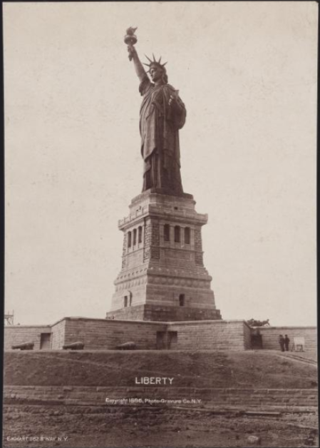

**Immigration Inquiry**

**Directions:** After you read and answer the questions for your document, write the document name on the title line. Then, add the date of the document. Finally, summarize your understanding of the document in two sentences. Be prepared to take notes on the document you did not read.

|  |  |  |
| --- | --- | --- |
| **Document 1**  **Title: \_\_\_\_\_\_\_\_\_\_\_\_\_\_\_\_\_\_\_\_\_\_\_\_\_\_\_ \_\_\_\_\_\_\_\_\_\_\_\_\_\_\_\_\_\_\_\_\_\_\_\_\_\_\_\_\_\_\_\_** | **Document 2**  **Title: \_\_\_\_\_\_\_\_\_\_\_\_\_\_\_\_\_\_\_\_\_\_\_\_\_\_\_ \_\_\_\_\_\_\_\_\_\_\_\_\_\_\_\_\_\_\_\_\_\_\_\_\_\_\_\_\_\_\_\_** | **Document 3**  **Title: \_\_\_\_\_\_\_\_\_\_\_\_\_\_\_\_\_\_\_\_\_\_\_\_\_\_\_ \_\_\_\_\_\_\_\_\_\_\_\_\_\_\_\_\_\_\_\_\_\_\_\_\_\_\_\_\_\_\_\_** |
| **Date: \_\_\_\_\_\_\_\_\_\_\_\_\_\_\_\_\_\_\_\_\_\_\_\_\_\_\_** | **Date: \_\_\_\_\_\_\_\_\_\_\_\_\_\_\_\_\_\_\_\_\_\_\_\_\_\_\_** | **Date: \_\_\_\_\_\_\_\_\_\_\_\_\_\_\_\_\_\_\_\_\_\_\_\_\_\_\_** |
| **Two Sentence Summary: \_\_\_\_\_\_\_\_\_\_\_\_\_\_\_\_\_\_\_\_\_\_\_\_\_\_\_\_\_\_\_**  **\_\_\_\_\_\_\_\_\_\_\_\_\_\_\_\_\_\_\_\_\_\_\_\_\_\_\_\_\_\_\_**  **\_\_\_\_\_\_\_\_\_\_\_\_\_\_\_\_\_\_\_\_\_\_\_\_\_\_\_\_\_\_\_**  **\_\_\_\_\_\_\_\_\_\_\_\_\_\_\_\_\_\_\_\_\_\_\_\_\_\_\_\_\_\_\_**  **\_\_\_\_\_\_\_\_\_\_\_\_\_\_\_\_\_\_\_\_\_\_\_\_\_\_\_\_\_\_\_**  **\_\_\_\_\_\_\_\_\_\_\_\_\_\_\_\_\_\_\_\_\_\_\_\_\_\_\_\_\_\_\_**  **\_\_\_\_\_\_\_\_\_\_\_\_\_\_\_\_\_\_\_\_\_\_\_\_\_\_\_\_\_\_\_**  **\_\_\_\_\_\_\_\_\_\_\_\_\_\_\_\_\_\_\_\_\_\_\_\_\_\_\_\_\_\_\_**  **\_\_\_\_\_\_\_\_\_\_\_\_\_\_\_\_\_\_\_\_\_\_\_\_\_\_\_\_\_\_\_** | **Two Sentence Summary: \_\_\_\_\_\_\_\_\_\_\_\_\_\_\_\_\_\_\_\_\_\_\_\_\_\_\_\_\_\_\_**  **\_\_\_\_\_\_\_\_\_\_\_\_\_\_\_\_\_\_\_\_\_\_\_\_\_\_\_\_\_\_\_**  **\_\_\_\_\_\_\_\_\_\_\_\_\_\_\_\_\_\_\_\_\_\_\_\_\_\_\_\_\_\_\_**  **\_\_\_\_\_\_\_\_\_\_\_\_\_\_\_\_\_\_\_\_\_\_\_\_\_\_\_\_\_\_\_**  **\_\_\_\_\_\_\_\_\_\_\_\_\_\_\_\_\_\_\_\_\_\_\_\_\_\_\_\_\_\_\_**  **\_\_\_\_\_\_\_\_\_\_\_\_\_\_\_\_\_\_\_\_\_\_\_\_\_\_\_\_\_\_\_**  **\_\_\_\_\_\_\_\_\_\_\_\_\_\_\_\_\_\_\_\_\_\_\_\_\_\_\_\_\_\_\_**  **\_\_\_\_\_\_\_\_\_\_\_\_\_\_\_\_\_\_\_\_\_\_\_\_\_\_\_\_\_\_\_**  **\_\_\_\_\_\_\_\_\_\_\_\_\_\_\_\_\_\_\_\_\_\_\_\_\_\_\_\_\_\_\_** | **Two Sentence Summary: \_\_\_\_\_\_\_\_\_\_\_\_\_\_\_\_\_\_\_\_\_\_\_\_\_\_\_\_\_\_\_**  **\_\_\_\_\_\_\_\_\_\_\_\_\_\_\_\_\_\_\_\_\_\_\_\_\_\_\_\_\_\_\_**  **\_\_\_\_\_\_\_\_\_\_\_\_\_\_\_\_\_\_\_\_\_\_\_\_\_\_\_\_\_\_\_**  **\_\_\_\_\_\_\_\_\_\_\_\_\_\_\_\_\_\_\_\_\_\_\_\_\_\_\_\_\_\_\_**  **\_\_\_\_\_\_\_\_\_\_\_\_\_\_\_\_\_\_\_\_\_\_\_\_\_\_\_\_\_\_\_**  **\_\_\_\_\_\_\_\_\_\_\_\_\_\_\_\_\_\_\_\_\_\_\_\_\_\_\_\_\_\_\_**  **\_\_\_\_\_\_\_\_\_\_\_\_\_\_\_\_\_\_\_\_\_\_\_\_\_\_\_\_\_\_\_**  **\_\_\_\_\_\_\_\_\_\_\_\_\_\_\_\_\_\_\_\_\_\_\_\_\_\_\_\_\_\_\_**  **\_\_\_\_\_\_\_\_\_\_\_\_\_\_\_\_\_\_\_\_\_\_\_\_\_\_\_\_\_\_\_** |

|  |
| --- |
| **Summary Questions:**   1. How did Chinese immigrants contribute to American history?   **\_\_\_\_\_\_\_\_\_\_\_\_\_\_\_\_\_\_\_\_\_\_\_\_\_\_\_\_\_\_\_\_\_\_\_\_\_\_\_\_\_\_\_\_\_\_\_\_\_\_\_\_\_\_\_\_\_\_\_\_\_\_\_\_\_\_\_\_\_\_\_\_\_\_\_\_\_\_\_\_\_\_\_\_\_\_\_\_\_\_\_\_\_\_\_\_\_\_\_\_\_\_\_\_\_\_\_\_\_\_\_\_\_\_\_\_\_\_\_\_\_\_\_\_\_\_\_\_\_\_\_\_\_\_\_\_\_\_\_**  **\_\_\_\_\_\_\_\_\_\_\_\_\_\_\_\_\_\_\_\_\_\_\_\_\_\_\_\_\_\_\_\_\_\_\_\_\_\_\_\_\_\_\_\_\_\_\_\_\_\_\_\_\_\_\_\_\_\_\_\_\_\_\_\_\_\_\_\_\_\_\_\_\_\_\_\_\_\_\_\_\_\_\_\_\_\_\_\_\_\_\_\_\_\_\_\_\_\_\_\_\_\_\_\_\_\_\_\_\_\_\_\_\_\_\_\_\_\_\_\_\_\_\_\_\_\_\_\_\_\_\_\_\_\_\_\_\_\_\_**   1. Why were Chinese immigrants a small fraction of overall U.S. immigration between 1882-1921?   **\_\_\_\_\_\_\_\_\_\_\_\_\_\_\_\_\_\_\_\_\_\_\_\_\_\_\_\_\_\_\_\_\_\_\_\_\_\_\_\_\_\_\_\_\_\_\_\_\_\_\_\_\_\_\_\_\_\_\_\_\_\_\_\_\_\_\_\_\_\_\_\_\_\_\_\_\_\_\_\_\_\_\_\_\_\_\_\_\_\_\_\_\_\_\_\_\_\_\_\_\_\_\_\_\_\_\_\_\_\_\_\_\_\_\_\_\_\_\_\_\_\_\_\_\_\_\_\_\_\_\_\_\_\_\_\_\_\_\_**  **\_\_\_\_\_\_\_\_\_\_\_\_\_\_\_\_\_\_\_\_\_\_\_\_\_\_\_\_\_\_\_\_\_\_\_\_\_\_\_\_\_\_\_\_\_\_\_\_\_\_\_\_\_\_\_\_\_\_\_\_\_\_\_\_\_\_\_\_\_\_\_\_\_\_\_\_\_\_\_\_\_\_\_\_\_\_\_\_\_\_\_\_\_\_\_\_\_\_\_\_\_\_\_\_\_\_\_\_\_\_\_\_\_\_\_\_\_\_\_\_\_\_\_\_\_\_\_\_\_\_\_\_\_\_\_\_\_\_\_**   1. How would the experience of immigrating to the U.S. have been different for Chinese and European people between 1882-1921?   **\_\_\_\_\_\_\_\_\_\_\_\_\_\_\_\_\_\_\_\_\_\_\_\_\_\_\_\_\_\_\_\_\_\_\_\_\_\_\_\_\_\_\_\_\_\_\_\_\_\_\_\_\_\_\_\_\_\_\_\_\_\_\_\_\_\_\_\_\_\_\_\_\_\_\_\_\_\_\_\_\_\_\_\_\_\_\_\_\_\_\_\_\_\_\_\_\_\_\_\_\_\_\_\_\_\_\_\_\_\_\_\_\_\_\_\_\_\_\_\_\_\_\_\_\_\_\_\_\_\_\_\_\_\_\_\_\_\_\_**  **\_\_\_\_\_\_\_\_\_\_\_\_\_\_\_\_\_\_\_\_\_\_\_\_\_\_\_\_\_\_\_\_\_\_\_\_\_\_\_\_\_\_\_\_\_\_\_\_\_\_\_\_\_\_\_\_\_\_\_\_\_\_\_\_\_\_\_\_\_\_\_\_\_\_\_\_\_\_\_\_\_\_\_\_\_\_\_\_\_\_\_\_\_\_\_\_\_\_\_\_\_\_\_\_\_\_\_\_\_\_\_\_\_\_\_\_\_\_\_\_\_\_\_\_\_\_\_\_\_\_\_\_\_\_\_\_\_\_\_** |

**DOCUMENT 1**

**House Resolution 751**

The following Resolution was introduced into the House of Representatives in 2014. Read the excerpt and answer the questions that follow it.

House Resolution.751 Sponsor: Rep. Meng, Grace [D-NY-6] (Introduced 11/12/2014)

**RESOLUTION**

Expressing the sense of the House of Representatives that a commemorative postage stamp should be issued in honor of the Chinese railroad workers from 1865 to 1869, and that the Citizens’ Stamp Advisory Committee should recommend to the Postmaster General that such a stamp be issued…

Whereas the Transcontinental Railroad was one of the most remarkable engineering feats of the 19th century;

Whereas the construction of the Transcontinental Railroad took six years and stretched for nearly 2,000 miles;

Whereas the completion of the Transcontinental Railroad facilitated commerce and reduced cross-country travel times from 6 months to a single week after being completed;

Whereas the 150th anniversary of the completion of the Transcontinental Railroad will take place on May 10, 2019;

Whereas nearly 12,000 Chinese immigrants were employed in the construction of the Transcontinental Railroad, comprising more than 80 percent of the workforce of Central Pacific Railroad Company;

Whereas the Chinese railroad workers were considered indispensable by their foremen and were respected for their work ethic and discipline;

Whereas the Chinese railroad workers set a world record by laying 10 miles of railroad track in just one work day;

Whereas the Chinese railroad workers were given the most difficult, dangerous jobs and were paid lower wages than other railroad workers;

Whereas nearly 1,200 Chinese railroad workers died from work accidents, avalanches, and explosions while working in the Sierra Nevada Mountains…

Resolved, That it is the sense of the House of Representatives that—

(1) a commemorative postage stamp should be issued by the United States Postal Service honoring the Chinese railroad workers; and

(2) the Citizens’ Stamp Advisory Committee should recommend to the Postmaster General that such a postage stamp be issued.

**Questions**

1. What does this resolution say about the work of Chinese railroad workers?

\_\_\_\_\_\_\_\_\_\_\_\_\_\_\_\_\_\_\_\_\_\_\_\_\_\_\_\_\_\_\_\_\_\_\_\_\_\_\_\_\_\_\_\_\_\_\_\_\_\_\_\_\_\_\_\_\_\_\_\_\_\_\_\_\_\_\_\_\_\_\_\_\_\_\_\_\_\_\_\_\_\_\_\_\_\_\_\_\_\_\_\_\_\_\_\_\_\_\_\_\_\_\_\_\_\_\_\_\_\_\_\_\_\_\_\_\_\_\_\_\_\_\_\_\_\_\_\_\_\_\_\_\_\_\_\_\_\_\_\_\_\_\_\_\_\_\_\_\_\_\_\_\_\_\_\_\_\_\_\_\_\_\_\_\_\_\_\_\_\_\_\_\_\_\_\_\_\_\_\_

1. How vital was the Chinese contribution to building the Transcontinental Railroad?

\_\_\_\_\_\_\_\_\_\_\_\_\_\_\_\_\_\_\_\_\_\_\_\_\_\_\_\_\_\_\_\_\_\_\_\_\_\_\_\_\_\_\_\_\_\_\_\_\_\_\_\_\_\_\_\_\_\_\_\_\_\_\_\_\_\_\_\_\_\_\_\_\_\_\_\_\_\_\_\_\_\_\_\_\_\_\_\_\_\_\_\_\_\_\_\_\_\_\_\_\_\_\_\_\_\_\_\_\_\_\_\_\_\_\_\_\_\_\_\_\_\_\_\_\_\_\_\_\_\_\_\_\_\_\_\_\_\_\_\_\_\_\_\_\_\_\_\_\_\_\_\_\_\_\_\_\_\_\_\_\_\_\_\_\_\_\_\_\_\_\_\_\_\_\_\_\_\_\_\_

1. How were Chinese workers treated compared to other workers?

\_\_\_\_\_\_\_\_\_\_\_\_\_\_\_\_\_\_\_\_\_\_\_\_\_\_\_\_\_\_\_\_\_\_\_\_\_\_\_\_\_\_\_\_\_\_\_\_\_\_\_\_\_\_\_\_\_\_\_\_\_\_\_\_\_\_\_\_\_\_\_\_\_\_\_\_\_\_\_\_\_\_\_\_\_\_\_\_\_\_\_\_\_\_\_\_\_\_\_\_\_\_\_\_\_\_\_\_\_\_\_\_\_\_\_\_\_\_\_\_\_\_\_\_\_\_\_\_\_\_\_\_\_\_\_\_\_\_\_\_\_\_\_\_\_\_\_\_\_\_\_\_\_\_\_\_\_\_\_\_\_\_\_\_\_\_\_\_\_\_\_\_\_\_\_\_\_\_\_\_

1. What was the quality of the work performed by Chinese workers?

\_\_\_\_\_\_\_\_\_\_\_\_\_\_\_\_\_\_\_\_\_\_\_\_\_\_\_\_\_\_\_\_\_\_\_\_\_\_\_\_\_\_\_\_\_\_\_\_\_\_\_\_\_\_\_\_\_\_\_\_\_\_\_\_\_\_\_\_\_\_\_\_\_\_\_\_\_\_\_\_\_\_\_\_\_\_\_\_\_\_\_\_\_\_\_\_\_\_\_\_\_\_\_\_\_\_\_\_\_\_\_\_\_\_\_\_\_\_\_\_\_\_\_\_\_\_\_\_\_\_\_\_\_\_\_\_\_\_\_\_\_\_\_\_\_\_\_\_\_\_\_\_\_\_\_\_\_\_\_\_\_\_\_\_\_\_\_\_\_\_\_\_\_\_\_\_\_\_\_\_

**DOCUMENT 2**

**Chinese Exclusion Act**

An excerpt from An Act of May 6, 1882, Public Law 71, 47th Congress, 1st Session, 22 STAT 58, to Execute Certain Treaty Stipulations Relating to the Chinese Exclusion Act of 1882 Public Law 47-71

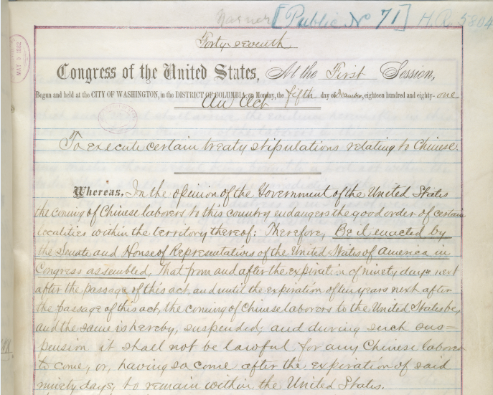

Transcript:

Whereas in the opinion of the government of the United States the coming of Chinese laborers to this country endangers the good order of certain localities within the territory thereof: Therefore, Be it enacted by the Senate and House of Representatives of the United States of America in Congress assembled, that from and after the expiration of ninety days next after the passage of this act and until the expiration of ten years next after the passage of this act, the coming for Chinese laborers to the United States be, and the same is hereby, suspended; and during such suspension it shall not be lawful for any Chinese laborer to come, or having, so come after the expiration of said ninety days, to remain within the United States.

**Questions**

1. What does this legislation say about Chinese laborers?

\_\_\_\_\_\_\_\_\_\_\_\_\_\_\_\_\_\_\_\_\_\_\_\_\_\_\_\_\_\_\_\_\_\_\_\_\_\_\_\_\_\_\_\_\_\_\_\_\_\_\_\_\_\_\_\_\_\_\_\_\_\_\_\_\_\_\_\_\_\_\_\_\_\_\_\_\_\_\_\_\_\_\_\_\_\_\_\_\_\_\_\_\_\_\_\_\_\_\_\_\_\_\_\_\_\_\_\_\_\_\_\_\_\_\_\_\_\_\_\_\_\_\_\_\_\_\_\_\_\_\_\_\_\_\_\_\_\_\_\_\_\_\_\_\_\_\_\_\_\_\_\_\_\_\_\_\_\_\_\_\_\_\_\_\_\_\_\_\_\_\_\_\_\_\_\_\_\_\_\_

1. What regulation does this bill propose?

\_\_\_\_\_\_\_\_\_\_\_\_\_\_\_\_\_\_\_\_\_\_\_\_\_\_\_\_\_\_\_\_\_\_\_\_\_\_\_\_\_\_\_\_\_\_\_\_\_\_\_\_\_\_\_\_\_\_\_\_\_\_\_\_\_\_\_\_\_\_\_\_\_\_\_\_\_\_\_\_\_\_\_\_\_\_\_\_\_\_\_\_\_\_\_\_\_\_\_\_\_\_\_\_\_\_\_\_\_\_\_\_\_\_\_\_\_\_\_\_\_\_\_\_\_\_\_\_\_\_\_\_\_\_\_\_\_\_\_\_\_\_\_\_\_\_\_\_\_\_\_\_\_\_\_\_\_\_\_\_\_\_\_\_\_\_\_\_\_\_\_\_\_\_\_\_\_\_\_\_

1. How would this law impact Chinese immigration?

\_\_\_\_\_\_\_\_\_\_\_\_\_\_\_\_\_\_\_\_\_\_\_\_\_\_\_\_\_\_\_\_\_\_\_\_\_\_\_\_\_\_\_\_\_\_\_\_\_\_\_\_\_\_\_\_\_\_\_\_\_\_\_\_\_\_\_\_\_\_\_\_\_\_\_\_\_\_\_\_\_\_\_\_\_\_\_\_\_\_\_\_\_\_\_\_\_\_\_\_\_\_\_\_\_\_\_\_\_\_\_\_\_\_\_\_\_\_\_\_\_\_\_\_\_\_\_\_\_\_\_\_\_\_\_\_\_\_\_\_\_\_\_\_\_\_\_\_\_\_\_\_\_\_\_\_\_\_\_\_\_\_\_\_\_\_\_\_\_\_\_\_\_\_\_\_\_\_\_\_

**DOCUMENT 3**

**Photograph of Americanization Class, Trenton, New Jersey, 1921**

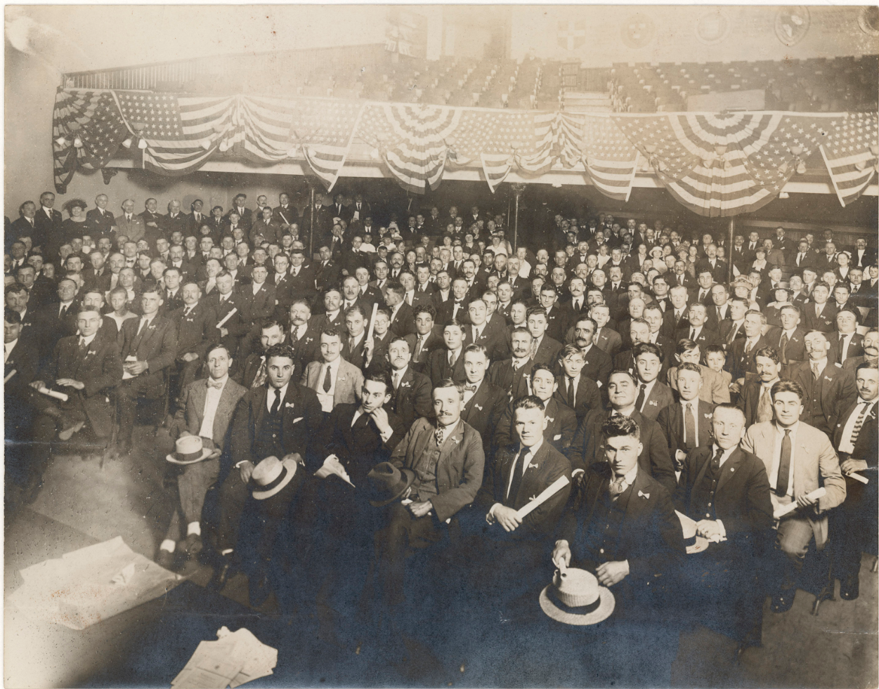

**Questions**

1. What common features can you observe in the members of this audience?

\_\_\_\_\_\_\_\_\_\_\_\_\_\_\_\_\_\_\_\_\_\_\_\_\_\_\_\_\_\_\_\_\_\_\_\_\_\_\_\_\_\_\_\_\_\_\_\_\_\_\_\_\_\_\_\_\_\_\_\_\_\_\_\_\_\_\_\_\_\_\_\_\_\_\_\_\_\_\_\_\_\_\_\_\_\_\_\_\_\_\_\_\_\_\_\_\_\_\_\_\_\_\_\_\_\_\_\_\_\_\_\_\_\_\_\_\_\_\_\_\_\_\_\_\_\_\_\_\_\_\_\_\_\_\_\_\_\_\_\_\_\_\_\_\_\_\_\_\_\_\_\_\_\_\_\_\_\_\_\_\_\_\_\_\_\_\_\_\_\_\_\_\_\_\_\_\_\_\_\_

1. What would be the purpose of an Americanization class?

\_\_\_\_\_\_\_\_\_\_\_\_\_\_\_\_\_\_\_\_\_\_\_\_\_\_\_\_\_\_\_\_\_\_\_\_\_\_\_\_\_\_\_\_\_\_\_\_\_\_\_\_\_\_\_\_\_\_\_\_\_\_\_\_\_\_\_\_\_\_\_\_\_\_\_\_\_\_\_\_\_\_\_\_\_\_\_\_\_\_\_\_\_\_\_\_\_\_\_\_\_\_\_\_\_\_\_\_\_\_\_\_\_\_\_\_\_\_\_\_\_\_\_\_\_\_\_\_\_\_\_\_\_\_\_\_\_\_\_\_\_\_\_\_\_\_\_\_\_\_\_\_\_\_\_\_\_\_\_\_\_\_\_\_\_\_\_\_\_\_\_\_\_\_\_\_\_\_\_\_

1. Why might there be no Asians in this photo?

\_\_\_\_\_\_\_\_\_\_\_\_\_\_\_\_\_\_\_\_\_\_\_\_\_\_\_\_\_\_\_\_\_\_\_\_\_\_\_\_\_\_\_\_\_\_\_\_\_\_\_\_\_\_\_\_\_\_\_\_\_\_\_\_\_\_\_\_\_\_\_\_\_\_\_\_\_\_\_\_\_\_\_\_\_\_\_\_\_\_\_\_\_\_\_\_\_\_\_\_\_\_\_\_\_\_\_\_\_\_\_\_\_\_\_\_\_\_\_\_\_\_\_\_\_\_\_\_\_\_\_\_\_\_\_\_\_\_\_\_\_\_\_\_\_\_\_\_\_\_\_\_\_\_\_\_\_\_\_\_\_\_\_\_\_\_\_\_\_\_\_\_\_\_\_\_\_\_\_\_

**Documents 1, 2 and 3 – Sample Answers**

**Document 1 - House Resolution 751**

1. What does this resolution say about the work of Chinese railroad workers?

12,000 Chinese immigrants were employed in the construction of the Railroad. They were considered indispensable by their foremen and respected for their work ethic and discipline. Chinese railroad workers were given the most difficult, dangerous jobs and were paid lower wages than other railroad workers.

1. How vital was the Chinese contribution to building the Transcontinental Railroad?

They were considered “indispensable” by their foremen and respected for their work ethic and discipline. The Chinese railroad workers set a world record by laying 10 miles of railroad track in just one work day.

1. How were Chinese workers treated compared to other workers?

Chinese railroad workers were given the most difficult, dangerous jobs and were paid lower wages than other railroad workers.

1. What was the quality of the work done by Chinese workers?

The Chinese railroad workers were considered indispensable by their foremen and were respected for their work ethic and discipline.

**Document 2 – Chinese Exclusion Act**

1. What does this legislation say about Chinese laborers?

They can no longer immigrate to the United States.

1. What regulation does this bill propose?

Immigration by Chinese laborers is banned for ten years.

1. How would this law impact Chinese immigration?

Chinese immigration would decrease significantly. The law says that Chinese laborers cannot immigrate and that would impact their families ability to immigrate as well.

**Document 3 – Photograph of Americanization Class**

1. What common features can you observe in the members of this audience?

The audience appears to be all men, white, and dressed in suits.

1. What would be the purpose of an Americanization class?

To teach new immigrants about American tradition and culture.

1. Why might there be no Asians in this photo?

Even after the ten year ban on Chinese laborers immigrating to the United States, Chinese immigration was smaller than other groups of people moving to the United States.

**Immigration Inquiry – Sample Answers**

**Directions:** After you read and answer the questions for your document, write the document name on the title line. Then, add the date of the document. Finally, summarize your understanding of the document in two sentences.

|  |  |  |
| --- | --- | --- |
| **Document 1**  **Title:** House Resolution 751 | **Document 2**  **Title:** Chinese Exclusion Act | **Document 3**  **Title:** Photograph of Americanization Class |
| **Date:** 2014 | **Date:** 1882 | **Date:** 1921 |
| **Two Sentence Summary:**  A commemorative stamp should be issued recognizing the contribution of 12,000 Chinese immigrants employed in the construction of the Transcontinental Railroad. Chinese immigrants comprised more than 80% of the workforce of the Central Pacific Railroad Company. | **Two Sentence Summary:**  This act prevented the immigration of Chinese laborers to the United States for ten years. This act made it illegal for Chinese laborers who enter the United States after 90 days of the passage of the act to stay in the country. | **Two Sentence Summary:**  This photograph shows an Americanization class meeting in New Jersey. The audience members appear to be all men, white and dressed in suits. |

|  |
| --- |
| **Summary Questions:**   1. How did Chinese immigrants contribute to American history?   Chinese immigrants significantly contributed to the construction of the Trasncontinental Railroad.   1. Why were Chinese immigrants a small fraction of overall U.S. immigration between 1882-1921?   Due to the Chinese Exclusion Act that banned the immigration of Chinese laborers to the United States for ten years.   1. How would the experience of immigrating to the U.S. have been different for Chinese and European people between 1882-1921?   Chinese immigrants were banned from entering the United States while European people did not experience a ban on entering the country. |

**Macintosh HD:Users:vmcvey:Downloads:photo_analysis_worksheet_former-2.pdf**