STUDENTS INVESTIGATING PRIMARY SOURCES
Guidance on Government: Federal Edition
How does the U.S. Constitution organize the government?
A Short Activity for Fifth Grade
Benchmark Correlations
Constitution Day Information
SS.5.C.3.1 – Describe the organizational structure (legislative, executive, judicial branches) and powers of the federal government as defined in Articles I, II, and III of the U.S. Constitution.
Benchmark Clarification: Students will identify responsibilities of the legislative, executive, and judicial branches of the United States government as defined in Articles I, II, and III of the U.S. Constitution.
LAFS.5.RI.3.9 – Integrate information from several texts on the same topic in order to write or speak about the subject knowledgeably.

Activity Documents and Handouts
- Guidance on Government: Federal Edition PowerPoint Presentation
- U.S. Constitution Graphic Organizer

Full Document Citations
Anyone Home? cartoon by Clifford Berryman, February 24, 1920; Berryman Political Cartoon Collection, 1896-1949; Records of the U.S. Senate, Record Group 46; Center for Legislative Archives, Washington, DC. National Archives Identifier: 6011590.
[https://catalog.archives.gov/id/6011590]
[https://www.docsteach.org/documents/document/untitled-%5Brailroad-bill%5D-cartoon-by-clifford-berryman]

Constitution of the United States, 9/17/1787; General Records of the United States Government, Record Group 11; National Archives at Washington, DC. National Archives Identifier: 1667751.
[https://catalog.archives.gov/id/1667751]
[https://www.docsteach.org/documents/document/constitution]

Photograph of President Lyndon Johnson Signing the Voting Rights Act as Martin Luther King, Jr. with Other Civil Rights Leaders in the Capitol Rotunda, Washington, DC, 8/6/1965; White House Photo Office Collection, 11/22/1963-1/20/1969; Lyndon Baines Johnson Library. National Archives Identifier: 2803443.
[https://catalog.archives.gov/id/2803443]
[https://www.docsteach.org/documents/document/photograph-of-president-lyndon-johnson-signs-the-voting-rights-act-as-martin-luther-king-jr-with-other-civil-rights-leaders-in-the-capitol-rotunda-washington-dc]

Photograph of Supreme Court Building n.d.; Records of the National Archives and Records Administration, Record Group 64; National Archives at College Park. National Archives Identifier: 594954.
[https://catalog.archives.gov/id/594954]
[https://www.docsteach.org/documents/document/photograph-of-supreme-court-building]

Photograph of The White House, 1/15/1977; Combined Military Service Digital Photographic Files, 1982-2007; Records of the Office of the Secretary of Defense, Record Group 330; National Archives at College Park. National Archives Identifier: 6384319.
[https://catalog.archives.gov/id/6384319]
[https://www.docsteach.org/documents/document/2-the-white-house]

Photograph of the View of U.S. Capitol, ca. 2013; Digital Photographs Related to America’s Byways, ca. 1995-ca. 2013; Records of the Federal Highway Administration, Record Group 406; National Archives at College Park. National Archives Identifier: 7718585.
[https://catalog.archives.gov/id/7718585]
[https://www.docsteach.org/documents/document/view-of-us-capitol]

Tallahassee Democrat headline for segregation ban - Tallahassee, Florida. 1954. Black & white photoprint. State Archives of Florida, Florida Memory. Accessed 21 Jul. 2016.<https://www.floridamemory.com/items/show/34838>.

United States map taken from http://www.yourchildlearns.com/us_map.htm, accessed on July 21, 2016.

Activity Vocabulary
Congress – the legislative branch of government, consists of the House of Representatives and the Senate
executive power - the power of government to enforce laws, make sure laws are followed
House of Representatives – the lower house of the U.S. Congress
judicial power – the power of government to interpret laws
legislative power – the power of government to make laws
President – the head of the executive branch
Senate – the upper house of the U.S. Congress
Supreme Court – the highest court of the United States
Vice President– takes over the presidency if the president can’t do his job

Teacher Note: As an instructional option, lead students through the activities for the legislative branch as a whole class (Steps 1-15), have students work with a partner to complete the activities related to the executive branch (Steps 16-25) and then have students work independently to complete the activities related to the judicial branch (Steps 26-35).
Teacher Note: The PowerPoint Presentation file follows along with the activity sequence. Before starting this activity, be sure to download and open the PowerPoint file.
- Open the PowerPoint file and project the map of the United States. Quickly point out Florida and Washington D.C. to students. Be sure to point out that the federal government is located in Washington, D.C.
- Project the image of the U.S. Constitution.
- Direct students to visually scan the document and identify three items that stand out to them in the document. (Examples could include: We the People in large text, text is divided into sections, script)
- Direct students to share their items with a partner. Teacher Note: Circulate through the pairs to listen and monitor understanding.
- Explain to students that our government’s structure and powers are outlined in the U.S. Constitution. Our government is divided into three branches.
- Pass out the U.S. Constitution Graphic Organizer to each student and project the U.S. Capitol image.
- Ask students if they can identify the building. Explain to students that this is the U.S. Capitol building and this is where laws are made. Instruct students to make a note on their graphic organizer about the Capitol.
- Read aloud the text from Article I, Section I of the U.S. Constitution on the graphic organizer while students follow along.
- Instruct students to circle the following terms: legislative, Congress, Senate and House of Representatives.
- Share with students the following key points about the legislative branch: The legislative branch is responsible for making laws. The legislative branch is divided into two parts: The Senate and The House of Representatives. The legislative branch is also called Congress. Once the legislative branch passes a bill, it goes to the president for approval.
- Instruct students to talk with to their partner about the legislative branch and write 2-3 notes on their graphic organizer to summarize what they have learned.
- Project the political cartoon from Clifford Berryman called Anyone Home?
- Direct students to visually scan the image and identify three items that stand out to them in the image. (Examples could include: a large bill with a face and hands, OK House, OK Senate, Ringing the doorbell)
- Direct student attention to the graphic organizer and discuss the question as a whole class.
- Instruct students to answer the question on their graphic organizer. Teacher Note: Circulate through the students to ensure that students understand that Congress has passed a bill that is waiting for action from the president.
- Project the White House image.
- Ask students if they can identify the building. Explain to students that they are looking at the White House. This where the president lives and works. Instruct students to make a note on their graphic organizer on the White House.
- Read aloud the text from Article II, Section I of the U.S. Constitution on the graphic organizer while students follow along.
- Instruct students to circle the following terms: executive, President, and Vice President.
- Share with students the following key points about the executive branch: The executive branch is responsible for implementing laws. This means that the president is in charge of the departments that make sure laws are followed. The executive branch is led by the President and includes the Vice President and executive departments. The president lives and works in the White House.
- Instruct students to talk with their partner about the terms and write 2-3 notes on their graphic organizer to summarize what they have learned.
- Project the image of President Johnson signing the Voting Rights Act.
- Direct students to visually scan the document and identify three items that stand out to them in the document. (Examples could include: president sitting at a desk signing something, Martin Luther King, Jr., large diverse crowd)
- Direct student attention to the graphic organizer and discuss the question as a whole class.
- Instruct students to answer the question on their graphic organizer. Teacher Note: Circulate through the students to ensure that students understand that the president is signing a bill into law.
- Project the U.S. Supreme Court image.
- Ask students if they can identify the building. Explain to students that this is a picture of the U.S. Supreme Court, the highest court in the United States. Instruct students to make a note on their graphic organizer on the Supreme Court.
- Read aloud the text from Article III, Section I of the U.S. Constitution on the graphic organizer.
- Instruct students to circle the following terms: judicial and Supreme Court.
- Share with students the following key points about the judicial branch: The judicial branch is responsible for making sure laws follow the U.S. Constitution. The U.S. Supreme Court is the highest court in the United States. There are usually nine judges who work at the Supreme Court and they are called justices. Congress creates lower courts.
- Instruct students to talk with to their partner about the terms and write 2-3 notes on their graphic organizer to summarize what they have learned.
- Project the headline image about Brown v. Topeka, Kansas Board of Education.
- Direct students to visually scan the document and identify three items that stand out to them in the document. (Examples could include: October, 1954; from a Florida paper, names of people involved in the case, headline of the story)
- Direct student attention to the graphic organizer and discuss the question as a whole class.
- Instruct students to answer the question on their graphic organizer. Teacher Note: Circulate through the students to ensure that students understand that the newspaper heading is about a Supreme Court case.
- Pose the following question for closure: How does the Constitution organize the government? Instruct students to independently respond in writing on their own notebook paper.

Name: ______________________________________________ Date: __________________
U.S. Constitution
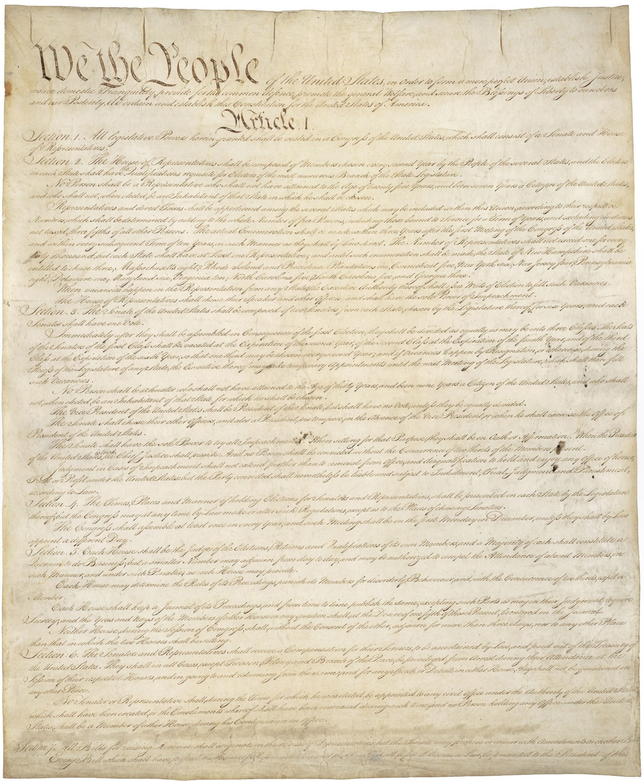

Legislative Branch  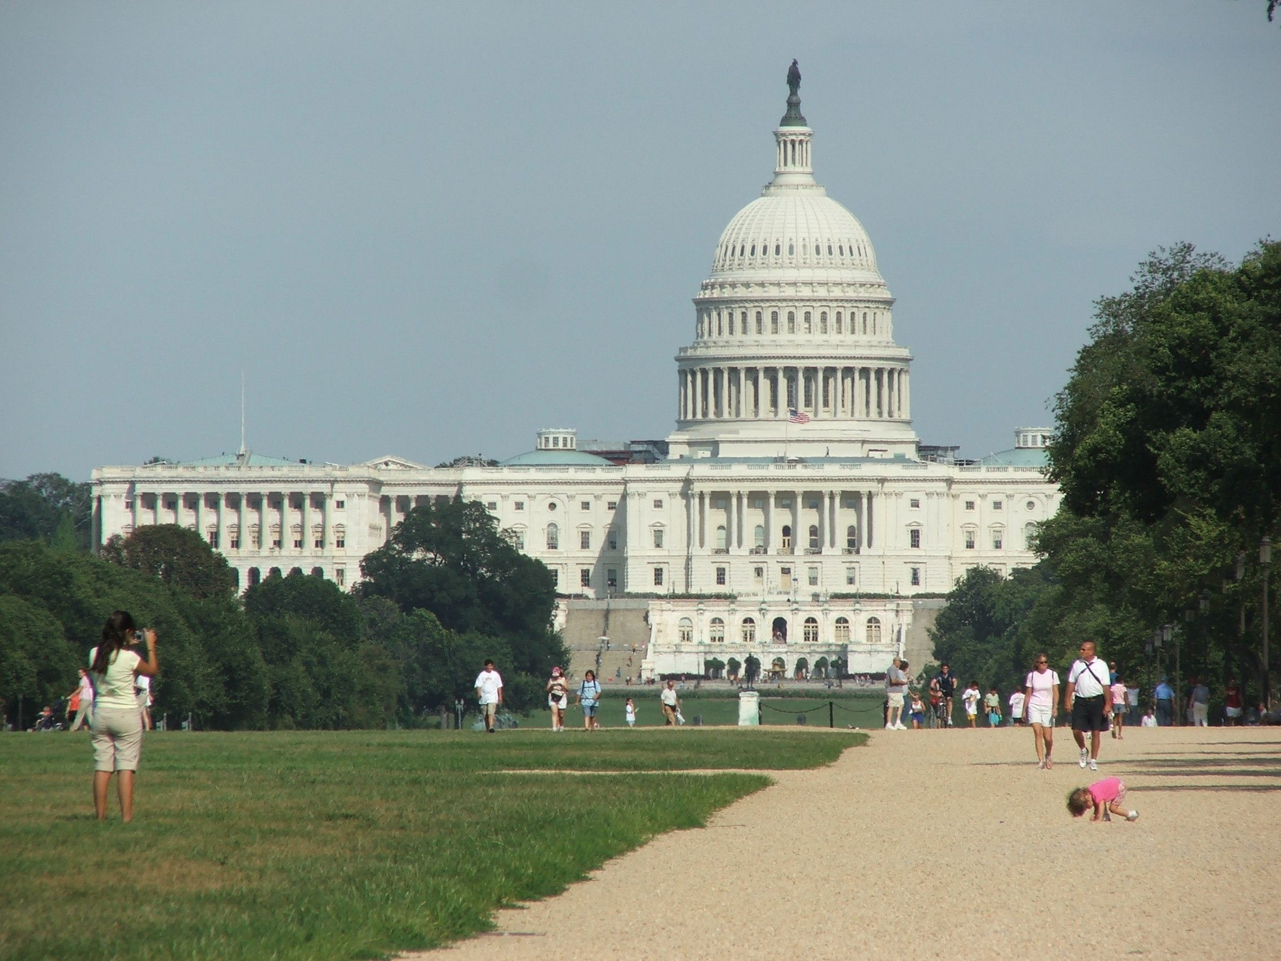 | Executive Branch  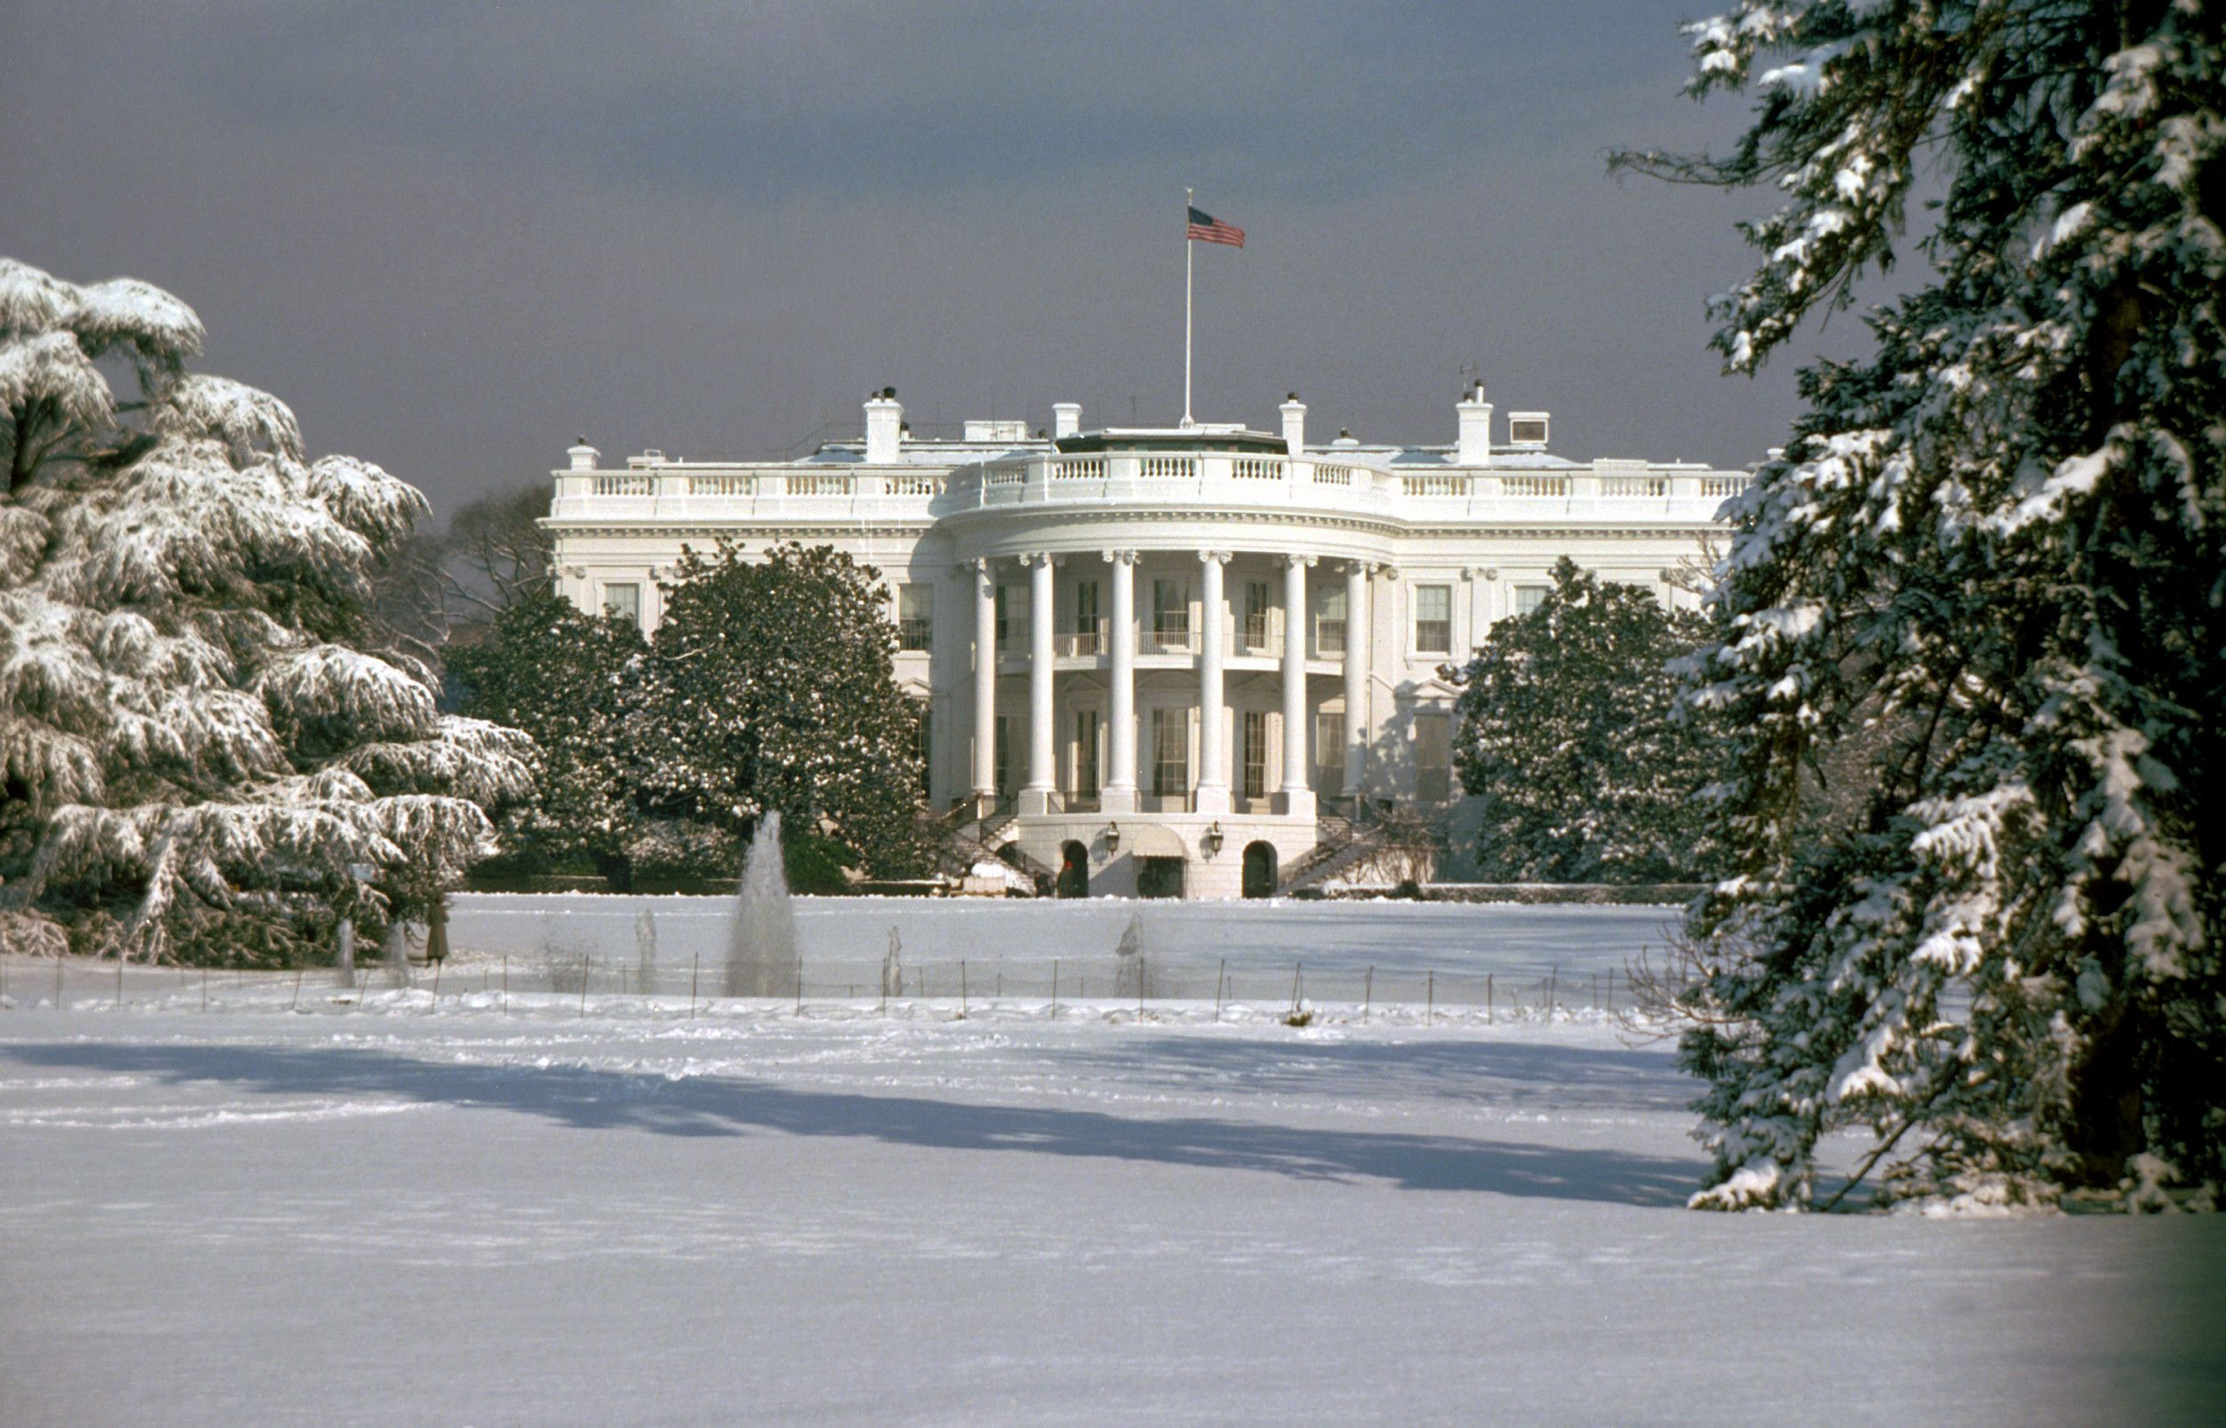 | Judicial Branch  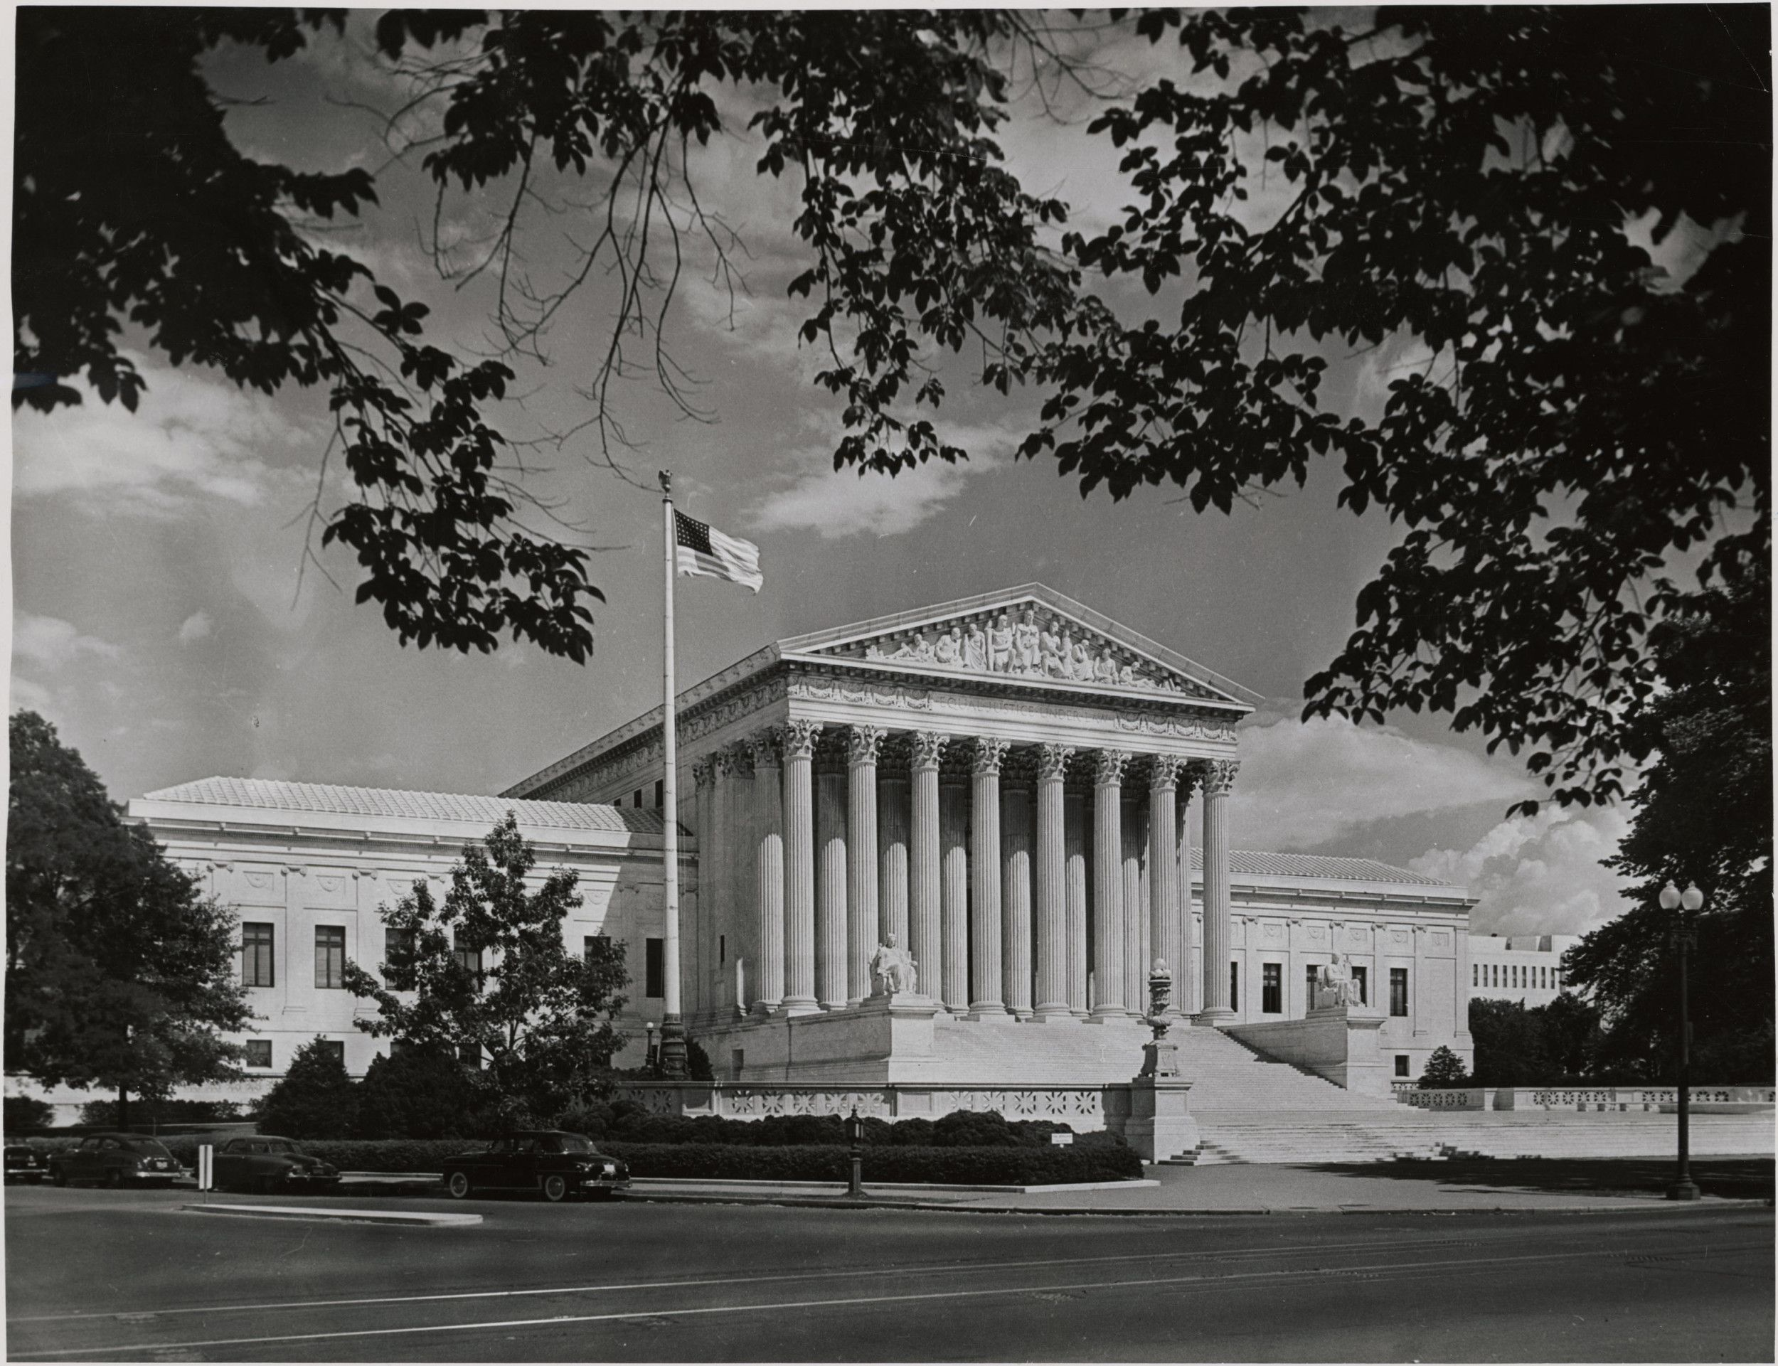
All legislative powers herein granted shall be vested in a Congress of the United States, which shall consist of a Senate and House of Representatives | The executive power shall be vested in a President of the United States of America. He shall hold his office during the term of four years, and, together with the Vice President chosen for the same term… | The judicial power of the United States, shall be vested in one Supreme Court, and in such inferior Courts as the Congress may from time to time ordain and establish.
________________________________  ________________________________  ________________________________  ________________________________  ________________________________  ________________________________ | ________________________________  ________________________________  ________________________________  ________________________________  ________________________________  ________________________________ | ________________________________  ________________________________  ________________________________  ________________________________  ________________________________  ________________________________
What does this political cartoon have to do with the legislative branch? | What does this image have to do with the executive branch? | What does this image have to do with the judicial branch?
________________________________  ________________________________  ________________________________  ________________________________ | ________________________________  ________________________________  ________________________________  ________________________________ | ________________________________  ________________________________  ________________________________  ________________________________

