STUDENTS INVESTIGATING PRIMARY SOURCES
Guidance on Government: State Edition
How does the Florida Constitution organize the government?
A Short Activity for Fourth Grade
Benchmark Correlations
Constitution Day Information
SS.4.C.3.1 – Identify the three branches (Legislative, Judicial, Executive) of government in Florida and the powers of each.
Benchmark Clarification: Students will identify the legislative, judicial, and executive branches of Florida’s government.
Benchmark Clarification: Students will provide an example of actions taken by each of Florida’s three branches of government.
LAFS.4.RI.3.9 – Integrate information from two texts on the same topic in order to write or speak about the subject knowledgeably.

Activity Documents and Handouts
- Guidance on Government: State Edition PowerPoint Presentation
- Florida Constitution Graphic Organizer

Full Document Citations
Constitution of the United States, 9/17/1787; General Records of the United States Government, Record Group 11; National Archives at Washington, DC. National Archives Identifier: 1667751.
[https://catalog.archives.gov/id/1667751]
[https://www.docsteach.org/documents/document/constitution]

Florida map taken from https://en.wikipedia.org/wiki/File:Florida_Political_Map_Kwh.png , accessed on July 21, 2016.
Front of the Florida Supreme Court Building during repainting project in Tallahassee, Florida. 1997. Color digital image. State Archives of Florida, Florida Memory. Accessed 21 Jul. 2016.<https://www.floridamemory.com/items/show/47097>.
Front view of the Florida Governor's Mansion - Tallahassee, Florida. 199-. Color transparency. State Archives of Florida, Florida Memory. Accessed 21 Jul. 2016.<https://www.floridamemory.com/items/show/94967>.
Holland, Karl E., 1919-1993. Governor Claude Kirk signing the Disney bill at the Governor's mansion - Tallahassee, Florida. 1967. Black & white photoprint. State Archives of Florida, Florida Memory. Accessed 21 Jul. 2016.<https://www.floridamemory.com/items/show/80377>.
Old and new capitol buildings - Tallahassee, Florida. 19--. Color slide. State Archives of Florida, Florida Memory. Accessed 21 Jul. 2016.<https://www.floridamemory.com/items/show/44071>.
Organizational session of the Florida House of Representatives. 1979. Black & white photonegative. State Archives of Florida, Florida Memory. Accessed 21 Jul. 2016.<https://www.floridamemory.com/items/show/20051>.
Photograph of the Florida Supreme Court Justices take from http://www.floridasupremecourt.org/justices/Fullcourt2014_HiRes.jpg , accessed on July 21, 2016.

Activity Vocabulary
executive power - the power of government to enforce laws, make sure laws are followed
Florida House of Representatives – the lower house of the Florida legislature
Florida Senate – the upper house of the Florida legislature
Florida Supreme Court – the highest court in Florida
governor – the head of a state government
judicial power – the power of government to interpret laws
legislative power – the power of government to make laws
state legislature – the lawmaking branch of the state government

Teacher Note: The PowerPoint Presentation file follows along with the activity sequence. Before starting this activity, be sure to download and open the PowerPoint file.
- Open the PowerPoint file and project the image of the U.S. Constitution.
- Direct students to visually scan the document and identify three items that stand out to them in the document. (Examples could include: We the People in large text, text is divided into sections, script)
- Explain to students that Article 4 of the U.S. Constitution gives power to the states to establish their own state government.
- Project the map of Florida. Quickly point out your city and Tallahassee to the students. Explain to students that Tallahassee is the capital of Florida and the state government is located there.
- Share with students that Florida has a state constitution that outlines the structure and powers of the state government.
- Pass out the Florida Constitution Graphic Organizer to each student and project the Florida Historic Capitol and Capitol Complex image.
- Ask students if they can identify the buildings. Explain to students that this image shows the Historic Capitol and part of the Capitol Complex. The Capitol Complex is where state laws are made. Instruct students to make a note on their graphic organizer about the Capitol Complex.
- Read aloud the text from Article III, Section I of the Florida Constitution on the graphic organizer while students follow along.
- Instruct students to circle the following terms: legislative, legislature, Senate and House of Representatives.
- Share with students the following key points about the state legislative branch: The legislative branch is responsible for making laws. The legislative branch is divided into two parts: The Senate and The House of Representatives. Once the legislative branch passes a bill, it goes to the governor for approval.
- Instruct students to talk with to their partner about the legislative branch and write 2-3 notes on their graphic organizer to summarize what they have learned.
- Project the Florida House of Representatives image.
- Direct students to visually scan the document and identify three items that stand out to them in the document. (Examples could include: large group of people meeting, a large desk at the front of the room, list of names on a screen)
- Direct student attention to the graphic organizer and discuss the question as a whole class.
- Instruct students to answer the question on their graphic organizer. Teacher Note: Circulate through the students to ensure that students understand that the Florida House of Representatives is voting on a bill.
- Project the Florida Governor’s Mansion image.
- Ask students if they can identify the building. Explain to students that this is where the governor of Florida lives. Instruct students to make a note on their graphic organizer on the Governor’s Mansion.
- Read aloud the text from Article IV, Section I of the Florida Constitution on the graphic organizer while students follow along.
- Instruct students to circle the following terms: executive and governor.
- Share with students the following key points about the executive branch: The executive branch is responsible for implementing laws. The governor is the leader of the executive branch and he is charge of making sure laws are put into place. The governor signs bills into law and is in charge of the departments that make sure laws are followed. The executive branch also includes the lieutenant governor and executive departments.
- Instruct students to talk with their partner about the terms and write 2-3 notes on their graphic organizer to summarize what they have learned.
- Project the image of Claude Kirk signing the Disney bill.
- Direct students to visually scan the document and identify three items that stand out to them in the document. (Examples could include: a man signing a paper, a child looking on, men standing behind him)
- Direct student attention to the graphic organizer and discuss the question as a whole class.
- Instruct students to answer the question on their graphic organizer. Teacher Note: Circulate through the students to ensure that students understand that the governor is signing a bill into law.
- Project the Florida Supreme Court image.
- Ask students if they can identify the building. Explain to students that this is the Florida Supreme Court. Instruct students to make a note on their graphic organizer on the Florida Supreme Court.
- Read aloud the text from Article V, Section I of the Florida Constitution on the graphic organizer.
- Instruct students to circle the following terms: judicial and supreme court.
- Share with students the following key points about the judicial branch: The judicial branch is responsible for making sure laws follow the Florida Constitution. The Florida Supreme Court is the highest court in the state. There are three levels of courts lower than the Supreme Court: district courts of appeal, circuit courts and county courts.
- Instruct students to talk with to their partner about the four terms and write 2-3 notes on their graphic organizer to summarize what they have learned.
- Project the image of the seven justices of the Florida Supreme Court.
- Direct students to visually scan the document and identify three items that stand out to them in the document. (Examples could include: seven people, sitting behind a large desk, they are wearing robes, Florida and U.S. flag in the background)
- Direct student attention to the graphic organizer and discuss the question as a whole class.
- Instruct students to answer the question on their graphic organizer. Teacher Note: Circulate through the students to ensure that students understand that this is an image of the seven justices of the Florida Supreme Court.
- Pose the following question for closure: How does the Florida Constitution organize the state government? Instruct students to independently respond in writing on their own notebook paper.

NAME_________________________________________ DATE__________________
Florida Constitution
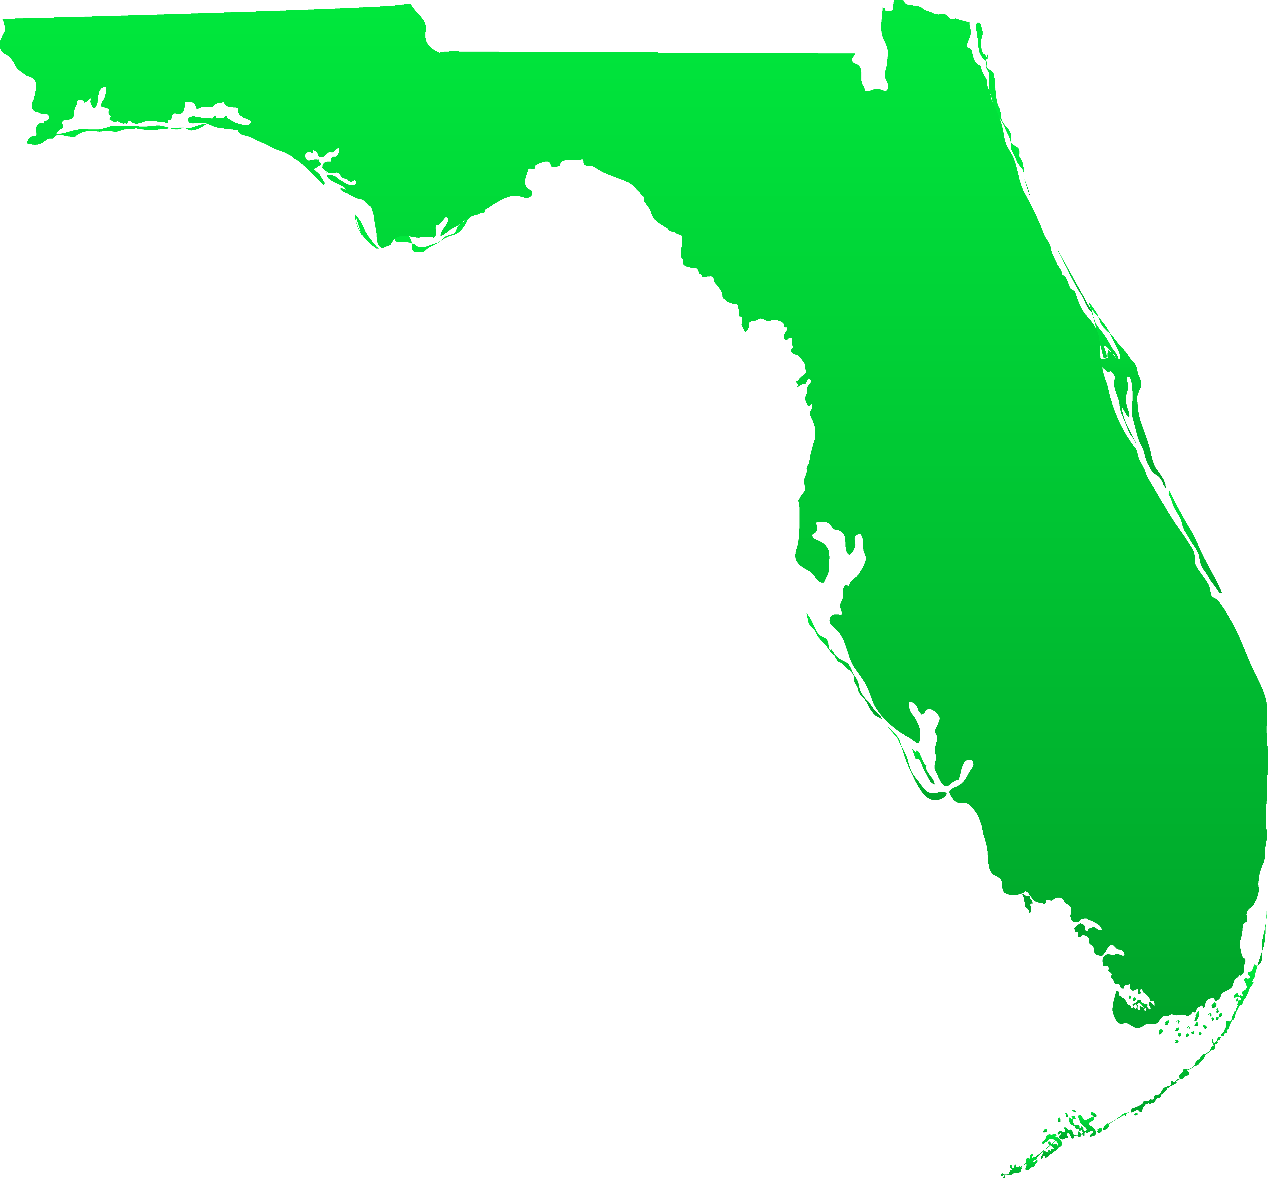
Legislative Branch  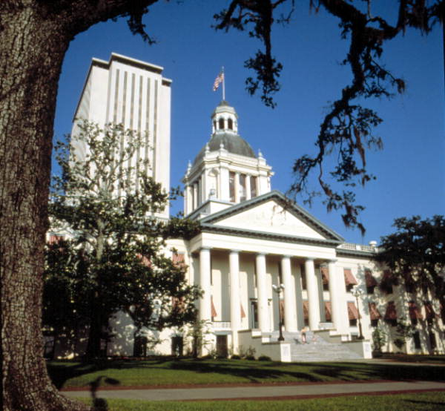  The legislative power of the state shall be vested in a legislature of the State of Florida, consisting of a senate …. and a house of representatives …. | Executive Branch  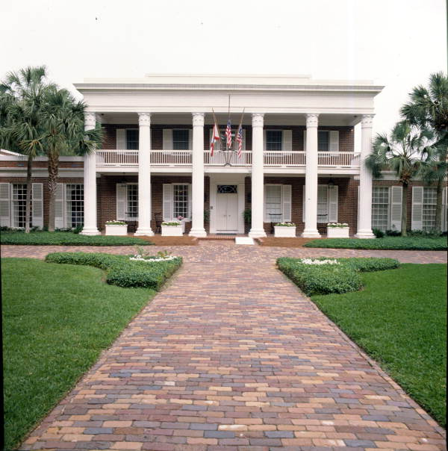  The supreme executive power shall be vested in a governor…. | Judicial Branch  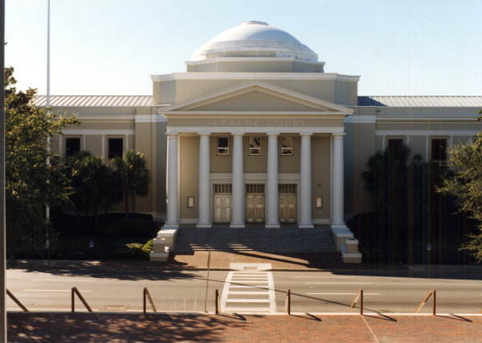  The judicial power shall be vested in a supreme court, district courts of appeal, circuit courts and county courts.
________________________________  ________________________________  ________________________________  ________________________________  ________________________________  ________________________________  ________________________________ | ________________________________  ________________________________  ________________________________  ________________________________  ________________________________  ________________________________  ________________________________ | ________________________________  ________________________________  ________________________________  ________________________________  ________________________________  ________________________________  ________________________________
What does this image have to do with the legislative branch? | What does this image have to do with the executive branch? | What does this image have to do with the judicial branch?
________________________________  ________________________________  ________________________________  ________________________________  ________________________________ | ________________________________  ________________________________  ________________________________  ________________________________  ________________________________ | ________________________________  ________________________________  ________________________________  ________________________________  ________________________________

