STUDENTS INVESTIGATING PRIMARY SOURCES
Thinking Through Timelines: Inching Toward Independence
Why do we celebrate Independence Day?
A Short Activity for Second Grade
Benchmark Correlations
Constitution Day Information
Celebrate Freedom Week Information
SS.2.A.1.1 – Examine primary and secondary sources.
Benchmark Clarification: Students will examine primary sources, including by not limited to, artifacts, documents, maps, and photographs.
SS.2.C.3.2 – Recognize symbols, individuals, events, and documents that represent the United States.
Benchmark Clarification: Students will identify and describe the role of symbolic documents such as the Constitution, the Bill of Rights, and the Declaration of Independence.
LAFS.2.RI.1.3 – Describe the connection between a series of historical events, scientific ideas or concepts, or steps in technical procedures in a text.

Activity Documents and Handouts
- The Road to Independence PowerPoint Presentation
- Copies of Primary Sources: the Boston Tea Party, The First Blow for Liberty, Washington Taking Command, and the Declaration of Independence painting
- Inching Toward Independence Graphic Organizer

Full Document Citations
Constitution of the United States, 9/17/1787; General Records of the United States Government, Record Group 11; National Archives at Washington, DC. National Archives Identifier: 1667751.
[https://catalog.archives.gov/id/1667751]
[https://www.docsteach.org/documents/document/constitution]

The Destruction of Tea at Boston Harbor. 1773. Copy of lithograph by Sarony & Major, 1846; George Washington Bicentennial Commission, 1931 - 1932; Records of Commissions of the Legislative Branch, Record Group 148. National Archives at College Park. National Archives Identifier: 532892.
[https://catalog.archives.gov/id/532892]
[https://www.docsteach.org/documents/document/the-destruction-of-tea-at-boston-harbor-1773-copy-of-lithograph-by-sarony-major-1846]

Dunlap Broadside [Declaration of Independence], July 4, 1776; Rough Journals, 9/5/1774 - 3/2/1789; Records of the Continental and Confederation Congresses and the Constitutional Convention, 1765 - 1821, Record Group 360; National Archives Building, Washington DC. National Archives Identifier: 301682.
[https://catalog.archives.gov/id/301682]
[https://www.docsteach.org/documents/document/dunlap-broadside]

Engrossed Declaration of Independence, 7/4/1776 - 8/2/1776; Records of the Continental and Confederation Congresses and the Constitutional Convention, Record Group 360. National Archives at Washington, DC. National Archives Identifier: 1419123.
[https://catalog.archives.gov/id/1419123]
[https://www.docsteach.org/documents/document/the-declaration-of-independence]

The First Blow for Liberty. Battle of Lexington, April 1775. Copy of print by A. H. Ritchie after F.O.C. Darley; John K. Hillers Collection, 1870-1900. National Archives at College Park. National Archives Identifier: 559250.
[https://catalog.archives.gov/id/559250]
[https://www.docsteach.org/documents/document/the-first-blow-for-liberty-battle-of-lexington-april-1775-copy-of-print-by-a-h-ritchie-after-foc-darley]

A Fourth of July fireworks display at the Washington Monument, 7/4/1986; Combined Military Service Digital Photographic Files, 1982-2007; Records of the Office of the Secretary of Defense, Record Group 330. National Archives at College Park. National Archives Identifier: 6413316.
[https://catalog.archives.gov/id/6413316]
[https://www.docsteach.org/documents/document/a-fourth-of-july-fireworks-display-at-the-washington-monument]

Map of the British Empire in 1763 taken from http://www.conservapedia.com/File:B-Emp-1763.jpg , accessed on July 22, 2016.

Map of the Original 13 Colonies in 1776 taken from http://mrnussbaum.com/images/13map13a.gif, accessed on July 22, 2016.

Photograph of a Painting of Washington Taking Command of the American Army at Cambridge, Massachusetts, 1876; George Washington Bicentennial Commission, 1931 - 1932; Records of Commissions of the Legislative Branch, Record Group 148. National Archives at College Park. National Archives at Identifier: 532915.
[https://catalog.archives.gov/id/532915]
[https://www.docsteach.org/documents/document/washington-taking-command]
Activity Vocabulary
Battle of Lexington – April 19, 1775 – the first battle of the Revolutionary War
Boston Tea Party – December 16, 1773 – a key event leading up to the American Revolution, colonists threw tea into Boston Harbor to fight against Great Britain’s trade rules and tea taxes
Declaration of Independence – July 4, 1776 – the document that stated the American colonists’ independence from Great Britain
George Washington – June 15, 1775 – he becomes the leader, or general, of the Continental (American Colonist) Army during the American Revolution; he eventually becomes the first president of the United States
United States Constitution – September 17, 1787 – this document organizes and outlines the structure and powers of the government for the United States

Teacher Note: The PowerPoint Presentation file follows along with the activity sequence. Before starting this activity, be sure to download and open the PowerPoint file.
- Project the image of the Washington Monument with fireworks from the PowerPoint file.
- Direct students to visually scan the document and identify one item that stands out to them in the image. (Examples could include: fireworks, nighttime, large building)
- Ask students if they can identify the holiday that is being celebrated. (Independence Day)
- Project the map from the PowerPoint file. Explain to students that before the United States was an independent country, it was part of Great Britain. All of the land that was part of Great Britain was called the British Empire. Explain to students that there were important events that led to the United States of America becoming independent, or free, from Great Britain and that they will explore some of those events.
- Move students into pairs or small groups and pass out copies of the following primary source images: the Boston Tea Party, The First Blow for Liberty, Washington Taking Command, and the Declaration of Independence painting.
- Instruct students to work with their partner or group members to think about how each of these images relate to the colonists becoming independent from Great Britain and the order, by date, the images go in. Provide students only a minute to do this and then have students share out some of their ideas.
- Pass out the Inching Toward Independence graphic organizer and project the image of the Boston Tea Party from the PowerPoint file. Direct students to visually scan the document and work with their partner or small group to identify three items that stand out to them in the image. (Examples could include: a ship, many people, boxes in the water, people cheering/yelling)
- Share with students that this image illustrates that people were angry that Great Britain was charging too many taxes. In response to the taxes, colonists threw tea over the sides of the ship to protest or fight against the taxes. This was an important event that helped lead to war between the colonies and Great Britain and the colonists eventually declaring their independence, or freedom, from Great Britain. Instruct students to write the date of the event and a note on their graphic organizers about the image.
- Project the next image of the Battle of Lexington. Direct students to visually scan the image and identify three items that stand out to them in the image. (Examples could include: black and white image, men fighting, a house, a tree, confusion)
- Share with students that this image illustrates the very first battle of the American Revolution in Lexington, Massachusetts. Direct students to write the date of the event and a note on their graphic organizer about the Battle of Lexington.
- Project the next image of Washington Taking Command of the Continental (American Colonist) Army. Direct students to visually scan the document and work with their partner or small group to identify three items that stand out to them in the image. (Examples could include: a man on a horse, soldiers lined up, outdoors)
- Explain to students that George Washington, before he was the first president of the United States, was the commander of the Continental (American Colonist) Army that fought for independence from Great Britain.
- Direct students to write the date of the event and a note about General George Washington on their graphic organizer.
- Project the image of the signing of the Declaration of Independence. Direct students to visually scan the document and identify three items that stand out to them in the document. (Examples could include: black and white image, a large group of men, a formal room, someone sitting at a desk, papers)
- Explain to students that the leaders of each colony came together in Philadelphia and signed a document explaining why they wanted freedom from Great Britain. This document is called the Declaration of Independence and was signed on July 4, 1776. Direct students to write the date of the event and a note about the signing of the Declaration of Independence on their graphic organizer.
- Project the image of the Dunlap Broadside of the Declaration of Independence. Share with students that the Declaration told the world why the colonies wanted independence from Great Britain. This document led to the colonies becoming independent and eventually becoming one country, the United States. Direct students to write the date of the event and a note about the Declaration of Independence on their graphic organizer.
- Project the image of the U.S. Constitution. Share with students that eleven years after the signing of the Declaration of Independence the U.S. Constitution was written. The U.S. Constitution establishes the structure and powers of the United States government. Our government today still follows the U.S. Constitution. Direct students to write the date of the event and a note about the U.S. Constitution on their graphic organizer.
- Return back to the image of the Washington Monument in the PowerPoint presentation. Pose the following question for closure: Why do we celebrate Independence Day? (The signing of the Declaration of Independence and the colonists declaring their independence from Great Britain.)
Enrichment Suggestion – Instruct students to create a front-page newspaper headline and corresponding image to illustrate their understanding of the reason we celebrate Independence Day.
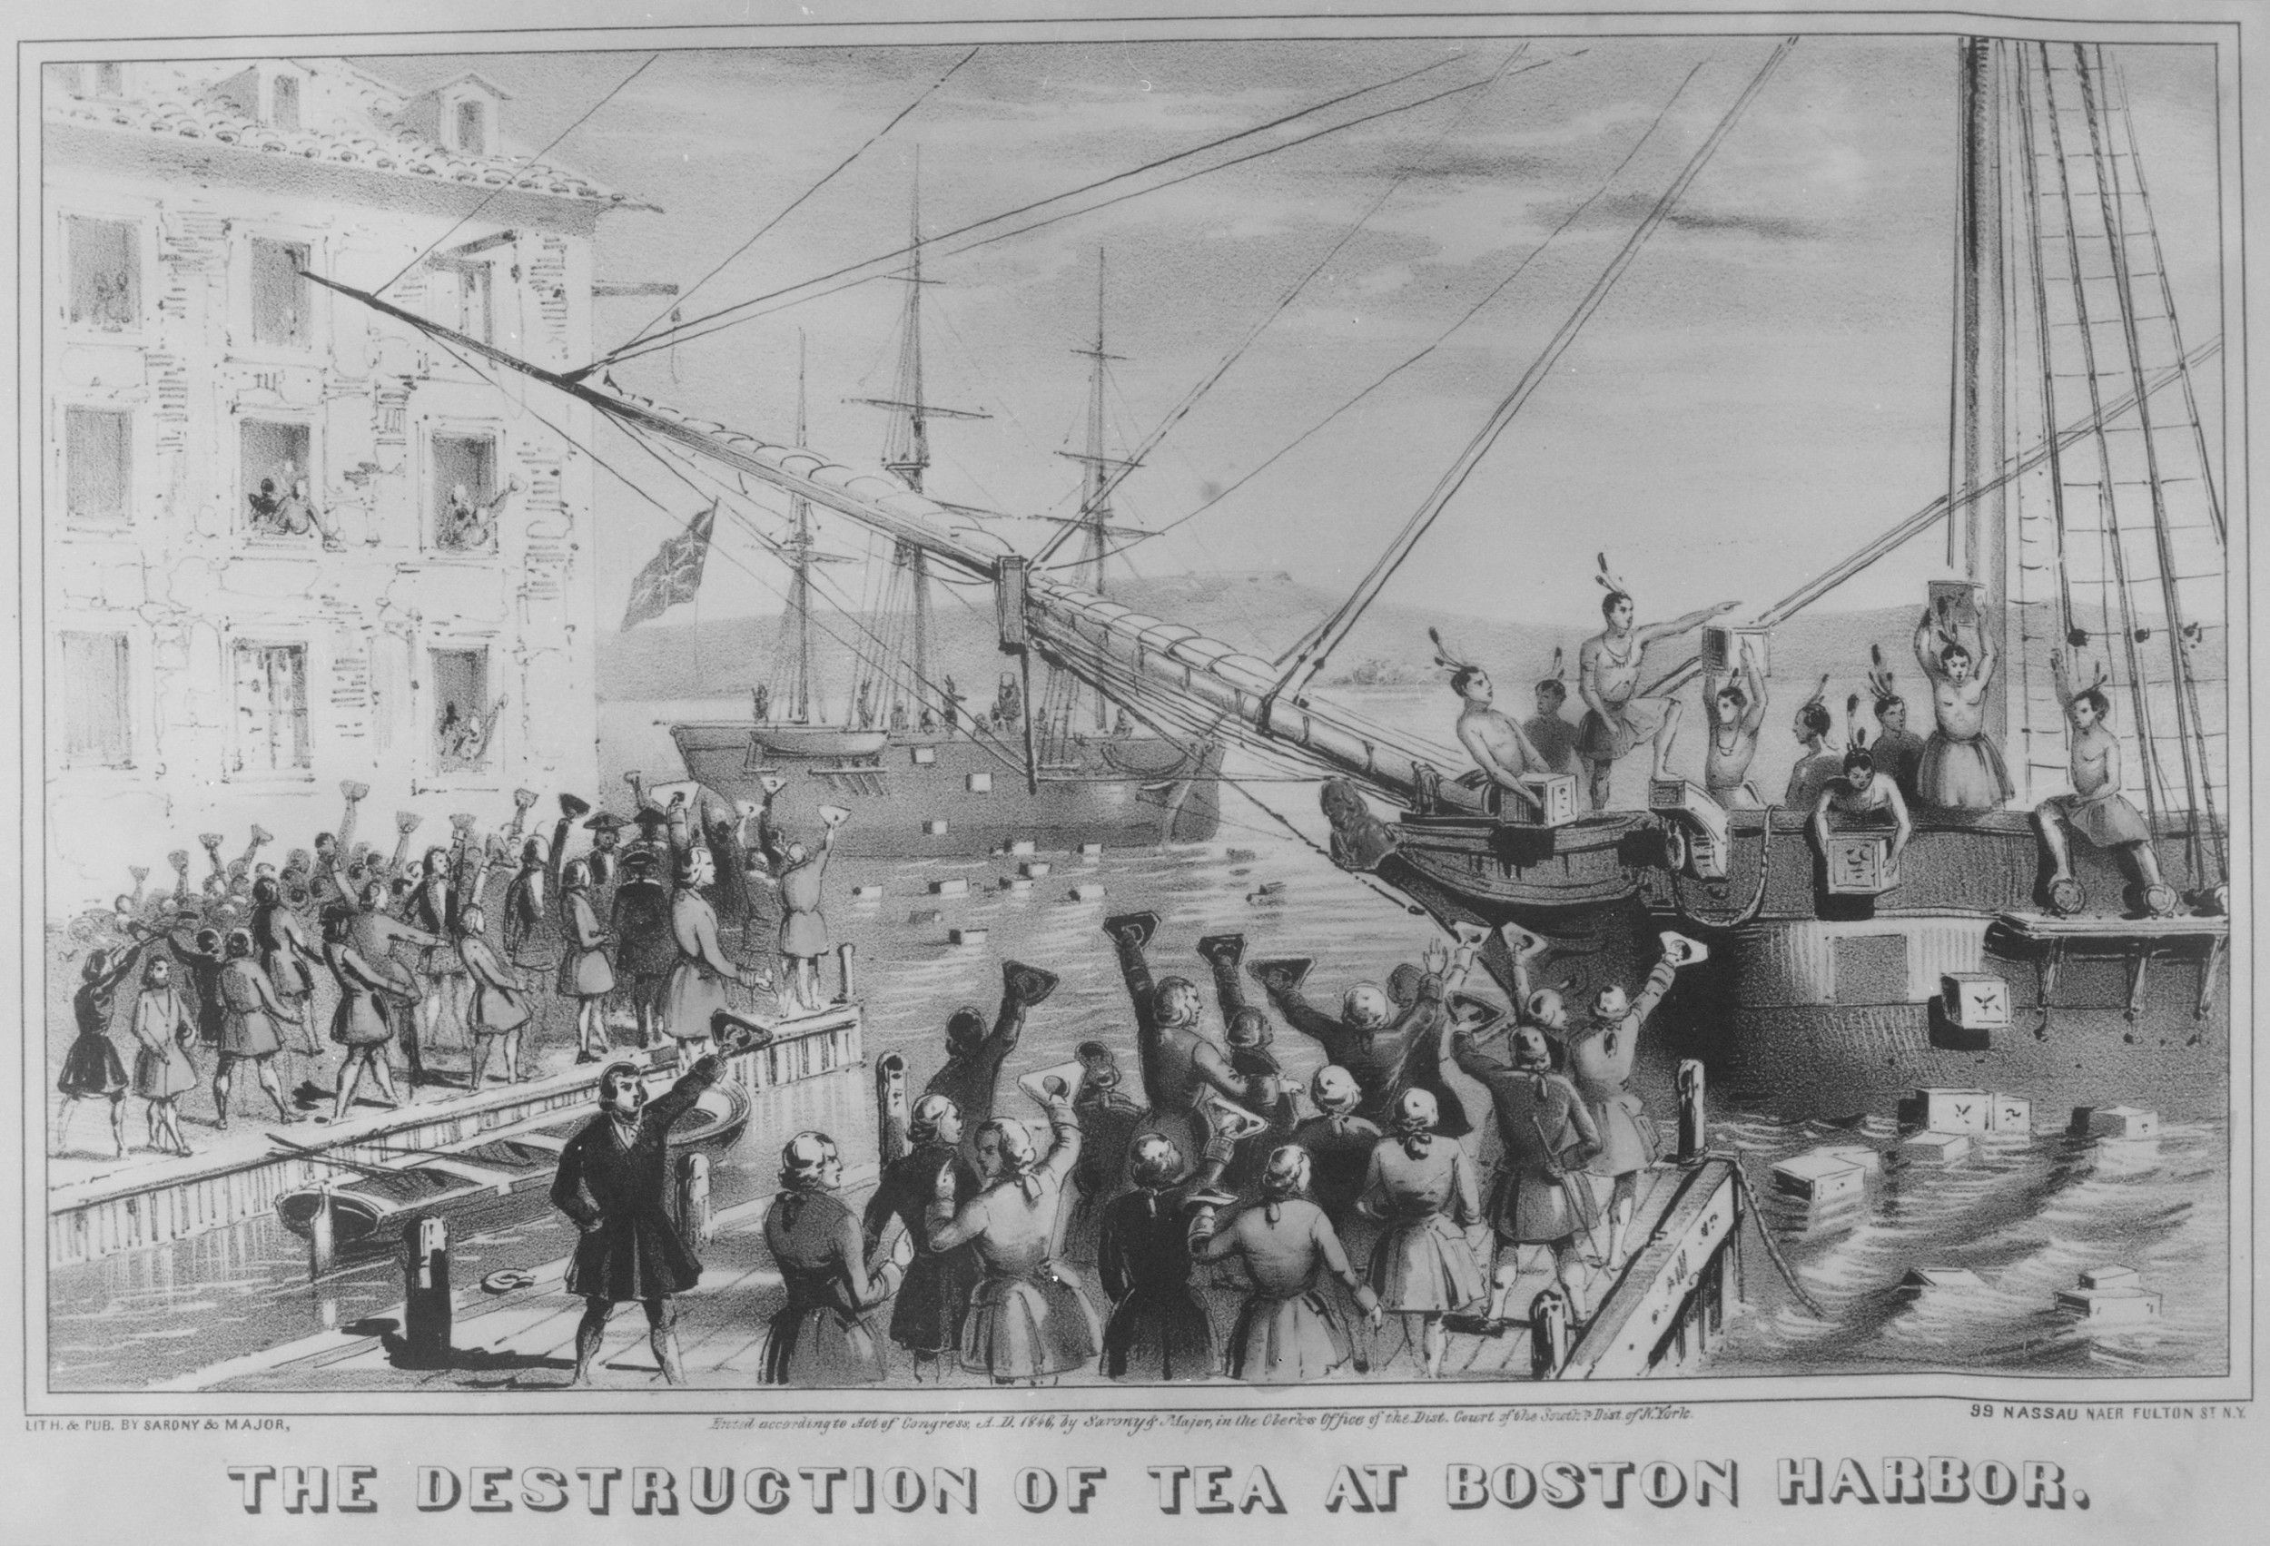
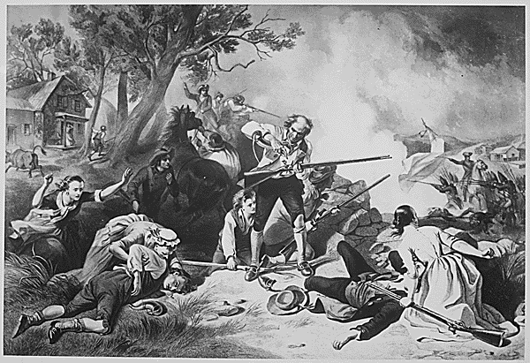

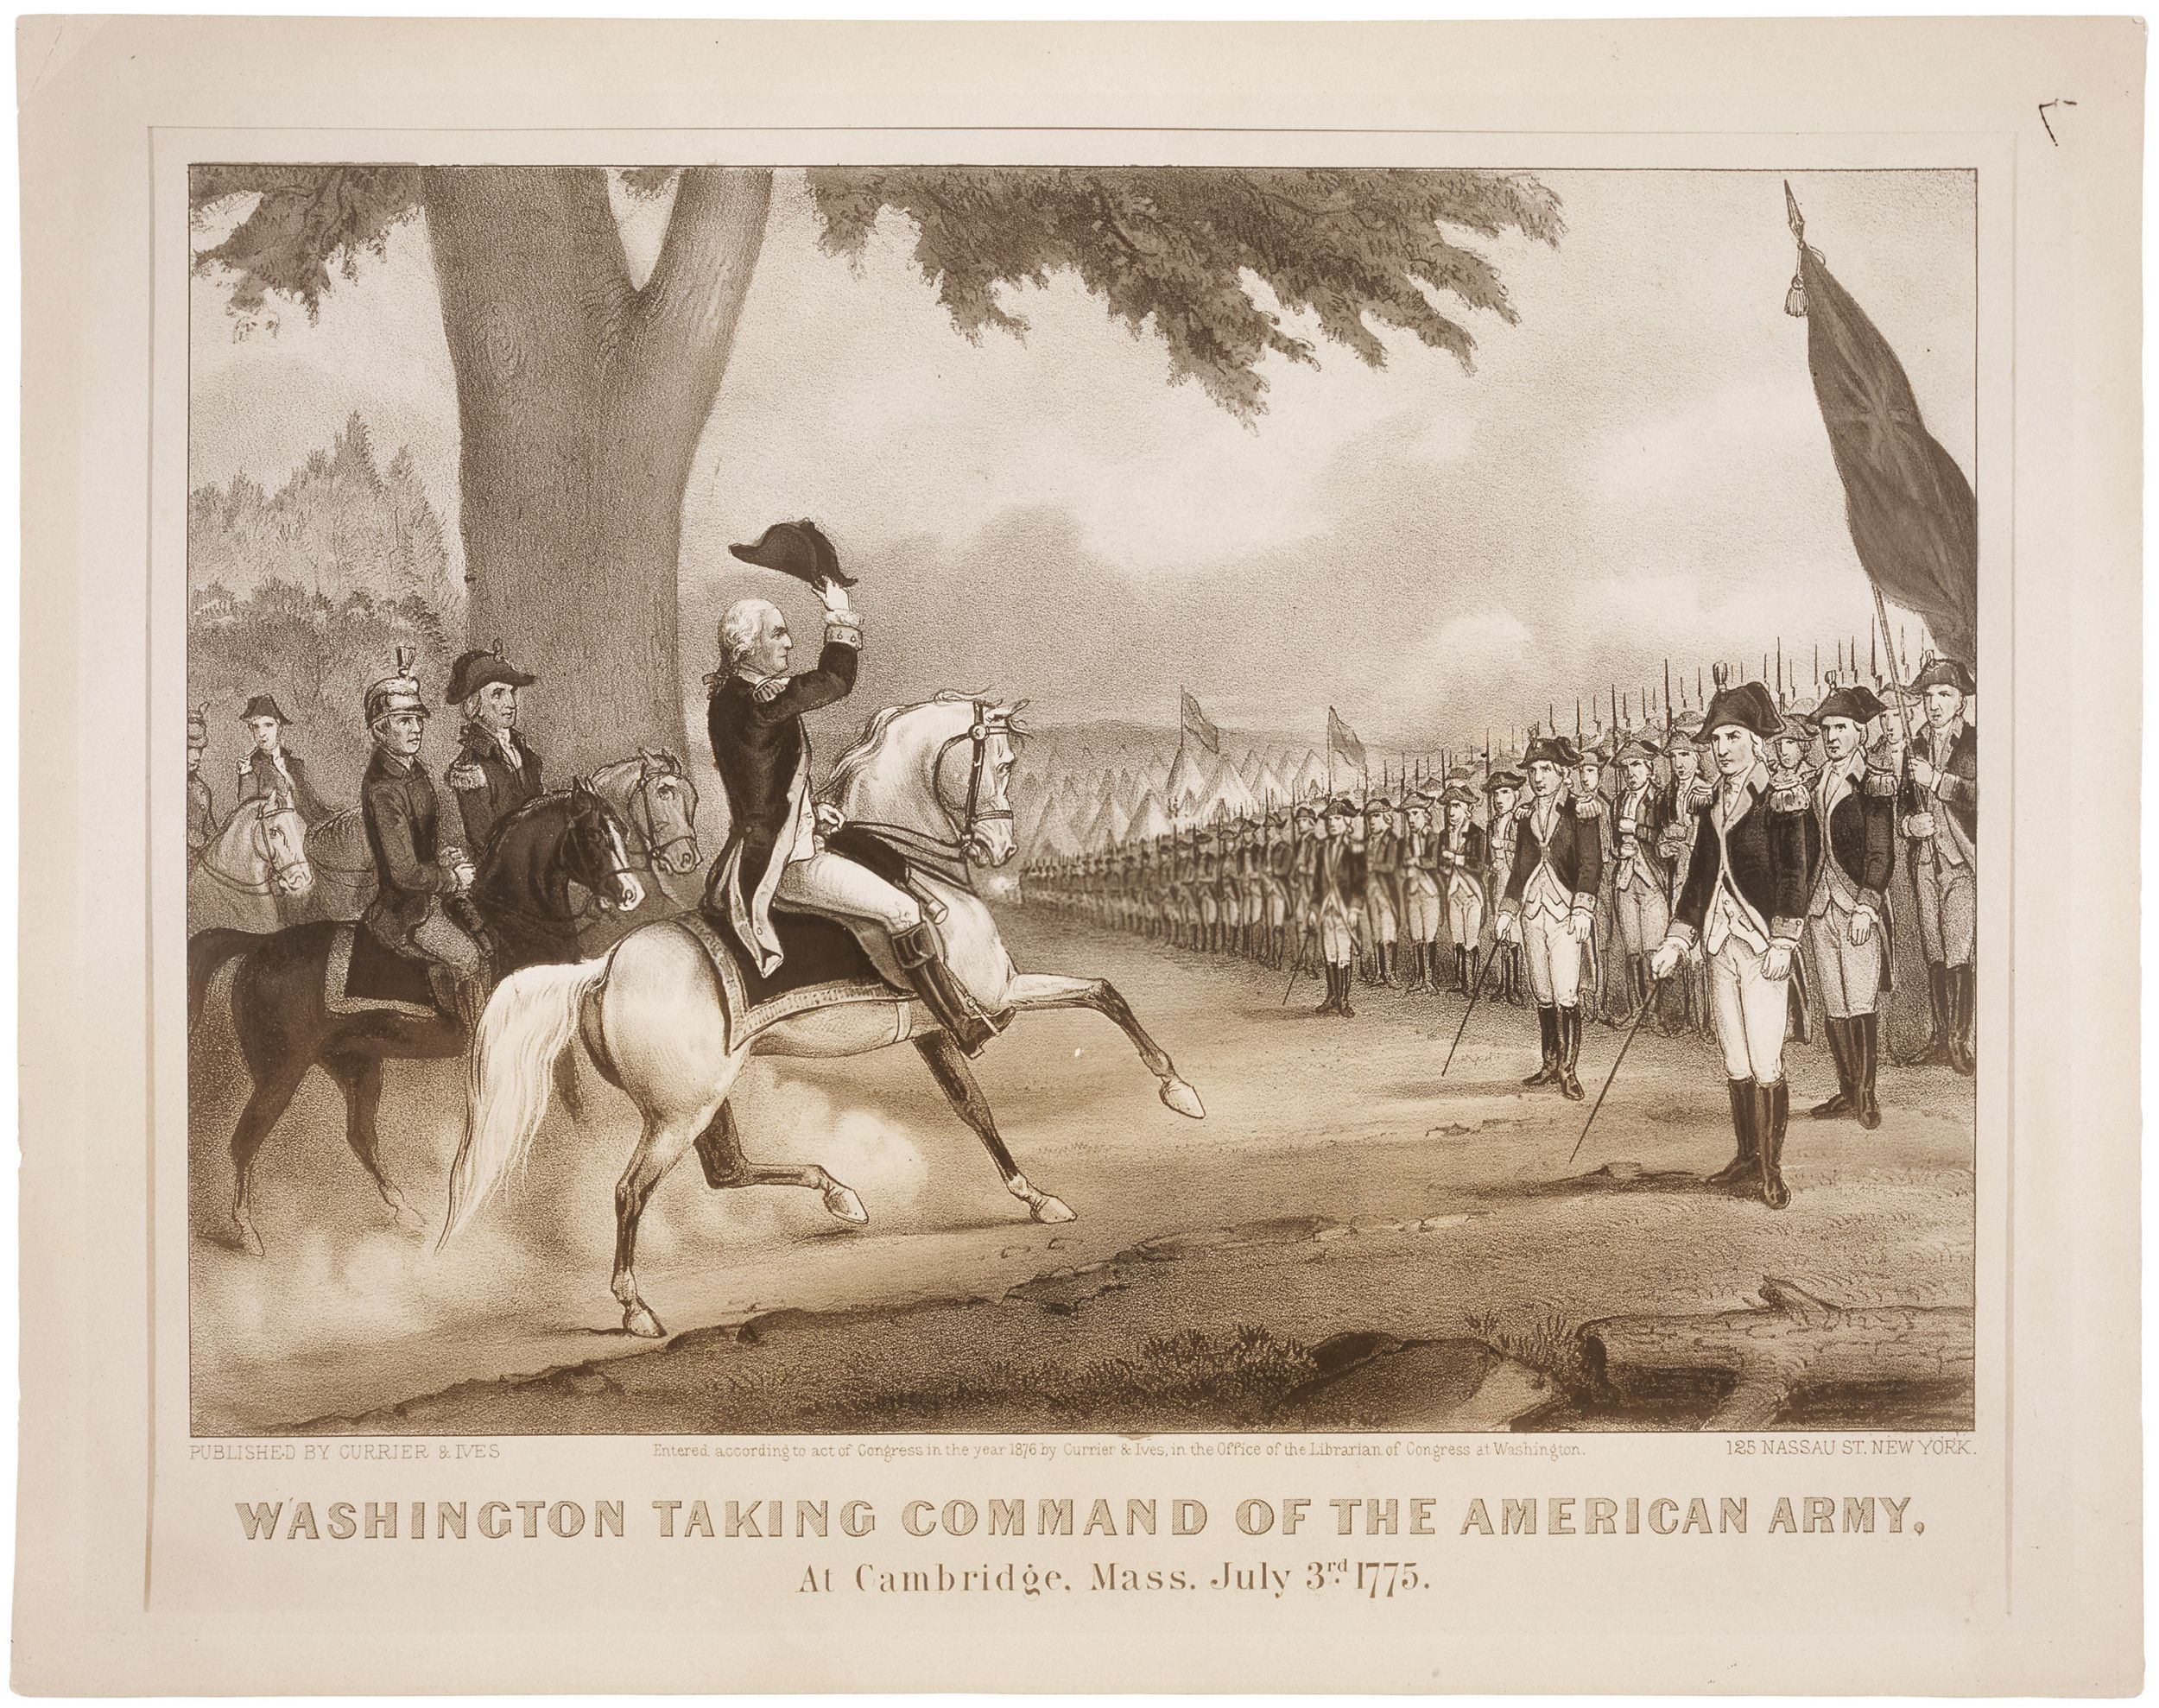

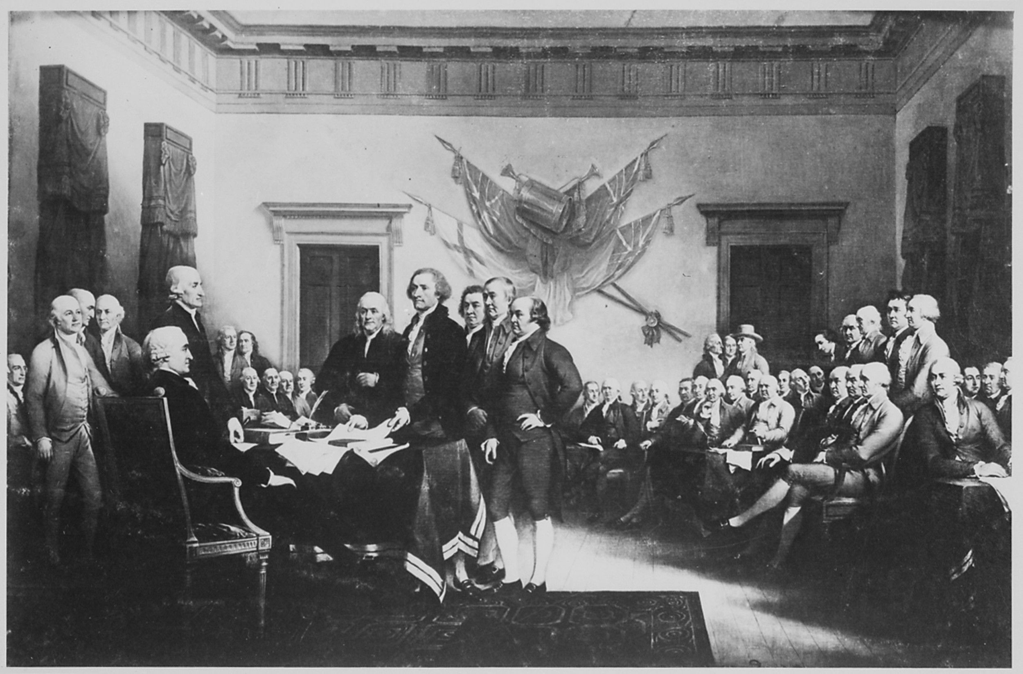
Name: __________________________________________________ Date: _____________________
Inching Toward Independence
Date: __________________________________________
Note: __________________________________________
________________________________________________
Date: __________________________________________
Note: __________________________________________
________________________________________________

Date: __________________________________________
Note: __________________________________________
________________________________________________

Date: __________________________________________
Note: __________________________________________
________________________________________________

Date: __________________________________________
Note: __________________________________________
________________________________________________

Date: __________________________________________
Note: __________________________________________
________________________________________________

The Constitution of the United States
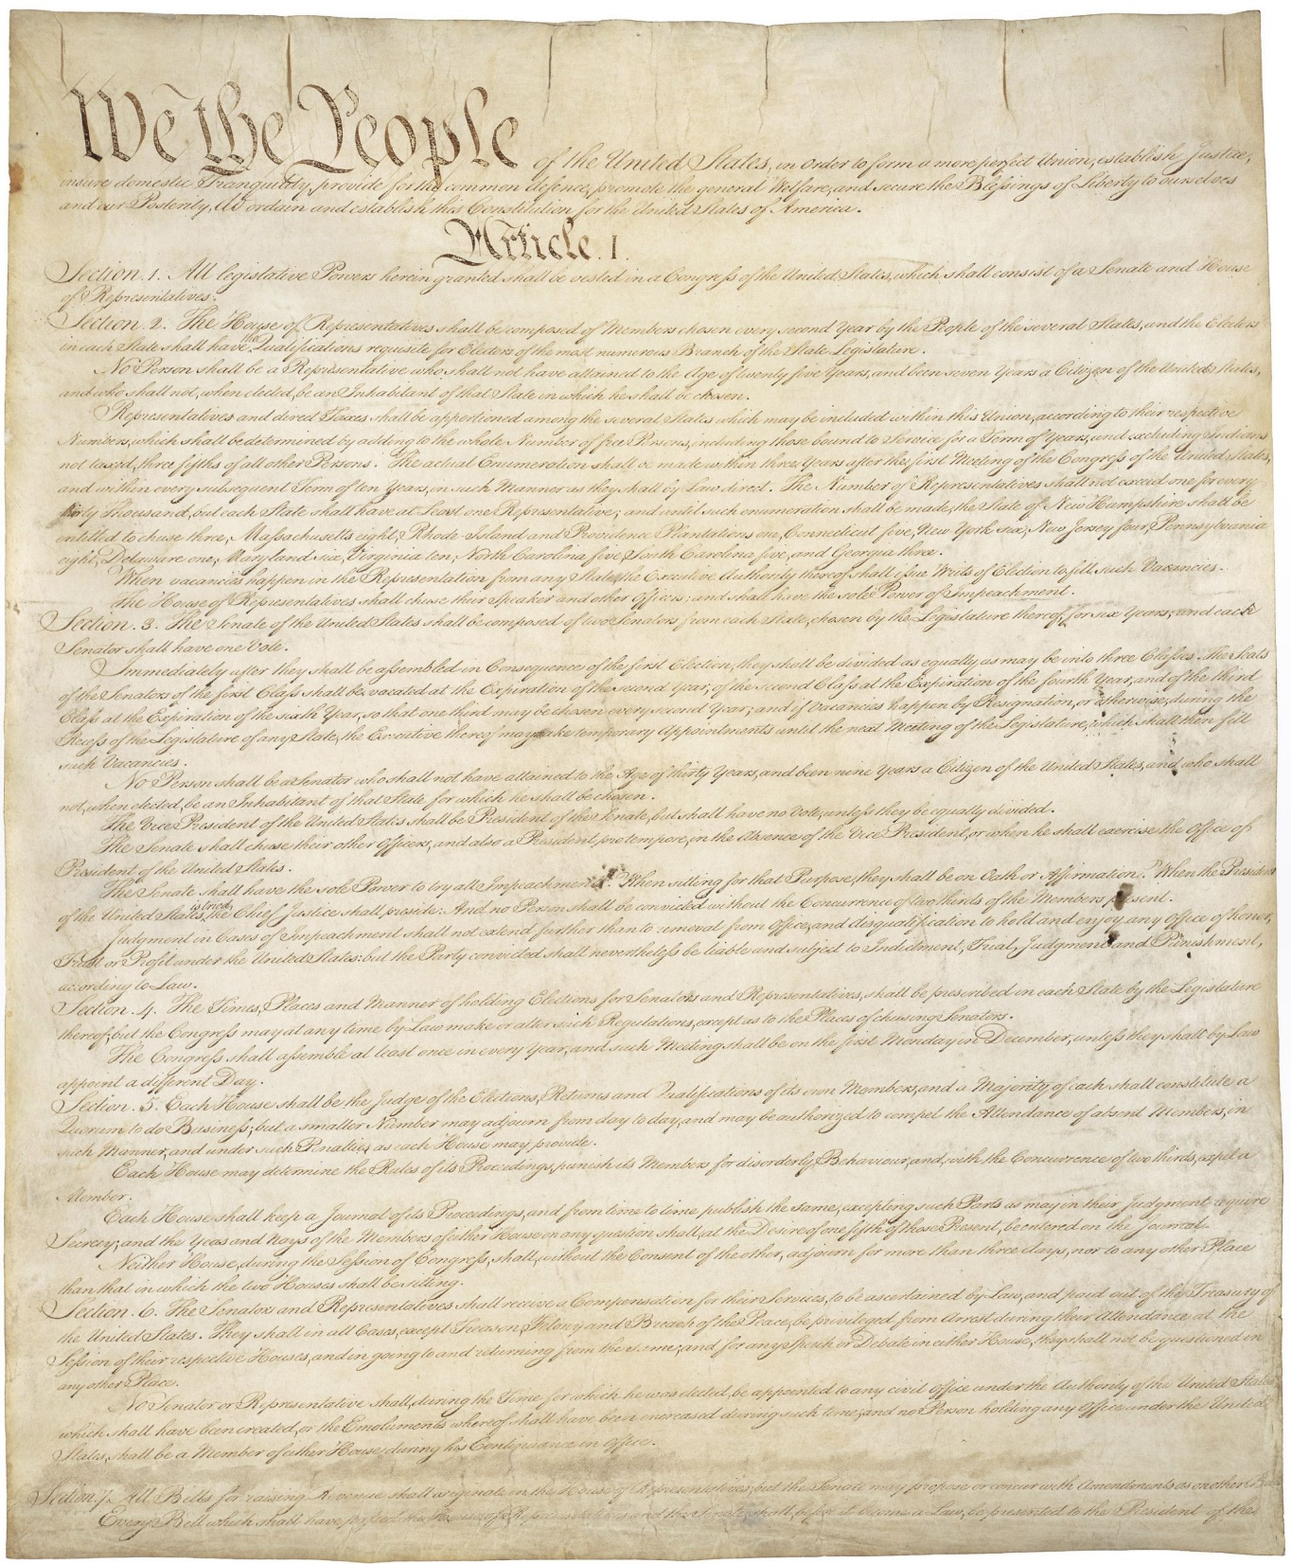

The Declaration of Independence
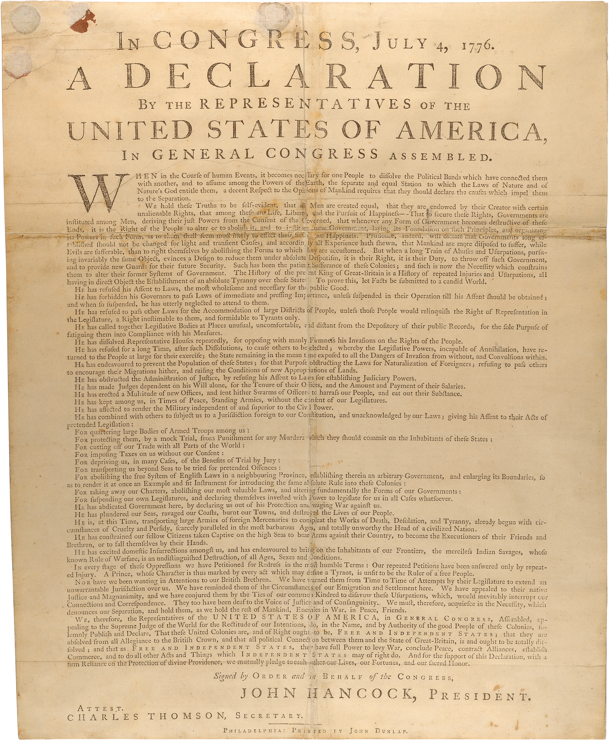

The Signing of the Declaration of Independence

Washington Takes Command of the American Army

The Battle of Lexington
The Boston Tea Party

