Holocaust Education through a Civics Lens

Civil Disobedience

This lesson plan was developed to facilitate teaching and learning the history of the Holocaust and the required instructional approach as outlined in state statute 1003.42.2(g)1 . In addition, this lesson is aligned to the expectations of state statute 1003.42.2(g)2: Holocaust Education Week.

Teacher Notes: N/A

Lesson Benchmark Alignment Appendix

All accompanying links are found in the lesson plan below

Lesson Title | Florida Civics Benchmarks | Duration of Lesson
Civil Disobedience and the Holocaust | SS.7.C.2.2 and SS.7.C.3.6 | 1- 2 Class Periods
Other Course Applications:
US Government
World History

Essential Questions
How does the concept of the common good justify performing the responsibilities of citizenship?
What are the consequences for society when citizens do not fulfill their citizenship responsibilities?
How do individual rights shape involvement in social and political systems
Learning Goals
In this lesson students will be introduced to the concept of civil disobedience through direct instruction and methods of classification regarding types of resistance. The students will then examine multiple primary sources of Jewish and non-Jewish resistance during the Holocaust. Students will then classify the type of resistance presented in the primary source scenarios.

Note: The Florida Joint Center for Citizenship (free teacher account) offers lessons on benchmark SS.7.C.2.2 and benchmark SS.7.C.3.6 under the “Resources” tab.

Content Notes for Teachers
In the face of Nazi terror, many Jews resisted the Germans and their collaborators.

In ghettos throughout Nazi-occupied Europe, Jews defied Nazi terror through spiritual resistance and attempts to preserve their communal and cultural life. They held clandestine religious services, established schools and libraries, and maintained cultural traditions through secret publications, lectures, and performances. Underground networks of forgers and smugglers supplied life-saving official documents and food to people in ghettos and in hiding throughout Europe.

Organized armed resistance was the most direct form of Jewish opposition to the Nazis. In western Europe, Jewish partisans [resistance fighters] smuggled endangered people to safety and aided those in hiding. They also joined non-Jewish resistance units and sabotaged German military operations. In April 1943, the Jews of the Warsaw ghetto, outgunned and outnumbered, launched the largest ghetto uprising. After almost a month, the Germans suppressed the uprising. Jews fought the Germans both in the ghettos and behind the front lines in nearby forests. Prisoner revolts even took place in Nazi camps.

There was also a variety of non-Jewish groups which offered resistance to the Nazi regime.
Examples of non-Jewish resistance include:

- A German theologian who broke from mainstream church hierarchies that supported the Nazi regime.
- Several failed assassination attempts against Hitler.
- The White Rose, a small resistance group of Munich university students, sought to directly expose Nazi atrocities against Jews, and to urge Germans to actively oppose the Nazi regime.
- A French general who openly refused to swear allegiance to the Nazis and advocated open resistance.
- Resistance movements there committed acts of sabotage and assaults on German officials.
- In August 1944, Poles mounted an uprising against the German occupation.
- Non-violent resistance included sheltering Jews and listening to forbidden Allied radio broadcasts

Source: Excerpted from the Holocaust Center for Humanity, Seattle, Washington.

Florida Civics Benchmarks
SS.7.C.2.2 - Evaluate the obligations citizens have to obey laws, pay taxes, defend the nation, and serve on juries. (Benchmark Clarifications-recognize the concept of the common good as a rationale for fulfilling the obligations and/or responsibilities of citizenship and identify the consequences or predict the outcome on society of citizens who do not fulfill their citizenship responsibilities)
Benchmark Clarifications:
- Students will distinguish between an obligation or duty and a responsibility as it relates to citizenship. Responsibilities may include, but are not limited to, voting, attending civic meetings, petitioning government, and running for office.
- Students will recognize the concept of the common good as a rationale for fulfilling the obligations and/or responsibilities of citizenship.
- Students will evaluate the obligations and/or responsibilities of citizens as they relate to active participation in society and government.
- Students will examine the significant contributions of citizens to a democratic society.
- Students will use scenarios to assess specific obligations of citizens.
- Students will identify the consequences or predict the outcome on society of citizens who do not fulfill their citizenship responsibilities.
- Students will evaluate the impact of civic participation on society, government, or the political process.

SS.7.C.3.6 - Evaluate constitutional rights and their impact on individuals and society. (Benchmark Clarifications- recognize how individual rights shape involvement in the social, political, and economic systems)
Benchmark Clarifications:
- Students will recognize how individual rights shape involvement in the social, political, and economic systems.
- Students will recognize how the social, political, and economic systems in the United States are dependent upon individual rights.
- Students will use scenarios to recognize and/or evaluate options for exercising constitutional rights.
- Students will evaluate the impact of the government upholding and/or restricting individual constitutional rights.

Instructional Strategies/Lesson Activity
Day 1
Hook Activity
- Read or display the following text to the class:
The following is part of a decree established in 1941 regarding helping Jews from the non-Jewish population.
“...those knowingly helping ...Jews by providing shelter, supplying food, or selling them foodstuffs are ...subject to the death penalty This is a categorical warning to the non-Jewish population…”
Source: “Life in the Ghetto”

- Present the following scenario to students:
Imagine that you are a 12-year-old Polish Christian girl or boy, and your mother sends you to the market to buy three loaves of bread. As you are walking to the market you pass the Jewish ghetto and the large wall that blocks your entry. You go to the market, and purchase three loaves of bread. On your way back from the market you pass the ghetto wall again. You think about other children your age going without food.

- Ask students:
- What are your options?
*Options may include
- doing nothing and continuing to walk past the ghetto
- throwing 1-2 loaves of bread over the wall and keeping some for yourself
- throwing all three loaves of bread over the wall and keeping nothing for yourself

- Based on student answers, explain how every response other than the “do nothing” response is an act of resistance. With each choice there will be a consequence whether you choose to obey the decree or resist the decree.

- What are the consequences of your actions? Discussion points below
- Giving no bread - obeying the law (obligation of citizenship); giving up bread is too little to make a difference to solve the problem (thought of the common good but does not solve the larger problem)
- Giving one loaf - breaking the law, but leaves open the possibility that someone will eat that day (common good); also leaves open the possibility of lying to your mother to cover up the choice (e.g., dropped a loaf of bread in the mud); working toward the common good, act of civil disobedience
- Giving two loaves - breaking the law, but is more clearly an act of resistance, and reduces the bread available to your family; puts your family at risk for punishment up to and including the death penalty for you and your family; working toward the common good, act of civil disobedience
- Giving three loaves - breaking the law, a clear act of resistance, more severely reduces the bread available to your family; puts your family at risk for punishment up to and including the death penalty for you and your family, working toward the common good, act of civil disobedience

Activity
Part 1
- Begin explaining the concept of resistance through direct instruction to students. You may use the following passage to assist in the explanation:

Students often believe that armed fighting is the only type of activity that counts as resistance. In reality, many different activities may be considered resistance. Some were physical, such as armed attacks carried out against the Nazis. Others might be cultural, educational, or spiritual activities designed to encourage the victims in their struggle to survive. Both types of activities are evidence that Jewish people did not go “like sheep to the slaughter,” but rather fought to maintain their lives, families, and communities and to preserve their human dignity in the face of the Nazis’ overwhelming destructive policies.

Part 2
- Distribute the Holocaust Resistance and Civil Disobedience - STUDENT COPY document to each student
Part 3
- Inform students that they will explore multiple scenarios regarding resistance of Jews and non-Jews during the Holocaust
- Inform students that you will be modeling two of the four scenarios; use the following steps
*use the Resistance and Civil Disobedience - TEACHER KEY and the Sample Images for Holocaust Resistance for reference)

Part 4
- Choose one of the four Jewish resistance scenarios (Warsaw ghetto uprising, Petr Ginz and the Boys of Vedem, the White Rose or The Vrba - Wetzler Report) on the Holocaust Resistance & Civil Disobedience - TEACHER KEY to model for students.
- Read the scenario to students and at the same time have them follow along on their document
- Use the Holocaust Resistance” presentation to help visually guide students through the activity
- After reading the document, guide students through answering the questions on the document for that scenario. Do not fill in the “Classification” section of the document until Day 2.

Part 5
- After modeling one of the scenarios give students time to read the other three scenarios and respond to the questions that accompany each question
- Collect all materials at the end of class for the next class meeting

Day 2
Activity
Part 1
- Redistribute the Holocaust Resistance and Civil Disobedience - STUDENT COPY document to students from the day before
- Inform students that today we will classify each scenario into specific categories of resistance
- Explain the classification of resistance through direct instruction to students
- You may use the following passage to assist in the teaching about the explanation:
As you work to analyze resistance scenarios from the Holocaust era, it may help to remember there is a diverse nature of resistance. Some acts were carried out physically against the oppressors or in support of the physical needs of the victims. Others were dedicated to enriching the spirit of the victims, giving them encouragement and support to continue the struggle to survive, both as individuals and as members of the Jewish community.

Theses acts of resistance can be classified as physical/armed or spiritual/cultural
- Physical/Armed - direct, active acts against the Nazis
- Examples of physical resistance could be a revolt against guards in a concentration camp, partisan fighters against the German army in the forests of eastern Europe, and the smuggling of food into ghettos to help starving inmates survive.
- Spiritual/Cultural - indirect, passive acts supporting the victims
- Examples of cultural/spiritual resistance could be keeping a secret diary, producing art, music, literature, or drama in a ghetto, and running or attending a secret school.
These categories are not mutually exclusive. Many acts of resistance could be considered both physical and cultural. The main goal of classifying resistance acts by category is to broaden our thinking to recognize the validity of diverse resistance strategies.
- Use the Holocaust Resistance” presentation to help visually guide students through the activity

Part 2
- With each scenario do the following
- briefly review the scenario with students
- have students share their group's answers to the questions from the previous class
- clarify any points of interest to students
- guide students to the proper clarification of each scenario
- have students record the classification on their documents
*use the“Resistance and Civil Disobedience - TEACHER KEY” for reference

*For further reading and research on resistance please review the following resources:
USHMM
FCIT
Yad Vashem
Jewish Virtual Library
The Holocaust Explained
Jewish Partisan Educational Foundation

Assignment(s)
- Resistance and Civil Disobedience Student Document

Assessment and Monitoring (Checks for content and mastery)
- Teacher observation and questioning of groups and individuals at each step of the instructional process and during transitions between activities.
- Check scenario documents and questions for accuracy.
- Check specific test items on the unit test for mastery of the content.

Adaptations for Unique Student Needs
- Convert scenarios into audio text for struggling readers
- Add appropriate visuals for each of the scenarios
- Annotate the scenario readings for evidentiary support to the questions

Resources and Materials
- Holocaust Resistance and Civil Disobedience - STUDENT COPY
- Resistance and Civil Disobedience - TEACHER KEY
- Sample Images for Holocaust Resistance
- Holocaust Resistance presentation
- Civil Disobedience & the Holocaust Test Items

Note: The Florida Joint Center for Citizenship (free teacher account) offers lessons on benchmark SS.7.C.2.2 and benchmark SS.7.C.3.6 under the “Resources” tab.

HOLOCAUST RESISTANCE and CIVIL DISOBEDIENCE
Jewish Resistance - Scenario: The Warsaw Ghetto Uprising
The largest resistance effort by Jews against the Nazis occurred in the Warsaw ghetto. In 1943, Jews within Warsaw Ghetto opposed the Nazi’s final effort to send the remaining Ghetto population to Treblinka [Nazi Death Camp]. Resistance in the Ghetto refused to surrender to the police commander, fired on German troops and helped other ghetto residents into hiding places. The resistance received very few weapons but were determined to do as much as possible with what they had. They were able to hold out under siege for four weeks. The Nazis finally put down the uprising on May 16, 1943 by destroying the ghetto and sending any survivors to death or labor camps.

On April 23, Mordechai Anielewicz, commander of the ŻOB , wrote:
“What happened exceeded our boldest dreams. The Germans fled twice from the ghetto. One of our companies held its position for forty minutes, while the other one lasted—upwards of six hours . . . My life's dream has become a reality. I have seen the Jewish defense of the ghetto in all its strength and glory.”
Question: How does the concept of the common good justify performing the responsibilities of citizenship? | Answer:
Question: What are the consequences for society when citizens do not fulfill their citizenship responsibilities? | Answer:
Question: How do individual rights shape involvement in social and political systems? | Answer:
Classification:

Jewish Resistance - Scenario: Petr Ginz and the Boys of Vedem
“They tore us unjustly away from the fertile ground of work, joy, and culture, which was supposed to nourish our youth. They do this for only one purpose – to destroy us not physically, but spiritually and morally. Will they succeed? Never! Deprived of our former sources of culture, we shall create new ones. Separated from the sources of our old happiness, we shall create a new and joyfully radiant life!” ~Petr Ginz, Terezin

Petr Ginz was 14 years-old when the Nazis imprisoned him in the Terezin Ghetto. The Nazis considered Petr to be half-Jewish because his dad was Jewish, but his mother was not. Petr was a gifted writer, poet, and artist. As a prisoner, he and his friends broke the rules to produce a secret weekly newspaper they named Vedem, which means, “We lead”. The boys investigated the news, did interviews, wrote and edited the articles and created the visuals. Petr was deported from Terezin to Auschwitz and murdered there in 1944.
Question: How does the concept of the common good justify performing the responsibilities of citizenship? | Answer:
Question: What are the consequences for society when citizens do not fulfill their citizenship responsibilities? | Answer:
Question: How do individual rights shape involvement in social and political systems? | Answer:
Classification:

Non-Jewish Resistance - Scenario: The White Rose
In the early summer of 1942, a non-violent resistance group in Nazi Germany called ‘The White Rose’ was formed, consisting of several students from the University of Munich and their professor. The core of the White Rose consisted of five students — Sophie Scholl, her brother Hans Scholl, Alex Schmorell, Willi Graf, and Christoph Probst, all in their early twenties. The group became known for an anonymous leaflet campaign, that called for active opposition to the Nazis regime. They would also write graffiti in large letters on streets and buildings all over Munich: “Down with Hitler! . . . Hitler the Mass Murderer!”. Hans, Sophie, and Christoph were caught and executed on February 22,1943 for treason.

White Rose Leaflet Excerpt:
” Since the conquest of Poland 300,000 Jews have been murdered, a crime against human dignity…Germans encourage fascist criminals if no chord within them cries out at the sight of such deeds. An end in terror is preferable to terror without end.”
Question: How does the concept of the common good justify performing the responsibilities of citizenship? | Answer:
Question: What are the consequences for society when citizens do not fulfill their citizenship responsibilities? | Answer:
Question: How do individual rights shape involvement in social and political systems? | Answer:
Classification:

Jewish Resistance - Scenario: The Vrba - Wetzler Report
“Rudolph and Alfred were responsible for “the largest single rescue of Jews in the second World War.” ~Martin Gilbert, Holocaust Historian, 2008.

On April 10 1944, two Jewish prisoners, Rudolf Vrba and Alfred Wetzler, escaped from the Auschwitz death camp. They took with them reports and documentation that had been secretly gathered by the camp’s underground resistance so they could get out information about the crimes that were being committed in Auschwitz. The Allies knew by this time that Jews were being murdered in Auschwitz, but they lacked details. This report provided information about the transports, the gas chambers, and the number of victims. Once Vrba and Wetzler had escaped, they went into hiding and worked together with other resistance group members to translate their report into several languages. They hoped to save the Hungarian Jews whose deportation began in May 1944. Their report is often given credit for convincing the leader of Hungary to stop the transports of Jews by mid-July. Although over 400,000 Jews from Hungary had already been sent to Auschwitz, tens of thousands were saved from deportation and survived.

The Vrba-Wetzler Report was also used as evidence to prosecute Nazi crimes after the war.
Question: How does the concept of the common good justify performing the responsibilities of citizenship? | Answer:
Question: What are the consequences for society when citizens do not fulfill their citizenship responsibilities? | Answer:
Question: How do individual rights shape involvement in social and political systems? | Answer:
Classification:
HOLOCAUST RESISTANCE and CIVIL DISOBEDIENCE-Teacher Key
Jewish Resistance - Scenario: The Warsaw Ghetto Uprising
The largest resistance effort by Jews against the Nazis occurred in the Warsaw ghetto. In 1943, Jews within Warsaw Ghetto opposed the Nazi’s final effort to send the remaining Ghetto population to Treblinka [Nazi Death Camp]. Resistance in the Ghetto refused to surrender to the police commander, fired on German troops and helped other ghetto residents into hiding places. The resistance received very few weapons but were determined to do as much as possible with what they had. They were able to hold out under siege for four weeks. The Nazis finally put down the uprising on May 16, 1943 by destroying the ghetto and sending any survivors to death or labor camps. The Warsaw Ghetto uprising inspired future resistance efforts throughout the end of the war.

On April 23, Mordechai Anielewicz, commander of the ZOB, wrote:
“What happened exceeded our boldest dreams. The Germans fled twice from the ghetto. One of our companies held its position for forty minutes, while the other one lasted—upwards of six hours . . . My life's dream has become a reality. I have seen the Jewish defense of the ghetto in all its strength and glory.”
Question: How does the concept of the common good justify performing the responsibilities of citizenship? | Possible Responses: Supporting the defense of Jews in the ghetto, which included shooting at the Germans and helping other ghetto residents into hiding places
Question: What are the consequences for society when citizens do not fulfill their citizenship responsibilities? | Possible Responses: Taking an active role in the resistance may have helped ghetto residents survive and helped to inspire future resistance efforts by Jews; not taking an active role in the resistance meant that fewer Jews would have tried this type of resistance.
Question: How do individual rights shape involvement in social and political systems? | Possible Responses: Jews who took part in the uprising showed the Germans that they saw themselves as part of a community that should be defended no matter the odds against their survival  Jews taking part in the Warsaw ghetto took part in civil disobedience
Classification: Physical and Armed
Jewish Resistance - Scenario: Petr Ginz and the Boys of Vedem
“They tore us unjustly away from the fertile ground of work, joy, and culture, which was supposed to nourish our youth. They do this for only one purpose – to destroy us not physically, but spiritually and morally. Will they succeed? Never! Deprived of our former sources of culture, we shall create new ones. Separated from the sources of our old happiness, we shall create a new and joyfully radiant life!” ~Petr Ginz, Terezin

Petr Ginz was 14 years-old when the Nazis imprisoned him in the Terezin Ghetto. The Nazis considered Petr to be half-Jewish because his dad was Jewish, but his mother was not. Petr was a gifted writer, poet, and artist. As a prisoner, he and his friends broke the rules to produce a secret weekly newspaper they named Vedem, which means, “We lead”. The boys investigated news stories, conducted interviews, wrote and edited the articles and created the visuals. Petr was deported from Terezin to Auschwitz and murdered there in 1944 at age 16.
Question: How does the concept of the common good justify performing the responsibilities of citizenship? | Possible Responses: Petr Ginz wanted to support and encourage his fellow ghetto prisoners. He also hoped that someday the world would know about what went on in the Terezin ghetto. Informing fellow ghetto prisoners supported the common good so that they would be informed. Petr’s poetry and art uplifted other Terezin ghetto residents.
Question: What are the consequences for society when citizens do not fulfill their citizenship responsibilities? | Possible Responses: The responsibilities of citizenship include civic participation. Petr Ginz understood that failing to keep his fellow ghetto residents informed would limit their opportunities to act on that information if they chose to and if they could; if ghetto residents did not work together in ways to support each other life in the ghetto, which was already horrible.
Question: How do individual rights shape involvement in social and political systems? | Possible Responses: Petr Ginz did not have the right to take part in German society, nor did he have the right to publish his writings. By producing the newspaper (even though it was against the law) he put his life at risk.  Petr Ginz took part in civil disobedience.
Classification: Spiritual and Cultural
Non-Jewish Resistance - Scenario: The White Rose
In the early summer of 1942, a non-violent resistance group in Nazi Germany called ‘The White Rose’ was formed, consisting of several students from the University of Munich and their professor. The core of the White Rose consisted of five students — Sophie Scholl, her brother Hans Scholl, Alex Schmorell, Willi Graf, and Christoph Probst, all in their early twenties. The group became known for an anonymous leaflet campaign, that called for active opposition to the Nazis regime. They would also write graffiti in large letters on streets and buildings all over Munich: “Down with Hitler! . . . Hitler the Mass Murderer!”. Hans, Sophie, and Christoph were caught and executed on February 22,1943 for treason.

White Rose Leaflet Excerpt
” Since the conquest of Poland 300,000 Jews have been murdered, a crime against human dignity…Germans encourage fascist criminals if no chord within them cries out at the sight of such deeds. An end in terror is preferable to terror without end.”
Question: How does the concept of the common good justify performing the responsibilities of citizenship? | Possible Responses: The White Rose believed that it was the duty of a citizen, even in times of war, to stand up against an evil regime, especially when it is sending hundreds of thousands of its citizens to their deaths.
Question: What are the consequences for society when citizens do not fulfill their citizenship responsibilities? | Possible Responses: Most German citizens took a stand that that once war breaks out, it is the duty of the citizen to support the troops by supporting the government. The White Rose felt the responsibility to inform citizens that Germany was being led down a path of destruction of not only the country but also its citizens.
Question: How do individual rights shape involvement in social and political systems? | Possible Responses: Members of the White Rose were non-Jewish German citizens. By distributing these leaflets, these students were publicly denouncing the actions of the government and faced the possibility of being executed.  The White Rose took part in civil disobedience
Classification: Cultural
Jewish Resistance - Scenario: The Vrba - Wetzler Report

On April 10 1944, two Jewish prisoners, Rudolf Vrba and Alfred Wetzler, escaped from the Auschwitz death camp. They took with them reports and documentation that had been secretly gathered by the camp’s underground resistance so they could get out information about the crimes that were being committed in Auschwitz. The Allies knew by this time that Jews were being murdered in Auschwitz, but they lacked details. This report provided information about the transports, the gas chambers, and the number of victims. Once Vrba and Wetzler had escaped, they went into hiding and worked together with other resistance group members to translate their report into several languages. They hoped to save the Hungarian Jews whose deportation began in May 1944. Their report is often given credit for convincing the leader of Hungary to stop the transports of Jews by mid-July. Although over 400,000 Jews from Hungary had already been sent to Auschwitz, tens of thousands were saved from deportation and survived.

The Vrba-Wetzler Report was also used as evidence to prosecute Nazi crimes after the war.
Question: How does the concept of the common good justify performing the responsibilities of citizenship? | Possible Responses: The Vrba-Wetzler report inform key officials about what was going on in Auschwitz. Informing reports created by the underground resistance supported the common good so that government officials, such as the Hungarian government, would be informed.
Question: What are the consequences for society when citizens do not fulfill their citizenship responsibilities? | Possible Responses: Being committed to collecting information about the conditions at Auschwitz allowed Vrba and Wetzler to compile, translate and distribute their report. Had other death camp residents not collected the information, or had Vrba and Wetzler not distributed the information after their escape, tens of thousands of Hungarian Jews would not have been saved from deportation nor would they have survived.
Question: How do individual rights shape involvement in social and political systems? | Possible Responses: Vrba and Wetzler did not have the right to collect information while they were prisoners at Auschwitz. This limited their opportunities to collect information. Due to their escape Vrba and Wetzler were able to give information to the Hungarian government which saved tens of thousands of Jews.  Escaping from Auschwitz was an act of civil disobedience
Classification: Physical

HOLOCAUST SCENARIO | IMAGE
Warsaw Ghetto Uprising | 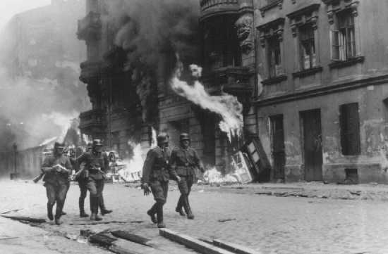  German soldiers burn residential buildings to the ground, one by one, during the Warsaw ghetto uprising. Poland, April 19-May 16, 1943.  Source: National Archives and Records Administration, College Park, Md  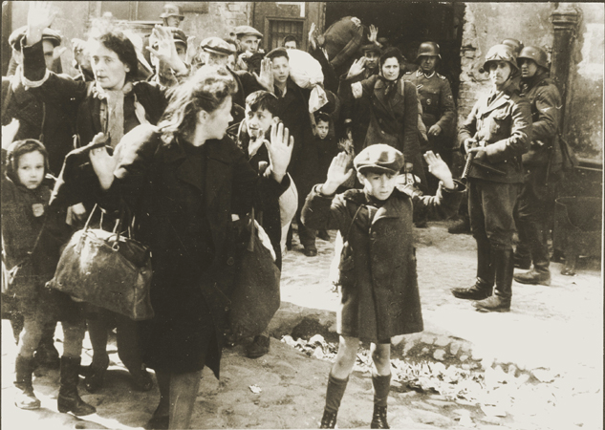  Jews captured by German troops during the Warsaw Ghetto uprising in April-May 1943. This photograph appeared in the Stroop Report, an album compiled by SS Major General Juergen Stroop, commander of German forces that suppressed the Warsaw ghetto uprising. The album was introduced as evidence at the International Military Tribunal at Nuremberg. In the decades since the trial this photo has become one of the iconographic images of the Holocaust.  Source: National Archives and Records Administration, College Park, Md.
Petr Ginz and the Boys of Vedem | 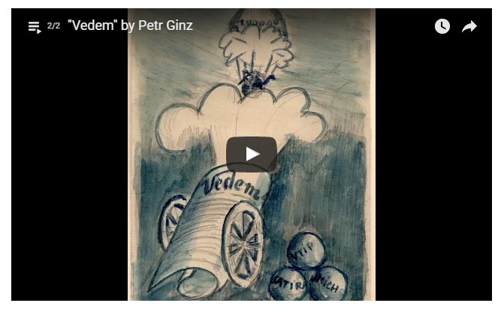  The art of Petr Ginz (click on image above to view video of his work)  Source: Yad Vashem  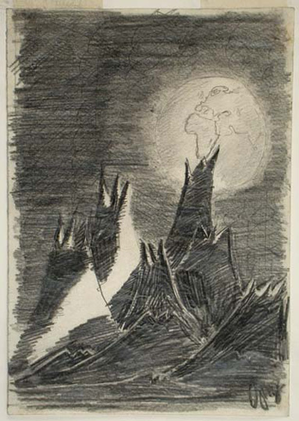  “Moon Landscape” by Petr Ginz, while a prisoner at Terezin 1942-1944  Source: Wikipedia
The White Rose | 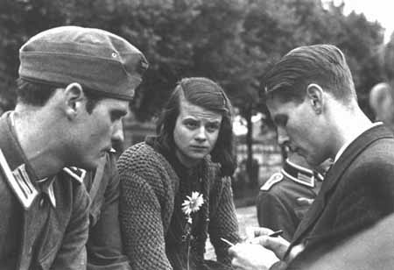  Hans Scholl (left), Sophie Scholl and Christoph Probst, leaders of the White Rose resistance organization. They were caught and executed on February 22,1943 for treason. Munich 1942  Source: (USHMM Photo)  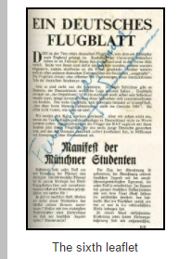  Source: The Holocaust Research Project
The Vrba-Wetzler Report | 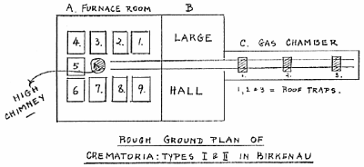  Vrba’s sketch of the Crematorium at Birkenau  Source: The Holocaust Research Project  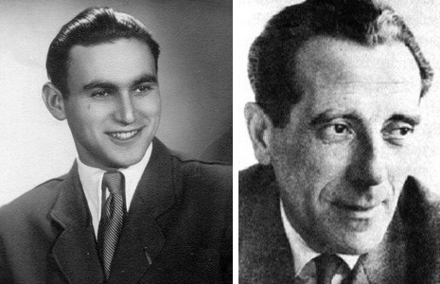  Photographs of Rudolf Vrba and Alfred Wetzler

Test Items
Benchmark | Benchmark Clarification | Cognitive Complexity
2.2 | BC 3 | Moderate

Question | Below is a scenario:  In July 1942, Moshe Jaffe refused the police who ordered him to help them find persons accused of crimes who were going to be deported.  Which requirement of citizenship did Moshe Jaffe violate?
A. | Attending civic meetings
B. | Serving on a jury
C. | Voting in elections
D. | Obeying the law

Question | Below is a scenario:  In July 1942, Moshe Jaffe refused the police who ordered him to help them find persons accused of crimes who were going to be deported.  Which requirement of citizenship did Moshe Jaffe violate?
A. | Attending civic meetings | Incorrect-Moshe Jaffe’s actions did not involve attending a civic meeting even though Moshe Jaffe spoke with the police, who are a part of government.
B. | Serving on a jury | Incorrect-Moshe Jaffe’s action did not involve serving on a jury even though Moshe Jaffe spoke with police, who are a part of government.
C. | Voting in elections | Incorrect-The scenario did not focus on voting in elections, which is a responsibility of citizenship.
D. | Obeying the law | Correct-Moshe Jaffe, because he refused the police orders, did not fulfill the obligation of citizenship to obey the law which includes obeying the police.

Benchmark | Benchmark Clarification | Cognitive Complexity
2.2 | BC 2 | L

Question | Which option represents beliefs or actions that are intended to benefit the larger community rather than individual interests?
A. | Common good
B. | Civil liberties
C. | Common property
D. | Civil rights

Question | Which option represents beliefs or actions that are intended to benefit the larger community rather than individual interests?
A. | Common good | Correct-the common good is also known as the public good; the purpose of the common good is to focus on what is best for the community
B. | Civil liberties | Incorrect- civil liberties are the freedoms associated with being a citizen
C. | Common property | Incorrect-common property may be property shared in a community, but does not represent beliefs or actions
D. | Civil rights | Incorrect-civil rights are the rights guaranteed to citizens by the government

Benchmark | Benchmark Clarification | Cognitive Complexity
2.2 | BC 7 | M

Question | Examine the newspaper article title below.  November 18, 2016  Trailblazing Journalist Ruth Gruber who Brought 1,000 Refugees to US Dies  Why did Ruth Gruber accompany refugees to the United States?
A. | to promote the common good
B. | to increase immigration to the U.S.
C. | to limit voting in the U.S.
D. | to discourage civic obligation

Question | Examine the newspaper article title below.  November 18, 2016  Trailblazing Journalist Ruth Gruber who Brought 1,000 Refugees to US Dies  Why did Ruth Gruber accompany refugees to the United States?
A. | to promote the common good | Correct-Ruth Gruber’s actions were not intended to benefit her directly since she was working with refugees.
B. | to increase immigration to the U.S. | Incorrect-The group of persons were refugees which suggests that they were persecuted in their home country.
C. | to limit voting in the U.S. | Incorrect-Bringing refugees into the country would not be eligible to vote. There would be no impact on voting in the U.S. once these persons were brought to the country.
D. | to discourage civic obligation | Incorrect-Bringing refugees into the United States was an act of civic participation that set an example for other persons to seek to promote the common good.

Benchmark | Benchmark Clarification | Cognitive Complexity
3.6 | BC 4 | L

Question | Below is scenario.  Petr Ginz, age 14, while in prison produced a secret weekly newspaper called “We Lead”.  In which action was Petr Ginz participating?
A. | Attending civic meetings
B. | Civil disobedience
C. | Civic engagement
D. | Public service

Question | Below is scenario.  Petr Ginz, age 14, while in prison produced a secret weekly newspaper called “We Lead”.  In which action was Petr Ginz participating?
A. | Attending civic meetings | Incorrect-The scenario presented does not involve attending civic meetings; Petr Ginz was in prison.
B. | Civil disobedience | Correct-By producing a newspaper in secret it was clear that producing a newspaper in prison was against prison rules. Producing a newspaper knowing that it was against prison rules was an act of civil disobedience.
C. | Civic engagement | Incorrect-The scenario presented does not involve civic engagement which does not normally occur in prison.
D. | Public service | Incorrect-The scenario presented does not involve public service even though producing a newspaper provided a service to other inmates. This service was not public, however.

Benchmark | Benchmark Clarification | Cognitive Complexity
3.6 | BC 4 | H

Question | Below is a scenario.  A government displays a sign stating that those helping members of a specific religious minority by providing shelter, supplying food, or selling them food will be put to death.  Some persons decide to provide shelter and food to members of the religious minority group identified on the sign.  Why did persons reading the sign decide to do what they did?
A. | To advance the common good
B. | To advance popular sovereignty
C. | To limit tyranny
D. | To limit suffrage

Question | Below is a scenario.  A government displays a sign stating that those helping members of a specific religious minority by providing shelter, supplying food, or selling them food will be put to death.  Some persons reading the sign decide to provide shelter and food to members of the religious minority group identified on the sign even though they know that it is against the law and they may be put to death.  Why did persons reading the sign break the law?
A. | To advance the common good | Correct-Advancing the common good may involve persons engaging in civil disobedience.
B. | To advance popular sovereignty | Incorrect-Popular sovereignty involves citizens participating in governing themselves directly or through their representatives
C. | To limit tyranny | Incorrect-Tyranny is the abuse of power by government. The government action described in the scenario is an example of tyranny. Violating the law does not limit tyranny.
D. | To limit suffrage | Incorrect-Suffrage is the right to vote. Voting rights are not described in the scenario.

