STUDENTS INVESTIGATING PRIMARY SOURCES
Intentions for Independence
Celebrate Freedom Week Series: Part II
Were the colonists justified in declaring independence?
A Short Activity for High School and Middle School
Benchmark Correlations
SS.912.C.1.2-Explain how the Declaration of Independence reflected the political principles of popular sovereignty, social contract, natural rights, and individual rights.
Benchmark Clarification: Students will identify grievances listed in the Declaration of Independence in terms of popular sovereignty, social contract, natural rights, and individual rights.
SS.912.CG.1.4 Analyze how the ideals and principles expressed in the founding documents shape America as a constitutional republic.
ELA.10.R.2.1 - Analyze the impact of multiple text structures and the use of features in text(s).
ELA.10.R.2.2 - Analyze the central idea(s) of historical American speeches and essays.
ELA.10.R.2.3 - Analyze an author’s choices in establishing and achieving purpose(s) in historical American speeches and essays.
ELA.10.R.3.2 - Paraphrase content from grade-level texts.
ELA.9.R.2.1 - Analyze how multiple text structures and/or features convey a purpose and/or meaning in texts.
ELA.9.R.2.2 - Evaluate the support an author uses to develop the central idea(s) throughout a text.
ELA.9.R.2.3 - Analyze how an author establishes and achieves purpose(s) through rhetorical appeals and/or figurative language.
ELA.9.R.3.2 - Paraphrase content from grade-level texts.

SS.8.A.3.7- Examine the structure, content, and consequences of the Declaration of Independence.
Benchmark Clarification: Students will identify specific charges outlined in the Declaration of Independence.
SS.8.CG.1.1 Compare the views of Patriots, Loyalists and other colonists on limits of government authority, inalienable rights and resistance to tyranny.
SS.7.C.1.4- Analyze the ideas (natural rights, role of the government) and complaints set forth in the Declaration of Independence.
Benchmark Clarification: Students will recognize colonial complaints as identified in the Declaration of Independence (imposing taxes without the consent of the people, suspending trial by jury, limiting judicial powers, quartering soldiers, and dissolving legislatures).
SS.7.CG.1.6 Analyze the ideas and complaints set forth in the Declaration of Independence.
ELA.8.R.2.1 - Analyze how individual text sections and/or features convey a purpose and/or meaning in texts.
ELA.8.R.2.2 - Analyze two or more central ideas and their development throughout a text.
ELA.8.R.2.3 - Explain how an author establishes and achieves purpose(s) through rhetorical appeals and/or figurative language.
ELA.8.R.2.4 - Track the development of an argument, analyzing the types of reasoning used and their effectiveness, identifying ways in which the argument could be improved.
ELA.8.R.3.2 - Paraphrase content from grade-level texts.
ELA.7.R.2.1 - Explain how individual text sections and/or features convey a purpose in texts.
ELA.7.R.2.2 - Compare two or more central ideas and their development throughout a text.
ELA.7.R.2.3 - Explain how an author establishes and achieves purpose(s) through diction and syntax.
ELA.7.R.2.4 - Track the development of an argument, analyzing the types of reasoning used and their effectiveness.
ELA.7.R.3.2 - Paraphrase content from grade-level texts.

Activity Documents and Handouts
- Projected image of the Dunlap Broadside of the Declaration of Independence
- Annotated Declaration of Independence
- Scavenger Hunt Graphic Organizer
- Intentions for Independence PowerPoint file

Full Document Citation
Dunlap Broadside [Declaration of Independence], July 4, 1776; Rough Journals, 9/5/1774 - 3/2/1789; Records of the Continental and Confederation Congresses and the Constitutional Convention, 1765 - 1821, Record Group 360; National Archives Building, Washington DC. National Archives Identifier: 301682.
[https://catalog.archives.gov/id/301682]
[https://www.docsteach.org/documents/document/dunlap-broadside]

Activity Vocabulary
See Page 7

Teacher Note: This activity can be modified to increase student engagement by turning the scavenger hunt into a race where groups will be given the first clue at the same time and compete to find the answer to receive their next clue. In this situation the PowerPoint questions with clues and hints can be turned into strips of paper and given to each group as they progress through the competition.

Teacher Note: The PowerPoint Presentation file follows along with the activity sequence. Before starting this activity, be sure to download and open the PowerPoint file.
- Project the Dunlap Broadside of the Declaration of Independence and explain to students that they will investigate the following guiding question: Were the colonists justified in declaring independence? Explain to students that they will participate in a scavenger hunt using the text of the Declaration of Independence in order to answer this question.
- Move students into small working groups and pass out the annotated Declaration of Independence, Activity Vocabulary and Scavenger Hunt Graphic Organizer.
- Explain to students that each clue has a question and the answer is located in their text. Teacher Note: A hint is included for each question to help students focus on particular sections of the text. To make this activity more challenging, remove the hints from each slide.
- Direct students to the first clue box on their graphic organizer and project the corresponding slide from the PowerPoint file.
- Read the clue question aloud to the class and remind students that they can use the activity vocabulary handout to assist with text comprehension.
- Set the timer and go! Provide students with 3-4 minutes MAXIMUM for each question.
  - Clue 1 Question: The authors of this document identify themselves in two different ways in this document, who are the authors and how did they identify themselves?
  - Clue 2 Question: Who is the intended audience or audiences of this document?
  - Clues 3-5 Questions: Can you find an example of a grievance related to individual rights, representation, or economic issues (taxation)?
  - Clue 6 Question: What evidence is given to show that independence is the only option left?
- Repeat Step 4-6 until all of the questions have been answered.
- Direct student attention back to the guiding question. Have students work independently to answer the question on the bottom of the graphic organizer. Teacher Note: If needed, provide the following support questions: What is the argument made in the document? Were you persuaded by the argument? Did this document accomplish what it wants to accomplish?

Enrichment Suggestion – Provide students with the following RAFT activity. Students will select one of the historical topics and perspectives. Prior to writing the RAFT, students may want to conduct some brief research to investigate their role’s perspective.
RAFT
Student Directions: Please choose one of the four writing prompts (RAFTs). Make sure you know what your role is, who your audience is, what the format you will be writing is, and what your topic is. In your RAFT, you need to persuade the audience. Please base your response off the Declaration of Independence and historical knowledge.
Choice | R=Role | A=Audience | F=Format | T=Topic
1 | Colonial Patriot | Other Colonists (both loyalist and patriots) | Commercial | The British have abused us! Join the fight for independence today!!!
2 | Colonial Loyalist | World | Editorial | The Declaration of Independence is one sided and exaggerated. Parliament and the King have not been abusive.
3 | British Parliament Member | World | Letter | Rebuttal to the Declaration of Independence
4 | King George III | American Colonists | Speech | Response to the grievances

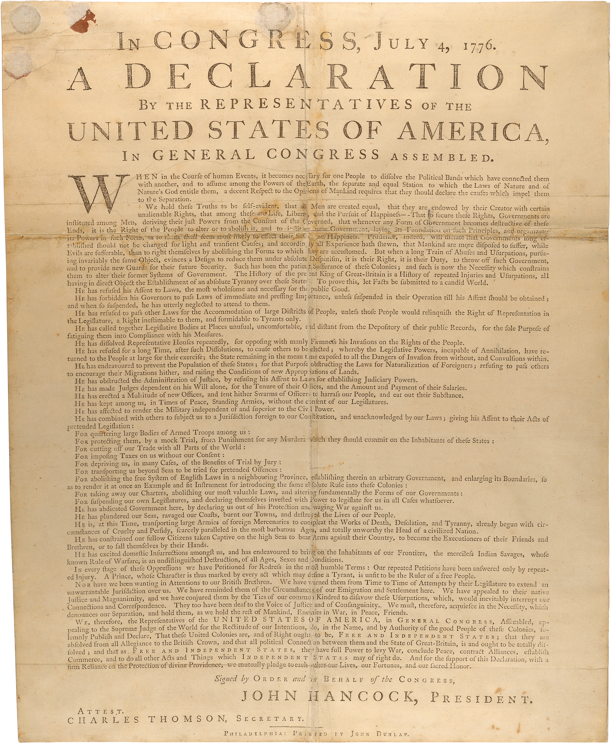

Annotated Declaration of Independence
 | Line
SECTION 1 | 1 | IN CONGRESS, July 4, 1776
 | 2 | The unanimous Declaration of the thirteen united States of America,
 | 3 | When in the Course of human events, it becomes necessary for one people to dissolve the political
 | 4 | bands which have connected them with another, and to assume among the powers of the earth, the
 | 5 | separate and equal station to which the Laws of Nature and of Nature's God entitle them, a decent
 | 6 | respect to the opinions of mankind requires that they should declare the causes which impel them
 | 7 | to the separation.
 | Line
SECTION 2 | 1 | We hold these truths to be self-evident, that all men are created equal, that they are endowed by their
 | 2 | Creator with certain unalienable Rights, that among these are Life, Liberty and the pursuit of
 | 3 | Happiness.--That to secure these rights, Governments are instituted among Men, deriving their just
 | 4 | powers from the consent of the governed, --That whenever any Form of Government becomes
 | 5 | destructive of these ends, it is the Right of the People to alter or to abolish it, and to institute new
 | 6 | Government, laying its foundation on such principles and organizing its powers in such form, as to them
 | 7 | shall seem most likely to effect their Safety and Happiness. Prudence, indeed, will dictate that
 | 8 | Governments long established should not be changed for light and transient causes; and accordingly
 | 9 | all experience hath shewn, that mankind are more disposed to suffer, while evils are sufferable, than to
 | 10 | right themselves by abolishing the forms to which they are accustomed. But when a long train of
 | 11 | abuses and usurpations, pursuing invariably the same Object evinces a design to reduce them under
 | 12 | absolute Despotism, it is their right, it is their duty, to throw off such Government, and to new Guards
 | 13 | for their future security.—Such has been the patient sufferance of these Colonies; and such is now the
 | 14 | necessity which constrains them to alter their former Systems of Government. The history of the
 | 15 | present King of Great Britain is a history of repeated injuries and usurpations, all having in direct object
 | 16 | the establishment of an absolute Tyranny over these States. To prove this, let Facts be submitted to
 | 17 | a candid world.
 | Grievance
SECTION 3 | 1 | He has refused his Assent to Laws, the most wholesome and necessary for the public good.
 | 2 | He has forbidden his Governors to pass Laws of immediate and pressing importance, unless suspended in their operation till his Assent should be obtained; and when so suspended, he has utterly neglected to attend to them.
 | 3 | He has refused to pass other Laws for the accommodation of large districts of people, unless those people would relinquish the right of Representation in the Legislature, a right inestimable to them and formidable to tyrants only.
 | 4 | He has called together legislative bodies at places unusual, uncomfortable, and distant from the depository of their public Records, for the sole purpose of fatiguing them into compliance with his measures.
 | 5 | He has dissolved Representative Houses repeatedly, for opposing with manly firmness his invasions on the rights of the people.
 | 6 | He has refused for a long time, after such dissolutions, to cause others to be elected; whereby the Legislative powers, incapable of Annihilation, have returned to the People at large for their exercise; the State remaining in the mean time exposed to all the dangers of invasion from without, and convulsions within.
 | 7 | He has endeavoured to prevent the population of these States; for that purpose obstructing the Laws for Naturalization of Foreigners; refusing to pass others to encourage their migrations hither, and raising the conditions of new Appropriations of Lands.
 | 8 | He has obstructed the Administration of Justice, by refusing his Assent to Laws for establishing Judiciary powers.
 | 9 | He has made Judges dependent on his Will alone, for the tenure of their offices, and the amount and payment of their salaries.
 | 10 | He has erected a multitude of New Offices, and sent hither swarms of Officers to harrass our people, and eat out their substance.
 | Grievance
SECTION 3 | 11 | He has kept among us, in times of peace, Standing Armies without the Consent of our legislatures.
 | 12 | He has affected to render the Military independent of and superior to the Civil power.
 | 13 | He has combined with others to subject us to a jurisdiction foreign to our constitution, and unacknowledged by our laws; giving his Assent to their Acts of pretended Legislation:  For Quartering large bodies of armed troops among us:  For protecting them, by a mock Trial, from punishment for any Murders which they should commit on the Inhabitants of these States:  For cutting off our Trade with all parts of the world:  For imposing Taxes on us without our Consent:  For depriving us in many cases, of the benefits of Trial by Jury:  For transporting us beyond Seas to be tried for pretended offences  For abolishing the free System of English Laws in a neighbouring Province, establishing therein an Arbitrary government, and enlarging its Boundaries so as to render it at once an example and fit instrument for introducing the same absolute rule into these Colonies:  For taking away our Charters, abolishing our most valuable Laws, and altering fundamentally the Forms of our Governments:  For suspending our own Legislatures, and declaring themselves invested with power to legislate for us in all cases whatsoever.
 | 14 | He has abdicated Government here, by declaring us out of his Protection and waging War against us.
 | 15 | He has plundered our seas, ravaged our Coasts, burnt our towns, and destroyed the lives of our people.
 | 16 | He is at this time transporting large Armies of foreign Mercenaries to compleat the works of death, desolation and tyranny, already begun with circumstances of Cruelty & perfidy scarcely paralleled in the most barbarous ages, and totally unworthy the Head of a civilized nation.
 | 17 | He has constrained our fellow Citizens taken Captive on the high Seas to bear Arms against their Country, to become the executioners of their friends and Brethren, or to fall themselves by their Hands.
 | 18 | He has excited domestic insurrections amongst us, and has endeavoured to bring on the inhabitants of our frontiers, the merciless Indian Savages, whose known rule of warfare, is an undistinguished destruction of all ages, sexes and conditions.
 | Line
SECT 4 | 1 | In every stage of these Oppressions We have Petitioned for Redress in the most humble terms: Our
 | 2 | repeated Petitions have been answered only by repeated injury. A Prince whose character is thus
 | 3 | marked by every act which may define a Tyrant, is unfit to be the ruler of a free people.
 | Line
SECTION 5 | 1 | Nor have We been wanting in attentions to our Brittish brethren. We have warned them from time to
 | 2 | time of attempts by their legislature to extend an unwarrantable jurisdiction over us. We have reminded
 | 3 | them of the circumstances of our emigration and settlement here. We have appealed to their native
 | 4 | justice and magnanimity, and we have conjured them by the ties of our common kindred to disavow
 | 5 | these usurpations, which, would inevitably interrupt our connections and correspondence. They too
 | 6 | have been deaf to the voice of justice and of consanguinity. We must, therefore, acquiesce in the
 | 7 | necessity, which denounces our Separation, and hold them, as we hold the rest of mankind, Enemies
 | 8 | in War, in Peace Friends.
 | Line
SECTION 6 | 1 | We, therefore, the Representatives of the united States of America, in General Congress, Assembled,
 | 2 | appealing to the Supreme Judge of the world for the rectitude of our intentions, do, in the Name, and
 | 3 | by Authority of the good People of these Colonies, solemnly publish and declare, That these United
 | 4 | Colonies are, and of Right ought to be Free and Independent States; that they are Absolved from all
 | 5 | Allegiance to the British Crown, and that all political connection between them and the State of Great
 | 6 | Britain, is and ought to be totally dissolved; and that as Free and Independent States, they have full
 | 7 | Power to levy War, conclude Peace, contract Alliances, establish Commerce, and to do all other Acts
 | 8 | and Things which Independent States may of right do. And for the support of this Declaration, with a
 | 9 | firm reliance on the protection of divine Providence, we mutually pledge to each other our Lives, our
 | 10 | Fortunes and our sacred Honor.

Name: ________________________________________________________________________ Date: _______________________________________
Intentions for Independence
Scavenger Hunt!
Clue 1: Author | Clue 2: Intended Audience
Clue 3: Grievance 1 - Individual Rights | Clue 4: Grievance 2 - Representation
Clue 5: Grievance 3 – Economic Issues (Taxation) | Clue 6: Why is independence the only option left?

Were the colonists justified in declaring independence? Support your answer with evidence from the document.
_______________________________________________________________________________________________________________________
_______________________________________________________________________________________________________________________
_______________________________________________________________________________________________________________________
_______________________________________________________________________________________________________________________
_______________________________________________________________________________________________________________________

Activity Vocabulary

TERM | DEFINITION
absolve | excuse from blame
acquiesce | to agree or come to an agreement
arbitrary | based on or determined by a person’s preference or opinion
assent | to agree
candid | truthful
compliance | the act of submitting, usually giving up power to another person
consanguinity | relation by blood
desolation | an event that results in total destruction
despotism | tyranny, a ruler who has absolute power and/or is cruel
endeavor | to make an effort
endowed | given or provided
liberty | freedoms
jurisdiction | the right and power to apply the law
magnanimity | high-mindedness; nobility of character
perfidy | disloyal
rectitude | honorable or morally correct thinking and behavior
redress | act of correcting an error or an evil
relinquish | to let go of
render | to become
self-evident | clear or obvious
transient | not lasting a long time
unalienable | cannot be taken away or denied
unanimous | united or fully in agreement
usurpations | the act of exercising power by force
unwarrantable | unjustified

Intentions for Independence
Scavenger Hunt! - Sample Answers
Author: The 13 United States of America, the Representatives of the United States in General Congress  Section 1 Line 2  “The unanimous Declaration of the thirteen united States of America”  Section 6 Line 1  “We, therefore, the Representatives of the united States of America, in General Congress, Assembled,” | Intended Audience: The rest of the world, (not the King, as he is referred to in the 3rd person, “he”  Section 2, Lines 16-17  “To prove this, let Facts be submitted to a candid world.”  Section 6 Line 2  “appealing to the Supreme Judge of the world”
Grievance 1: Individual Rights  #13: (students can choose one from 13) For Quartering large bodies of armed troops among us; For depriving us in many cases, of the benefits of Trial by Jury; For transporting us beyond Seas to be tried for pretended offences; For taking away our Charters, abolishing our most valuable Laws, and altering fundamentally the Forms of our Governments:  #15: He has plundered our seas, ravaged our Coasts, burnt our towns, and destroyed the lives of our people.  #17: He has constrained our fellow Citizens taken Captive on the high Seas to bear Arms against their Country, to become the executioners of their friends and Brethren, or to fall themselves by their Hands. | Grievance 2: Representation  #3: “He has refused to pass other Laws for the accommodation of large districts of people, unless those people would relinquish the right of Representation in the Legislature, a right inestimable to them and formidable to tyrants only.”  #5: He has dissolved Representative Houses repeatedly, for opposing with manly firmness his invasions on the rights of the people.  #6 He has refused for a long time, after such dissolutions, to cause others to be elected; whereby the Legislative powers, incapable of Annihilation, have returned to the People at large for their exercise; the State remaining in the mean time exposed to all the dangers of invasion from without, and convulsions within.  #13: For suspending our own Legislatures, and declaring themselves invested with power to legislate for us in all cases whatsoever.
Grievance 3: Economic Issues (Taxation)  #13: For imposing Taxes on us without our Consent  Additional Economic Issues:  #13: For cutting off our Trade with all parts of the world:  #15: He has plundered our seas, ravaged our Coasts, burnt our towns, and destroyed the lives of our people. | Why is independence the only option left?  The authors tried petitioning the King to set things right, but this only resulted in additional injury. The authors tried to get their fellow citizens in Britain on their side by sharing the injustices happening in America, but the British did not do anything.  Section 4, Lines 1-2  In every stage of these Oppressions We have Petitioned for Redress in the most humble terms: Our repeated Petitions have been answered only by repeated injury.  Section 5, Lines 1-6  Nor have We been wanting in attentions to our Brittish brethren. We have warned them from time to time of attempts by their legislature to extend an unwarrantable jurisdiction over us. We have reminded them of the circumstances of our emigration and settlement here. We have appealed to their native justice and magnanimity, and we have conjured them by the ties of our common kindred to disavow these usurpations, which, would inevitably interrupt our connections and correspondence. They too have been deaf to the voice of justice and of consanguinity.

