STUDENTS INVESTIGATING PRIMARY SOURCES
Forward to the Future: The Declaration of Independence in Our Lives
Celebrate Freedom Week Series: Part IV
How are the ideas from the Declaration of Independence connected to our government today?
A Short Activity for High School and Middle School
Benchmark Correlations
SS.912.C.1.2-Explain how the Declaration of Independence reflected the political principles of popular sovereignty, social contract, natural rights, and individual rights.
SS.912.CG.1.4 Analyze how the ideals and principles expressed in the founding documents shape America as a constitutional republic.
ELA.10.R.2.2 - Analyze the central idea(s) of historical American speeches and essays.
ELA.10.R.3.2 - Paraphrase content from grade-level texts.
ELA.9.R.2.2 - Evaluate the support an author uses to develop the central idea(s) throughout a text.
ELA.9.R.3.2 - Paraphrase content from grade-level texts.

SS.8.A.3.7- Examine the structure, content, and consequences of the Declaration of Independence.
SS.8.CG.1.1 Compare the views of Patriots, Loyalists and other colonists on limits of government authority, inalienable rights and resistance to tyranny.
SS.7.C.1.4- Analyze the ideas (natural rights, role of the government) and complaints set forth in the Declaration of Independence.
Benchmark Clarification: Students will analyze the relationship between natural rights and the role of government.
SS.7.CG.1.6 Analyze the ideas and complaints set forth in the Declaration of Independence.
ELA.8.R.2.2 - Analyze two or more central ideas and their development throughout a text.
ELA.8.R.3.2 - Paraphrase content from grade-level texts.
ELA.7.R.2.1 - Explain how individual text sections and/or features convey a purpose in texts.
ELA.7.R.2.2 - Compare two or more central ideas and their development throughout a text.
ELA.7.R.3.2 - Paraphrase content from grade-level texts.

Activity Documents and Handouts
- Projected image of the Dunlap Broadside of the Declaration of Independence
- Gallery Wall/Carousel Station Handouts
- Forward to the Future Graphic Organizer

Full Document Citations
Bill of Rights, 9/25/1789; General Records of the United States Government, Record Group 11; National Archives at Washington, DC. National Archives Identifier: 1408042.
[https://catalog.archives.gov/id/1408042]
[https://www.docsteach.org/documents/document/bill-of-rights]

Constitution of the United States, 9/17/1787; General Records of the United States Government, Record Group 11; National Archives at Washington, DC. National Archives Identifier: 1667751.
[https://catalog.archives.gov/id/1667751]
[https://www.docsteach.org/documents/document/constitution]

Dunlap Broadside [Declaration of Independence], July 4, 1776; Rough Journals, 9/5/1774 - 3/2/1789; Records of the Continental and Confederation Congresses and the Constitutional Convention, 1765 - 1821, Record Group 360; National Archives Building, Washington DC. National Archives Identifier: 301682.
[https://catalog.archives.gov/id/301682]
[https://www.docsteach.org/documents/document/dunlap-broadside]

Activity Vocabulary
abolish – to end or destroy
abridge – to shorten or make less
alter – to change
amendment – a change to a constitution
deriving– taking from
legislative power – the power of the government to make laws
judicial power – the power of the government to interpret laws
petition the government - the right to ask the government to solve a problem or to express an opinion about how the government is being run
secure – protect
tenure – time period or length of holding a position
vested – to place or give into the possession or control of some person or authority

Teacher Note: This activity uses a Gallery Walk or Carousel strategy. Post the Activity Vocabulary on the board during the activity to assist with reading comprehension.
- Project the Dunlap Broadside of the Declaration of Independence - https://catalog.archives.gov/id/301682
- Ask students if they can identify the document based on the image and text they have viewed. Lead students to the understanding that they are looking at the Declaration of Independence of the United States of America.
- Share with students that they will analyze text from the Declaration of Independence and text from the U.S. Constitution and Bill of Rights in order to answer the question: How are the ideas from the Declaration of Independence connected to our government today?
- Explain to students that they will rotate through different stations around the room. Each station has text from the Declaration of Independence, text from the Bill of Rights or U.S. Constitution and three questions. Instruct students to work as a group to read the text and answer the questions. One member of each group will serve as the leader and be responsible for recording the group’s response at each station.
- Place each student group at a station around the classroom. Provide students with 3-4 minutes at each station and provide time for each student group to visit each of the five stations. Teacher Note: To shorten this activity, have students visit less than all five stations.
- Have students return to their seats.
- Review the examples students came up with from the third question on the graphic organizer.
- Pose the following questions for discussion and closure: What are some of the big ideas from the excerpts of the Declaration of Independence, Bill of Rights and the U.S. Constitution? How are the ideas from the Declaration of Independence connected to our government today? What does this tell you about the impact of the Declaration of Independence on the U.S. government?
Extension Suggestion – Provide students with copies of the full text of the Declaration of Independence, the U.S. Constitution and the Bill of Rights and instruct students to find additional connections between the three documents.

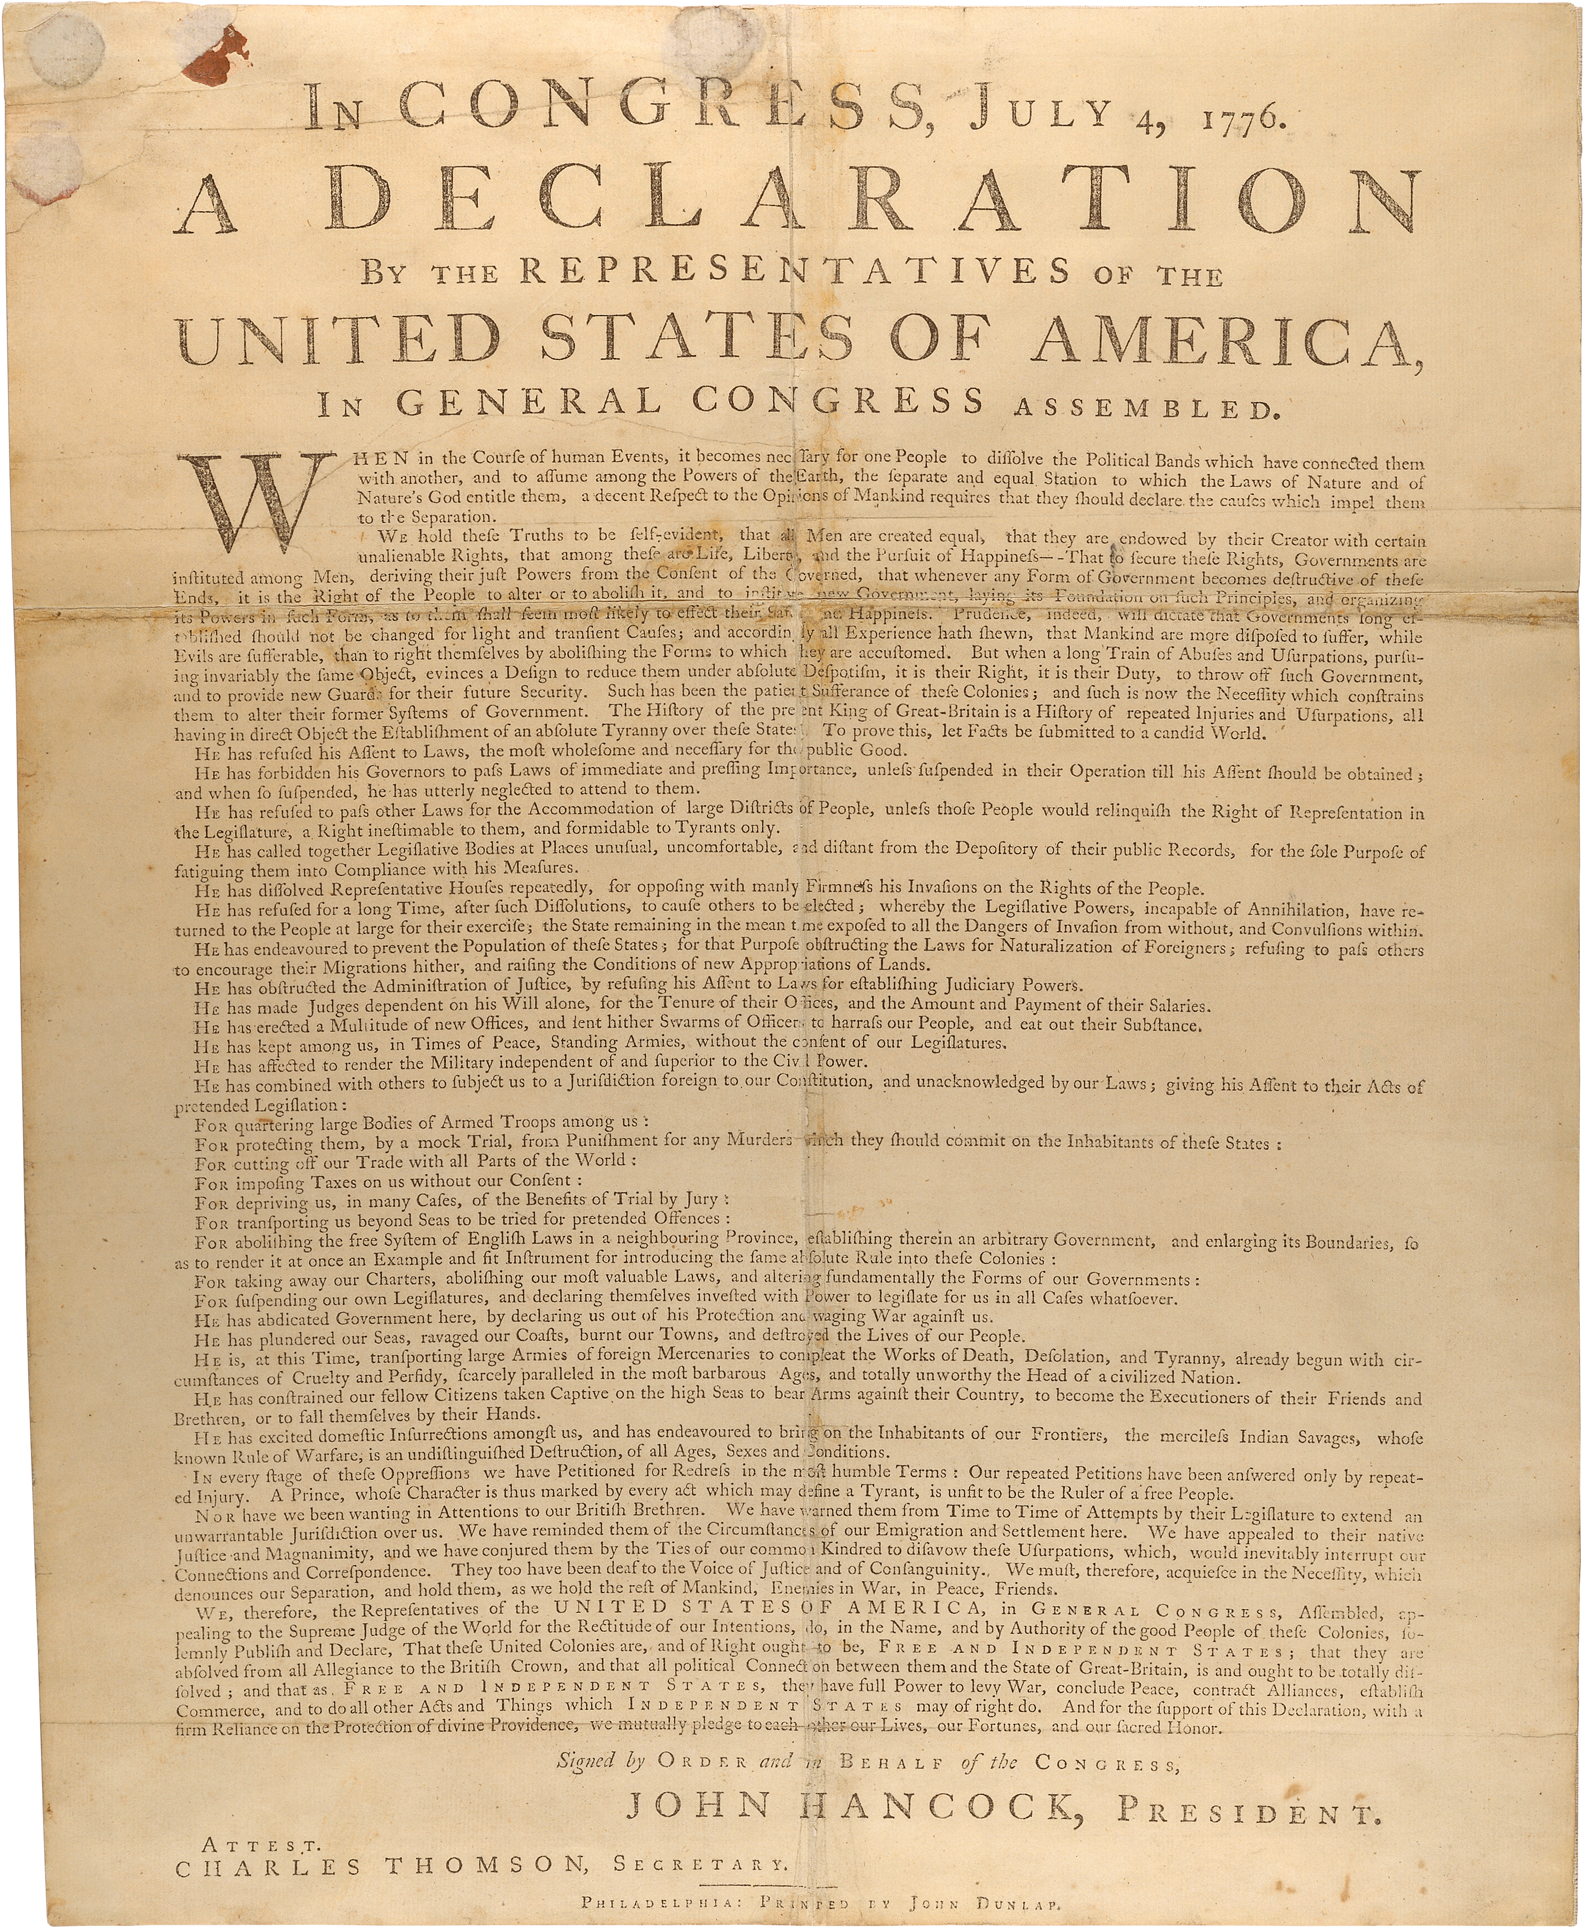
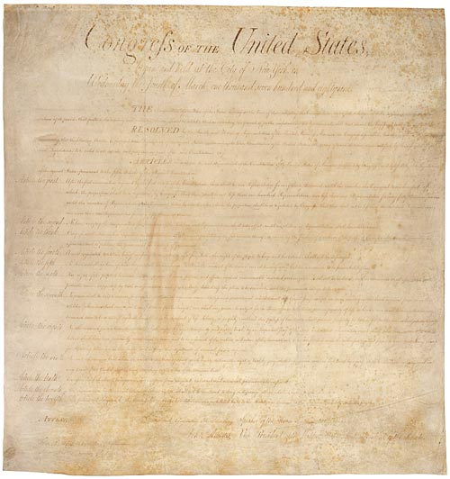

STATION 1
The Declaration of Independence
1776
The Bill of Rights
1791

 | Declaration of Independence | First Amendment of  the Bill of Rights
Actual Text | That to secure these rights, Governments are instituted among Men… | Congress shall make no law respecting an establishment of religion, or prohibiting the free exercise thereof; or abridging the freedom of speech, or of the press; or the right of the people peaceably to assemble, and to petition the Government for a redress of grievances.
What does the text mean? | People create governments to guarantee their natural rights to life, liberty, and the pursuit of happiness. | ??????

Work with your group members to answer the following questions on your handout:
1. What does the text of the First Amendment mean in your own words?
2. What is the common idea between these two pieces of text?
3. What is an example of this idea in life today?

STATION 2
The Declaration of Independence
1776
The United States Constitution
1787

 | Declaration of Independence | Article I of the U.S. Constitution
Actual Text | Governments are instituted among Men, deriving their just powers from the consent of the governed… | The House of Representatives shall be composed of Members chosen every second Year by the People of the several States,
What does the text mean? | Governments receive their power to act fairly from the consent of the people. | ??????

Work with your group members to answer the following questions on your handout:
1. What does the text from Article I mean in your own words?
2. What is the common idea between these two pieces of text?
3. What is an example of this idea in life today?

STATION 3
The Declaration of Independence
1776
The United States Constitution
1787

 | Declaration of Independence | Article V of the U.S. Constitution
Actual Text | That whenever any Form of Government becomes destructive of these ends, it is the Right of the People to alter or abolish it and to institute new Government… | The Congress, whenever two thirds of both Houses shall deem it necessary, shall propose Amendments to this Constitution, or, on the Application of the Legislatures of two thirds of the several States, shall call a Convention for proposing Amendments,
What does the text mean? | When the government fails to protect the rights of the people, the people have the right and responsibility to change it or overthrow it and start a new government. | ??????

Work with your group members to answer the following questions on your handout:
1. What does the text from Article V mean in your own words?
2. What is the common idea between these two pieces of text?
3. What is an example of this idea in life today?

The Declaration of Independence
1776
The United States Constitution
1787
STATION 4

 | Declaration of Independence | Article III of the U.S. Constitution
Actual Text | He has made Judges dependent on his Will alone for the tenure of their offices, and the amount and payment of their salaries. | Section 1: The judicial Power of the United States, shall be vested in one supreme Court, and in such inferior Courts as the Congress may from time to time ordain and establish. The Judges of both the Supreme and inferior Courts, shall hold their Offices during good Behavior, and shall, at stated Times, receive for their services, a Compensation, which shall not be diminished during their Continuance in Office.
What does the text mean? | The king has taken away judges’ independence to make decisions. Instead, judges have to make decisions that will please the king in order to continue to stay in their position and get paid. | ??????

Work with your group members to answer the following questions on your handout:
1. What does the text from Article III mean in your own words?
2. What is the common idea between these two pieces of text?
3. What is an example of this idea in life today?

The Declaration of Independence
1776
The United States Constitution
1787
STATION 5

 | Declaration of Independence | Article I of the U.S. Constitution
Actual Text | He has forbidden his Governors to pass Laws of immediate and pressing importance | All legislative Powers herein granted shall be vested in a Congress of the United States, which shall consist of a Senate and House of Representatives.
What does the text mean? | He has forbidden the legislature to pass laws | ??????

Work with your group members to answer the following questions on your handout:
1. What does the text from Article I mean in your own words?
2. What is the common idea between these two pieces of text?
3. What is an example of this idea in life today?

Name: _____________________________________________________ Date:_______________________________________
Forward to the Future: The Declaration of Independence in Our Lives
How are the ideas from the Declaration of Independence connected to our government today?

 | STATION 1 | STATION 2 | STATION 3 | STATION 4 | STATION 5
What does the text mean in your own words? | ________________________  ________________________  ________________________  ________________________  ________________________  ________________________  ________________________  ________________________ | ________________________  ________________________  ________________________  ________________________  ________________________  ________________________  ________________________  ________________________ | ________________________  ________________________  ________________________  ________________________  ________________________  ________________________  ________________________  ________________________ | ________________________  ________________________  ________________________  ________________________  ________________________  ________________________  ________________________  ________________________ | ________________________  ________________________  ________________________  ________________________  ________________________  ________________________  ________________________  ________________________
What is the common idea between the two pieces of text? | ________________________  ________________________  ________________________  ________________________  ________________________  ________________________  ________________________  ________________________ | ________________________  ________________________  ________________________  ________________________  ________________________  ________________________  ________________________  ________________________ | ________________________  ________________________  ________________________  ________________________  ________________________  ________________________  ________________________  ________________________ | ________________________  ________________________  ________________________  ________________________  ________________________  ________________________  ________________________  ________________________ | ________________________  ________________________  ________________________  ________________________  ________________________  ________________________  ________________________  ________________________
What is an example of this idea in life today? | ________________________  ________________________  ________________________  ________________________  ________________________  ________________________  ________________________  ________________________ | ________________________  ________________________  ________________________  ________________________  ________________________  ________________________  ________________________  ________________________ | ________________________  ________________________  ________________________  ________________________  ________________________  ________________________  ________________________  ________________________ | ________________________  ________________________  ________________________  ________________________  ________________________  ________________________  ________________________  ________________________ | ________________________  ________________________  ________________________  ________________________  ________________________  ________________________  ________________________  ________________________

Forward to the Future: The Declaration of Independence in Our Lives – Sample Answers
How are the ideas from the Declaration of Independence connected to our government today?

 | STATION 1 | STATION 2 | STATION 3 | STATION 4 | STATION 5
What does the text mean in your own words? | This text is an amendment to the U.S. Constitution that prevents Congress from establishing a religion, and from interfering with freedom of religious exercise, press, speech, assembly, or petition | Members of the House of Representatives are elected by the people every two years. | Congress or a convention of the states can propose amendments, or changes, to the U.S. Constitution. | Judicial power belongs to the U.S. Supreme Court and lower courts. Judges receive a salary (compensation) for doing their job and are required to maintain good behavior during their time as a judge.  Teacher Note: Be sure to explain to students that this only applies to federal judges. State and local level judges have different qualifications. | Legislative powers belong to Congress: the Senate and House of Representatives.
What is the common idea between the two pieces of text? | Rights | Consent of the people | The people have a right to change the government. | Judicial power | Legislative power
What is an example of this idea in life today? | We have rights that are protected by the government. | We elect people to represents us at all levels of government. | We currently have 27 amendments and many more amendments have been proposed. | We have a Supreme Court and lower federal courts today that have made and continue to make decisions. | We have a Congress with a House of Representatives and Senate. They are responsible for making laws for the United States.

