STUDENTS INVESTIGATING PRIMARY SOURCES
Decoding the Declaration
Celebrate Freedom Week Series: Part I
What did declaring independence say about the importance of rights?
A Short Activity for High School and Middle School
Benchmark Correlations
SS.912.C.1.2 - Explain how the Declaration of Independence reflected the political principles of popular sovereignty, social contract, natural rights, and individual rights.
Benchmark Clarification: Students will identify and explain rights specified in the Declaration of Independence (i.e., natural rights, popular sovereignty, social contract).
Benchmark Clarification: Students will identify and describe popular sovereignty, social contract, natural rights, and individual rights.
SS.912.CG.1.4 Analyze how the ideals and principles expressed in the founding documents shape America as a constitutional republic.
ELA.10.R.2.2 - Analyze the central idea(s) of historical American speeches and essays.
ELA.10.R.3.2 - Paraphrase content from grade-level texts.
ELA.9.R.2.2 - Evaluate the support an author uses to develop the central idea(s) throughout a text.
ELA.9.R.3.2 - Paraphrase content from grade-level texts.

SS.8.A.3.7 - Examine the structure, content, and consequences of the Declaration of Independence.
SS.8.CG.1.1 Compare the views of Patriots, Loyalists and other colonists on limits of government authority, inalienable rights and resistance to tyranny.
SS.7.C.1.4 - Analyze the ideas (natural rights, role of the government) and complaints set forth in the Declaration of Independence.
Benchmark Clarification: Students will explain the concept of natural rights as expressed in the Declaration of Independence.
Benchmark Clarification: Students will identify the natural rights specifically expressed in the Declaration of Independence (life, liberty, and the pursuit of happiness).
SS.7.CG.1.6 Analyze the ideas and complaints set forth in the Declaration of Independence.
ELA.8.R.2.2 - Analyze two or more central ideas and their development throughout a text.
ELA.8.R.3.2 - Paraphrase content from grade-level texts.
ELA.7.R.2.2 - Compare two or more central ideas and their development throughout a text.
ELA.7.R.3.2 - Paraphrase content from grade-level texts.

Activity Documents and Handouts
- Projected image of the Dunlap Broadside of the Declaration of Independence
- Excerpted text from the Declaration of Independence
- Decoding the Declaration Graphic Organizer

Full Document Citations
Dunlap Broadside [Declaration of Independence], July 4, 1776; Rough Journals, 9/5/1774 - 3/2/1789; Records of the Continental and Confederation Congresses and the Constitutional Convention, 1765 - 1821, Record Group 360; National Archives Building, Washington DC. National Archives Identifier: 301682.
[https://catalog.archives.gov/id/301682]
[https://www.docsteach.org/documents/document/dunlap-broadside]

Engrossed Declaration of Independence, August 2, 1776; Miscellaneous Papers of the Continental Congress, 1774 - 1789; Records of the Continental and Confederation Congresses and the Constitutional Convention, 1765 - 1821, Record Group 360; National Archives Building, Washington, DC. National Archives Identifier: 1419123.
[https://catalog.archives.gov/id/1419123]
[https://www.docsteach.org/documents/document/the-declaration-of-independence]

Activity Vocabulary
endowed – given or provided
liberty – freedom, an individual’s right to be free
self-evident – clear or obvious
unalienable – cannot be taken away or denied

- Project the Dunlap Broadside of the Declaration of Independence and then project the excerpted text from the transcript on Page 5.
- Ask students if they can identify the document based on the image and text they have viewed. Lead students to the understanding that they are looking at the Declaration of Independence of the United States of America.
- Ask students the following question: What did declaring independence say about the importance of rights?
- Pass out the Decoding the Declaration graphic organizer and explain to students that they will analyze a piece of text from the preamble, or introduction, of the Declaration of Independence to understand the relationship between the document and rights. Teacher Note: Be sure to explain to students that preamble of the Declaration of Independence focuses on individual rights.
- Explain to students that you will model how to analyze the text by reading it aloud, thinking aloud and modeling a possible answer for the column labeled “What I think it means”. Teacher Note: Utilize the Sample Answers to guide this step.
- Instruct students to follow along while you model the first section of the text.
- Explain to students that it is now their turn to analyze the rest of the text from the Declaration of Independence. Teacher Note: Students can be divided in a number of ways: individually, in pairs, or in groups. If students need more guidance before moving from direct instruction, support students by having them work in pairs.
- Provide time for students to complete the rest of the graphic organizer. Circulate through the classroom to monitor understanding.
- Bring students back together as a whole class.
- Review each piece of text and have students share out what they think it means. After students share their ideas, use the completed graphic organizer to guide students to understand what the text really means.
- Direct students to the question at the bottom of the graphic organizer and provide students with time to answer the question independently.

Enrichment Suggestion #1 – Instruct students to answer the following questions in writing: How does this statement from the Declaration of Independence relate to United States government today? What does this statement mean to you?
Enrichment Suggestion #2 – Have students use DocsTeach to find images to create a photo collage of images that symbolize the words from the text they studied. On the back of the collage, instruct students to explain why they selected each image and how it connects to the words.
Enrichment Suggestion #3 – Show students an example of a dramatic reading of the Declaration of Independence. (For example, show this celebrity reading from DeclareYourself on SchoolTube. The dramatic reading starts at 4:35.) Have students work in pairs or in a small group to create and perform their own dramatic reading.

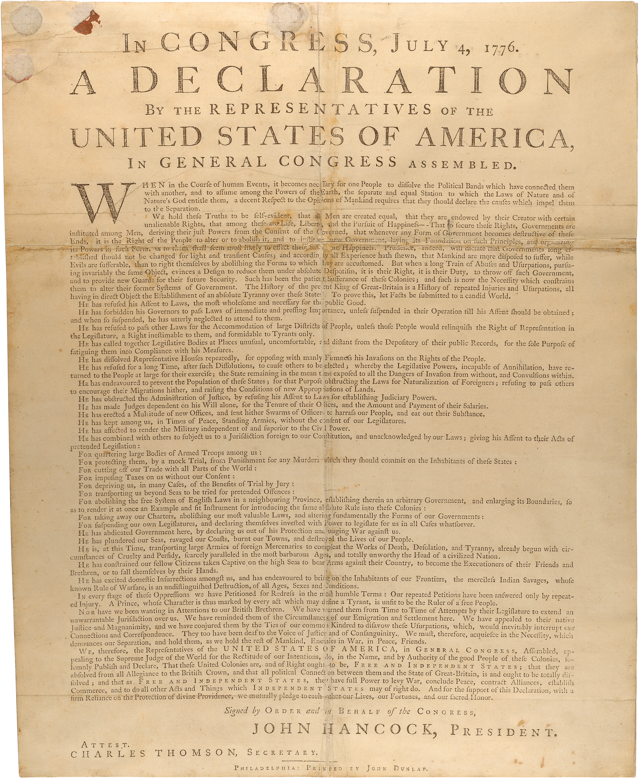

“We hold these truths to be self-evident, that all men are created equal, that they are endowed by their Creator with certain unalienable Rights, that among these are Life, Liberty and the pursuit of Happiness.”
Name: ______________________________________________ Date: _____________

Decoding the Declaration
VOCABULARY
endowed – given or provided
liberty – freedom, an individual’s right to be free
self-evident – clear or obvious
unalienable – cannot be taken away or denied

Text | What I think it says | What it really means
We hold these truths to be self-evident,
that all men are created equal,
that they are endowed by their Creator with certain unalienable Rights,
that among these are Life, Liberty and the pursuit of Happiness.

Guiding Question: What did declaring independence say about the importance of rights?

__________________________________________________________________________________________________________________________________________________________________________________________________________________________________________________________________________________________________________________________________________________________________________________________________________________________________________________________________________________________________________________________________________

Decoding the Declaration – Sample Think Aloud Process and Answers
Text | What I think it says | What it really means
We hold these truths to be self-evident, (teacher model or think aloud) | Teacher: Can you think of any examples of things that are so obvious that they don’t need explaining and are accepted by everyone?  Students: may respond with the sky is up  Teacher: Self-evident is similar to this. It means that it is should be obvious to everyone. Now that we have discussed this vocabulary word. Let’s look at the rest of this portion of the sentence “We hold these truths to be self-evident”. If I know self-evident means obvious than I could say We hold these truths to be obvious. That makes me think what truths? Maybe the “truths” are ideas and will be discussed below. So, We hold these ideas to be obvious. But, that makes me think what does “We hold” mean? I guess I could say, We believe these ideas are obvious. | We believe these are ideas are SO OBVIOUS that they shouldn’t even need explaining
that all men are created equal,  (Possible “we do”) | Teacher Note: Prompt the students to explain the phrase that all men are created equal.  Teacher can ask the student: Does the men mean just males? Or does it mean all people?  Students will suggest various ideas in class discussion | All people are created the same.  They note that all people are created the same, but at the time when this was written this ideal did not match reality.  Teacher note to discuss with students: Example- Slavery existed and women had limited rights.
that they are endowed by their Creator with certain unalienable Rights,  (see Teacher Note about grouping students) | Students will record various ideas  Teacher Note: Prompt the students to explain the phrase. Teacher can ask: Who is “they” and who is the “Creator”? What is the relationship between the Creator and rights? | People are given by their Creator particular rights that can’t be denied because they were given to the people by their Creator.
that among these are Life, Liberty and the pursuit of Happiness.  (see Teacher Note about grouping students) | Students will record various ideas  Teacher Note: Prompt the students to explain the phrase. Teacher can ask: what are these referring to? What do you think the founders really meant by happiness? Do you think they mean people are happy or something else? How do you know? Do you agree with the Founding Fathers that life, liberty, and pursuit of happiness are undeniable rights granted by a higher power? | Rights given by a higher power are life, freedom, and the ability to pursue happiness.
Guiding Question:
One possible answer students may record is: By declaring independence the Founding Fathers said that it is obvious that the rights of life, freedom, and ability to obtain property given by a higher power should not be denied to any person. This assertion or belief is important since it sets the basis of the Founding Fathers argument to create an independent nation separate of Britain because of Britain abuse of these rights.

